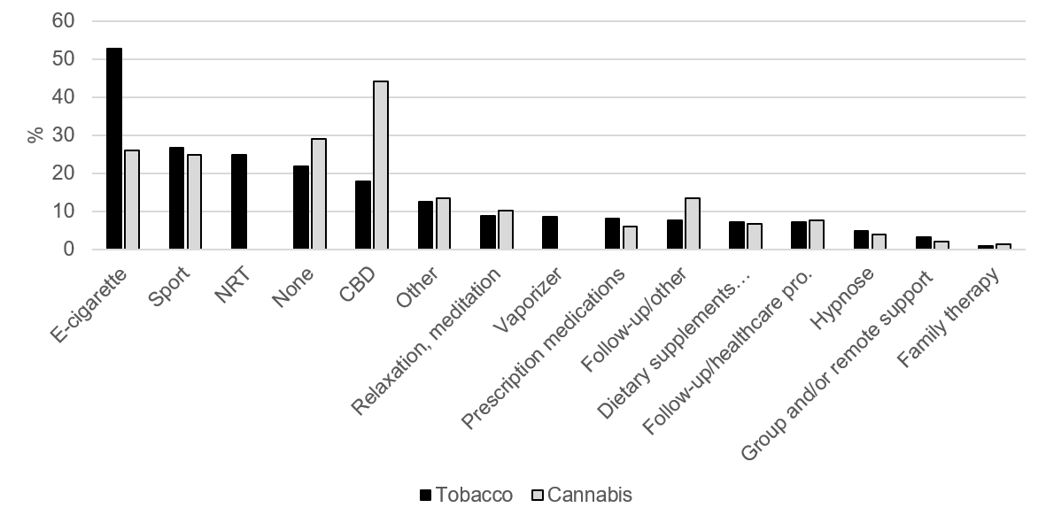Supplementary Figure 4. Types of quitting methods tried during previous tobacco (n=226) and cannabis (n=238) cessation attempts
Exact wording of the types of methods are provided in Supplementary Table 4.

