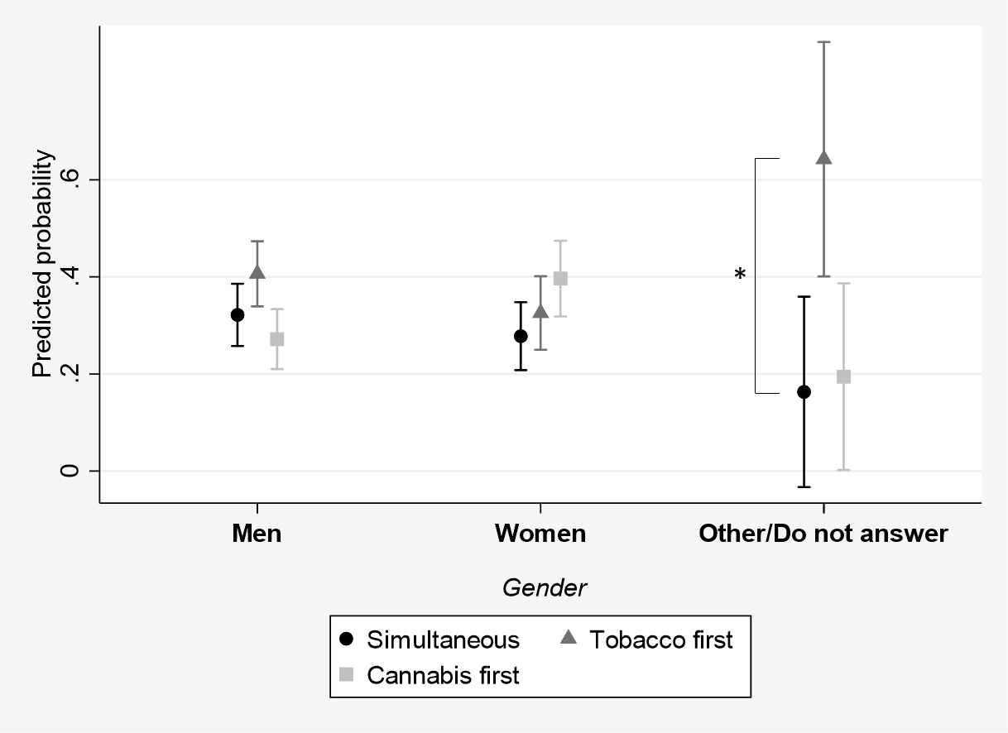
Supplementary Figure 1. Predicted probabilities of preferring simultaneous or sequential cessation according to gender (multinomial regression model, n=357)

