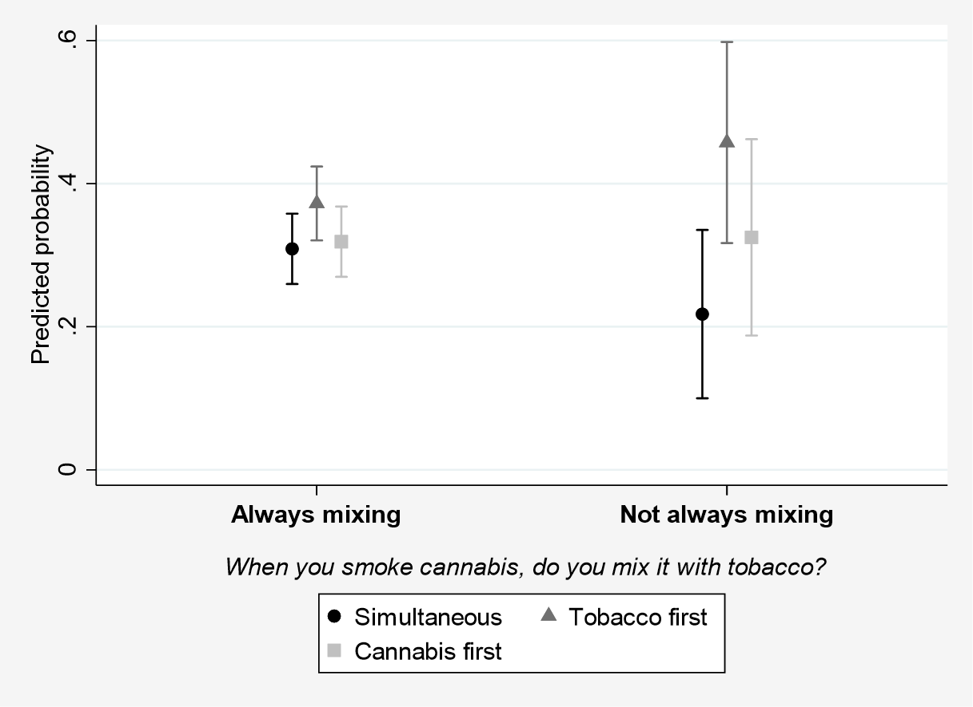
Supplementary Figure 2. Predicted probabilities of preferring simultaneous or sequential cessation according to mixing cannabis with tobacco when smoking cannabis (multinomial regression model, n=357)

