Dicentrine, an Aporphine Alkaloid from Ocotea langsdorffii, Induces Mitochondrial Dysfunction and Oxidative Stress in Leishmania (L.) infantum

Camila S. de Freitas^{a *}, Eduardo Oliveira S. da Silva^{b}, Daniela C. Tristão^{b},
Guilherme M. Antar^{c}, Daniela P. Lageª, Dóris M. Abrãoª, Luciana M. Ribeiro Antinarelli^{d}, Elaine S. Coimbra^{d}, João Henrique G. Lago^{b}, Eduardo A.F. Coelhoª

ª Post-graduation Program in Health Sciences - Infectiology and Tropical Medicine, Medicine Faculty, Federal University of Minas Gerais, Belo Horizonte, MG, 30130-100, Brazil.
^{b} Center of Natural Sciences and Humanities, Federal University of the ABC, Santo Andre, SP, 09210-180, Brazil.
^{c} Department of Agricultural and Biological Sciences, Federal University of Espirito Santo, São Matheus, ES, 29932-540, Brazil.
^{d} Departament of Parasitology, Microbiology and Imunology, Institute of Biological Sciences, Federal University of Juiz de Fora, Juiz de Fora, MG, 36036‐900, Brazil

* Corresponding author
E-mail address: camilasimoesf@gmail.com

SUPPLEMENTARY INFORMATION

Table S1 - ¹H and ¹³C NMR data to dicentrine
(δ/ppm, 500 e 125 MHz, CDCl₃)

 | ¹H (mult., J/Hz) |  | ¹³C
Position | Experimental | Literature* | Experimental | Literature*
1 | - | - | 146.6 | 146.2
1a | - | - | 116.5 | 116.2
1b | - | - | 126.3 | 126.3
2 | - | - | 141.7 | 141.4
3 | 6.52 (s) | 6.51 (s) | 106.7 | 106.2
3a | - | - | 126.5 | 126.6
4 | 3.16 – 3.03 (m)  2.65 – 2.60 (m) | 3.16 (m)  2.64 (br d, 14.0) | 29.1 | 28.9
5 | 3.16 – 3.03 (m)  2.65 – 2.60 (m) | 3.07 (m)  2.56 (m) | 53.5 | 53.2
6a | 3.16 – 3.03 (m) | 3.23 (br d, 10.0) | 62.3 | 62.1
7 | 3.16 – 3.03 (m)  2.65 – 2.60 (m) | 3.07 (dd, 15.0, 4.5)  2.67 (dd, 15.0, 10.0) | 34.1 | 33.8
7a | - | - | 128.3 | 128.2
8 | 6.78 (s) | 6.79 (s) | 111.3 | 111.2
9 | - | - | 147.6 | 147.5
10 | - | - | 148.2 | 148.2
11 | 7.67 (s) | 7.63 (s) | 110.6 | 110.4
11a | - | - | 123.5 | 123.1
9-OCH₃ | 3.92 (s) | 3.93 (s) | 55.8 | 55.4
10-OCH₃ | 3.92 (s) | 3.93 (s) | 56.1 | 55.6
OCH₂O | 5.92 (s)  6.07 (s) | 5.93 (s)  6.05 (s) | 100.6 | 100.4
NCH₃ | 2.55 (s) | 2.58 (s) | 43.8 | 43.3

*W. G. Ma, Y. Fukushi, S. Tahara, T. Osawa. ‘Fungitoxic alkaloids from Hokkaido Papaveraceae’ Fitoterapia 2000, 71, 527-34.
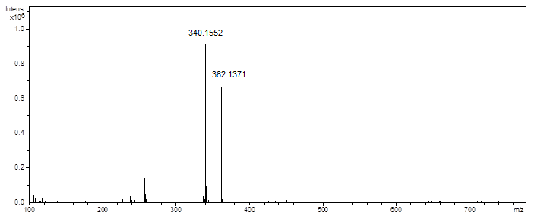

Figure S1. ESI-HRMS spectrum (positive mode) of dicentrine.

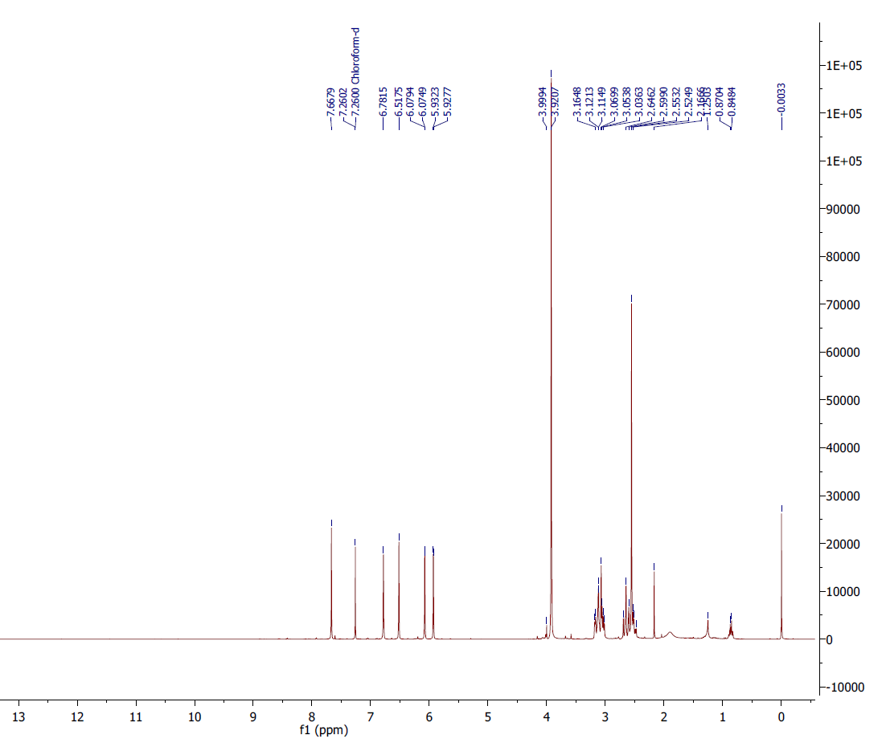
Figure S2. ¹H NMR spectrum of dicentrine (δ, 500 MHz, CDCl₃).
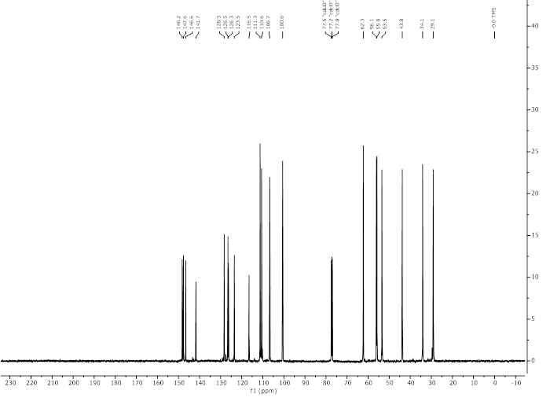
Figure S3. ¹³C NMR spectrum of dicentrine (δ, 125 MHz, CDCl₃).

