Appendix A: Cannabis Health Literacy Survey

Eligibility Questions

- In what province or territory do you reside in?
- Alberta
- British Columbia
- Manitoba
- New Brunswick
- Newfoundland & Labrador
- Nova Scotia
- Northwest Territories
- Nunavut
- Ontario
- Prince Edward Island
- Quebec
- Saskatchewan
- Yukon
- I do not live in Canada.

- What is your age?
- Under 19
- 19-29 years
- 30-39 years
- 40-49 years
- 50-59 years
- 60-69 years
- 70 years and older

EQ5D- Quality of Life Scale

- Mobility
- I have no problems in walking about.
- I have slight problems in walking about.
- I have moderate problems in walking about.
- I have severe problems in walking about.
- I am unable to walk about.

- Self-Care
- I have no problems washing or dressing myself.
- I have slight problems washing or dressing myself.
- I have moderate problems washing or dressing myself.
- I have severe problems washing or dressing myself.
- I am unable to wash or dress myself.

- Usual Activities (e.g., work, study, housework, family, or leisure activities)
- I have no problem doing my usual activities.
- I have slight problems doing my usual activities.
- I have moderate problems doing my usual activities.
- I have severe problems doing my usual activities.
- I am unable to do my usual activities.

- Pain/ Discomfort
- I have no pain or discomfort.
- I have slight pain or discomfort.
- I have moderate pain or discomfort.
- I have severe pain or discomfort.
- I have extreme pain or discomfort.

- Anxiety/Depression
- I am not anxious or depressed.
- I am slightly anxious or depressed.
- I am moderately anxious or depressed.
- I am severely anxious or depressed.
- I am extremely anxious or depressed.

- We would like to know how good or bad your health is TODAY. This scale is numbered from 0 to 100; 100 means the best health you can imagine and 0 means the worst health you can imagine.

Please use the scale below to indicate how your health is TODAY.
 | 0 | 10 | 20 | 30 | 40 | 50 | 60 | 70 | 80 | 90 | 100

Please use the scale below to indicate how your health is TODAY. | 

Cannabis Health Literacy Questionnaire

To what extent do you agree or disagree with the following statements:

- I am confident I know where to find information about cannabis.
- Strongly Disagree
- Disagree
- Neither disagree nor agree
- Agree
- Strongly agree

- I am confident I can ask questions to a health care provider about cannabis.
- Strongly Disagree
- Disagree
- Neither disagree nor agree
- Agree
- Strongly agree

- I am confident I know where to find information on how to manage unpleasant side effects with cannabis use.
- Strongly Disagree
- Disagree
- Neither disagree nor agree
- Agree
- Strongly agree

- I am confident in using the cannabis information I find to make cannabis health-related decisions.
- Strongly Disagree
- Disagree
- Neither disagree nor agree
- Agree
- Strongly agree

- According to the label displayed below, what is the total THC in this product?
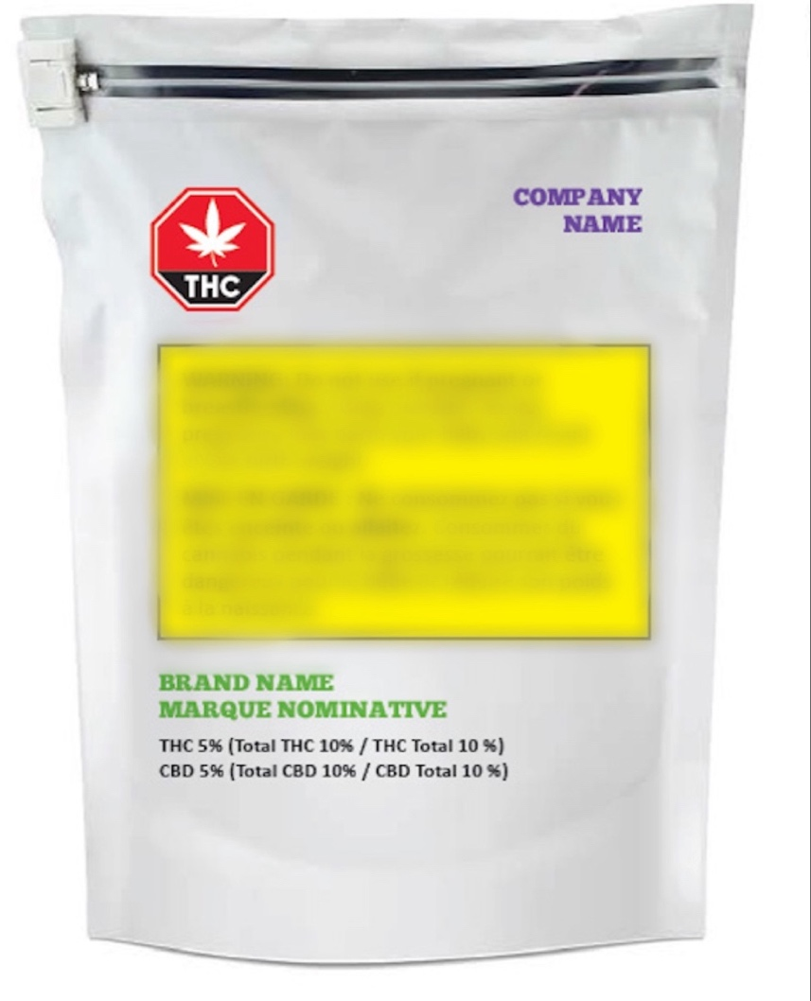
Image source: Health Canada
- 5 %
- 10%
- 15%
- 20%
- I don’t know

- According to the product label displayed below, how many milligrams (mg) of cannabinoids are in one soft gel?
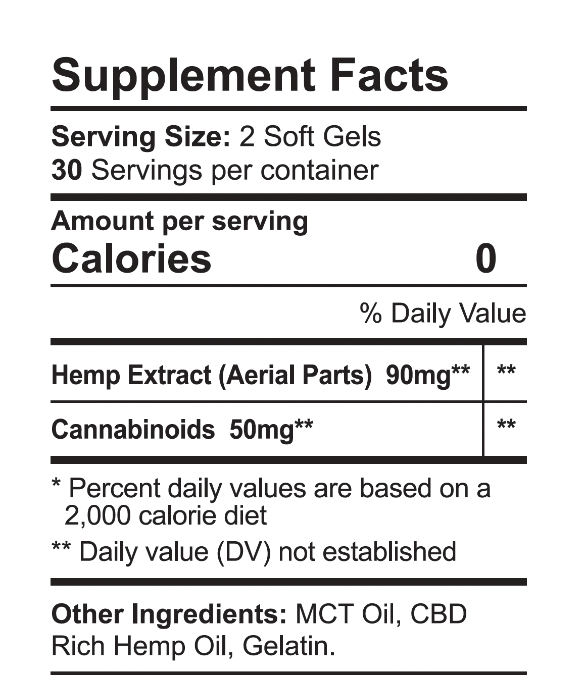
Image source: CBDFX

- 15 mg
- 25 mg
- 50 mg
- 100 mg
- I don’t know

- If one drop of CBD oil = 1.1mg, how many drops would you need to have 16.5 mg of CBD?
- 10 drops
- 15 drops
- 20 drops
- 25 drops
- I don’t know
- If a syringe of 1 mL has 20 mg of CBD (i.e., 1 mL = 20 mg of CBD), how many mL would you need to have 5 mg of CBD?
- 0.2 mL
- 0.25 mL
- 4 mL
- 5 mL
- I don’t know

- Which of the ingredients of cannabis produces the feeling or experience of being “high”?
- THC (Tetrahydrocannabinol)
- CBD (Cannabidiol)
- CBG (Cannabigerol) & CBN (Cannabinol)
- Terpenes
- I don’t know

- Too much of which ingredient in cannabis products can most likely lead to cannabis poisoning?
        - Terpenes
        - CBG (Cannabigerol) & CBN (Cannabinol)
        - CBD (Cannabidiol)
        - THC (Tetrahydrocannabinol)
        - I don’t know.

- Which method of cannabis consumption typically has the longest delay before experiencing the feeling or experience of being high?
        - Eating edibles or drinking cannabis beverages
        - Lotions or oils for skin
        - Smoking or vaping
        - Sprays or Tinctures
        - I don’t know.

- Which of the ingredients in cannabis products is most likely to give rise to adverse (i.e., unpleasant) side effects?
- CBD (Cannabidiol)
- Terpenes
- THC (Tetrahydrocannabinol)
- CBG (Cannabigerol) & CBN (Cannabinol)
- I don’t know

- Which of the following health conditions has the least amount of evidence for the medical use of cannabis?
        - Epilepsy
        - Multiple Sclerosis (MS)
        - Symptoms associated with Cancer
        - Irritable bowel syndrome (IBS)
        - I don’t know.

- If a cannabis flower product contains 300 mg/g of THC, then what is the percentage (%) of THC in the product?

        - 0.3%
        - 3%
        - 30%
        - 300%
        - I don’t know.

- After smoking cannabis, what is the minimum amount of time a person should wait before driving?
- less than 1 hour
- 1 to 3 hours
- 4 to 8 hours
- more than 10 hours
- I don’t know.

- People can experience harm to brain development from cannabis use when they start consuming cannabis any time before the age of ______.
        - 19
        - 21
        - 25
        - 30
        - I don’t know.

To what extent do you agree or disagree with the following statements:

- Smoking Cannabis can be harmful.
- Strongly Disagree
- Disagree
- Neither disagree nor agree
- Agree
- Strongly agree

- Using cannabis when pregnant or breastfeeding can be harmful.
- Strongly Disagree
- Disagree
- Neither disagree nor agree
- Agree
- Strongly agree

- Cannabis can be addictive.
- Strongly Disagree
- Disagree
- Neither disagree nor agree
- Agree
- Strongly agree

- Driving or operating machinery after cannabis use is dangerous.
- Strongly Disagree
- Disagree
- Neither disagree nor agree
- Agree
- Strongly agree

- Regular cannabis use can increase the risk for psychosis or schizophrenia.
- Strongly Disagree
- Disagree
- Neither disagree nor agree
- Agree
- Strongly agree

- Teenagers are at a greater risk of harm from using cannabis than adults.
- Strongly Disagree
- Disagree
- Neither disagree nor agree
- Agree
- Strongly agree

- In your opinion, how common are the following side effects with THC consumption?

 | Uncommon | Common | I don’t know
Hallucinations
Dry mouth/ red eyes
Rapid heart rate
Low appetite

Cannabis Consumption History

- Which of the following best describes your cannabis use history?
  - I have never consumed cannabis.
  - I consumed cannabis before legalization and have continued to consume cannabis after legalization.
  - I consumed cannabis before legalization and stopped, then re-started consuming cannabis after legalization.
  - I consumed cannabis before legalization, and I do not consume cannabis now
  - I started consuming cannabis after legalization.

- Have you consumed cannabis in the past 12 months?
- Yes
- No

- Which of the following best describes your reason for consuming cannabis?
- Medical purposes (authorized or self-treating)
- Recreational purposes (non-medical)
- Both medical and recreational purposes
- Prefer not to say.

Demographics

- What is the option that best describes your biological sex at birth?
- Male
- Female
- Prefer not to say.

- What is the option that best describes your current gender identity? (Select all that apply).
- Man
- Woman
- Trans Man
- Trans Woman
- Genderqueer/ Gender non-conforming
- Prefer to self-identify: _______________________________
- Prefer not to say.

- What is the highest level of education you have completed?
- Did not attend high school.
- Some high school attended.
- High school diploma or equivalent
- Some college/university education attended.
- College diploma or bachelor’s degree
- Graduate degree (e.g., master’s degree, doctoral degree)
- Professional degree (e.g., MD, DDS, DVM, JD, PharmD)

- Which ethno-racial category best describes you? (Select all that apply)
- Black (e.g., African, Caribbean, African Canadian descent, Caribbean Canadian descent)
- East Asian (e.g., Chinese, Korean, Japanese, Taiwanese descent)
- Latino (e.g., Latin American, Hispanic descent)
- Middle Eastern (e.g., Arab, Persian, West Asian descent, Afghan, Egyptian, Iranian)
- South Asian (e.g., Filipino, Vietnamese, Cambodian, Thai, Southeast Asian descent)
- White (e.g., European descent)
- Mixed Race or Biracial
- Another race category: _______________________
- Prefer not to say.

