Development and In Vivo Pharmacokinetic Evaluation of a Phospholipid Complex Self-Nanoemulsifying Drug Delivery System (PLC-SNEDDS) for Enhanced Oral Bioavailability of Cannabidiol
Thabata Muta¹, Songhita Mukhopadhyay¹, Benjamin Noll¹, Yunmei Song¹, and Sanjay Garg¹.
¹Adelaide University, Adelaide, SA, 5000, Australia
Corresponding author: Sanjay.Garg@unisa.edu.au

Supplementary Table S1. Crossover study design
ID | Female-1 |  | Female-2 | Female-3 | Female-4 | Male-1 | Male-2 | Male-3 | Male-4 | Male-5
Dose 1 | Oral A | Control |  | IV | Oral B | Oral A | Oral B | IV | Control | IV
Dose 2 | Control | IV |  | Oral B | Oral A | Control | Oral A | Oral B | IV | Control
Dose 3 | Oral B | Oral A |  | Control | IV | Oral B | IV | Control | Oral A | -

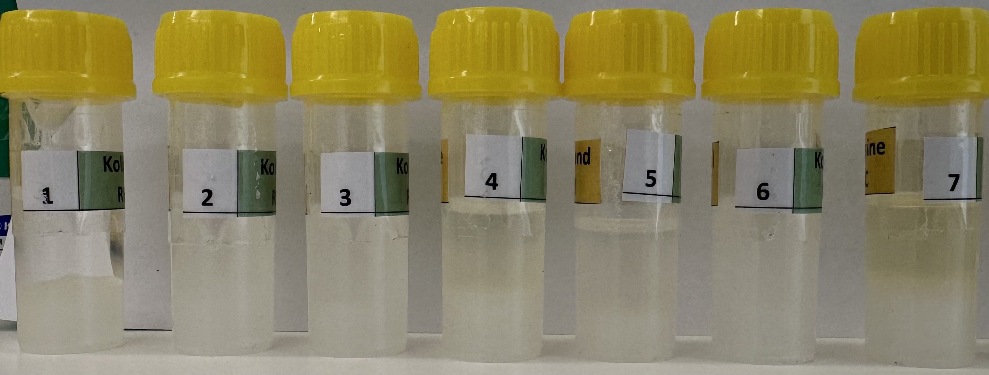
Day 0
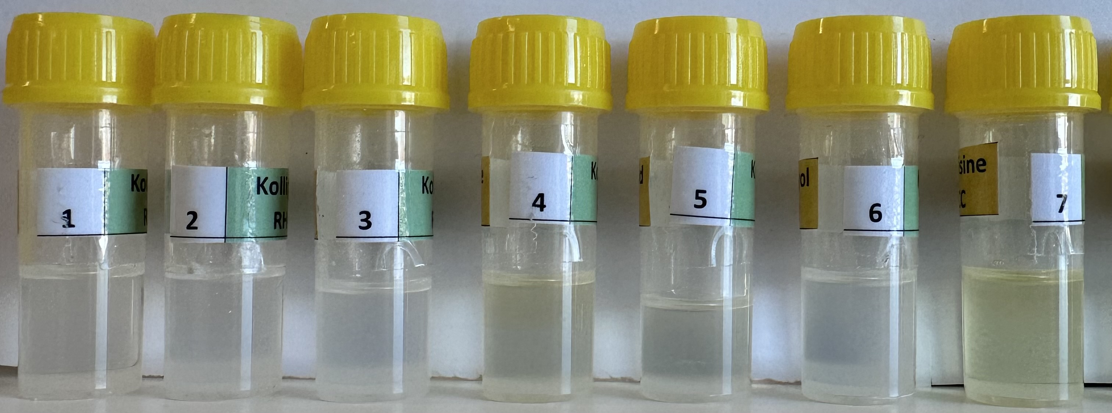
Day 14
Day 0
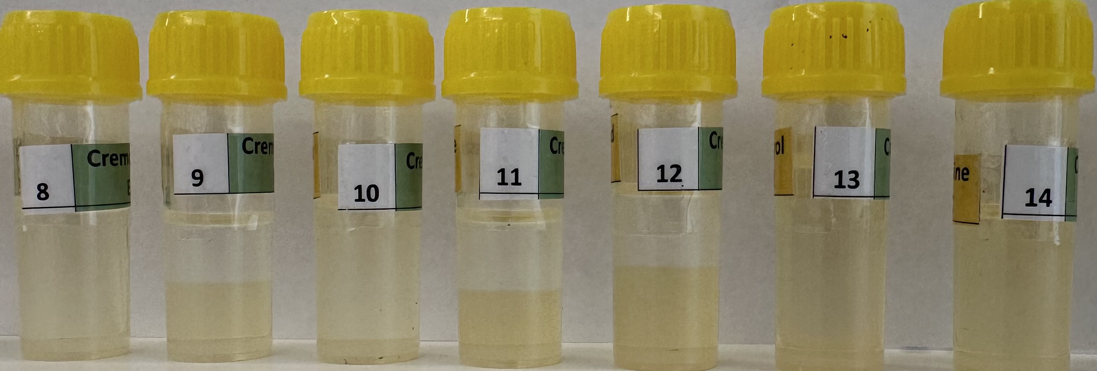
Day 0
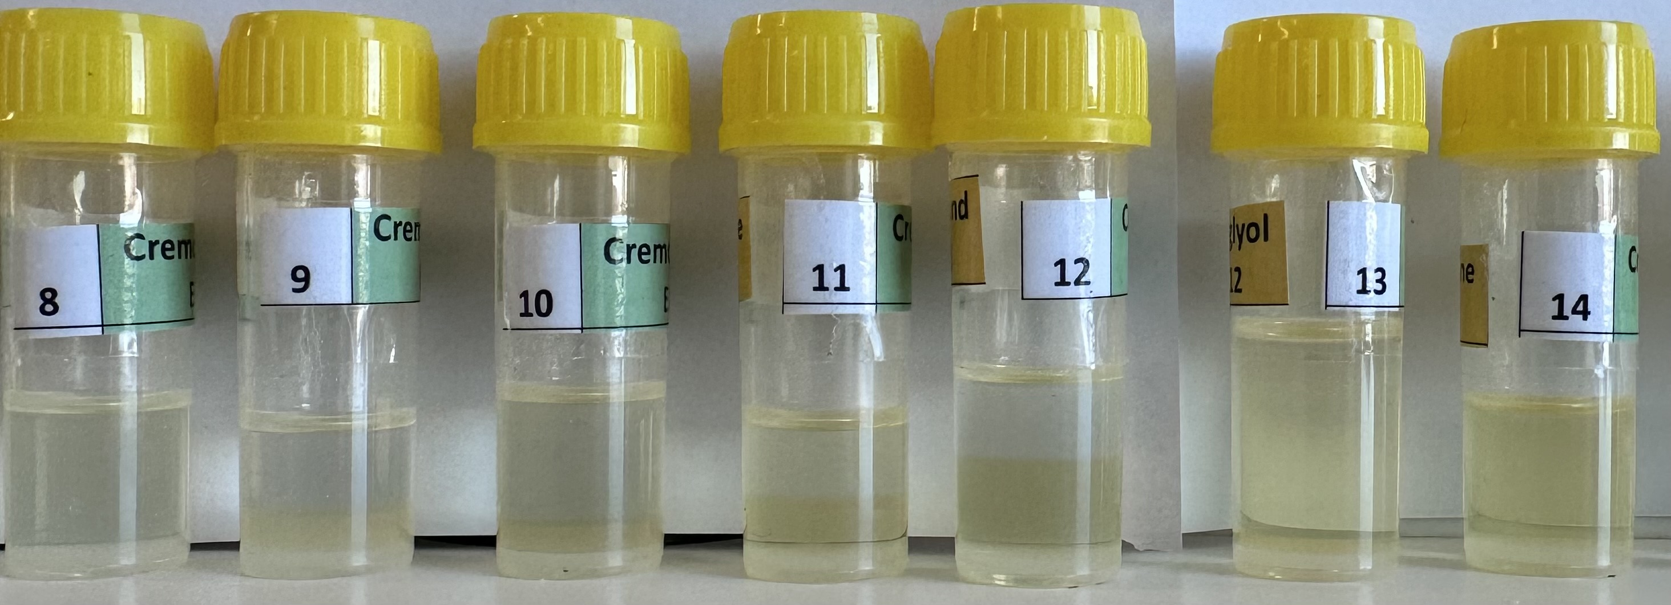
Day 14
Day 0
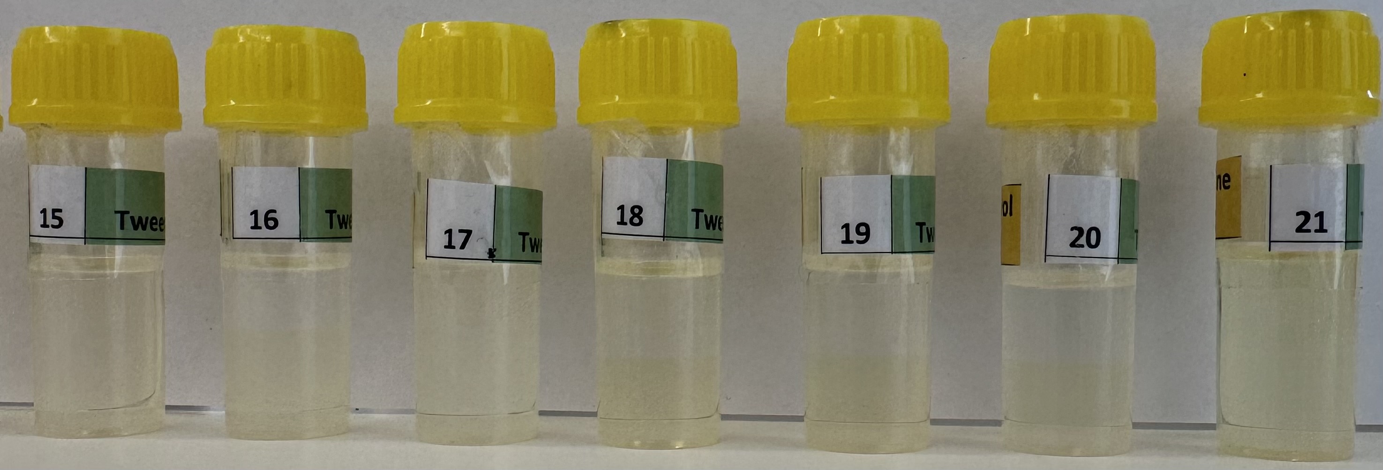
Day 0
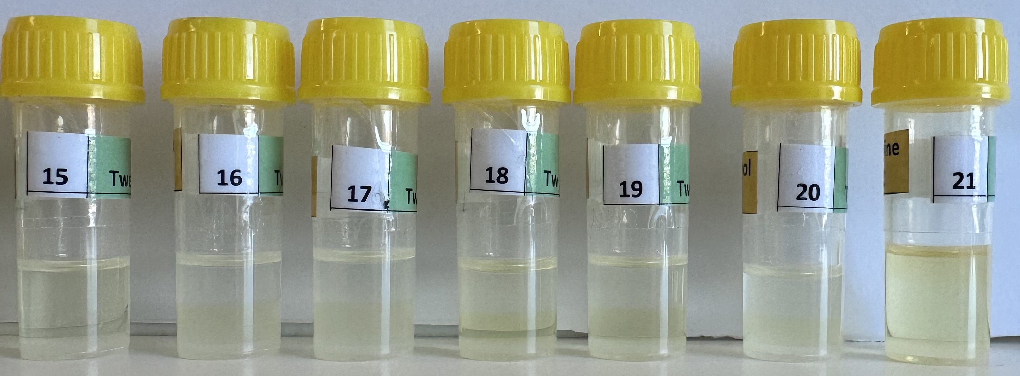
Day 14
Day 0
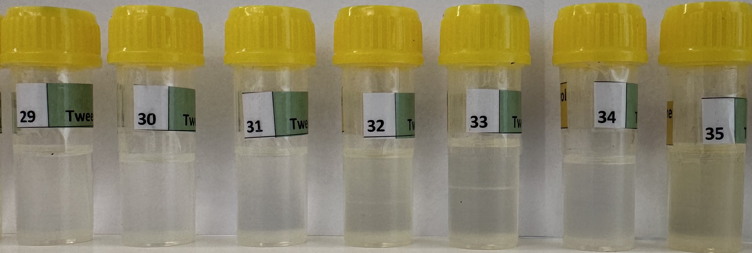
Day 0
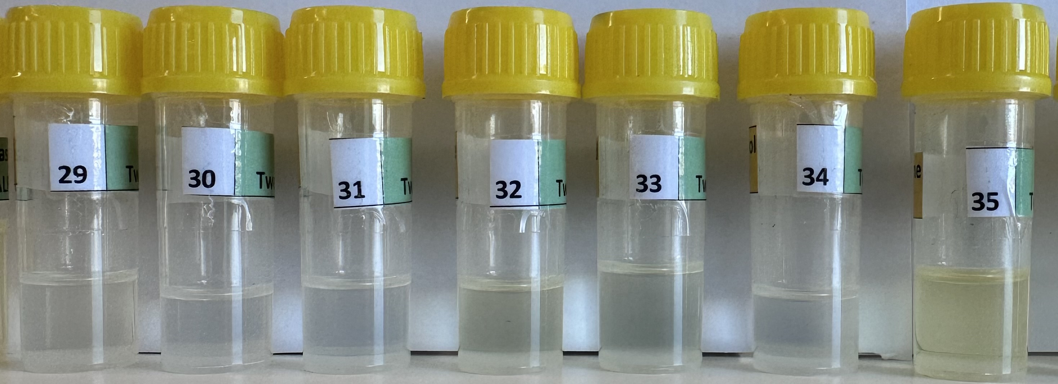
Day 14
Day 0

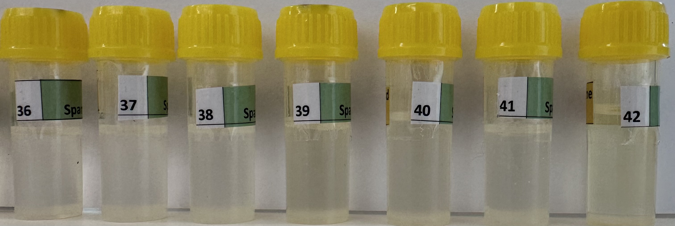
Day 0
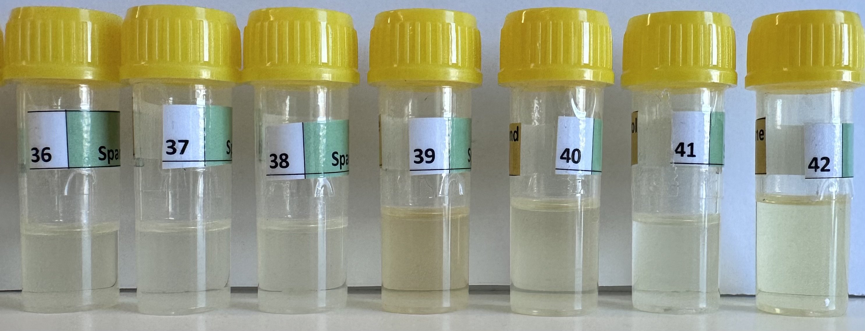
Day 14
Day 0
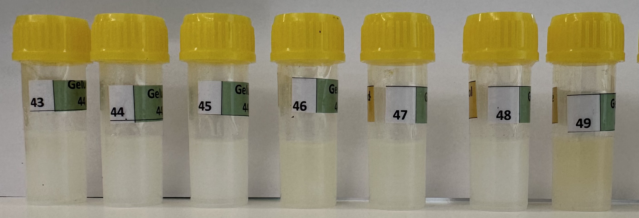
Day 0
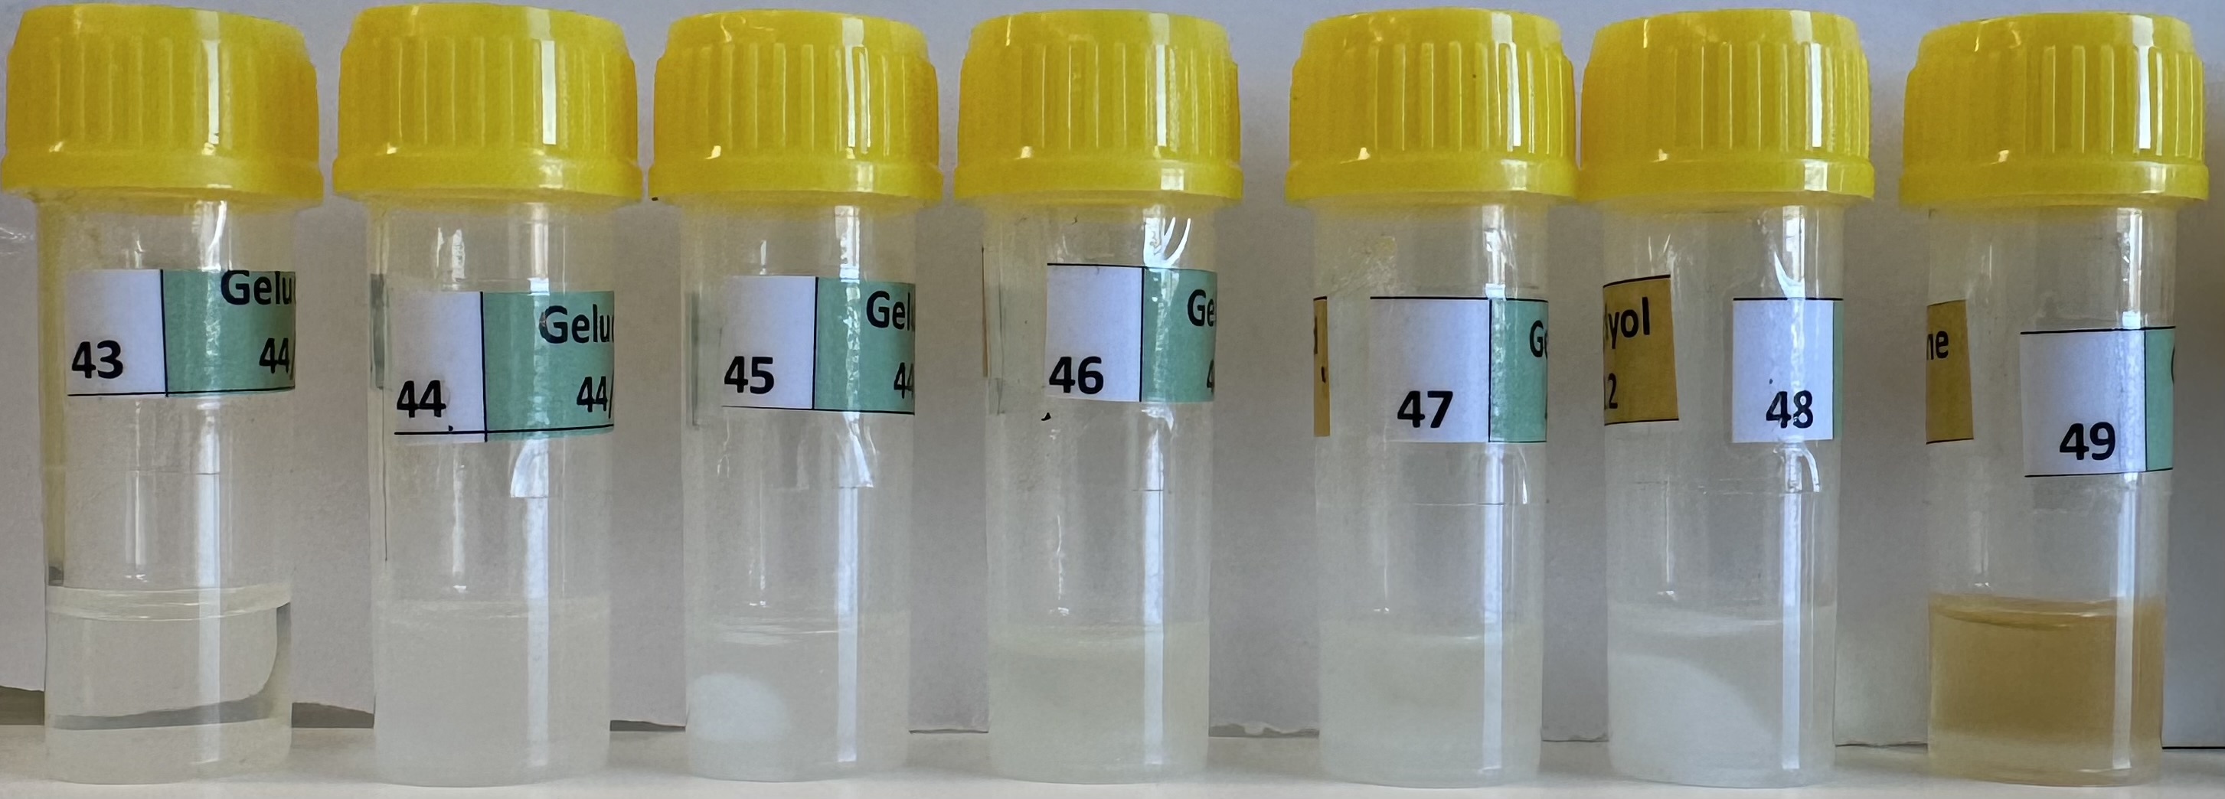
Day 14
Day 0

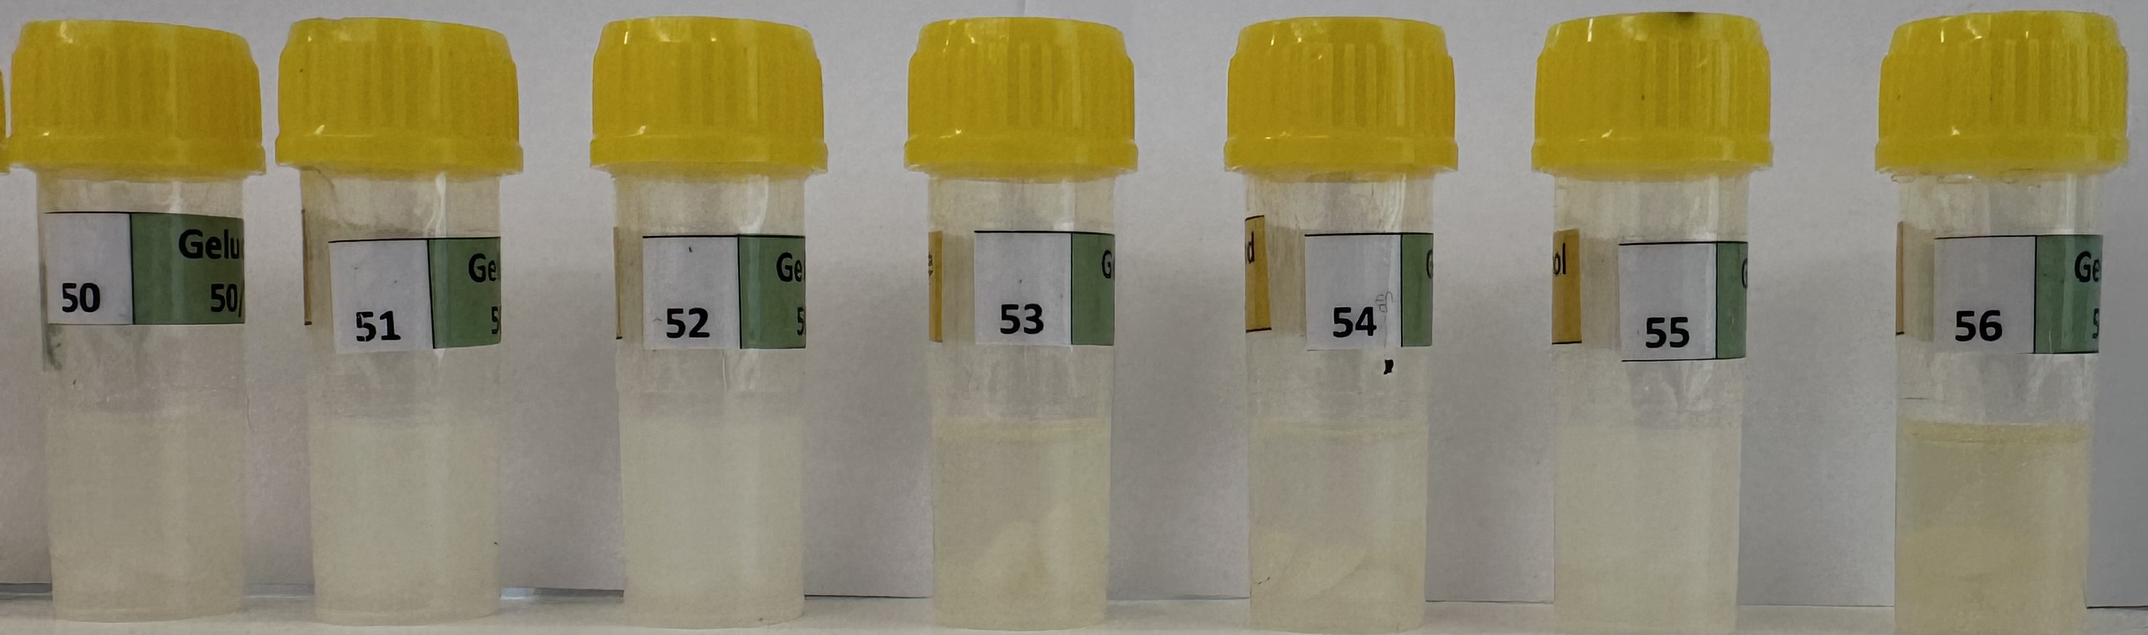
Day 14
Day 0
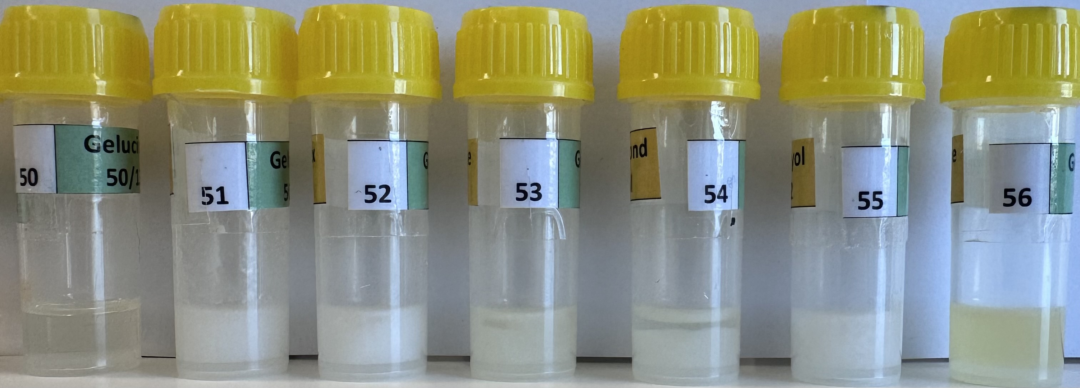
Supplementary Fig. 1 Visual Stability Assessment of 56 Initial SNEDDS Formulations at Day 0 and After 2 Weeks of Accelerated Storage at 60°C During Pre-DoE Screening for CBD-PLC-SNEDDS Optimization
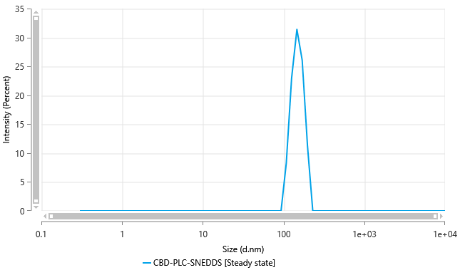

Supplementary Fig. 2 Representative Particle Size Distribution of Optimized CBD-PLC-SNEDDS

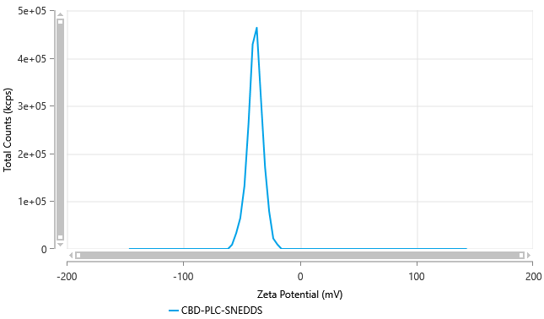

Supplementary Fig. 3 Zeta Potential Distribution of Optimized CBD-PLC-SNEDDS

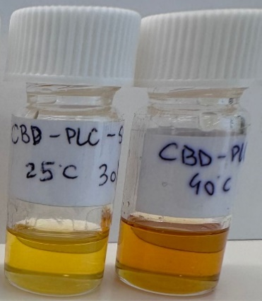

Supplementary Fig. 4 Visual Appearance of CBD-PLC-SNEDDS Formulations after 4 Months of Storage at 25°C/60% RH and 40°C/75% RH (ICH Q1A(R2) Conditions)

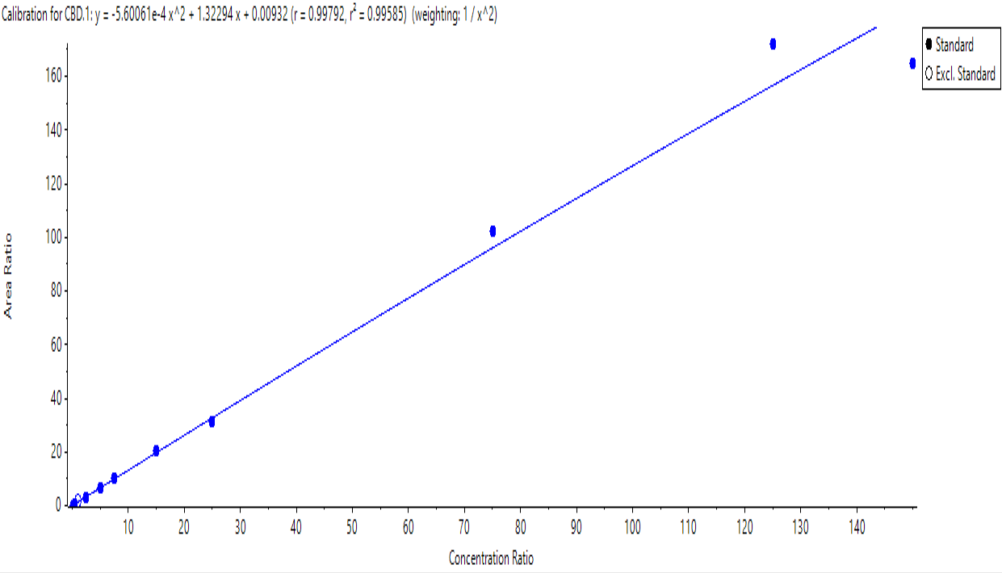

Supplementary Fig. 5 Quadratic Calibration Curve for CBD in Rat Plasma Using LC-MS/MS (1–1500 ng/mL), Fitted with Model y=−5.601×104x2+1.323x+0.0093 y = -5.601 \times 10⁴ x² + 1.323x + 0.0093 y=−5.601×104x2+1.323x+0.0093 (R² > 0.99)

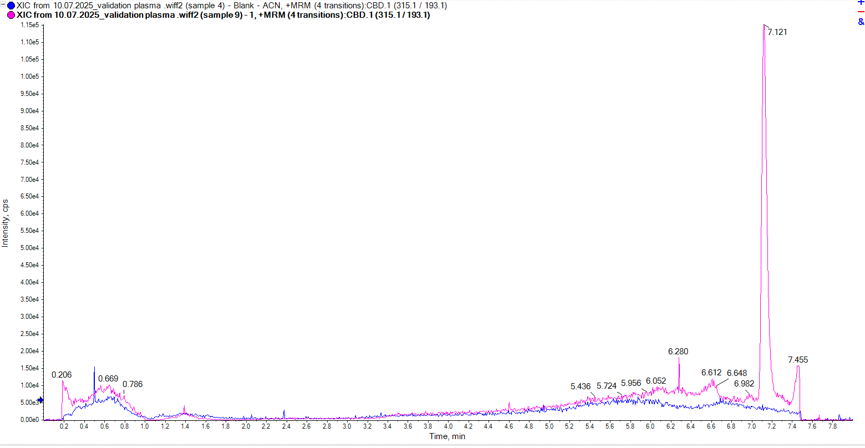
Supplementary Fig. 6 Representative MRM Chromatogram of Cannabidiol (CBD) at Limit of Detection (LOD = 1 ng/mL) in Rat Plasma Extract, Validating LC-MS/MS Method Sensitivity

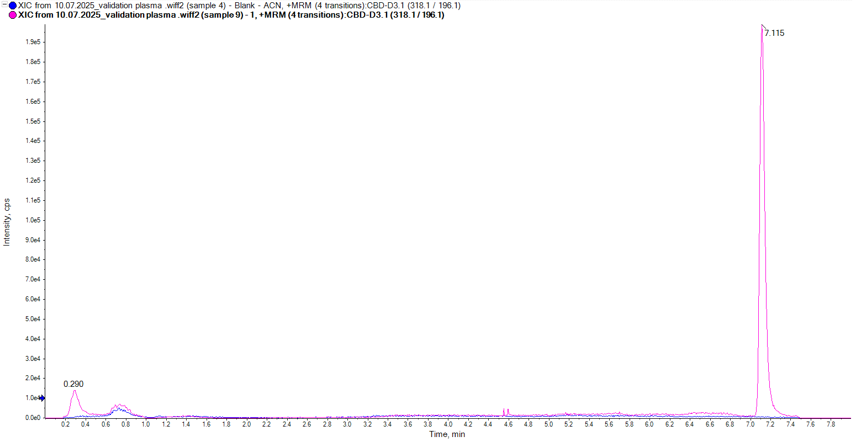
Supplementary Fig. 7 Representative MRM Chromatogram of Internal Standard (CBD-D₃) at LOD (1 ng/mL) in Blank Rat Plasma, Confirming Absence of Interference

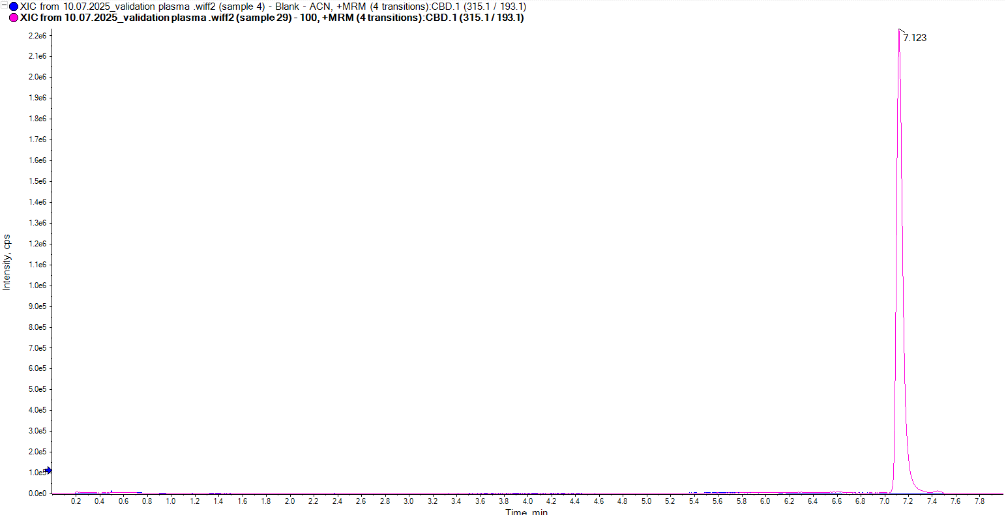
Supplementary Fig. 8 Representative MRM Chromatogram of Cannabidiol (CBD) at 100 ng/mL in Rat Plasma, Demonstrating Method Selectivity and Peak Resolution

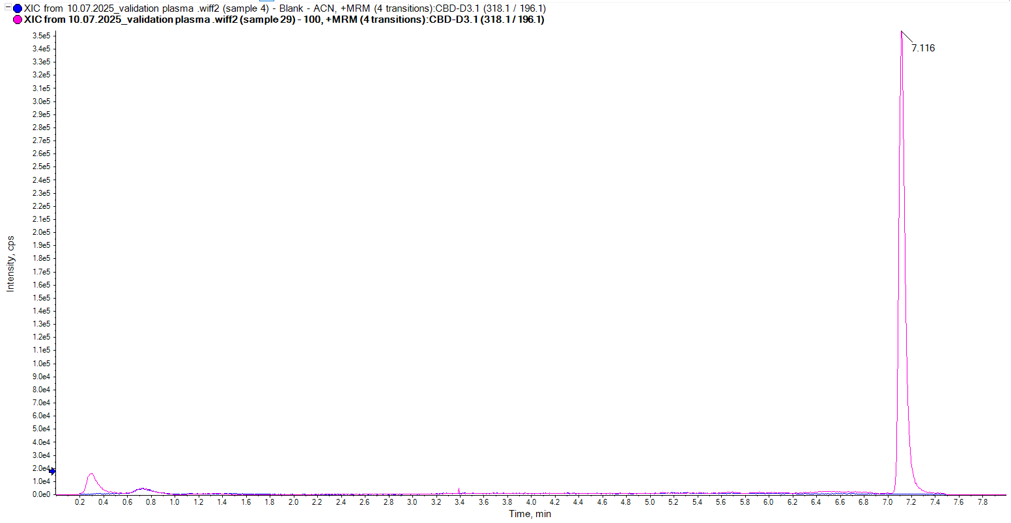

Supplementary Fig. 9 Representative MRM Chromatogram of Internal Standard (CBD-D₃) at 100 ng/mL in Blank Rat Plasma, Confirming Specificity and No Matrix Interference

