Appendix: Figures

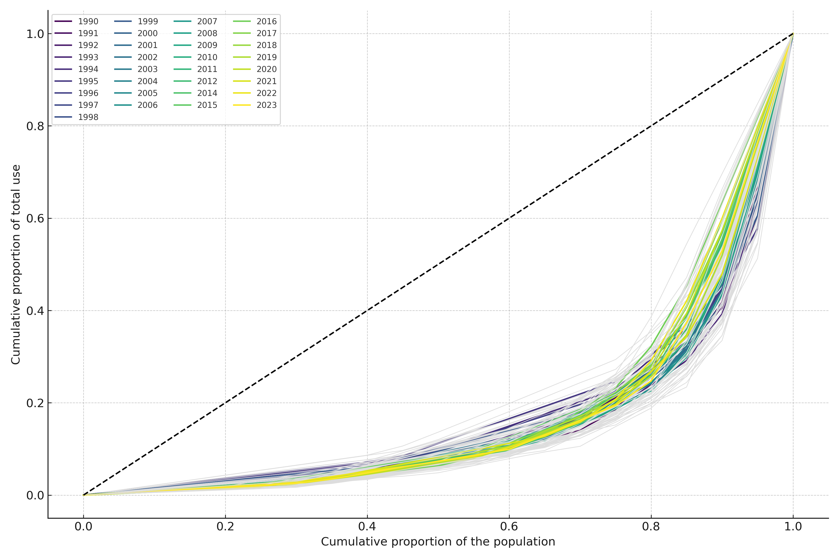
Figure 1. Lorenz curves with 95% confidence intervals for frequency of cannabis consumption. Based on annual data 1990-2023 (excluding 2013) for 9th-grade students.

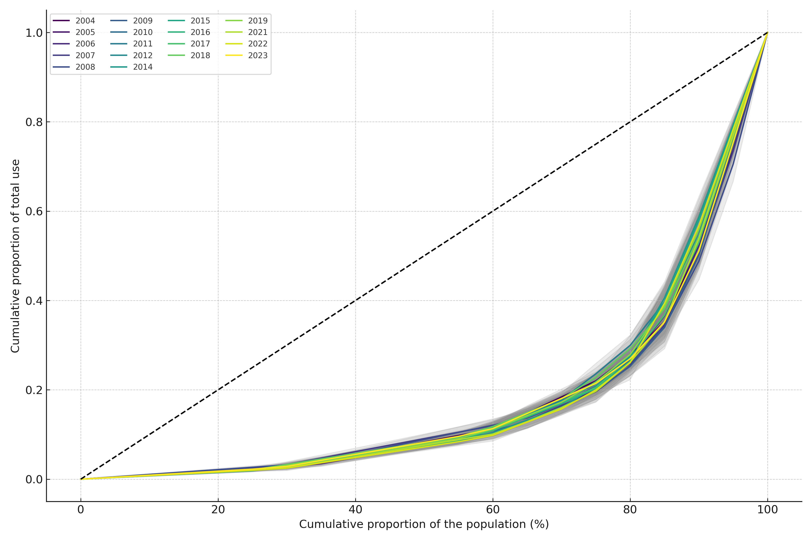
Figure 2. Lorenz curves with 95% confidence intervals for frequency of cannabis consumption. Based on annual data 2004-2023 (excluding 2013 and 2020) for 2nd-year high school students.

