In Vivo Evaluation of Synthetic Cannabinoid JWH-018 Derivatives as Potential New Psychoactive Substances

Salman Khan†, Minseo Baek†, Jeong-Hoon Jang*, and In-Soo Myeong*

College of Pharmacy, Daegu Catholic University, Gyeongsan, Gyeongbuk 38430, Republic of Korea

† Both authors contributed equally to this work.

Table of Content
Figure S1. ¹H NMR spectroscopic characterization of 1 | … SI-2
Figure S2. ¹³C NMR spectroscopic characterization of 1 | … SI-3
Figure S3. ¹H NMR spectroscopic characterization of 7 | … SI-4
Figure S4. ¹³C NMR spectroscopic characterization of 7 | … SI-5
Figure S5. ¹H NMR spectroscopic characterization of 4 | … SI-6
Figure S6. ¹³C NMR spectroscopic characterization of 4 | … SI-7
Figure S7. ¹H NMR spectroscopic characterization of 9 | … SI-8
Figure S8. ¹³C NMR spectroscopic characterization of 9 | … SI-9
Figure S9. ¹H NMR spectroscopic characterization of 5 | … SI-10
Figure S10. ¹³C NMR spectroscopic characterization of 5 | … SI-11
Figure S11. HPLC chromatogram of 1 | … SI-12
Figure S12. HPLC chromatogram of 4 | … SI-13
Figure S13. HPLC chromatogram of 5 | … SI-14

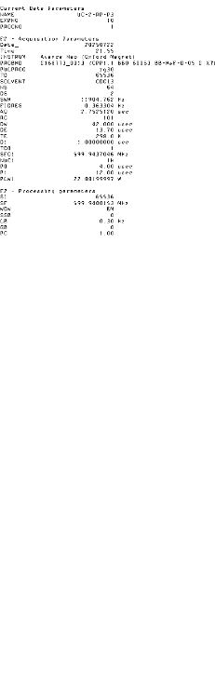
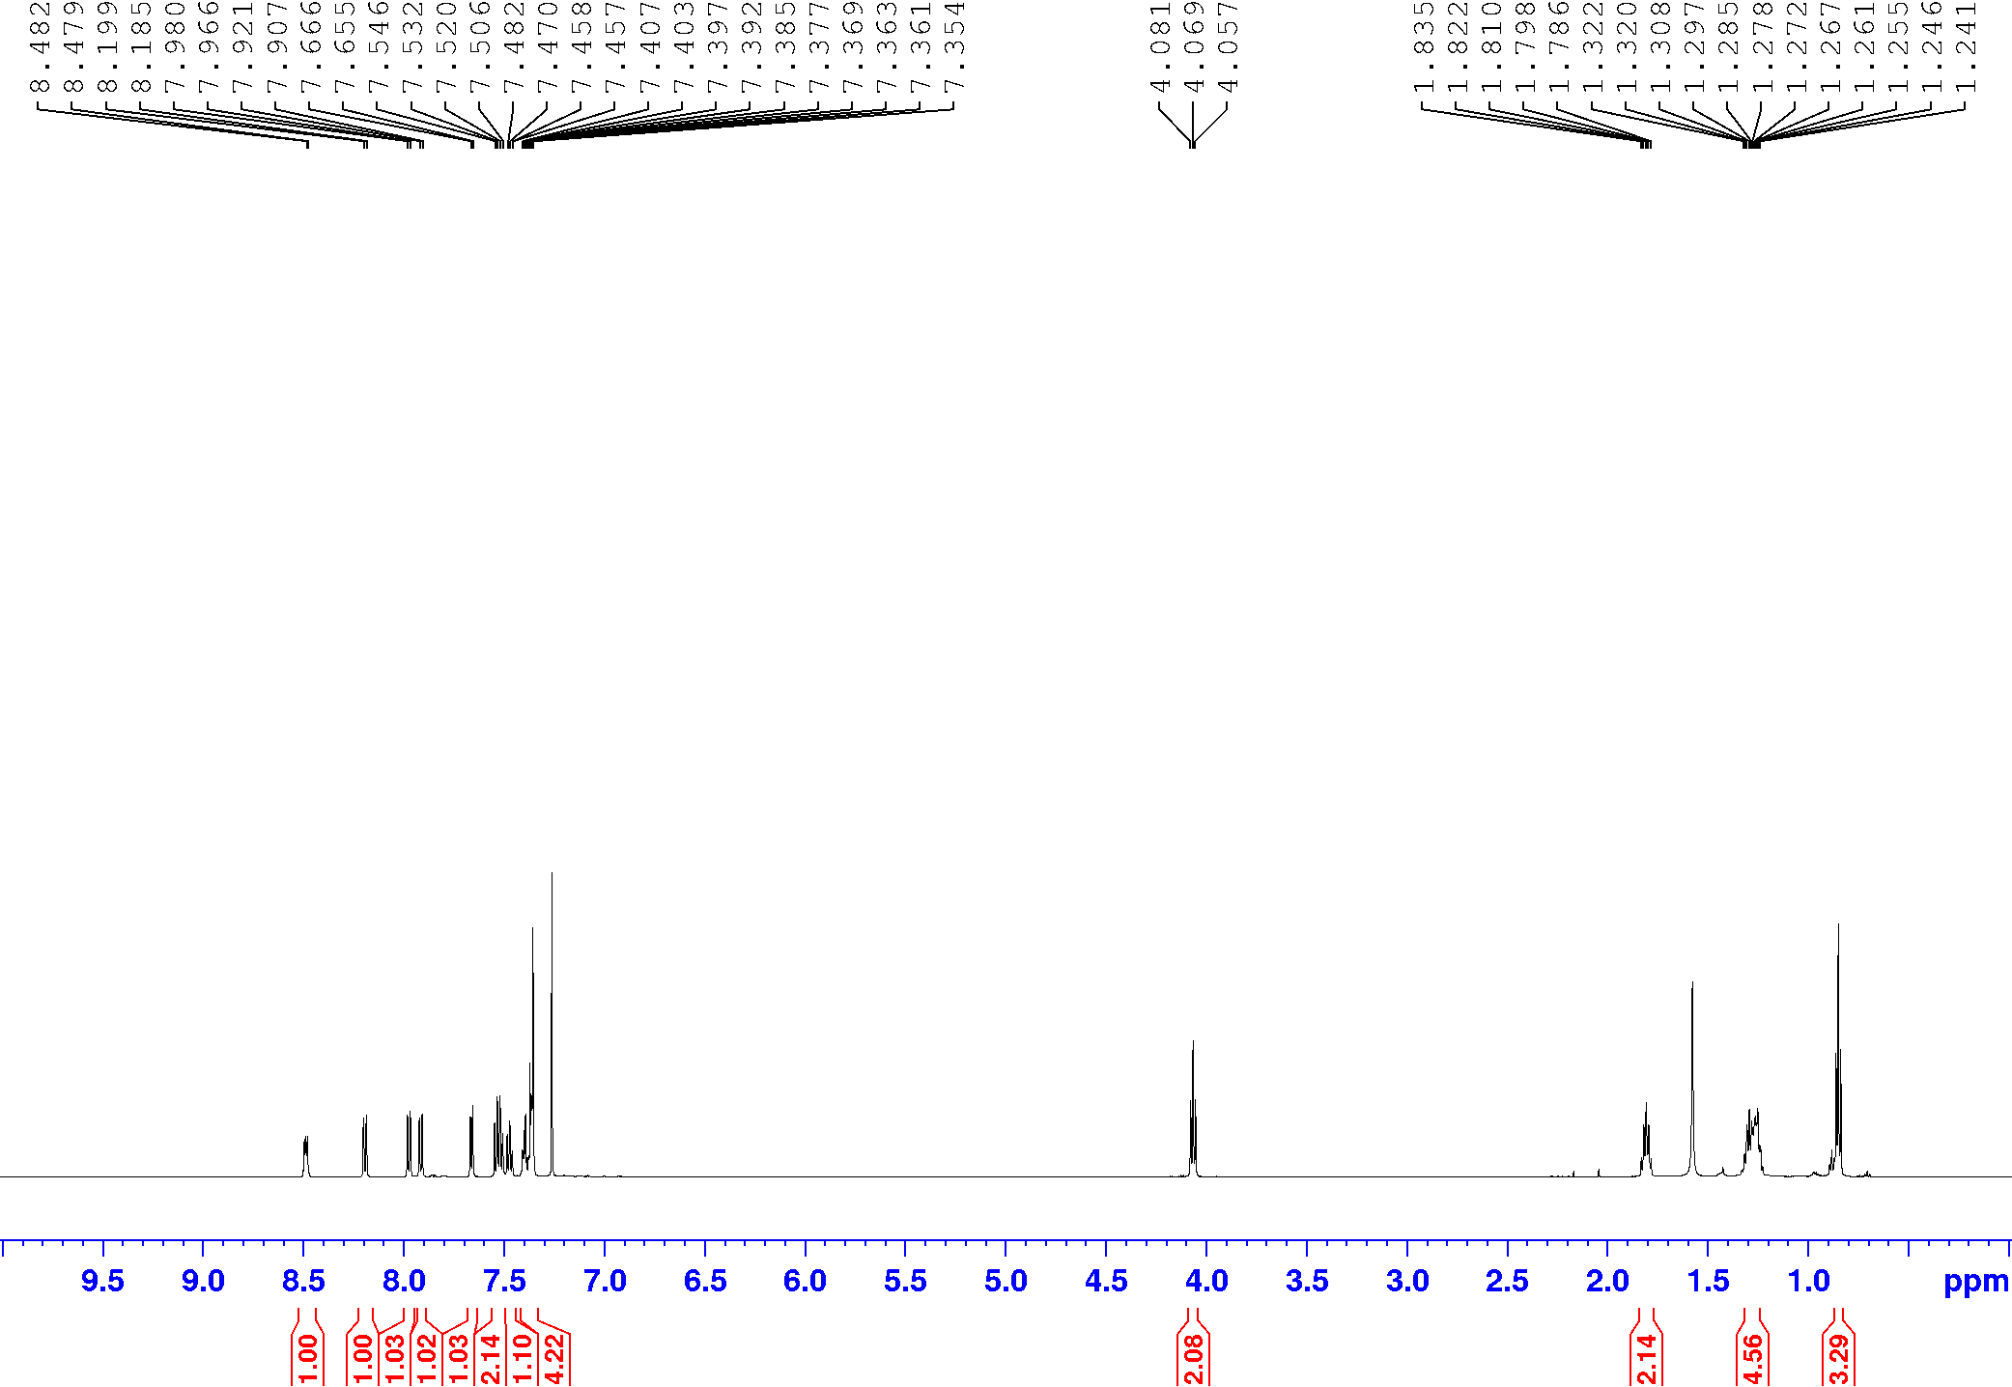
Figure S1. ¹H NMR of compound 1
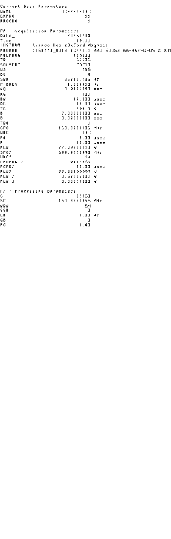
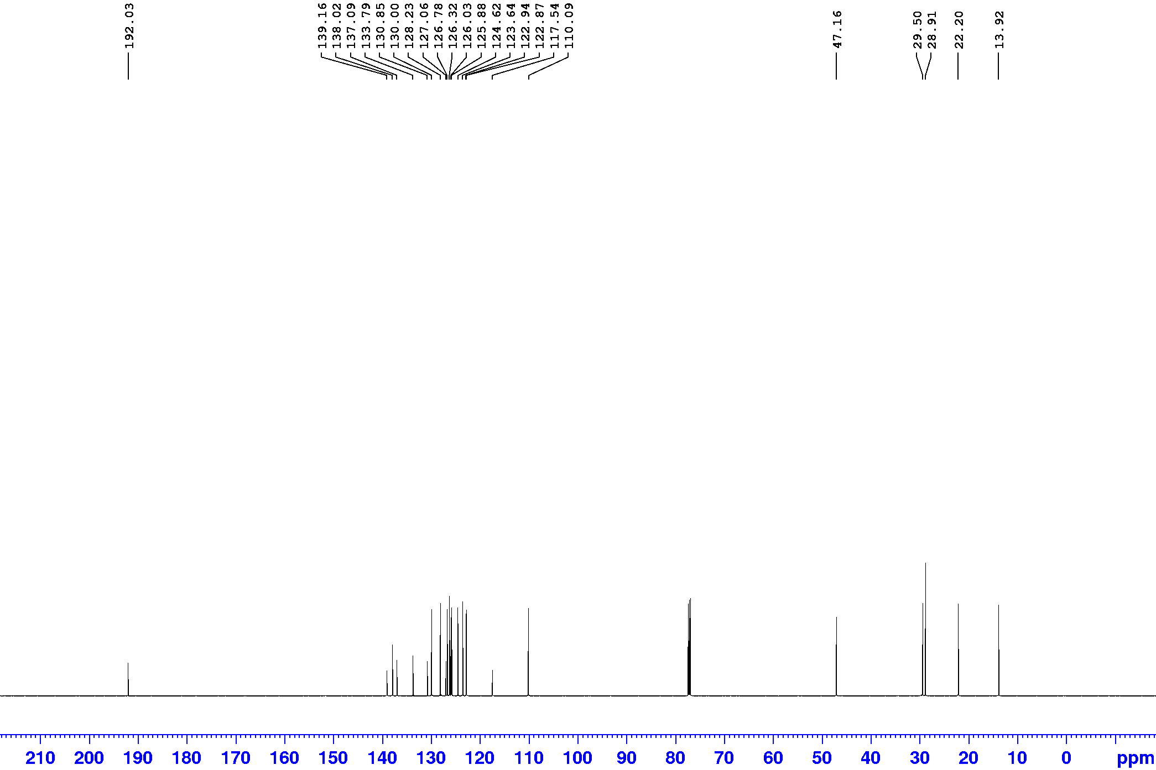
Figure S2. ¹³C NMR of compound 1
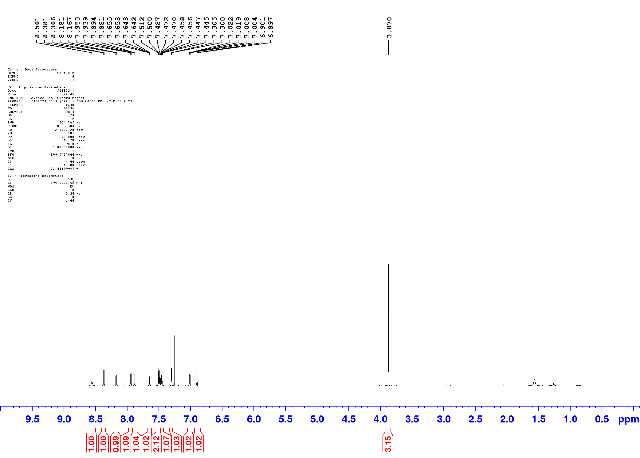
Figure S3. ¹H NMR of compound 7
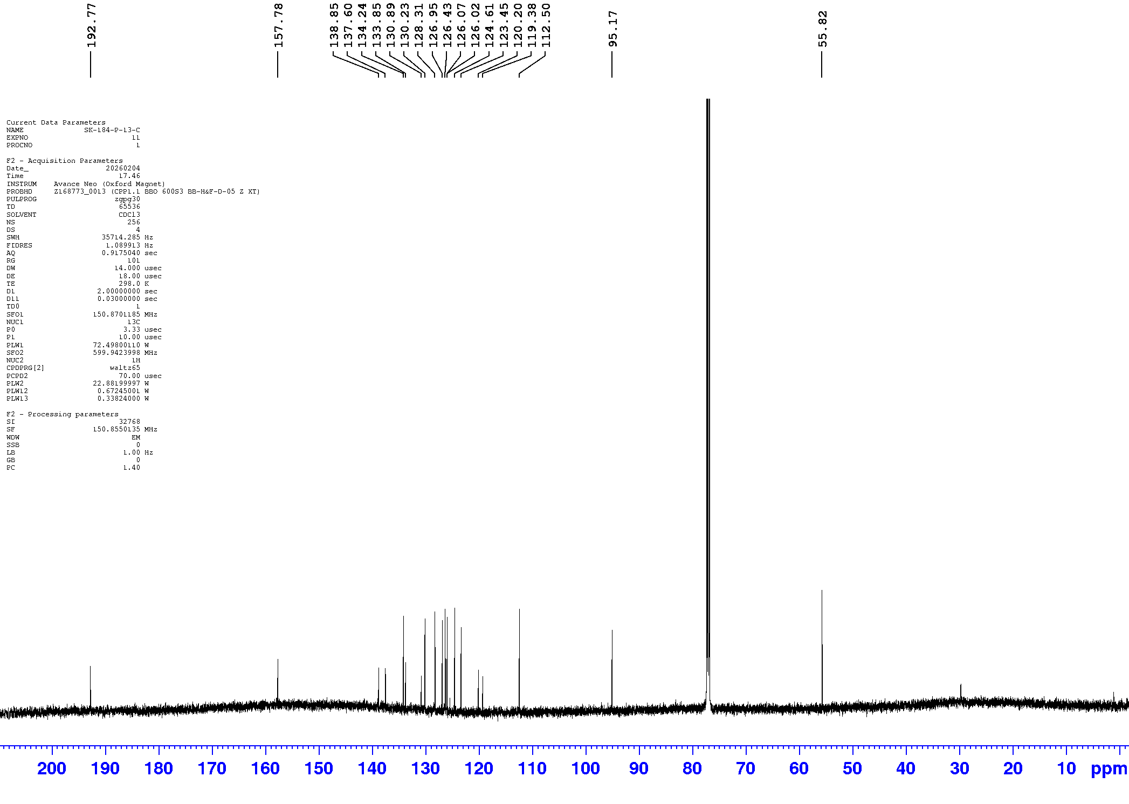
Figure S4. ¹³C NMR of compound 7
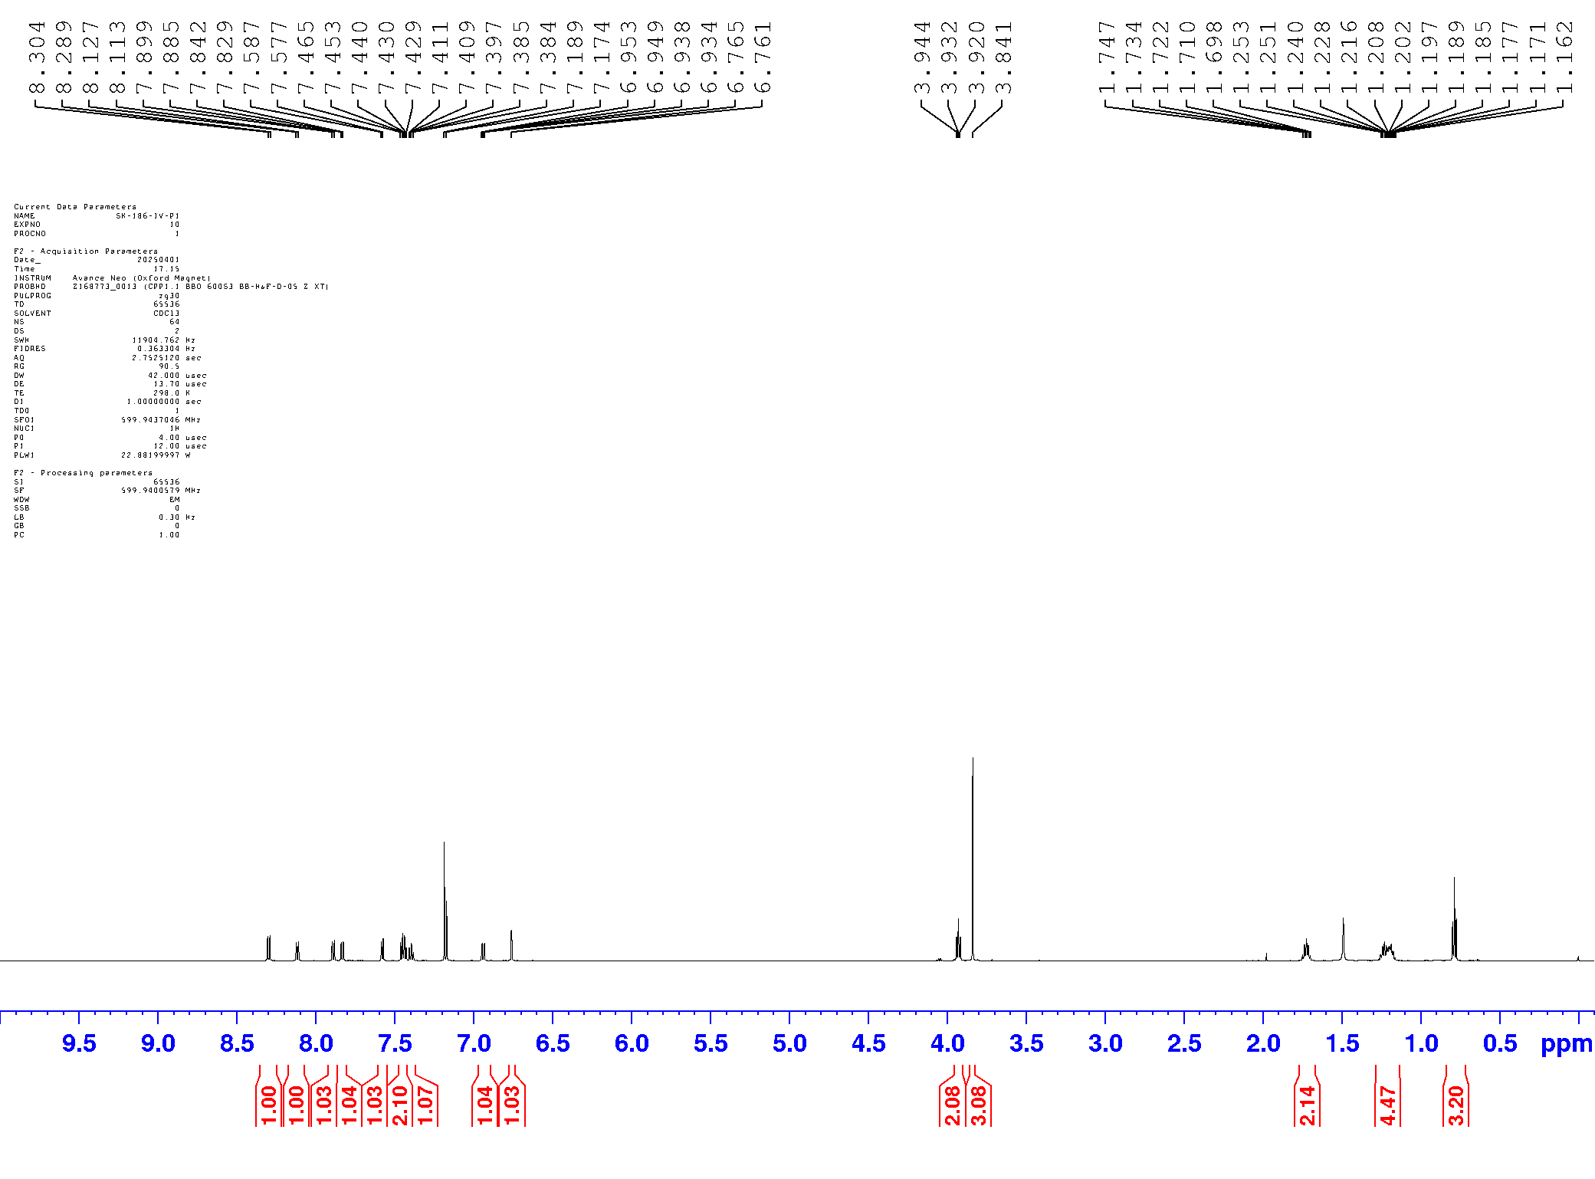
Figure S5. ¹H NMR of compound 4
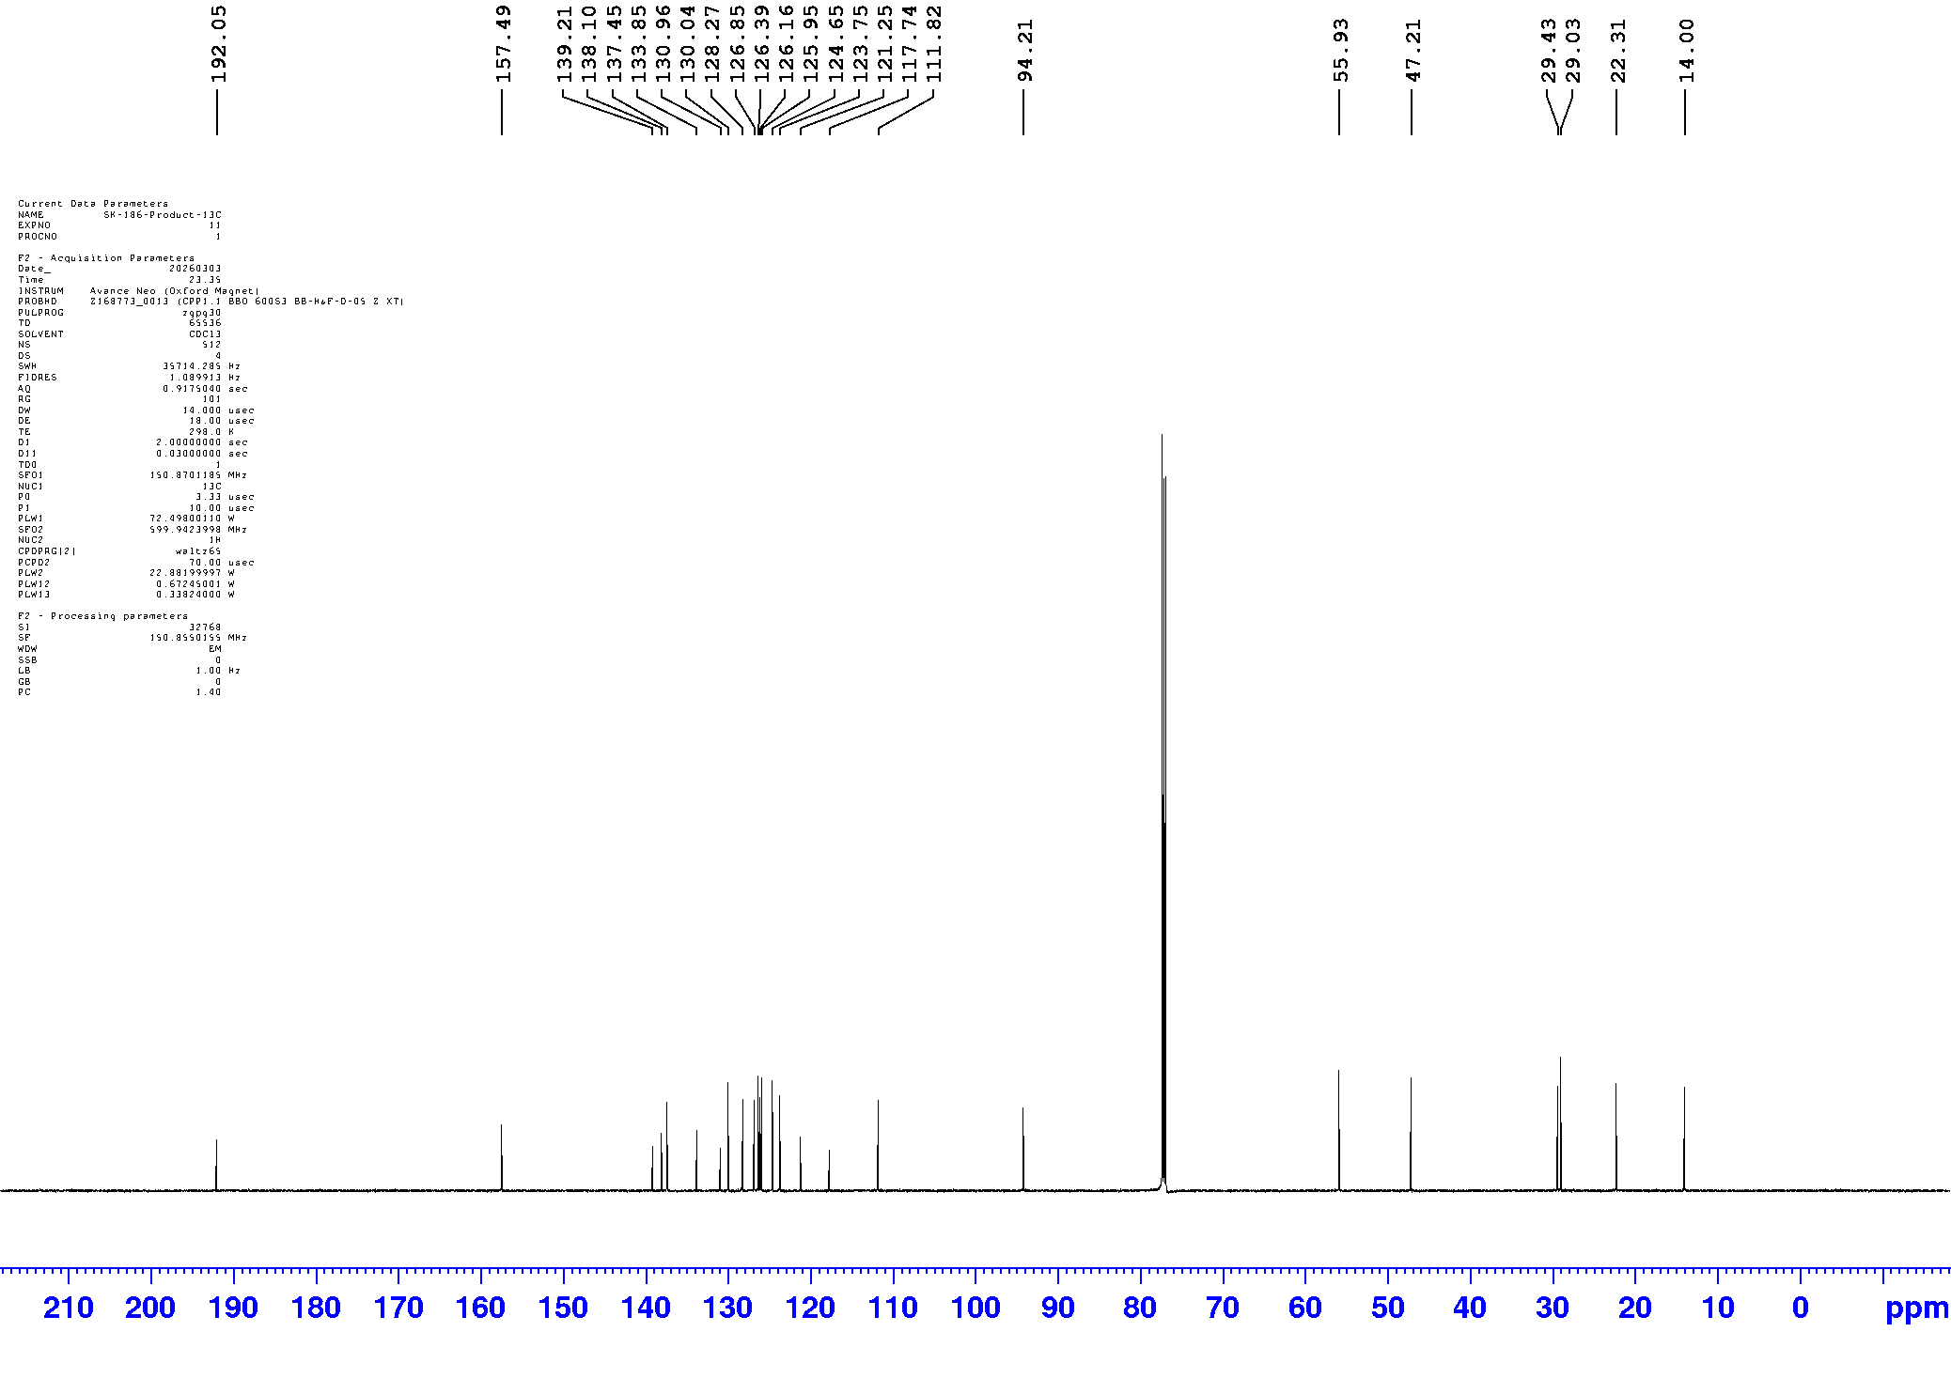
Figure S6. ¹³C NMR of compound 4
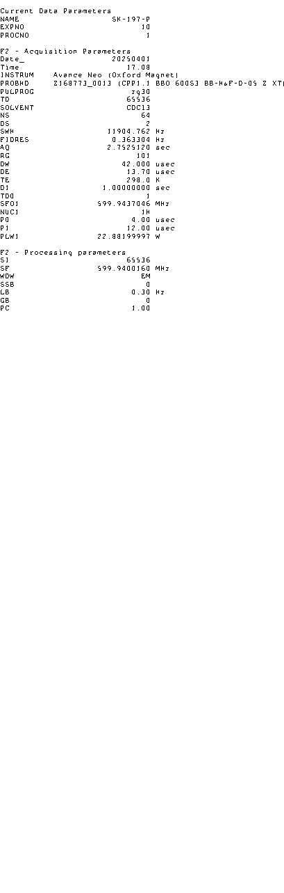
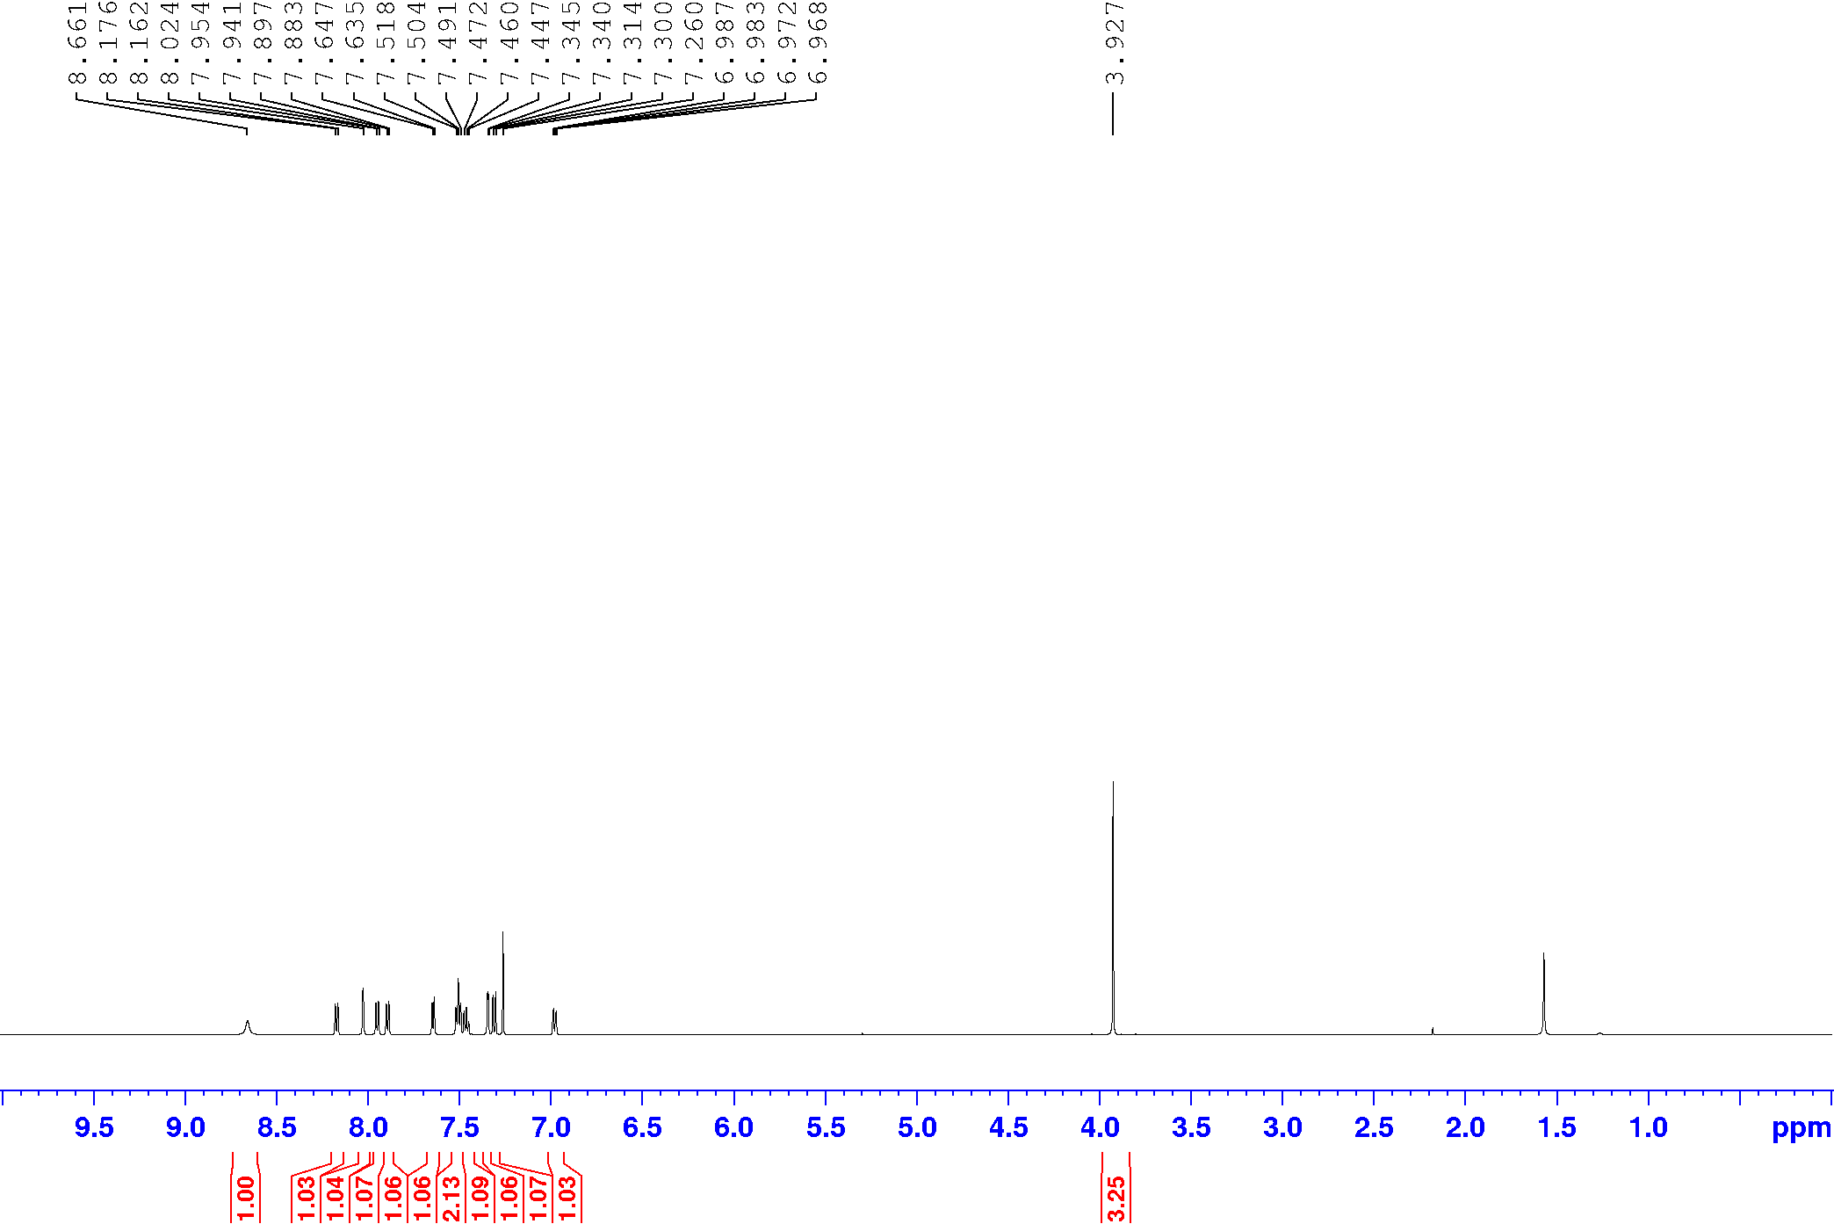
Figure S7. ¹H NMR of compound 9
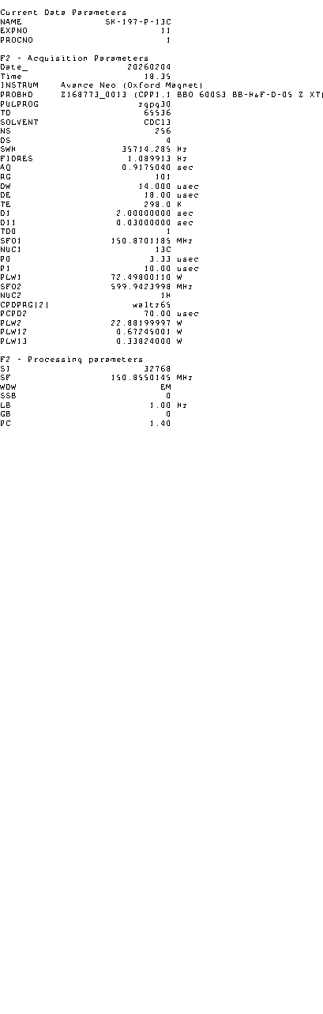
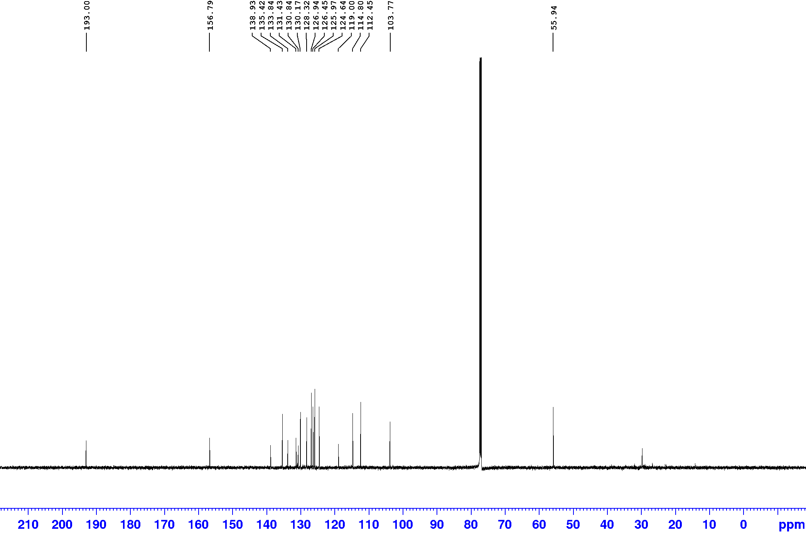
Figure S8. ¹³C NMR of compound 9
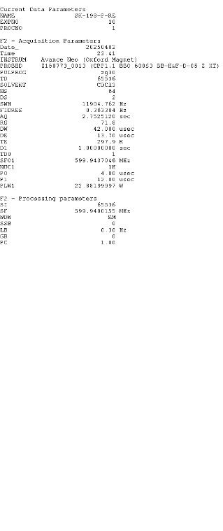
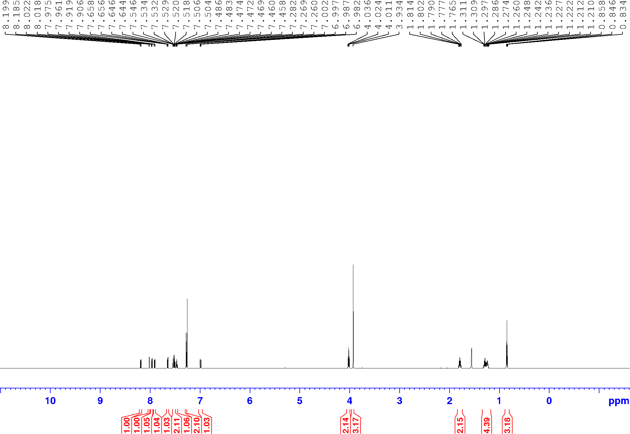
Figure S9. ¹H NMR of compound 5
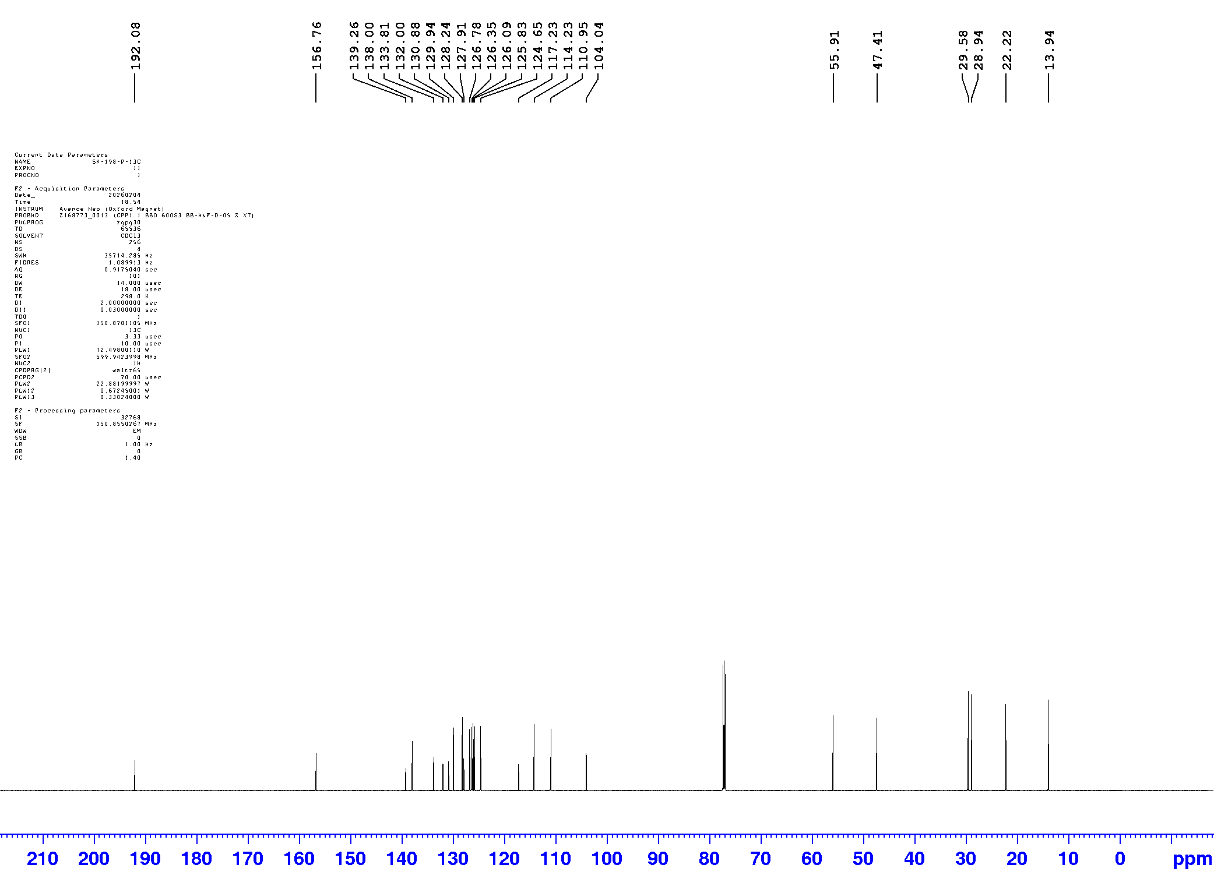
Figure S10. ¹³C NMR of compound 5

Figure S11. HPLC data for 1

Figure S12. HPLC data for 4

Figure S13. HPLC data for 5

