Figure S1 Mendelian randomization study investigating the causal association between DHRS3 (ENSG00000162496) expression and Malignant neoplasm of connective and soft tissue. A: Scatter plots showed the genetic associations of DHRS3 and Malignant neoplasm of connective and soft tissue. B: Detailed characteristics of SNPs. C: leave-one-out plots of DHRS3 and Malignant neoplasm of connective and soft tissue. D: Forest plots of SNPs associated with DHRS3 and Malignant neoplasm of connective and soft tissue.
Figure S2. Upregulated DHRS3 expression in HCC tissues with high tumor mutational burden (TMB) or microsatellite instability (MSI). (A) IHC analysis showed increased DHRS3 protein expression in HCC tissues compared with adjacent non-tumor tissues. (B) DHRS3 expression in TCGA-LIHC cohort (n=373) was positively correlated with patient age (left: DHRS3 expression differences between high/low age groups; right: Spearman correlation analysis). (C) Elevated DHRS3 expression in male HCC patients (TCGA-LIHC). (D) No association between DHRS3 expression and TNM staging in TCGA-LIHC cohort. (E-H) IHC validation in clinical HCC specimens confirmed DHRS3 upregulation in older patients (E), but no correlation with sex (F), TNM stage (G), or T stage (H). (I,J) DHRS3 expression in TCGA-LIHC cohort significantly correlated with MSI (I) and tumor TMB (J) (left: DHRS3 expression differences between high/low MSI/TMB groups; right: Spearman correlation analysis). One-way ANOVA test (B,C,E,F,I,J) or Kruskal-Wallis test (D,G,H) were used for statistical analysis..
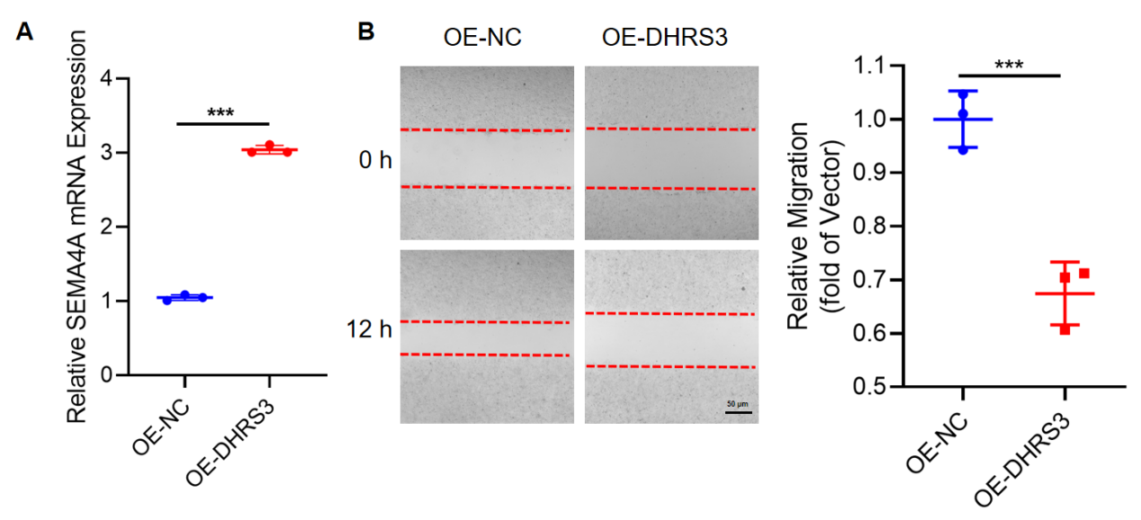
Figure S3. DHRS3 overexpression enhances SEMA4A expression and inhibits endothelial cell migration. (A) RT-qPCR analysis of SEMA4A mRNA levels in SK-HEP-1 cells after DHRS3 overexpression (n=3). (B) Wound healing assay quantifying migration capacity of DHRS3-overexpressing SK-HEP-1 cells (n=3). All experiments were repeated three times. The data are presented as mean ± SD values. Student's t-tests was used for statistical analysis. ***p < 0.001.
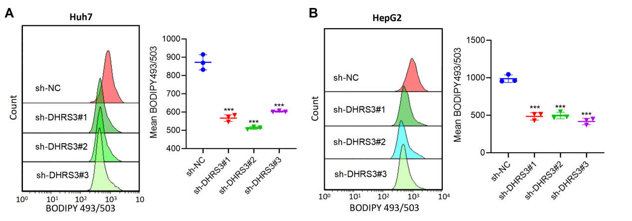
Figure S4. DHRS3 knockdown reduces lipid droplet content in HCC lines. (A, B) BODIPY staining was used to detect the lipid droplet content in HCC lines Huh-7 (A) and HepG2 (B) upon DHRS3 knockdown (n=3).The data are presented as mean ± SD values. Unpaired t-tests was used for statistical analysis. ***p < 0.001.

Table S1 The specific clinical characteristics of the patients
Characteristics
Sex (No. (%))
Female | 12(15)
Male | 68(85)
Age (mean (SD)) | 54.28 (11.18)
pT Stage (No. (%)) a
T1 | 5(6.25)
T2 | 26(32.5)
T3 | 32(40)
T4 | 17(21.25)
pN Stage (No. (%))b
N0 | 77(96.25)
N1 | 2(2.5)
N2 | 1(1.25)
pM Stage (No. (%))c
M0 | 77(96.25)
M1 | 3(3.75)
pTNM Stage (No. (%))d
I/II | 55(68.75)
III/IV | 25(31.25)
Follow-up Duration (mean (SD)) | 27.51 (18.73)
（^{a-d} According to the American Joint Committee on Cancer/Union for International Cancer Control 8th staging system.）;

