Supplementary Figure 1. Calibration Curve for Rosmarinic Acid

Supplementary Figure 2. Calibration Curve for p-Coumaric Acid

Supplementary Figure 3. Calibration Curve for Luteoilin

Supplementary Figure 4. Calibration Curve for Quercetin

Supplementary Figure 5. Calibration Curve for Eriodictyol

Supplementary Figure 6. Calibration Curve for Hydroxybenzoic Acid

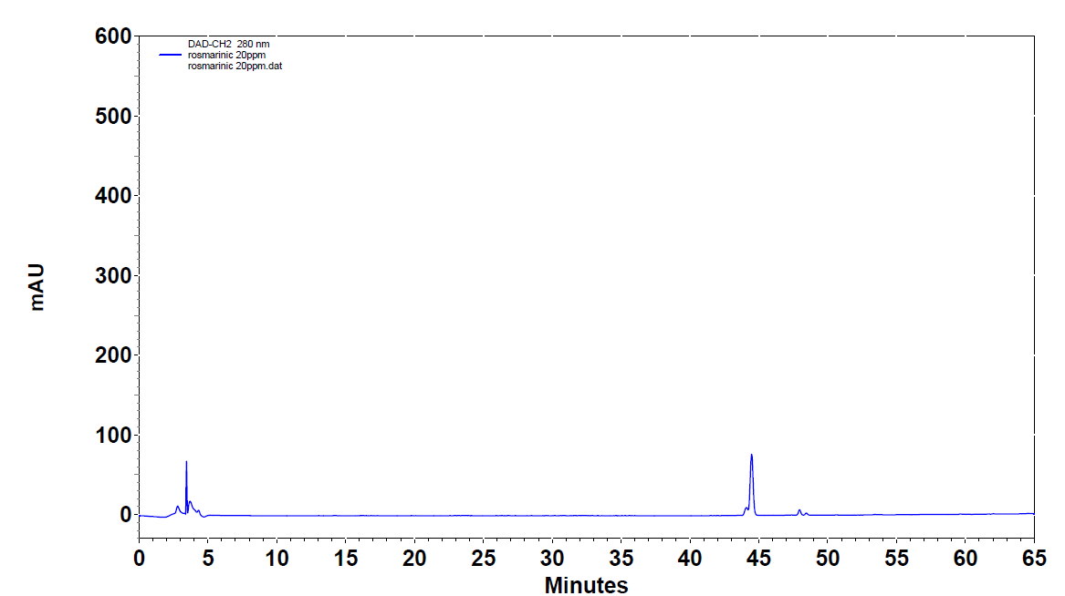
Supplementary Figure 7. Representative chromatogram for Rosmarinic Acid
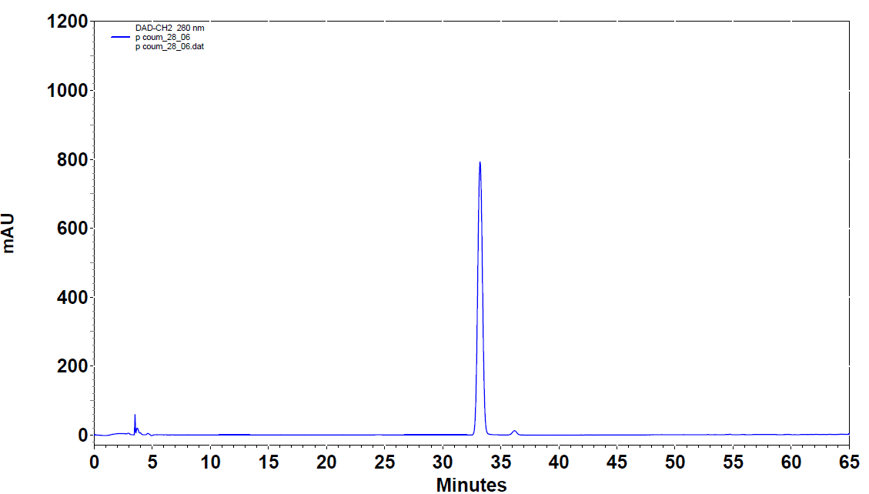
Supplementary Figure 8. Representative chromatogram for p-Coumaric Acid

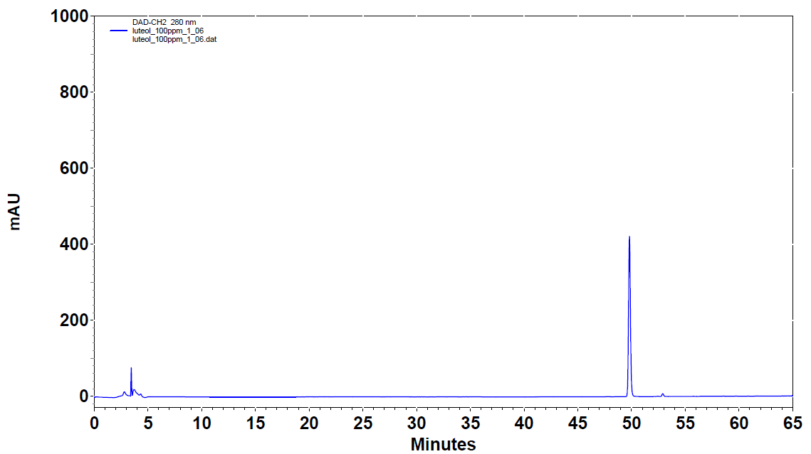
Supplementary Figure 9. Representative chromatogram for Luteolin

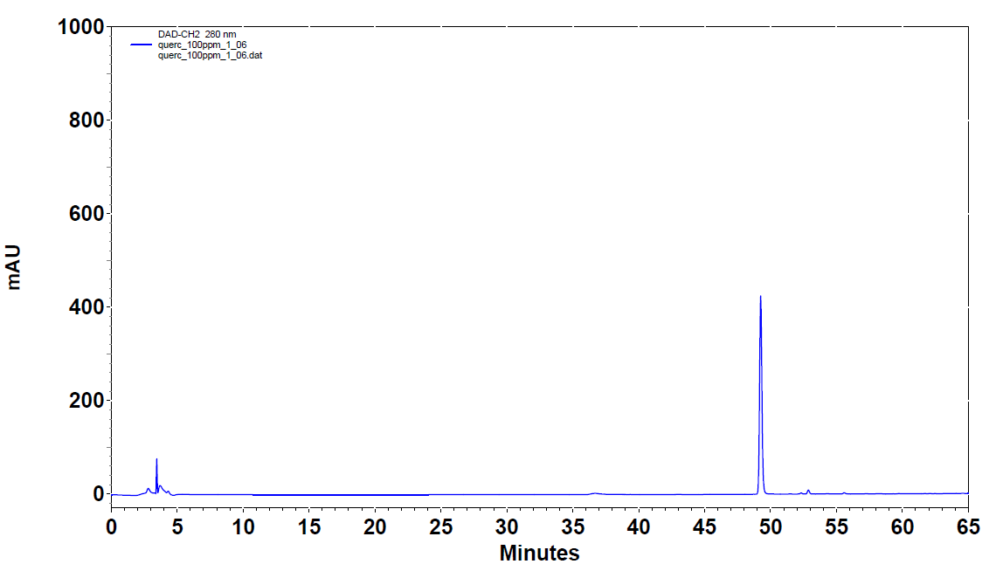
Supplementary Figure 10. Representative chromatogram for Quercetin

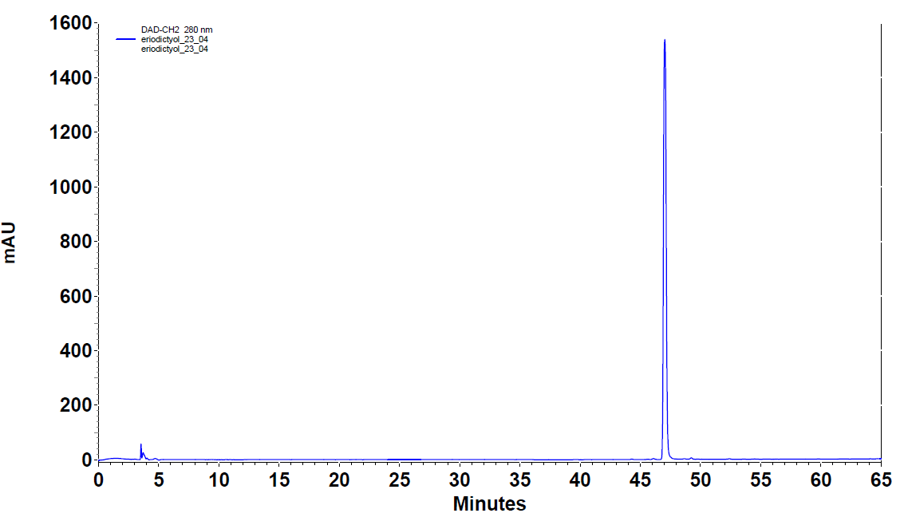
Supplementary Figure 11. Representative chromatogram for Eriodictyol

Supplementary Table 1. Standard compounds, their retention time, calibration curves, maxima wavelengths in ultraviolet region
 | Standard compounds | Retention time (min) | Calibration Curve | Regression Coefficient (R²) | Maxima wavelengths (nm)
A. | Rosmarinic acid | 44.50 | y=342476x-1E+06 | 0.9948 | 206,245,330
B. | Coumaric acid | 33.50 | y=1E+06x-268063 | 0.9962 | 216,309,395
C. | Luteolin | 49.80 | y=201134x+343231 | 0.9961 | 256,263,349
D. | Quercetin | 49.24 | y=208457x+441912 | 0.9992 | 230,256,370
E. | Eriodictyol | 46.96 | y=462783x+901504 | 0.9993 | 205,230,288
F. | Hydroxybenzoic acid | 19.29 | y=216500x-261891 | 0.9962 | 210,260,388
G. | Naringenin | 50.11 | y=392749x+600702 | 0.998 | 235,289
H. | Thymol | 57.99 | y=140232x+563914 | 0.9953 | 215,276,345
I. | Carvacrol | 57.65 | y=96580x+159301 | 0.9987 | 221,275
J. | Kaempferol | 52.03 | y=265195x-28475 | 0.998 | 250,315
K. | Apigenin | 52.21 | y=407824x+599220 | 0.9992 | 267,338
L. | Apigenin-7-glucoside | 43.20 | y=475911x-3E+06x | 0.9918 | 206,267,337
M. | Rutin | 40.63 | y=101038x+244152 | 0.9948 | 258,356
N. | Vanillic acid | 22.55 | y=280308x+1E+06 | 0.9972 | 208,265,292
O. | Ferulic acid | 36.77 | y=361100x+667162 | 0.9984 | 210,322
P. | Caffeic acid | 24.57 | y=460642x-243764 | 0.9934 | 209,240,323
Q. | Benzoic acid | 42.23 | y=56565x+111379 | 0.9969 | 273,370

