Supplementary Information

Fungicidal Activity and In silico Studies of Triazoles Derived From Glycerol Against Neocosmospora falciformis, a Causal Agent of Guava Tree Decline

Adilson Vidal Costa,^{1*} Arêssa de Oliveira Correia,² Breno Benvindo dos Anjos,² Mariana Belizario de Oliveira,¹ Poliana Aparecida Rodrigues Gazolla,¹ Vagner Tebaldi de Queiroz,¹ Juliana Alves Resende,³ Róbson Ricardo Teixeira,^{4*} Osmair Vital de Oliveira,⁵ Gabriel Jacomin Vargas,⁴ Waldir Cintra de Jesus Júnior,⁶ Willian Bucker Moraes,² and Fábio Ramos Alves²

¹Department of Chemistry and Physics, Federal University of Espírito Santo, Alegre, Espírito Santo, Brazil.
²Department of Agronomy, Federal University of Espírito Santo, Alegre, Espírito Santo, Brazil.
³Department of Pharmacy and Nutrition, Federal University of Espírito Santo, Alegre, Espírito Santo, Brazil.
⁴Department of Chemistry, Federal University of Viçosa, Viçosa, Minas Gerais, Brazil.
⁵Federal Institute of São Paulo, Catanduva Campus, Catanduva, São Paulo, Brazil.
⁶Federal University of São Carlos, Lagoa do Sino Campus, Buri, São Paulo, Brazil.

*Corresponding authors: e-mail: avcosta@hotmail.com; robsonr.teixeira@ufv.br

1. IR, NMR (¹H AND ¹³C), AND MS SPECTRA

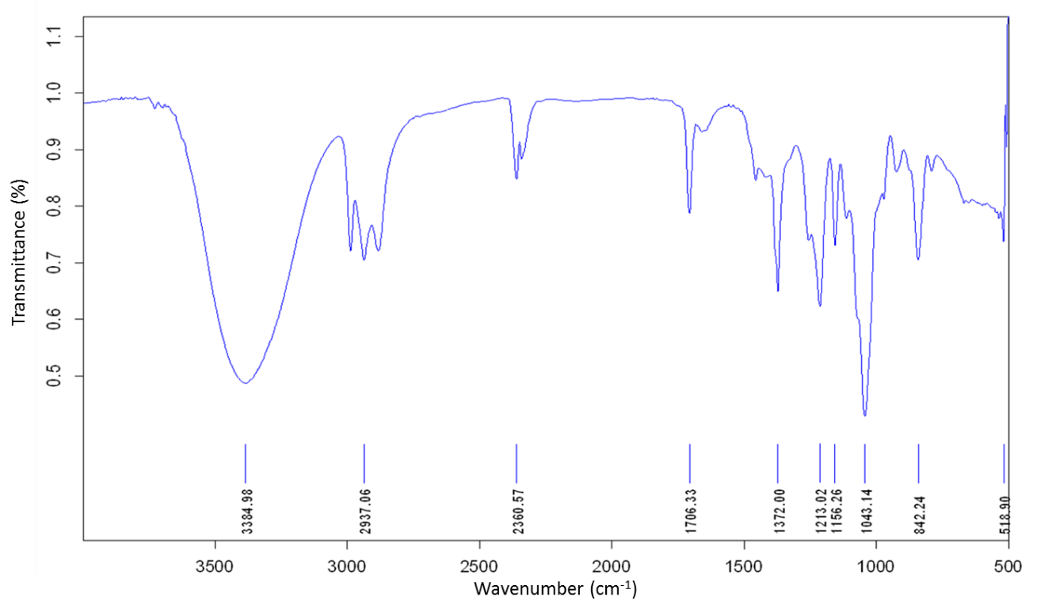
Figure S1. IR spectrum of (2,2-dimethyl-1,3-dioxolan-4-yl)methanol (1).

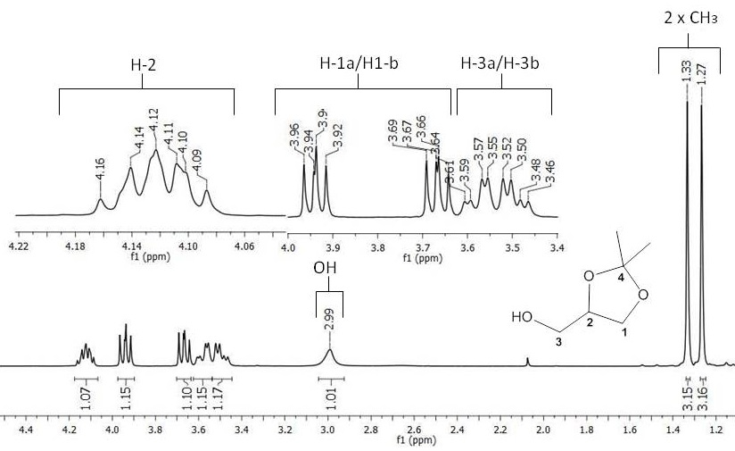
Figure S2. ¹H NMR spectrum (300 MHz, CDCl₃) of (2,2-dimethyl-1,3-dioxolan-4-yl)methanol (1).
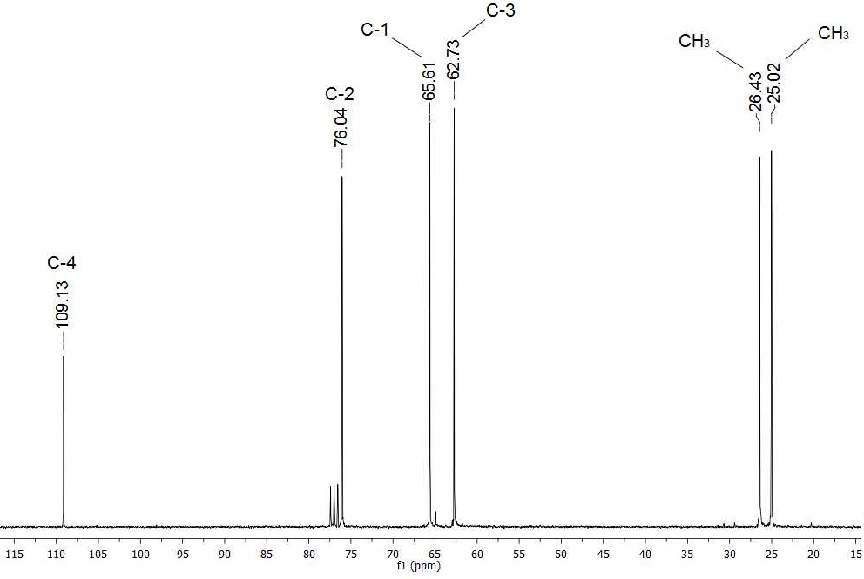
Figure S3. ¹³C NMR spectrum (75 MHz, CDCl₃) of (2,2-dimethyl-1,3-dioxolan-4-yl)methanol (1).

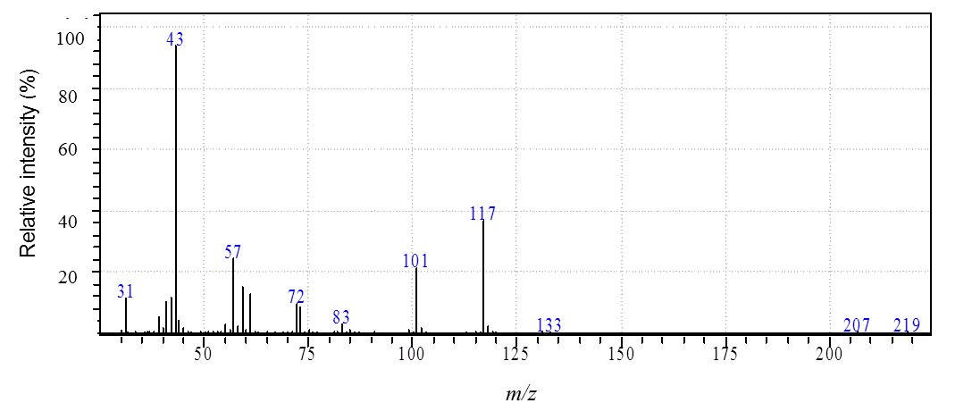
Figure S4. MS spectrum of (2,2-dimethyl-1,3-dioxolan-4-yl)methanol (1).

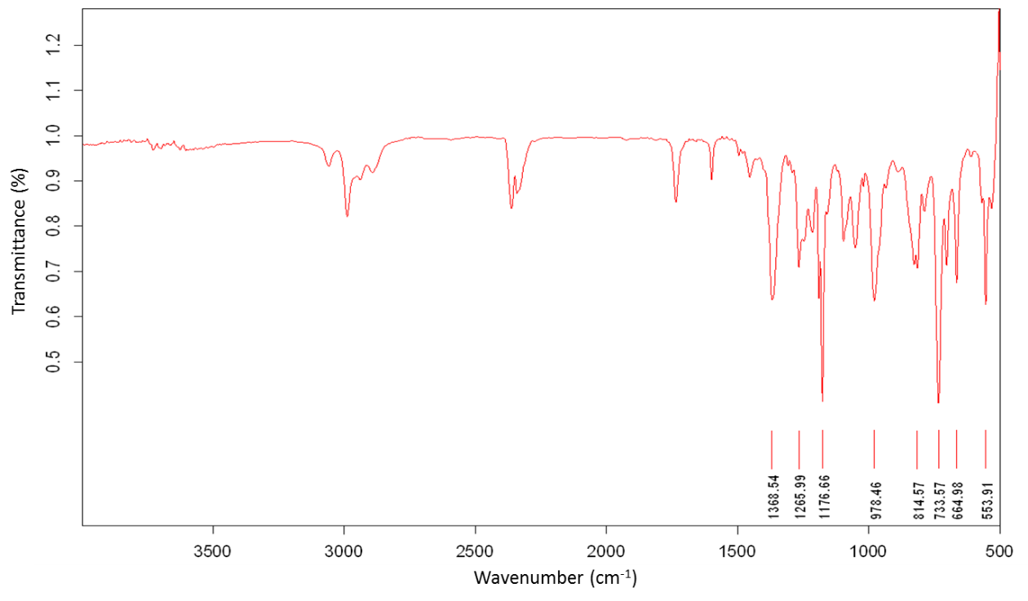
Figure S5. IR spectrum of (2,2-dimethyl-1,3-dioxolan-4-yl)methyl-4-methylbenzenesulfonate (2).

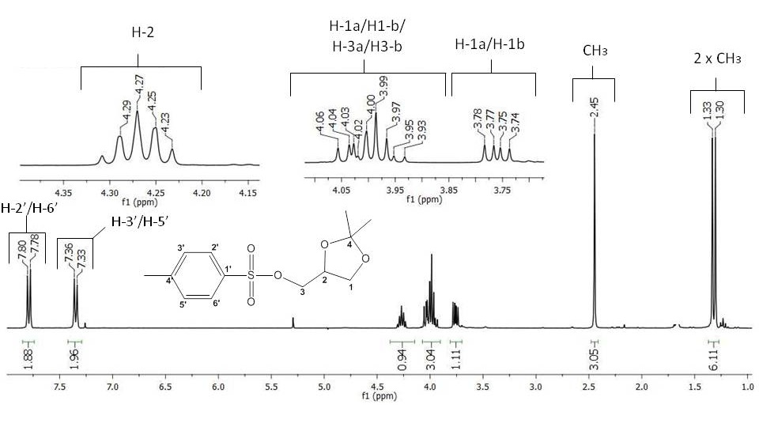
Figure S6. ¹H NMR spectrum (300 MHz, CDCl₃) of (2,2-dimethyl-1,3-dioxolan-4-yl)methyl-4-methylbenzenesulfonate (2).

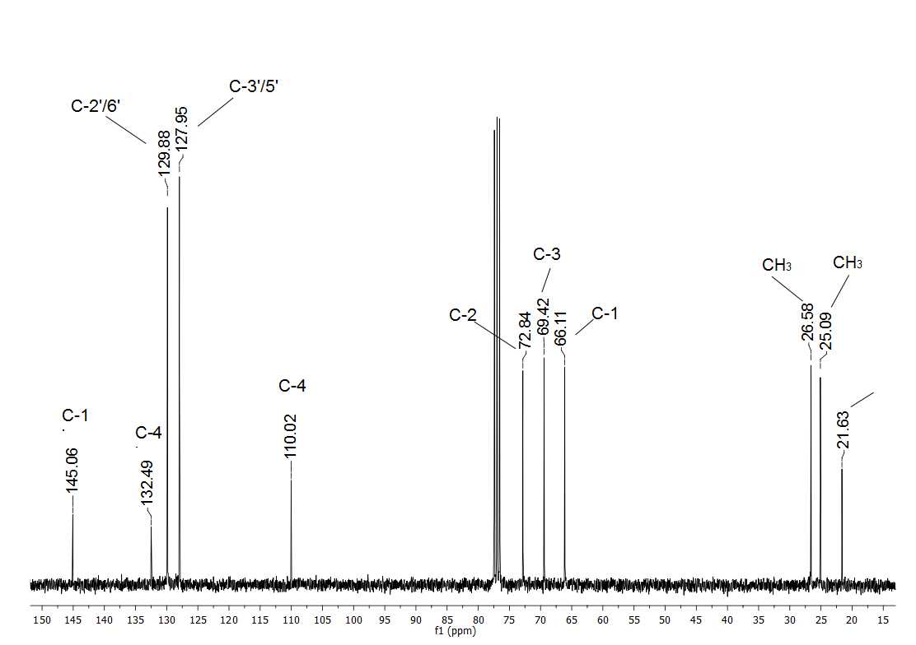
Figure S7. ¹³C NMR spectrum (75 MHz, CDCl₃) of (2,2-dimethyl-1,3-dioxolan-4-yl)methyl-4-methylbenzenesulfonate (2).

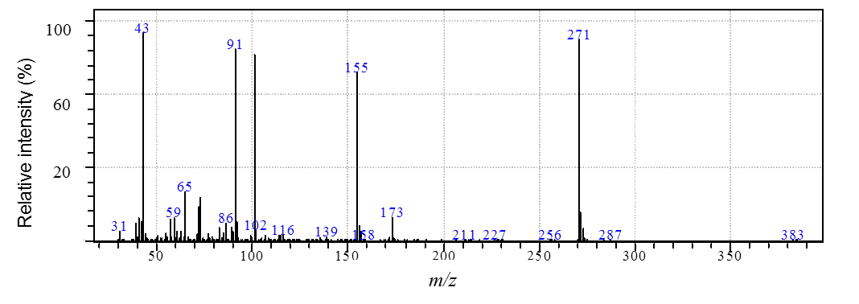
Figure S8. MS spectrum of (2,2-dimethyl-1,3-dioxolan-4-yl)methyl-4-methylbenzenesulfonate (2).

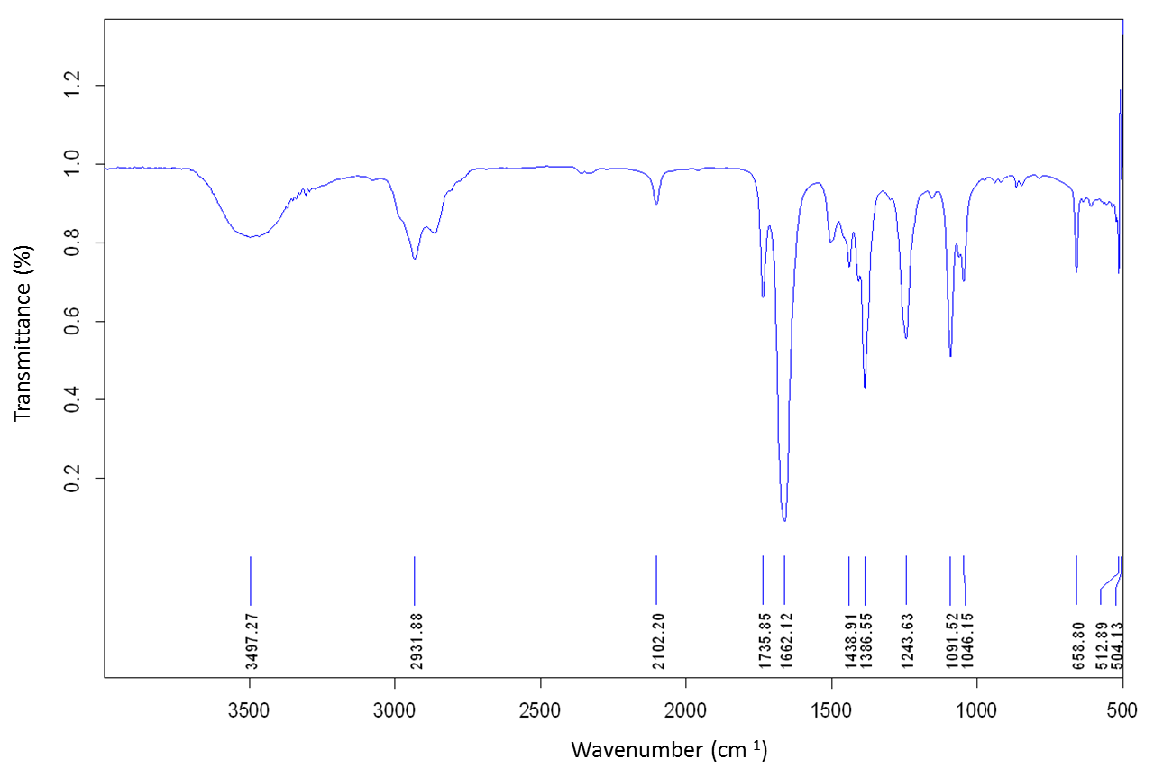
Figure S9. IR spectrum of 4-(azidomethyl)-2,2-dimethyl-1,3-dioxolane (3).

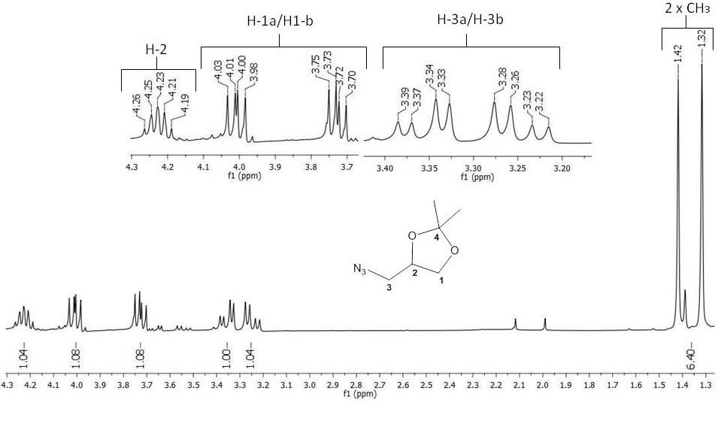
Figure S10. ¹H NMR spectrum (300 MHz, CDCl₃) of 4-(azidomethyl)-2,2-dimethyl-1,3-dioxolane (3).

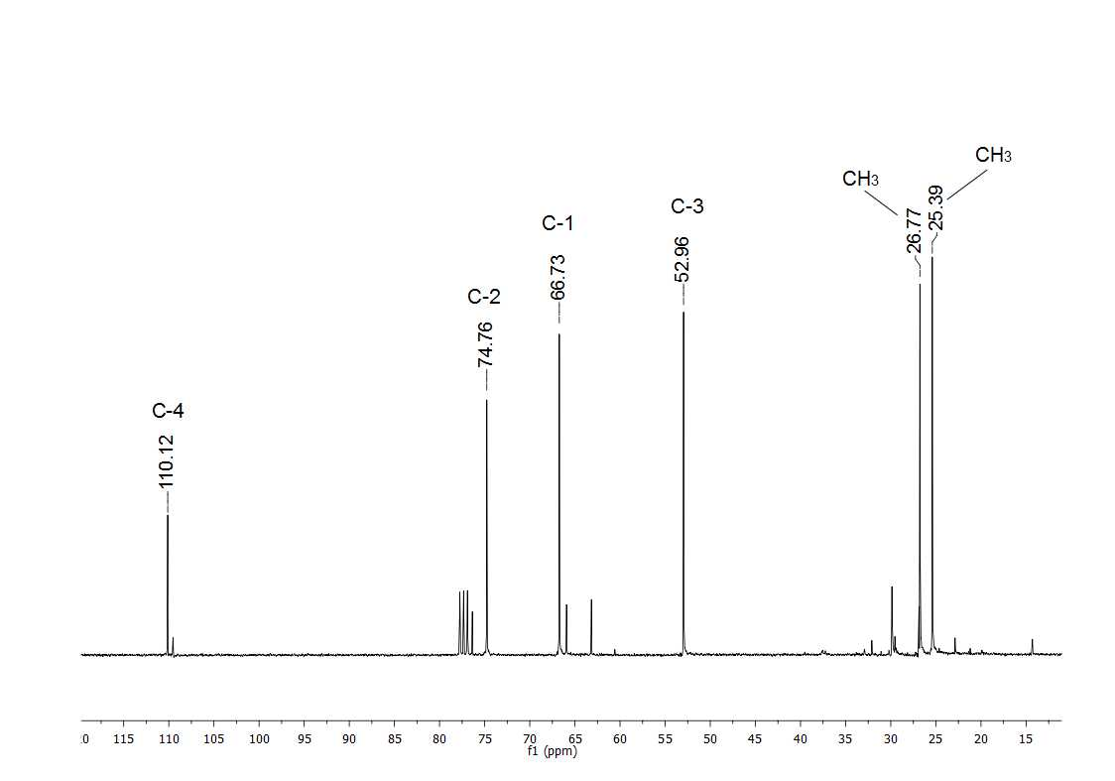
Figure S11. ¹³C NMR spectrum (75 MHz, CDCl₃) of 4-(azidomethyl)-2,2-dimethyl-1,3-dioxolane (3).

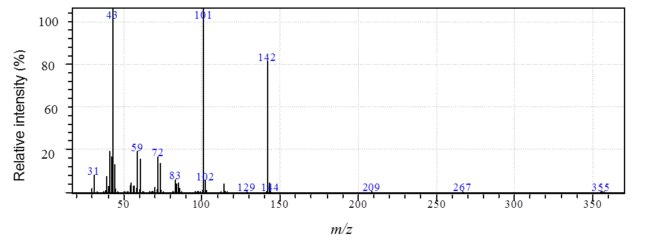
Figure S12. MS spectrum of 4-(azidomethyl)-2,2-dimethyl-1,3-dioxolane (3).

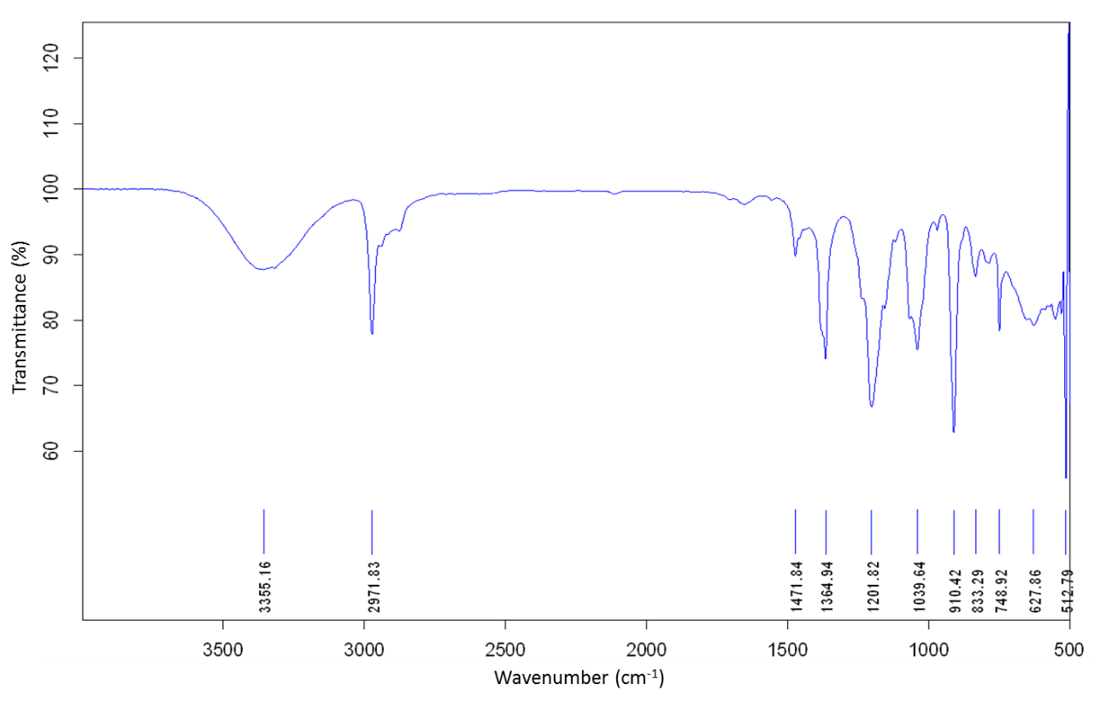
Figure S13. IR spectrum of (1-((2,2-dimethyl-1,3-dioxolan-4-yl)methyl)-1H-1,2,3-triazol-4-yl)methanol (4a).

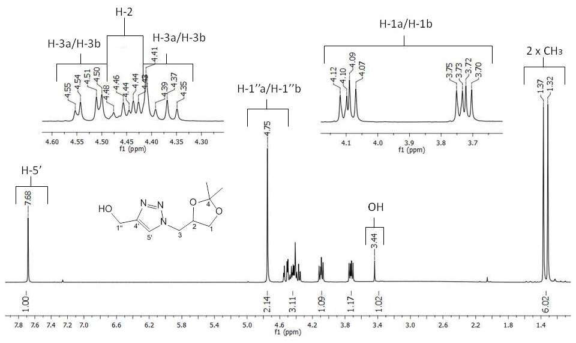
Figure S14. ¹H NMR spectrum (300 MHz, CDCl₃) of (1-((2,2-dimethyl-1,3-dioxolan-4-yl)methyl)-1H-1,2,3-triazol-4-yl)methanol (4a).

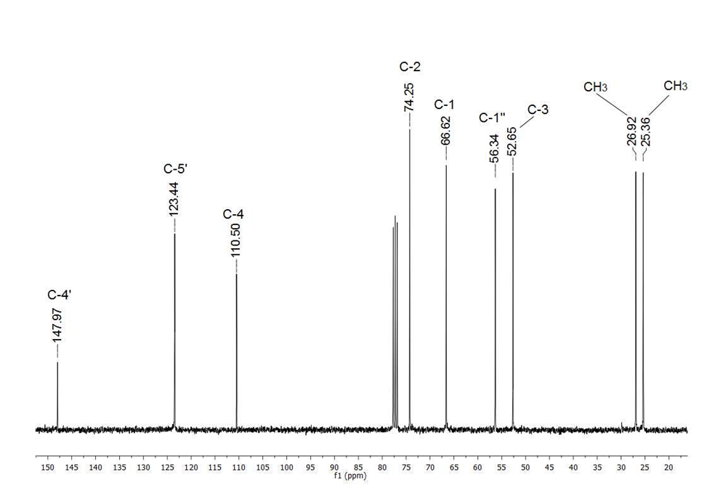
Figure S15. ¹³C NMR spectrum (75 MHz, CDCl₃) of (1-((2,2-dimethyl-1,3-dioxolan-4-yl)methyl)-1H-1,2,3-triazol-4-yl)methanol (4a).

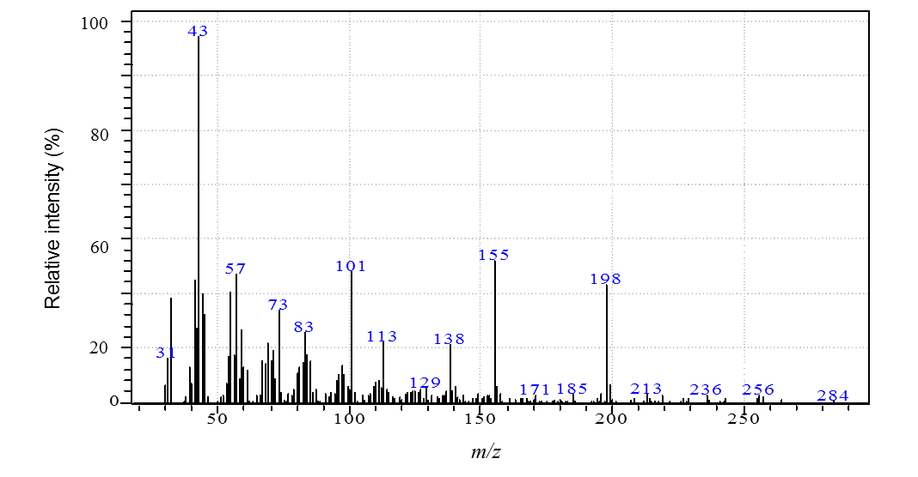
Figure S16. MS spectrum of (1-((2,2-dimethyl-1,3-dioxolan-4-yl)methyl)-1H-1,2,3-triazol-4-yl)methanol (4a).

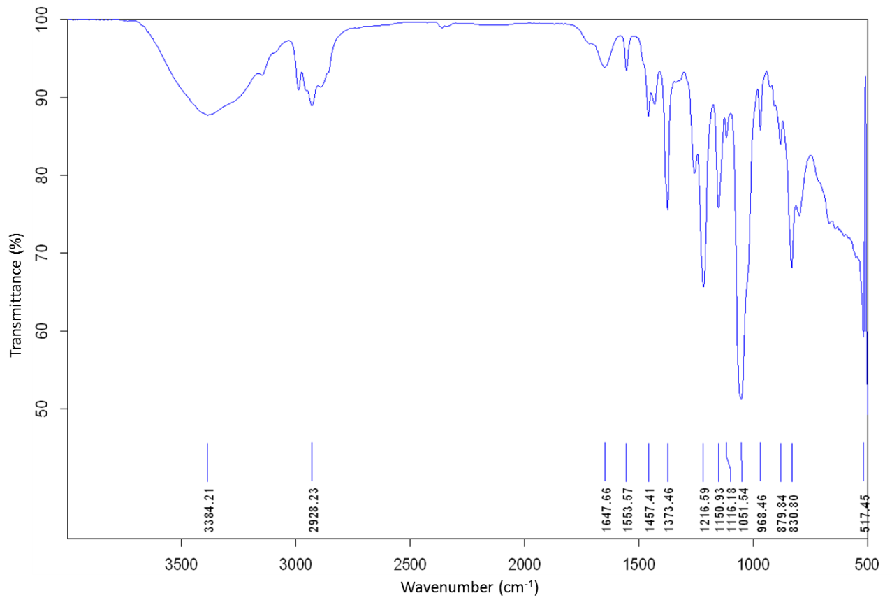
Figure S17. IR spectrum of 2-(1-((2,2-dimethyl-1,3-dioxolan-4-yl)methyl)-1H-1,2,3-triazol-4-yl)ethanol (4b).

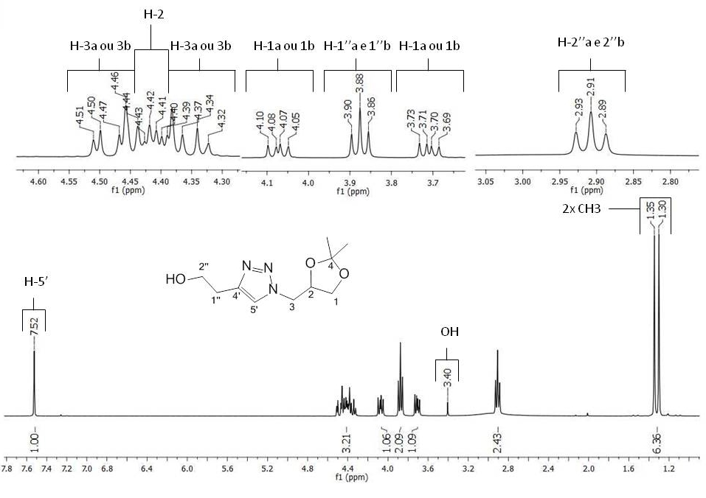
Figure S18. ¹H NMR spectrum (300 MHz, CDCl₃) of 2-(1-((2,2-dimethyl-1,3-dioxolan-4-yl)methyl)-1H-1,2,3-triazol-4-yl)ethanol (4b).

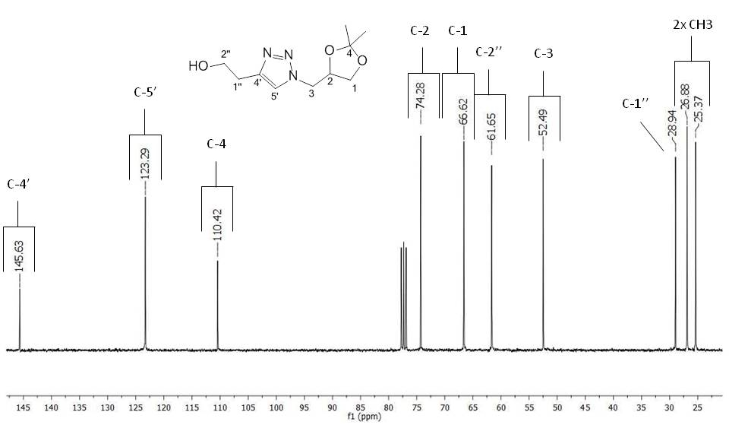
Figure S19. ¹³C NMR spectrum (75 MHz, CDCl₃) of 2-(1-((2,2-dimethyl-1,3-dioxolan-4-yl)methyl)-1H-1,2,3-triazol-4-yl)ethanol (4b).

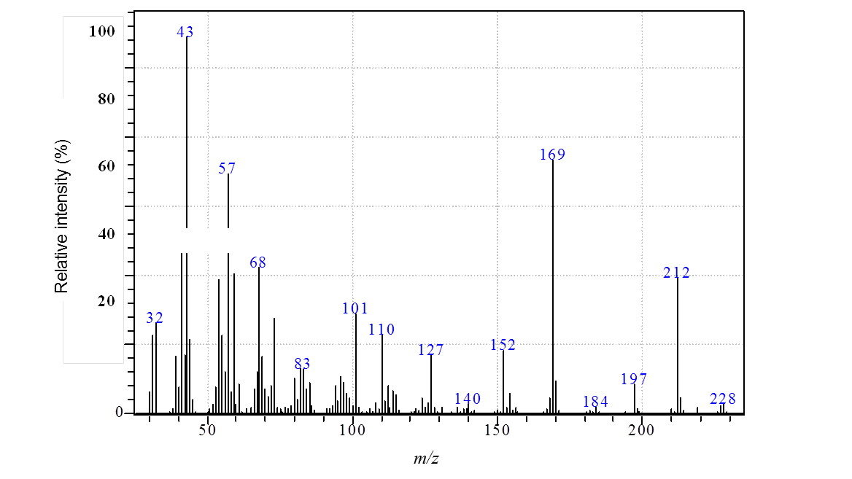
Figure S20. MS spectrum of 2-(1-((2,2-dimethyl-1,3-dioxolan-4-yl)methyl)-1H-1,2,3-triazol-4-yl)ethanol (4b).

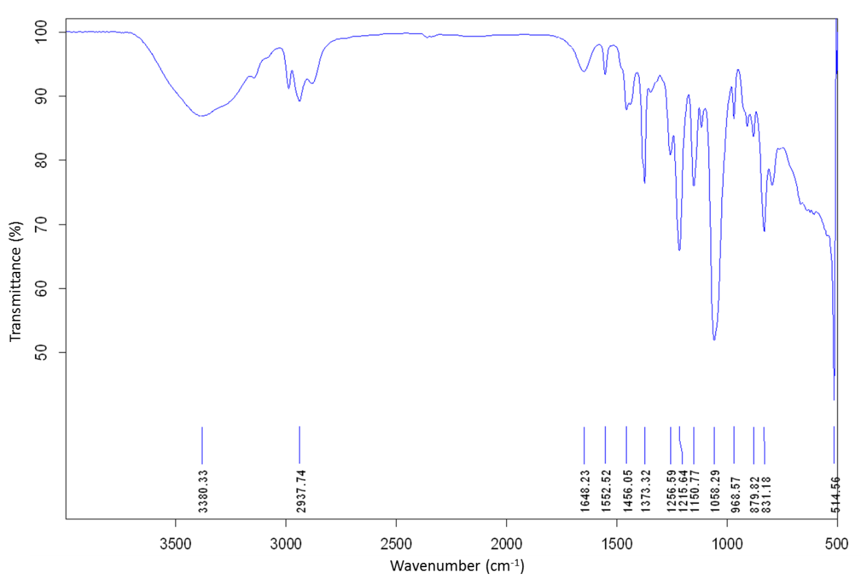
Figure S21. IR spectrum of 3-(1-((2,2-dimethyl-1,3-dioxolan-4-yl)methyl)-1H-1,2,3-triazol-4-yl)propan-1-ol (4c).

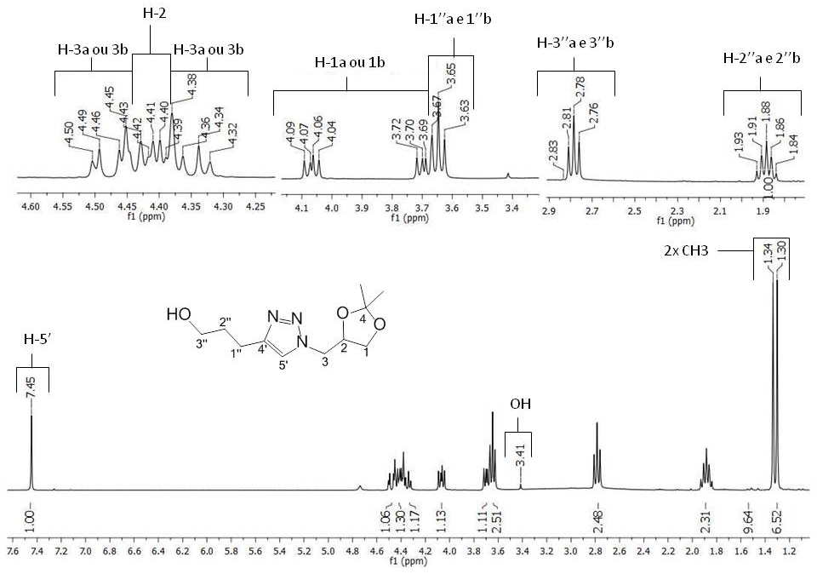
Figure S22. ¹H NMR spectrum (300 MHz, CDCl₃) of 3-(1-((2,2-dimethyl-1,3-dioxolan-4-yl)methyl)-1H-1,2,3-triazol-4-yl)propan-1-ol (4c).

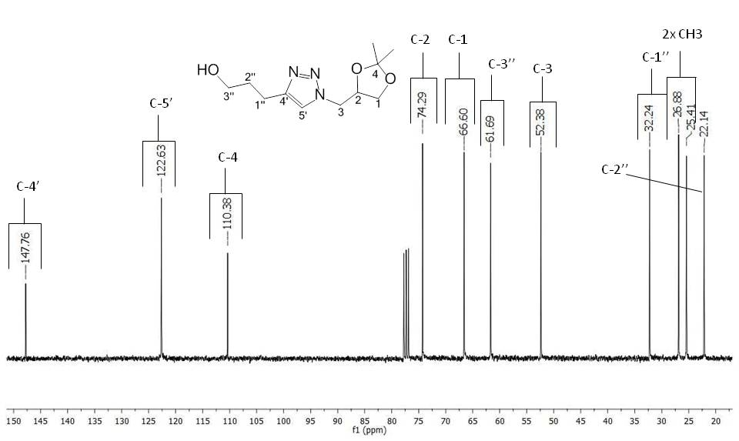
Figure S23. ¹³C NMR spectrum (75 MHz, CDCl₃) of 3-(1-((2,2-dimethyl-1,3-dioxolan-4-yl)methyl)-1H-1,2,3-triazol-4-yl)propan-1-ol (4c).

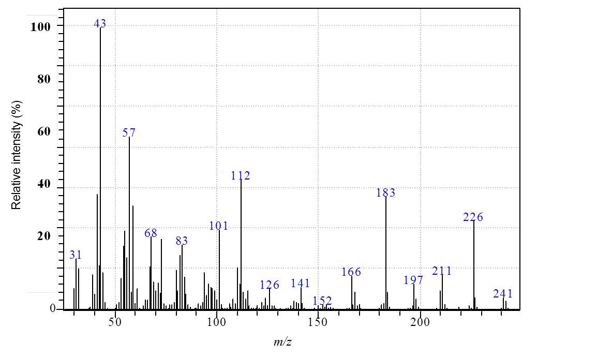
Figure S24. MS spectrum of 3-(1-((2,2-dimethyl-1,3-dioxolan-4-yl)methyl)-1H-1,2,3-triazol-4-yl)propan-1-ol (4c).

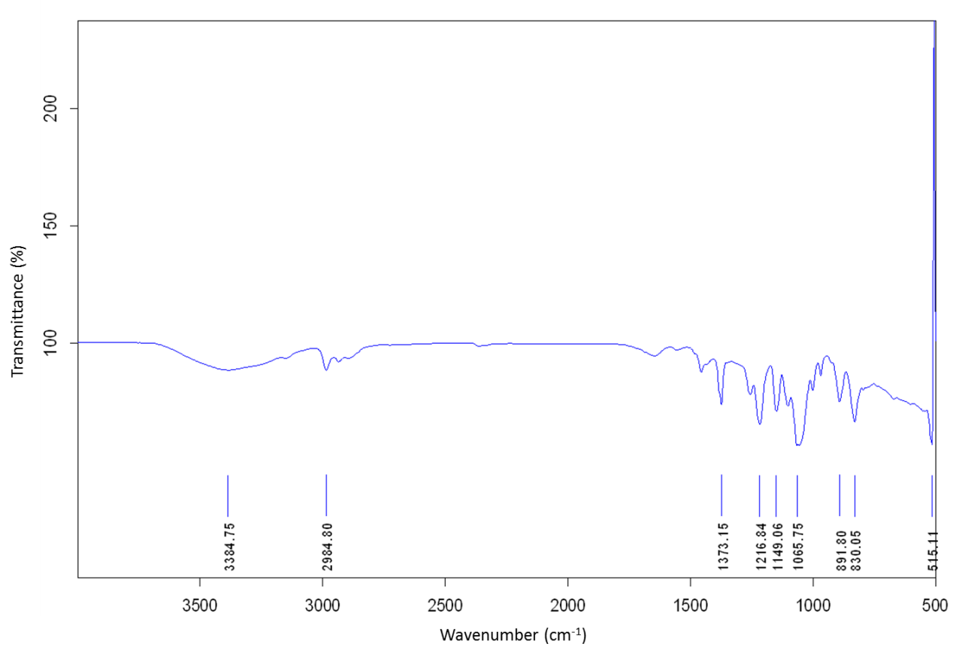
Figure S25. IR spectrum of 1-(1-((2,2-dimethyl-1,3-dioxolan-4-yl)methyl)-1H-1,2,3-triazol-4-yl)ethanol (4d).

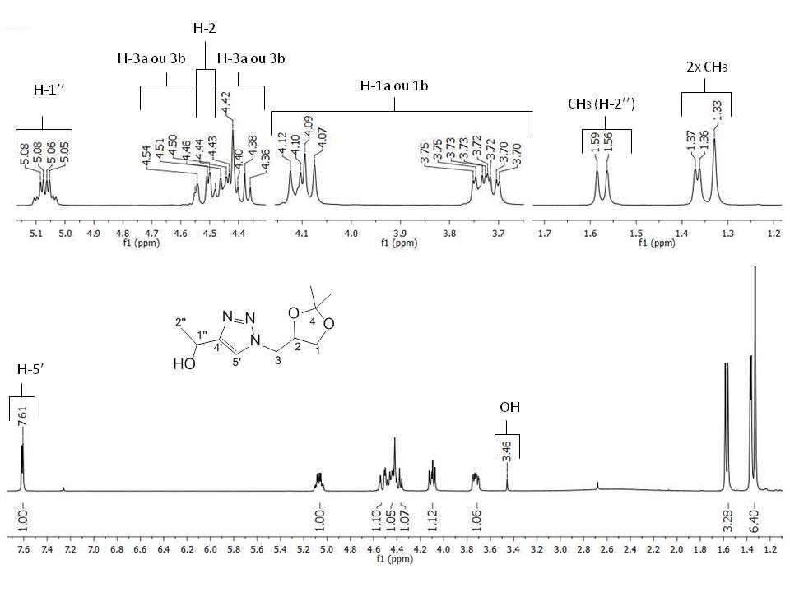
Figure S26. ¹H NMR spectrum (300 MHz, CDCl₃) of 1-(1-((2,2-dimethyl-1,3-dioxolan-4-yl)methyl)-1H-1,2,3-triazol-4-yl)ethanol (4d).

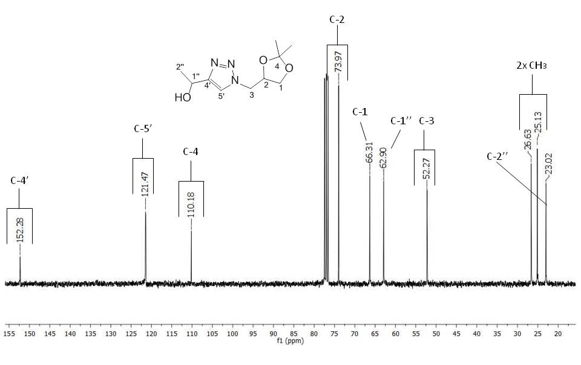
Figure S27. ¹³C NMR spectrum (75 MHz, CDCl₃) of 1-(1-((2,2-dimethyl-1,3-dioxolan-4-yl)methyl)-1H-1,2,3-triazol-4-yl)ethanol (4d).

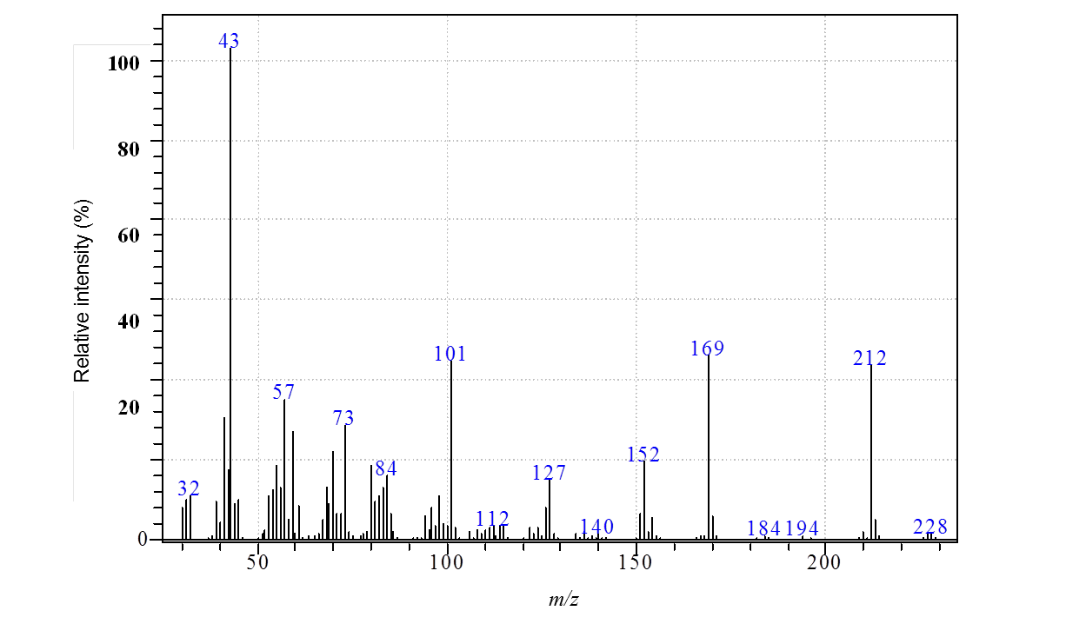
Figure S28. MS spectrum of 1-(1-((2,2-dimethyl-1,3-dioxolan-4-yl)methyl)-1H-1,2,3-triazol-4-yl)ethanol (4d).

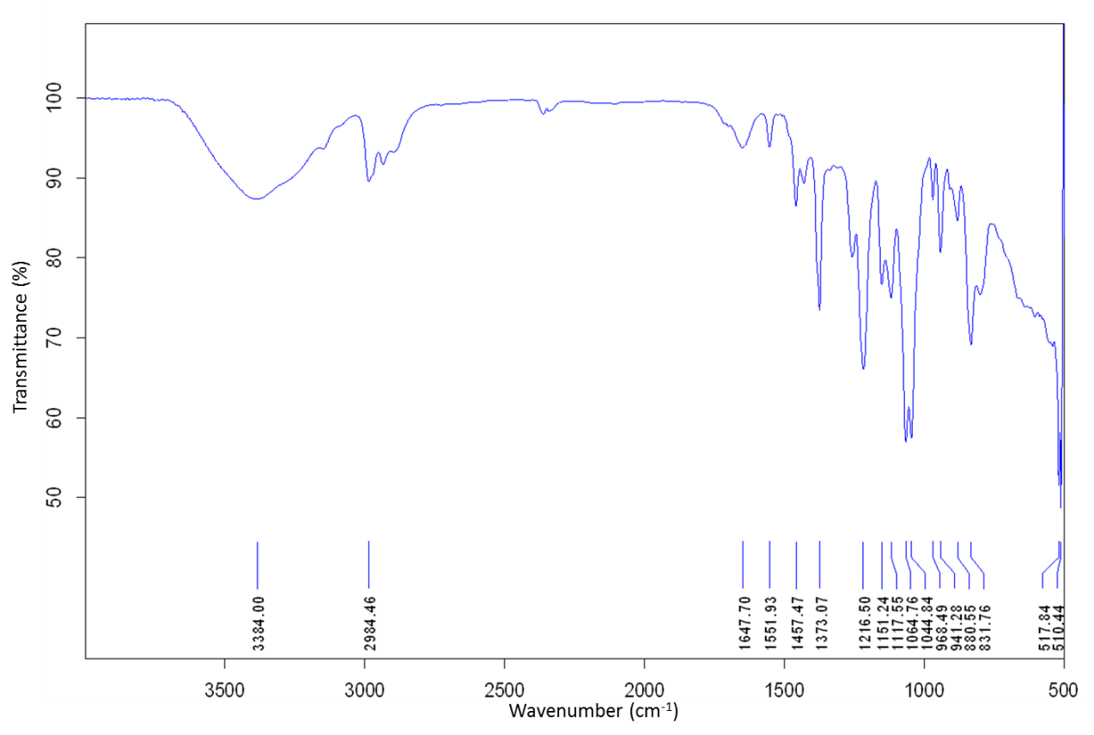
Figure S29. IR spectrum of 1-(1-((2,2-dimethyl-1,3-dioxolan-4-yl)methyl)-1H-1,2,3-triazol-4-yl)propan-2-ol (4e).

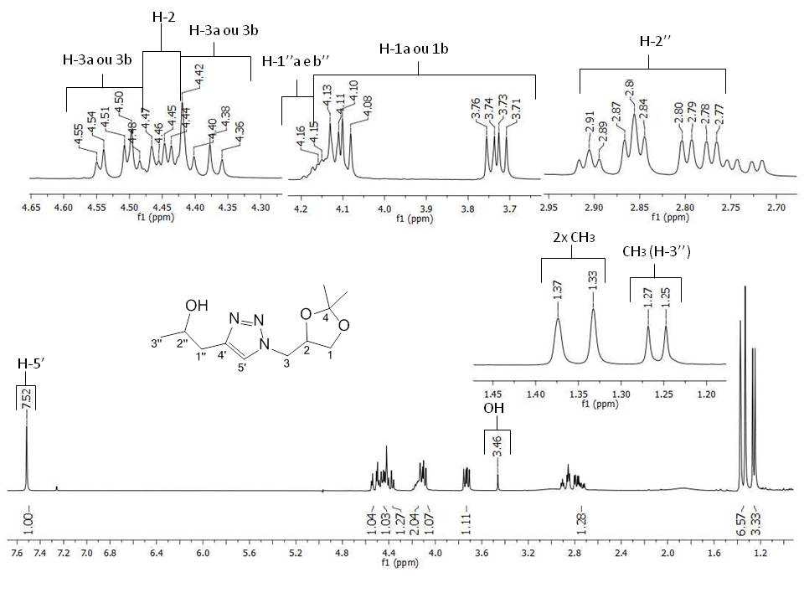
Figure S30. ¹H NMR spectrum (300 MHz, CDCl₃) of 1-(1-((2,2-dimethyl-1,3-dioxolan-4-yl)methyl)-1H-1,2,3-triazol-4-yl)propan-2-ol (4e).

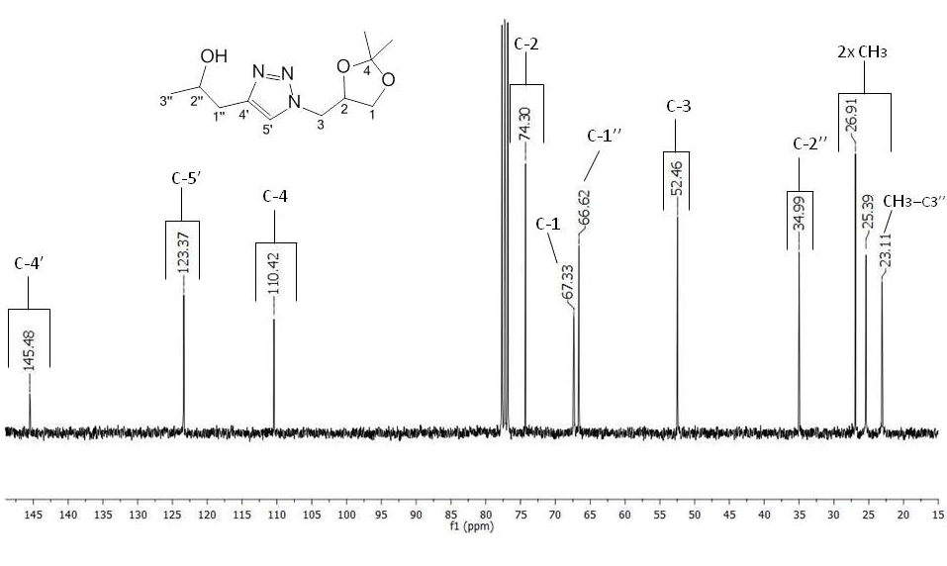
Figure S31. ¹³C NMR spectrum (75 MHz, CDCl₃) of 1-(1-((2,2-dimethyl-1,3-dioxolan-4-yl)methyl)-1H-1,2,3-triazol-4-yl)propan-2-ol (4e).

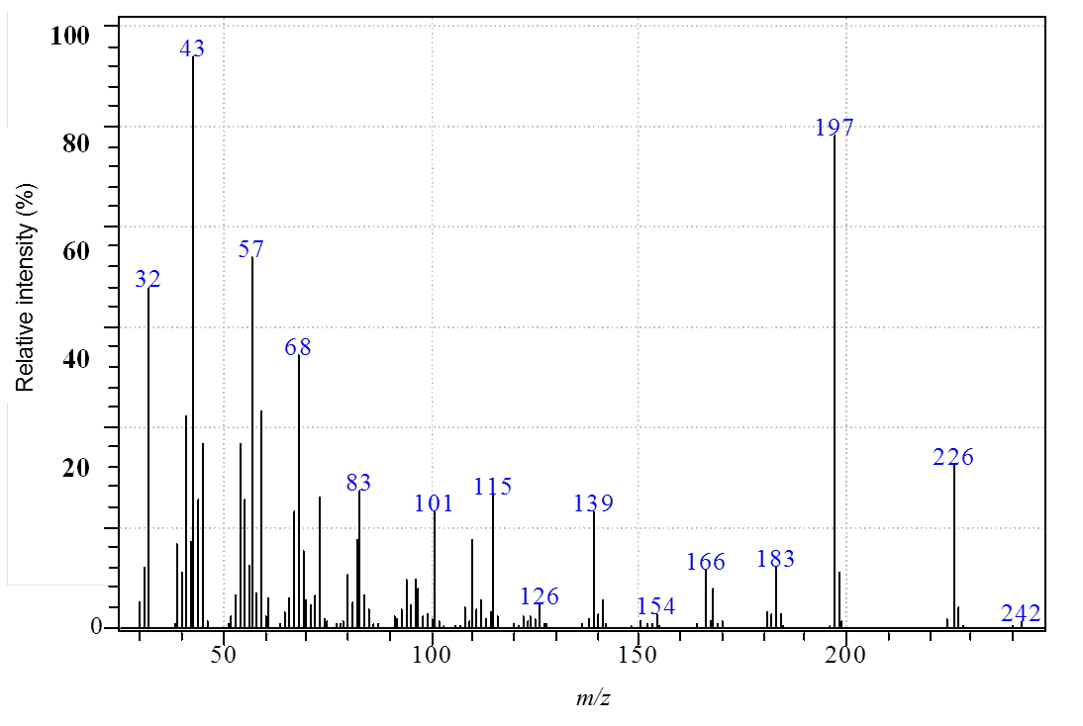
Figure S32. MS spectrum of 1-(1-((2,2-dimethyl-1,3-dioxolan-4-yl)methyl)-1H-1,2,3-triazol-4-yl)propan-2-ol (4e).

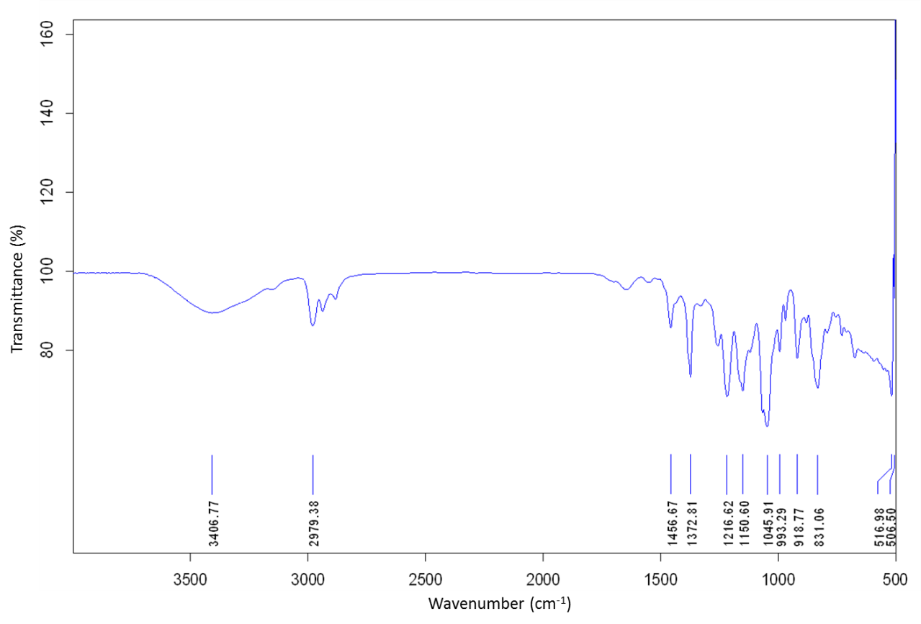
Figure S33. IR spectrum of 2-(1-((2,2-dimethyl-1,3-dioxolan-4-yl)methyl)-1H-1,2,3-triazol-4-yl)butan-2-ol (4f).

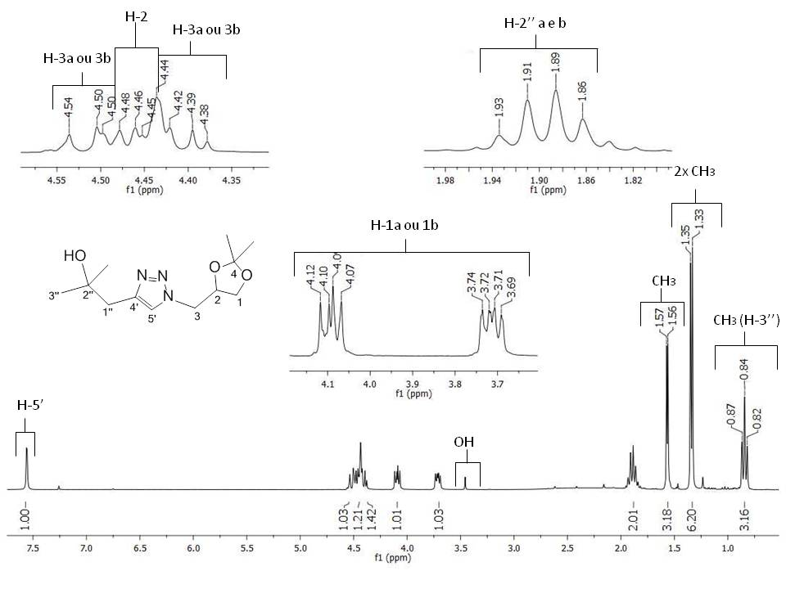
Figure S34. ¹H NMR spectrum (300 MHz, CDCl₃) of 2-(1-((2,2-dimethyl-1,3-dioxolan-4-yl)methyl)-1H-1,2,3-triazol-4-yl)butan-2-ol (4f).
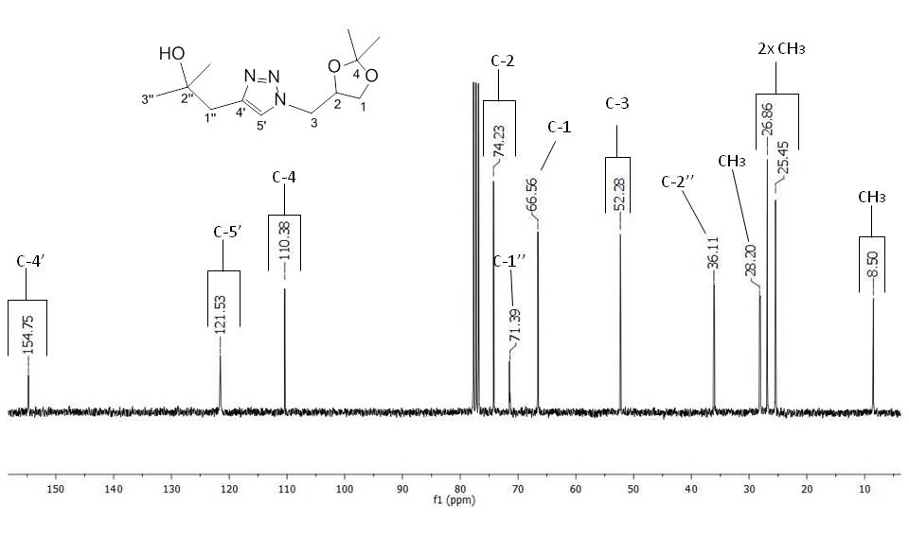
Figure S35. ¹³C NMR spectrum (75 MHz, CDCl₃) of 2-(1-((2,2-dimethyl-1,3-dioxolan-4-yl)methyl)-1H-1,2,3-triazol-4-yl)butan-2-ol (4f).

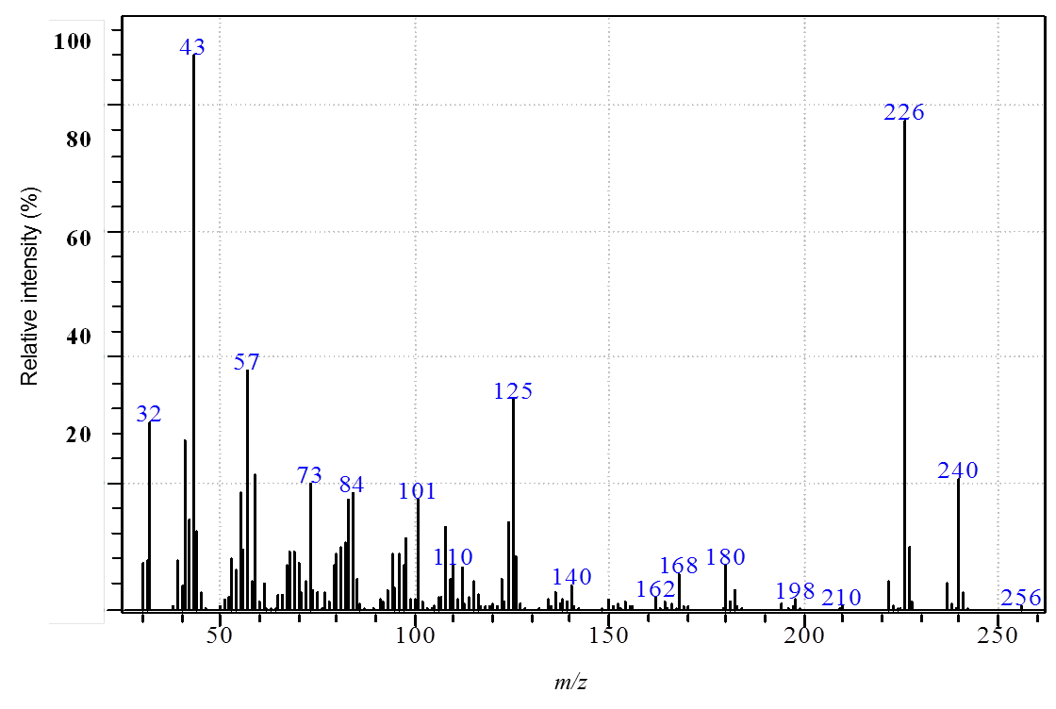
Figure S36. MS spectrum of 2-(1-((2,2-dimethyl-1,3-dioxolan-4-yl)methyl)-1H-1,2,3-triazol-4-yl)butan-2-ol (4f).

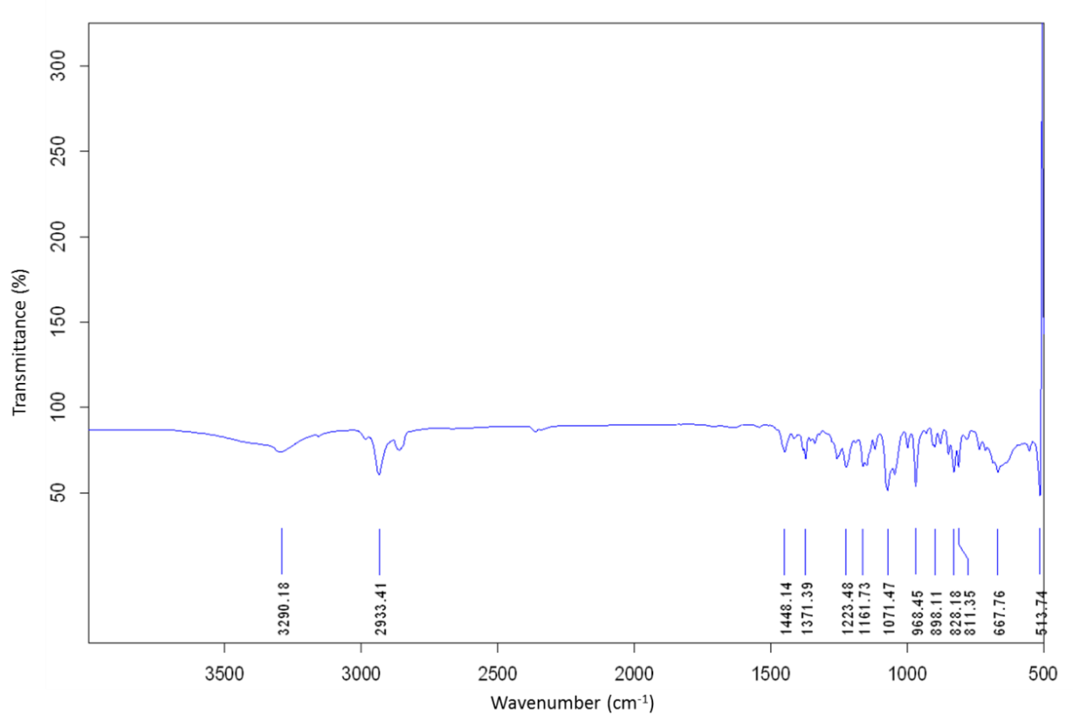
Figure S37. IR spectrum of 1-(1-((2,2-dimethyl-1,3-dioxolan-4-yl)methyl)-1H-1,2,3-triazol-4-yl)cyclohexanol (4g).

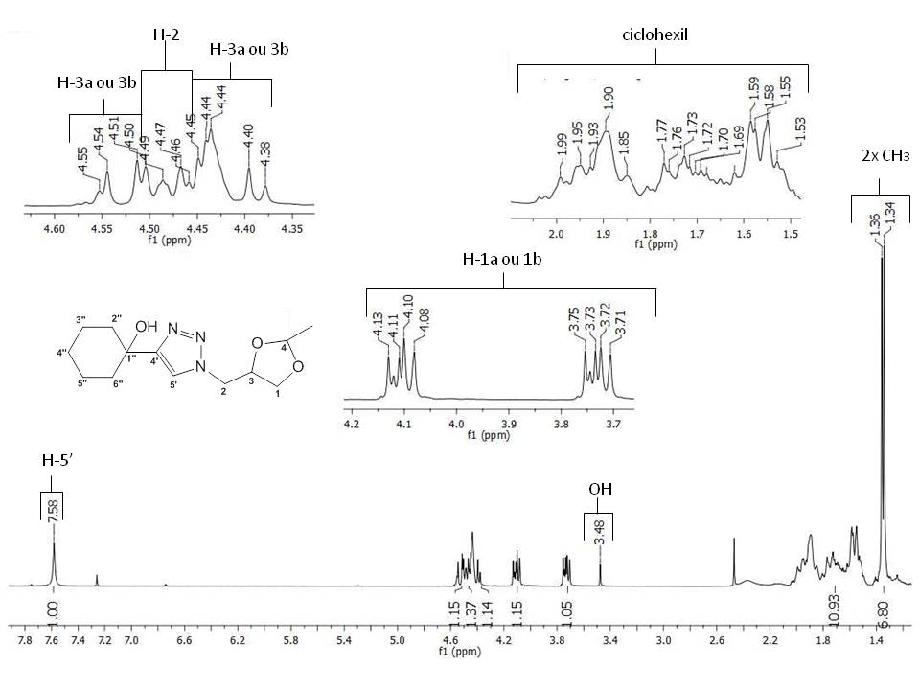
Figure S38. ¹H NMR spectrum (300 MHz, CDCl₃) of 1-(1-((2,2-dimethyl-1,3-dioxolan-4-yl)methyl)-1H-1,2,3-triazol-4-yl)cyclohexanol (4g).
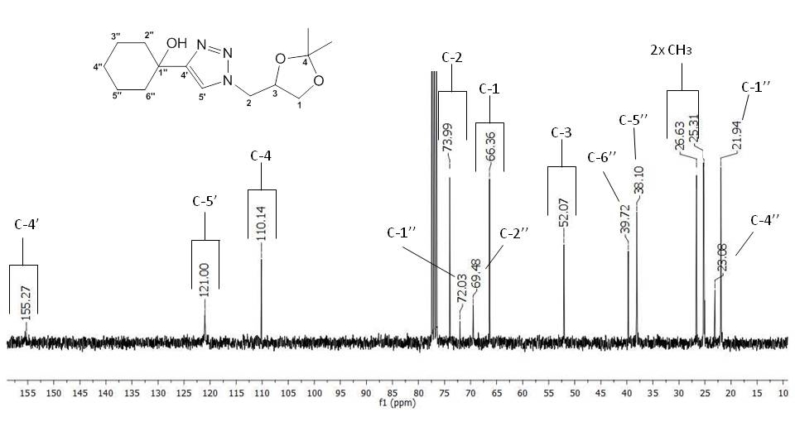
Figure S39. ¹³C NMR spectrum (75 MHz, CDCl₃) of 1-(1-((2,2-dimethyl-1,3-dioxolan-4-yl)methyl)-1H-1,2,3-triazol-4-yl)cyclohexanol (4g).

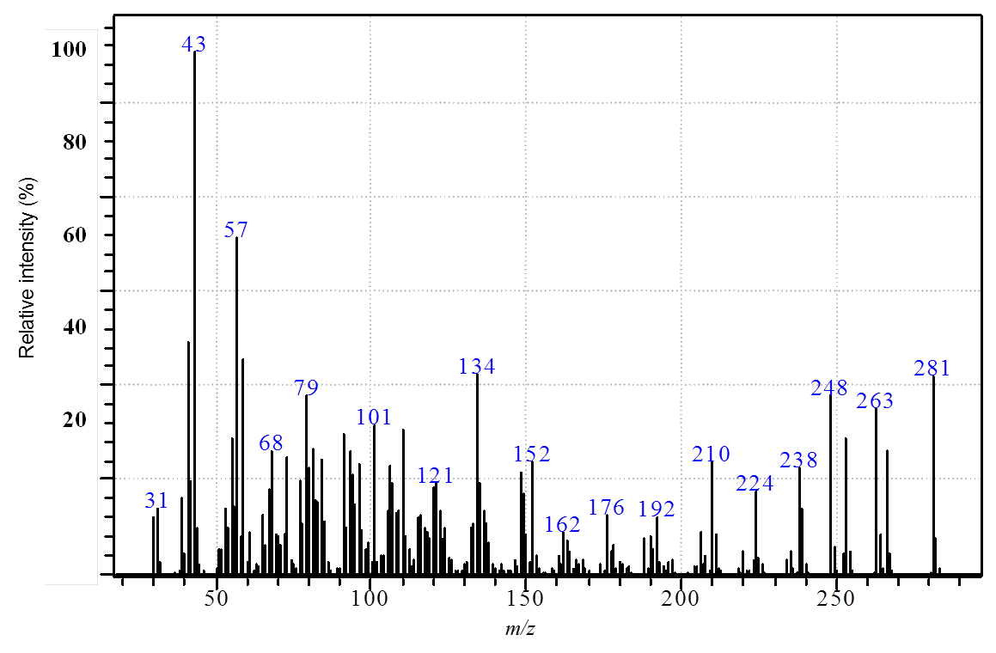
Figure S40. MS spectrum of 1-(1-((2,2-dimethyl-1,3-dioxolan-4-yl)methyl)-1H-1,2,3-triazol-4-yl)cyclohexanol (4g).

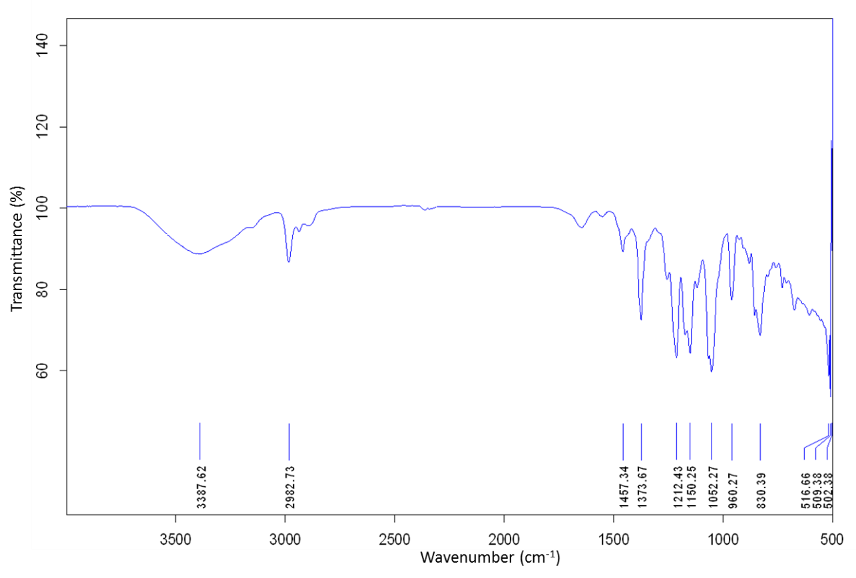
Figure S41. IR spectrum of 2-(1-((2,2-dimethyl-1,3-dioxolan-4-yl)methyl)-1H-1,2,3-triazol-4-yl)propan-2-ol (4h).

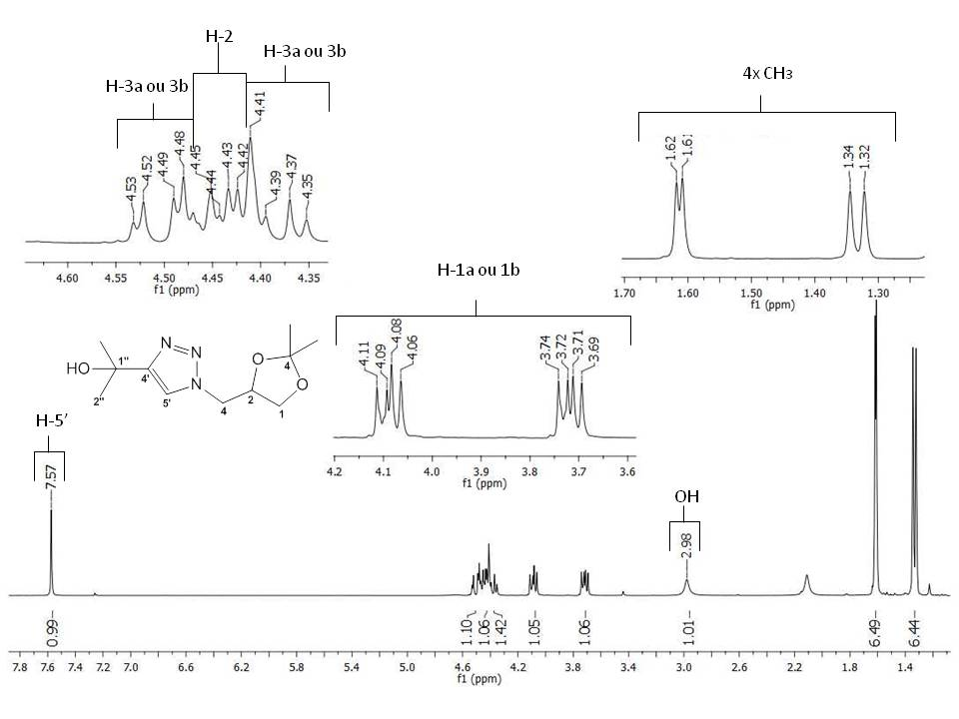
Figure S42. ¹H NMR spectrum (300 MHz, CDCl₃) of 2-(1-((2,2-dimethyl-1,3-dioxolan-4-yl)methyl)-1H-1,2,3-triazol-4-yl)propan-2-ol (4h).

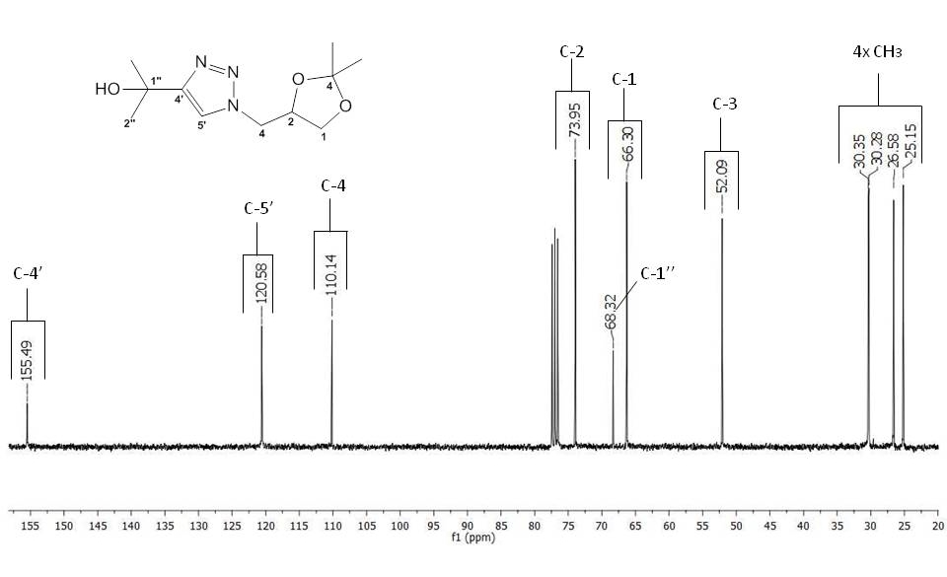
Figure S43. ¹³C NMR spectrum (75 MHz, CDCl₃) of 2-(1-((2,2-dimethyl-1,3-dioxolan-4-yl)methyl)-1H-1,2,3-triazol-4-yl)propan-2-ol (4h).

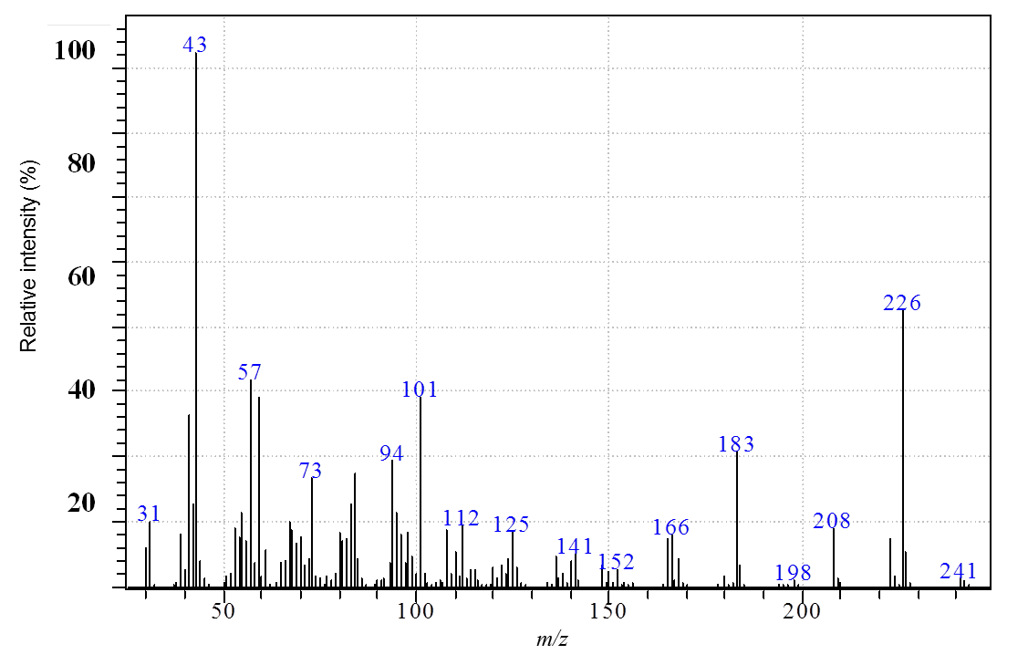
Figure S44. MS spectrum of 2-(1-((2,2-dimethyl-1,3-dioxolan-4-yl)methyl)-1H-1,2,3-triazol-4-yl)propan-2-ol (4h).
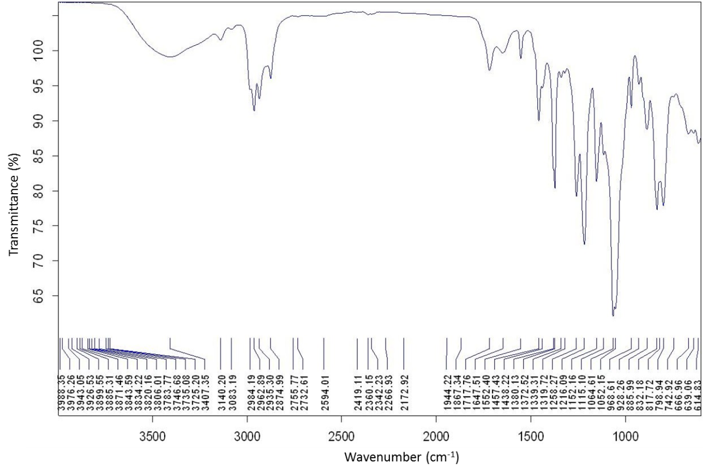
Figure S45. IR spectrum of 1-((2,2-dimethyl-1,3-dioxolan-4-yl)methyl)-4-propyl-1H-1,2,3-triazole (4i).

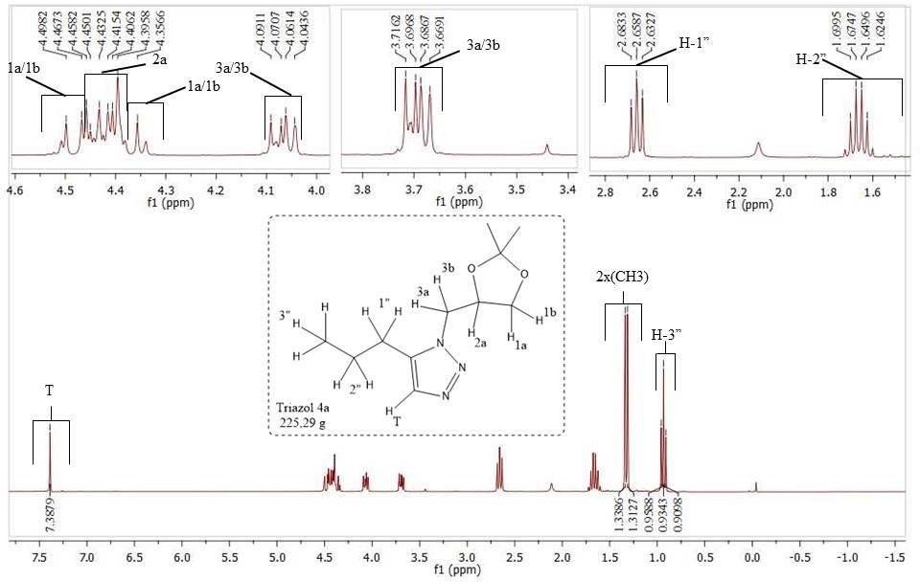
Figure S46. ¹H NMR spectrum (300 MHz, CDCl₃) of 1-((2,2-dimethyl-1,3-dioxolan-4-yl)methyl)-4-propyl-1H-1,2,3-triazole (4i).

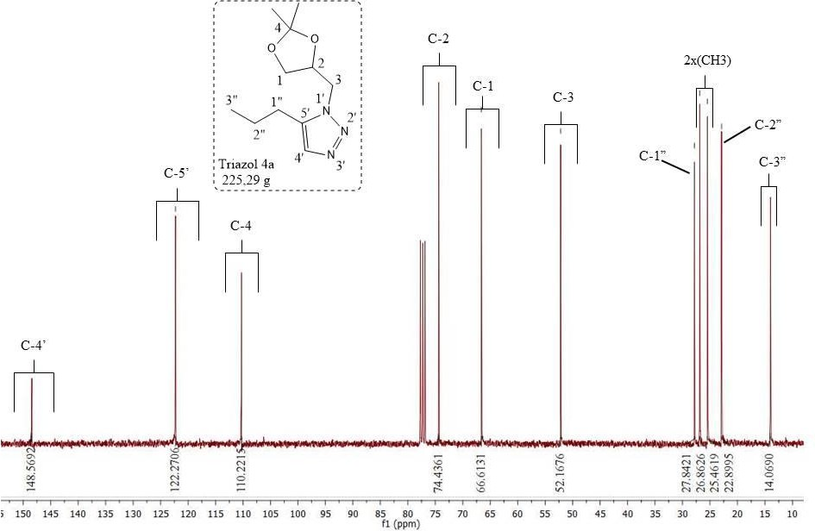
Figure S47. ¹³C NMR spectrum (75 MHz, CDCl₃) of 1-((2,2-dimethyl-1,3-dioxolan-4-yl)methyl)-4-propyl-1H-1,2,3- triazole (4i).

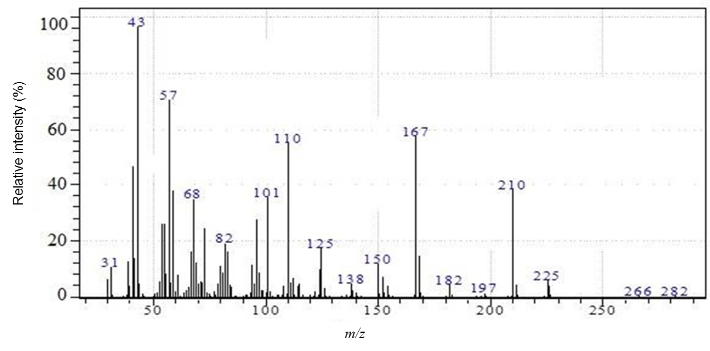
Figure S48. MS spectrum of 1-((2,2-dimethyl-1,3-dioxolan-4-yl)methyl)-4-propyl-1H-1,2,3- triazole (4i).

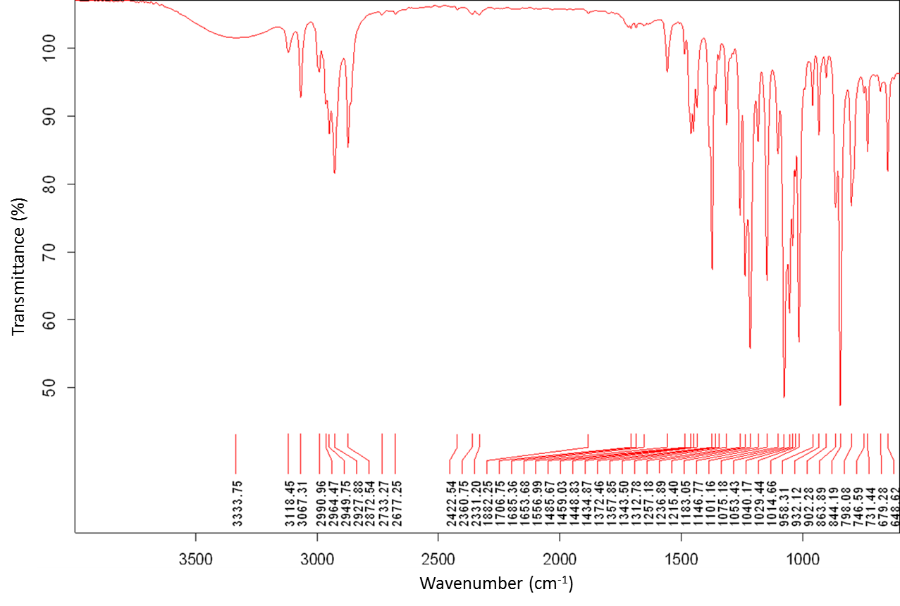
Figure S49. IR spectrum of 1-((2,2-dimethyl-1,3-dioxolan-4-yl)methyl)-4-butyl-1H-1,2,3-triazole (4j).

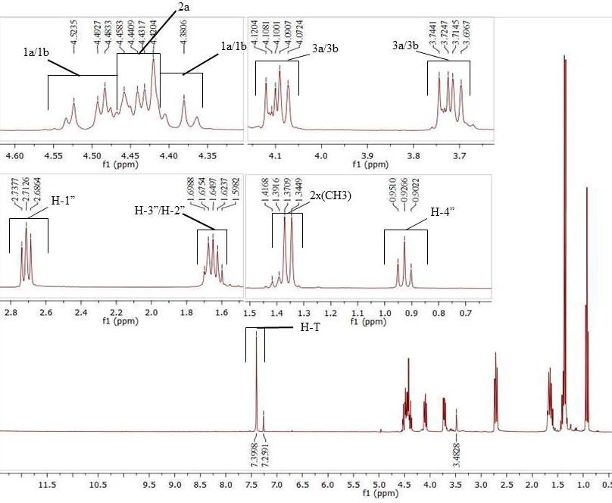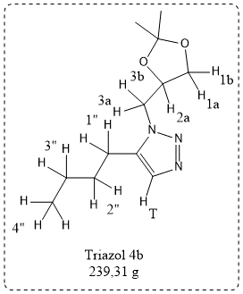
Figure S50. ¹H NMR spectrum (300 MHz, CDCl₃) of 1-((2,2-dimethyl-1,3-dioxolan-4-yl)methyl)-4-butyl-1H-1,2,3-triazole (4j).

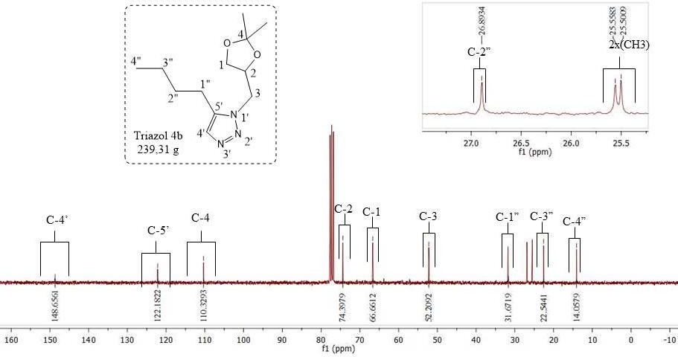
Figure S51. ¹³C NMR spectrum (75 MHz, CDCl₃) of 1-((2,2-dimethyl-1,3-dioxolan-4-yl)methyl)-4-butyl-1H-1,2,3-triazole (4j).

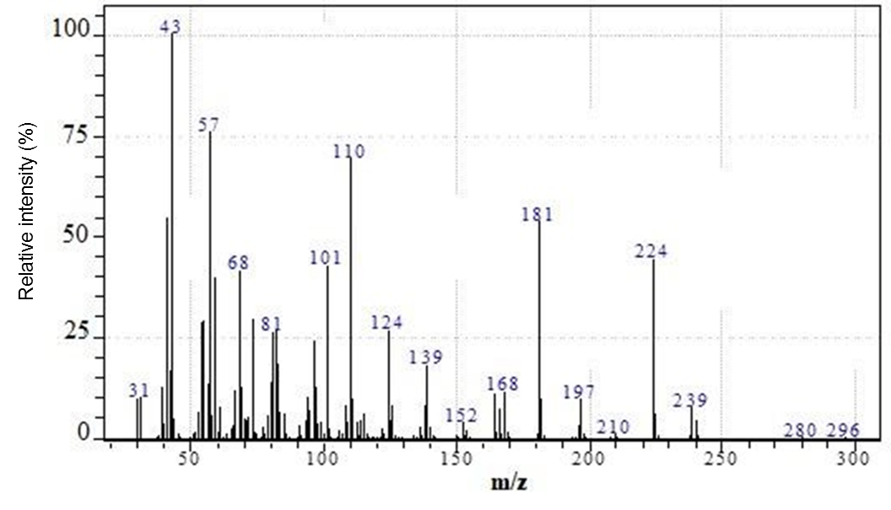
Figure S52. MS spectrum of 1-((2,2-dimethyl-1,3-dioxolan-4-yl)methyl)-4-butyl-1H-1,2,3-triazole (4j).

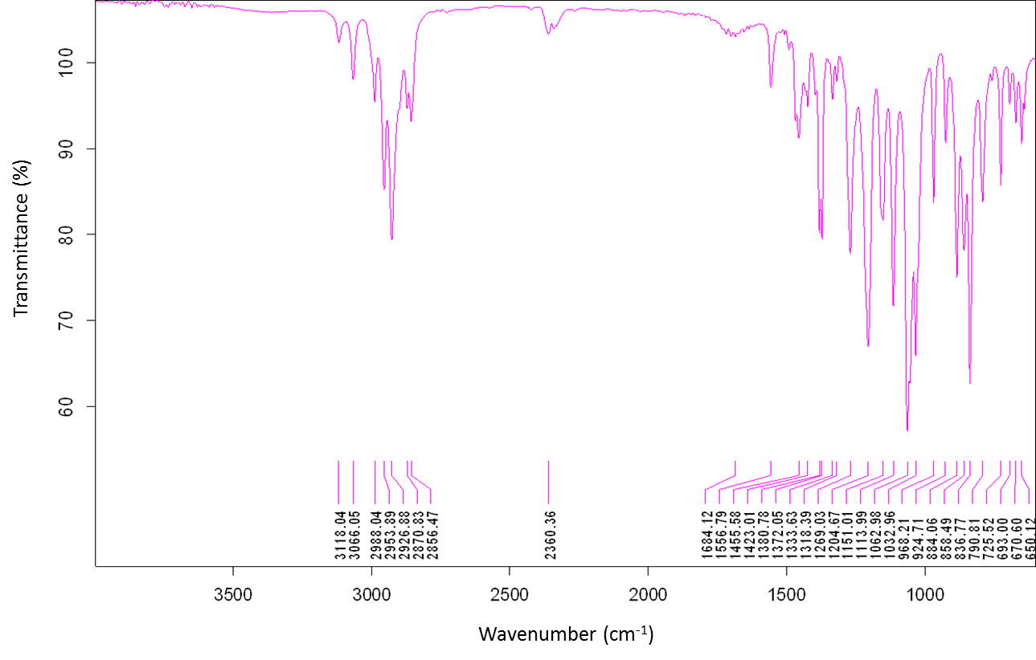
Figure S53. IR spectrum of 1-((2,2-dimethyl-1,3-dioxolan-4-yl)methyl)-4-pentyl-1H-1,2,3-triazole (4k).

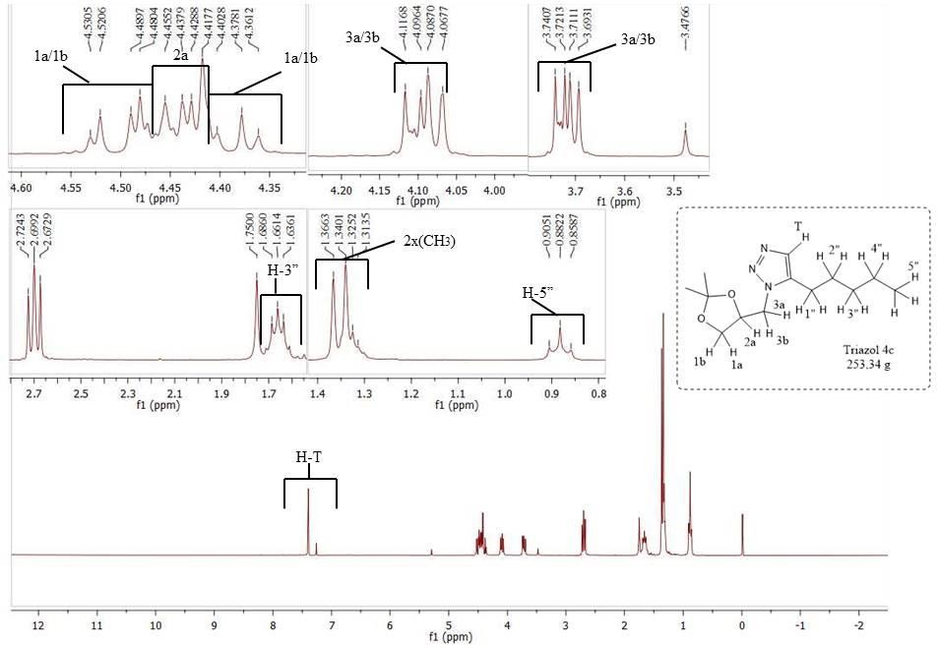
Figure S54. ¹H NMR spectrum (300 MHz, CDCl₃) of 1-((2,2-dimethyl-1,3-dioxolan-4-yl)methyl)-4-pentyl-1H-1,2,3-triazole (4k).

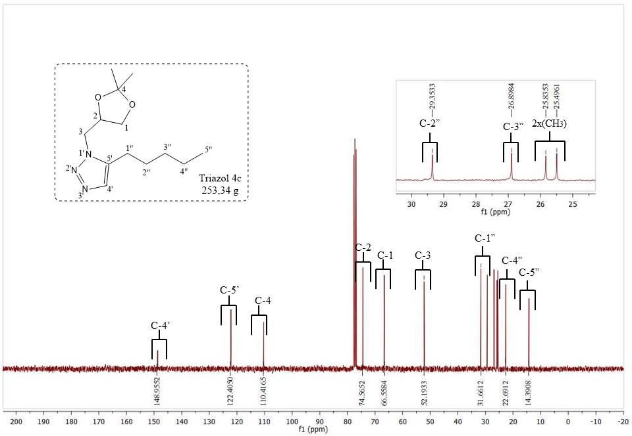
Figure S55. ¹³C NMR spectrum (75 MHz, CDCl₃) of 1-((2,2-dimethyl-1,3-dioxolan-4-yl)methyl)-4-pentyl-1H-1,2,3-triazole (4k).

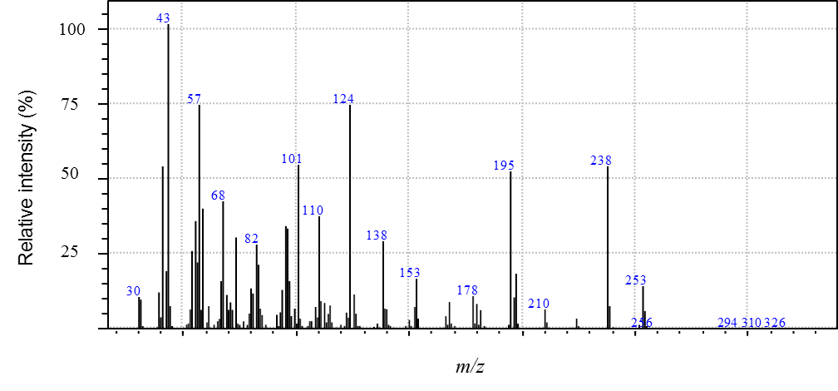
Figure S56. MS spectrum of 1-((2,2-dimethyl-1,3-dioxolan-4-yl)methyl)-4-pentyl-1H-1,2,3-triazole (4k).

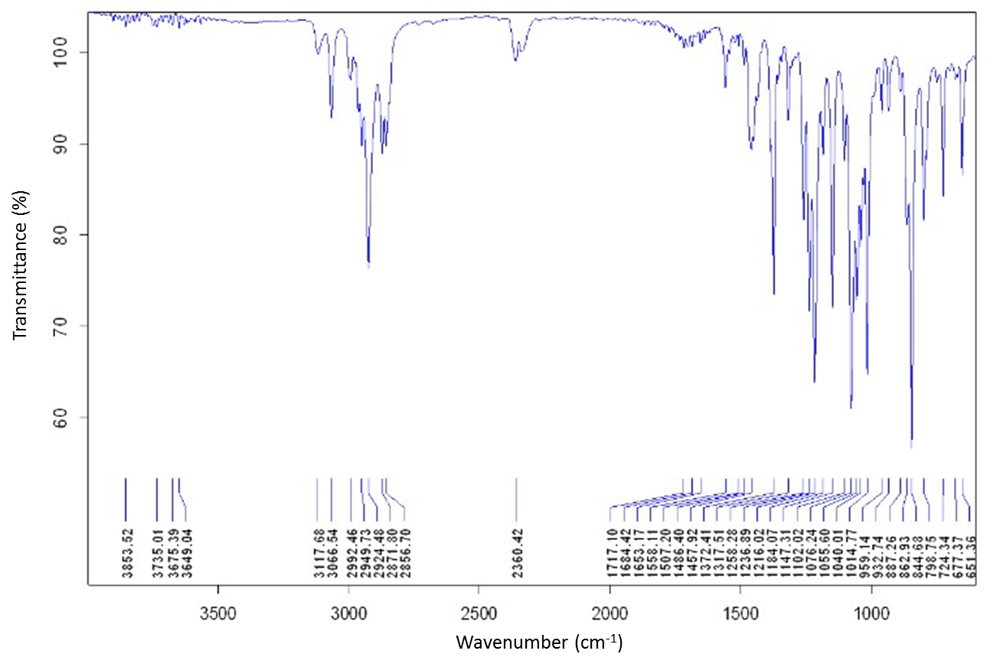
Figure S57. IR spectrum of 1-((2,2-dimethyl-1,3-dioxolan-4-yl)methyl)-4-hexyl-1H-1,2,3-triazole (4l).

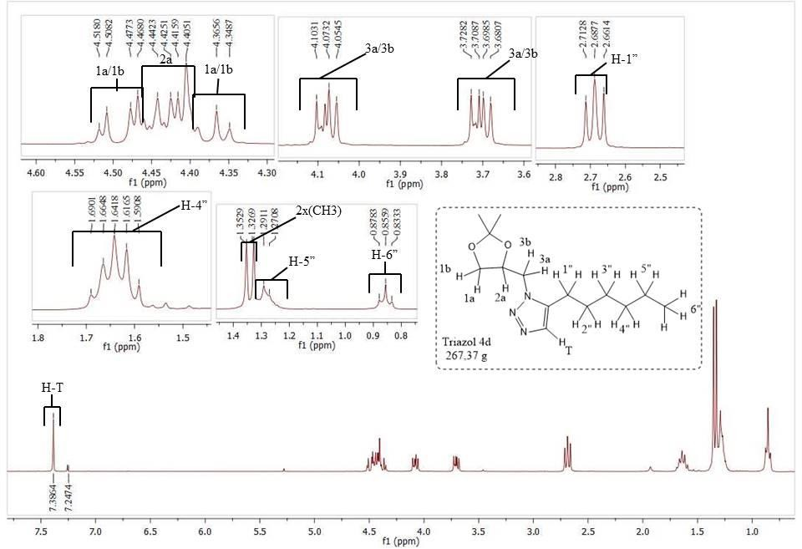
Figure S58. ¹H NMR spectrum (300 MHz, CDCl₃) of 1-((2,2-dimethyl-1,3-dioxolan-4-yl)methyl)-4-hexyl-1H-1,2,3-triazole (4l).
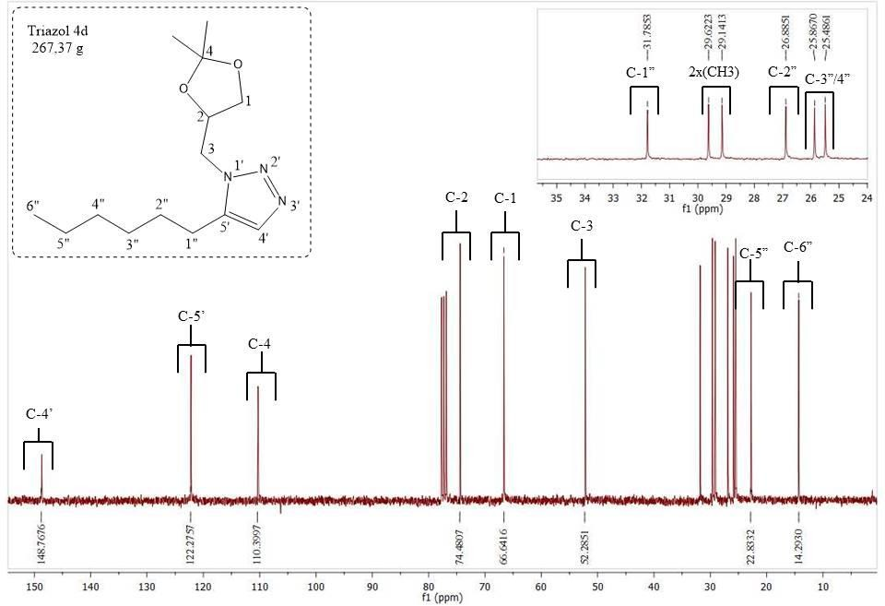
Figure S59. ¹³C NMR spectrum (75 MHz, CDCl₃) of 1-((2,2-dimethyl-1,3-dioxolan-4-yl)methyl)-4-hexyl-1H-1,2,3-triazole (4l).

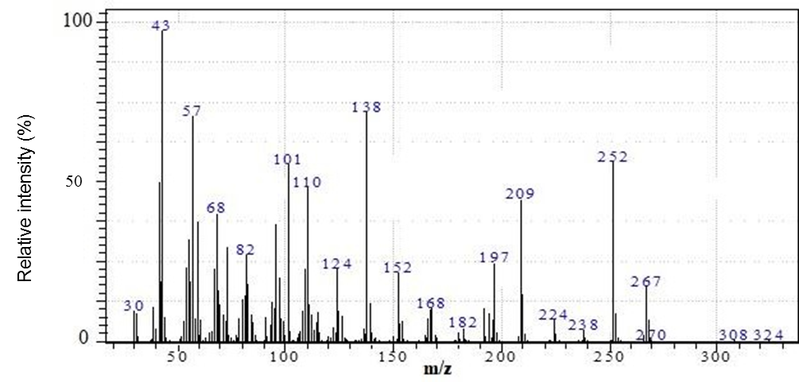
Figure S60. MS spectrum of 1-((2,2-dimethyl-1,3-dioxolan-4-yl)methyl)-4-hexyl-1H-1,2,3-triazole (4l).

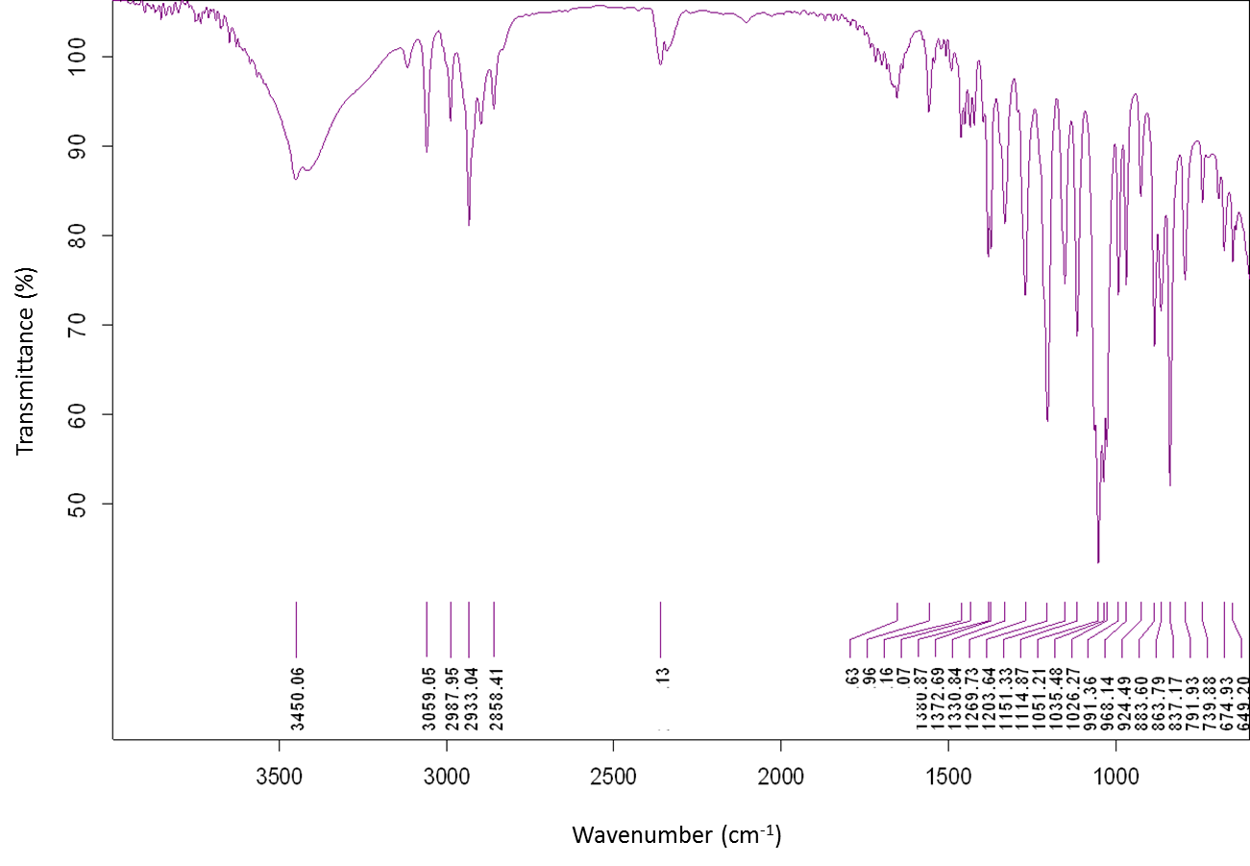
Figure S61. IR spectrum of 4-(1-((2,2-dimethyl-1,3-dioxolan-4-yl)methyl)-4-(4-hydroxybutyl)-1H-1,2,3-triazole (4m).

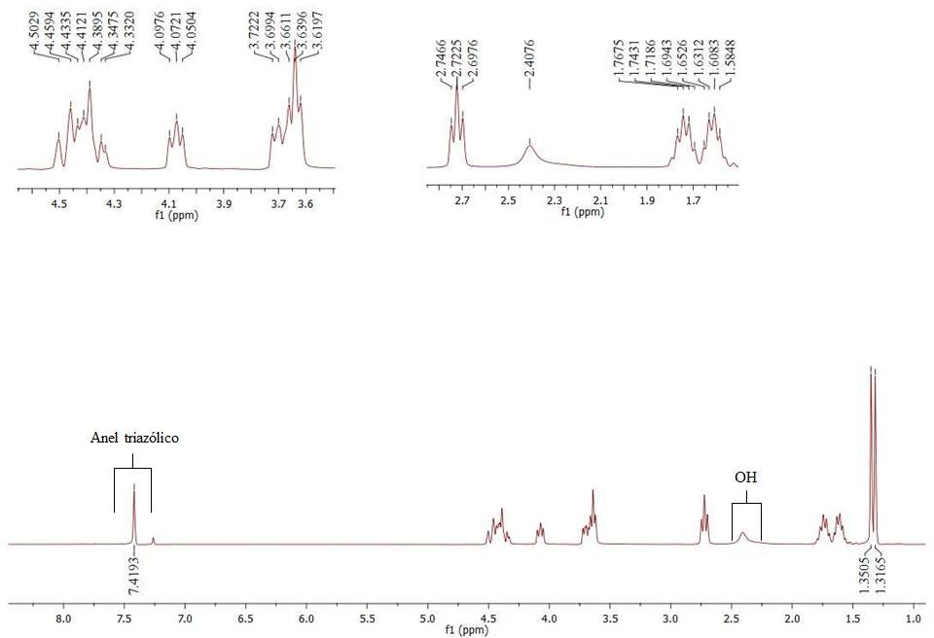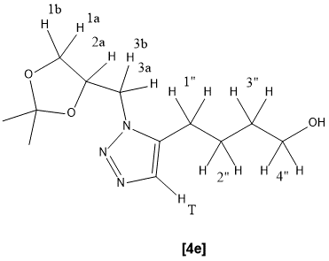
Figure S62. ¹H NMR spectrum (300 MHz, CDCl₃) of 4-(1-((2,2-dimethyl-1,3-dioxolan-4-yl)methyl)-4-(4-hydroxybutyl)-1H-1,2,3-triazole (4m).
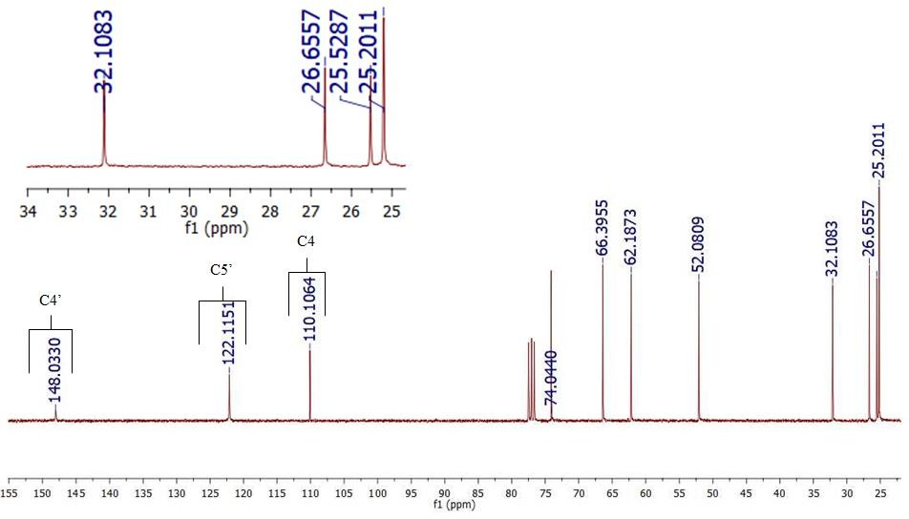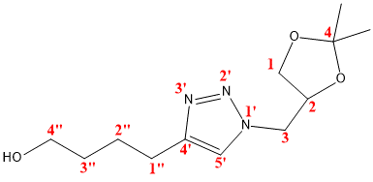
Figure S63. ¹³C NMR spectrum (75 MHz, CDCl₃) of 4-(1-((2,2-dimethyl-1,3-dioxolan-4-yl)methyl)-4-(4-hydroxybutyl)-1H-1,2,3-triazole (4m).

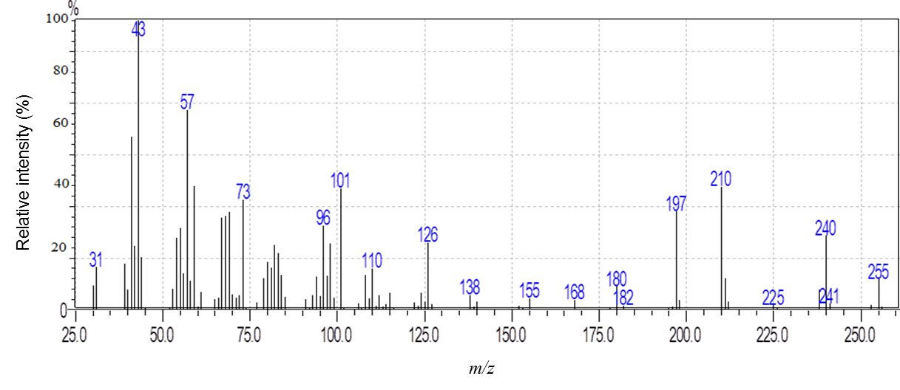
Figure S64. MS spectrum of 4-(1-((2,2-dimethyl-1,3-dioxolan-4-yl)methyl)-4-(4-hydroxybutyl)-1H-1,2,3-triazole (4m).

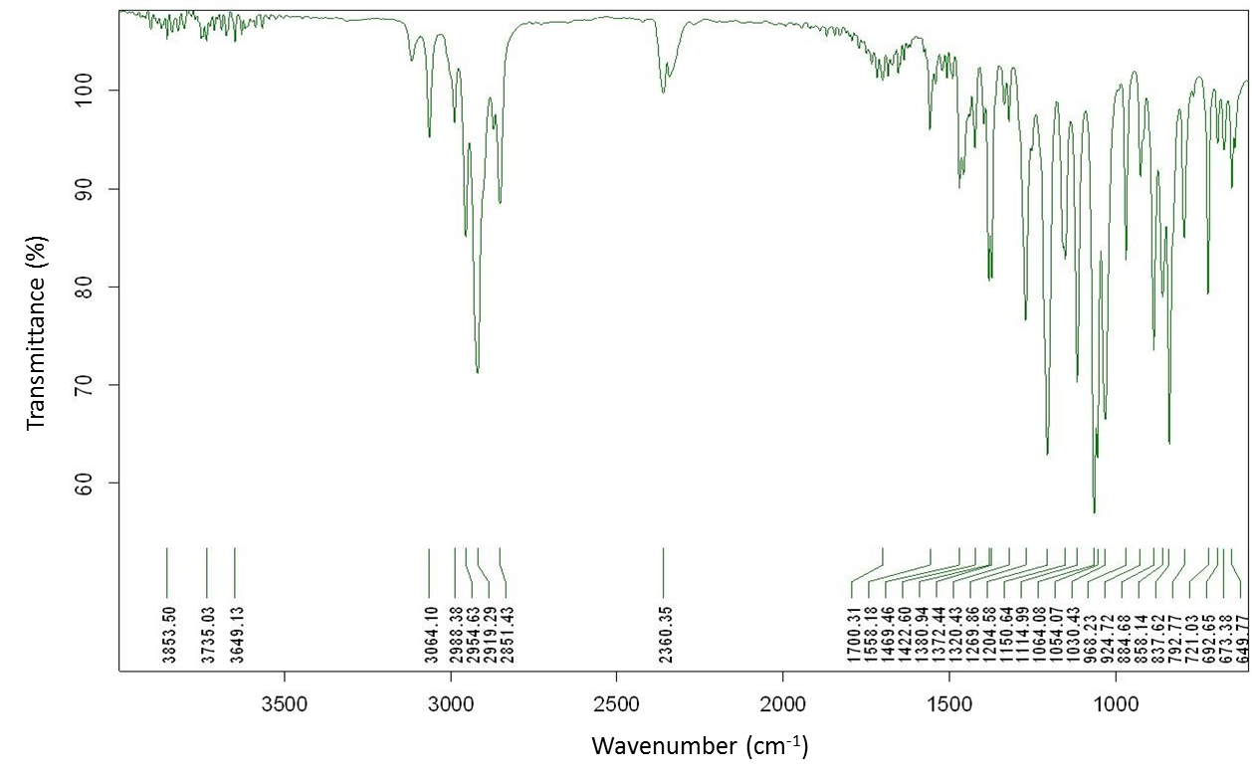
Figure S65. IR spectrum of 1-((2,2-dimethyl)1,3-dioxolan-4-yl)-4-heptyl-1H-1,2,3-triazole (4n).

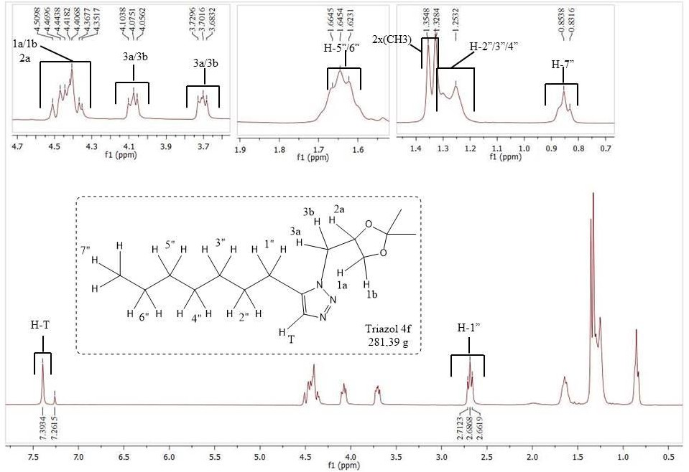
Figure S66. ¹H NMR spectrum (300 MHz, CDCl₃) of 1-((2,2-dimethyl)1,3-dioxolan-4-yl)-4-heptyl-1H-1,2,3-triazole (4n).
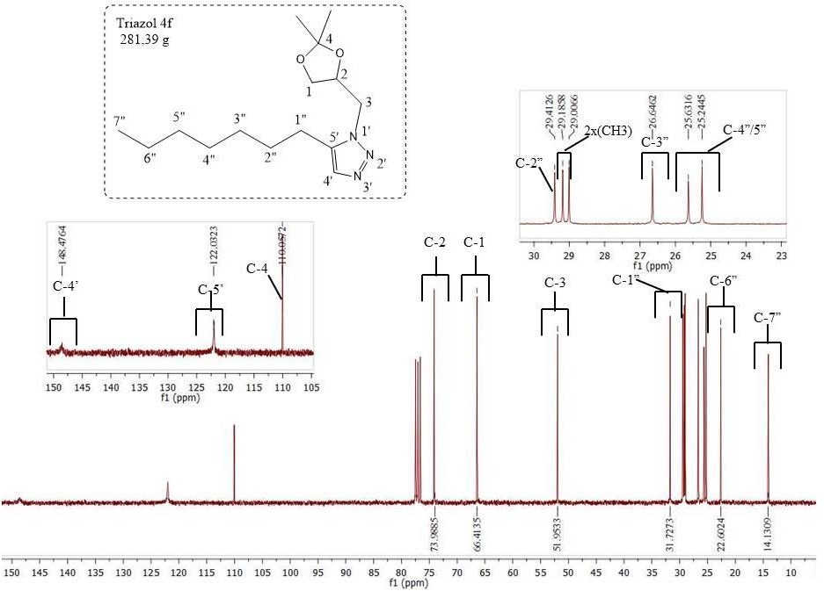
Figure S67. ¹³C NMR spectrum (75 MHz, CDCl₃) of 1-((2,2-dimethyl)1,3-dioxolan-4-yl)-4-heptyl-1H-1,2,3-triazole (4n).

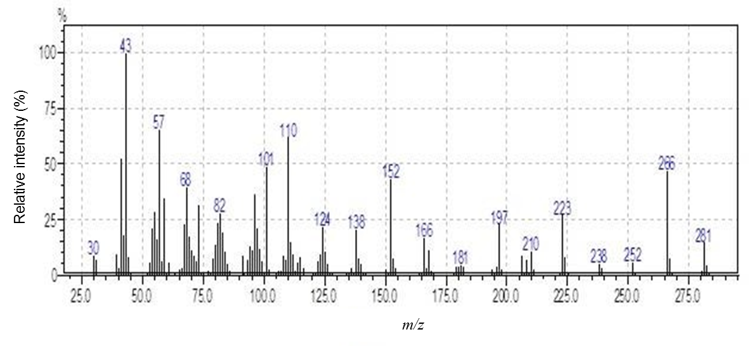
Figure S68. MS spectrum of 1-((2,2-dimethyl)1,3-dioxolan-4-yl)-4-heptyl-1H-1,2,3-triazole (4n).

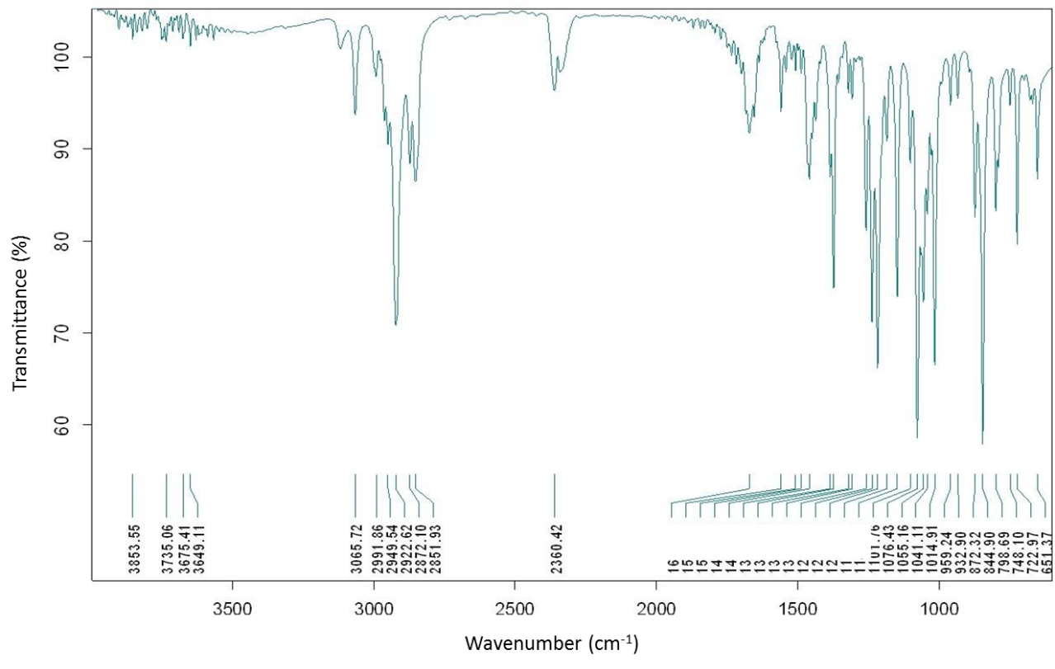
Figure S69. IR spectrum of 1-((2,2-dimethyl-1,3-dioxolan-4-yl)methyl)-4-octyl-1H-1,2,3-triazole (4o).

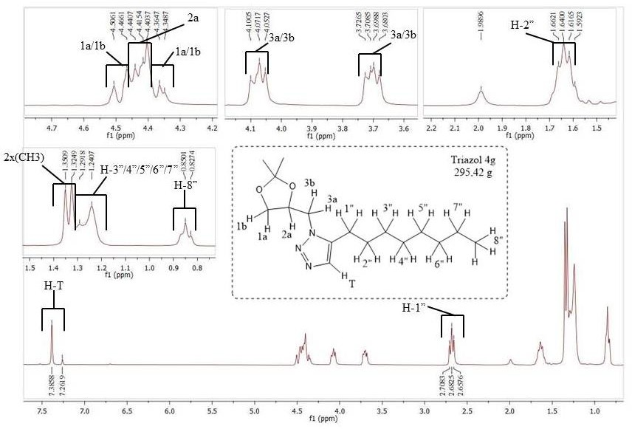
Figure S70. ¹H NMR spectrum (300 MHz, CDCl₃) of 1-((2,2-dimethyl-1,3-dioxolan-4-yl)methyl)-4-octyl-1H-1,2,3-triazole (4o).

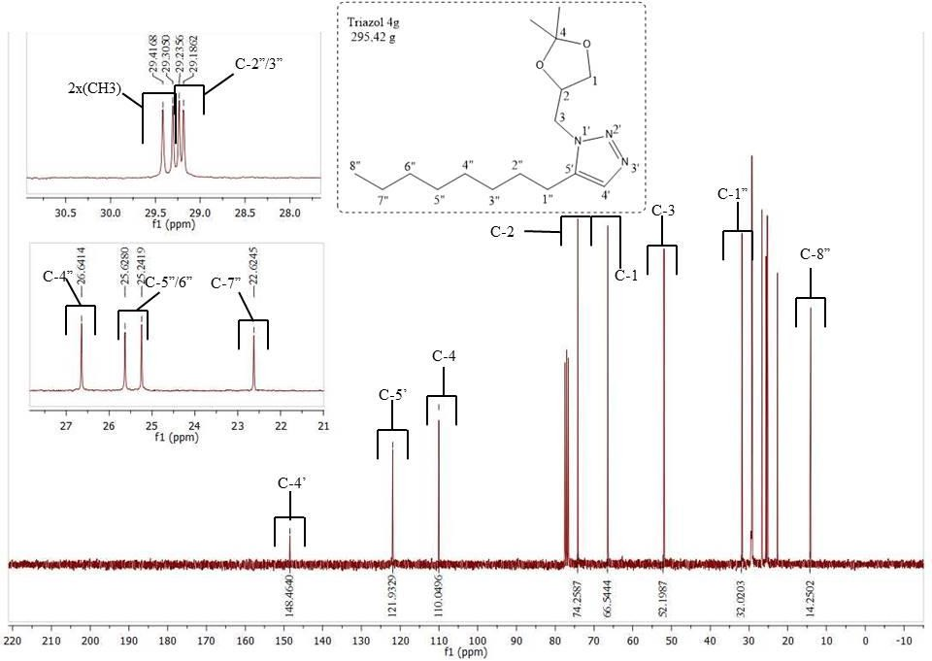
Figure S71. ¹³C NMR spectrum (75 MHz, CDCl₃) of 1-((2,2-dimethyl-1,3-dioxolan-4-yl)methyl)-4-octyl-1H-1,2,3-triazole (4o).

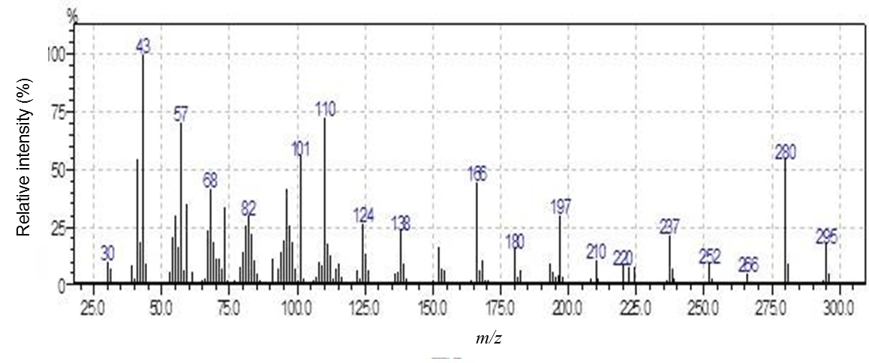
Figure S72. MS spectrum of 1-((2,2-dimethyl-1,3-dioxolan-4-yl)methyl)-4-octyl-1H-1,2,3-triazole (4o).

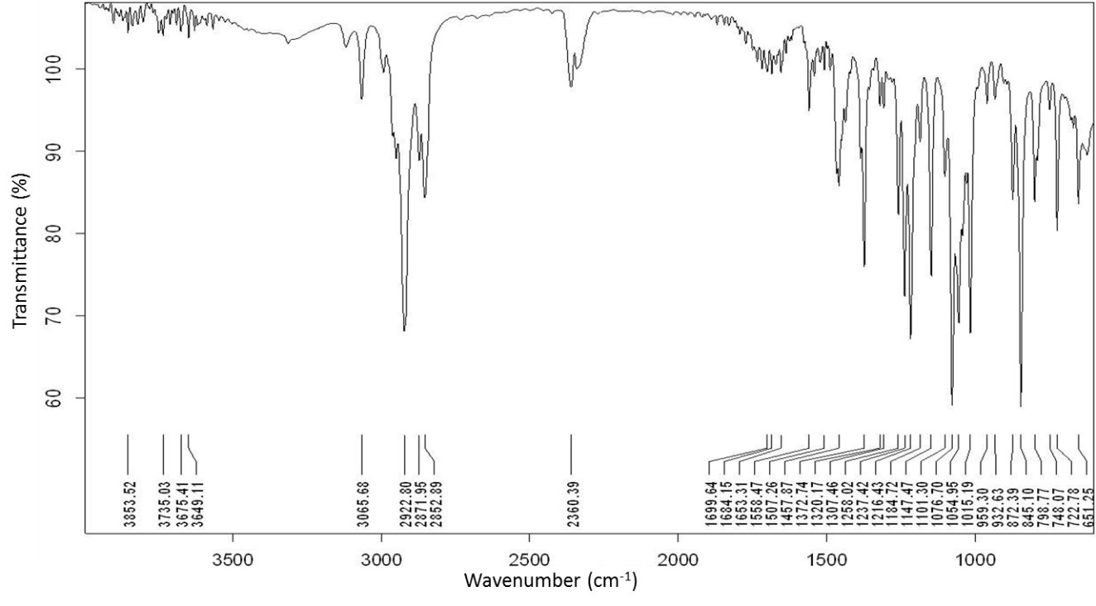
Figure S73. IR spectrum of 1-((2,2-dimethyl-1,3-dioxolan-4-yl)methyl)-4-nonyl-1H-1,2,3-triazole (4p).

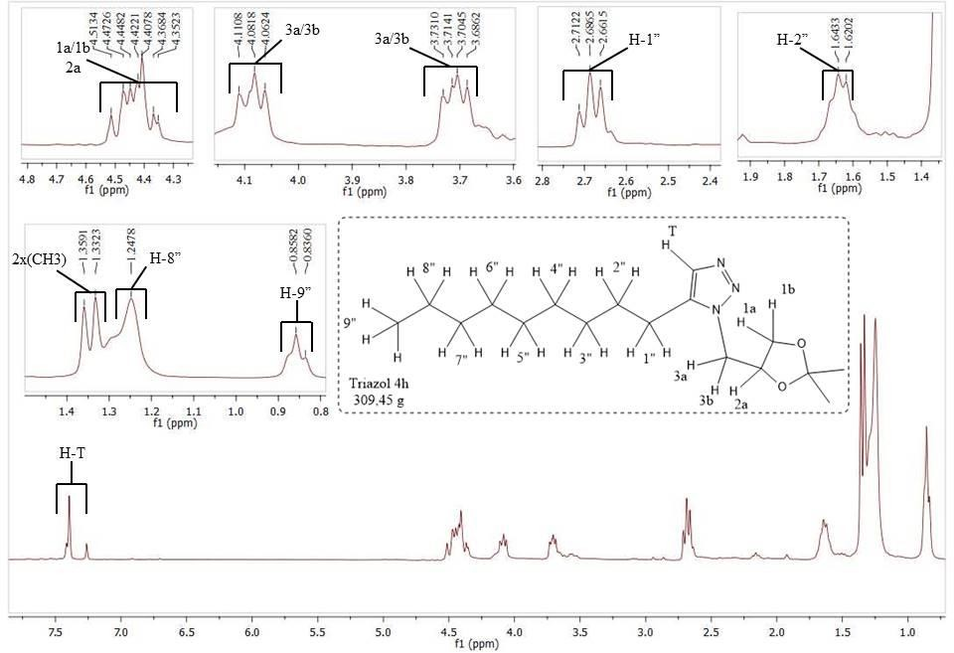
Figure S74. ¹H NMR spectrum (300 MHz, CDCl₃) of 1-((2,2-dimethyl-1,3-dioxolan-4-yl)methyl)-4-nonyl-1H-1,2,3-triazole (4p).

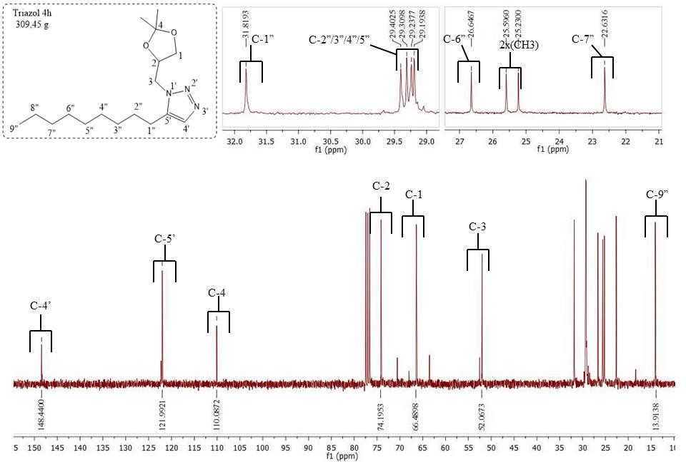
Figure S75. ¹³C NMR spectrum (75 MHz, CDCl₃) of 1-((2,2-dimethyl-1,3-dioxolan-4-yl)methyl)-4-nonyl-1H-1,2,3-triazole (4p).

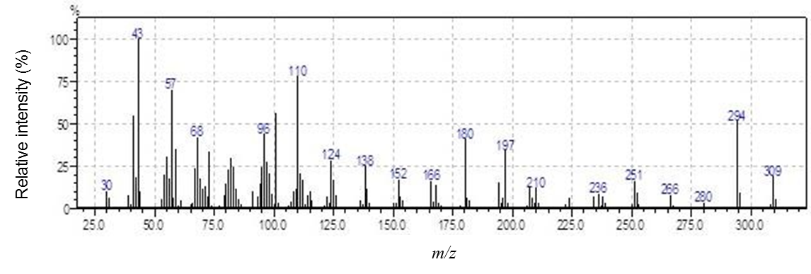
Figure S76. MS spectrum of 1-((2,2-dimethyl-1,3-dioxolan-4-yl)methyl)-4-nonyl-1H-1,2,3-triazole (4p).

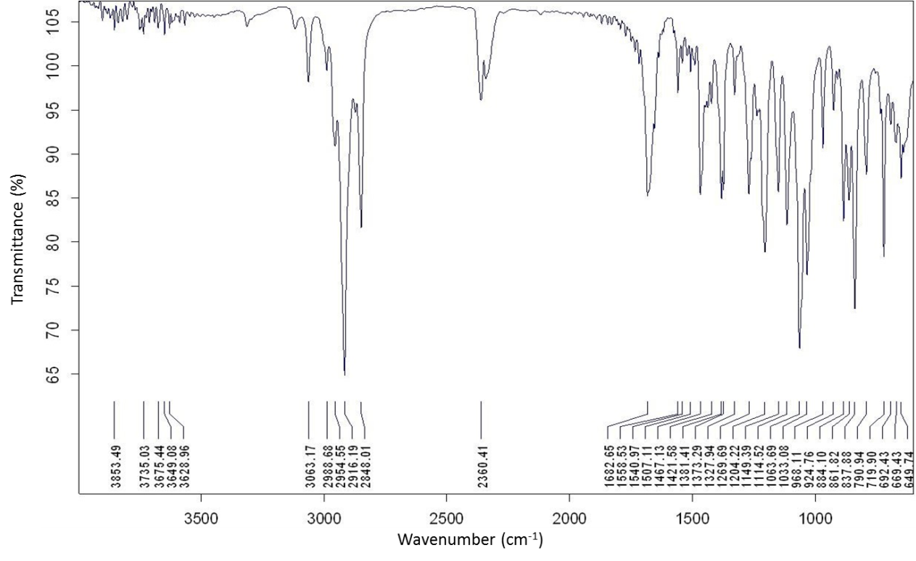
Figure S77. IR spectrum of 1-((2,2-dimethyl-1,3-dioxolan-4-yl)methyl)-4-decyl-1H-1,2,3-triazole (4q).

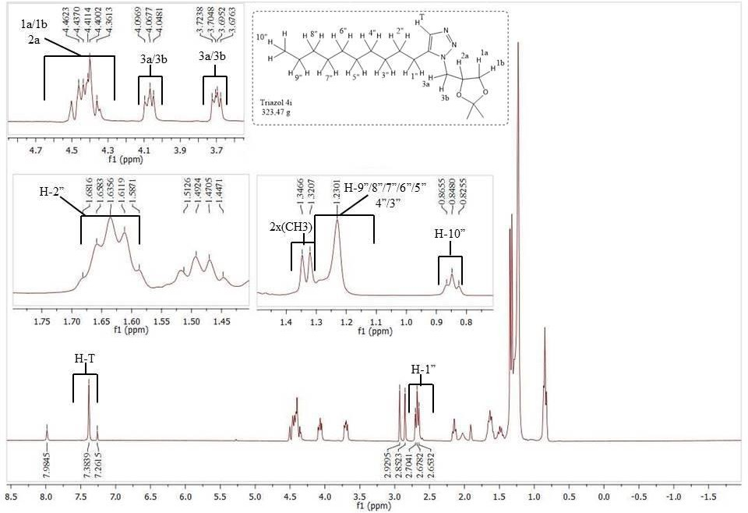
Figure S78. ¹H NMR spectrum (300 MHz, CDCl₃) of 1-((2,2-dimethyl-1,3-dioxolan-4-yl)methyl)-4-decyl-1H-1,2,3-triazole (4q).

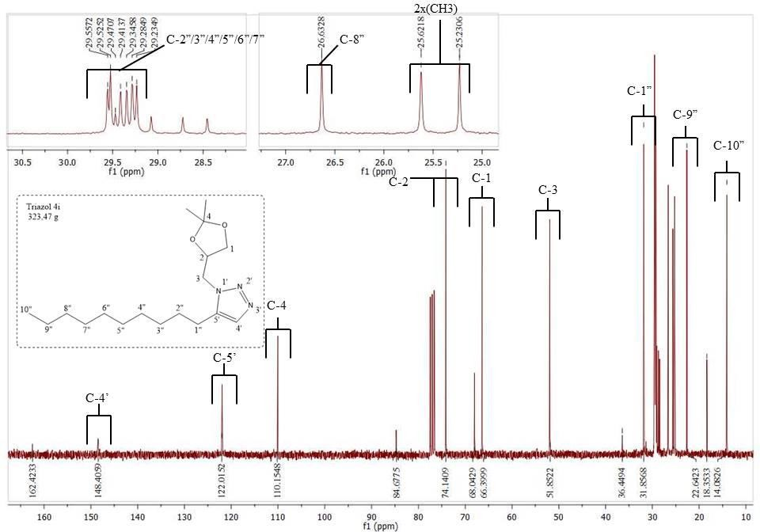
Figure S79. ¹³C NMR spectrum (75 MHz, CDCl₃) of 1-((2,2-dimethyl-1,3-dioxolan-4-yl)methyl)-4-decyl-1H-1,2,3-triazole (4q).

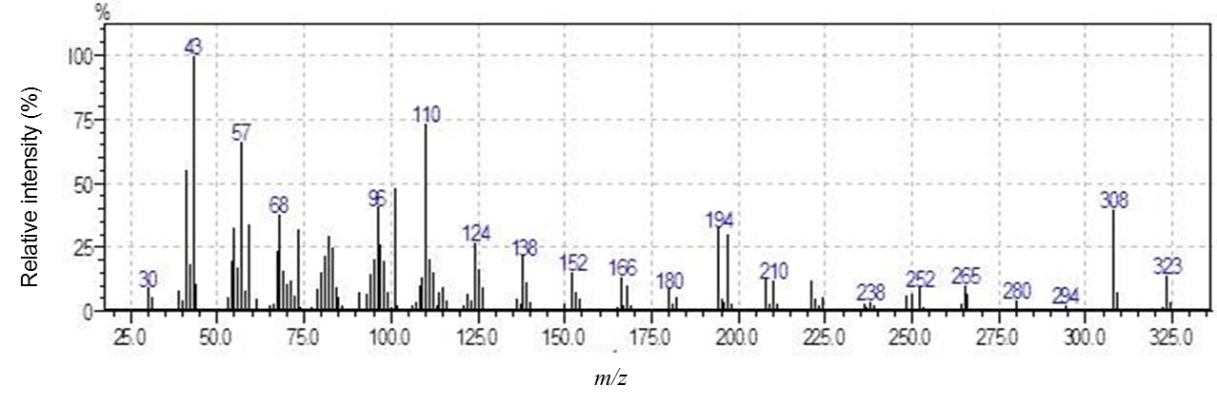
Figure S80. MS spectrum of 1-((2,2-dimethyl-1,3-dioxolan-4-yl)methyl)-4-decyl-1H-1,2,3-triazole (4q).

2. The structural characterization data of compounds 1, 2, 3, and triazoles 4a−4q.

Synthesis of (2,2-dimethyl-1,3-dioxolan-4-yl)methanol (1). Colorless liquid, prepared in 63% yield from the reaction between glycerol (100 mL, 1.36 mol), acetone (100 mL, 1.36 mol), p-toluenesulfonic acid (0.080 g, 0.460 mmol) and copper sulfate pentahydrate (10.000 g, 62.65 mmol); TLC (hexane-ethyl acetate 3:1 v v⁻¹); R_{f} = 0.35; IR (ATR) –v_{max}/cm⁻¹ 3385, 2937, 1372, 1213, 1156. ¹H NMR (300 MHz, CDCl₃) δ 1.27 (s, 3H), 1.33 (s, 3H), 2.99 (brs, 1H), 3.49 (dd, 1H, J 11.5, 5.2 Hz), 3.58 (dd, 1H, J 11.5, 4.2 Hz), 3.66 (dd, 1H, J 8.2, 6.6 Hz), 3.94 (dd, 1H, J 8.2, 6.6 Hz), 4.09−4.16 (m, 1H). ¹³C NMR (75 MHz, CDCl₃) δ 25.0, 26.4, 62.8, 65.6, 76.0, 109.1. MS (m/z, %): 117 ([M−15]+, 38), 101 (22), 72 (10), 57 (25), 43 (100), 31 (12).

Synthesis of (2,2-dimethyl-1,3-dioxolan-4-yl)methyl-4-methylbenzenesulfonate (2). Colorless liquid, prepared in 75% yield from the reaction between compound 1 (12.520 g, 98.48 mmol), pyridine (50 mL, 640.0 mmol) and 4-toluenesulfonyl chloride (27.000 g, 142.2 mmol); TLC (hexane-ethyl acetate 3:1 v v⁻¹); R_{f} = 0.89; IR (ATR) –v_{max}/cm⁻¹ 2995, 2985, 1600, 1365, 1265, 1176, 978. ¹H NMR (300 MHz, CDCl₃) δ 1.30 (s, 3H,), 1.33 (s, 3H,), 2.45 (s, 3H), 3.76 (dd, 1H, J 8.8 Hz, 5.2 Hz), 3.93−4.04 (m, 3H), 4.23−4.31 (m, 1H), 7.34 (d, 2H, J 8.2 Hz), 7.79 (d, 2H, J 8.2 Hz). ¹³C NMR (75 MHz, CDCl₃) δ 21.6, 25.1, 26.6, 66.1, 69.4, 72.8, 110.0, 127.9, 129.8, 132.4, 145.0. MS (m/z, %): 271 ([M −15]+, 90), 173 (10), 155 (76), 101 (86), 91(89), 65 (24), 59 (10), 43 (100), 31(4).

Synthesis of 4-(azidomethyl)-2,2-dimethyl-1,3-dioxolane (3). Yellow liquid, prepared in 93% yield from the reaction between compound 2 (0.900 g, 3.15 mmol), and sodium azide (1.000 g, 15.73 mmol); TLC (ether-dicloromethane 10:1 v v⁻¹); R_{f} = 0.51; IR (ATR) –v_{max}/cm⁻¹ 3497, 2932, 2102, 1736, 1662, 1439, 1386, 1244, 1091, 1046, 659. ¹H NMR (300 MHz, CDCl₃) δ 1.32 (s, 3H), 1.42 (s, 3H), 3.24 (dd, 1H, J 12.6, 5.4 Hz), 3.35 (dd, 1H, J 12.6, 4.7 Hz), 3.72 (dd, 1H, J 8.5, 5.7 Hz), 4.00 (dd, 1H, J 8.5, 6.3 Hz), 4.19−4.26 (m, 1H). ¹³C NMR (75 MHz, CDCl₃) δ 25.4, 26.6, 53.0, 66.7, 74.7, 110.2. MS (m/z, %): 142 ([M − 15]+, 39), 101 (61), 83 (4), 72 (10), 59 (12), 43 (100), 31 (5).

Synthesis of (1-((2,2-dimethyl-1,3-dioxolan-4-yl)methyl)-1H-1,2,3-triazol-4-yl)methanol (4a). Yellow liquid, prepared in 76% yield from the reaction between prop-2-yn-1-ol (0.538 g, 9.6 mmol) and azide 3 (1.000 g, 6.4 mmol); TLC (ether-dicloromethane 10:1 v v⁻¹); R_{f} = 0.32; IR (ATR) –v_{max}/cm⁻¹ 3355, 2972, 1472, 1365, 1202, 1040, 910, 833; ¹H NMR (300 MHz, CDCl₃) δ 1.32 (s, 3H), 1.37 (s, 3H), 3.44 (s, 1H), 3.72 (dd, 1H, J 8.8, 5.5 Hz), 4.10 (dd, 1H, J 8.8, 6.0 Hz), 4.38 (dd, 1H, J 12.9, 6.0 Hz), 4.41−4.48 (m, 1H), 4.53 (dd, 1H, J 12.9, 3.3 Hz), 4.75 (s, 2H), 7.68 (s, 1H). ¹³C NMR (75 MHz, CDCl₃) δ 25.3, 26.9, 52.5, 56.3, 66.6, 74.4, 110.6, 123.6, 148.0. MS (m/z, %): 213 ([M+], 1), 198 ([M − 15]+, 42), 155 (49), 138 (18), 113 (18), 101 (44), 83 (10), 73 (23), 57 (23), 43 (100), 31 (12).

Synthesis of 2-(1-((2,2-dimethyl-1,3-dioxolan-4-yl)methyl)-1H-1,2,3-triazol-4-yl)ethanol (4b). Yellow liquid, prepared in 82% yield from the reaction between but-3-yn-1-ol (0.673 g, 9.6 mmol) and azide 3 (1.000 g, 6.4 mmol); TLC (ether-dicloromethane 10:1 v v⁻¹); R_{f} = 0.35; IR (ATR) –v_{max}/cm⁻¹ 3384, 2928, 1648, 1554, 1457, 1373, 1217, 1151, 1116, 1051, 968, 880, 831. ¹H NMR (300 MHz, CDCl₃) δ 1.30 (s, 3H), 1.35 (s, 3H), 2.91 (t, 2H, J 6.3 Hz), 3.40 (s, 1H), 3.70 (dd, 1H, J 8.8, 5.5 Hz), 3.88 (t, 2H, J 6.3 Hz), 4.08 (dd, 1H, J 8.8, 6.0 Hz), 4.35 (dd, 1H, J 12.6, 5.4 Hz), 4.39−4.45 (m, 1H), 4.48 (dd, 1H, J 12.6, 3.3 Hz), 7.52 (s, 1H). ¹³C NMR (75 MHz, CDCl₃) δ 25.4, 26.9, 28.9, 52.5, 61.6, 66.6, 74.3, 110.4, 123.3, 145.4. MS (m/z, %): 228 ([M+], 2), 227 (M+, 2), 212 ([M − 15]+, 35), 197 (8), 169 (65), 152 (16), 127 (15), 110 (20), 101 (25), 68 (37), 57 (62), 43 (100), 32 (50).

Synthesis of 3-(1-((2,2-dimethyl-1,3-dioxolan-4-yl)methyl)-1H-1,2,3-triazol-4-yl)propan-1-ol (4c). Yellow liquid, prepared in 68% yield from the reaction between pent-4-yn-1-ol (0.808 g, 9.6 mmol) and azide 3 (1.000 g, 6.4 mmol); TLC (ether-dicloromethane 10:1 v v⁻¹); Rf = 0.37; IR (ATR) –v_{max}/cm⁻¹ 3380, 2938, 1648, 1552, 1456, 1373, 1257, 1216, 1151, 1058, 969, 880, 831. ¹H NMR (300 MHz, CDCl₃) δ 1.30 (s, 3H), 1.34 (s, 3H), 1.88 (quint, 2H, J 7.4, 6.3 Hz), 2.78 (t, 2H, J 7.4 Hz), 3.41(s, 1H), 3.69 (t, 2H, J 6.3 Hz), 3.70 (dd, 1H, J 8.7, 5.7 Hz), 4.07 (dd, 1H, J 8.7, 5.7 Hz),4.35 (dd, 1H, J 12.6, 5.2 Hz), 4.38−4.45 (m, 1H), 4.48 (dd, 1H, J 12.6, 3.2 Hz), 7.44 (s, 1H). ¹³C NMR (75 MHz, CDCl₃) δ 22.1, 25.4, 26.7, 32.2, 52.4, 61.7, 66.6, 74.3, 110.4, 122.6, 147.8. MS (m/z, %): 242 ([M+], 2), 241 ([M+], 4), 226 ([M − 15]+, 31), 211 (12), 197 (9), 183 (39), 166 (11), 112 (46), 101 (28), 83 (223), 68 (25), 57 (61), 43 (100), 41 (41), 31 (18).

Synthesis of 1-(1-((2,2-dimethyl-1,3-dioxolan-4-yl)methyl)-1H-1,2,3-triazol-4-yl)ethanol (4d). Yellow liquid, prepared in 75% yield from the reaction between but-3-yn-2-ol (0.673 g, 9.6 mmol) and azide 3 (1.000 g, 6.4 mmol); TLC (ether-dicloromethane 10:1 v v⁻¹); R_{f} = 0.37; IR (ATR) –v_{max}/cm⁻¹ 3385, 2985, 1373, 1217, 1149, 1066, 892, 830. ¹H NMR (300 MHz, CDCl₃) δ 1.33 (s, 3H), 1.37 (s, 3H), 1.58 (d, J 6.6 Hz), 3.50 (s, 1H), 3.73 (dd, 1H, J 8.8, 5.4 Hz), 4.10 (dd, 1H, J 8.8, 5.7 Hz), 4.39 (dd, 1H, J 12.9, 5.5 Hz), 4.42−4.49 (m, 1H), 4.52 (dd, 1H, J 12.9, 3.0 Hz), 5.07 (q, 1H, J 6.6 Hz), 7.61 (s, 1H). ¹³C NMR (75 MHz, CDCl₃) δ 23.0, 25.1, 26.6, 52.2, 62.9, 66.3, 74.0, 110.1, 121.4, 152.7. MS (m/z, %): 228 ([M+], 1), 227 ([M+], 1), 212 ([M−15]+, 36), 169 (38), 152 (16), 127 (12), 101 (36), 73 (23), 57 (29), 43 (100), 31 (8).

Synthesis of 1-(1-((2,2-dimethyl-1,3-dioxolan-4-yl)methyl)-1H-1,2,3-triazol-4-yl)propan-2-ol (4e). Yellow liquid, prepared in 70% yield from the reaction between pent-4-yn-2-ol (0.808 g, 9.6 mmol) and azide 3 (1.000 g, 6.4 mmol); TLC (ether-dicloromethane 10:1 v v⁻¹); R_{f} = 0.29; IR (ATR) –v_{max}/cm⁻¹ 3384, 2985, 1648, 1552, 1457, 1373, 1216, 1151, 1117, 1065, 1045, 968, 941, 880, 831. ¹H NMR (300 MHz, CDCl₃) δ 1.26 (d, 3H, J 6.3 Hz), 1.33 (s, 3H), 1.37 (s, 3H), 2.72−292 (m, 1H), 3.46 (s, 1H), 3.74 (dd, 1H, J 8.8, 5.7 Hz), 4.10 (dd, 1H, J 8.8, 5.8 Hz), 4.15−4.17 (m, 2H), 4.39 (dd, 1H, J 12.6, 5.7 Hz), 4.42−4.49 (m, 1H), 4.52 (dd, 1H, J 12.6, 3.3 Hz), 7.52 (s, 1H). ¹³C NMR (75 MHz, CDCl₃) δ 23.1, 25.4, 26.9, 35.0, 52.5, 66.6, 67.3, 74.3, 110.4, 123.4, 145.5. MS (m/z, %): 242 ([M+], 1), 226 ([M − 15]+, 31), 197 (94), 183 (12), 166 (11), 139 (22), 115 (26), 101 (22), 83 (26),68 (50), 57 (69), 43 (100).

Synthesis of 2-(1-((2,2-dimethyl-1,3-dioxolan-4-yl)methyl)-1H-1,2,3-triazol-4-yl)butan-2-ol (4f). Yellow liquid, prepared in 84% yield from the reaction between 3-methylpent-1-yn-3-ol (0.942 g, 9.6 mmol) and azide 3 (1.000 g, 6.4 mmol); TLC (ether-dicloromethane 10:1 v v⁻¹); R_{f} = 0.42; IR (ATR) –v_{max}/cm⁻¹ 3407, 2979, 1457, 1373, 1217, 1151, 1046, 993, 919, 831. ¹H NMR (300 MHz, CDCl₃) δ 0.84 (t, 3H, J 7.4 Hz), 1.33 (s, 3H), 1.35 (s, 3H), 1.56 (d, 3H, J 3.6 Hz), 1.89 (sept, 2H, J 7.4 Hz), 3.46 (s, 1H), 3.71 (dd, 1H, J 8.7, 5.5 Hz), 4.09 (dd, 1H, J 8.7, 6.0 Hz), 4.39 (dd, 1H, J 12.9, 5.2 Hz), 4.42−4.49 (m, 1H), 4.51 (dd, 1H, J 12.9, 4.4 Hz), 7.55 (s, 1H). ¹³C NMR (75 MHz, CDCl₃) δ 8.5, 25.4, 26.7, 28.2, 36.1, 52.3, 66.6, 71.4, 74.4, 110.4, 121.5, 154.7. MS (m/z, %): 256 ([M+], 1), 240 ([M − 15]+, 25), 226 (95), 180 (9), 125 (40), 101 (20), 84 (22), 57 (45), 43 (100), 31 (9).

Synthesis of 1-(1-((2,2-dimethyl-1,3-dioxolan-4-yl)methyl)-1H-1,2,3-triazol-4-yl)cyclohexanol (4g). White solid, prepared in 65% yield from the reaction between 1-ethynylcyclohexan-1-ol (1.192 g, 9.6 mmol) and azide 3 (1.000 g, 6.4 mmol); TLC (ether-dicloromethane 10:1 v v⁻¹); R_{f} = 0.26; m.p. 85−88 ºC; IR (ATR) –v_{max}/cm⁻¹ 3290, 2933, 1448, 1371, 1223, 1162, 1071, 968, 898, 828. ¹H NMR (300 MHz, CDCl₃) δ 1.34 (s, 3H), 1.36 (s, 3H), 1.52−1.99 (m, 10H), 3.48 (s, 1H), 3.73 (dd, 1H, J 8.5, 5.4 Hz), 4.11 (dd, 1H, J 8.5, 6.0 Hz), 4.38−4.55 (m, 3H), 7.58 (s, 1H). ¹³C NMR (75 MHz, CDCl₃) δ 21.9, 23.1, 25.3, 26.6, 38.1, 39.7, 52.1, 66.4, 69.5, 72.0, 74.0, 110.1, 121.0, 152.0. MS (m/z, %): 281 ([M+], 33), 263 (32), 248 (34), 238 (18), 210 (19), 176 (12), 152 (19), 134 (39), 121 (18), 101 (27), 79 (35), 68 (33), 57 (65), 43 (100), 31 (12).

Synthesis of 2-(1-((2,2-dimethyl-1,3-dioxolan-4-yl)methyl)-1H-1,2,3-triazol-4-yl)propan-2-ol (4h). Yellow liquid, prepared in 73% yield from the reaction between 2-methylbut-3-yn-2-ol (0.808 g, 9.6 mmol) and azide 3 (1.000 g, 6.4 mmol); TLC (ether-dicloromethane 10:1 v v⁻¹); R_{f} = 0.37; IR (ATR) –v_{max}/cm⁻¹ 3388, 2983, 1457, 1374, 1212, 1150, 1052, 960, 830. ¹H NMR (300 MHz, CDCl₃) δ 1.32 (s, 3H), 1.34 (s, 3H), 1.61 (s, 3H), 1.62 (s, 3H), 2.98 (s, 1H), 3.72 (dd, 1H, J 8.8, 5.2Hz), 4.09 (dd, 1H, J 8.8, 5.7 Hz), 4.38 (dd, 1H, J 12.6, 5.2 Hz), 4.41−4.47 (m, 1H), 4.51 (dd, 1H, J 12.6, 3.3 Hz), 7.57 (s, 1H). ¹³C NMR (75 MHz, CDCl₃) δ 25.1, 26.6, 30.2, 30.4, 52.1, 66.3, 68.3, 73.9, 110.1, 120.6, 155.7. MS (m/z, %): 241 ([M+], 1), 226 ([M − 15]+, 49), 208 (11), 183 (24), 166 (10), 101 (35), 94 (24), 73 (21), 57 (38), 43 (100), 31 (12).

Synthesis of 1-((2,2-dimethyl-1,3-dioxolan-4-yl)methyl)-4-propyl-1H-1,2,3-triazole (4i). Yellow liquid, prepared in 85% yield from the reaction between pent-1-yne (1.300 g, 19.2 mmol) and azide 3 (2.000 g, 12.8 mmol); TLC (ether-dicloromethane 10:1 v v⁻¹); R_{f} = 0.61; IR (ATR) –v_{max}/cm⁻¹ 2984, 1372, 1216, 1064, 832, 798; ¹H NMR (300 MHz, CDCl₃) δ 0.93 (t, 3H, J 9.0 Hz), 1.31 (s, 3H), 1.34 (s, 3H), 1.67 (sept, 2H, J 9.0 Hz), 2.66 (t, 2H, J 9.0 Hz), 3.70 (dd, 1H, J 9.0, 6.0 Hz), 4.07 (dd, 1H, J 9.0, 6.0 Hz), 4.37 (dd, 1H, J 12.0, 6.0 Hz), 4.40−4.45 (m, 1H), 4.48 (dd, 1H, J 12.0, 3.0 Hz), 7.38 (s,1H); ¹³C NMR (75 MHz, CDCl₃) δ 14.0, 22.9, 25.4, 26.8, 27.8, 52.1, 66.6, 74.3, 110.2, 122.2, 148.3; MS (m/z, %) 225 ([M+], 4), 210 ([M − 15]+, 3), 168 (11), 167 (46), 150 (13), 125 (13), 110 (50), 101 (30), 82 (1), 73 (27), 68 (35), 57 (57), 43 (100), 32 (17).

Synthesis of 1-((2,2-dimethyl-1,3-dioxolan-4-yl)methyl)-4-butyl-1H-1,2,3-triazole (4j). White solid, prepared in 93% yield from the reaction between hex-1-yne (1.600 g, 19.2 mmol) and azide 3 (2.000 g, 12.8 mmol); TLC (ether-dichloromethane 10:1 v v⁻¹); R_{f} = 0.60; m.p. 52−53 ºC; IR (ATR) –v max/cm⁻¹ 3067, 2927, 1312, 1236, 1183, 1014, 844, 798, 648; ¹H NMR (300 MHz, CDCl₃) δ 0.93 (t, 3H, J 9.0 Hz), 1.34 (s, 3H), 1.37 (s, 3H), 1.38 (sept, 2H, J 9.0 Hz), 1.68 (quint, 2H, J 9.0 Hz), 2.71 (t, 2H, J 9.0 Hz), 3.77 (dd, 1H, J 9.0, 6.0 Hz), 4.10 (dd, 1H, J 9.0, 6.0 Hz), 4.40 (dd, 1H, J 12.0, 6.0 Hz), 4.40−4.45 (m, 1H), 4.51 (dd, 1H, J 12.0, 6.0 Hz), 7.40 (s, 1H);¹³C NMR (75 MHz, CDCl₃) δ 14.0, 22.5, 25.5, 25.5, 26.8, 31.7, 52.2, 66.6, 74.4, 110.3, 122.1, 148.7; MS (m/z, %) 239 ([M+], 6), 124 ([M − 15]+, 25), 224 (40), 181 (48), 164 (11), 139 (16), 110 (66), 101 (38), 82 (27), 68 (41), 57 (74), 43 (100), 31 (10).

Synthesis of 1-((2,2-dimethyl-1,3-dioxolan-4-yl)methyl)-4-pentyl-1H-1,2,3-triazole (4k). White solid, prepared in 87% yield from the reaction between hep-1-yne (1.800 g, 19.2 mmol) and azide 3 (2.000 g, 12.8 mmol); TLC (ether-dichloromethane 10:1 v v⁻¹); R_{f} = 0.60; m.p. 32−33 ºC; IR (ATR) –v_{max} /cm⁻¹ 2968, 2926,1380, 1269, 1204, 1062, 1032, 884, 836; ¹H NMR (300 MHz,CDCl₃) δ 0.88 (t, 3H, J 9.0 Hz), 1.33 (s, 3H), 1.36 (s, 3H), 1.37 (sept, 4H, J 9.0 Hz), 1.65 (quint, 2H, J 9.0 Hz), 2.70 (t, 2H, J 9.0 Hz), 3.71 (dd, 1H, J 9.0, 6.0 Hz), 4.09 (dd, 1H, J 9.0, 6.0 Hz), 4.39 (dd, 1H, J 12.0, 9.0 Hz), 4.38−4.46 (m,1H), 4.50 (dd, 1H, J 12.0, 9.0 Hz), 7.39 (s, 1H); ¹³C NMR (75 MHz, CDCl₃) δ 14.2, 22.6, 25.5, 25.8, 26.9, 29.3, 31.6, 52.1, 66.6, 74.3, 110.3, 122.1, 148.7; MS (m/z, %) 253 ([M+], 12), 238 ([M − 15]+, 50), 195 (47), 178 (11), 138 (27), 124 (69), 110 (36), 101 (49), 73 (30), 57 (73), 43 (100), 30 (10).

Synthesis of 1-((2,2-dimethyl-1,3-dioxolan-4-yl)methyl)-4-hexyl-1H-1,2,3-triazole (4l). White solid, prepared in 75% yield from the reaction between oct-1-yne (2.110 g, 19.2 mmol) and azide 3 (2.000 g, 12.8 mmol); TLC (ether-dichloromethane 10:1 v v⁻¹); R_{f} = 0.68; m.p. 58−60 ºC; IR (ATR) –v_{max}/cm⁻¹ 2871, 1372, 1216, 1147, 1076, 1014, 844, 798; ¹H NMR (300 MHz, CDCl₃) δ 0.86 (t, 3H, J 9.0 Hz), 1.30 (sept, 6H, J 9.0 Hz), 1.33 (s, 3H), 1.35 (s, 3H), 1.64 (quint, 2H, J 9.0 Hz), 2.69 (t, 2H, J 9.0 Hz), 3.70 (dd, 1H, J 9.0, 6.0 Hz), 4.07 (dd, 1H, J 9.0, 6.0 Hz), 4.37 (dd, 1H, J 12.0, 6.0 Hz), 4.40−4.46 (m, 1H), 4.49 (dd, 1H, J 12.0, 6.0 Hz), 7.39 (s, 1H); ¹³C NMR (75 MHz, CDCl₃) δ 14.2, 22.7, 25.4, 25.8, 26.8, 29.1, 29.6, 31.7, 52.1, 66.6, 74.3, 110.3, 122.1, 148.6; MS (m/z, %) 267 ([M+], 15), 252 ([M − 15]+, 52), 209 (40), 192 (10), 168 (9), 152 (20), 138 (67), 124 (22), 101 (52), 96 (36), 68 (39), 57 (71), 43 (100), 30 (10).

Synthesis of 4-(1-((2,2-dimethyl-1,3-dioxolan-4-yl)methyl)-4-(4-hydroxybutyl)-1H-1,2,3-triazole (4m). Yellow solid, prepared in 81% yield from the reaction between hex-5-yn-1-ol (1.400 g, 14.4 mmol) and azide 3 (1.500 g, 9.60 mmol); TLC (ether-dichloromethane 10:1 v v⁻¹); R_{f} = 0.15; m.p. 57−58 ºC; IR (ATR) ̅v_{max}/cm⁻¹ 3450, 3059, 2933, 1269, 1203, 1051, 883, 837, 791; ¹H NMR (300 MHz, CDCl₃) δ 1.32 (s, 3H), 1.35 (s, 3H), 1.61 (quint, 2H, J 12.0 Hz) 1.74 (quint, 2H, J 9.0 Hz), 2.41 (s, 1H, OH), 2.72 (t, 2H, J 9.0 Hz), 3.66 (dd, 1H, J 9.0, 6.0 Hz), 4.08 (dd, 1H, J 9.0, 6.0 Hz), 4.34 (dd, 1H, J 12.0, 6.0 Hz), 4.35−4.45 (m,1H), 4.48 (dd, 1H, J 12.0, 6.0 Hz), 7.42 (s, 1H); ¹³C NMR (75 MHz, CDCl₃) δ 25.2, 25.5, 26.6, 32.1, 52.0, 62.1, 66.4, 74.1, 110.1, 122.1, 148.0; MS (m/z, %) 255 ([M+], 3), 240 ([M − 15]+, 8), 210 (13), 197 (10), 126 (7), 101 (13), 69 (13), 57 (21), 43 (53), 32 (100).

Synthesis of 1-((2,2-dimethyl)1,3-dioxolan-4-yl)-4-heptyl-1H-1,2,3-triazole (4n). White solid, prepared in 85% yield from the reaction between non-1-yne (1.780 g, 14.4 mmol) and azide 3 (1.500 g, 9.60 mmol); TLC (ether-dichloromethane 10:1 v v⁻¹); R_{f} = 0.68; m.p. 45−47 ºC; IR (ATR) –v_{max} /cm⁻¹ 2954, 2919, 2851, 2360, 1380, 1320, 1150, 1030, 924; ¹H NMR (300 MHz, CDCl₃) δ 0.85 (t, 3H, J 9.0 Hz), 1.29 (sept, 8H, J 9.0 Hz), 1.33 (s, 3H), 1.35 (s, 3H), 1.64 (quint, 2H, J 9.0 Hz), 2.69 (t, 2H, J 9.0 Hz), 3.69 (dd, 1H, J 9.0, 6.0 Hz), 4.09 (dd, 1H, J 9.0, 6.0 Hz), 4.32 (dd, 1H, J 12.0, 6.0 Hz), 4.39−4.43 (m, 1H), 4.43 (dd, 1H, J 12.0, 6.0 Hz), 7.39 (s, 1H); ¹³C NMR (75 MHz, CDCl₃) δ 14.0, 22.6, 22.2, 25.6, 26.6, 29.0, 29.1, 29.4, 31.7, 51.9, 66.4, 74.1, 110.0, 122.0, 148.5; MS (m/z, %) 281 ([M+], 13), 266 ([M − 15]+, 44), 223 (25), 210 (10), 197 (21), 166 (16), 152 (41), 138 (19), 124 (21), 110 (60), 101 (46), 82 (27), 68 (39), 57 (64), 43 (100), 30 (8).

Synthesis of 1-((2,2-dimethyl-1,3-dioxolan-4-yl)methyl)-4-octyl-1H-1,2,3-triazole (4o). White solid, prepared in 92% yield from the reaction between dec-1-yne (1.980 g, 14.4 mmol) and azide 3 (1.500 g, 9.60 mmol); TLC (ether-dichloromethane 10:1 v v⁻¹); R_{f} = 0.69; m.p. 64−65 ºC; IR (ATR) –v_{max}/cm⁻¹ 2991, 2949, 2922, 2872, 2360, 1458, 1372, 1101, 844; ¹H NMR (300 MHz, CDCl₃) δ 0.85 (t, 3H, J 9.0 Hz), 1.25 (sept, 10H, J 9.0 Hz), 1.31 (s, 3H), 1.34 (s, 3H), 1.63 (quint, 2H, J 9.0 Hz), 2.68 (t, 2H, J 9.0 Hz), 3.70 (dd, 1H, J 9.0, 6.0 Hz), 4.08 (dd, 1H, J 9.0, 6.0 Hz), 4.36 (dd, 1H, J 12.0, 6.0 Hz), 4.35−4.45 (m, 1H), 4.49 (dd, 1H, J 12.0, 6.0 Hz), 7.47 (s, 1H); ¹³C NMR (75 MHz, CDCl₃) δ 14.0, 22.6, 25.2, 25.6, 26.6, 29.1, 29.2, 29.3, 29.4, 31.8, 51.9, 66.4, 74.1, 110.0, 121.9, 148.4; MS (m/z, %) 295 ([M+], 15), 280 ([M − 15]+,48), 237 (19), 210 (9), 197 (27), 180 (14), 166 (40), 138 (21), 124 (25), 110 (68), 101 (50), 82 (29), 68 (40), 57 (67), 43 (100), 32 (93).

Synthesis of 1-((2,2-dimethyl-1,3-dioxolan-4-yl)methyl)-4-nonyl-1H-1,2,3-triazole (4p). White solid, prepared in 88% yield from the reaction between undec-1-yne (0.500 g, 3.28 mmol) and azide 3 (0.562 g, 3.62 mmol); TLC (ether-dichloromethane 10:1 v v⁻¹); R_{f} = 0.69; m.p. 55−57 ºC; IR (ATR) –v_{max}/cm⁻¹ 2922, 2852, 2360, 1507, 1307, 1258, 1184, 1076, 845; ¹H NMR (300 MHz, CDCl₃) δ 0.85 (t, 3H, J 9.0 Hz), 1.25 (sext, 6H, J 9.0 Hz), 1.33 (s, 3H), 1.36 (s, 3H), 1.65 (quint, 2H, J 9.0 Hz), 2.69 (t, 2H, J 9.0 Hz), 3.71 (dd, 1H, J 9.0, 6.0 Hz), 4.09 (dd, 1H, J 9.0, 6.0 Hz), 4.36 (dd, 1H, J 12.0, 6.0 Hz), 4.42−4.45 (m, 1H), 4.46 (dd, 1H, J 12.0,6.0 Hz), 7.48 (s, 1H); ¹³C NMR (75 MHz, CDCl₃) δ 14.0, 22.6, 25.2, 25.6, 26.6, 29.1, 29.2, 29.3, 29.4, 31.8, 51.9, 66.4, 74.1, 110.0, 121.9, 148.4; MS (m/z, %) 309 ([M+], 16), 294 ([M − 15]+, 47), 251 (14), 210 (11), 197 (32), 180 (37), 166 (15), 152 (16), 138 (23), 124 (27), 110 (75), 96 (43), 68 (41), 57 (68), 43 (100), 32 (29).

Synthesis of 1-((2,2-dimethyl-1,3-dioxolan-4-yl)methyl)-4-decyl-1H-1,2,3-triazole (4q). White solid, prepared in 94% yield from the reaction between dodec-1-yne (2.390 g, 14.4 mmol) and azide 3 (1.500 g, 9.60 mmol); TLC (ether-dichloromethane 10:1 v v⁻¹); R_{f} = 0.53; m.p. 54−56 ºC; IR (ATR) –v_{max} /cm⁻¹ 3063, 2954, 2916, 2848, 2360, 1682, 1558, 1540, 1269, 1063, 837; ¹H NMR (300 MHz, CDCl₃) δ 0.85 (t, 3H, J 9.0 Hz), 1.30 (sext, 14H, J 9.0 Hz), 1.32 (s, 3H), 1.35 (s, 3H), 1.64 (quint, 2H, J 9.0 Hz), 2.68 (t, 2H, J 9.0 Hz), 3.70 (dd, 1H, J 12.0, 6.0 Hz), 4.07 (dd, 1H, J 12.0, 6.0 Hz), 4.35 (dd, 1H, J 9.0, 6.0 Hz), 4.39−4.44 (m, 1H), 4.45 (dd, 1H, J 9.0, 6.0 Hz), 7.39 (s, 1H); ¹³C NMR (75 MHz, CDCl₃) δ 14.0, 22.6, 25.2, 25.6, 26.6, 29.1, 29.2, 29.3, 29.4, 29.5, 29.5, 31.8, 51.9, 66.4, 74.1, 110.0, 121.9, 148.4; MS (m/z, %) 323 ([M+], 3), 308 ([M − 15]+, 9), 210 (2), 194 (7), 168 (2), 152 (3), 138 (5), 124 (6), 110 (19), 96 (11), 69 (18), 57 (17), 44 (34), 32 (100).

3. The biological assay data of triazole derivatives (4a−4q)

Figure S81. Effects of glycerol-derived triazoles on the mycelial growth of Neocosmospora falciformis

Supplementary Material – Table S1. ANOVA for mycelial growth diameter (cm) of Neocosmospora falciformis UENF/CF 295 at different concentrations of the tested compounds (n = 5).

Concentration: 1 µg/mL
Source of Variation | DF | SS | MS | F | p-value
Treatment | 17 | 3.284 | 0.193 | 1.027 | 0.447 ns
Residual | 72 | 13.548 | 0.188 | – | –
Total | 89 | 16.832 | – | – | –

Concentration: 10 µg/mL
Source of Variation | DF | SS | MS | F | p-value
Treatment | 17 | 6.912 | 0.407 | 2.174 | 0.020 *
Residual | 72 | 13.484 | 0.187 | – | –
Total | 89 | 20.396 | – | – | –

Concentration: 100 µg/mL
Source of Variation | DF | SS | MS | F | p-value
Treatment | 17 | 49.873 | 2.934 | 13.674 | < 0.001 ***
Residual | 72 | 15.452 | 0.215 | – | –
Total | 89 | 65.325 | – | – | –

Concentration: 500 µg/mL
Source of Variation | DF | SS | MS | F | p-value
Treatment | 17 | 160.245 | 9.426 | 44.936 | < 0.001 ***
Residual | 72 | 15.108 | 0.210 | – | –
Total | 89 | 175.353 | – | – | –

Concentration: 1000 µg/mL
Source of Variation | DF | SS | MS | F | p-value
Treatment | 17 | 212.388 | 12.493 | 84.278 | < 0.001 ***
Residual | 72 | 10.672 | 0.148 | – | –
Total | 89 | 223.060 | – | – | –

Legend for Table S1
- DF: degrees of freedom
- SS: sum of squares
- MS: mean square
- F: F-statistic
- p-value: statistical significance
- ns: not significant (p > 0.05)
- *** p < 0.001; ** p < 0.01; * p < 0.05
Five replicates per treatment (n = 5). Data met assumptions of homogeneity of variances (Bartlett’s test) and normality of residuals (Shapiro–Wilk test). Means were grouped by the Scott-Knott test at 5% significance, as shown in Table 1 of the main article.

Supplementary Material – Table S2. ANOVA for the average number of spores produced by Neocosmospora falciformis UENF/CF 295 at different concentrations of the tested compounds (n = 5).
Concentration: 1 µg/mL
Source of Variation | DF | SS | MS | F | p-value
Treatment | 17 | 14,872.3 | 874.84 | 4.62 | < 0.001 ***
Residual | 72 | 13,634.7 | 189.37 | – | –
Total | 89 | 28,507.0 | – | – | –

Concentration: 10 µg/mL
Source of Variation | DF | SS | MS | F | p-value
Treatment | 17 | 62,847.5 | 3,696.9 | 18.73 | < 0.001 ***
Residual | 72 | 14,212.6 | 197.40 | – | –
Total | 89 | 77,060.1 | – | – | –

Concentration: 100 µg/mL
Source of Variation | DF | SS | MS | F | p-value
Treatment | 17 | 97,917.3 | 5,759.8 | 29.21 | < 0.001 ***
Residual | 72 | 14,197.2 | 197.18 | – | –
Total | 89 | 112,114.5 | – | – | –

Concentration: 500 µg/mL
Source of Variation | DF | SS | MS | F | p-value
Treatment | 17 | 154,839.6 | 9,108.2 | 48.12 | < 0.001 ***
Residual | 72 | 13,628.3 | 189.28 | – | –
Total | 89 | 168,467.9 | – | – | –

Concentration: 1000 µg/mL
Source of Variation | DF | SS | MS | F | p-value
Treatment | 17 | 558,681.1 | 32,863.6 | 172.87 | < 0.001 ***
Residual | 72 | 13,686.2 | 190.09 | – | –
Total | 89 | 572,367.3 | – | – | –

Legend for Table S2
- DF: degrees of freedom
- SS: sum of squares
- MS: mean square
- F: F-statistic
- p-value: statistical significance
- *** p < 0.001
Five replicates per treatment (n = 5). Data met assumptions of homogeneity of variances (Bartlett’s test) and normality of residuals (Shapiro–Wilk test). Means were grouped by the Scott-Knott test at 5% significance, as shown in Table 3 of the main article.

