Table 1. Exploratory factor analysis and factor loadings (EFA) of C-NICAS

Item number | Pattern matrix: factor 1 | Pattern matrix: factor 2 | Pattern matrix: factor 3 | Structure matrix: factor 1 | Structure matrix: factor 2 | Structure matrix: factor 3 | Communalities
Q1 | 0.498 | 0.265 | 0.689 | 0.830 | 0.716 | 0.906 | 0.666
Q2 | 0.603 | 0.350 | 0.551 | 0.902 | 0.784 | 0.880 | 0.709
Q3 | 0.299 | 0.922 | 0.272 | 0.673 | 0.939 | 0.599 | 0.652
Q4 | 0.451 | 0.686 | 0.247 | 0.760 | 0.858 | 0.675 | 0.583
Q5 | 0.213 | 0.839 | 0.326 | 0.658 | 0.918 | 0.697 | 0.627
Q6 | 0.263 | 0.725 | 0.566 | 0.661 | 0.897 | 0.827 | 0.667
Q7 | 0.261 | 0.606 | 0.754 | 0.707 | 0.886 | 0.948 | 0.762
Q8 | 0.270 | 0.204 | 0.725 | 0.689 | 0.690 | 0.985 | 0.887
Q9 | 0.295 | 0.663 | 0.640 | 0.610 | 0.638 | 0.709 | 0.815
Q10 | 0.406 | 0.925 | 0.424 | 0.548 | 0.934 | 0.713 | 0.675
Q11 | 0.323 | 0.746 | 0.593 | 0.630 | 0.899 | 0.831 | 0.677
Q12 | 0.366 | 0.821 | 0.491 | 0.569 | 0.891 | 0.745 | 0.627
Q13 | 0.214 | 0.749 | 0.330 | 0.425 | 0.667 | 0.375 |  | 0.331
Q14 | 0.683 | 0.655 | 0.426 | 0.810 | 0.805 | 0.523 |  | 0.596
Q15 | 0.670 | 0.223 | 0.517 | 0.848 | 0.630 | 0.788 |  | 0.582
Q16 | 0.513 | 0.367 | 0.518 | 0.801 | 0.729 | 0.802 |  | 0.568
Q17 | 0.636 | 0.668 | 0.343 | 0.821 | 0.839 | 0.586 |  | 0.615
Q18 | 0.329 | 0.206 | 0.881 | 0.736 | 0.657 | 0.956 |  | 0.681
Q19 | 0.498 | 0.619 | 0.263 | 0.702 | 0.755 | 0.555 |  | 0.460
Q20 | 0.585 | 0.481 | 0.933 | 0.864 | 0.559 | 0.905 |  | 0.844
Q21 | 0.991 | 0.424 | 0.388 | 0.808 | 0.775 | 0.616 |  | 0.790
Q22 | 0.887 | 0.227 | 0.280 | 0.951 | 0.671 | 0.709 |  | 0.670
Q23 | 0.430 | 0.611 | 0.754 | 0.992 | 0.639 | 0.640 |  | 0.729
Q24 | 0.957 | 0.260 | 0.269 | 0.964 | 0.617 | 0.691 |  | 0.687
Q25 | 0.511 | 0.227 | 0.247 | 0.967 | 0.615 | 0.626 |  | 0.691
Q26 | 0.740 | 0.234 | 0.471 | 0.883 | 0.633 | 0.776 |  | 0.610
 |  | Kaiser–Meyer–Olkin measure of sampling adequacy = 0.976, indicating excellent suitability of the data for factor analysis.

Table 2. Confirmatory Factor Analysis (CFA) for C-NICAS

Model | χ² | df | P | CFI | IFI | RMSEA (90% CI)
C-NICAS 4-factor | 2.02 | 1 | .001 | 1.000 | 1.000 | 0.081
Model fit parameters: CFI=1.000, IFI=1.000, RMSEA=0.081. CFI = comparative fit index; IFI = incremental fit index; RMSEA = root mean square error of approximation. The model showed acceptable fit with χ²/df=2.02, P=.001.

Table 3. Confirmatory factor analysis for DT-SE

Test | Value
Kaiser–Meyer–Olkin measure of sampling adequacy | 0.930
Bartlett’s test of sphericity: χ² (df), P | 2987.109 (136), P<.001

Table 4. Total variance explained of DT-SE

Component | Initial eigenvalues: total | % of variance | Cumulative %
1 | 8.156 | 47.975 | 47.975
2 | 2.156 | 12.682 | 60.657
3 | 1.200 | 7.061 | 67.717

Table 5. Rotated factor loadings of DT-SE

Item | Factor 1 | Factor 2 | Factor 3
DT15 | 0.788 | – | –
DT13 | 0.787 | – | –
DT14 | 0.708 | – | –
DT12 | 0.704 | – | –
DT9 | 0.691 | – | –
DT10 | 0.689 | – | –
DT17 | 0.599 | – | –
DT4 | – | 0.679 | –
DT3 | – | 0.673 | –
DT2 | – | 0.669 | –
DT5 | – | 0.620 | –
DT6 | – | 0.527 | –
DT8 | – | – | 0.810
DT11 | – | – | 0.739
DT7 | – | – | 0.727
DT16 | – | – | 0.587
DT1 | – | – | 0.560

Table 6. Confirmatory factor analysis for DT-SE

Indicator | Value
Sample size | 243
Rows with missing | 20
−2 log likelihood | 11290.367
Iterations | 11
Number of parameters | 51
AICc | 11413.841
BICu | 198.75003
Chi-square | 877.10282
df | 119
P | <.001
CFI | 0.755
RMSEA | 0.146
Lower 90% CI (RMSEA) | 0.137
Upper 90% CI (RMSEA) | 0.155

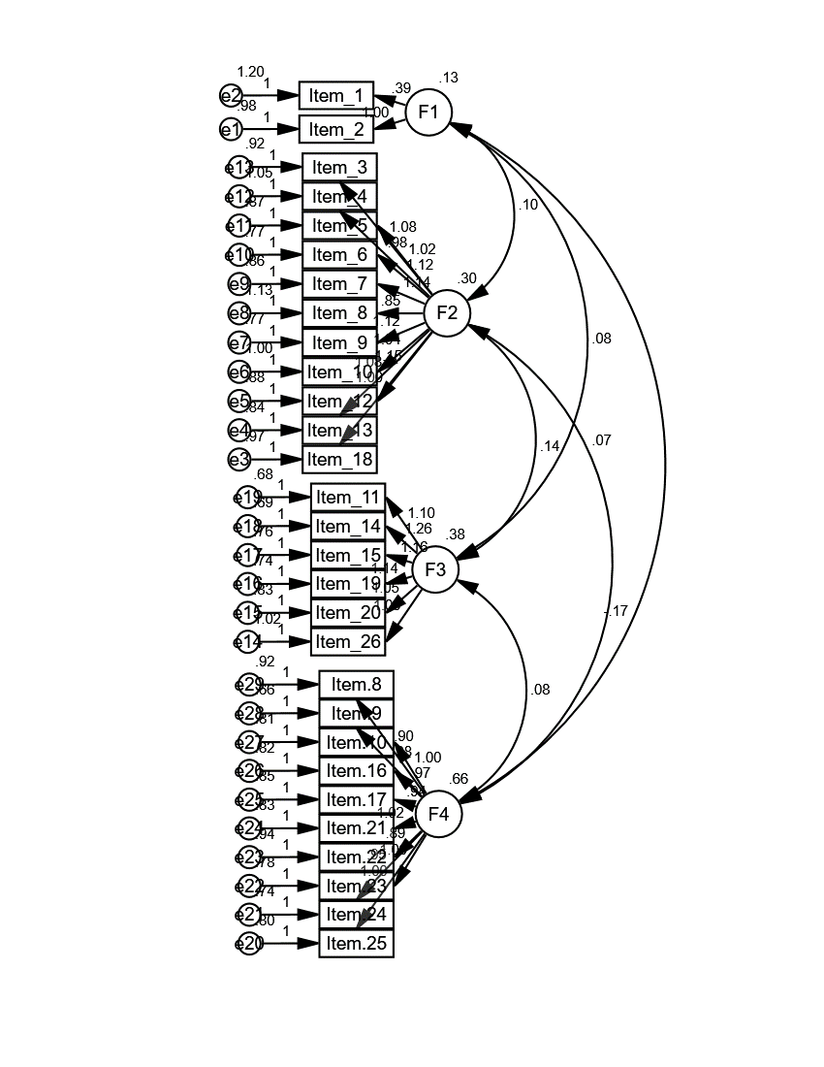
Figure 1. Exploratory factor analysis and factor loadings

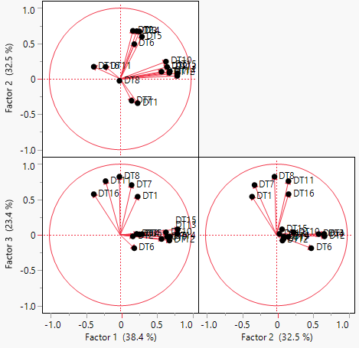
Figure 2. Factor loadings plot of DT-SE

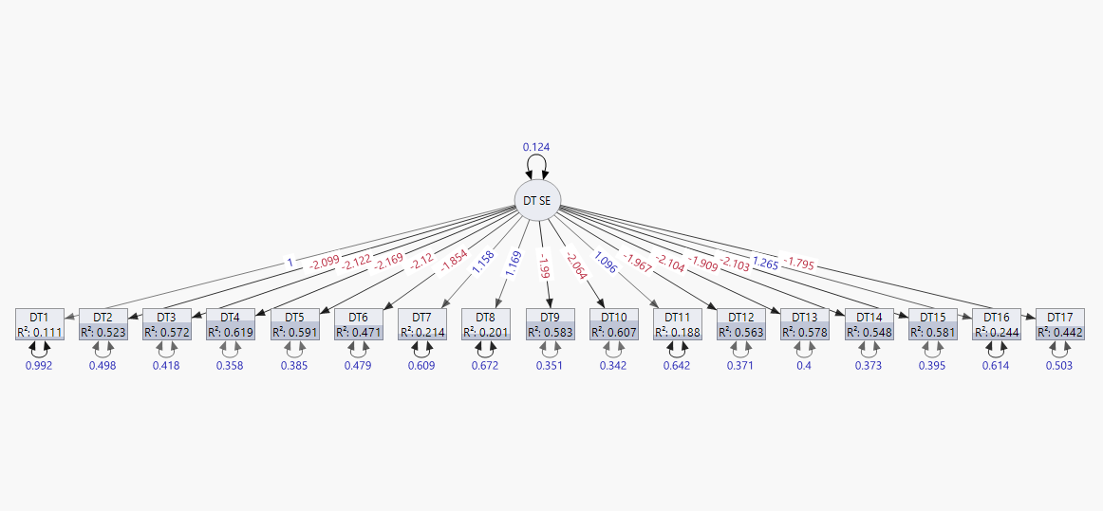
Figure 3. Confirmatory factor analysis for DT-SE

