Mapping the Technological and Pharmacological Landscape of Casearia sylvestris: An Evidence-Based Prospection for Wound Healing and Pain Management
Luiza Gonçalves Soutierª•, Yasmim Parisotto de Souza Silvaª•, Carla Suelen Gurski^{c}, Jaqueline Carneiro^{c}, Jéssica Brandão Reolon^{b}, Roberto Pontarolo^{a,c}, Marcel Henrique Marcondes Sari^{c}, Gabriel Blum Vestena^{b}, Weber Cláudio Francisco Nunes da Silva^{b}, Juliana Sartori Bonini^{b}, Luana Mota Ferreira^{a,c}*.
•These authors contributed equally to this study.

ª Departamento de Farmácia, Universidade Federal do Paraná - UFPR, Curitiba, Brasil
^{b} Departamento de Farmácia, Universidade Estadual do Centro Oeste - UNICENTRO, Guarapuava, Brasil
^{c} Programa de Pós-graduação em Ciências Farmacêuticas, Universidade Federal do Paraná - UFPR, Curitiba, Brasil.
* Departamento de Farmácia, Universidade Federal do Paraná, Curitiba, 80210-170, Brazil. Email: luanamota@ufpr.br. Phone: +55 41 3360 4095

Supplementary Material – Figures
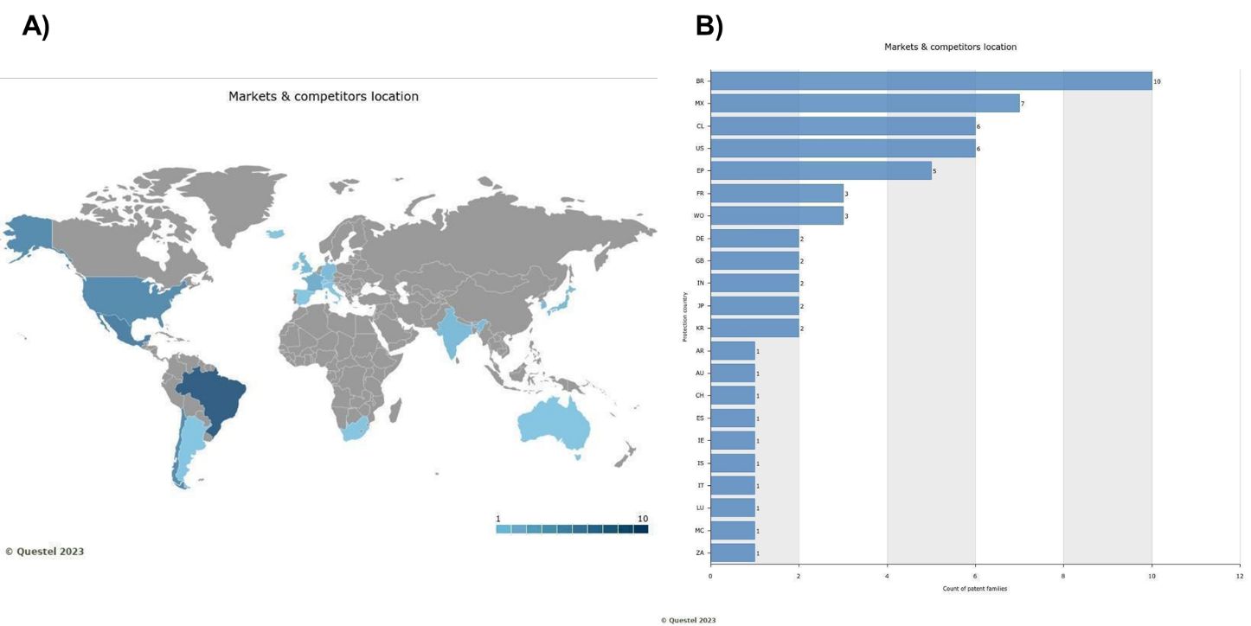
Figure S1. Geographical distribution of Casearia sylvestris patent families by market. (A) World map of filings. (B) Number of patent families per country. Source: Orbit (2023).
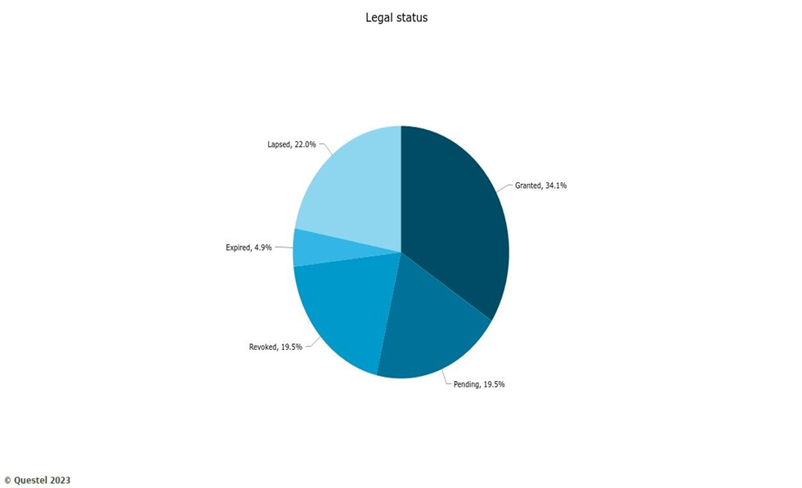
Figure S2. Legal status. Source: Orbit (2023).
Table S1. Patent search results
Term combination | Results
Casearia sylvestris | 41
Casearia sylvestris AND painkiller | 0
Casearia sylvestris AND analgesic | 4
Casearia sylvestris AND cicatrizant | 0
Casearia sylvestris AND scarifier | 0
Casearia sylvestris AND scar | 7
Casearia sylvestris AND wound healing | 12
Casearia sylvestris AND anodyn | 0
Casearia sylvestris AND cicatrix | 0
Casearia sylvestris AND antinociceptive | 0
Casearia sylvestris AND cicatrization | 0
Casearia sylvestris AND wound closure | 1
Casearia sylvestris AND anti-inflammator | 0
Casearia sylvestris AND anti inflammator | 26
Casearia sylvestris AND antiinflammator | 0

Table S2. Full patent list
Patent number | Title | Included? (Yes/No) | If not, why?
WO202315364 | Cosmetic composition comprising Casearia sylvestris, Schinus terebinthifolius, Hymenaea courbaril, and Lactobacillus, and a method for preventing and/or treating signs resulting from skin aging. | No | Did not evaluate wound healing
Ep3545946 | Anti-senescence cosmetic composition comprising derivatives of Casearia sylvestris and/or Hymenaea courbaril, a method for preventing cellular senescence, and a cellular method for modulating the expression of β-galactosidase, p16, p21, and/or IL-8. | No | Did not evaluate wound healing
BRPI0602094 | Medicinal composition based on Casearia sylvestris and its therapeutic use. | Yes | -
BRPI0306167 | Process for obtaining extracts and active fractions of Casearia sylvestris and their applications. | Yes | -
EP3466407 | Composition for modulating genes responsible for general skin functions, method for modulating the expression of such genes, and use of a plant extract. | No | Did not evaluate wound healing
BR102016011816 | Composition for modulating genes responsible for general skin functions, method for modulating gene expression, and use of Casearia sylvestris, Schinus terebinthifolius, and Paeonia albiflora. | No | Did not evaluate wound healing
EP3038715 | Composition comprising guaçatonga extract and aroeira extract for preventing and/or treating skin aging. | No | Did not evaluate wound healing
BR102018008368 | Mouthwash solution based on Melaleuca alternifolia and Casearia sylvestris for the prevention and treatment of mucositis in patients undergoing chemotherapy. | Yes | -
BRPI0900645 | Extracts, active fractions, and/or isolated compounds of Casearia sylvestris, pharmaceutical formulations containing them, and their uses. | Yes | -
BR102018071621 | Effect of glycolic extract of Casearia sylvestris Swartz (guaçatonga) on wound healing in rats. | Yes | -
BR102020000001 | Process for obtaining an active fraction from the essential oil of Casearia sylvestris leaves (Sw.), active fraction 1–6, and reversal activity in a fluconazole-resistant strain. | No | Did not evaluate wound healing
WO202370178 | Composition and process for producing bioactive bioceramic membranes and synthetic hydroxyapatite bone grafts. | No | Did not evaluate wound healing
BR102016022682 | Composition for modulating genes responsible for general skin functions, method for modulating gene expression, and use of Casearia sylvestris, Schinus terebinthifolius, and hyaluronic acid. | No | Did not evaluate wound healing
BR102016015370 | Aqueous nanoemulsion from the essential oil of Casearia sylvestris leaves (Sw.) for viral inhibition against herpes simplex virus type I. | No | Did not evaluate wound healing
BR102016022152 | Differentiated process for supercritical extraction of Casearia sylvestris. | No | Did not evaluate wound healing
BR102014008978 | Medicinal composition with antibiotic, anti-inflammatory, and wound-healing activity. | Yes | -
EP3150213 | Medicinal composition with antibiotic, anti-inflammatory, and wound-healing properties. | No | Did not use Casearia sylvestris
BRPI0805322 | Compounds with cytomodulatory activity, formulations containing them, and process for their preparation. | Yes | -
Ep3466406 | Anti-wrinkle cosmetic composition, composition system, and method for cosmetic skin treatment. | No | Did not evaluate wound healing
EP3501491 | Cosmetic anti-sagging composition, use of the composition, and anti-sagging treatment method. | No | Did not evaluate wound healing
EP3501494 | Cosmetic anti-blemish composition, use of the composition, and method for anti-blemish treatment. | No | Did not evaluate wound healing
EP-916663 | Esculentin A (18β,19β-diacetyloxy-18α,19α-epoxy-3,13(16),14-clerodatrien-2-one) and Esculentin B (18β,19β-diacetyloxy-18α,19α-epoxy-3,12,14-clerodatrien-2β-isovaleryloxy-6β,7α-diol), process for their preparation, and their use in the manufacture of medicines. | No | Did not use Casearia sylvestris
BR102016011793 | Anti-aging cosmetic composition and composition system. | No | Did not evaluate wound healing
US9980998 | Medicinal composition with antibiotic, anti-inflammatory, and wound-healing activity. | No | Did not focus on Casearia sylvestris
WO202082140 | Processes for obtaining liquid concentrates at room temperature from plant species intended for infusion or decoction, as well as from wine, and products obtained and provided in individual portable doses. | No | Did not use Casearia sylvestris
WO2021191811 | Novel wound gel composition. | Yes | -
BR102016011821 | Composition for modulating genes responsible for general skin functions, method for modulating gene expression, and use of passion fruit ceramides and Cichorium intybus. | No | Did not use Casearia sylvestris
BR102015021047 | Improved liquid chromatograph for extraction of micromolecules from solid matrices and chromatographic analysis method using said equipment. | No | Not formulation relatated
WO202077428 | Compounds, their use in the preparation of a pharmaceutical composition, and a pharmaceutical composition comprising 7,11b-dihydro-6H-indeno[2,1-c]chromene-3,6a,9,10-tetrol, its derivatives or analogs, neutral or ionized, for prevention and/or senolytic therapy. | No | Did not use Casearia sylvestris
Ep2499123 | Anti-inflammatory compounds. | No | Did not use Casearia sylvestris
BR102017004926 | Biopolymers composed of polysaccharides and derivatives of cashew nut shell liquid. | No | Did not use Casearia sylvestris
BR102018077212 | Topical gel formulation with wound-healing activity containing microalgae extract. | No | Did not use Casearia sylvestris
BR102014028886 | Device for attracting or repelling insects and method for gradual release of a volatile substance using said device. | No | Did not use Casearia sylvestris
Ep2320879 | Pharmaceutical composition comprising jasmonates. | No | Did not use Casearia sylvestris
Ep2654665 | Method for developing a liquid composition to be applied to the skin as a foam and a composition suitable for topical application. | No | Did not evaluate wound healing
WO200667419 | Myrtaceous honey and its use as an immunomodulator. | No | Did not use Casearia sylvestris
US20100292280 | Antipyretic vasodilators. | No | Did not evaluate wound healing
WO201372332 | Methods for using bitter taste receptor antagonists. | No | Did not evaluate wound healing
Ep2986117 | Binary insecticidal or pesticidal mixture. | No | Did not evaluate wound healing
US20020194646 | Methods for inducing dwarf phenotypes in plants. | No | Did not evaluate wound healing
KR101401154 | Pharmaceutical composition for inhibiting regulatory T-cell activity comprising methyl gallate. | No | Did not evaluate wound healing

Table S3. Raw data table used for patent analysis
Patent | Plant use | Final product | Pharmacological application | Analysis
BRPI0602094 | - | Ointment (orobase) | Healing/antiviral | Clinical analysis
BRPI0306167 | Purified extract, from leaves | Enhanced and more purified extract | Gastroduodenal ulcer | Chemical characterization of the active fractions
BR102018008368 | Extracts | Mouthwash solution | Mucositis treatment | Clinical analysis, patient wound test
BRPI0900645A2 | Extracts, active fractions and/or isolated compounds from Casearia sylvestris | Oral and intravenous dosage forms | Gastroduodenal ulcer | Chemical characterization of the active fractions
BR102018071621A2 | Extrato glicólico | Nano-spray/Biofilm | Wound healing | In vivo, wound area measurement and histopathological analysis
BR102014008978A2 | Extrato seco | Biofilm | Wound healing/antibiotic | Inhibition of microbial growth
BRPI0805322A2 | Purified extract, from leaves | Isolated extract of Casearin X | Cytomodulatoryn treatment of related wounds | In vivo, hystopathological analysis
WO2021191811 | - | Gel | Wound healing | Clinical analysis, patient wound test

Table S4. Raw data table used for scientific analysis
Reference | Part of the plant | Extraction method | Final product | Pharmacological application | In vitro or In vivo | Type of cell | Species | Analysis
De Campos, 2015 | Leaf | Hydroalcoholic extraction | Biofilm and liquid formulation | Healing of burn injuries | In vivo | - | Adult male swiss and wistar rats | Macroscopic wound healing score (0–5) based on infection, inflammation, necrosis, and epithelialization; treatments: saline spray, extract spray, biofilm, and extract-loaded biofilm
De Mattos, 2007 | Dried leaf | Maceration | Hydroalcoholic extract | Antinociceptive | In vivo | - | Male swiss mice | Antinociceptive activity evaluated in mice treated orally with hydroalcoholic extract
Dezena, 2021 | Not reported | Percolation | Tincture | Wound healing | In vitro | Wistar rat skin | - | Microscopy (histology sample)
Lipinski, 2012 | Leaf and twigs | Decoction | Gel | Wound healing | In vivo | - | Beef cattle | Wound area measurement and histological analysis
Piovezan, 2017 | Leaf | Hydroalcoholic extraction | Ointment | Treatment of chronic post-ischemia pain | In vivo | - | Mice | Behavioral, histological and molecular
Napolitano, 2005 | Leaf, stem wood, stem bark, root wood and root bark | Maceration | Crude plant extract | Anti-inflammatory | In vitro | J774 murine macrophage cell line | - | Griess reagent assay
Trecco, 2014 | Leaf | Maceration | Natural latex membranes incorporated with ethanolic extract | Anti-inflammatory and wound healing | In vitro | Not reported | - | In vitro release analysis using UV spectroscopy

