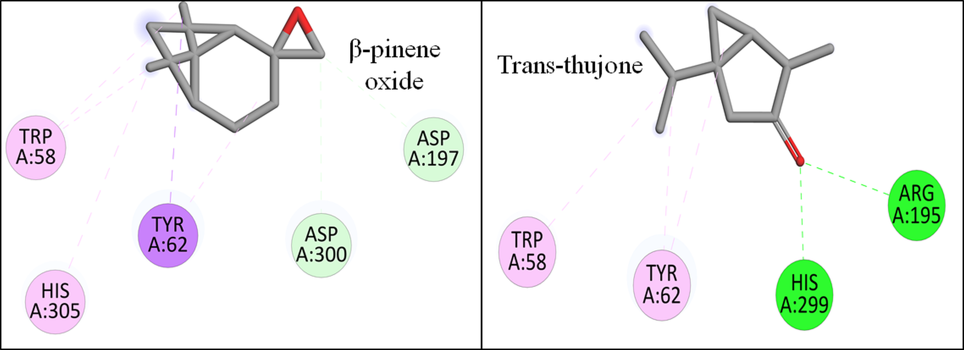
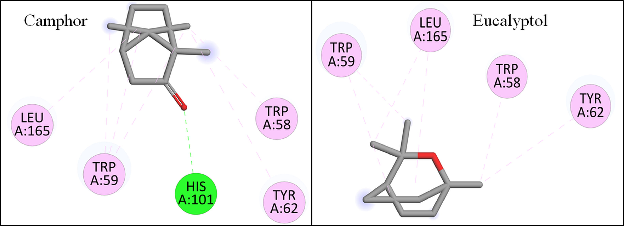
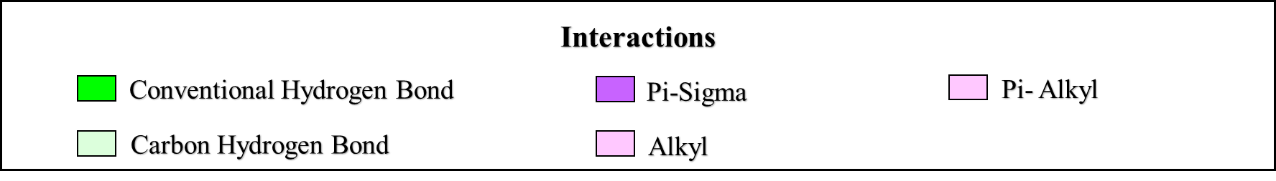
Figure S1. 2D Binding interactions of selected O. majorana EO compounds with the active site of α-amylase
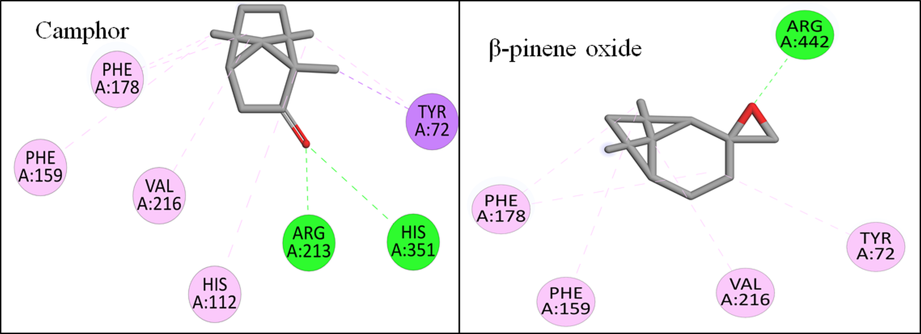
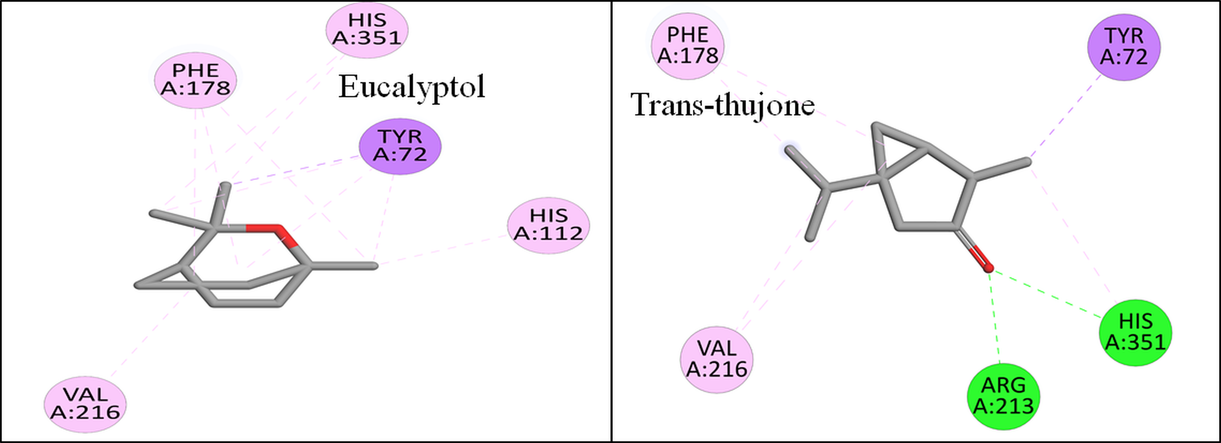
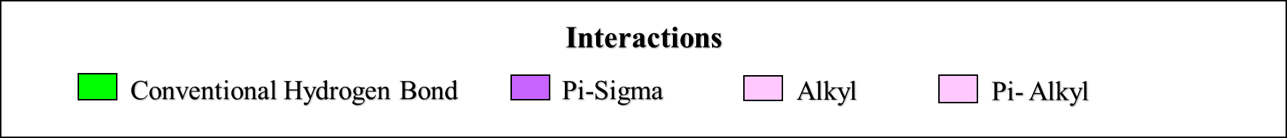
Figure S2. 2D Binding interactions of selected O. majorana EO compounds with the active site of α-glucosidase
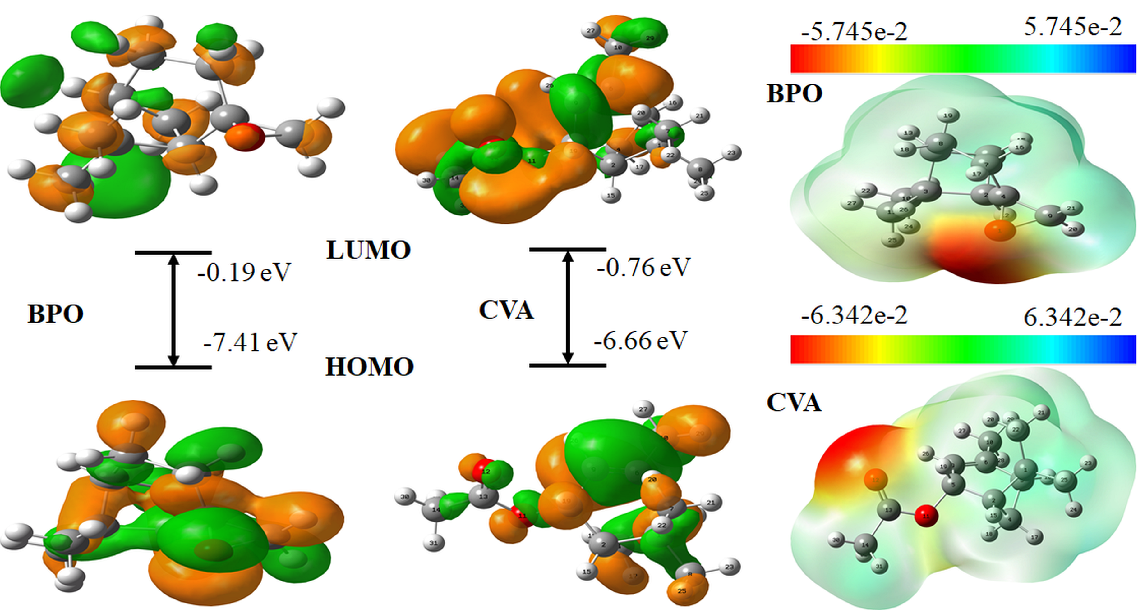
Figure S3. FMO and MEP surface of CVA and BPO in water phase

