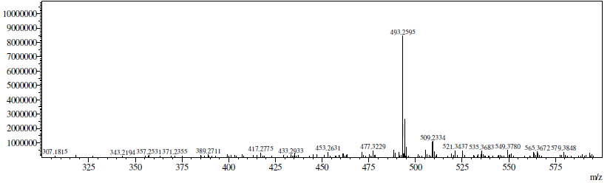
Figure S1. Mass spectrum of Withanolide D
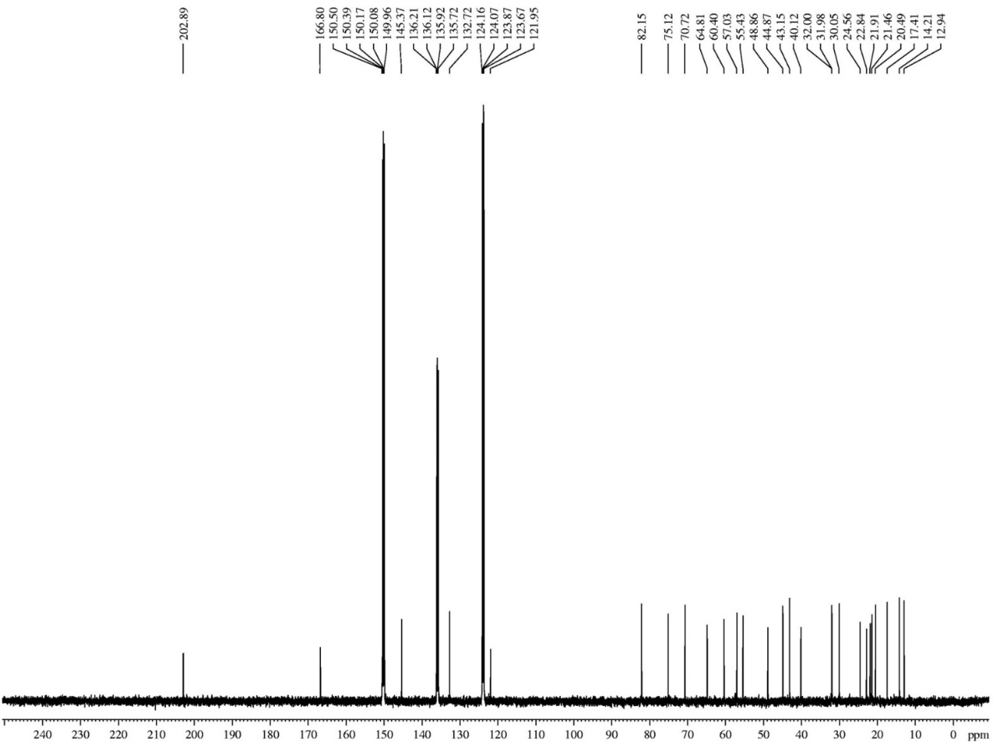
Figure S2. Carbon 13 spectrum of Withanolide D
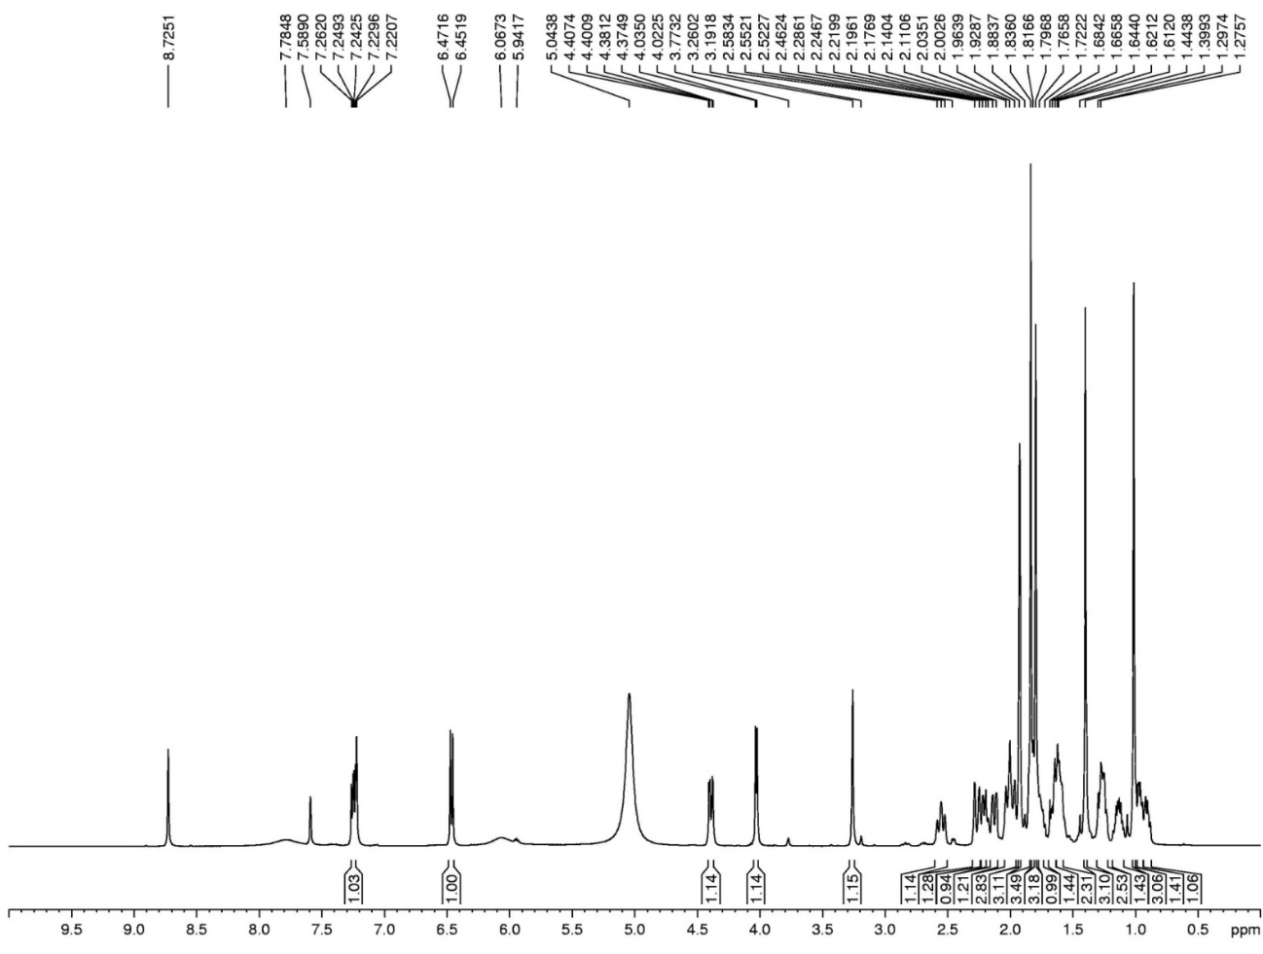

Figure S3. ¹H NMR spectrum of Withanolide D

