Supporting Information

Entomological consequences and toxicological detection of synthetic cannabinoid receptor agonists (SCRAs) in necrophagous larvae (Diptera: Calliphoridae)

Chloé A. K. Blavier^{a,b}, Martin H. Villet^{c}, Annette Zschiesche^{d,e}, Volker Auwärter^{d}, Matthias Grawª, Christoph Geffert^{f}, and Olwen C. Groth*ª

ª Institute of Forensic Medicine, Ludwig-Maximilians-Universität in Munich, Nussbaumstrasse 26, D-80336 Munich, Germany
^{b} Polytech Nice Sophia Engineering School – University Côte d'Azur, 06903 Sophia Antipolis, France
^{c} Department of Zoology & Entomology, Rhodes University, Makhanda, 6140 South Africa
ORCID 0000-0002-4335-5667, E-mail address: martin.villet@gmail.com
^{d} Institute of Forensic Medicine, Forensic Toxicology, Medical Center – University of Freiburg, Faculty of Medicine, University of Freiburg, Albertstrasse 9, 79104 Freiburg, Germany, ORCID 0000-0002-1883-2804
^{e} Hermann Staudinger Graduate School, University of Freiburg, Hebelstrasse 27, 79104 Freiburg, Germany, ORCID 0009-0005-9017-0111
^{f} Labor Staber, Bremer Strasse 9, 01665 Klipphausen, Germany

*Corresponding author
ORCID 0000-0003-4672-041X, E-mail address: olwen.groth@med.uni-muenchen.de

Table S1. Transitions and optimised mass spectrometric parameters used in Multiple Reaction Monitoring (MRM) mode for SCRA analytes and deuterated analogues. Analytes are followed by their corresponding deuterated analogues (bold type)
Analyte |  | RT  [min] | Q1  [Da] | Q3  [Da] | DP  [V] | EP  [V] | CE  [V] | CXP  [V]
 | ADB-BUTINACA N-(4-hydroxy-butyl) metabolite | 2.16 | 347.20 | 217.10 | 50 | 10 | 35 | 17
 |  |  |  | 302.20 | 50 | 10 | 18 | 18
 | AB-PINACA N-pentanoic acid metabolite-d₄ | 2.00 | 365.11 | 320.10 | 64 | 10 | 21 | 32
 | 5F-ADB oxidative/hydrolytic defluorination metabolite | 4.35 | 376.20 | 213.00 | 62 | 10 | 37 | 15
 |  |  |  | 316.00 | 62 | 10 | 24 | 19
 | JWH-250 N-(4-hydroxypentyl) metabolite-d₅ | 4.24 | 357.20 | 121.10 | 72 | 10 | 31 | 20
 | 5F-ADB hydrolysis product | 4.75 | 364.00 | 233.00 | 50 | 10 | 33 | 15
 |  |  |  | 318.30 | 50 | 10 | 20 | 15
 | ADB-BUTINACA 3,3-dimethylbutanoic acid metabolite | 5.14 | 332.20 | 201.10 | 50 | 10 | 35 | 17
 |  |  |  | 145.00 | 50 | 10 | 57 | 14
 | MDMB-4en-PINACA  butanoic acid metabolite | 5.21 | 344.00 | 213.00 | 70 | 10 | 35 | 15
 |  |  |  | 298.00 | 70 | 10 | 20 | 10
 | JWH-073 N-(4-hydroxybutyl) metabolite-d₅ | 4.42 | 349.20 | 155.12 | 100 | 10 | 37 | 12
ADB-BUTINACA |  | 4.47 | 331.20 | 201.10 | 55 | 10 | 35 | 15
 |  | 4.47 | 331.20 | 286.19 | 55 | 10 | 21 | 15
AB-PINACA-d₉ |  | 4.45 | 340.27 | 224.17 | 85 | 10 | 34 | 15
5F-ADB |  | 6.15 | 378.10 | 233.20 | 70 | 10 | 35 | 11
 |  | 6.15 | 378.10 | 318.30 | 70 | 10 | 24 | 12
MDMB-4en-PINACA |  | 6.69 | 358.00 | 213.00 | 70 | 10 | 35 | 15
 |  | 6.69 | 358.00 | 298.20 | 70 | 10 | 25 | 17
JWH-015-d₇ |  | 6.57 | 335.20 | 155.10 | 85 | 5 | 34 | 11
RT: Retention time, Q1: m/z of precursor ion, Q3: m/z of fragment ion, DP: Declustering Potential, EP: Entrance Potential, CE: Collision energy, CXP: Collision cell exit potential

Table S2. Transitions and optimised mass spectrometric parameters used in MRM mode to detect 5F-ADB phase I metabolites and glucuronic acid conjugates, including those measured in unscheduled mode (RT = Unsch.), together with those of the deuterated internal standard analogues
Analyte | RT [min] | Q1 [Da] | Q3  [Da] | DP  [V] | EP  [V] | CE  [V] | CXP [V]
5F-ADB 1 | 6.15 | 378.1 | 233.2 | 70 | 10 | 35 | 11
5F-ADB 2 | 6.15 | 378.1 | 318.3 | 70 | 10 | 24 | 12
5F-ADB 3 | 6.15 | 378.1 | 145 | 70 | 10 | 55 | 10
5F-ADB hydrolysis 1 | 4.75 | 364.0 | 233.001 | 50 | 10 | 32 | 15
5F-ADB hydrolysis 2 | 4.75 | 364 | 318 | 50 | 10 | 20 | 15
5F-ADB hydrolysis 3 | 4.75 | 364.00 | 145.001 | 50 | 10 | 52 | 15
5F-ADB N-5-OH 1 | 4.35 | 376.2 | 213 | 62 | 10 | 37 | 15
5F-ADB N-5-OH 2 | 4.35 | 376.2 | 231 | 62 | 10 | 33 | 17
5F-ADB N-5-OH 3 | 4.35 | 376.2 | 316 | 62 | 10 | 24 | 19
5F-ADB N-5-OH 4 | 4.35 | 376.2 | 145 | 62 | 10 | 52 | 14
MDMB-INACA 1 | 3.75 | 290.15 | 230.1 | 48 | 10 | 26 | 15
MDMB-INACA 2 | 3.75 | 290.15 | 145 | 48 | 10 | 47 | 11
5F-ADB N-pentanoic acid 1 | Unsch. | 390.2 | 217.1 | 68 | 10 | 39 | 13
5F-ADB N-pentanoic acid 2 | Unsch. | 390.2 | 227.1 | 68 | 10 | 37 | 14
5F-ADB N-pentanoic acid 3 | Unsch. | 390.2 | 245.1 | 68 | 10 | 35 | 15
5F-ADB N-pentanoic acid 4 | Unsch. | 390.2 | 330.2 | 68 | 10 | 26 | 19
5F-ADB N-pentanoic acid 5 | Unsch. | 390.2 | 145 | 68 | 10 | 56 | 11
5F-ADB-OH 1 | Unsch. | 394.2 | 249.1 | 62 | 10 | 34 | 15
5F-ADB-OH 2 | Unsch. | 394.2 | 231.1 | 62 | 10 | 36 | 14
5F-ADB-OH 3 | Unsch. | 394.2 | 334.2 | 62 | 10 | 26 | 18
5F-ADB-OH 4 | Unsch. | 394.2 | 145 | 62 | 10 | 55 | 12
5F-ADB-OH 5 | Unsch. | 394.2 | 161 | 62 | 10 | 53 | 13
5F-ADB-OH 6 | Unsch. | 394.2 | 213.1 | 62 | 10 | 38 | 14
5F-ADB-OH 7 | Unsch. | 394.2 | 233.2 | 62 | 10 | 35 | 15
5F-ADB hyd + OH 1 | Unsch. | 380.2 | 249.1 | 61 | 10 | 35 | 15
5F-ADB hyd + OH 2 | Unsch. | 380.2 | 231.1 | 61 | 10 | 37 | 14
5F-ADB hyd + OH 3 | Unsch. | 380.2 | 334.2 | 61 | 10 | 24 | 17
5F-ADB hyd + OH 4 | Unsch. | 380.2 | 145 | 61 | 10 | 53 | 12
5F-ADB hyd + OH 5 | Unsch. | 380.2 | 161 | 61 | 10 | 52 | 13
5F-ADB hyd + OH 6 | Unsch. | 380.2 | 213.1 | 61 | 10 | 39 | 14
5F-ADB hyd + OH 7 | Unsch. | 380.2 | 233.2 | 61 | 10 | 37 | 15
5F-ADB hyd + N-5-OH 1 | Unsch. | 362.21 | 231.1 | 60 | 10 | 34 | 14
5F-ADB hyd+ N-5-OH 2 | Unsch. | 362.21 | 316.2 | 60 | 10 | 23 | 15
5F-ADB hyd+ N-5-OH 3 | Unsch. | 362.21 | 145 | 60 | 10 | 52 | 12
5F-ADB hyd + acid 1 | Unsch. | 376.18 | 217.1 | 65 | 10 | 38 | 13
5F-ADB hyd + acid 2 | Unsch. | 376.18 | 227.1 | 65 | 10 | 36 | 14
5F-ADB hyd + acid 3 | Unsch. | 376.18 | 245.1 | 65 | 10 | 34 | 15
5F-ADB hyd + acid 4 | Unsch. | 376.18 | 145 | 65 | 10 | 56 | 11
5F-ADB hyd + acid 5 | Unsch. | 376.18 | 330.2 | 65 | 10 | 21 | 18
5F-ADB hyd-H2 1 | Unsch. | 362.2 | 213.1 | 62 | 10 | 37 | 12
5F-ADB hyd-H2 2 | Unsch. | 362.2 | 233.1 | 62 | 10 | 34 | 14
5F-ADB hyd-H2 3 | Unsch. | 362.2 | 318.2 | 62 | 10 | 21 | 16
5F-ADB hyd-H2 4 | Unsch. | 362.2 | 145 | 62 | 10 | 55 | 11
5F-ADB hyd +Gluc 1 | Unsch. | 540.2 | 540.2 | 80 | 10 | 5 | 18
5F-ADB hyd +Gluc 2 | Unsch. | 540.2 | 364.2 | 80 | 10 | 29 | 16
5F-ADB hyd +Gluc 3 | Unsch. | 540.2 | 233.1 | 80 | 10 | 42 | 12
5F-ADB hyd +Gluc 4 | Unsch. | 540.2 | 318.2 | 80 | 10 | 31 | 14
5F-ADB hyd +Gluc 5 | Unsch. | 540.2 | 213.1 | 80 | 10 | 45 | 11
5F-ADB hyd +Gluc 6 | Unsch. | 540.2 | 145 | 80 | 10 | 68 | 10
5F-ADB OH + Gluc 1 | Unsch. | 570.25 | 570.246 | 80 | 10 | 5 | 18
5F-ADB OH + Gluc 2 | Unsch. | 570.25 | 145 | 80 | 10 | 69 | 11
5F-ADB OH + Gluc 3 | Unsch. | 570.25 | 231.1 | 80 | 10 | 47 | 12
5F-ADB OH + Gluc 4 | Unsch. | 570.25 | 249.1 | 80 | 10 | 45 | 13
5F-ADB OH + Gluc 5 | Unsch. | 570.25 | 334.2 | 80 | 10 | 38 | 14
5F-ADB OH + Gluc 6 | Unsch. | 570.25 | 394.2 | 80 | 10 | 28 | 16
5F-ADB OH + Gluc 7 | Unsch. | 570.25 | 161 | 80 | 10 | 67 | 11
5F-ADB N-5-OH + Gluc 1 | Unsch. | 552.26 | 552.255 | 80 | 10 | 5 | 17
5F-ADB N-5-OH + Gluc 2 | Unsch. | 552.26 | 145 | 80 | 10 | 67 | 11
5F-ADB N-5-OH + Gluc 3 | Unsch. | 552.26 | 213 | 80 | 10 | 47 | 12
5F-ADB N-5-OH + Gluc 4 | Unsch. | 552.26 | 231 | 80 | 10 | 45 | 13
5F-ADB N-5-OH + Gluc 5 | Unsch. | 552.26 | 376.2 | 80 | 10 | 28 | 15
5F-ADB N-5-OH + Gluc 6 | Unsch. | 552.26 | 316.2 | 80 | 10 | 36 | 14
5F-ADB acid + Gluc 1 | Unsch. | 566.23 | 566.234 | 80 | 10 | 5 | 17
5F-ADB acid + Gluc 2 | Unsch. | 566.23 | 390.2 | 80 | 10 | 27 | 15
5F-ADB acid + Gluc 3 | Unsch. | 566.23 | 217 | 80 | 10 | 47 | 12
5F-ADB acid + Gluc 4 | Unsch. | 566.23 | 227 | 80 | 10 | 45 | 13
5F-ADB acid + Gluc 5 | Unsch. | 566.23 | 245 | 80 | 10 | 43 | 14
5F-ADB acid + Gluc 6 | Unsch. | 566.23 | 145 | 80 | 10 | 68 | 11
5F-ADB acid + Gluc 7 | Unsch. | 566.23 | 330.2 | 80 | 10 | 34 | 16
5F-ADB acid + hyd + Gluc 1 | Unsch. | 552.22 | 552.219 | 80 | 10 | 5 | 17
5F-ADB acid + hyd + Gluc 2 | Unsch. | 552.22 | 217 | 80 | 10 | 47 | 12
5F-ADB acid + hyd + Gluc 3 | Unsch. | 552.22 | 227 | 80 | 10 | 45 | 13
5F-ADB acid + hyd + Gluc 4 | Unsch. | 552.22 | 245 | 80 | 10 | 43 | 14
5F-ADB acid + hyd + Gluc 5 | Unsch. | 552.22 | 376.2 | 80 | 10 | 28 | 16
5F-ADB acid + hyd + Gluc 6 | Unsch. | 552.22 | 145 | 80 | 10 | 69 | 11
5F-ADB acid + hyd + Gluc 7 | Unsch. | 552.22 | 330.2 | 80 | 10 | 35 | 15
5F-ADB N-5-OH + hyd + Gluc 1 | Unsch. | 538.24 | 538.24 | 80 | 10 | 5 | 18
5F-ADB N-5-OH + hyd + Gluc 2 | Unsch. | 538.24 | 145 | 80 | 10 | 67 | 11
5F-ADB N-5-OH + hyd + Gluc 3 | Unsch. | 538.24 | 213 | 80 | 10 | 48 | 13
5F-ADB N-5-OH + hyd + Gluc 4 | Unsch. | 538.24 | 231 | 80 | 10 | 46 | 14
5F-ADB N-5-OH + hyd + Gluc 5 | Unsch. | 538.24 | 362.21 | 80 | 10 | 28 | 16
5F-ADB N-5-OH + hyd + Gluc 6 | Unsch. | 538.24 | 316.2 | 80 | 10 | 35 | 15
5F-ADB Hyd + OH + Gluc 1 | Unsch. | 556.23 | 556.231 | 80 | 10 | 5 | 18
5F-ADB Hyd + OH + Gluc 2 | Unsch. | 556.23 | 145 | 80 | 10 | 68 | 11
5F-ADB Hyd + OH + Gluc 3 | Unsch. | 556.23 | 231 | 80 | 10 | 47 | 13
5F-ADB Hyd + OH + Gluc 4 | Unsch. | 556.23 | 249 | 80 | 10 | 45 | 14
5F-ADB Hyd + OH + Gluc 5 | Unsch. | 556.23 | 161 | 80 | 10 | 67 | 12
5F-ADB Hyd + OH + Gluc 6 | Unsch. | 556.23 | 334.2 | 80 | 10 | 36 | 15
5F-ADB Hyd + OH + Gluc 7 | Unsch. | 556.23 | 380.2 | 80 | 10 | 28 | 16
RT: Retention time, Q1: m/z of precursor ion, Q3: m/z of fragment ion, DP: Declustering Potential, EP: Entrance Potential, CE: Collision energy, CXP: Collision cell exit potential
Gluc: glucuronic acid conjugate, Hyd: hydrolysis product; OH: monohydroxylation product; Unsch.: measured in unscheduled mode

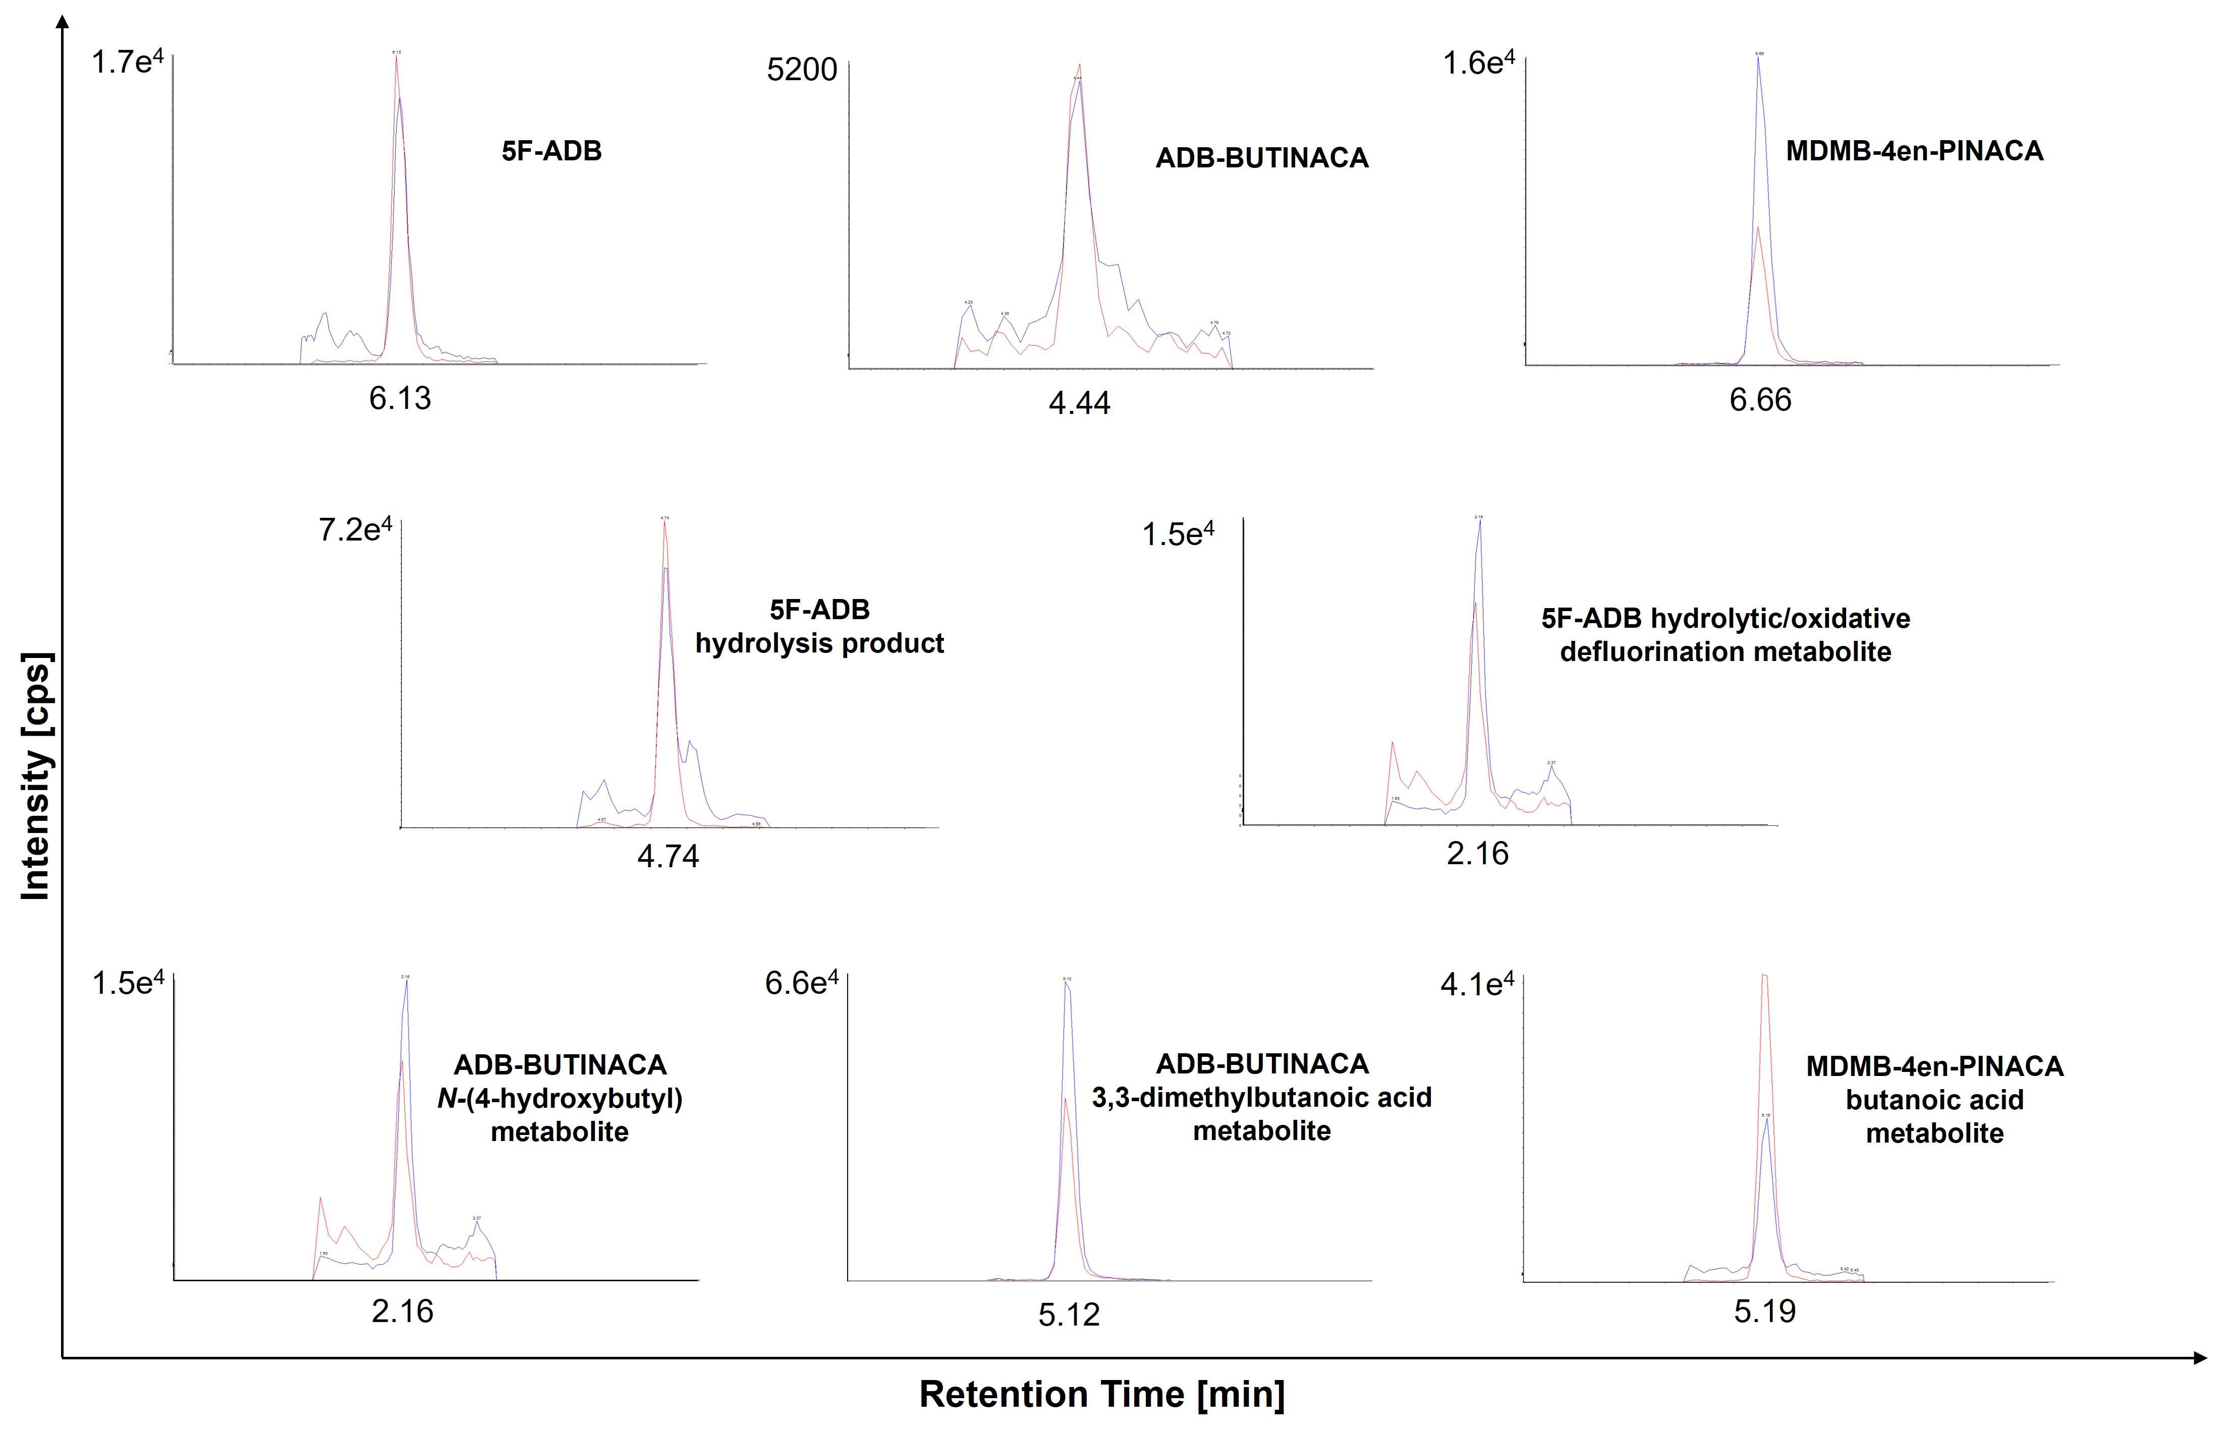Fig. S1. Chromatograms for the target and qualifier ions for each of the analytes depicted in Fig. S1 at a concentration of 0.25 µg/kg

Table S3. Matrix effects and extraction efficiencies, calculated according to the post-extraction addition method [1] at 5 µg/kg
Analyte |  | Matrix  Effects* | Extraction  Efficiencies
5F-ADB |  | 10.9% | 71.3%
 | 5F-ADB hydrolysis product | Significant ion enhancement | 44.6%
 | Hydrolytic/oxidative defluorination metabolite | 118.3% | 51.0%
ADB-BUTINACA |  | 104.1% | 97.0%
 | ADB-BUTINACA 3,3-dimethylbutanoic acid metabolite | Significant ion enhancement | 37.4%
 | ADB-BUTINACA N-(4-hydroxybutyl) metabolite | 92.2% | 90.4%
MDMB-4en-PINACA |  | 22.4% | 83.4%
 | MDMB-4en-PINACA hydrolysis product | Significant ion enhancement | 42.5%
*Values above 100% are indicative of ion enhancement and values below 100% of ion suppression

Table S4 Three-Way ANOVA, showing the effects of time, 5F-ADB dose, and beaker on larval mass
 | SS | DF | MS | F | p
Intercept | 6326.73 | 1 | 6326.727 | 613.7626 | 0.000000
Time | 17439.99 | 10 | 1743.999 | 169.1872 | 0.000000
Dose | 336.59 | 3 | 112.196 | 10.8842 | 0.000001
beaker nr | 28.72 | 2 | 14.361 | 1.3931 | 0.250180
time*dose | 2081.67 | 30 | 69.389 | 6.7315 | 0.000000
time*beaker nr | 261.21 | 20 | 13.061 | 1.2670 | 0.201463
dose*beaker nr | 119.76 | 6 | 19.960 | 1.9363 | 0.075434
time*dose*beaker nr | 769.85 | 60 | 12.831 | 1.2447 | 0.126566
Error | 2628.57 | 255 | 10.308
SS: Sum of Squares, DF: Degrees of Freedom, MS: Mean Square, F: F-statistic, Significant effects (p < 0.05) are indicated in bold type

Table S5 Three-Way ANOVA, showing the effects of sampling time (larval age) and 5F-ADB dose on larval length
 | SS | DF | MS | F | p
Intercept | 7592.636 | 1 | 7592.636 | 9571.489 | 0.000000
beaker nr | 3.379 | 2 | 1.689 | 2.130 | 0.120973
Time | 2791.236 | 10 | 279.124 | 351.871 | 0.000000
Dose | 25.368 | 3 | 8.456 | 10.660 | 0.000001
beaker nr*time | 19.685 | 20 | 0.984 | 1.241 | 0.220955
beaker nr*dose | 9.423 | 6 | 1.571 | 1.980 | 0.068948
time*dose | 96.657 | 30 | 3.222 | 4.062 | 0.000000
beaker nr*time*dose | 63.934 | 60 | 1.066 | 1.343 | 0.061965
Error | 203.867 | 257 | 0.793
SS: Sum of Squares, DF: Degrees of Freedom; MS: Mean Square, F: F-statistic, Significant effects (p < 0.05) are shown in bold type

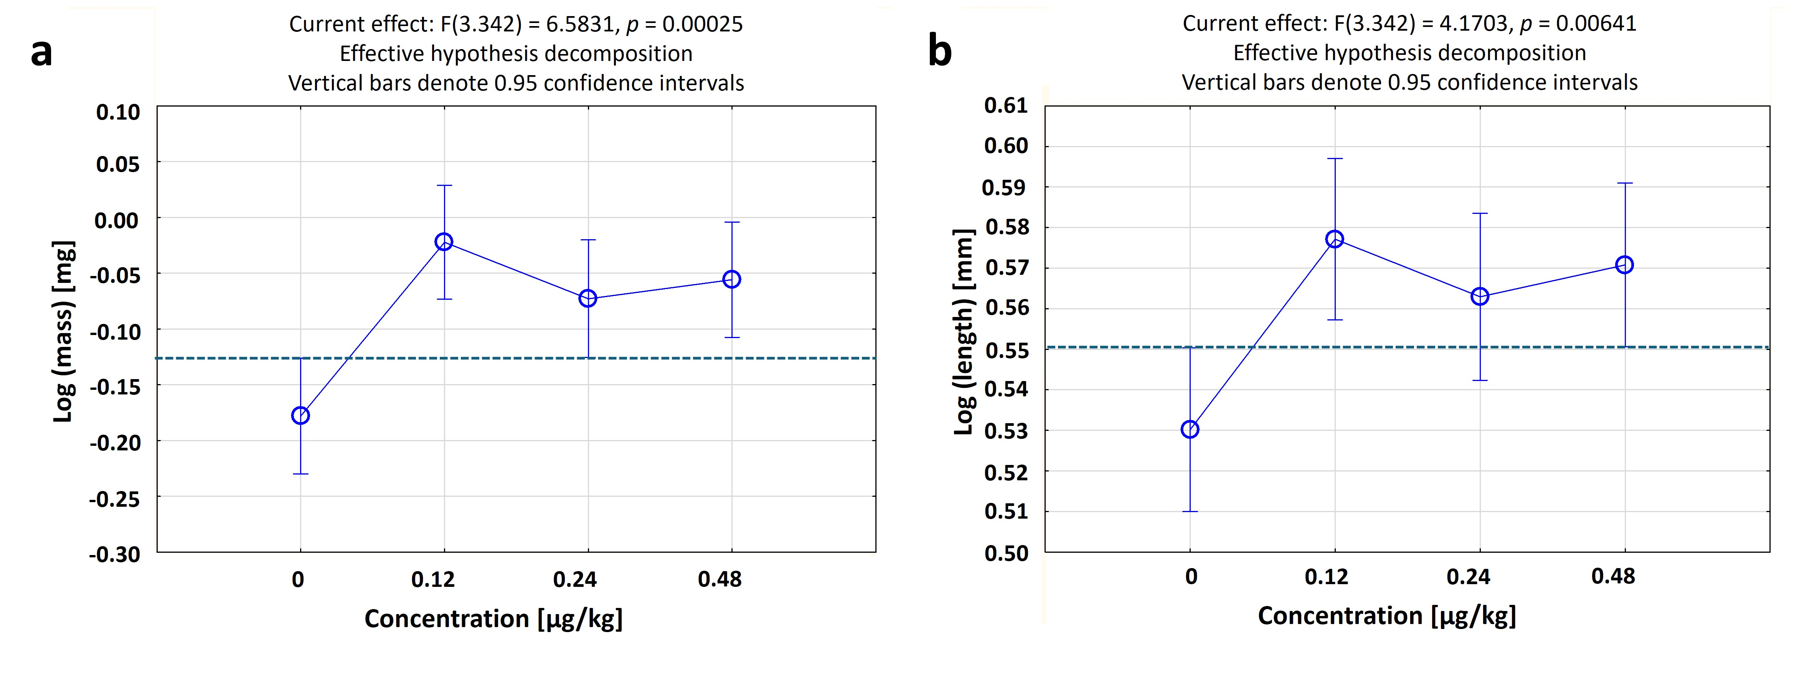
Fig. S2. (a) Log-transformed mean masses and (b) log-transformed mean lengths of larvae in the four dose treatments of In vitro Experiment I
References
1. Matuszewski BK, Constanzer ML, Chavez-Eng CM (2003) Strategies for the assessment of matrix effect in quantitative bioanalytical methods based on HPLC-MS/MS. Anal Chem 75:3019–3030

