Supplemental information

Title: The cannabinoid quinol VCE-004.8 alleviates bleomycin-induced scleroderma and exerts potent antifibrotic effects through peroxisome proliferator-activated receptor-γ and CB2 pathways.
Authors: Carmen del Rio¹, Carmen Navarrete², Juan A. Collado², M. Luz Bellido², Maria Gómez-Cañas³⁻⁵, M. Ruth Pazos³⁻⁵, Javier Fernández-Ruiz³⁻⁵, Federica Pollastro⁶, Giovanni Appendino⁶, Marco A. Calzado¹, Irene Cantarero^{1*} and Eduardo Muñoz^{1*}

VCE-004.8 synthesis. Benzylamine (1.3 mL, 11.913 mmol) was added to a solution of HU-331 (117 mg, 0.303 mmol) in EtOH (13 mL). The reaction mixture was stirred at r.t. for 18 h. It was poured into H₂O (50 mL), taken up to pH=2 with HCl (10% aqueous solution) and extracted with CH₂Cl₂ (30 mL). The organic layer was dried over Na₂SO₄ (anhydrous), filtered and concentrated. Crude residue was purified by reverse phase chromatography (30/70% vol/vol CH₃CN/H₂O) to give 87 mg of (1'R, 6’R)-3-(benzylamino)-6-hydroxy-3'-methyl-4-pentyl-6'-(prop-1-en-2-yl)-[1,1'bi(cyclohexane)]- 2',3,6-triene-2,5-dione [purple-colored solid, yield: 66%].
¹H NMR (CDCl₃, 300 MHz) d ppm: 8.30 (bs, 1H), 7.44-7.26 (m, 5H), 6.64 (m, 1H), 5.15 (s, 1H), 4.65 (d, J = 6.0 Hz, 2H), 4.59 (m, 2H), 3.64 (m, 1H), 2.73 (m, 1H), 2.47 (t, J = 7.7 Hz, 2H), 2.30-1.76 (m, 4H), 1.68 (s, 3H), 1.64 (s, 3H), 1.54-1.23 (m, 6H), 0.88 (m, 3H)

Cysteine recovery assay. 10 mg of HU-331 and a molar equivalent amount of VCE-004.8 were independently dissolved in 1 mL DMSO, and each solution was next treated with an excess (4 mol. equivalents) of cysteamine. After stirring at room temperature for 1 h, the solutions were diluted with water (2 mL) and extracted with hexane- ether 9:1. After evaporation, the solution was taken up in CDCl₃ and analyzed by ¹H-NMR. While compound VCE-004.8 could be recovered unscathed in an essential quantitative way, HU-331 was undetectable in the residue, indicating that it had irreversibly reactive with cysteamine to form polar and not extractable adducts.

Determination of ROS. Jurkat cells were seeded at 10⁶ cells/ml in 24-well plates and treated with VCE004.8 for 6 hours. Then, the cells were stained with 5-(and-6)-chloromethyl-2′,7′-dichlorodihydrofluorescein diacetate acetyl ester (CM-H₂DCFDA; Invitrogen) at 1 μM for 20 minutes at 37°C,. Later, washed twice with cold-PBS and maintained on ice until analysis. Cells exposed to pro-oxidant tert-Butyl hydroperoxide (TBHP) were used as positive control. Oxidation of H₂DCFDA was detected by flow cytometry using a BD FACSCantoTM (BD Bioscience, CA, USA).

Determination of mitochondria transmembrane potential. Jurkat cells were seeded at 10⁶ cells/ml in 24-well plates and incubated for 2 hour with VCE004.8, HU331 or tert-Butyl hydroperoxide (TBHP) as a positive control for loss of mitochondrial membrane potential. After that the cells were washed twice with cold PSB and stained with MitoTracker® Red CMXRos (Life technologies) for 20 min at 37ºC in the darkness. After washing with PBS the cells were analyzed by flow cytometry

Activation of the Nrf2 pathway. HaCaT cells stably expressing ARE-Luc reporter were seeded at 5x10³ cells/well in 96-well plates. Then, cells were treated with increasing concentrations of VCE-004.8 or tert-Butyl hydroquinone (TBHQ) as positive control for 24 hours. After stimulation the luciferase activities were quantified using Dual-Luciferase Assay.

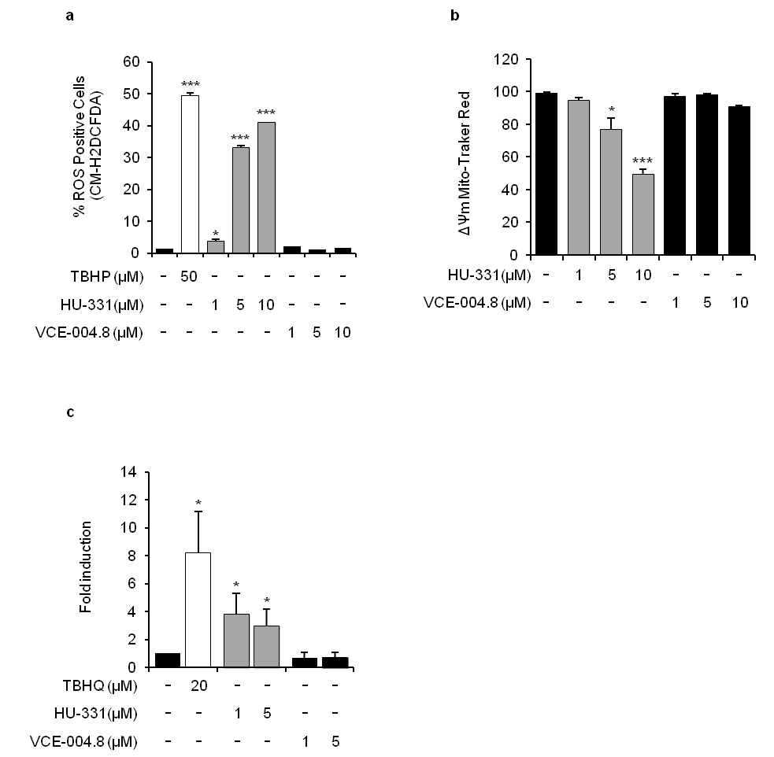

Supplementary Figure S1. VCE-004.8 is a non-electrophilic compound. (a) Reactive oxygen species production. Jurkat cells were treated with VCE004.8 or HU-331 for 6 hours. Then, cells were stained with CM-H₂DCFDA and measured by flow cytometry. Results are expressed as mean percentage of ROS positive cells ± S.D. (b) Effect on mitochondrial membrane potential. Jurkat cells were treated with VCE004.8 or HU-331 for 2 hours. Then, cells were stained with MitoTracker® Red CMXRos and measured by flow cytometry. Results are expressed as mean percentage ± S.D. (c) Effects on Nrf2 activation. ARE-Luc HaCat cells were incubated for 6 h with VCE-004.8 or HU-331 at the indicated concentrations and lysed for luciferase activity. Results are expressed as mean fold induction ± S.D relative to control sample. All the results are representative of at least three independent experiments.

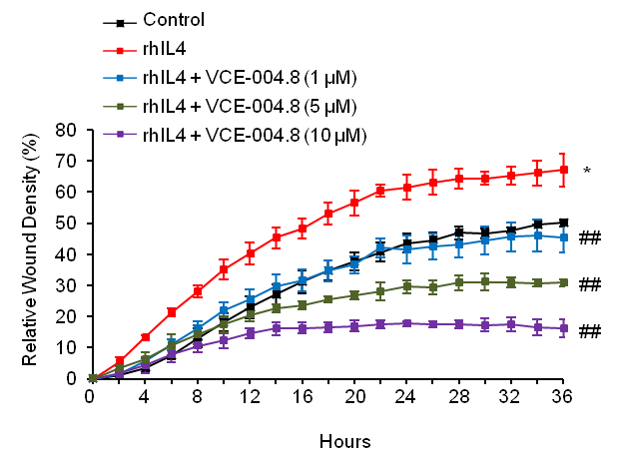
Supplementary Figure S2. Scratch assay on NHDFs cells treated with rhIL-4 in the absence or the presence of increasing concentrations of VCE-004.8. Results were plotted using the Incucyte^{FLR} software in terms of percentage of relative wound density ± S.D. as a function of time and are representative of two independent experiments performed in triplicate wells. *p<0.05 ** p<0.01 versus control; ## p<0.01 versus rhIL4 treated cells.

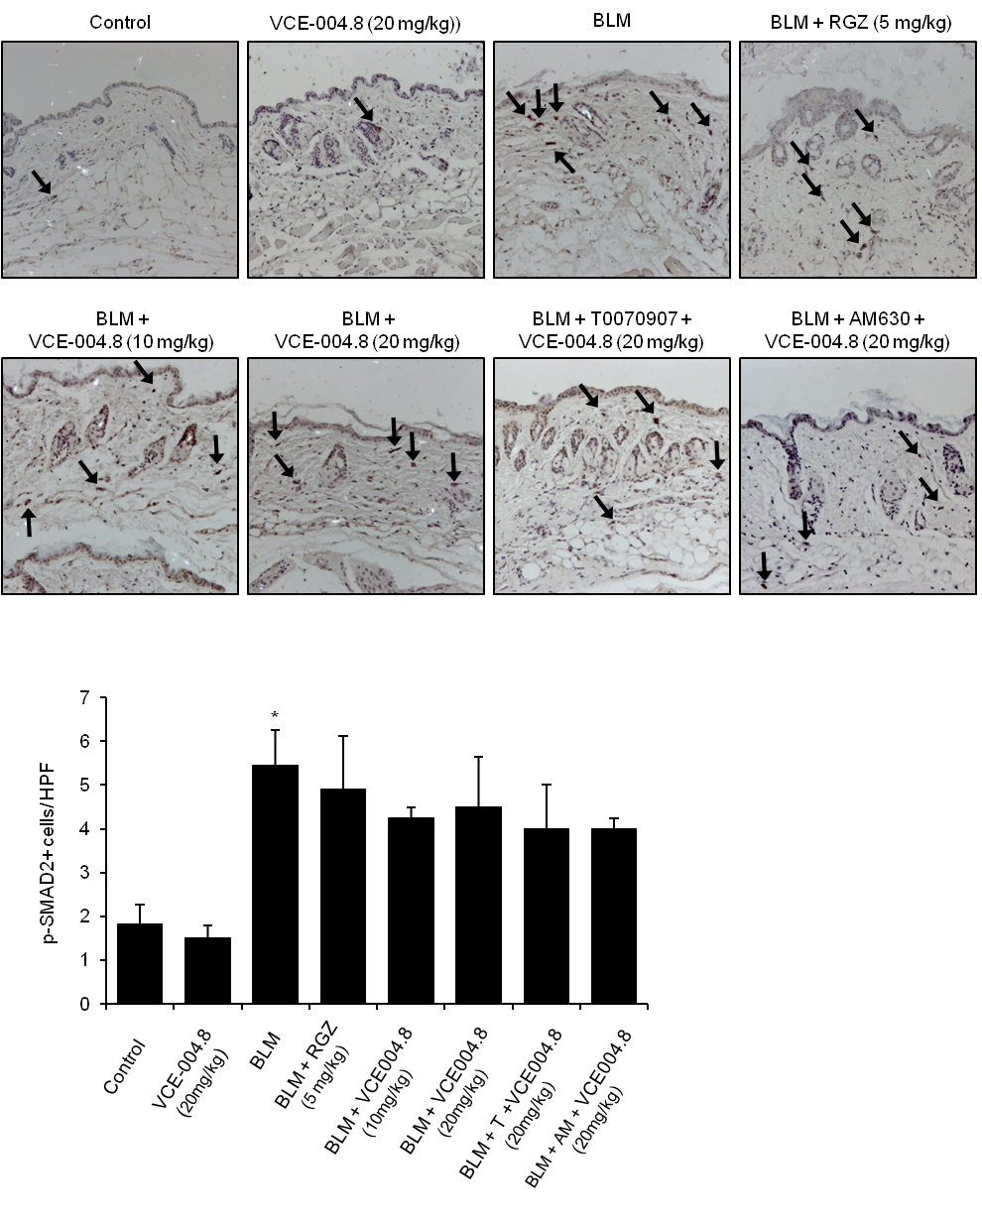
Supplementary Figure S3. Effect of VCE-004.8 on SMAD2 phosphorylation in the skin. (Upper panel) Images show immunostaining of skin sections for p-SMAD2 (indicated with arrows). (Bottom panel) Quantification of p-SMAD2(+) cells in skin. Values are expressed as mean ± SEM (n=8 animals per group). * p<0.05 versus control group.

