Supplementary Figure 1 Risk of bias assessments
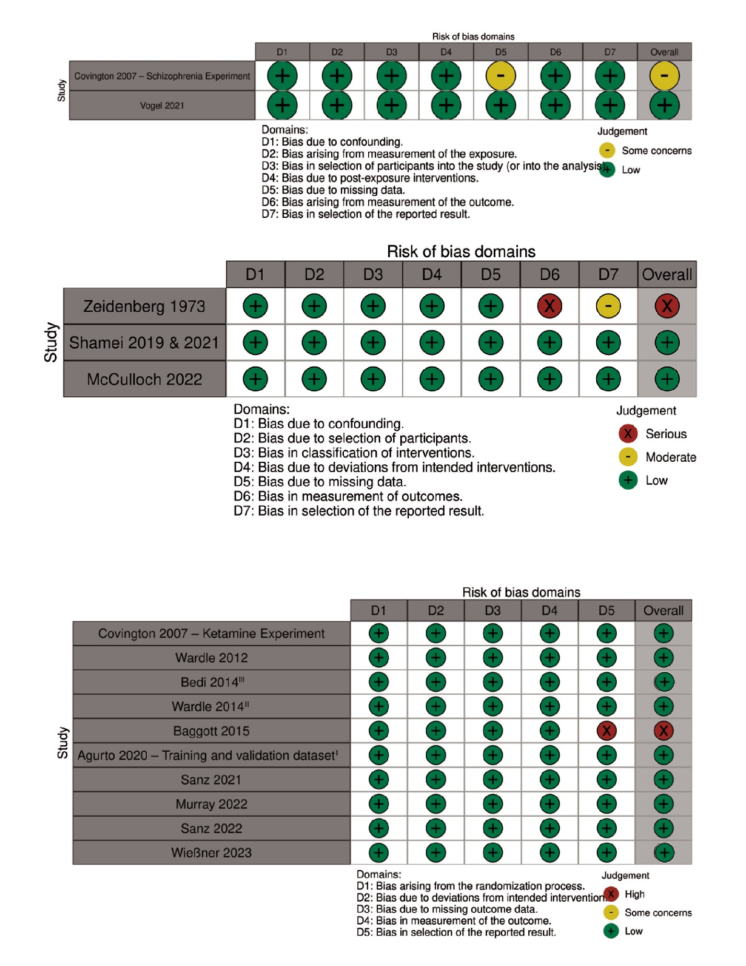
From top to bottom: risk of bias for cross-sectional studies, risk of bias for non-randomized trials, and risk of bias for randomized crossover trials included in the review. ^{I}For Agurto 2020 [5], we report the risk of bias for the main cohort of 31 healthy adults; ^{II}Wardle 2014 [3] and ^{III}Bedi 2014 [4] are both independently included in the review, but the data from these studies were also used in Agurto 2020 [5] as “Independent Datasets 1 and 2” for model testing.

