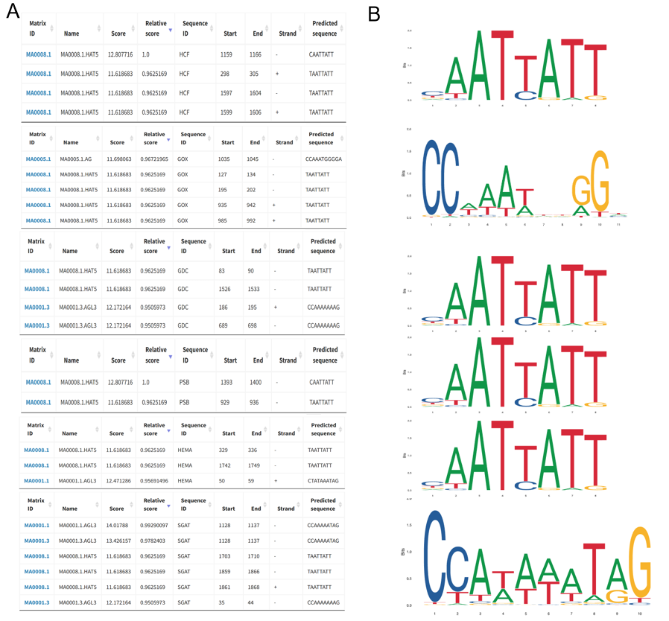
S5 Fig. The detailed motif information of the 6 hub genes. (A) Predicted transcription factor family and TF binding sites. (B) Motif analysis exhibited by MEME suite.

