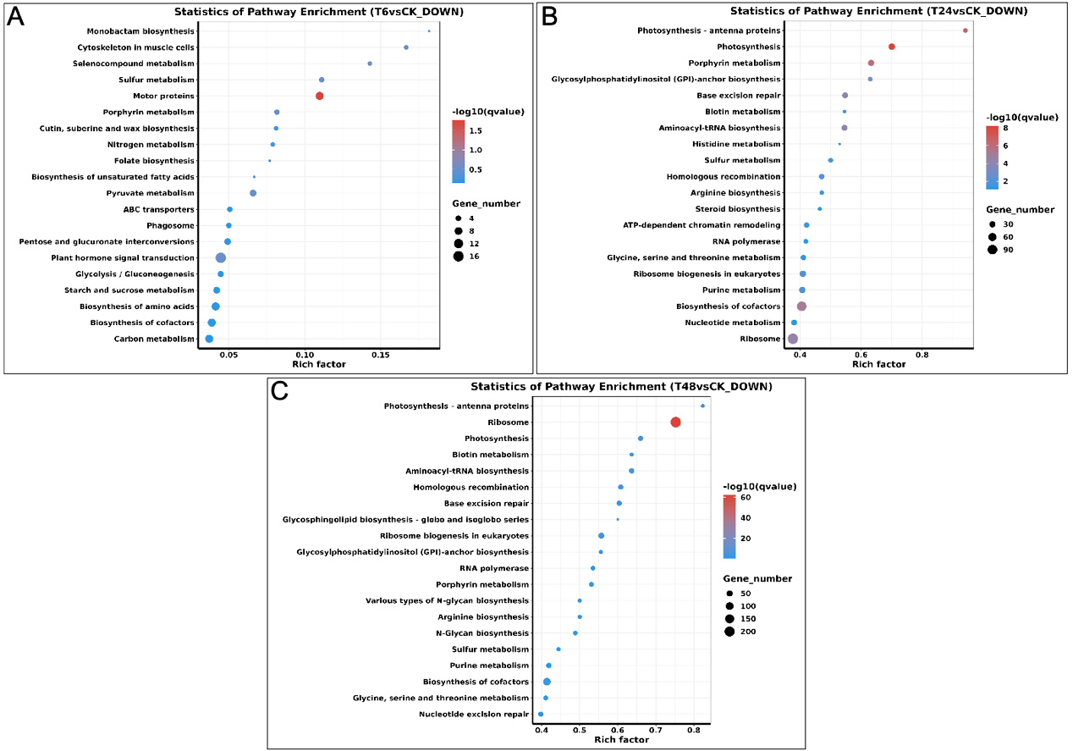
S4 Fig. Top 20 KEGG pathways enriched in the down-regulated DEGs. (A) Down-regulated DEGs under alkali-stress at 6 h. (B) Down-regulated DEGs under alkali-stress at 24 h. (C) Down-regulated DEGs under alkali-stress at 48 h.

