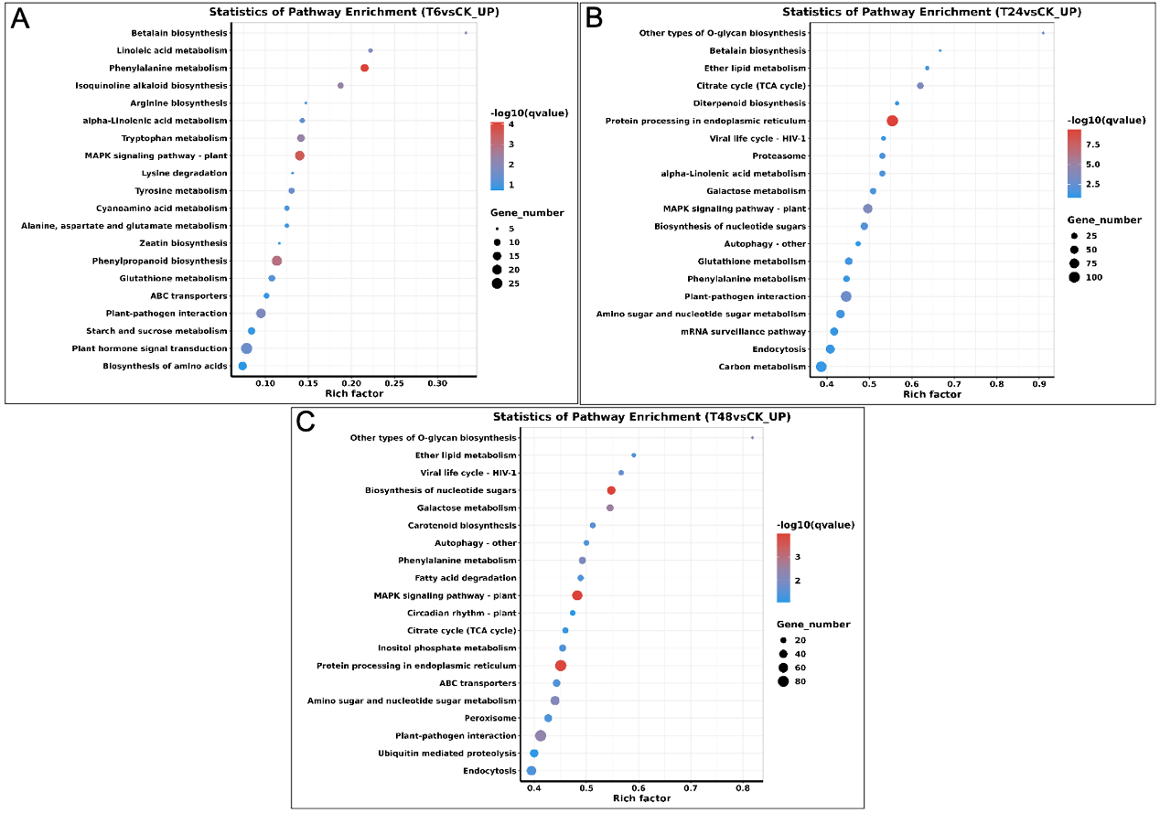
S3 Fig. Top 20 KEGG pathways enriched in the upregulated DEGs. (A) Up-regulated DEGs under alkali-stress at 6 h. (B) Up-regulated DEGs under alkali-stress at 24 h. (C) Up-regulated DEGs under alkali-stress at 48 h.

