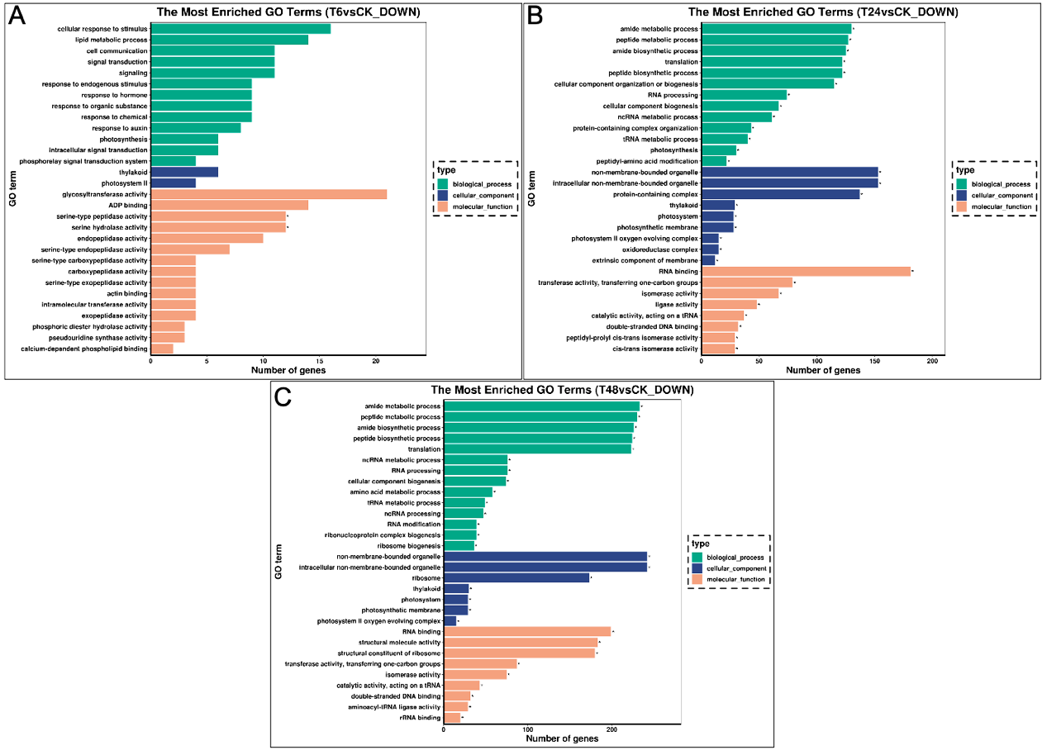
S2 Fig. GO enrichment of down-regulated DEGs. (A) Down-regulated genes under alkali-stress at 6 h. (B) Down-regulated genes under alkali-stress at 24 h. (C) Down-regulated genes under alkali-stress at 48 h.

