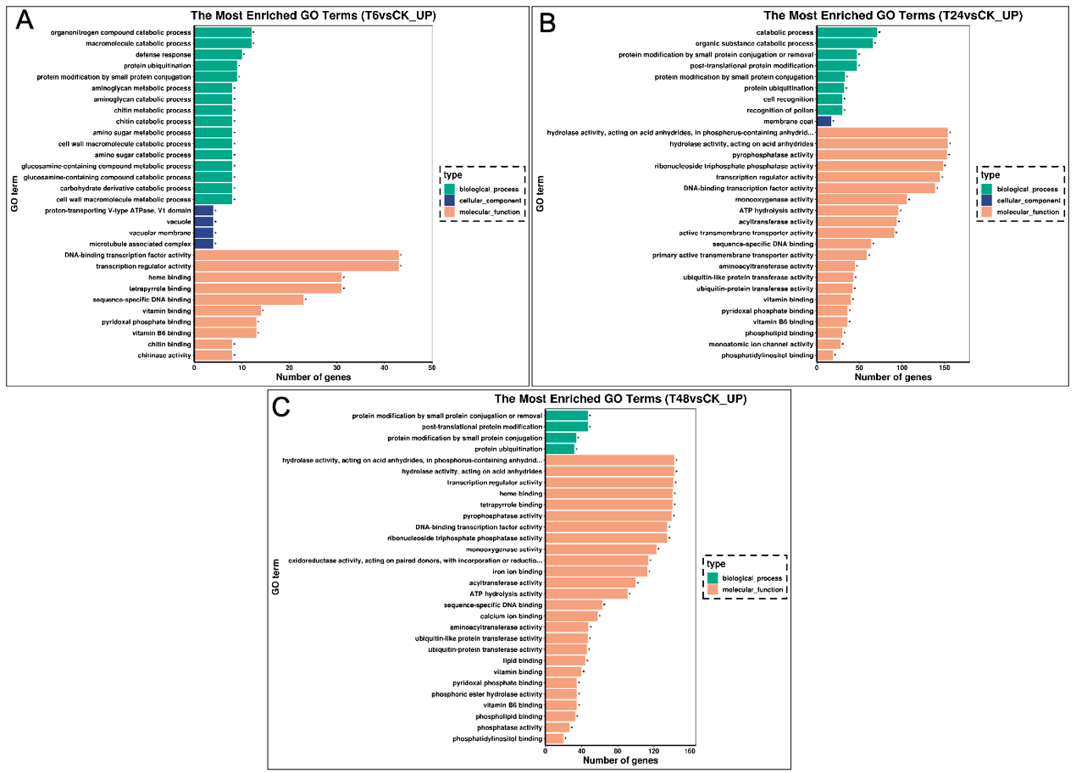
S1 Fig. GO enrichment of up-regulated DEGs. (A) Up-regulated genes under alkali stress at 6 h. (B) Up-regulated genes under alkali-stress at 24 h. (C) Up-regulated genes under alkali stress at 48 h.

