Table S1. List of 50 genes targets; immune checkpoint-related genes in group 1, and tumor suppressors/regulators in group 2.
Group 1 | Group 2
CD274 | PTEN
PDCD1 | TP53
CTLA4 | RB1
CDK4/6 6oql | NF1
EGFR | MGMT
STAT3 | CDKN2A
VEGFA | BAX
HIF1A | FAS
FOXP3 | CASP8
CXCL12 | GADD45A
CD276 | STK11
MMP9 | SMAD4
IL6 | PDCD4
IL10 | DUSP6
TGFBR1 | PRDM1
NFKB1 | BCL2L11
ZEB1 | NLRP3
AKT1 | FADD
PIK3CA | TIGAR
FOXO1 | CD4
ICAM1 | CD8A
ITGB3 | APC
TRAF2 | BID
PRKCB | MHC-II
BIRC5 | IRF1
Table S2. Human genes for head and neck cancer, a functional enrichment property of the STRING network
Gene | Z-score
EGFR | 7.0
TP53 | 6.9
CD274 | 6.8
CDKN2A | 6.6
AKT1 | 6.4
CD8A | 6.3
CTLA4 | 6.2
ERBB2 | 6.2
PDCD1 | 6.1
VEGFA | 6.1

Table S3. Human genes for U-87MG cell, a functional enrichment property of the STRING network
Gene | Z-score
MGMT | 5.8
EGFR | 5.7
TP53 | 5.7
AKT1 | 5.7
CASP3 | 5.6
ANXA5 | 5.5
PTEN | 5.4
EGF | 5.4
PROM1 | 5.4
PIK3CA | 5.3

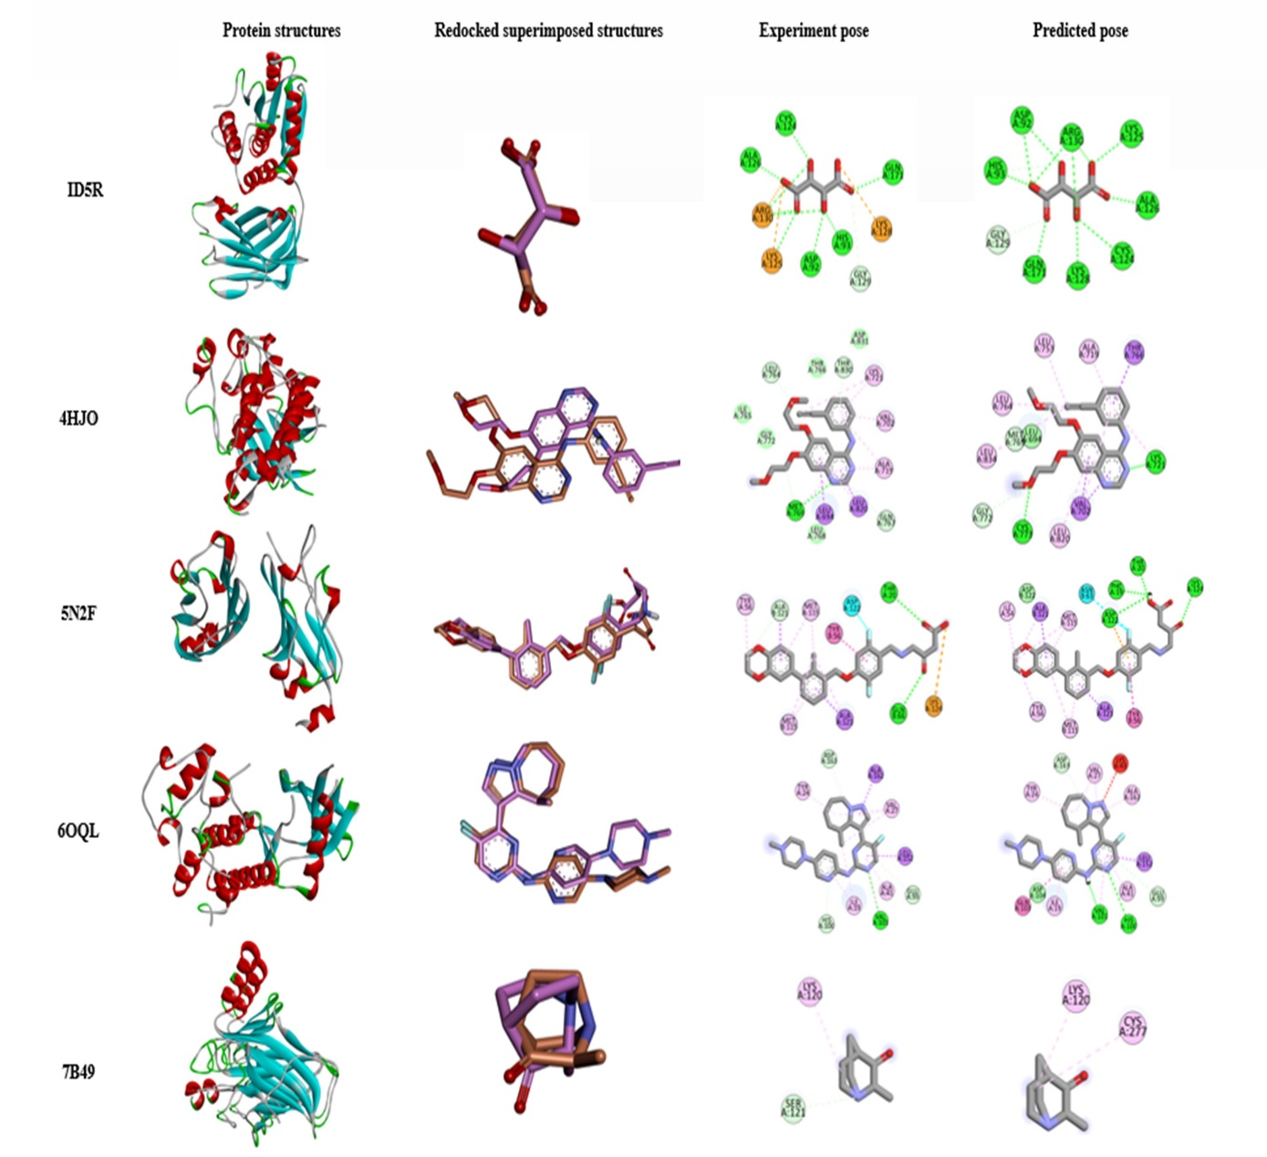
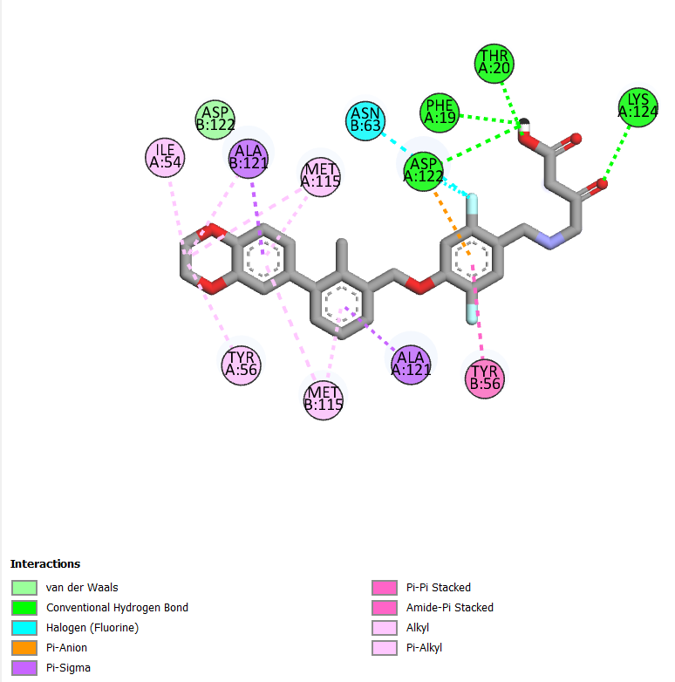

Fig S1. 3D structures of the target proteins along with redock-superimposed structures, crystallographic or experimental pose (orange), and their predicted structure pose (pink) and their 2D diagram showing interacting residues

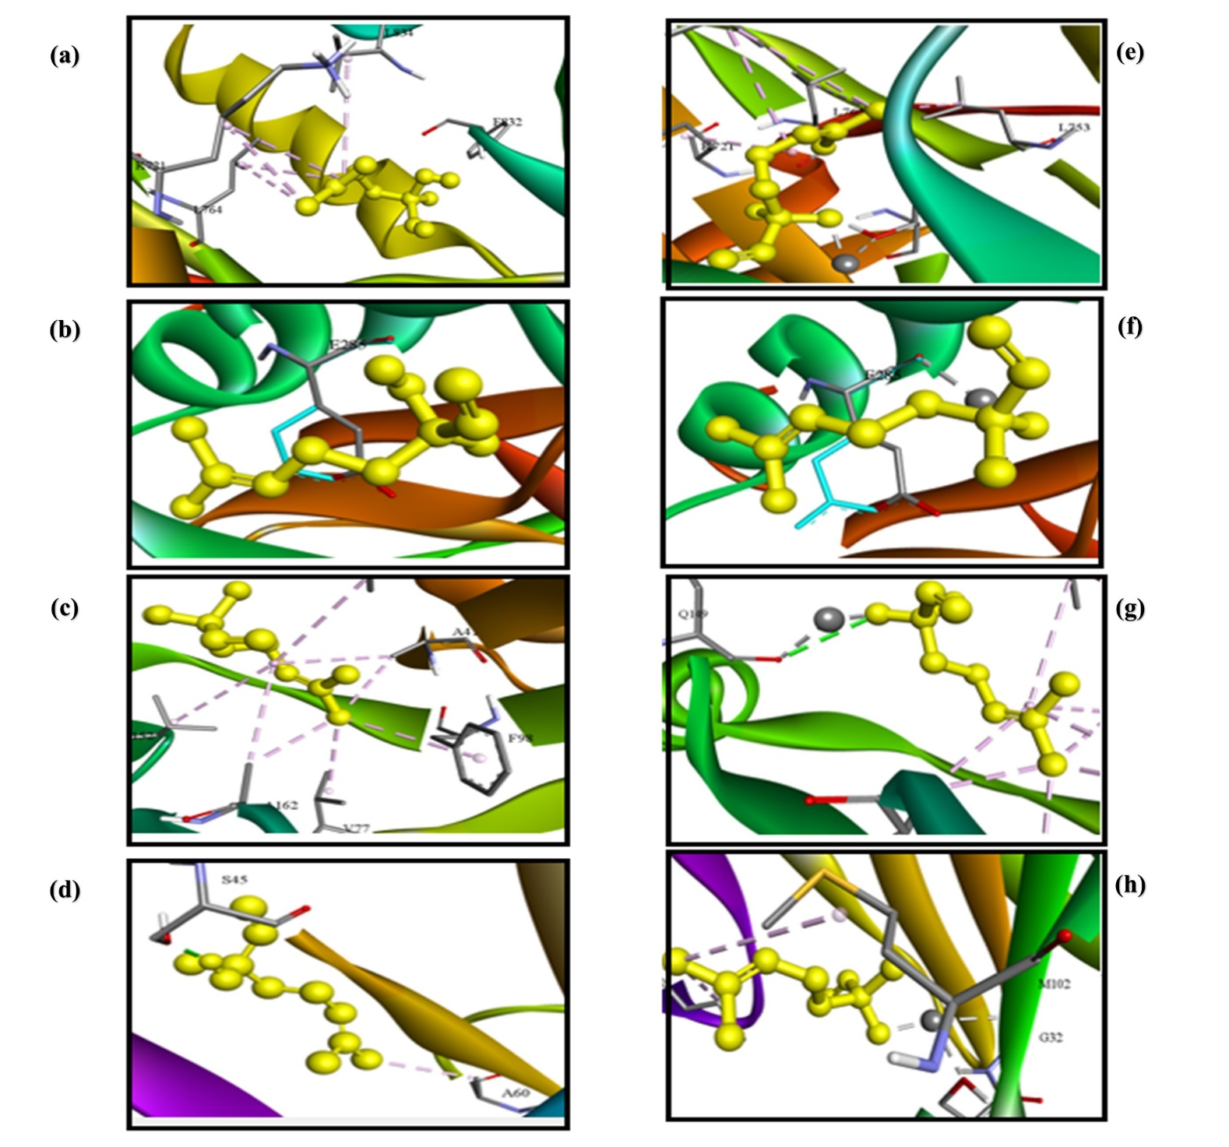
Fig S2. 3D representation of the binding mode of linalool with 4HJO, 7B49, 6OQL, 2HP4 (a-d) and LN@AgNPs with 4HJO, 7B49, 6OQL, 2HP4 (e-h)

