Supplementary Figures

Figure S1 KLF4 expression was analyzed base on pathological stage in BRCA, KIRC, KIRP, PAAD, TGCT, and THCA using TCGA datasets. A Log2 (TPM +1) transformation was applied.

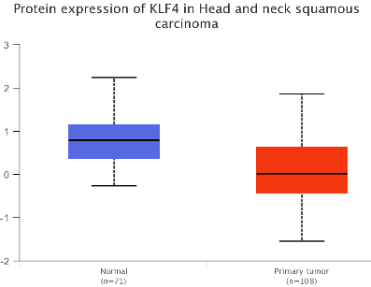
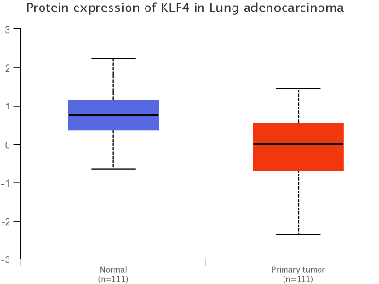
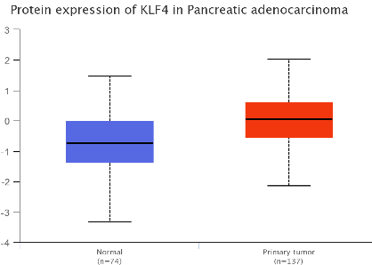
Figure S2 Examination of KLF4 total protein expression between normal and primary tumor tissues from different cancer types and based on the CPTAC dataset (p < 0.05).

Figure S3 Disease-specific survival (DSS) data for KLF4 in different tumors.

.

Figure S4 Analysis of KLF4 DNA methylation levels in different tumors.

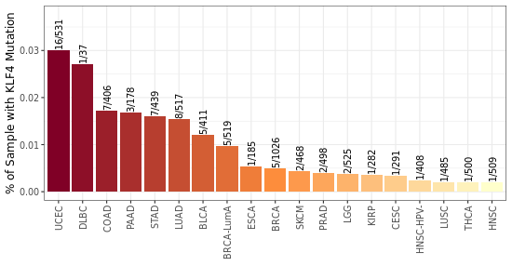
Figure S5 KLF4 mutational frequencies in different cancer types.

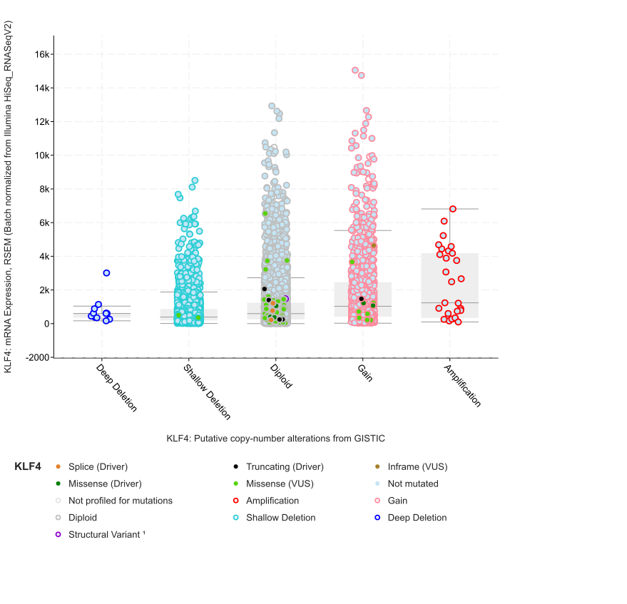
Figure S6 Lack of statistical relevance between DNA copy variations and RNA expression of KLF4 in most cases.

Figure S7 Investigation of the relationship between KLF4 expression and immune infiltration of CD8+ T cells based on ten algorithms across various cancer types using TIMER2.

Figure S8 ROC analysis to examine the prognostic ability of KLF4 in several tumor types.

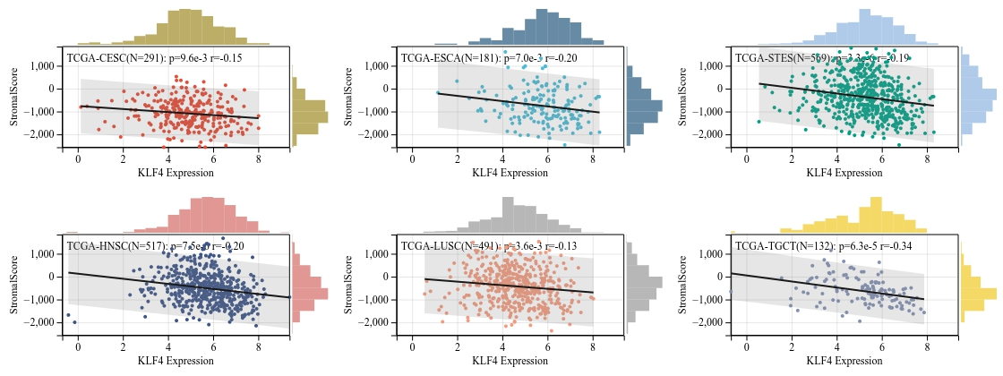
Figure S9 Correlations between the ESTIMATE scores and KLF4 expression.

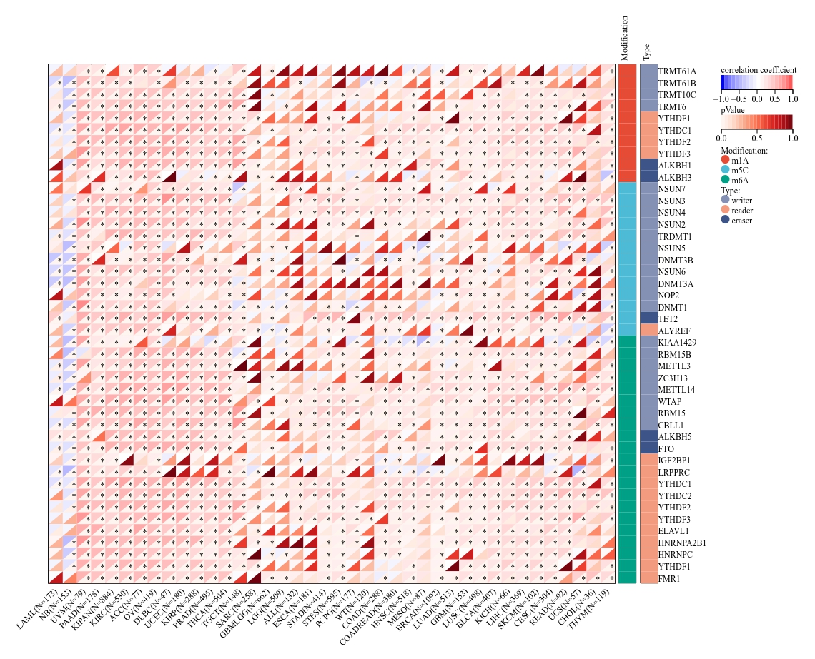
Figure S10 Correlation analysis of RNA modification genes associated with m6A, m5C, and m1A and KLF4 expression using Sangerbox. *p < 0.05.

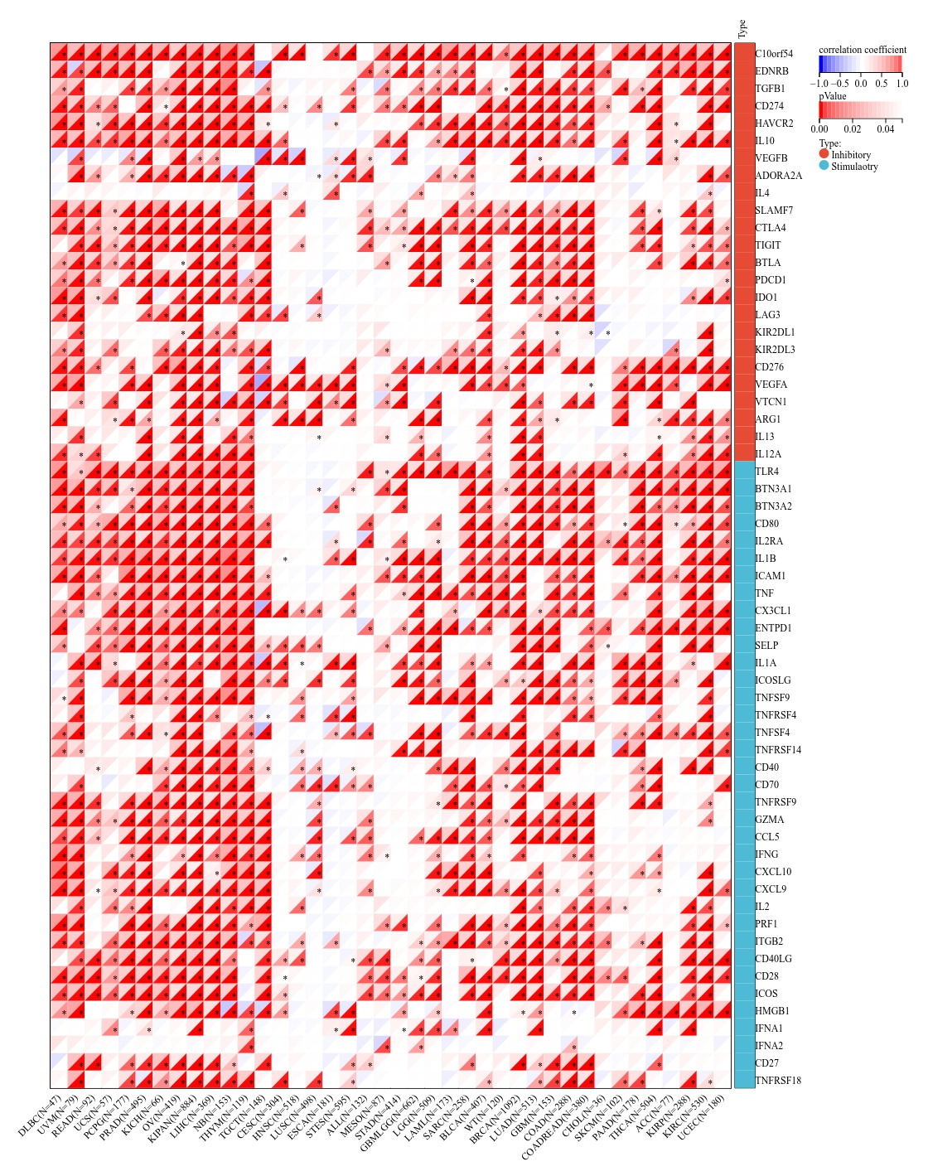
Figure S11 Correlation analysis of immune checkpoint genes and KLF4 expression using Sangerbox. *p < 0.05.
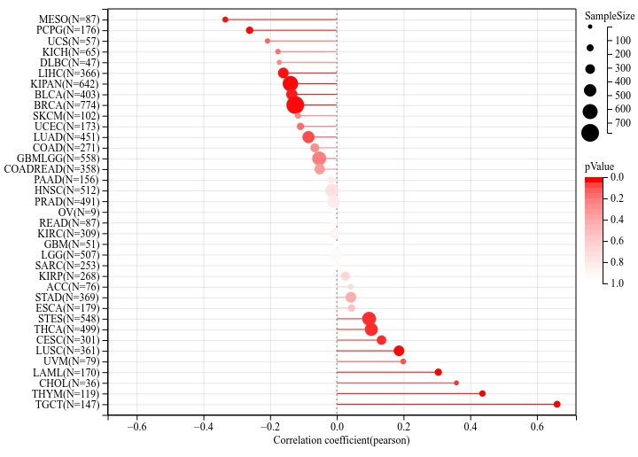
Figure S12 Correlation between KLF4 expression and cancer stemness scores (DNAss) based on Pearson’s correlation analysis.

