SUPPLEMENTARY FIGURES
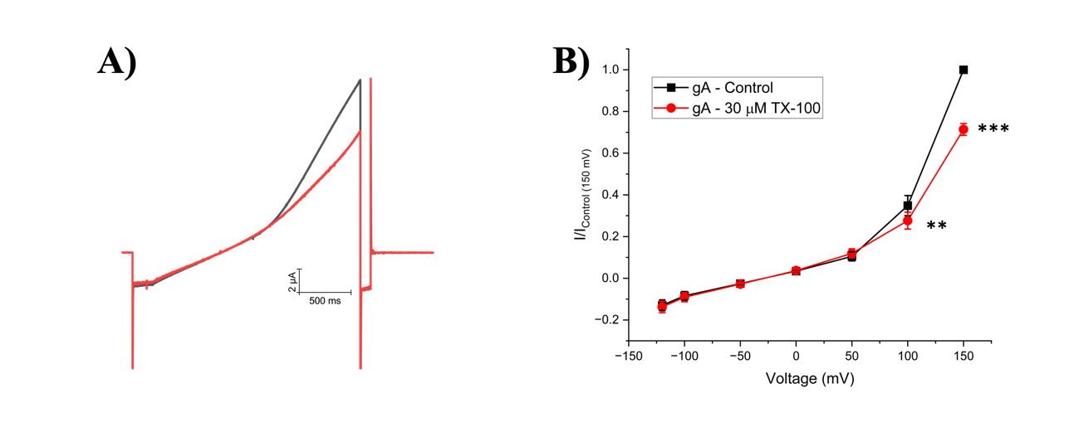
Figure S1: Triton-X 100 (TX-100) inhibits cationic gramicidin currents. A) Representative gA current traces in presence of TX-100. B) Averaged cationic gramicidin currents of TX-100. Test currents were averaged at -120 mV, -100 mV, -50 mV, 0 mV, +50 mV, +100 mV, and +150 mV. (n = 10; ** = P < 0.01, *** = P < 0.001)
C9
C1
C18
Figure S2: Structural properties of endocannabinoids. Gramicidin function was evaluated against three endocannabinoids characteristics: chain length, number of unsaturated bonds and the position of the first unsaturated bond. Representative endocannabinoid: Oleoyl Ethanolamide (OEA), has an 18-carbon tail length, one degree of unsaturation at the 9th carbon position. Carbon count starts at the C1 position located near the ethanolamide head group.

Table S1. Paired student T test P-values. Statistics of differences of averaged cationic currents at voltage +150, +100 and -120 mV in the presence of FAE endocannabinoids and TX-100.

Endocannabinoid​ | Change in current at 150 mV | P-value (+150 mV)​ | Change in current at 100 mV |  | P-value (+100 mV)​ |  | Change in current at -120 mV | P-value (-120 mV)​
AEA​† | 0.01±0.02 | 0.85 |  | 0.03±0.03 |  | 0.05 | -0.02±0.02 | 0.08
αLnEA†​ | 0.13±0.05 | 0.02 |  | 0.08±0.04 |  | 0.005 | -0.03±0.02 | 0.003
ArEA | 0.03±0.05 | 0.58 |  | 0.06±0.04 |  | 0.1 | -0.03±0.02 | 0.02
DEA​ | 0.08±0.03 | 0.02 |  | 0.05±0.05 |  | 0.05 | -0.02±0.02 | 0.11
LEA​† | 0.19±0.03 | 0.005 |  | 0.09±0.06 |  | 0.009 | -0.06±0.04 | 0.01
NEA​† | 0.29±0.08 | 0.004 |  | 0.09±0.07 |  | 0.006 | -0.04±0.04 | 0.01
OEA​† | -0.08±0.02 | 0.002 |  | -0.014±0.03 |  | 0.39 | -0.007±0.03 | 0.52
oxy-AEA†​ | 0.42±0.08 | 3.90E-04 |  | 0.23±0.05 |  | 3.12E-04 | -0.05±0.02 | 0.002
POEA​ | 0.09±0.03 | 0.01 |  | 0.05±0.02 |  | 0.007 | -0.03±0.02 | 0.009
SEA​ | 0.13±0.05 | 0.02 |  | 0.07±0.04 |  | 0.12 | -0.03±0.04 | 0.34
TEA​ | 0.15±0.05 | 0.02 |  | 0.04±0.04 |  | 0.16 | -0.01±0.03 | 0.12
γLnEA​ | 0.05±0.03 | 0.16 |  | 0.03±0.03 |  | 0.04 | -0.01±0.02 | 0.27
TX-100† | -0.38±0.04 | <0.0001 |  | -0.09±0.06 |  | 0.001 | -0.01±0.03 | 0.29
DMSO | 0.04±0.03 | 0.21 |  | 0.03±0.04 |  | 0.16 | -0.02±0.03 | 0.09

† representative gramicidin current traces and averaged current-voltage relationship shown in manuscript

Table S2. Paired student T test P-values. Statistics of differences of averaged cationic currents at voltage +150, +100 and -120 mV in the presence of 2-MG endocannabinoids.

Endocannabinoid​ | Change in current at 150 mV | P-value (+150 mV)​ | Change in current at 100 mV |  | P-value (+100 mV)​ |  | Change in current at -120 mV | P-value (-120 mV)​
1-AG | -0.02±0.01 | 0.08 |  | 0.02±0.03 |  | 0.14 | -0.01±0.02 | 0.05
1-MrG​ | 0.03±0.05 | 0.62 |  | 0.02±0.06 |  | 0.55 | -0.01±0.04 | 0.05
1-OrG† | -0.18±0.04 | 0.007 |  | -0.05±0.04 |  | 0.09 | -0.01±0.02 | 0.17
1-SG† | 0.14±0.02 | 0.001 |  | 0.04±0.04 |  | 0.01 | -0.02±0.03 | 0.09
1-OG | -0.009±0.03 | 0.81 |  | 0.01±0.03 |  | 0.71 | -0.02±0.01 | 0.06
2-AG† | -0.02±0.06 | 0.70 |  | 0.02±0.03 |  | 0.19 | -0.01±0.01 | 0.03
2-LG | -0.02±0.04 | 0.58 |  | 0.01±0.03 |  | 0.59 | -0.02±0.02 | 0.04
2-PG† | 0.12±0.04 | 0.01 |  | 0.06±0.04 |  | 0.009 | -0.03±0.03 | 0.01
2-SG† | 0.14±0.05 | 0.02 |  | 0.06±0.05 |  | 0.04 | -0.02±0.03 | 0.09
Glycerol | 0.04±0.03 | 0.22 |  | 0.006±0.03 |  | 0.58 | 0.01±0.04 | 0.26

† representative gramicidin current traces and averaged current-voltage relationship shown in manuscript

Table S3. Parametric values and statistical significance for linear correlation of FAE endocannabinoids.

Structural Property​ | Intercept | Slope​ | Pearsons’s r | R-Square | P-value
Number of Carbons | 0.94 ± 0.30 | 0.00 ± 0.01 | 0.08 | 0.06 | 0.80
Degree of Unsaturation | 1.02 ± 0.05 | 0.00 ± 0.02 | -0.02 | 0.10 | 0.95
Position of 1st Unsaturated bond | 0.98 ± 0.05 | 0.01 ± 0.01 | 0.29 | 0.08 | 0.37
LogP | 0.94 ± 0.19 | 0.01 ± 0.03 | 0.14 | 0.02 | 0.67
LogD (pH 7.4) | 1.01 ± 0.21 | 0.00 ± 0.04 | 0.01 | 0.00 | 0.98

Table S4. Parametric values and statistical significance for non-linear (curvilinear) correlation of 2-MG endocannabinoids.

Structural Property​ | Offset (y₀) | Center (x_{c})​ | Width (w) | Amplitude (A) | Reduced Chi-Sqr | R-Square | Residual sum of squares
Number of Carbons | 0.84 ± 0.11 | 16.5 ± 0.90 | 2.8 ± 1.23 | 0.27 ± 0.11 | 4.4 | 0.73 | 22.02431
P-values | 1.37E-4 | 2.03E-6 | 0.064 | 0.04 | - | -

Table S5. Parametric values and statistical significance for linear correlation of 2-MG endocannabinoids.

Structural Property​ | Intercept | Slope​ | Pearson’s r | R-Square | P-value
Number of Carbons | 0.67 ± 0.01 | 0.02 ± 0.00*** | 0.82 | 0.67 | <0.001
Degree of Unsaturation | 1.08 ± 0.03 | -0.03 ± 0.01* | -0.73 | 0.53 | 0.04
Position of 1st Unsaturated bond | 0.91 ± 0.02 | 0.01 ± 0.00*** | 0.92 | 0.84 | <0.001
LogP (saturated) | 0.72 ± 0.03 | 0.06 ± 0.00*** | 0.99 | 0.98 | <0.001
LogP (unsaturated) | 0.87 ± 0.01 | 0.02 ± 0.01 | 0.99 | 0.97 | 0.06
LogD (pH 7.4) (saturated) | 0.69 ± 0.05 | 0.06 ± 0.01* | 0.98 | 0.96 | 0.003
LogD (pH 7.4) (unsaturated) | 0.87 ± 0.03 | 0.02 ± 0.01 | 0.91 | 0.83 | 0.09

* = P < 0.05, *** = P < 0.001

