Supporting Figures
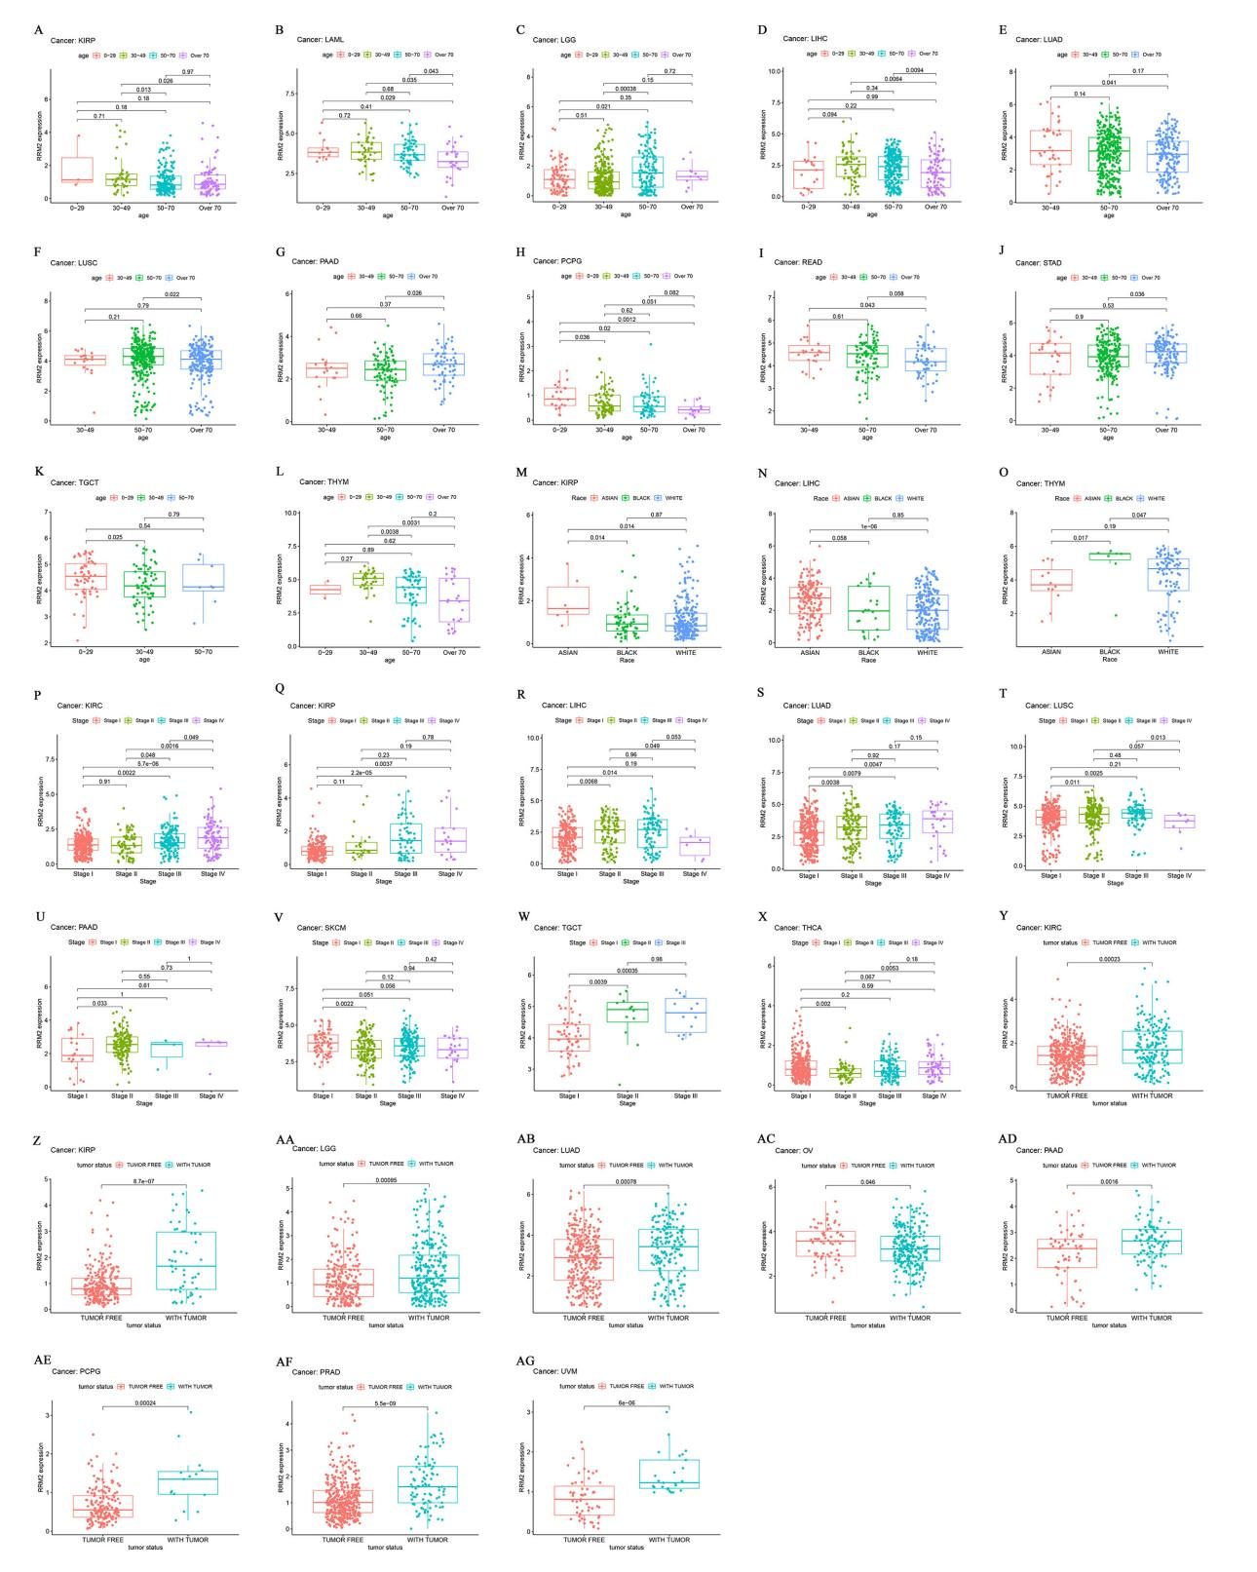
S1 Fig. The expression level of RRM2 and its clinical correlation in pan-cancer. (A-L) The clinical correlation between RRM2 expression level and age in KIRP, LAML, LGG, LIHC, LUAD, LUSC, PAAD, PCPG, READ, STAD, TGCT and THYM, respectively. (M-O) The clinical correlation between RRM2 expression level and race in KIRP, LIHC and THYM, respectively. (P-X) The clinical correlation between RRM2 expression level and tumor stage of tumor patient in KIRC, KIRP, LIHC, LUAD, LUSC, PAAD, SKCM, TGCT, and YHCA, respectively. (Y-AG) The clinical correlation between RRM2 expression level and tumor status of tumor patient in KIRC, KIRP, LGG, LUAD, OV, PAAD, PCPG, PRAD and UVM, respectively. The number above the horizontal line represents the p-value between the two groups.
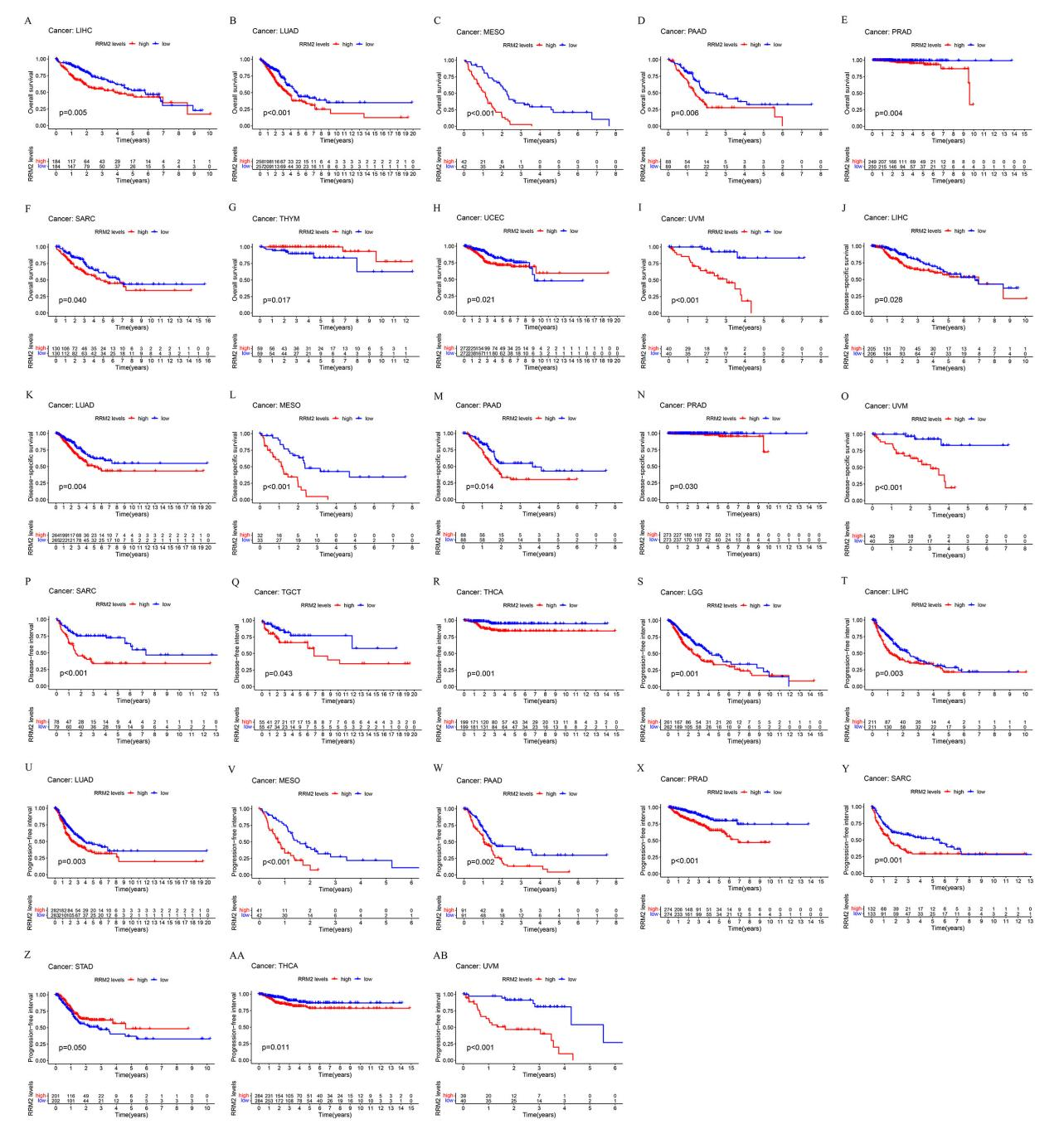
S2 Fig. Prognostic value of RRM2 in pan-cancer. (A-AB) Correlation between expression level of RRM2 and OS, DSS, DFI and PFI in pan-cancer, using the Kaplan-Meier method. OS, Overall survival (years); DSS, Disease-specific survival (years); DFI, Disease-free interval (years); PFI, Progression-free interval (years).
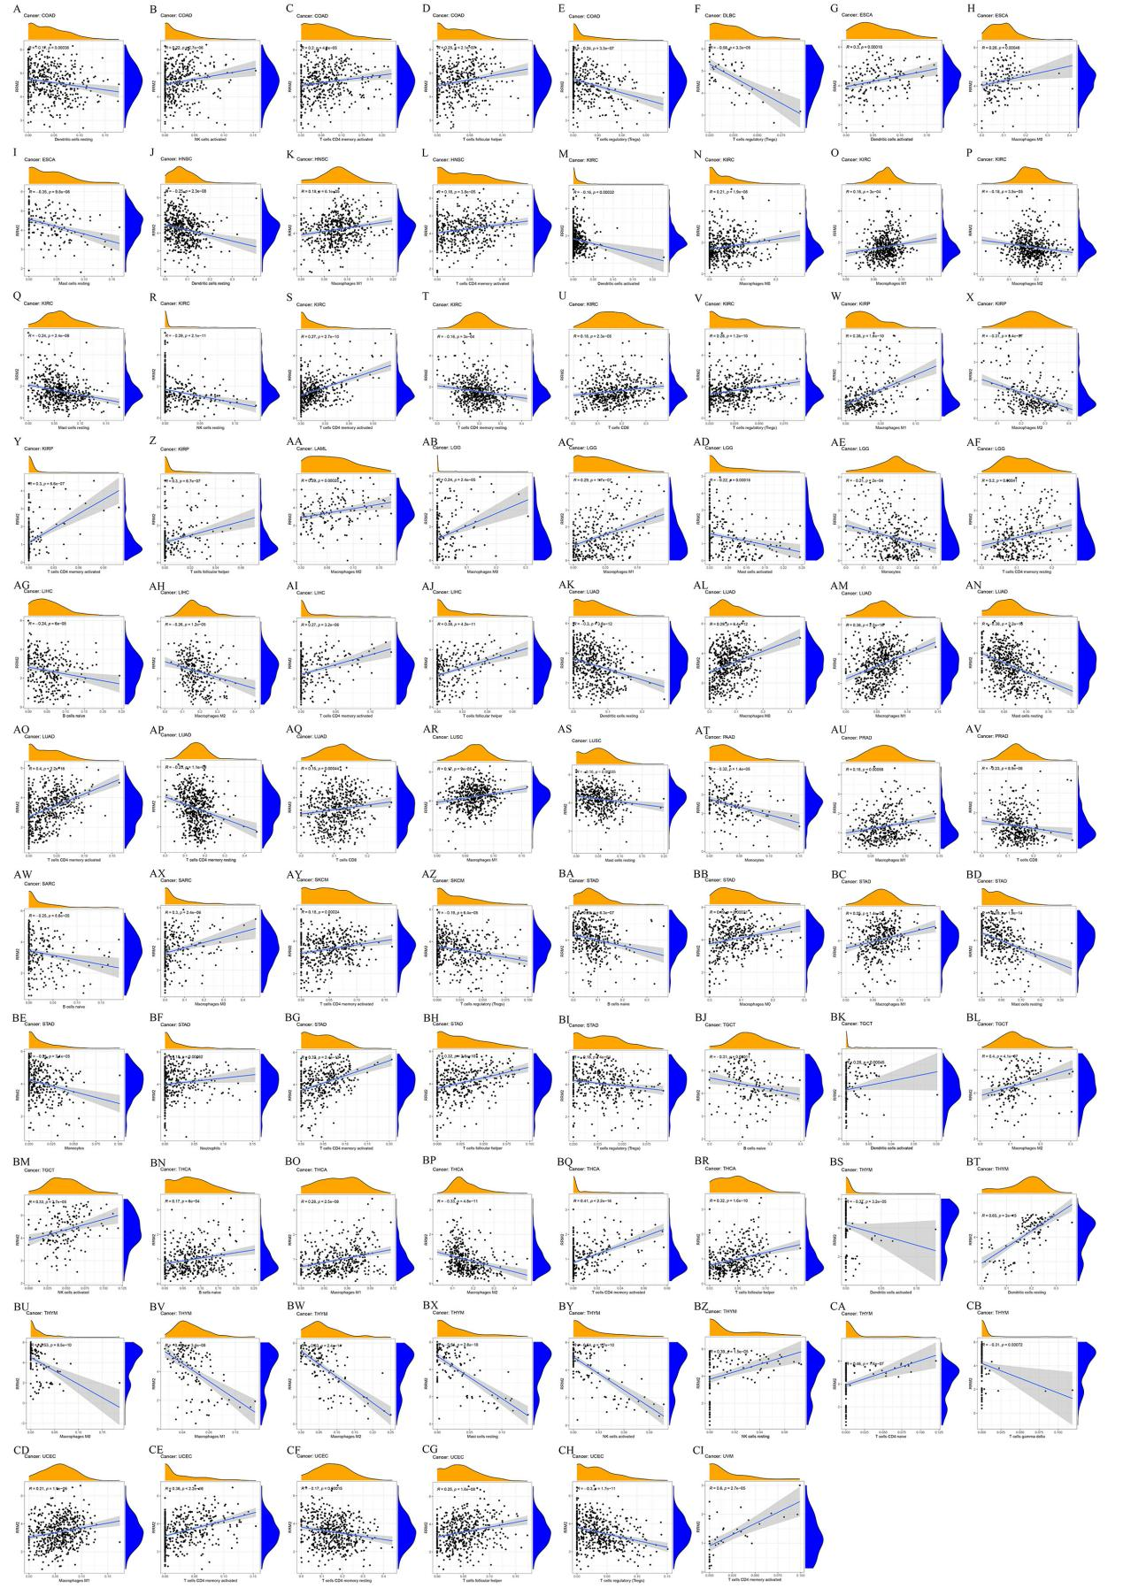
S3 Fig. Correlation analysis between RRM2 expression and immune infiltration of cancer-associated cells. (A-CI) The correlation between RRM2 gene expression and the infiltration level of diverse immune cells in pan-cancer.
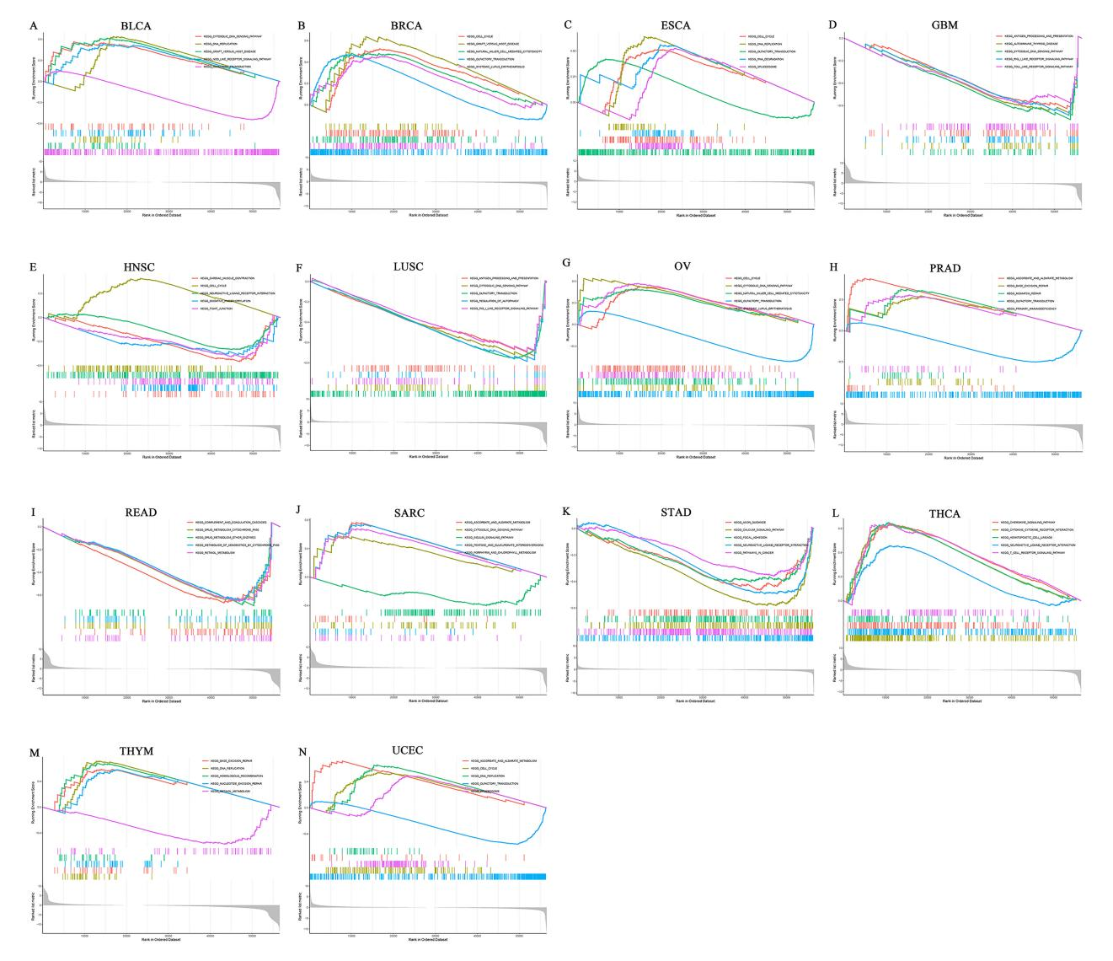
S4 Fig. Gene set enrichment analysis (GSEA) of RRM2 in pan-cancer.
- N) Gene set enrichment analysis (GSEA) of RRM2 in pan-cancer.

Supporting Tables

KEGG ID | Cancer Types | Number of  Cancer Types
KEGG_CELL_CYCLE | BLCA, BRCA, ESCA, HNSC, OV, STAD, THCA, UCEC | 8
KEGG_OLFACTORY_TRANSDUCTION | BLCA, BRCA, ESCA, LUSC, OV, PRAD, UCEC | 7
KEGG_CYTOSOLIC_DNA_SENSING_PATHWAY | BLCA, ESCA, GBM, LUSC, OV, SARC | 6
KEGG_DNA_REPLICATION | BLCA, BRCA, ESCA, STAD, THYM, UCEC | 6
KEGG_ANTIGEN_PROCESSING_AND_PRESENTATION | BLCA, BRCA, ESCA, GBM, LUSC | 5
KEGG_NATURAL_KILLER_CELL_MEDIATED_CYTOTOXICITY | BLCA, BRCA, ESCA, OV, THCA | 5
KEGG_SPLICEOSOME | BLCA, ESCA, OV, STAD, UCEC | 5
KEGG_ASCORBATE_AND_ALDARATE_METABOLISM | BRCA, PRAD, SARC, UCEC | 4
KEGG_CELL_ADHESION_MOLECULES_CAMS | ESCA, READ, STAD, THCA | 4
KEGG_NEUROACTIVE_LIGAND_RECEPTOR_INTERACTION | ESCA, HNSC, STAD, THCA | 4
KEGG_PENTOSE_AND_GLUCURONATE_INTERCONVERSIONS | BRCA, PRAD, SARC, UCEC | 4
KEGG_REGULATION_OF_AUTOPHAGY | ESCA, GBM, LUSC, OV | 4
KEGG_RIG_I_LIKE_RECEPTOR_SIGNALING_PATHWAY | ESCA, GBM, LUSC, THYM | 4
KEGG_BASE_EXCISION_REPAIR | PRAD, STAD, THYM | 3
KEGG_CALCIUM_SIGNALING_PATHWAY | ESCA, STAD, THCA | 3
KEGG_DRUG_METABOLISM_CYTOCHROME_P450 | BLCA, READ, STAD | 3
KEGG_GRAFT_VERSUS_HOST_DISEASE | BLCA, BRCA, THCA | 3
KEGG_HOMOLOGOUS_RECOMBINATION | PRAD, STAD, THYM | 3
KEGG_HYPERTROPHIC_CARDIOMYOPATHY_HCM | HNSC, STAD, THCA | 3
KEGG_LEISHMANIA_INFECTION | BLCA, ESCA, THCA | 3
KEGG_PORPHYRIN_AND_CHLOROPHYLL_METABOLISM | BRCA, SARC, UCEC | 3
KEGG_RETINOL_METABOLISM | READ, STAD, THYM | 3
KEGG_SYSTEMIC_LUPUS_ERYTHEMATOSUS | BRCA, OV, THCA | 3
KEGG_TOLL_LIKE_RECEPTOR_SIGNALING_PATHWAY | BLCA, GBM, LUSC | 3
S1 Table. The KEGG pathway that RRM2 regulates in pan-cancer by using GSEA.

Drug Target | Drug Name (Approved) | Drug ID
Histone deacetylase 1 (HDAC1) | Phenylbutyrate | D0B7CH
Histone deacetylase 1 (HDAC1) | Romidepsin | D0L7LC
Histone deacetylase 1 (HDAC1) | ITF2357 | D0GH3Q
Tyrosine-protein kinase ABL1 (ABL) | Adenosine triphosphate | D01BYB
Tyrosine-protein kinase ABL1 (ABL) | Bosutinib | D0OB0F
Tyrosine-protein kinase ABL1 (ABL) | SKI-758 | D03MNN
Tyrosine-protein kinase ABL1 (ABL) | Ponatinib | D0H0EQ
Cyclin-dependent kinase 4 (CDK4) | Apremilast | D07ESC
Cyclin-dependent kinase 4 (CDK4) | LY2835219 | D05SBO
Cyclin-dependent kinase 4 (CDK4) | Ribociclib Succinate | D01HVT
Cyclin-dependent kinase 6 (CDK6) | Apremilast | D07ESC
Cyclin-dependent kinase 6 (CDK6) | LY2835219 | D05SBO
Cyclin-dependent kinase 6 (CDK6) | Ribociclib Succinate | D01HVT
Transforming growth factor beta 1 (TGFB1) | Pirfenidone | D02WCI
S2 table. Potential drug prediction of RRM2 for pan-cancer

