S8 Text: Effect Direction Plots – End Stage Cancer
Summaries in this appendix present findings for studies in patients with end stage cancer according to outcome and nature of effect (including direction and statistical significance). Findings for cross-sectional and sequential studies should be interpreted as associations not effects. Cells split into two colours indicate more than one analysis for the outcome with differing findings. These summaries are intended to provide a high-level comprehensive mapping of available data for this sub-population.
Systematic Reviews of End-stage Cancer: Pain-related Outcomes
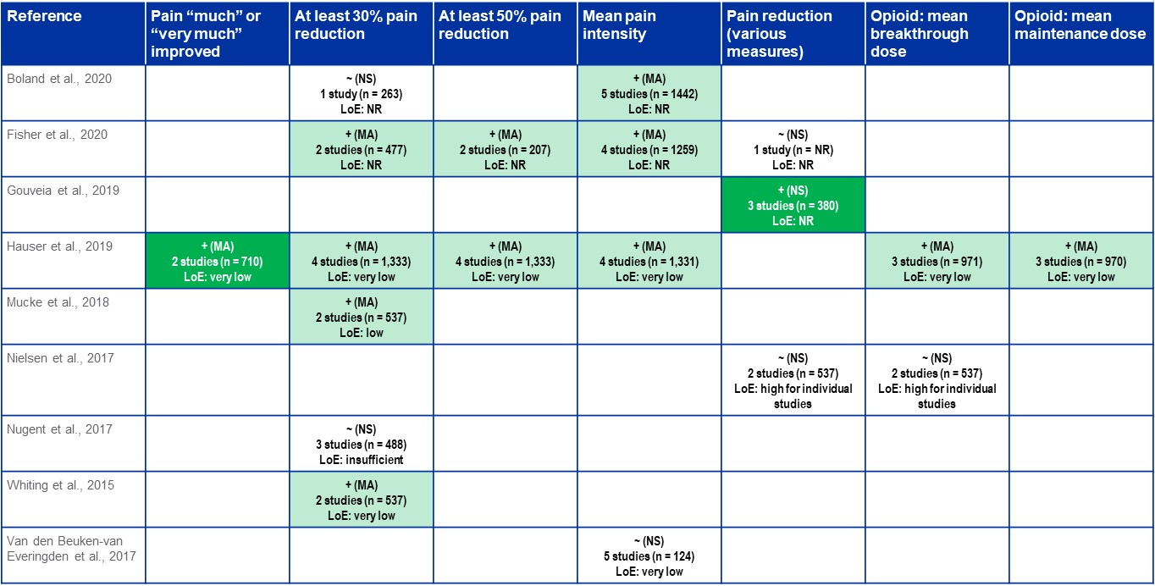

Systematic Reviews of End-stage Cancer: Adverse Events
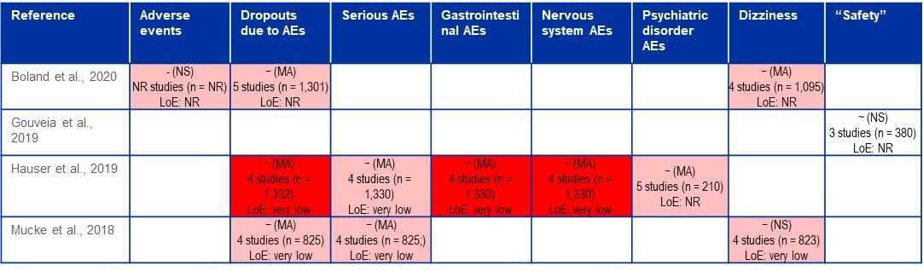

Systematic Reviews of End-stage Cancer: Other Outcomes
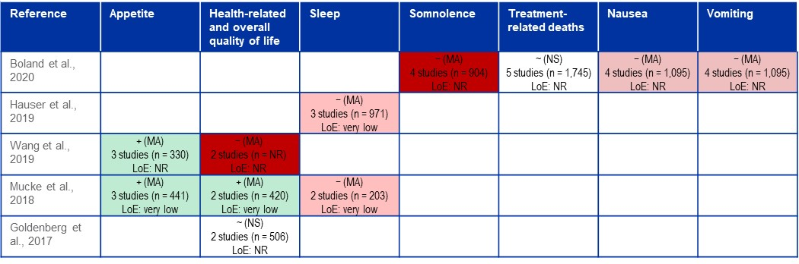

RCTs of End-stage Cancer: All Outcomes
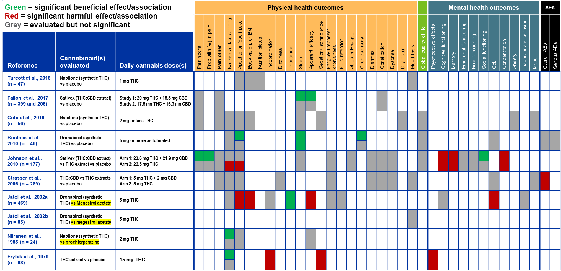
Non-randomized Studies of End-stage Cancer: All Outcomes
