S7 Text: Effect Direction Plots – Healthy Adults and General Population
Summaries in this appendix present findings for studies in healthy adults and the general population according to outcome and nature of effect (including direction and statistical significance). Findings for cross-sectional and sequential studies should be interpreted as associations not effects. Cells split into two colours indicate more than one analysis for the outcome with differing findings. These summaries are intended to provide a high-level comprehensive mapping of available data for this sub-population.
Non-randomized Studies of Healthy Older Adults and the Older General Public: Physical and Mental Health Outcomes

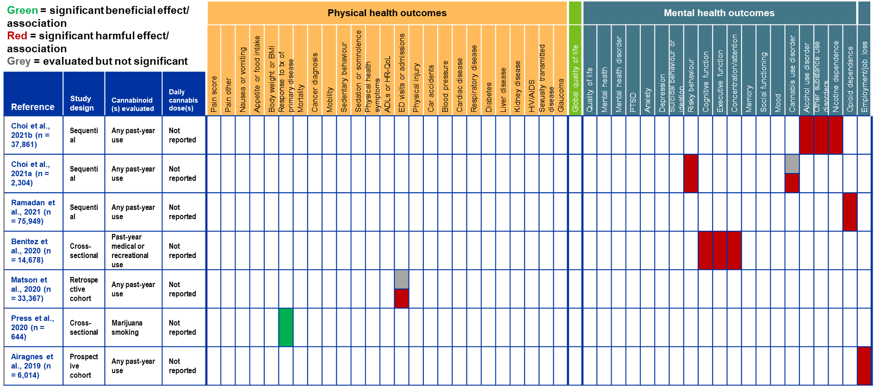
Non-randomized Studies of Healthy Older Adults and the Older General Public: Physical and Mental Health Outcomes (continued)
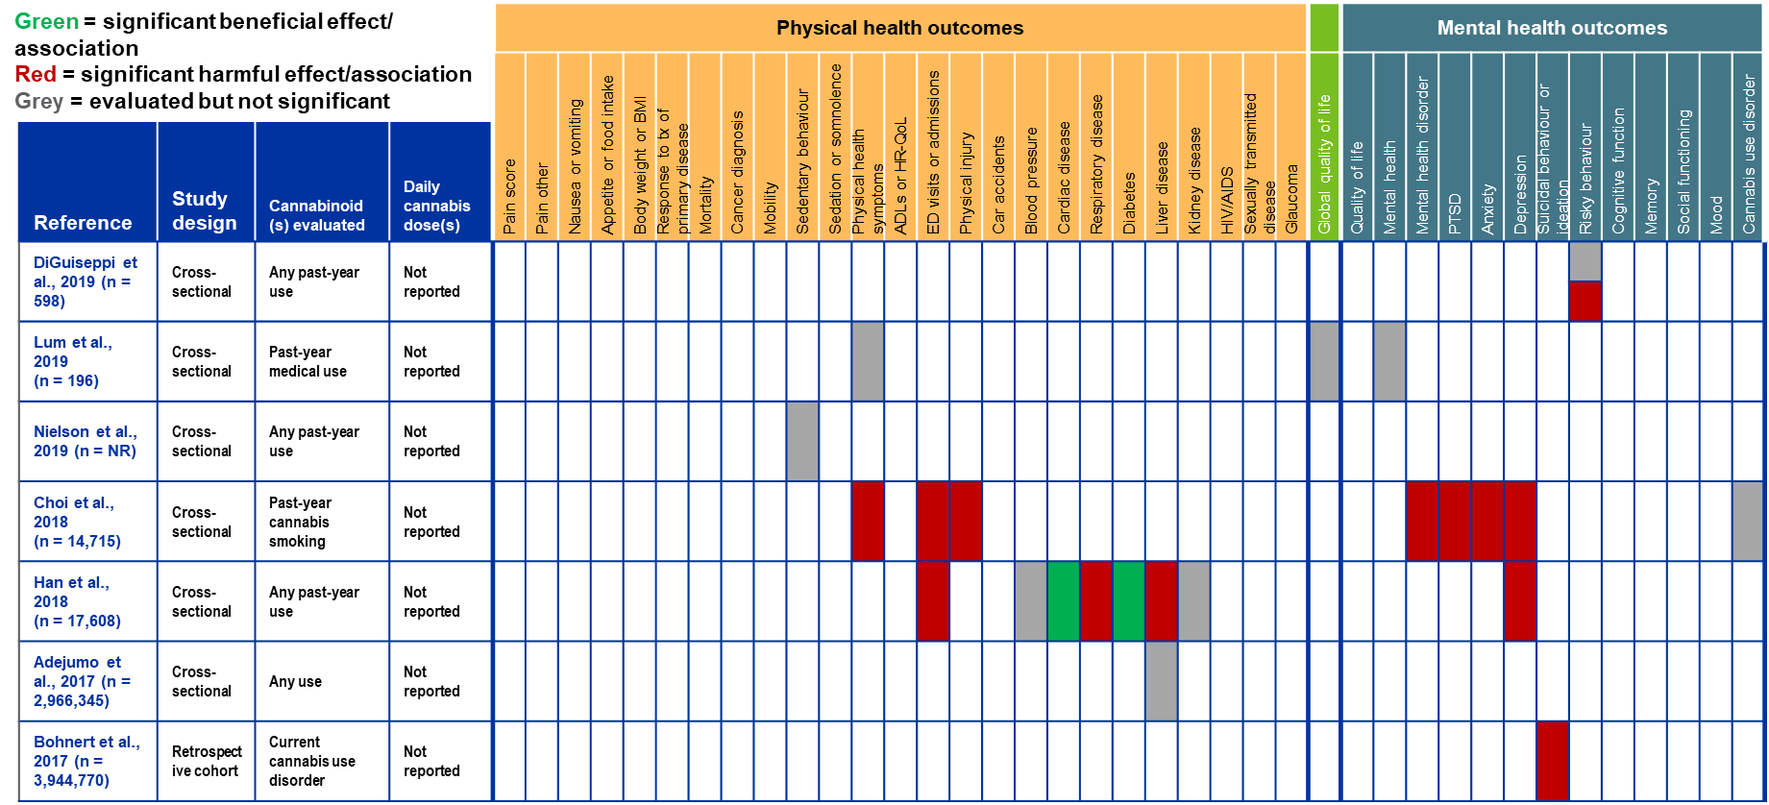

Non-randomized Studies of Healthy Older Adults and the Older General Public: Physical and Mental Health Outcomes (continued)
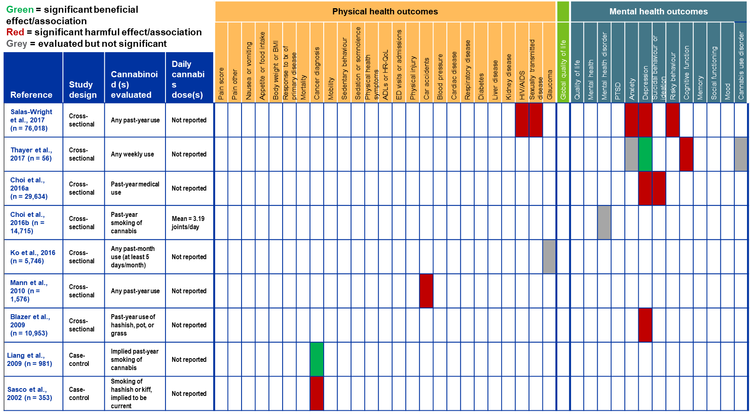

Non-randomized Studies of Healthy Older Adults and the Older General Public: Drug and Alcohol Outcomes
