Use of Machine Learning to Examine Disparities in Completion of Substance Use Disorder Treatment
SUPPLEMENTARY APPENDIX
Sup Appendix Table 1 describes the out-of-sample prediction statistics using balanced data (SMOTE) with 50% down-sampling so that the samples have a 1:1 ratio between treatment and control
Sup Appendix Table 1: Out-of-sample prediction accuracy |  |  |  |  |  | Sup Appendix Table 1: Out-of-sample prediction statistics
 | Random Forest | XGBoost | Logistic Reg. | Neural Network | Decision Tree
Accuracy | 0.800 | 0.792 | 0.774 | 0.743 | 0.726
AUC | 0.881 | 0.868 | 0.851 | 0.818 | 0.753
Precision | 0.655 | 0.647 | 0.628 | 0.641 | 0.573
Recall | 0.830 | 0.806 | 0.798 | 0.577 | 0.766
F1 | 0.732 | 0.718 | 0.703 | 0.425 | 0.656

Sup Appendix Table 2 describes missing data.
Sup Appendix Table 2: Missing data description for TEDS-D 2017-2019 combined data
Variable Description | Var. Abbr. | # Missing | % Missing
DSM Diagnosis | DSMCRIT | 1,499,754 | 29.7%
Frequency of use at discharge (primary) | FREQ1_D | 1,414,472 | 28.0%
Living arrangement at discharge | LIVARAG_D | 1,035,258 | 20.5%
Employment status at discharge | EMPLOY_D | 943,764 | 18.7%
Arrests in past 30 days prior to discharge | ARRESTS_D_num | 946,319 | 18.7%
Co-occurring mental and substance use disorders | PSYPROB | 684,041 | 13.5%
Frequency of use at admission (primary) | FREQ1 | 550,785 | 10.9%
Arrests in past 30 days prior to admission | ARRESTS_num | 516,651 | 10.2%
Previous substance use treatment episodes | NOPRIOR_num | 428,236 | 8.5%
Employment status at admission | EMPLOY | 326,786 | 6.5%
Referral Source | PSOURCE | 238,795 | 4.7%
Substance use at admission (secondary) | SUB2 | 175,889 | 3.5%
Substance use at admission (primary) | SUB1 | 173,493 | 3.4%
Ethnicity | ETHNIC | 155,573 | 3.1%
Race | RACE | 138,662 | 2.7%
Notes: Only variables with missing data are included in this table. If a variable is not present here, it had 0% missing data. The table is sorted by missing data percentage, with the largest values appearing at the top.

The following variables from TEDS-D were dropped from the analyses due to high collinearity or high missing values:
- Health insurance (HLTHINS)
- Payment source, primary (expected or actual) (PRIMPAY)
- Detailed not in labor force category at admission (DETNLF)
- Detailed not in labor force category at discharge (DETNLF_D)
- Route of administration (tertiary) (ROUTE3)
- Age at first use (secondary) (FRSTUSE2)
- Age at first use (tertiary) (FRSTUSE3)
- Pregnant at admission (PREG)
- Frequency of use at admission (secondary) (FREQ2)
- Frequency of use at discharge (tertiary) (FREQ3_D)
- Substance use at discharge (primary) (SUB1_D)
- Substance use at discharge (secondary) (SUB2_D)
- Substance use at discharge (tertiary) (SUB3_D)
- Type of treatment service/setting at discharge (SERVICES_D)
- Detailed criminal justice referral (DETCRIM)
- Frequency of use at discharge (secondary) (FREQ2_D)
- Substance use at admission (tertiary) (SUB3)
- Frequency of use at admission (tertiary) (FREQ3)
- Medication-assisted opioid therapy (METHUSE)
- Attendance at substance use self-help groups in past 30 days prior to admission (FREQ_ATND_SELF_HELP)
- Attendance at substance use self-help groups in past 30 days prior to discharge (FREQ_ATND_SELF_HELP_D)
- Alcohol reported at admission (ALCFLG)
- Heroin reported at admission (HERFLG)
- Other tranquilizers reported at admission (TRNQFLG)

Sup Appendix Table 3 describes the data both with and without rows that have at least one variable with missing data.
Sup Appendix Table 3: TEDS-D (2017-2019) descriptive statistics for all variables with and without rows with missing data
 |  |  | Categorical Description | Without Missingness |  | With Missingness
Variable | Abbr. | Value | Categorical Description | Freq | % | Freq | %
Year of client's discharge from treatment | DISYR |  | 2017 | 162,063 | 25 | 1,499,144 | 34.1
Year of client's discharge from treatment | DISYR |  | 2018 | 232,365 | 35.8 | 1,434,001 | 32.6
Year of client's discharge from treatment | DISYR |  | 2019 | 255,051 | 39.3 | 1,467,452 | 33.3
Reason for discharge | REASON | a | Treatment completed | 219,658 | 33.8 | 1,888,339 | 42.9
Reason for discharge | REASON | b | Dropped out of treatment | 148,174 | 22.8 | 1,119,905 | 25.4
Reason for discharge | REASON | c | Terminated by facility | 49,505 | 7.6 | 248,380 | 5.6
Reason for discharge | REASON | d | Transferred to another treatment program | 189,410 | 29.2 | 879,711 | 20
Reason for discharge | REASON | e | Incarcerated | 14,954 | 2.3 | 69,481 | 1.6
Reason for discharge | REASON | f | Death | 1,156 | 0.2 | 9,879 | 0.2
Reason for discharge | REASON | g | Other | 26,622 | 4.1 | 184,902 | 4.2
Race | RACE | a | Alaskan Native | 4,457 | 0.7 | 6,988 | 0.2
Race | RACE | b | American Indian | 12,915 | 2 | 104,839 | 2.5
Race | RACE | c | Asian or Pacific Islander | 16 | 0 | 1,254 | 0
Race | RACE | d | Black or African American | 114,081 | 17.6 | 767,482 | 18
Race | RACE | e | White | 455,413 | 70.1 | 2,881,306 | 67.6
Race | RACE | f | Asian | 3,402 | 0.5 | 29,235 | 0.7
Race | RACE | g | Other single race | 44,029 | 6.8 | 348,105 | 8.2
Race | RACE | h | Two or more races | 8,730 | 1.3 | 102,923 | 2.4
Race | RACE | i | Native Hawaiian or Other Pacific Islander | 6,436 | 1 | 19,803 | 0.5
Ethnicity | ETHNIC | a | Puerto Rican | 25,619 | 3.9 | 154,072 | 3.6
Ethnicity | ETHNIC | b | Mexican | 13,979 | 2.2 | 197,763 | 4.7
Ethnicity | ETHNIC | c | Cuban or other specific Hispanic | 19,484 | 3 | 134,816 | 3.2
Ethnicity | ETHNIC | d | Not of Hispanic or Latino Origin | 577,254 | 88.9 | 3,644,517 | 85.9
Ethnicity | ETHNIC | e | Hispanic or Latino, origin not specified | 13,143 | 2 | 113,856 | 2.7
Gender (Biological) | GENDER | a | Male | 402,735 | 62 | 2,855,101 | 64.9
Gender (Biological) | GENDER | b | Female | 246,744 | 38 | 1,543,830 | 35.1
Martial Status | MARSTAT | a | Never married | 424,619 | 65.4 | 2,185,473 | 66
Martial Status | MARSTAT | b | Now married | 81,081 | 12.5 | 423,574 | 12.8
Martial Status | MARSTAT | c | Separated | 44,916 | 6.9 | 196,565 | 5.9
Martial Status | MARSTAT | d | Divorced/widowed | 98,863 | 15.2 | 504,789 | 15.2
Education | EDUC | a | < Grade 9 | 34,945 | 5.4 | 243,553 | 6
Education | EDUC | b | Grades 9 to 11 | 146,245 | 22.5 | 843,008 | 20.9
Education | EDUC | c | Grade 12 (or GED) | 307,664 | 47.4 | 1,891,502 | 46.9
Education | EDUC | d | 1-3 years of post-secondary | 127,879 | 19.7 | 803,692 | 19.9
Education | EDUC | e | 4+ years of post-secondary | 32,746 | 5 | 248,214 | 6.2
Veteran Status | VET | a | Yes | 17,100 | 2.6 | 109,386 | 2.8
Veteran Status | VET | b | No | 632,379 | 97.4 | 3,772,424 | 97.2
Sources of income/support | PRIMINC | a | Wages/salary | 166,161 | 25.6 | 706,069 | 29.8
Sources of income/support | PRIMINC | b | Public assistance | 53,294 | 8.2 | 184,307 | 7.8
Sources of income/support | PRIMINC | c | Retirement/pension, disability | 38,081 | 5.9 | 168,238 | 7.1
Sources of income/support | PRIMINC | d | Other | 117,726 | 18.1 | 408,208 | 17.2
Sources of income/support | PRIMINC | e | None | 274,217 | 42.2 | 906,212 | 38.2
Age at admission (binned) | AGE | a | 12-14 years | 2,397 | 0.4 | 24,212 | 0.6
Age at admission (binned) | AGE | b | 15-17 years | 14,019 | 2.2 | 115,405 | 2.6
Age at admission (binned) | AGE | c | 18-20 years | 20,224 | 3.1 | 133,983 | 3
Age at admission (binned) | AGE | d | 21-24 years | 61,586 | 9.5 | 370,881 | 8.4
Age at admission (binned) | AGE | e | 25-29 years | 125,202 | 19.3 | 759,699 | 17.3
Age at admission (binned) | AGE | f | 30-34 years | 119,503 | 18.4 | 740,828 | 16.8
Age at admission (binned) | AGE | g | 35-39 years | 96,632 | 14.9 | 609,545 | 13.9
Age at admission (binned) | AGE | h | 40-44 years | 61,928 | 9.5 | 426,063 | 9.7
Age at admission (binned) | AGE | i | 45-49 years | 51,372 | 7.9 | 393,863 | 9
Age at admission (binned) | AGE | j | 50-54 years | 47,235 | 7.3 | 364,831 | 8.3
Age at admission (binned) | AGE | k | 55-64 years | 45,188 | 7 | 403,342 | 9.2
Age at admission (binned) | AGE | l | 65 years and older | 4,193 | 0.6 | 57,945 | 1.3
Employment status at admission | EMPLOY | a | Full-time | 106,412 | 16.4 | 714,025 | 17.5
Employment status at admission | EMPLOY | b | Part-time | 43,414 | 6.7 | 299,696 | 7.4
Employment status at admission | EMPLOY | c | Unemployed | 251,461 | 38.7 | 1,631,828 | 40.1
Employment status at admission | EMPLOY | d | Not in labor force | 248,192 | 38.2 | 1,428,262 | 35.1
Employment status at discharge | EMPLOY_D | a | Full-time | 125,296 | 19.3 | 724,394 | 21
Employment status at discharge | EMPLOY_D | b | Part-time | 48,646 | 7.5 | 283,306 | 8.2
Employment status at discharge | EMPLOY_D | c | Unemployed | 243,200 | 37.4 | 1,365,174 | 39.5
Employment status at discharge | EMPLOY_D | d | Not in labor force | 232,337 | 35.8 | 1,083,959 | 31.4
Living arrangement at admission | LIVARAG_A | a | Homeless | 107,181 | 16.5 | 648,271 | 16.3
Living arrangement at admission | LIVARAG_A | b | Dependent living | 119,742 | 18.4 | 722,020 | 18.1
Living arrangement at admission | LIVARAG_A | c | Independent living | 422,556 | 65.1 | 2,618,674 | 65.6
Living arrangement at discharge | LIVARAG_D | a | Homeless | 89,380 | 13.8 | 415,734 | 12.4
Living arrangement at discharge | LIVARAG_D | b | Dependent living | 135,898 | 20.9 | 755,599 | 22.5
Living arrangement at discharge | LIVARAG_D | c | Independent living | 424,201 | 65.3 | 2,194,006 | 65.2
Arrests in past 30 days prior to admission | ARRESTS | a | None | 595,125 | 91.6 | 3,576,526 | 92.1
Arrests in past 30 days prior to admission | ARRESTS | b | Once | 47,759 | 7.4 | 255,352 | 6.6
Arrests in past 30 days prior to admission | ARRESTS | c | Two or more times | 6,595 | 1 | 52,068 | 1.3
Arrests in past 30 days prior to discharge | ARRESTS_D | a | None | 601,854 | 92.7 | 3,256,638 | 94.3
Arrests in past 30 days prior to discharge | ARRESTS_D | b | Once | 37,010 | 5.7 | 153,537 | 4.4
Arrests in past 30 days prior to discharge | ARRESTS_D | c | Two or more times | 10,615 | 1.6 | 44,103 | 1.3
Previous substance use treatment episodes | NOPRIOR | a | No prior treatment episodes | 200,009 | 30.8 | 1,591,654 | 40.1
Previous substance use treatment episodes | NOPRIOR | b | One or more prior treatment episodes | 449,470 | 69.2 | 2,380,707 | 59.9
Type of treatment/ service setting at admission | SERVICES | a | Detox, 24 hour, hospital inpatient | 6,897 | 1.1 | 124,575 | 2.8
Type of treatment/ service setting at admission | SERVICES | b | Detox, 24 hour, free-standing residential | 48,287 | 7.4 | 718,901 | 16.3
Type of treatment/ service setting at admission | SERVICES | c | Rehab/residential, hospital (non-detox) | 346 | 0.1 | 12,486 | 0.3
Type of treatment/ service setting at admission | SERVICES | d | Rehab/residential, short term (<= 30 days) | 130,461 | 20.1 | 400,384 | 9.1
Type of treatment/ service setting at admission | SERVICES | e | Rehab/residential, long term (> 30 days) | 56,828 | 8.7 | 329,954 | 7.5
Type of treatment/ service setting at admission | SERVICES | f | Ambulatory, intensive outpatient | 98,844 | 15.2 | 591,277 | 13.4
Type of treatment/ service setting at admission | SERVICES | g | Ambulatory, non-intensive outpatient | 305,483 | 47 | 2,185,172 | 49.7
Type of treatment/ service setting at admission | SERVICES | h | Ambulatory, detoxification | 2,333 | 0.4 | 37,848 | 0.9
Length of stay in treatment (binned days) | LOS | a | between 1 and 30 days | 370,434 | 57 | 2,311,573 | 52.5
Length of stay in treatment (binned days) | LOS | b | between 31 and 45 days | 44,270 | 6.8 | 292,027 | 6.6
Length of stay in treatment (binned days) | LOS | c | between 46 and 60 days | 32,631 | 5 | 225,125 | 5.1
Length of stay in treatment (binned days) | LOS | d | between 61 and 90 days | 51,719 | 8 | 374,591 | 8.5
Length of stay in treatment (binned days) | LOS | e | between 91 and 120 days | 38,404 | 5.9 | 294,542 | 6.7
Length of stay in treatment (binned days) | LOS | f | between 121 and 180 days | 43,901 | 6.8 | 326,169 | 7.4
Length of stay in treatment (binned days) | LOS | g | between 181 and 365 days | 49,703 | 7.7 | 347,393 | 7.9
Length of stay in treatment (binned days) | LOS | h | greater than 365 days | 18,417 | 2.8 | 229,177 | 5.2
Referral Source | PSOURCE | a | Individual (includes self-referral) | 227,636 | 35 | 1,893,786 | 45.5
Referral Source | PSOURCE | b | Alcohol/drug use care provider | 70,792 | 10.9 | 385,524 | 9.3
Referral Source | PSOURCE | c | Other health care provider | 43,999 | 6.8 | 323,818 | 7.8
Referral Source | PSOURCE | d | School (educational) | 1,865 | 0.3 | 24,208 | 0.6
Referral Source | PSOURCE | e | Employer/EAP | 2,981 | 0.5 | 15,076 | 0.4
Referral Source | PSOURCE | f | Other community referral | 91,898 | 14.1 | 425,597 | 10.2
Referral Source | PSOURCE | g | Court/criminal justice referral/DUI/DWI | 210,308 | 32.4 | 1,093,793 | 26.3
DSM diagnosis (SuDS 4 or SuCDS 19) | DSMCRIT | a | Alcohol-induced disorder | 2,068 | 0.3 | 29,043 | 1
DSM diagnosis (SuDS 4 or SuCDS 19) | DSMCRIT | b | Substance-induced disorder | 16,332 | 2.5 | 86,229 | 3
DSM diagnosis (SuDS 4 or SuCDS 19) | DSMCRIT | c | Alcohol intoxication | 19,504 | 3 | 71,990 | 2.5
DSM diagnosis (SuDS 4 or SuCDS 19) | DSMCRIT | d | Alcohol dependence | 103,287 | 15.9 | 665,580 | 22.9
DSM diagnosis (SuDS 4 or SuCDS 19) | DSMCRIT | e | Opioid dependence | 176,549 | 27.2 | 869,192 | 30
DSM diagnosis (SuDS 4 or SuCDS 19) | DSMCRIT | f | Cocaine dependence | 28,756 | 4.4 | 124,662 | 4.3
DSM diagnosis (SuDS 4 or SuCDS 19) | DSMCRIT | g | Cannabis dependence | 44,891 | 6.9 | 197,470 | 6.8
DSM diagnosis (SuDS 4 or SuCDS 19) | DSMCRIT | h | Other substance dependence | 96,169 | 14.8 | 265,308 | 9.1
DSM diagnosis (SuDS 4 or SuCDS 19) | DSMCRIT | i | Alcohol abuse | 15,605 | 2.4 | 126,278 | 4.4
DSM diagnosis (SuDS 4 or SuCDS 19) | DSMCRIT | j | Cannabis abuse | 12,688 | 2 | 103,754 | 3.6
DSM diagnosis (SuDS 4 or SuCDS 19) | DSMCRIT | k | Other substance abuse | 10,242 | 1.6 | 48,915 | 1.7
DSM diagnosis (SuDS 4 or SuCDS 19) | DSMCRIT | l | Opioid abuse | 7,772 | 1.2 | 38,298 | 1.3
DSM diagnosis (SuDS 4 or SuCDS 19) | DSMCRIT | m | Cocaine abuse | 3,396 | 0.5 | 19,151 | 0.7
DSM diagnosis (SuDS 4 or SuCDS 19) | DSMCRIT | n | Anxiety disorders | 5,083 | 0.8 | 6,169 | 0.2
DSM diagnosis (SuDS 4 or SuCDS 19) | DSMCRIT | o | Depressive disorders | 6,861 | 1.1 | 10,541 | 0.4
DSM diagnosis (SuDS 4 or SuCDS 19) | DSMCRIT | p | Schizophrenia/other psychotic disorders | 1,923 | 0.3 | 2,541 | 0.1
DSM diagnosis (SuDS 4 or SuCDS 19) | DSMCRIT | q | Bipolar disorders | 2,824 | 0.4 | 4,692 | 0.2
DSM diagnosis (SuDS 4 or SuCDS 19) | DSMCRIT | r | Attention deficit/disruptive beh. disorders | 366 | 0.1 | 938 | 0
DSM diagnosis (SuDS 4 or SuCDS 19) | DSMCRIT | s | Other mental health condition | 95,163 | 14.7 | 230,092 | 7.9
Substance use at admission (primary) | SUB1 | a | None | - | 0 | 98,368 | 2.3
Substance use at admission (primary) | SUB1 | b | Alcohol | 168,218 | 25.9 | 1,378,931 | 32.6
Substance use at admission (primary) | SUB1 | c | Cocaine/crack | 49,874 | 7.7 | 234,535 | 5.5
Substance use at admission (primary) | SUB1 | d | Marijuana/hashish | 76,767 | 11.8 | 526,337 | 12.5
Substance use at admission (primary) | SUB1 | e | Heroin | 173,920 | 26.8 | 1,031,406 | 24.4
Substance use at admission (primary) | SUB1 | f | Non-prescription methadone | 1,661 | 0.3 | 8,889 | 0.2
Substance use at admission (primary) | SUB1 | g | Other opiates and synthetics | 56,429 | 8.7 | 323,127 | 7.6
Substance use at admission (primary) | SUB1 | h | PCP | 2,260 | 0.3 | 10,692 | 0.3
Substance use at admission (primary) | SUB1 | i | Hallucinogens | 1,182 | 0.2 | 4,625 | 0.1
Substance use at admission (primary) | SUB1 | j | Methamphetamines/speed | 96,848 | 14.9 | 495,547 | 11.7
Substance use at admission (primary) | SUB1 | k | Other amphetamines | 6,070 | 0.9 | 21,661 | 0.5
Substance use at admission (primary) | SUB1 | l | Other stimulants | 982 | 0.2 | 5,408 | 0.1
Substance use at admission (primary) | SUB1 | m | Benzodiazepines | 9,314 | 1.4 | 45,642 | 1.1
Substance use at admission (primary) | SUB1 | n | Other tranquilizers | 81 | 0 | 411 | 0
Substance use at admission (primary) | SUB1 | o | Barbiturates | 151 | 0 | 2,752 | 0.1
Substance use at admission (primary) | SUB1 | p | Other sedatives or hypnotics | 714 | 0.1 | 5,465 | 0.1
Substance use at admission (primary) | SUB1 | q | Inhalants | 386 | 0.1 | 1,956 | 0
Substance use at admission (primary) | SUB1 | r | Over-the-counter medications | 317 | 0 | 1,506 | 0
Substance use at admission (primary) | SUB1 | s | Other drugs | 4,305 | 0.7 | 29,846 | 0.7
Substance use at admission (secondary) | SUB2 | a | None | 3,060 | 0.5 | 2,143,222 | 50.7
Substance use at admission (secondary) | SUB2 | b | Alcohol | 104,041 | 16 | 369,984 | 8.8
Substance use at admission (secondary) | SUB2 | c | Cocaine/crack | 117,246 | 18.1 | 427,576 | 10.1
Substance use at admission (secondary) | SUB2 | d | Marijuana/hashish | 169,697 | 26.1 | 530,234 | 12.6
Substance use at admission (secondary) | SUB2 | e | Heroin | 40,725 | 6.3 | 139,987 | 3.3
Substance use at admission (secondary) | SUB2 | f | Non-prescription methadone | 2,421 | 0.4 | 6,708 | 0.2
Substance use at admission (secondary) | SUB2 | g | Other opiates and synthetics | 52,536 | 8.1 | 150,304 | 3.6
Substance use at admission (secondary) | SUB2 | h | PCP | 1,967 | 0.3 | 6,291 | 0.1
Substance use at admission (secondary) | SUB2 | i | Hallucinogens | 2,469 | 0.4 | 6,965 | 0.2
Substance use at admission (secondary) | SUB2 | j | Methamphetamines/speed | 73,852 | 11.4 | 233,231 | 5.5
Substance use at admission (secondary) | SUB2 | k | Other amphetamines | 7,387 | 1.1 | 18,639 | 0.4
Substance use at admission (secondary) | SUB2 | l | Other stimulants | 3,453 | 0.5 | 9,167 | 0.2
Substance use at admission (secondary) | SUB2 | m | Benzodiazepines | 35,957 | 5.5 | 124,894 | 3
Substance use at admission (secondary) | SUB2 | n | Other tranquilizers | 170 | 0 | 783 | 0
Substance use at admission (secondary) | SUB2 | o | Barbiturates | 504 | 0.1 | 1,471 | 0
Substance use at admission (secondary) | SUB2 | p | Other sedatives or hypnotics | 2,051 | 0.3 | 9,572 | 0.2
Substance use at admission (secondary) | SUB2 | q | Inhalants | 643 | 0.1 | 1,470 | 0
Substance use at admission (secondary) | SUB2 | r | Over-the-counter medications | 549 | 0.1 | 2,117 | 0.1
Substance use at admission (secondary) | SUB2 | s | Other drugs | 30,751 | 4.7 | 42,093 | 1
Route of administration (primary) | ROUTE1 | a | Oral | 218,128 | 33.6 | 1,679,489 | 41
Route of administration (primary) | ROUTE1 | b | Smoking | 162,850 | 25.1 | 1,035,423 | 25.3
Route of administration (primary) | ROUTE1 | c | Inhalation | 92,793 | 14.3 | 466,300 | 11.4
Route of administration (primary) | ROUTE1 | d | Injection | 171,502 | 26.4 | 882,116 | 21.5
Route of administration (primary) | ROUTE1 | e | Other | 4,206 | 0.6 | 34,471 | 0.8
Route of administration (secondary) | ROUTE2 | a | Oral | 189,859 | 29.2 | 641,421 | 31
Route of administration (secondary) | ROUTE2 | b | Smoking | 283,601 | 43.7 | 898,557 | 43.4
Route of administration (secondary) | ROUTE2 | c | Inhalation | 85,434 | 13.2 | 262,100 | 12.7
Route of administration (secondary) | ROUTE2 | d | Injection | 85,580 | 13.2 | 254,057 | 12.3
Route of administration (secondary) | ROUTE2 | e | Other | 5,005 | 0.8 | 13,643 | 0.7
Frequency of use at admission (primary) | FREQ1 | a | No use in past month | 201,785 | 31.1 | 1,006,749 | 26.2
Frequency of use at admission (primary) | FREQ1 | b | Some use | 186,790 | 28.8 | 1,098,562 | 28.5
Frequency of use at admission (primary) | FREQ1 | c | Daily use | 260,904 | 40.2 | 1,744,501 | 45.3
Frequency of use at discharge (primary) | FREQ1_D | a | No use in past month | 352,751 | 54.3 | 1,467,556 | 49.1
Frequency of use at discharge (primary) | FREQ1_D | b | Some use | 166,892 | 25.7 | 723,994 | 24.2
Frequency of use at discharge (primary) | FREQ1_D | c | Daily use | 129,836 | 20 | 794,575 | 26.6
Age at first use (primary) | FRSTUSE1 | a | 11 years and under | 33,397 | 5.1 | 236,795 | 5.8
Age at first use (primary) | FRSTUSE1 | b | 12-14 years | 113,169 | 17.4 | 738,632 | 18.2
Age at first use (primary) | FRSTUSE1 | c | 15-17 years | 154,708 | 23.8 | 1,022,305 | 25.1
Age at first use (primary) | FRSTUSE1 | d | 18-20 years | 114,827 | 17.7 | 754,705 | 18.5
Age at first use (primary) | FRSTUSE1 | e | 21-24 years | 83,225 | 12.8 | 493,442 | 12.1
Age at first use (primary) | FRSTUSE1 | f | 25-29 years | 67,519 | 10.4 | 362,788 | 8.9
Age at first use (primary) | FRSTUSE1 | g | 30 years and over | 82,634 | 12.7 | 460,184 | 11.3
 |  |  | None | - | 0 | 271,861 | 6.2
Substance abuse type | ALCDRUG | a | Alcohol only | 15 | 0 | 842,547 | 19.1
Substance abuse type | ALCDRUG | b | Other drugs only | 327,693 | 50.5 | 2,245,099 | 51
Substance abuse type | ALCDRUG | c | Alcohol and other drugs | 321,771 | 49.5 | 1,041,090 | 23.7
Co-occurring mental and substance use disorders | PSYPROB | 1 | Yes | 366,663 | 56.5 | 1,493,865 | 40.2
Co-occurring mental and substance use disorders | PSYPROB | 2 | No | 282,816 | 43.5 | 2,222,691 | 59.8

Robustness checks for disparities presented in the main paper
For the robustness checks, treatment completed was coded as 1. Both dropped out of treatment and terminated by facility were coded as 0. All other observations for all the other reasons were dropped to account for potential differences from the main results if transfers or other reasons for being discharged occurred.
For all the figures below, all left branches mean “yes” the branching condition was met. All right branches mean “no” the branching condition was not met. The decimal values represent the increased probability of completing substance abuse treatment due to being in the subgroup identified by the branching conditions. When higher, these decimal values indicate greater likelihood of completing treatment. The hues represent lower (lighter) or higher (darker) probabilities of completing treatment. The percentage indicates percentage of the discharges in the sample represented by the specific node.

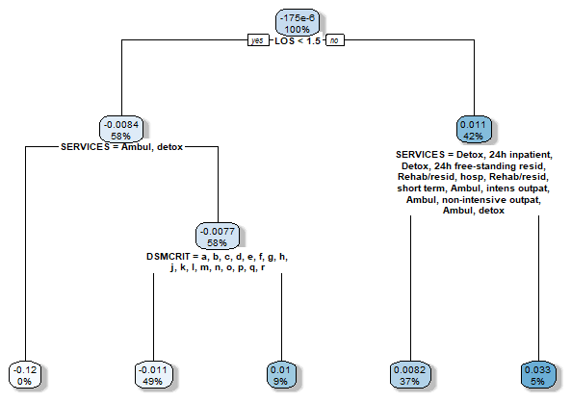
Sup Appendix Figure 1: Race/ethnicity disparity robustness (P_{1i} = white non-Hispanic)

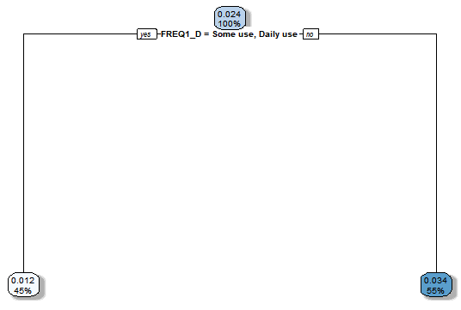
Sup Appendix Figure 2: Income source disparity robustness (P_{1i} = Wages/salary)

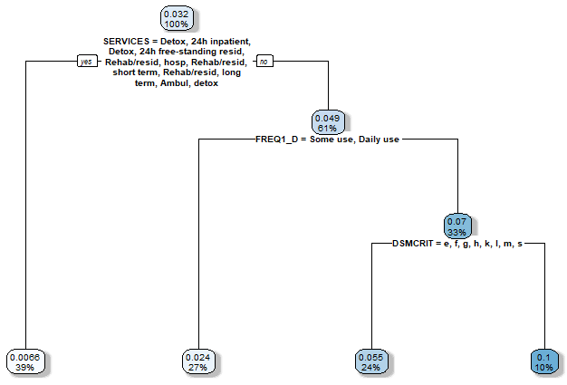
Sup Appendix Figure 3: No co-occurrence of mental health disorder disparity robustness (P_{1i} = No co-occurrence)

Additional Results
The following figures depict the decision trees (and associated robustness checks) run for disparities evaluated but ultimately not presented in the main paper. We note that we also attempted to run decision trees for gender (biological) and health insurance, but these decision trees did not generate, suggesting that disparities could not be found for these variables. Thus, the results below are only for those disparities for which decisions trees could be generated.
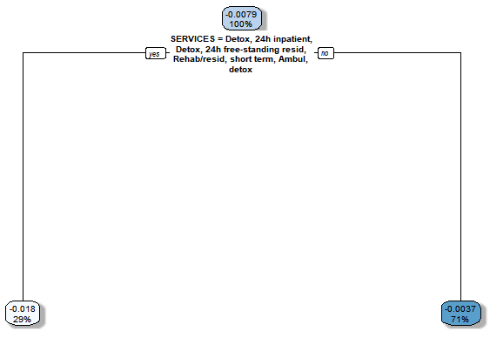
Sup Appendix Figure 4: Age disparity (P_{1i} = <35 years old)

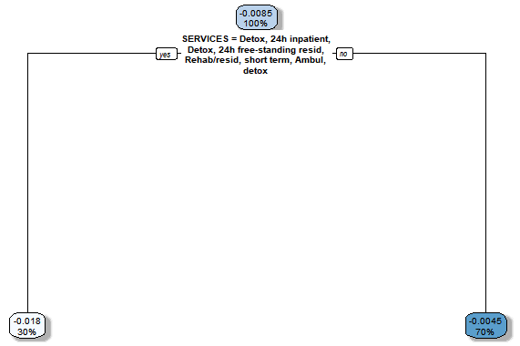
Sup Appendix Figure 5: Age disparity robustness (P_{1i} = <35 years old)

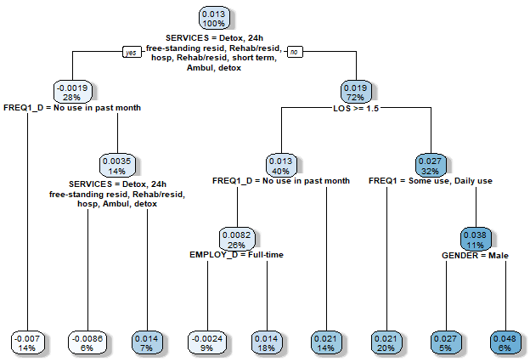
Sup Appendix Figure 6: Veteran status disparity (P_{1i} = Yes, veteran)

(Note: No robustness is available for Veteran status disparity as the random forest did not generate when the robustness constraints were applied to the data. Given that robustness did not hold, we did not report these results in the main paper.)

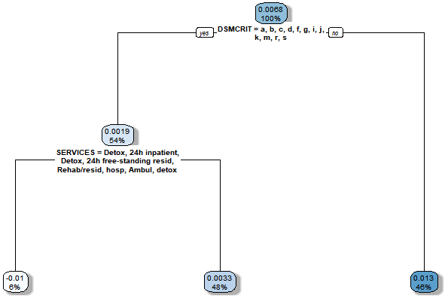
Sup Appendix Figure 7: Alcohol as primary substance disparity (P_{1i} = Alcohol as primary)

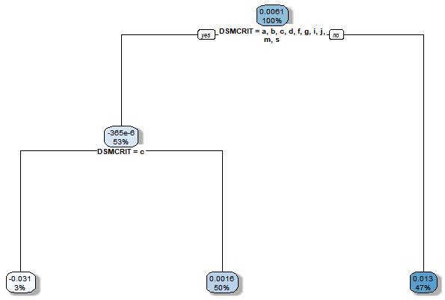
Sup Appendix Figure 8: Alcohol as primary substance disparity robustness (P_{1i} = Alcohol as primary)

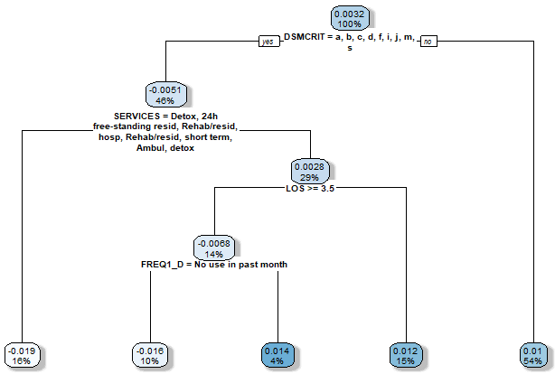
Sup Appendix Figure 9: Opioid as primary substance disparity (P_{1i} = Opioid as primary)

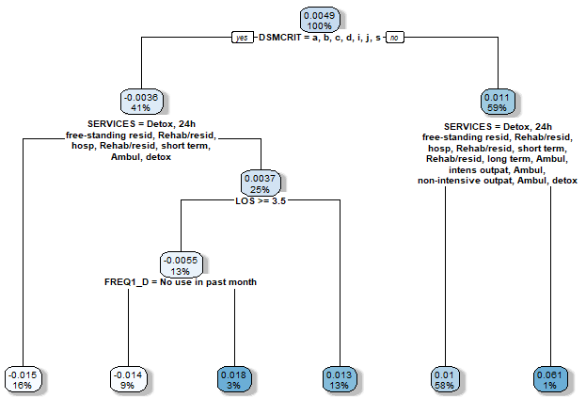
Sup Appendix Figure 10: Opioid as primary substance disparity robustness (P_{1i} = Opioid as primary)

