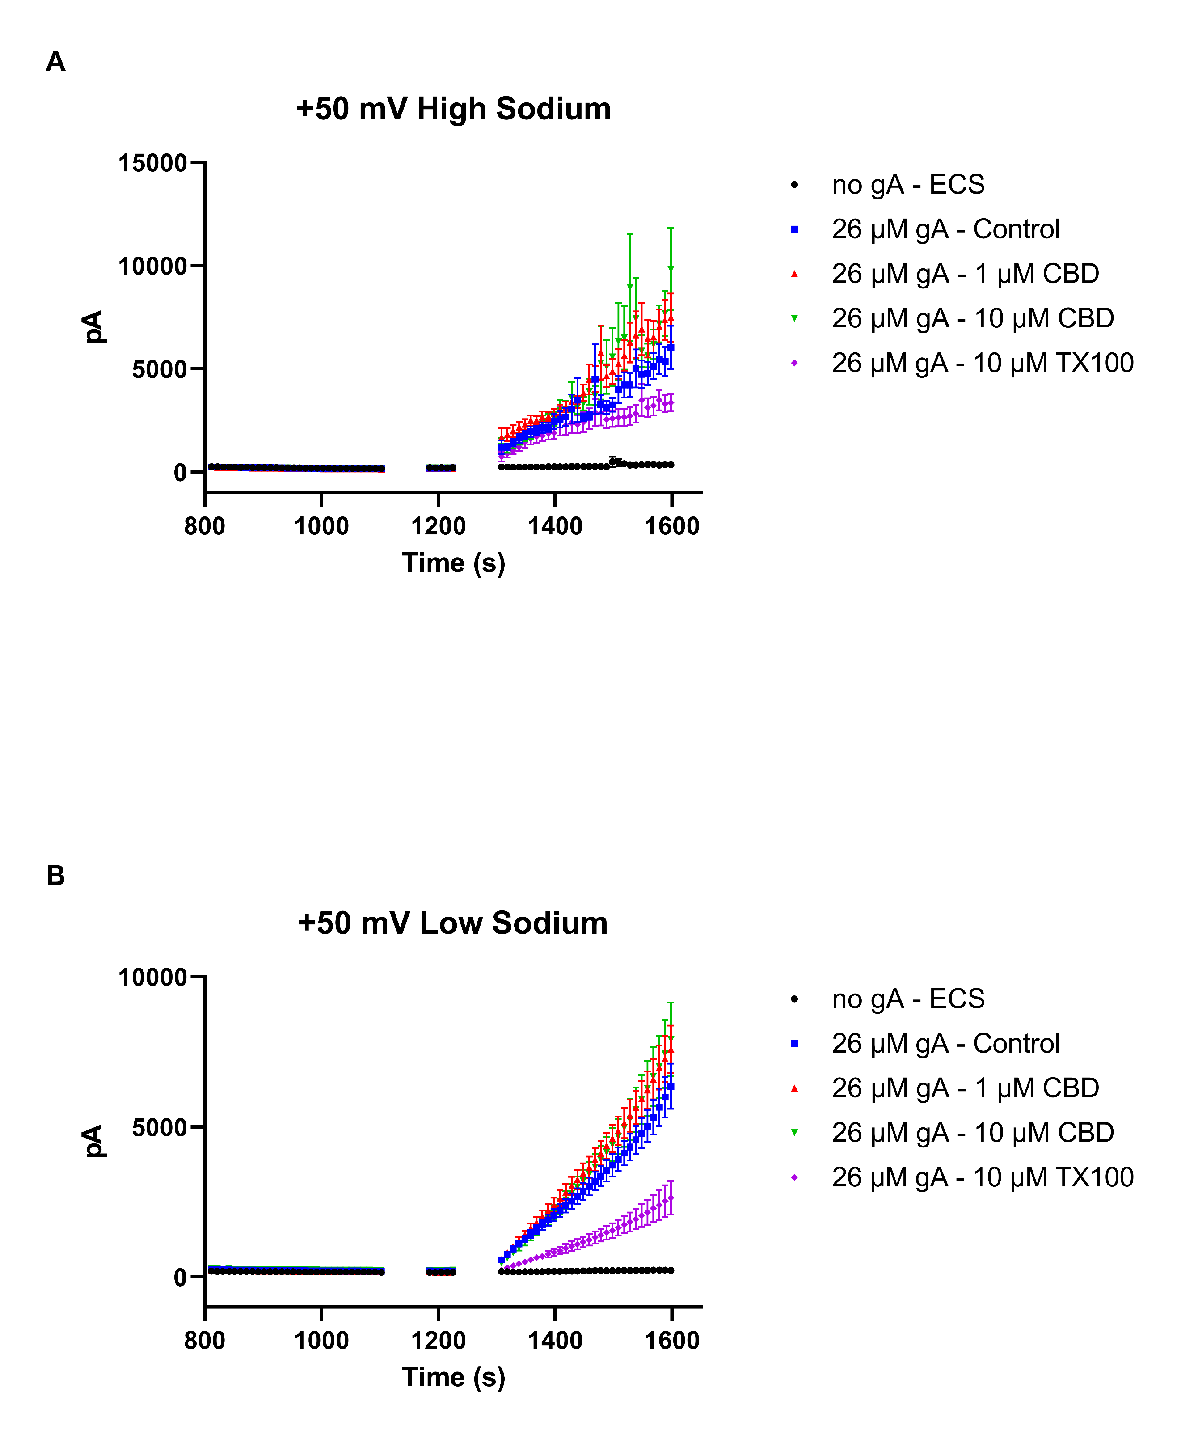
Figure S1 – Time course of experiment.
(A) Shows the time course of experiment at high sodium and (B) at low sodium concentrations.

