Cannabinoids versus placebo for pain: a systematic review with meta-analysis and Trial Sequential Analysis
Barakji J^{1,*}, Korang SK¹, Feinberg JB^{1,2} , Maagaard M^{1,3}, Mathiesen O^{3,4}, Gluud C^{1,5}, Jakobsen JC^{1,5}

¹ Copenhagen Trial Unit, Centre for Clinical Intervention Research, The Capital Region, Copenhagen University Hospital ─ Rigshospitalet, Copenhagen, Denmark
² Medical Department, Cardiology Section, Holbaek University Hospital, Holbaek, Denmark.
³ Centre for Anaesthesiological Research, Department of Anaesthesiology, Zealand University Hospital, Køge, Denmark
⁴ Department of Clinical Medicine, Copenhagen University, Copenhagen, Denmar
⁵ Department of Regional Health Research, The Faculty of Heath Sciences, University of Southern Denmark, Odense, Denmark

Supplemental
1 Databases searched
- Cochrane Central Register of Controlled Trials (CENTRAL)
- Medical Literature Analysis and Retrieval System Online (MEDLINE)
- Excerpta Medica database (EMBASE)
- Latin American and Carribean Health Sciences Literature (LILACS)
- Science Citation Index Expanded on Web of Science
- BIOSIS
- ClinicalTrials.gov
- Google Scholar
- The Turning Research into Practice (TRIP) Database
- European Medicines Agency (EMA), United States Food and Drug Administration (FDA)
- China Food and Drug Administration (CFDA)
- Medicines and Healthcare products Regulatory Agency
- The World Health Organization (WHO)

2 Search strategy
This was the search strategy that we used in MEDLINE and corrected to fit other databases as needed. We used a minimal search strategy to ensure that we did not miss any relevant trials.
1. exp Cannabis/
2. exp Cannabinoids/
3. (cannabi* or mari*uana or nabixmol* or dronabinol* or marinol* or nabilon* or cesamet* or hash* or hemp* or levonantradol* or anandamid* or 2-AG).mp. [mp=title, abstract, original title, name of substance word, subject heading word, floating sub-heading word, keyword heading word, organism supplementary concept word, protocol supplementary concept word, rare disease supplementary concept word, unique identifier, synonyms]
4. 1 or 2 or 3
5. exp Pain/
6. (pain* or ache* or migraine*).mp. [mp=title, abstract, original title, name of substance word, subject heading word, floating sub-heading word, keyword heading word, organism supplementary concept word, protocol supplementary concept word, rare disease supplementary concept word, unique identifier, synonyms]
7. 5 or 6
8. 4 and 7
9. (random* or blind* or placebo* or meta-analys*).mp. [mp=title, abstract, original title, name of substance word, subject heading word, floating sub-heading word, keyword heading word, organism supplementary concept word, protocol supplementary concept word, rare disease supplementary concept word, unique identifier, synonyms]
10. 8 and 9

3 PRISMA Flow Diagram
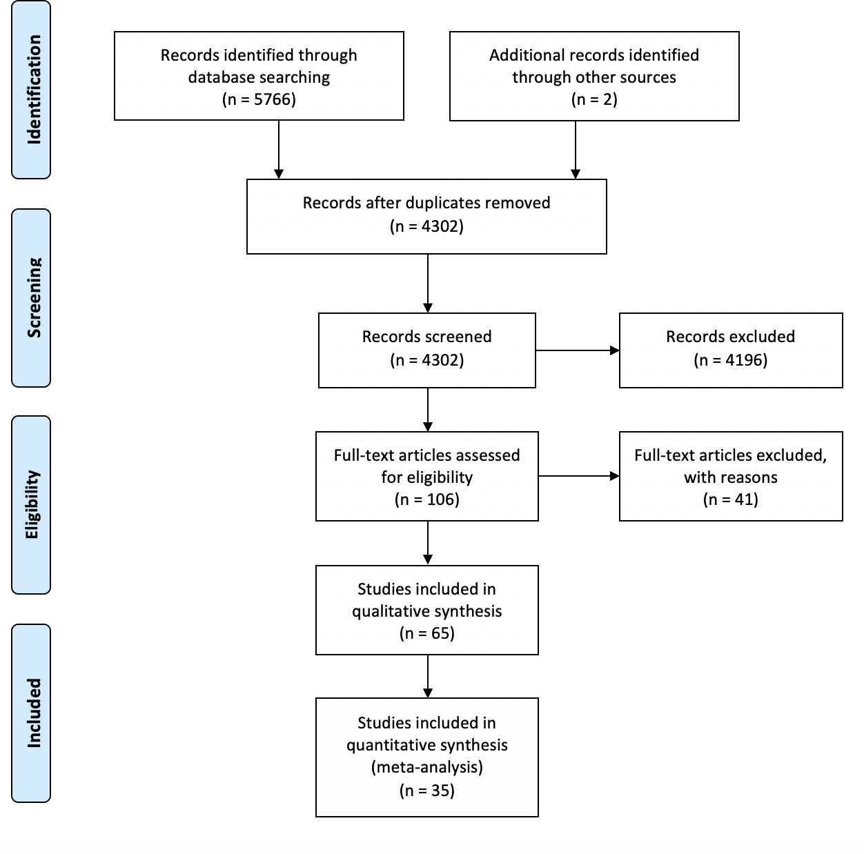

4 Risk of bias in included studies
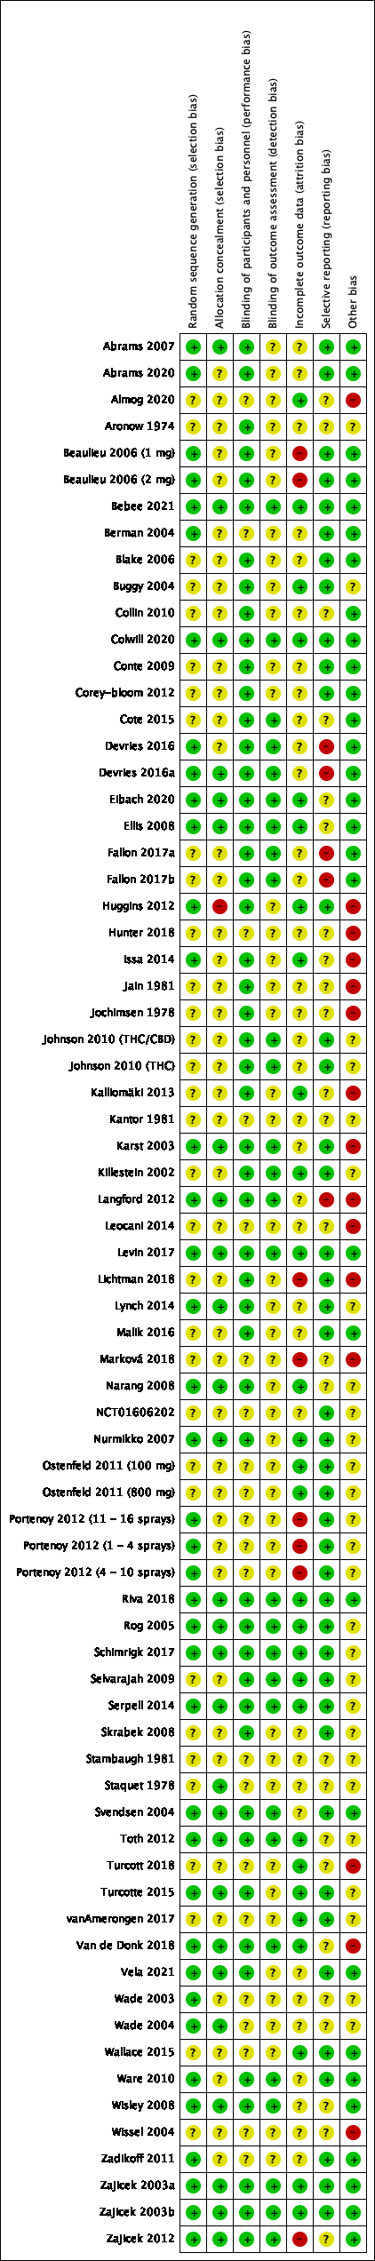

5 All-cause mortality
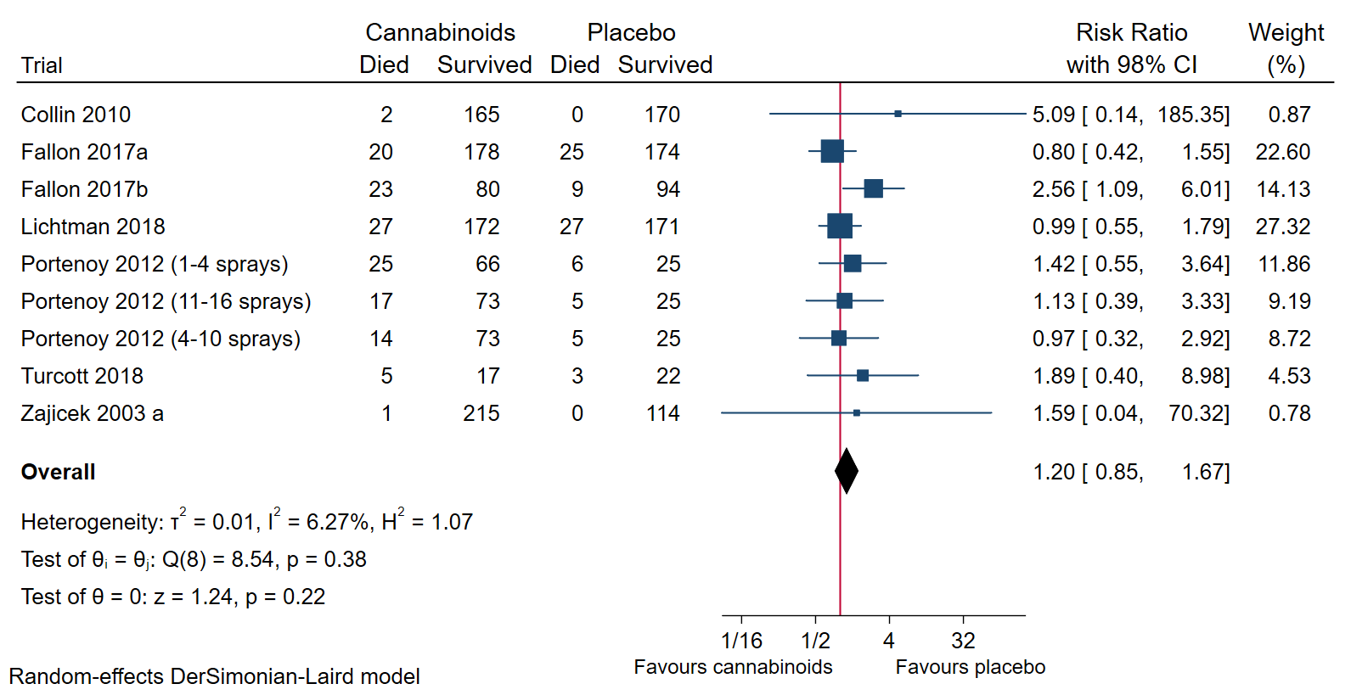
Figure 1: Forest plot of the meta-analysis of all-cause mortality with 98% CI. The meta-analysis showed no difference between cannabinoids versus placebo for pain on the outcome all-cause mortality.
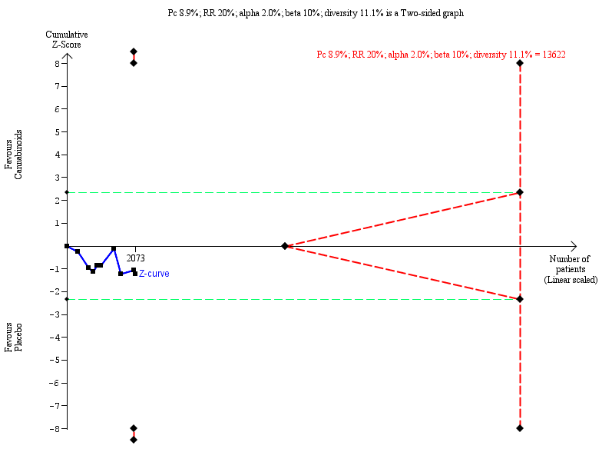
Figure 2: Trial Sequential Analysis graph of cannabinoids versus placebo for pain on the outcome all-cause mortality using random-effects meta-analysis. Trial Sequential Analysis showed the z-curve (the blue line) not breaching any boundary, showing that there was not enough information to confirm or reject that cannabinoids compared with placebo affected the risk of all-cause mortality by 20%.

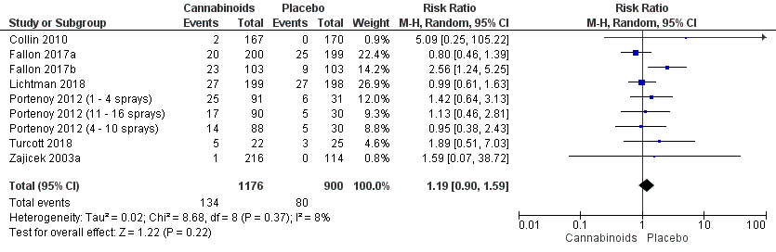
Figure 3: All-cause mortality best-worst case scenario
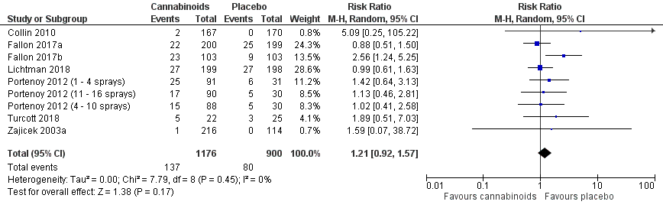
Figure 4: All-cause mortality worst-best case scenario

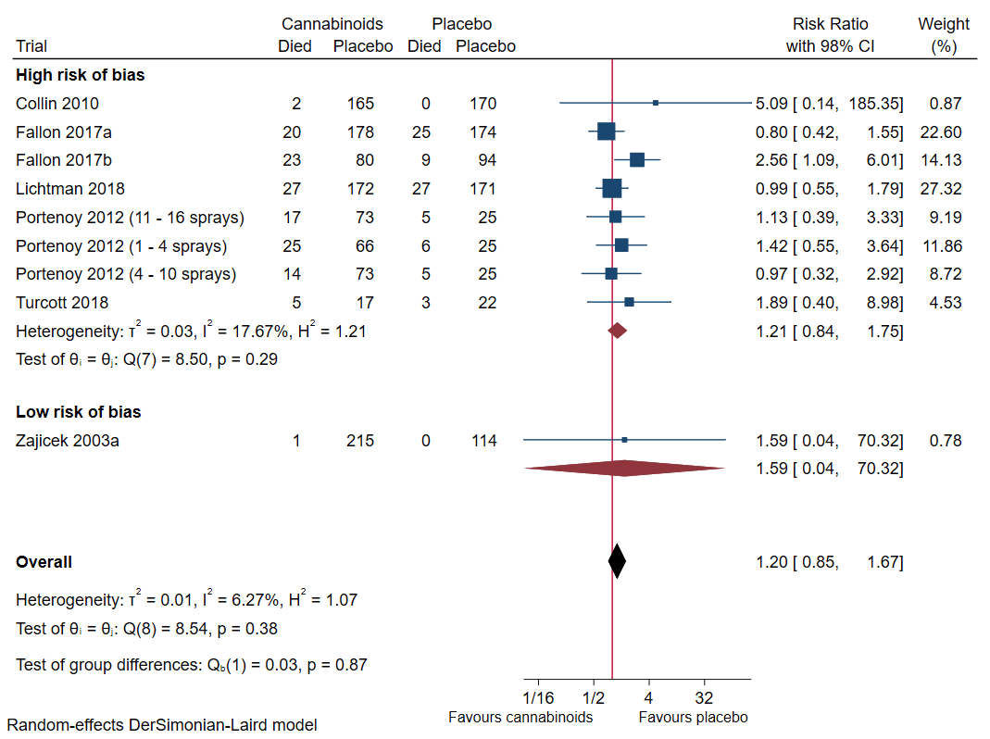
Figure 5: All-cause mortality subgroup analysis comparing trials assessed at high risk of bias to trials assessed at low risk of bias.
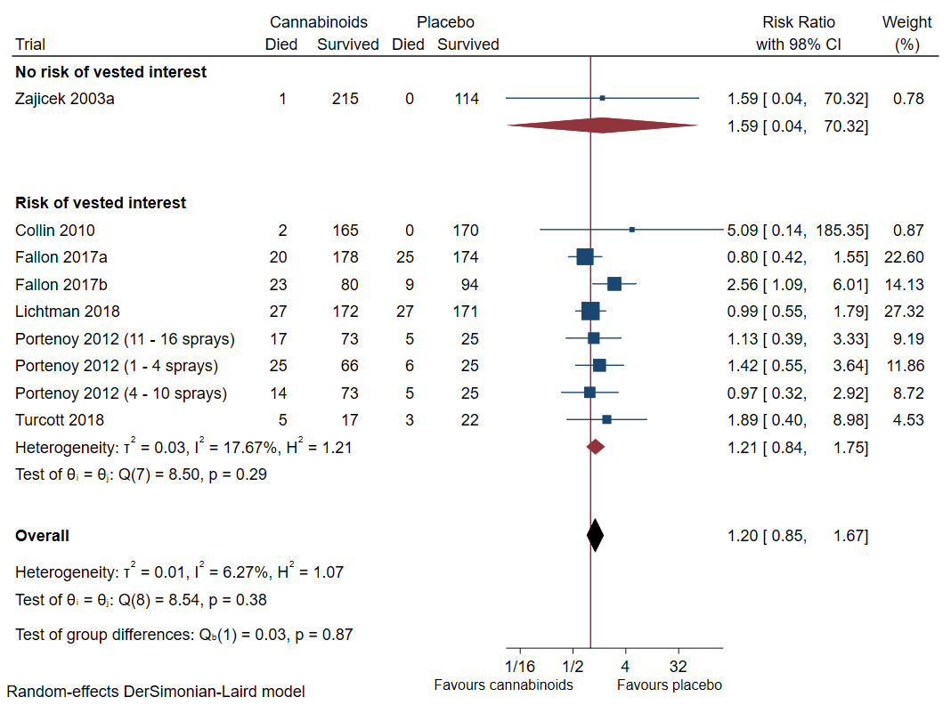
Figure 6: All-cause mortality subgroup analysis comparing trials at risk of vested interests and trials at no risk of vested interests.
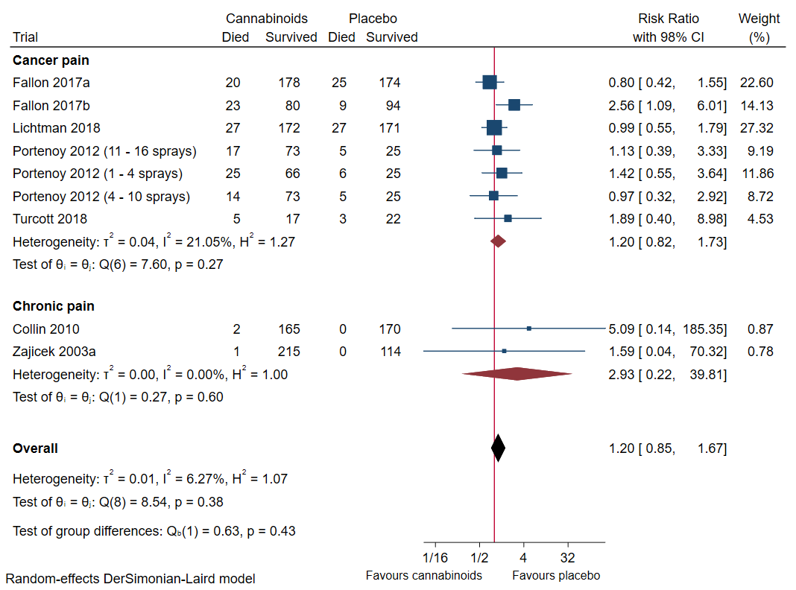
Figure 7: All-cause mortality subgroup analysis comparing trials randomising participants with cancer pain or chronic pain.
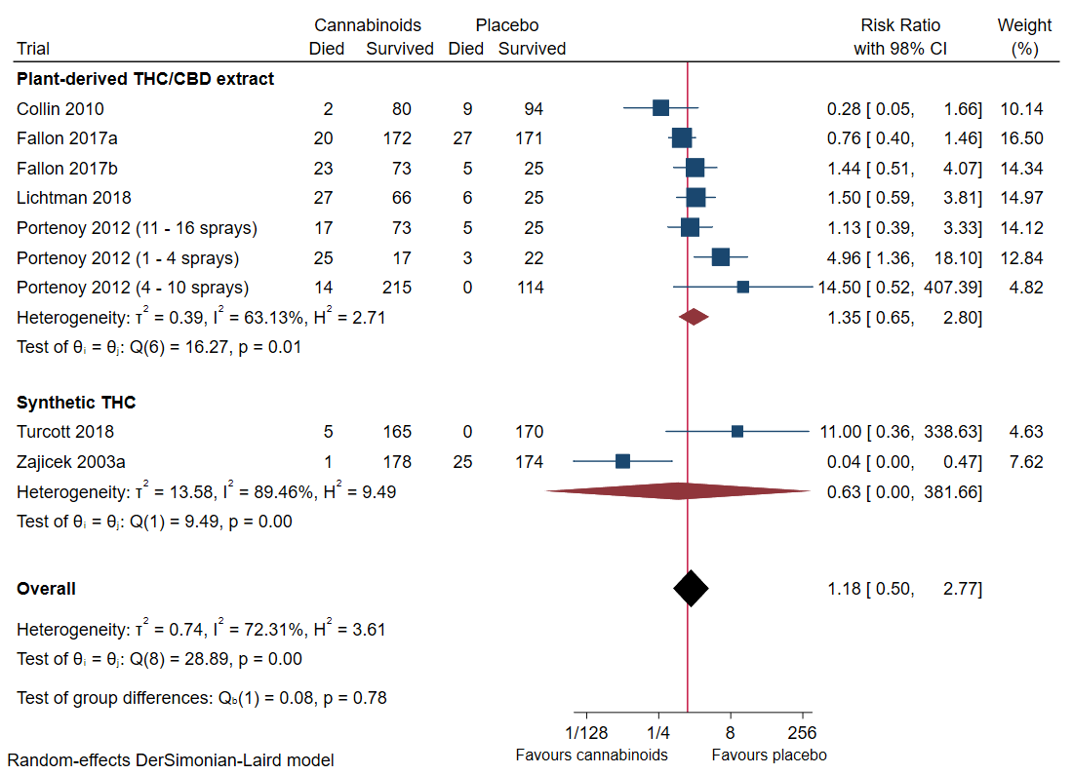
Figure 8: All-cause mortality subgroup analysis comparing plant-derived delta-9-tetrahydrocannabinol (THC)/ cannabidiol (CBD) with synthetic delta-9-tetrahydrocannabinol.

6 Pain
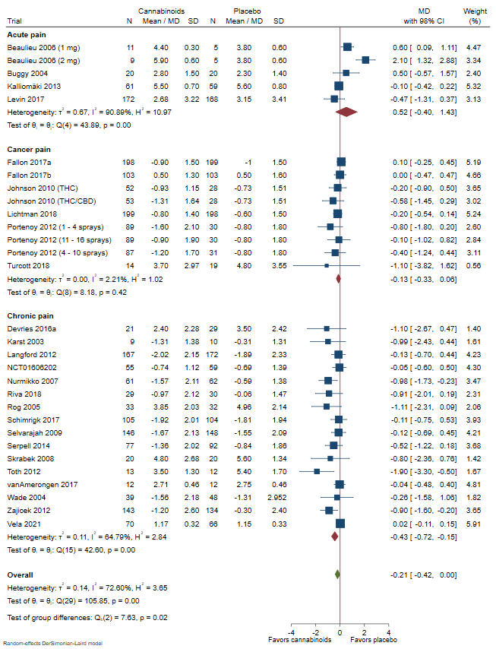
Figure 9: Pain score subgroup analysis comparing trials randomising participants with acute pain, cancer pain or chronic pain. The subgroup analysis indicates a difference between the different types of pain (P=0.02)

Acute pain
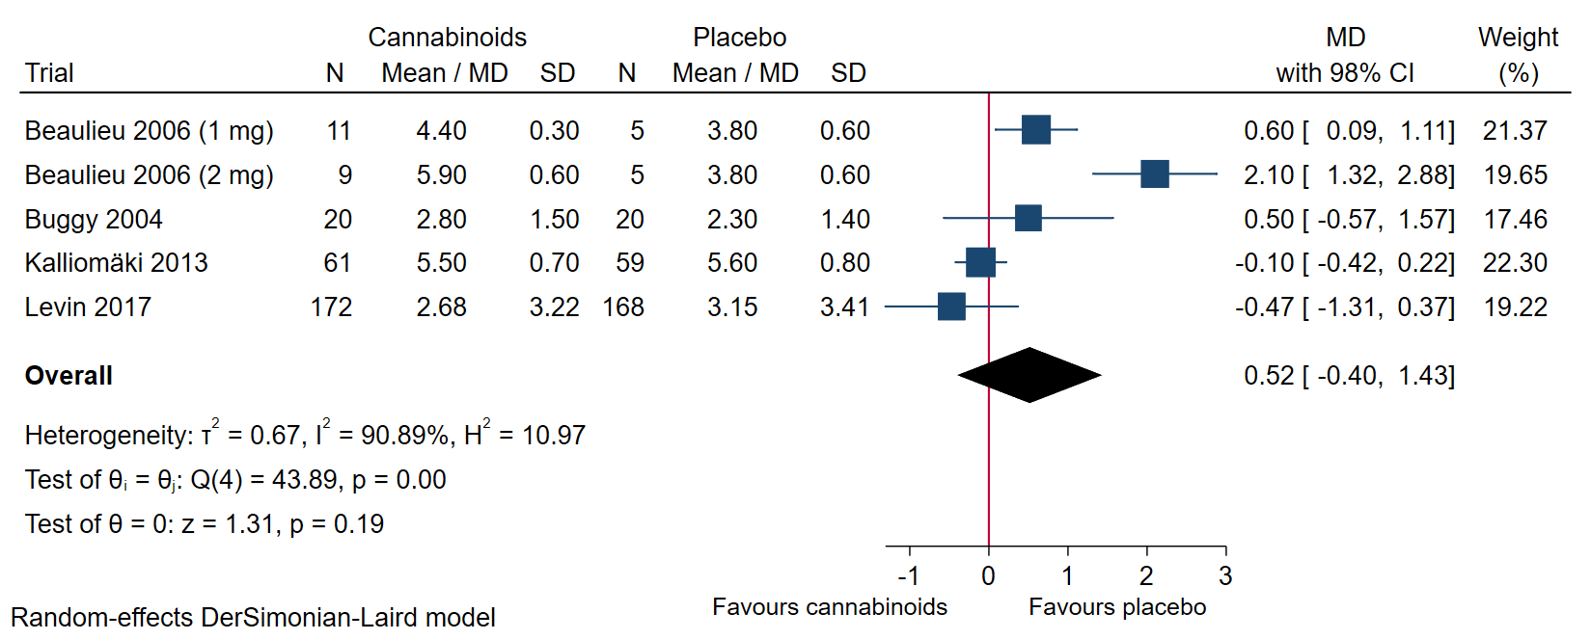
Figure 10: Forest plot of the meta-analysis of acute pain with 98% CI. The meta-analysis of acute pain showed no evidence of a statistically significant difference between cannabinoids and placebo. (SMD 0.42; 95% CI -0.14, 0.98; P=0.14)

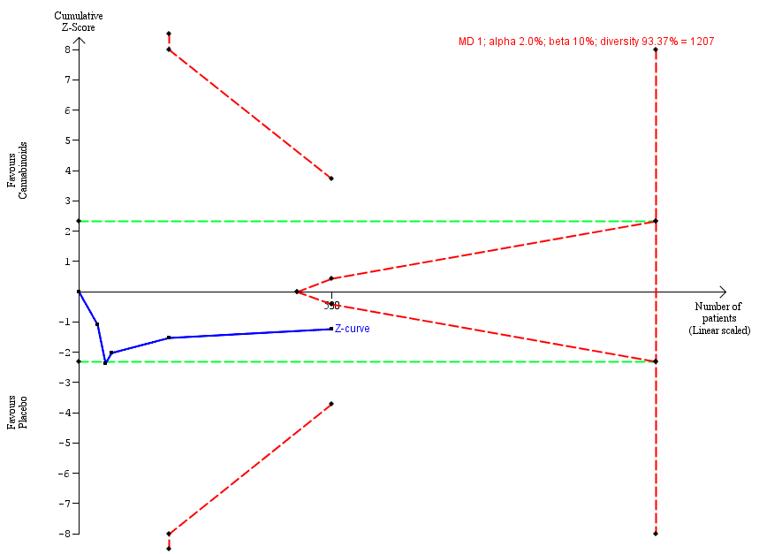
Figure 11: Trial Sequential Analysis graph of acute pain using random-effects meta-analysis. Trial Sequential Analysis showed the z-curve (the blue line) not breaching any boundary, showing that there was not enough information to confirm or reject that cannabinoids compared with placebo reduced acute pain (MD 0.52; 98% CI -1.03 to 2.06; P = 0.21).

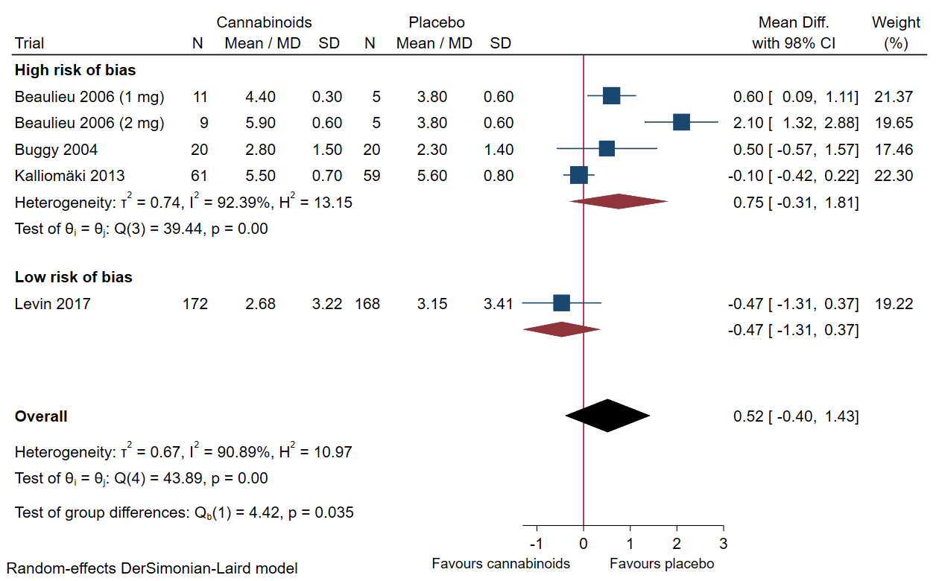
Figure 12: Acute pain subgroup analysis comparing trials assessed at high risk of bias to trials assessed at low risk of bias.

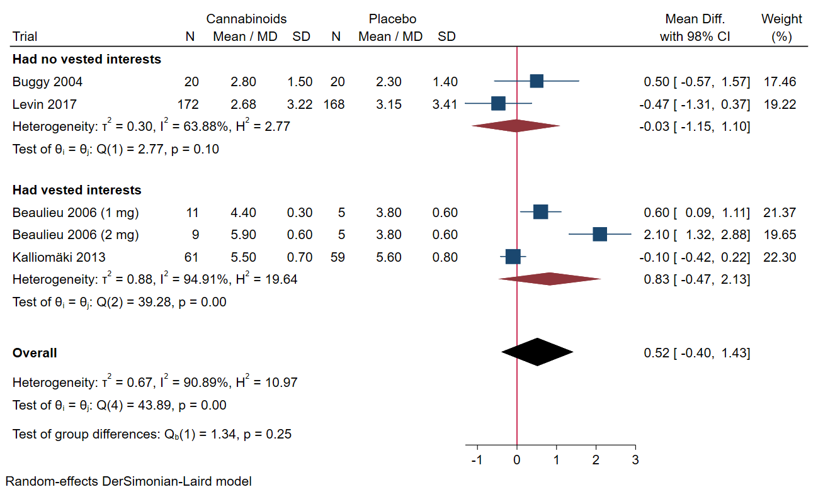
Figure 13: Acute pain subgroup analysis comparing trials at risk of vested interests and trials at no risk of vested interests.

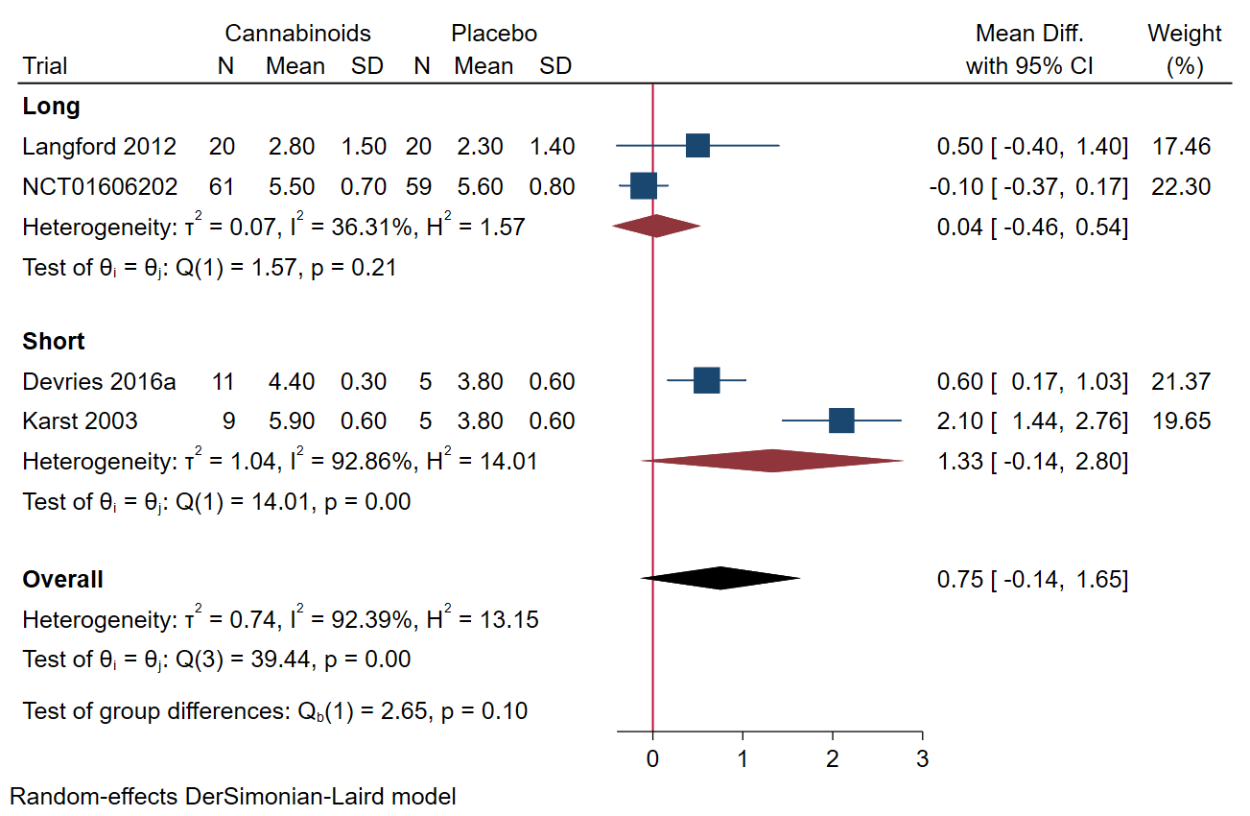
Figure 14: Forest plot of subgroup analysis comparing long-term follow-up with short-term follow-up in acute pain. Long-term defined as above the median and short-term defined below the median. The meta-analysis of acute pain showed no evidence of a statistically significant difference between long-term and short-term follow up in terms of acute pain (P=0.1).

Cancer pain
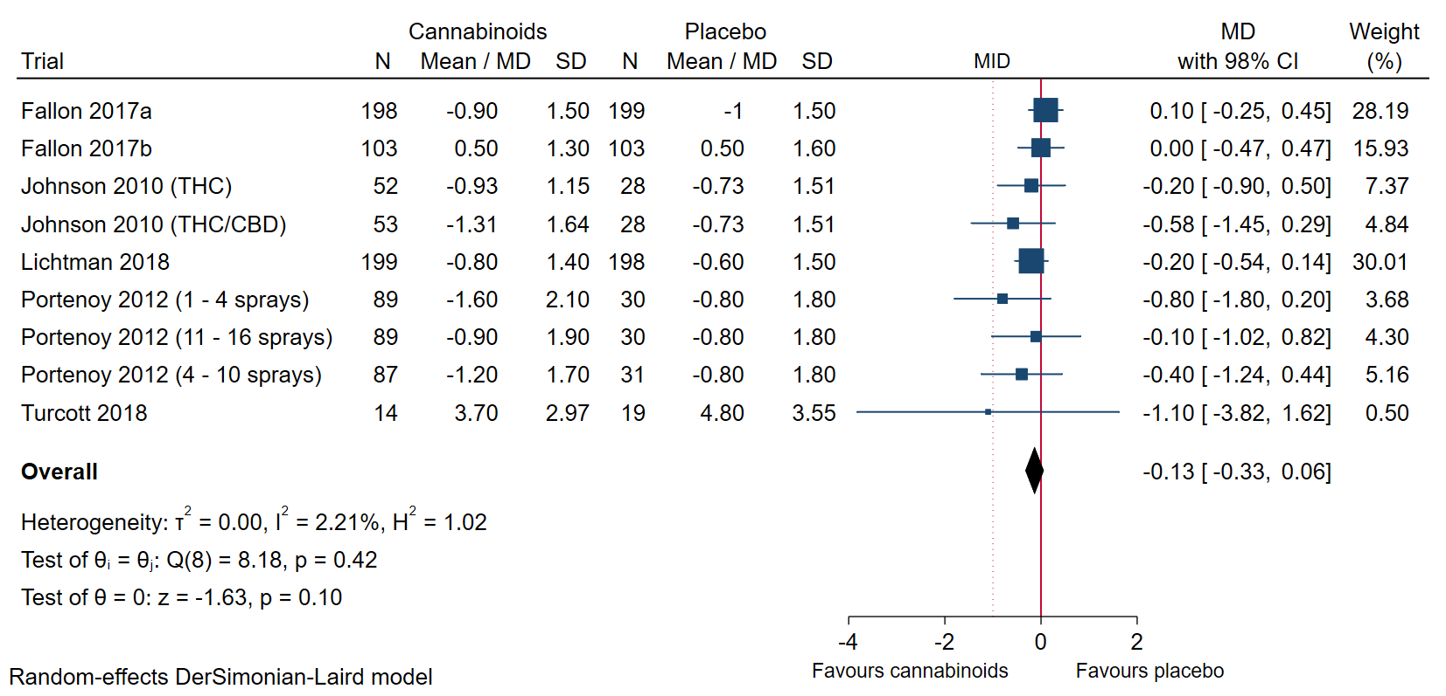
Figure 15: Forest plot of the meta-analysis of cancer pain with 98% CI. The meta-analysis of cancer pain showed no evidence of a statistically significant difference between cannabinoids and placebo. (SMD -0.09; 95% CI -0.20, 0.01; P= 0.07)

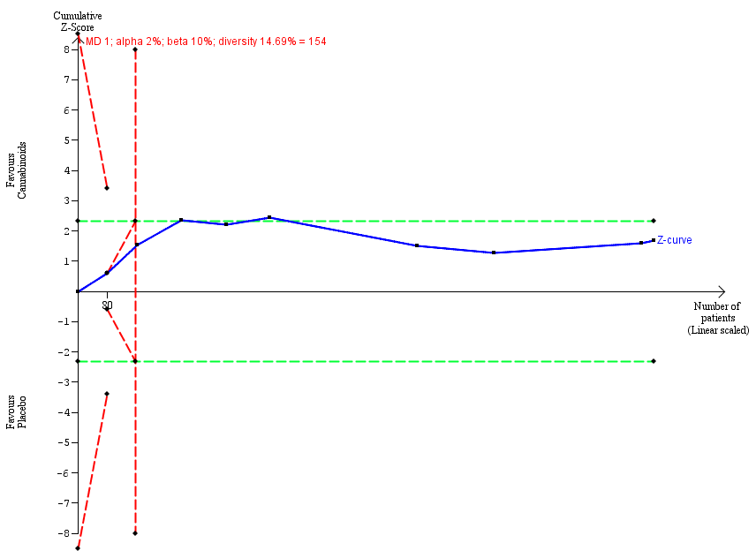
Figure 16: Trial Sequential Analysis graph of cancer pain using random-effect meta-analysis. Trial Sequential Analysis showed the z-curve (the blue line) breaching the boundary futility and showed that there was enough information to reject that cannabinoids compared with placebo reduced cancer pain.

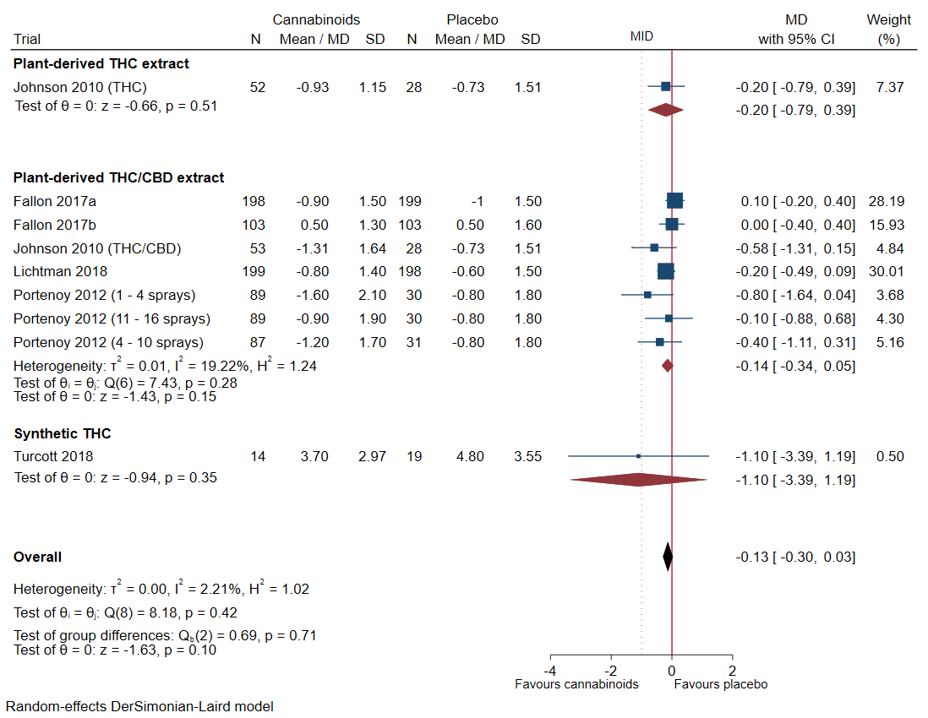
Figure 17: Cancer pain subgroup analysis comparing different types of cannabinoids.
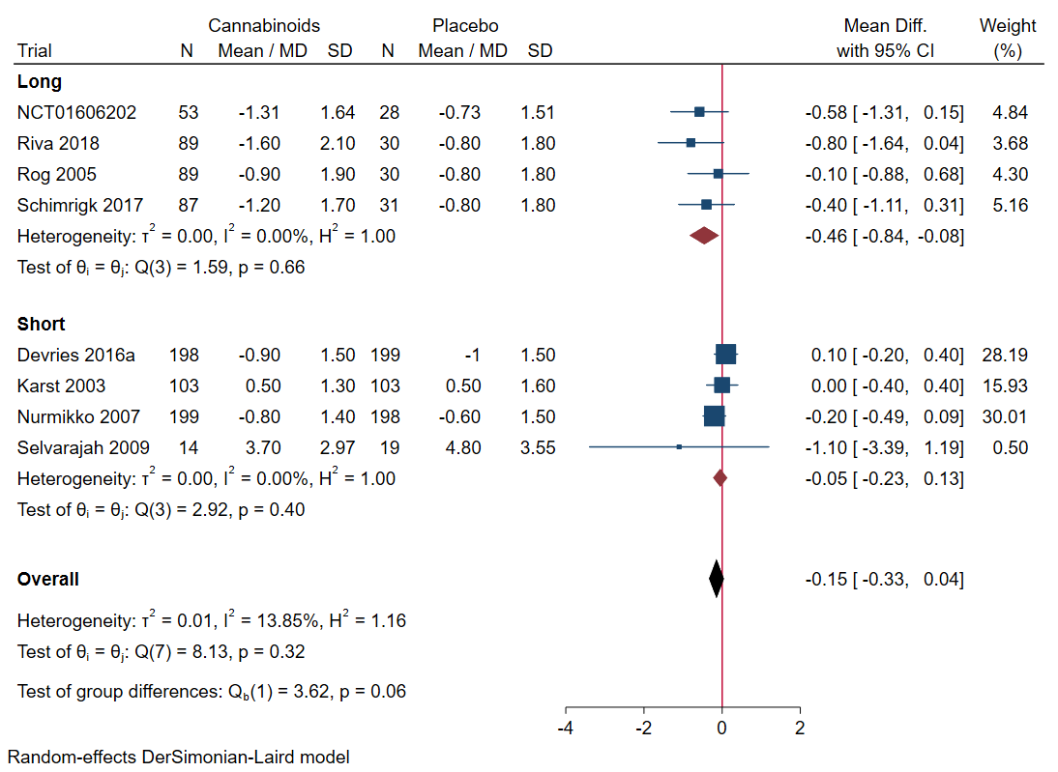
Figure 18: Forest plot of subgroup analysis comparing long-term follow-up with short-term follow-up in cancer pain. Long-term defined as above the median and short-term defined below the median. The meta-analysis of cancer pain showed no evidence of a statistically significant difference between long-term and short-term follow up in terms of cancer pain (P=0.06).

Chronic pain
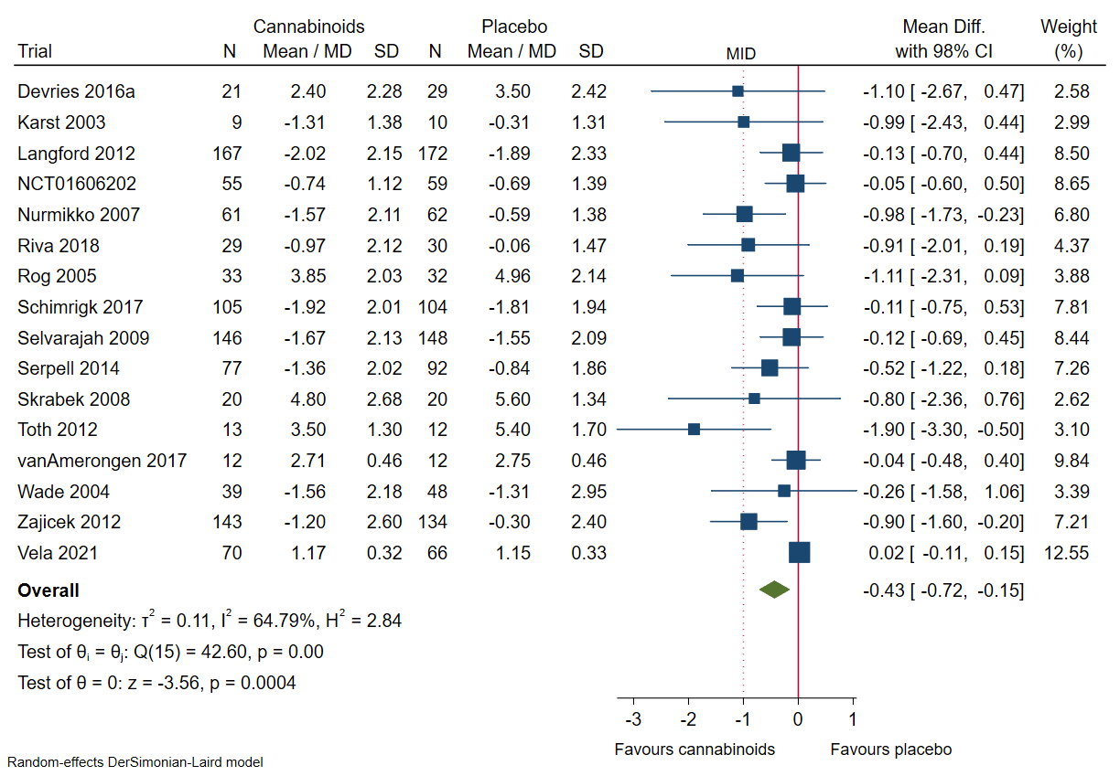
Figure 19: Forest plot of the meta-analysis of chronic pain with 98% CI. The meta-analysis of chronic pain showed evidence of a statistically significant difference between cannabinoids and placebo. (SMD -0.25; 95% CI -0.37, -0.13; P < 0.0001).
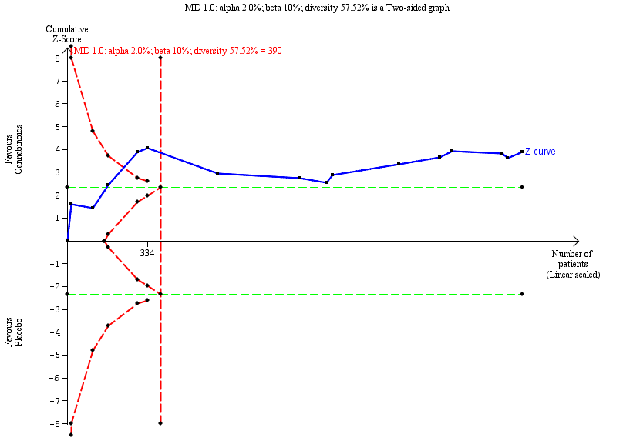
Figure 20: Trial Sequential Analysis graph of chronic pain score using random-effects meta-analysis. Trial Sequential Analysis showed the z-curve (the blue line) breaching the boundary of benefit, showing that there was enough information to confirm that cannabinoids compared with placebo reduced chronic pain.
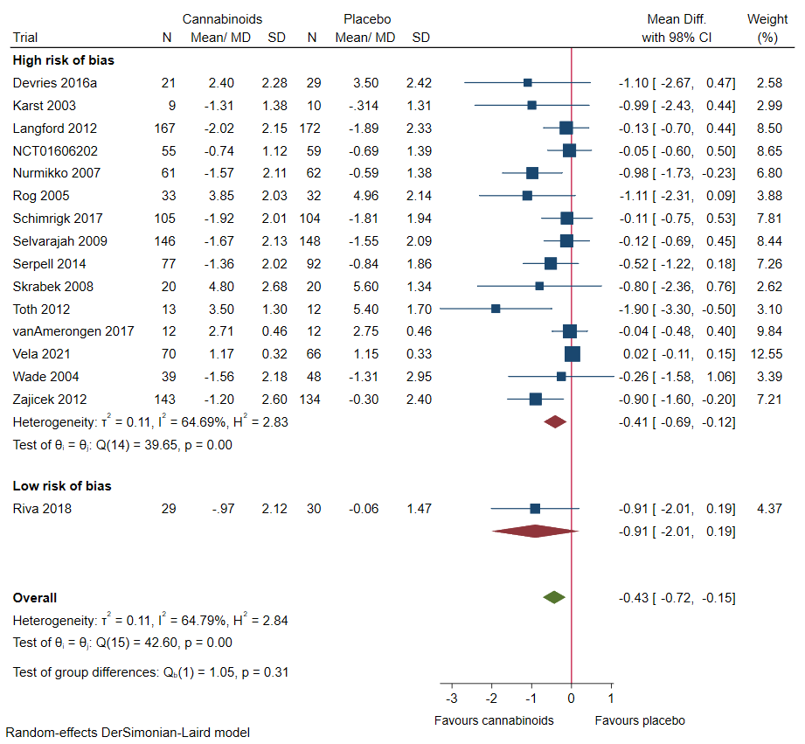
Figure 21: Chronic pain subgroup analysis comparing trials assessed at high risk of bias to trials assessed at low risk of bias.
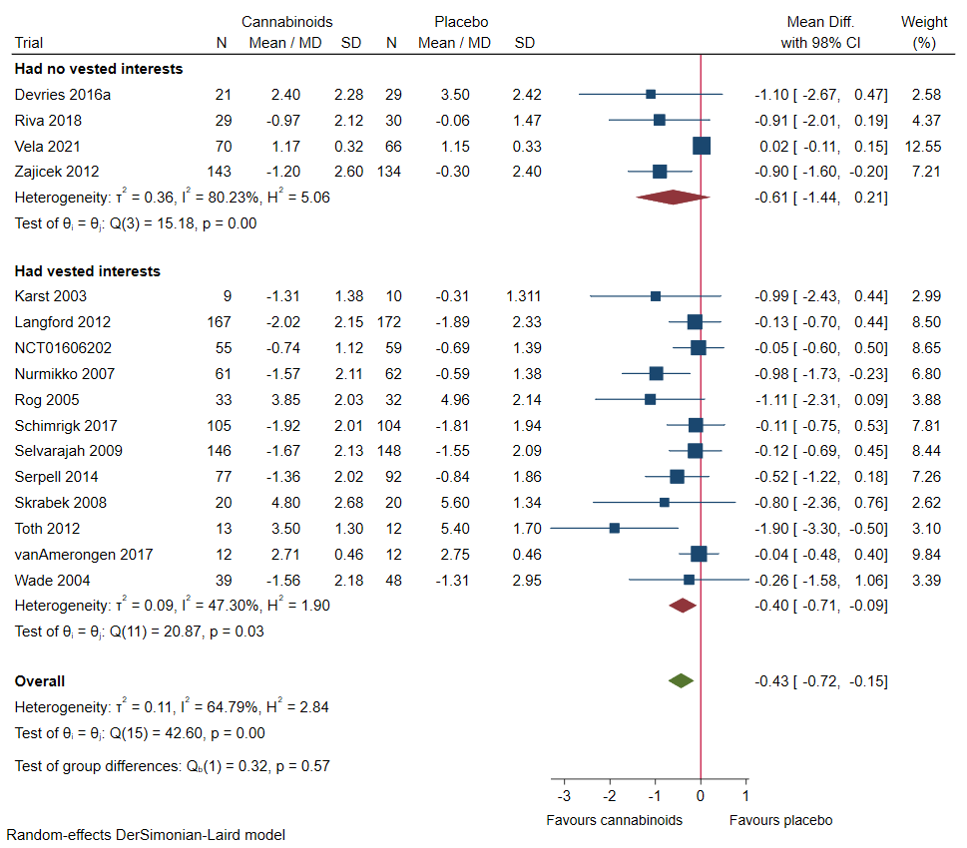
Figure 22: Chronic pain subgroup analysis comparing trials at risk of vested interests and trials at no risk of vested interests.
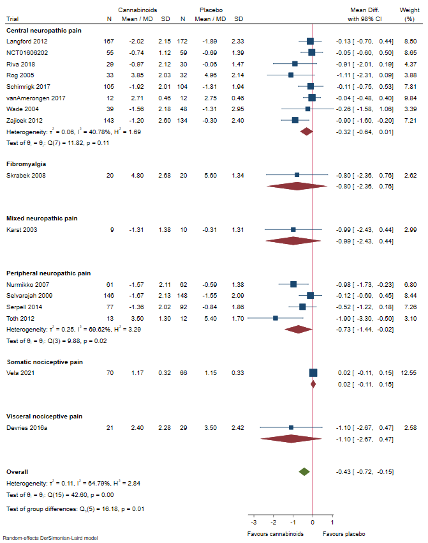
Figure 23: Chronic pain subgroup analysis comparing trials randomising participants with neuropathic pain (central, peripheral and mixed), fibromyalgia and visceral nociceptive pain.

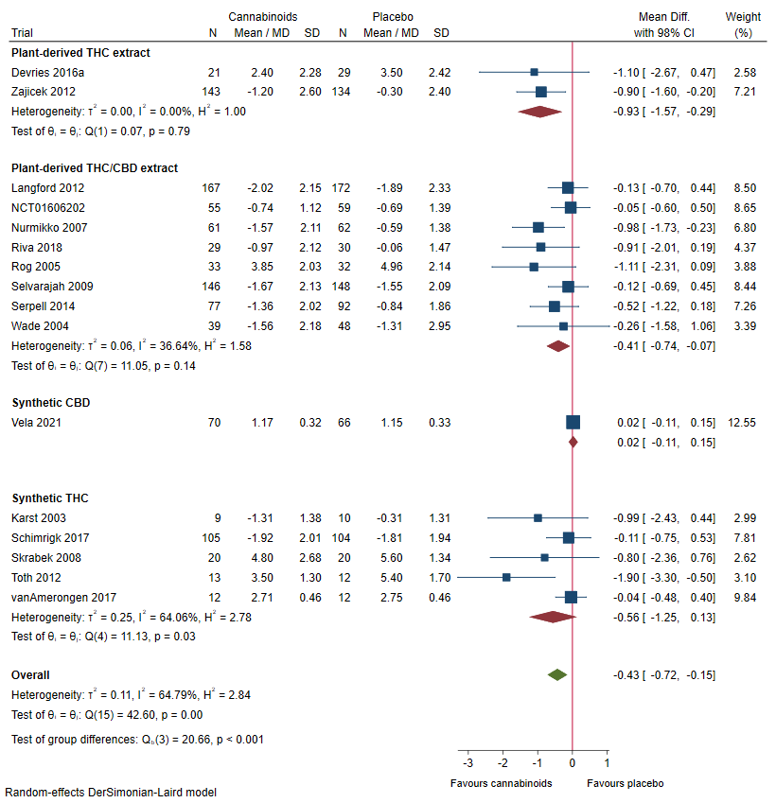
Figure 24: Chronic pain subgroup analysis comparing different types of cannabinoids.

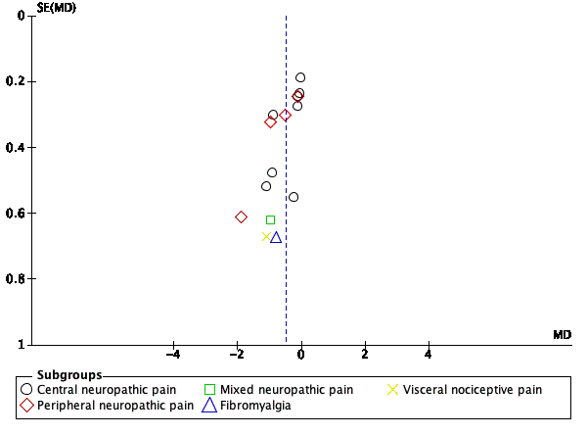
Figure 25: Funnel plot of chronic pain. The funnel plot showed no signs of small-study effects.
Regression-based Egger test for small-study effects: Random-effects model: Method: DerSimonian-Laird
H0: beta1 = 0; no small-study effects
beta1 = -2.61
SE of beta1 = 0.675
z = -3.87
Prob > |z| = 0.0001

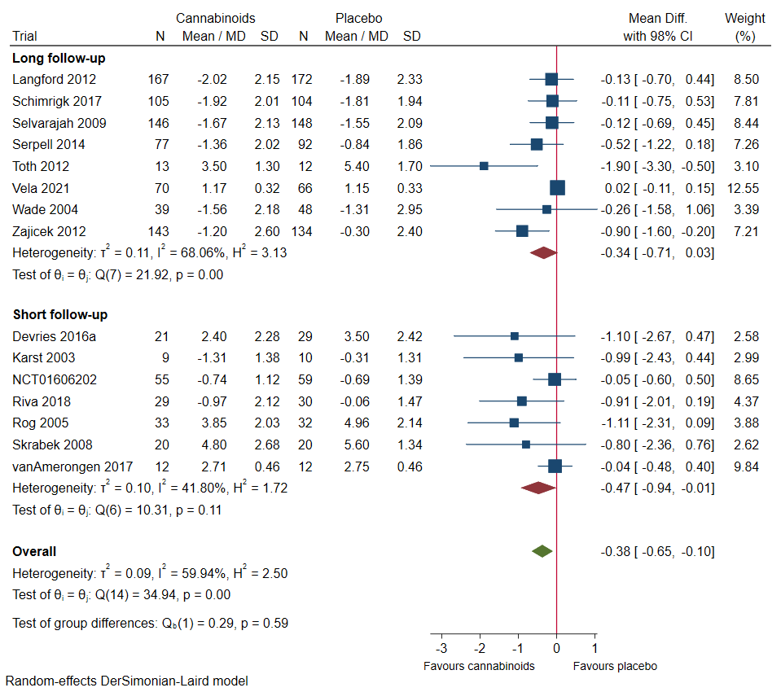
Figure 26: Forest plot of subgroup analysis comparing long-term follow-up with short-term follow-up in chronic pain. Long-term defined as above the median and short-term defined below the median. The meta-analysis of chronic pain showed no evidence of a statistically significant difference between long-term and short-term follow up in terms of chronic pain (P=0.59).

7 Serious adverse events
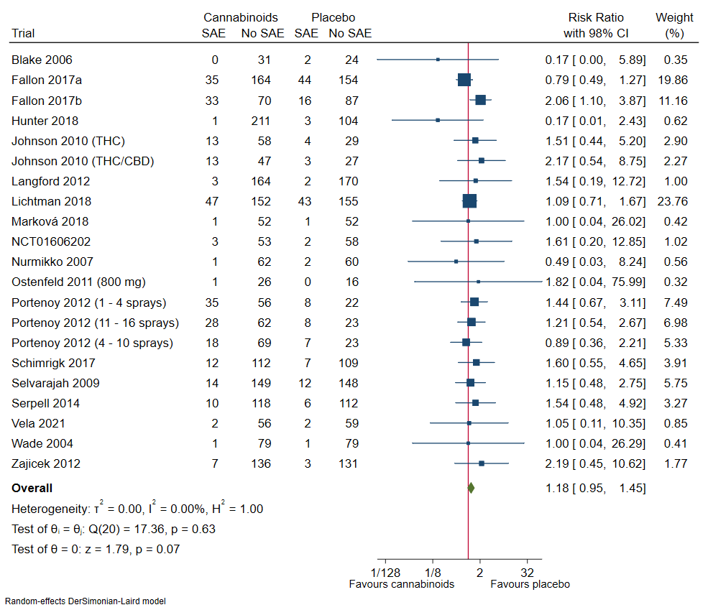
Figure 27: Forest plot of the meta-analysis of serious adverse events with 98% CI. The meta-analysis of serious adverse events showed no statistically significant evidence of a difference between cannabinoids and placebo.

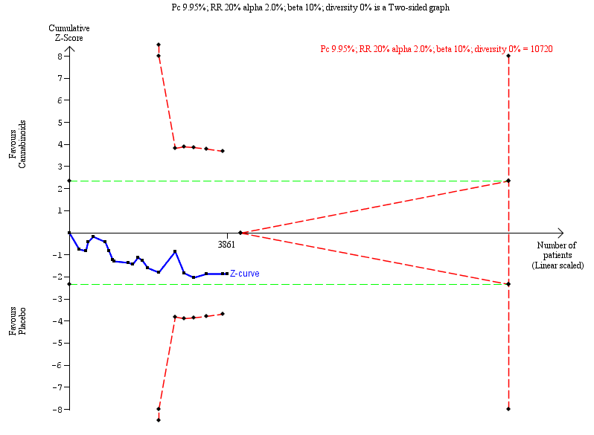
Figure 28: Trial Sequential Analysis graph of serious adverse event using random-effects meta-analysis. Trial Sequential Analysis showed the z-curve (the blue line) not breaching the boundary of harm, showing that there was not enough information to confirm or reject that cannabinoids compared with placebo increased the risk of serious adverse events by 20% (RR 1.18; 98% CI 0.95 to 1.46; P = 0.07).
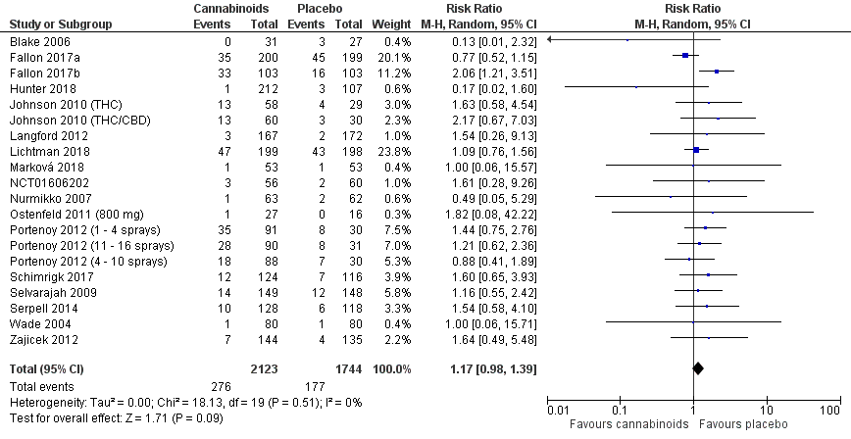
Figure 29: Serious adverse events best-worst case scenario
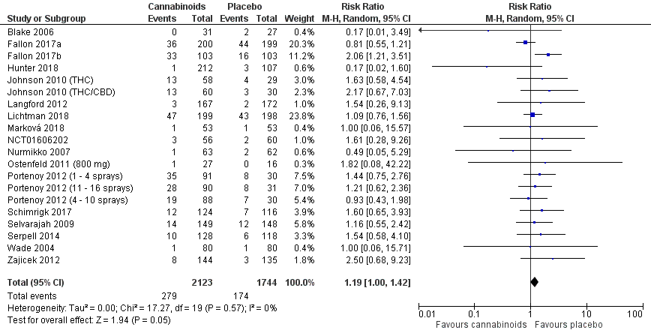
Figure 30: Serious adverse events worst-best case scenario

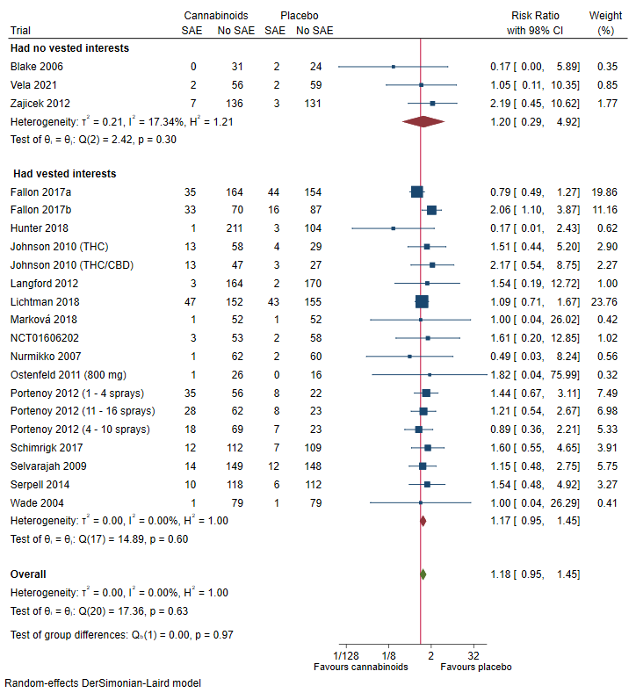
Figure 31: Serious adverse events subgroup analysis comparing trials at risk of vested interests and trials at no risk of vested interests.
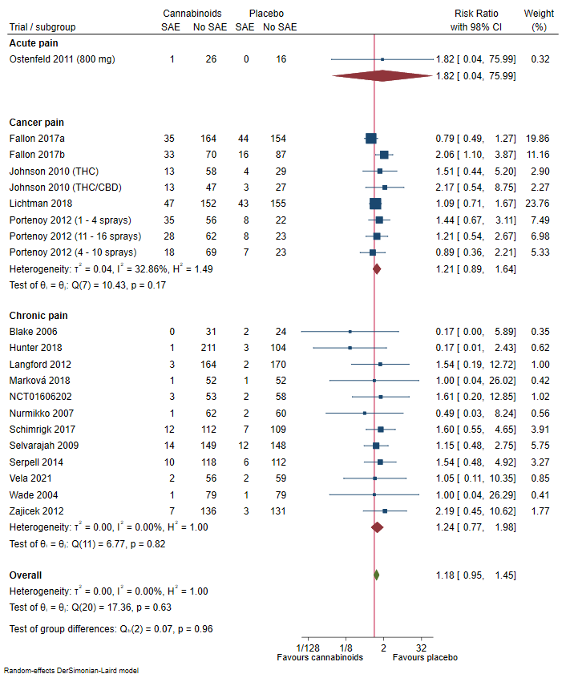
Figure 32: Serious adverse events subgroup analysis comparing trials randomising participants with acute pain, cancer pain or chronic pain.

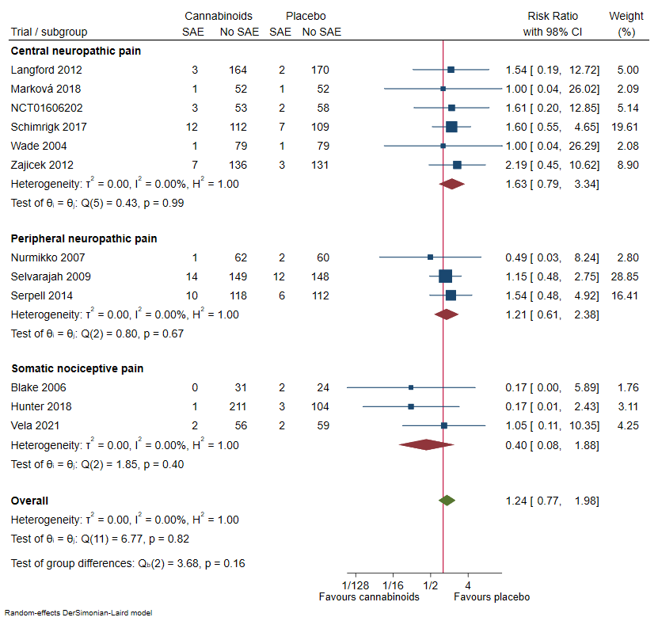
Figure 33: Serious adverse events subgroup analysis comparing trials randomising participants with neuropathic pain (central and peripheral) and somatic nociceptive pain.
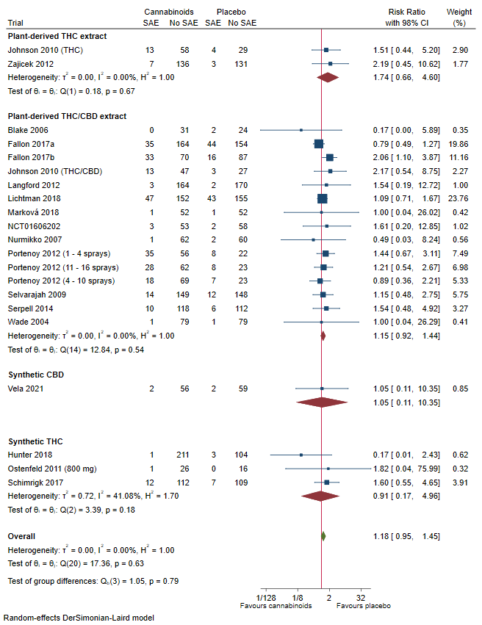
Figure 34: Serious adverse events subgroup analysis comparing different types of cannabinoids.

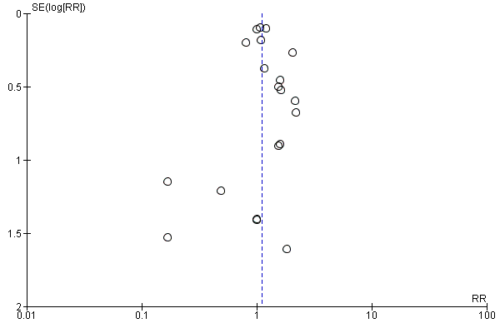Figure 35: Funnel plot of serious adverse events. The funnel plot showed no signs of small-study effects.
Regression-based Harbord test for small-study effects: Random-effects model: Method: DerSimonian-Laird
H0: beta1 = 0; no small-study effects
beta1 = -0.15
SE of beta1 = 0.427
z = -0.36
Prob > |z| = 0.7171

8 Quality of life

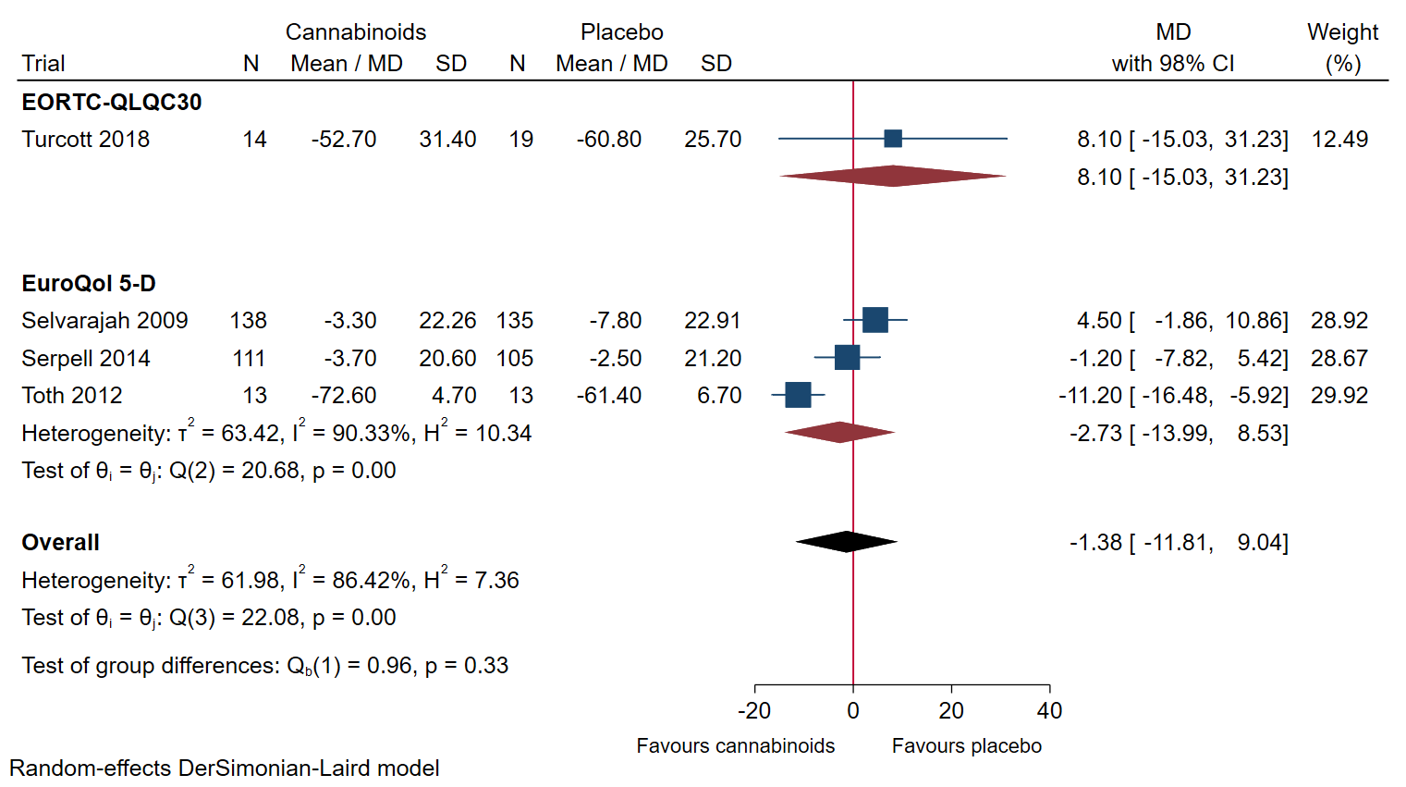
Figure 36: Forest plot of the meta-analysis of quality of life with 98% CI. The meta-analysis of quality of life showed no statistically significant evidence of a difference between cannabinoids and placebo. (SMD -0.19; 95% CI -0.70, 0.32; P= 0.46)
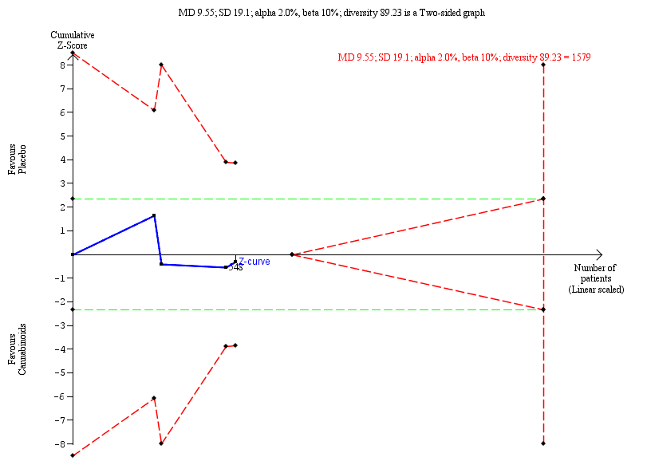
Figure 37: Trial Sequential Analysis graph of quality of life using random-effects meta-analysis. Trial Sequential Analysis showed the z-curve (the blue line) not breaching any boundary, showing that there was not enough information to confirm or reject that cannabinoids compared with placebo improved quality of life (MD -1.43; 98% CI -11.81 to 9.04; P = 0.75).
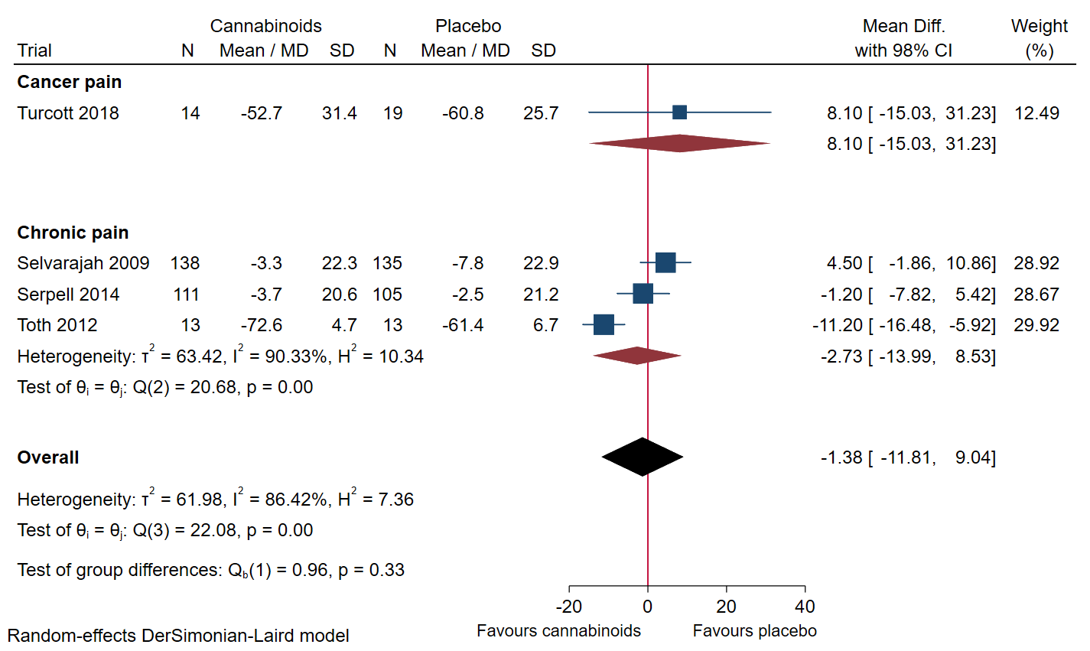
Figure 38: Quality of life subgroup analysis comparing trials randomising participants with cancer pain and chronic pain.

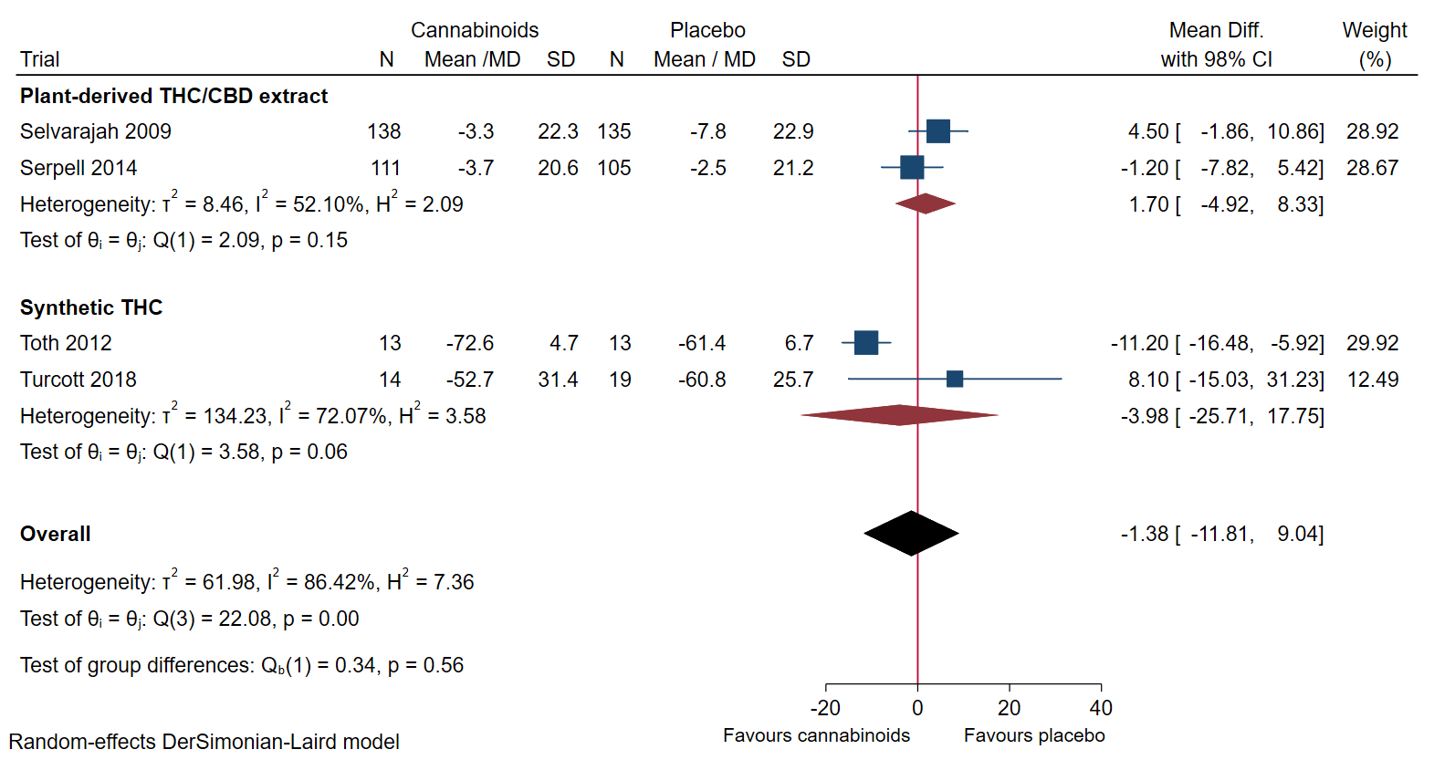
Figure 39: Quality of life subgroup analysis comparing different types of cannabinoids.

9 Non-serious adverse events
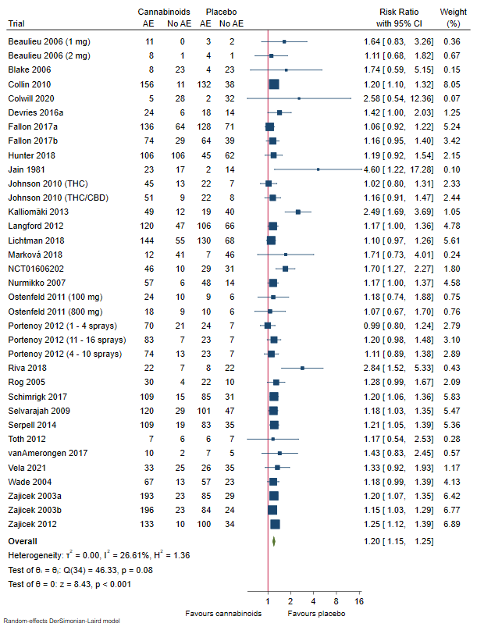
Figure 40: Forest plot of the meta-analysis of non-serious adverse events with 95% CI. The meta-analysis of non-serious adverse events showed evidence of a statistically significant difference between cannabinoids and placebo.

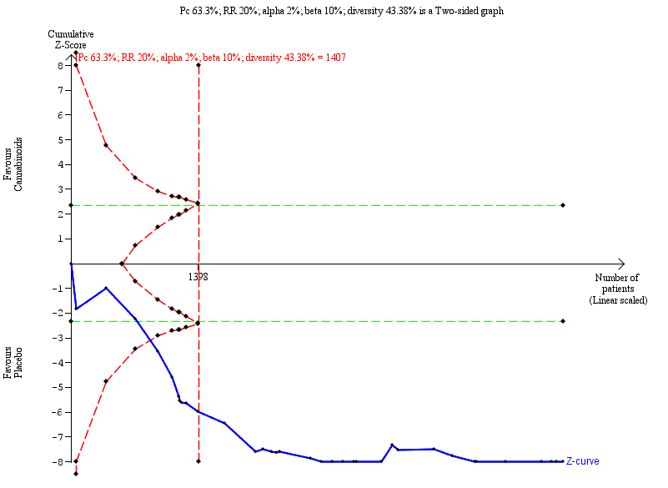

Figure 41: Trial Sequential Analysis graph of non-serious adverse event using random-effects meta-analysis. Trial Sequential Analysis showed the z-curve (the blue line) breaching the boundary of harm, showing that there was enough information to confirm that cannabinoids compared with placebo increased the risk of non-serious adverse events by 20%.

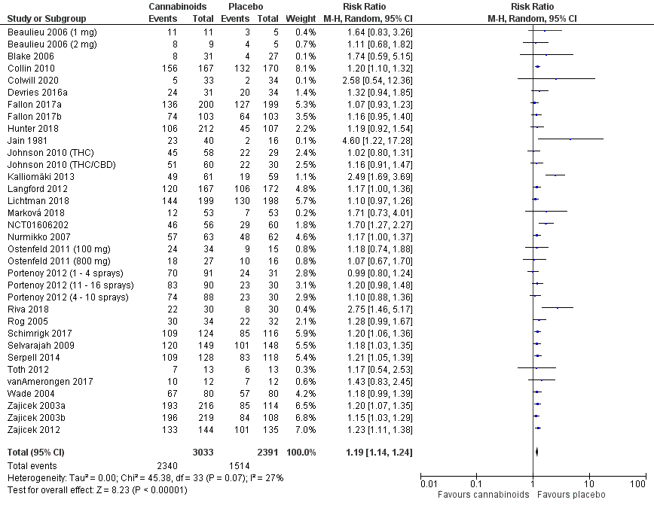
Figure 42: Non-serious adverse events best-worst case scenario

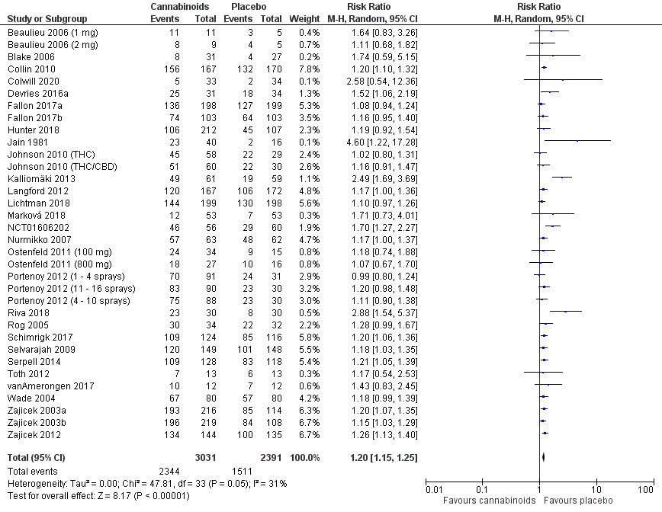
Figure 43: Non-serious adverse events worst-best case scenario

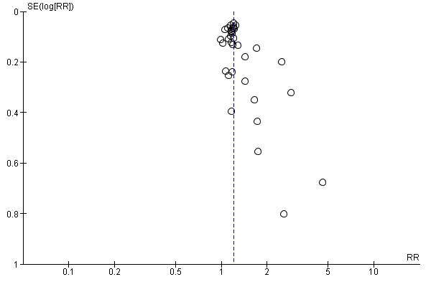
Figure 44: Funnel plot of non-serious adverse events. The funnel plot showed signs of small-study effects.
Regression-based Harbord test for small-study effects: Random-effects model: Method: DerSimonian-Laird
H0: beta1 = 0; no small-study effects
beta1 = 1.22
SE of beta1 = 0.366
z = 3.34
Prob > |z| = 0.0008

10 Quality of sleep
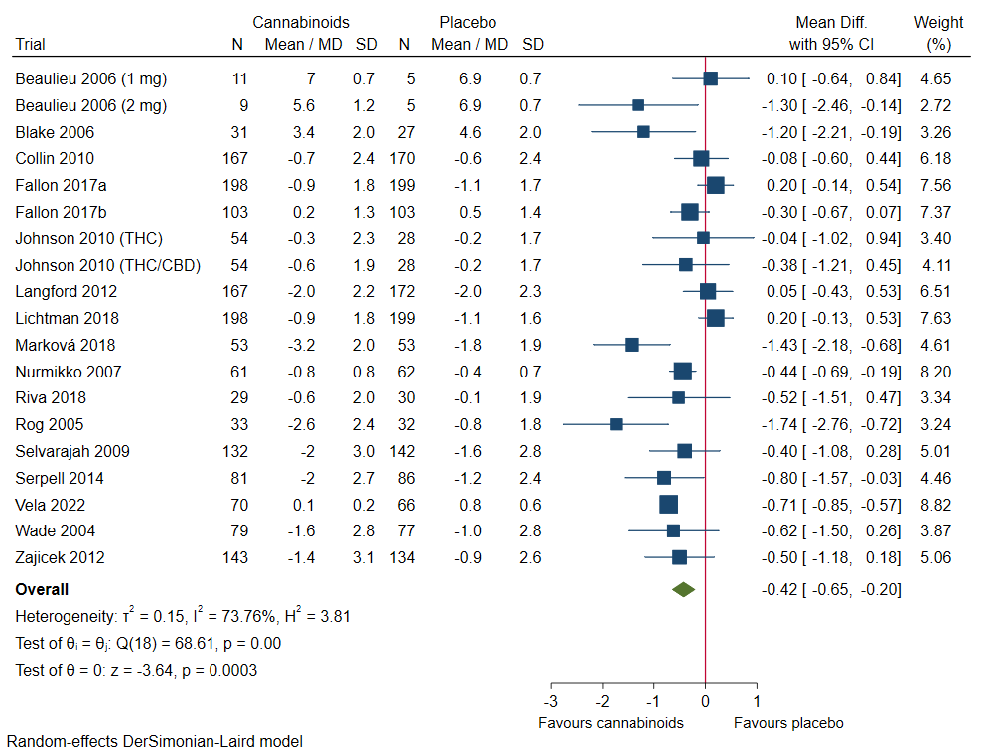
Figure 45: Forest plot of the meta-analysis of quality of sleep with 95% CI. The meta-analysis of quality of sleep showed evidence of a statistically significant difference between cannabinoids and placebo. (SMD -0.21; 95% CI -0.34, -0.08; P=0.001).

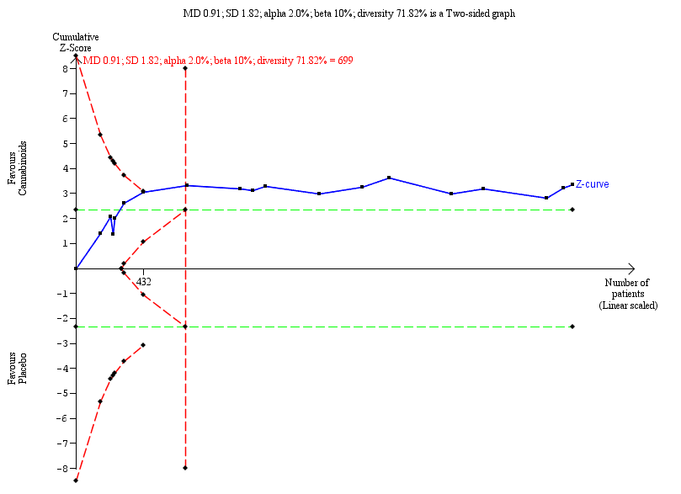
Figure 46: Trial Sequential Analysis graph of quality of sleep using random-effects meta-analysis. Trial Sequential Analysis showed the z-curve (the blue line) breaching the boundary of benefit, showing that there was enough information to confirm that cannabinoids compared with placebo improved quality of sleep.
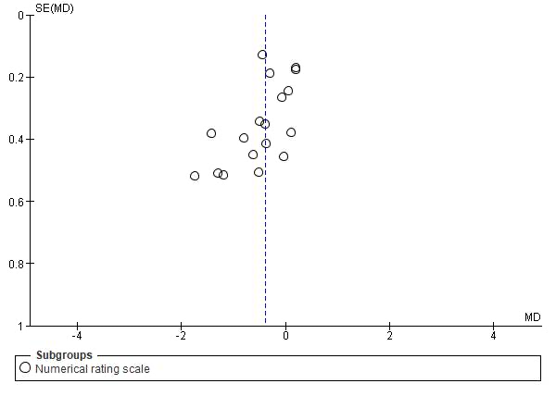
Figure 47: Funnel plot of quality of sleep. The funnel plot showed no signs of small-study effects.
Regression-based Egger test for small-study effects: Random-effects model: Method: DerSimonian-Laird
H0: beta1 = 0; no small-study effects
beta1 = -2.35
SE of beta1 = 0.798
z = -2.95
Prob > |z| = 0.0032

11 Twenty-four hours morphine consumption
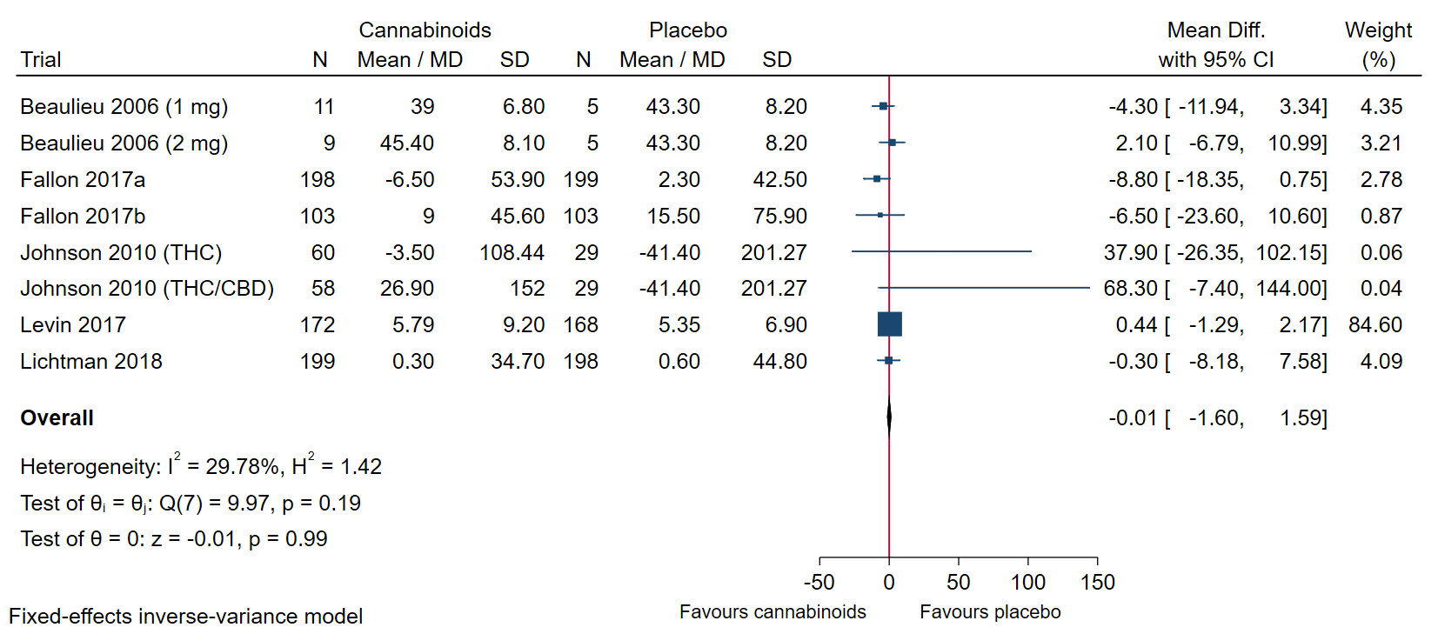
Figure 48: Forest plot of the meta-analysis of 24 hour morphine consumption with 95% CI. The meta-analysis of 24 hour morphine consumption showed no statistically significant evidence of a difference between cannabinoids and placebo. (SMD -0.02; 95% CI -0.12, 0.08; P=0.69).

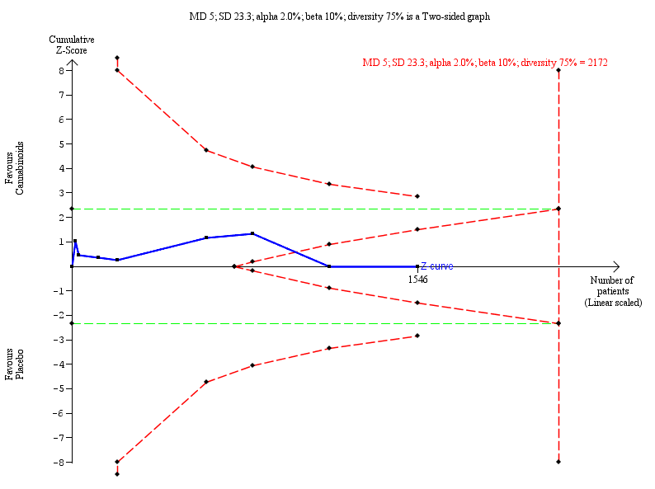
Figure 49: Trial Sequential Analysis graph of 24 hour morphine consumption using fixed-effects meta-analysis. Trial Sequential Analysis showed the z-curve (the blue line) breaching the boundary of futility, showing that there was enough information to reject that cannabinoids compared with placebo decreased the 24 hour morphine consumption by more than a mean difference of 5 mg.

12 Physical function
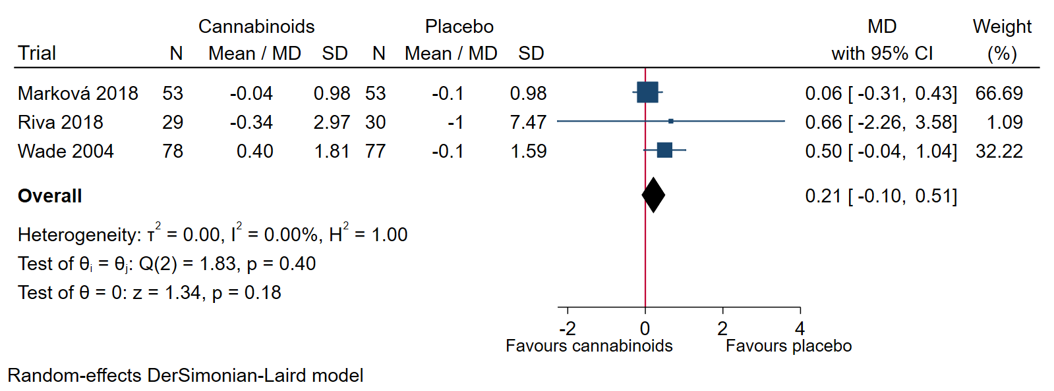
Figure 50: Forest plot of the meta-analysis of physical function with 95% CI. The meta-analysis of physical function showed no statistically significant evidence of a difference between cannabinoids and placebo. (SMD 0.18; 95% CI -0.04, 0.40; P= 0.10).

13 Depressive symptoms
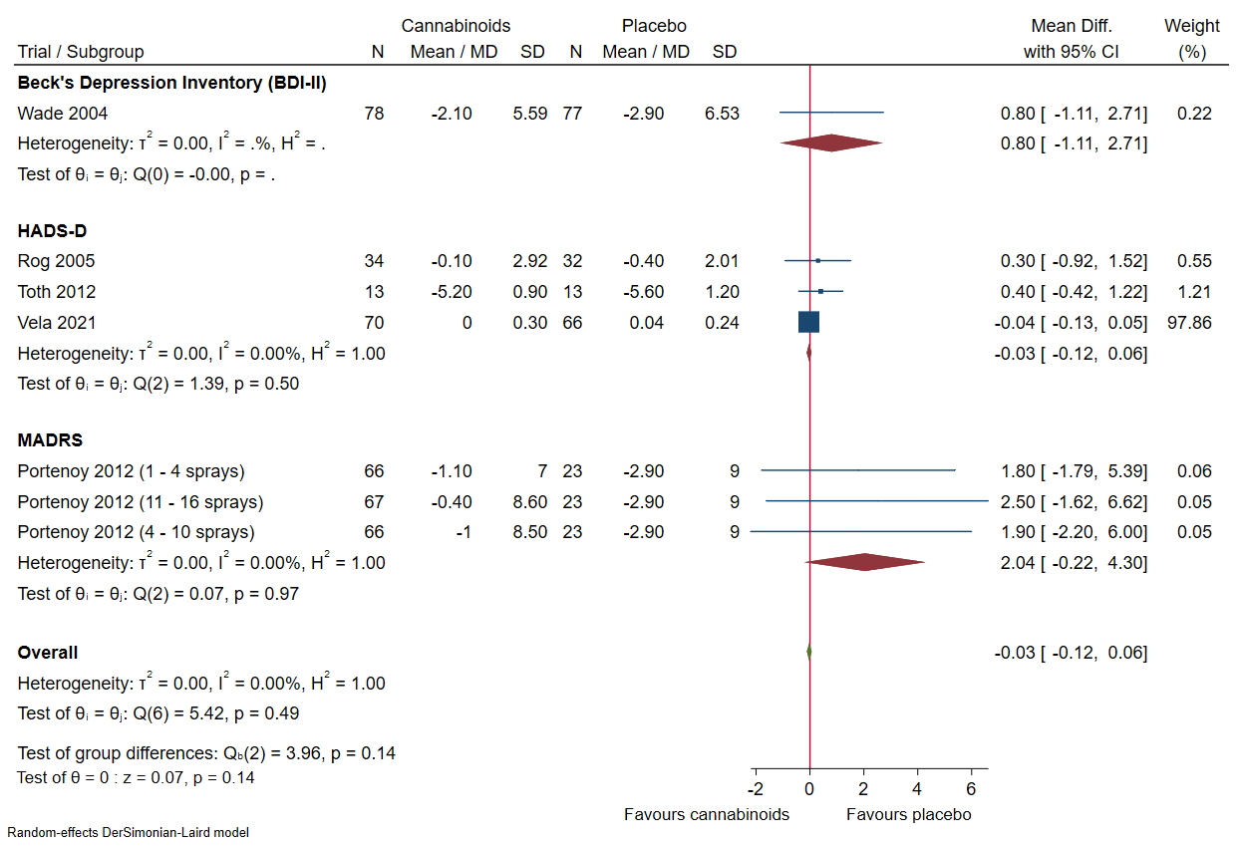
Figure 51: Forest plot of the meta-analysis of depressive symptoms with 95% CI. The meta-analysis of depressive symptoms showed no statistically significant evidence of a difference between cannabinoids and placebo. (SMD 0.19; 95% CI 0.01, 0.38; P= 0.04).

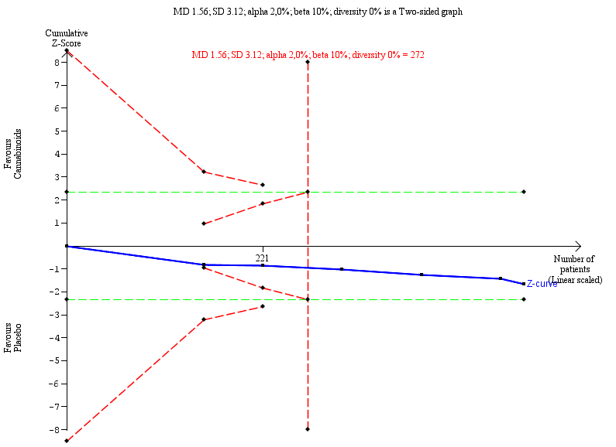
Figure 52: Trial Sequential Analysis graph of depressive symptoms using random-effect meta-analysis. Trial Sequential Analysis showed the z-curve (the blue line) breaching the boundary futility, showing that there was enough information to reject that cannabinoids compared with placebo decreased depressive symptoms.

14 Summary of findings:
Cannabinoids compared with placebo for pain
Patient or population: Pain
Intervention: Cannabinoids
Comparison: Placebo
Outcomes | Anticipated absolute effects* (95% CI) |  | Relative effect  (95% CI) | № of participants  (studies) | Certainty of the evidence  (GRADE) | Comments
Outcomes | Risk with Placebo | Risk with Cannabinoids
All cause mortality  follow up: mean 2 months | 89 per 1.000 | 107 per 1.000  (80 to 141) | RR 1.20  (0.90 to 1.59) | 2073  (7 RCTs) | ⨁⨁◯◯  LOW ^{a,b} | DARIS = 13622
Acute pain score difference  assessed with: NRS |  | MD 0.52 Points higher  (0.25 lower to 1.29 higher) | - | 530  (4 RCTs) | ⨁◯◯◯  VERY LOW ^{a,b,c} | DARIS = 1207
Cancer pain score difference  assessed with: NRS |  | MD 0.13 Points lower  (0.30 lower to 0.03 higher) | - | 1550  (6 RCTs) | ⨁⨁◯◯  LOW ^{a,b} | DARIS = 154
Chronic pain score difference  assessed with: NRS |  | MD 0.43 Points lower  (0.72 lower to 0.15 lower) | - | 2030  (16 RCTs) | ⨁⨁◯◯  LOW ^{a,d} | DARIS = 390
Serious adverse events  assessed with: RR | 100 per 1.000 | 118 per 1.000  (99 to 141) | RR 1.18  (0.95 to 1.45) | 3980  (18 RCTs) | ⨁⨁◯◯  LOW ^{a,e} | DARIS = 10720
Quality of life  Scale from: 0 to 100  follow up: mean 2 months |  | MD 1.38 points lower  (11.8 lower to 9.04 higher) | - | 548  (4 RCTs) | ⨁◯◯◯  VERY LOW ^{a,b,c} | DARIS = 1579
Adverse events not considered serious  assessed with: RR | 633 per 1.000 | 760 per 1.000  (728 to 791) | RR 1.20  (1.15 to 1.25) | 5536  (29 RCTs) | ⨁◯◯◯  VERY LOW ^{a,f,g} | DARIS = 1407
Quality of sleep  assessed with: NRS  follow up: mean 2 months |  | MD 0.42 points lower  (0.65 lower to 0.20 lower) | - | 3291  (17 RCTs) | ⨁⨁◯◯  LOW ^{a,d} | DARIS = 699
Twenty four hour morphine consumption  assessed with: mg |  | MD 0.01 mg lower  (1.60 lower to 1.59 higher) | - | 1546  (6 RCTs) | ⨁⨁◯◯  LOW ^{a,h} | DARIS = 2172
Physical function (measured by activities of daily living)  assessed with: Barthel index |  | MD 0.21 points higher  (0.1 lower to 0.51 higher) | - | 320  (3 RCTs) | ⨁◯◯◯  VERY LOW ^{a,i} | TSA could not be performed due to inadequate information size
Depressive symptoms  assessed with: HADS-D, MADRS and BDI-II |  | MD 0.03 points lower  (0.12 lower to 0.06 higher) | - | 651  (5 RCTs) | ⨁⨁◯◯  LOW ^{a,b} | DARIS = 272
*The risk in the intervention group (and its 95% confidence interval) is based on the assumed risk in the comparison group and the relative effect of the intervention (and its 95% CI).
CI: Confidence interval; RR: Risk ratio; MD: Mean difference; DARIS: Diversity adjusted required information size
GRADE Working Group grades of evidence
High certainty: We are very confident that the true effect lies close to that of the estimate of the effect
Moderate certainty: We are moderately confident in the effect estimate: The true effect is likely to be close to the estimate of the effect, but there is a possibility that it is substantially different
Low certainty: Our confidence in the effect estimate is limited: The true effect may be substantially different from the estimate of the effect
Very low certainty: We have very little confidence in the effect estimate: The true effect is likely to be substantially different from the estimate of effect

Explanations
a. Trials were generally assessed as high risk of bias. If the majority of the included trials were assessed as high risk of bias the outcome was assessed as high risk of bias, as well.
b. The required information size recommended by the Trial Sequential Analysis was not achieved.
c. Visual inspection of the forest plot, I² – statistic and Tau² – statistic indicated high heterogeneity of the overall meta-analysis.
d. Visual inspection of the forest plot, I² – statistic and Tau² – statistic indicated moderate heterogeneity of the overall meta-analysis.
e. There was a broad variety of the definition of a serious adverse event.
f. There was suspicion of small study effects according to the funnel plot for this outcome.
g. There was a broad variety of the definition of a non-serious adverse event.
h. Morphine consumption is an indirect outcome of the analgesic effect of cannabinoids.
i. Trial Sequential Analysis could not be performed due inadequate information size.

