Supplementary Information
Table S1: Cultivar name, reproductive type (D for Dioecious, H for Hermaphrodite (monoecious)), and haplotype group number for the 73 individual Cannabis sativa samples used here. Duplicate cultivar names are provided. Haplotype group number is 1-8 and corresponds to figure 1 in the main text.

Table S2: Variant call format table (SNPs & INDELs) for the 73 Cannabis sativa cultivars aligned to the reference cs10 (VCF was created using GATK).

Table S3: FASTA consensus sequence for each of the 73 Cannabis sativa cultivars aligned to the reference cs10 (Grassa et al. 2018). 1,356 SNPs are included for each individual.

Table S4: The normalized CNV values for each gene’s exon for the four hemp haplotypes.
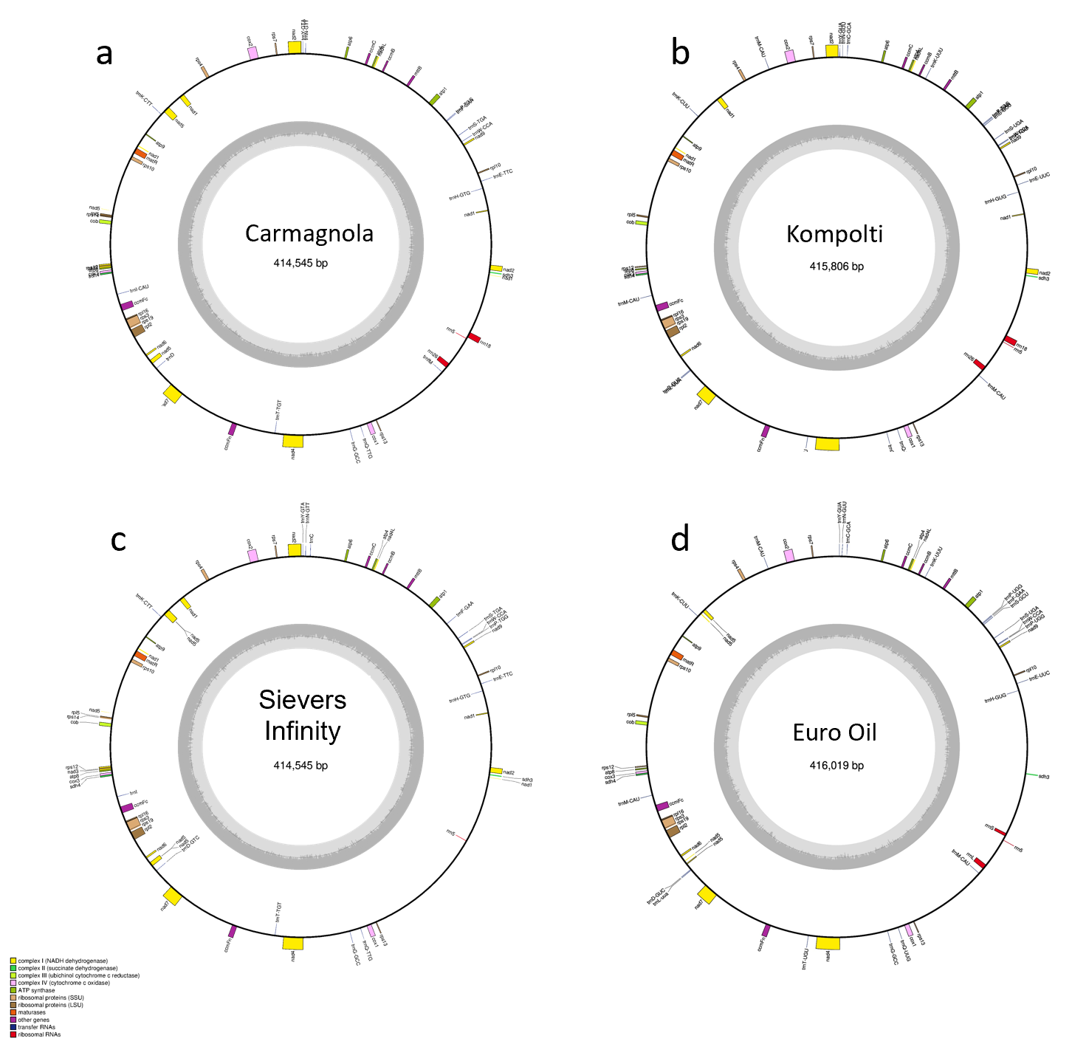
Fig S1. Genomic content for the Carmagnola (KR_059940) and Sievers Infinity (KU363807.1) as well as the two newly sequenced, assembled and annotated Cannabis sativa hemp Kompolti (MT361980.1) and Euro Oil (MT557709) mitochondrial genomes. Figures were produced using the OGDraw function from GeSeq (Tillich et al., 2017). Genomic content is given in the figure legends.
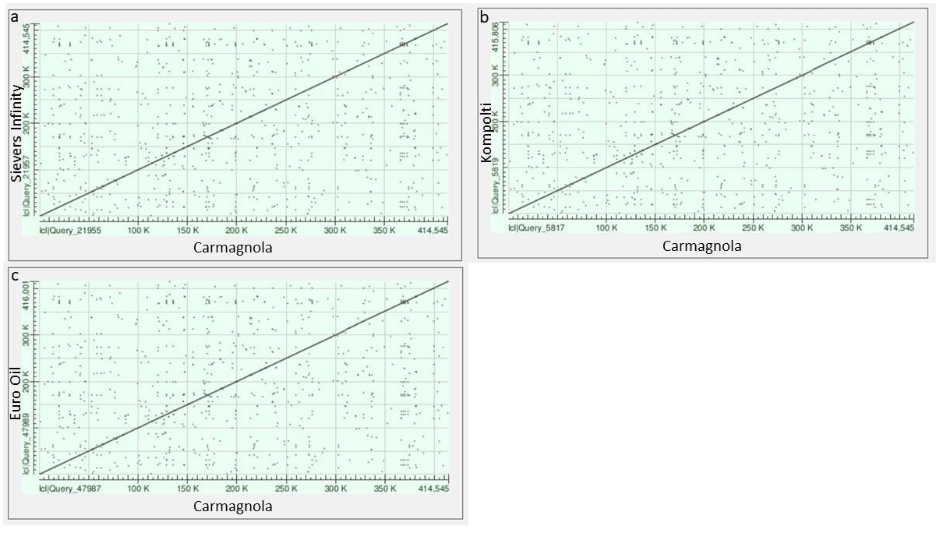
Fig S2. Dot plot synteny comparisons performed via NCBI’s blastn. FASTA sequences for Carmagnola (KR_059940) was compared against (a) Sievers Infinity (KU363807.1), (b) Kompolti (MT361980.1) and (c) Euro Oil (MT557709). Figures were produced via NCBI’s blastn web interface.

