Figure 10 I
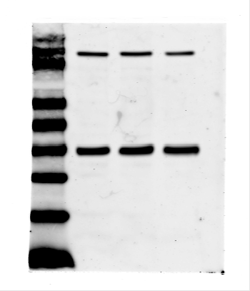
180
130
OAS3
GAPDH
33
25
KDa
95
70
55
10
17

