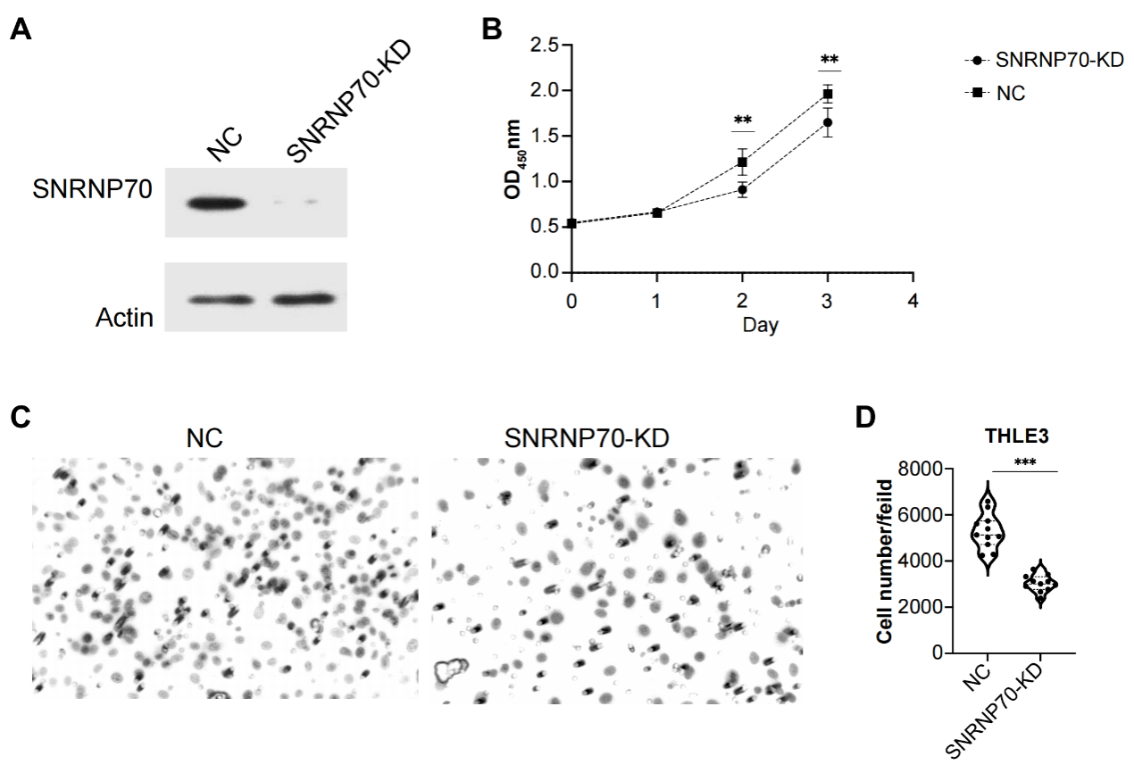

Supplementary Figure 1. SNRNP70 inhibits the proliferation and migration of THCE3 cells.
(A) The protein expression level after the downregulated of SNRNP70 in THCE3 cells was detected by WB. (B) Down-regulated SNRNP70 in CCK-8 experiments inhibited the proliferation of THCE3 cells. (C-D) The effect of down-regulation of SNRNP70 on THCE3 cells migration was measured by the scratch wound healing assay. **P<0.01, ***P<0.001.

