Supplemental Tables and Figures
Supplemental Table S1. The mean number of aphids on the experimental plants measured at two different time points after aphid infestations.
Mean aphids per leaflet | white | +red | +blue | red-blue
With aphids, week 10 | 85.1 ± 27.7 | 71.9 ± | 34.8 ± 12.9 | 291.3 ± 33.8
Without aphids, week 13 | 34.3 ± 4.3 | 28.3 ± 4.6 | 25.5 ± 4.5 | 30.8 ± 2.9
With aphids, week 13 | 418.5 ± 79.0 | 373.5 ± 135.1 | 200.8 ± 31.2 | 365.5 ± 64.2

Supplemental Figure Legends
Supplemental Figure S1. The timeline of hemp growth, aphid infestations, sampling and population management.
Supplemental Figure S2. Composition of each light color into the treatment for the plant-herbivore-light quality experiment. Each pie graph shows the percentage of red light (600-700 nm), green light (500-600 nm), and blue light (400-500 nm) in each light treatment’s PPFD (photosynthetic photon flux density). Both the day light quality and night light quality of the +red treatment is displayed because it was the only treatment to receive supplemental light at night. Values rounded to nearest whole number.
Supplemental Figure S3. Composition of each light color into the total treatment for the growth chamber experiment examining aphid life history traits. Each pie graph shows the percentage of red light (600-700 nm), green light (500-600 nm), and blue light (400-500 nm) in each light treatment’s PPFD (photosynthetic photon flux density). Both the day light quality and night light quality of the +red treatment is displayed because it was the only treatment to receive supplemental light at night. Values rounded to nearest whole number.

Supplemental Figure S1.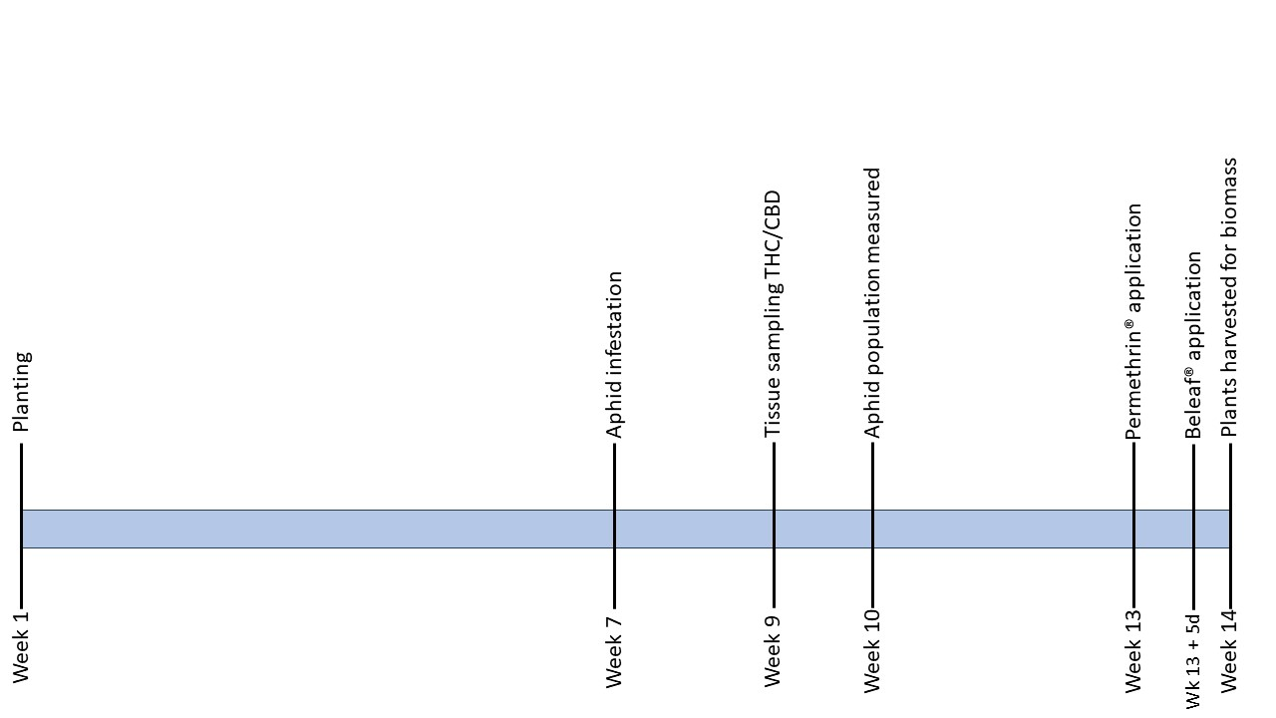

Supplemental Figure S2. 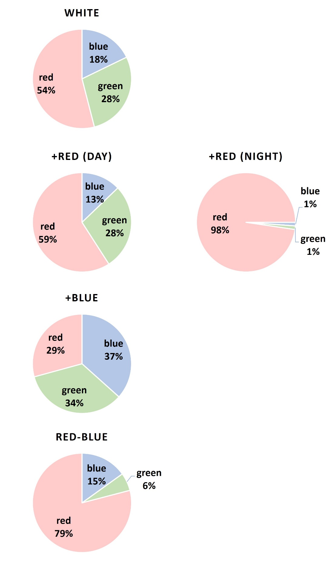

Supplemental Figure S3.