SUPPORTING INFORMATION

NMR study of the interaction between MinC and FtsZ and modeling of the FtsZ:MinC complex.

Luciana E. S. F. Machado^{a#}, Patricia Castellen^{a,b#}, Valdir Blasiosª, Helder V. Ribeiro-Filho^{b}, Alexandre W. Bisson-Filhoª, Jhonatan S. Benites Parienteª, Maria L. C. Nogueira^{b}, Mauricio Sforça^{b}, Rodrigo V. Honorato^{b}, Paulo S. Lopes-de-Oliveira^{b}, Roberto K. Salinasª, Ana C. Zeri^{b}, Frederico J. Gueiros-Filhoª.

This PDF file includes:
Supplemental Tables S1-S5
Supplemental Figures S1-S4
Supplemental References

Table S1. B. subtilis strains.
Strain | Genotype | Source | Figure
PY79 | prototroph | (Youngman et al., 1983) | WT parent strain
FG1454 | minCD::spc thr::P_{spac}-gfp-minC_minD (erm) | this work | S2A, S2B
VB28 | minCD::spc thr::P_{spac}-gfp-minC^{K12A}_minD (erm) | this work | S2A, S2B
VB29 | minCD::spc thr::P_{spac}-gfp-minC^{K15A}_minD (erm) | this work | S2A, S2B
VB45 | minCD::spc thr::P_{spac}-gfp-minC^{Y8A}_minD (erm) | this work | S2A, S2B
VB47 | minCD::spc thr::P_{spac}-gfp-minC^{H55A} _minD (erm) | this work | S2A, S2B
VB49 | minCD::spc thr::P_{spac}-gfp-minC^{H84A}_minD (erm) | this work | S2A, S2B

Table S2. Plasmids.
Plasmid | Genotype | Source | Figure
pAT6 | minC¹⁻¹⁰² in pET28a (kan) | (Castellen et al., 2015) | 1, S1
pAB20 | ftsZ¹⁻³⁸² in pET28a | (Blasios et al., 2013) | 4
pAB30 | minC¹⁻²²⁴ in pET24b | (Blasios et al., 2013) | 4
pBLA1 | minC^{K12A} in pET24b (kan) | this work | 4
pBLA2 | minC^{K15A} in pET24b (kan) | this work | 4
pBLA6 | minC^{Y8A} in pET24b (kan) | this work | 4
pBLA7 | minC^{H55A} in pET24b (kan) | this work | 4
pBLA8 | minC^{H84A} in pET24b (kan) | this work | 4
pBLA10 | thr::P_{spac}-gfp-minC^{K12A}_minD (erm) | this work | S2A, S2B
pBLA11 | thr::P_{spac}-gfp-minC^{K15A}_minD (erm) | this work | S2A, S2B
pBLA14 | thr::P_{spac}-gfp-minC^{Y8A}_minD (erm) | this work | S2A, S2B
pBLA15 | thr::P_{spac}-gfp-minC^{H55A} _minD (erm) | this work | S2A, S2B
pBLA16 | thr::P_{spac}-gfp-minC^{H84A} _minD (erm) | this work | S2A, S2B
pLM1 | minC¹⁻¹⁰² in pRP1B (kan) | this work | 2, 3
pLM2 | minC^{1-102 K12A} in pRP1B (kan) | this work | 2, 3
pLM3 | minC^{1-102 H55A} in pRP1B (kan) | this work | 2, 3
pLM4 | FtsZ^{1-315, A182E} in pRP1B (kan) | this work | 2, 3

Table S3. Frequency of hydrogen bond formation during MD simulation.

MinC residues | FtsZ residues | HB frequency (%)
LYS5-Main | ASN208-Side | 16.83%
LYS15-Side | ASP289-Side | 3.87%
LYS2-Side | ASP289-Side | 15.21%
TYR8-Side | ASP213-Side | 29.18%
LYS4-Side | LEU209-Main | 12.47%
LYS5-Side | GLY205-Main | 7.73%
SER2-Main | GLY37-Main | 17.21%
LYS12-Side | ASP213-Side | 26.31%
GLU42-Side | GLN288-Side | 8.73%
GLU42-Main | GLN288-Side | 3.99%
THR14-Side | GLN288-Main | 4.49%
LYS4-Main | ILE201-Main | 1.75%
LEU31-Main | GLN276-Side | 1.25%

Table S4. Features of complex´s interfaces estimated using COCOMAPS (https://www.molnac.unisa.it/BioTools/cocomaps/).
¹ Note that our complex contains only MinC^{N} and FtsZ without its unstructured tail, whereas AlphaFold’s used the full-length proteins.
Parameter | NMR/Docking | AlphaFold
Buried area upon complex formation (Å2) | 2353,6 | 2267,7
Buried area upon complex formation (%) ¹ | 11,41 | 5,77
Interface area (Å2) | 1176,8 | 1133,85
Interface area MOL1 (%) (MinC) ¹ | 15,15 | 7,49
Interface area MOL2 (%) (FtsZ) ¹ | 9,15 | 4,69
POLAR Buried area upon complex formation (Å2) | 1447,7 | 1536,2
POLAR Interface (%) | 61,51 | 67,74
POLAR Interface area (Å2) | 723,85 | 768,1
NON POLAR Buried area upon complex formation (Å2) | 905,8 | 731,5
NON POLAR Interface (%) | 38,49 | 32,26
NON POLAR Interface area (Å2) | 452,9 | 365,75
Residues at the interface_TOT (n) | 61 | 50
Residues at the interface_Mol1 (MinC) | 25 | 22
Residues at the interface_Mol2 (FtsZ) | 36 | 28
Number of interacting residues Molecule1 (MinC) | 46 | 44
Number of interacting residues Molecule2 (FtsZ) | 74 | 71
Number of hydrophilic-hydrophobic interaction | 185 | 160
Number of hydrophilic-hydrophilic interaction | 98 | 110
Number of hydrophobic-hydrophobic interaction | 84 | 79
Table S5. Comparison between E. coli MinC^{N} mutant data and residue presence in interface of predicted complexes.
¹ Residue correspondence as in Park et al. 2018.
² Residues which exhibited the same phenotype when mutated in B. subtilis are marked with asterisks.
³ Contacts predicted by COCMAPS, using a distance threshold of 5Å.

residue  E. coli | residue  B. subtilis^{1,2} | Phenotype | In our interface?³ | In AF interface? ³
E7K/E7A | T10 | normal | yes | yes
K9A | K12A* | defective | yes | yes
G10D | G13 | defective | yes | yes
S11D | T14 | normal | no | yes
S12D | K15A* | defective | yes | yes
S16D | T19 | defective | no | no
V18D | H21 | defective | no | no
K35E | M38 | defective | yes | no
Q38A | I41 | normal | no | yes
A39D | E42 | defective | yes | no
F42E | T45 | defective | yes | no

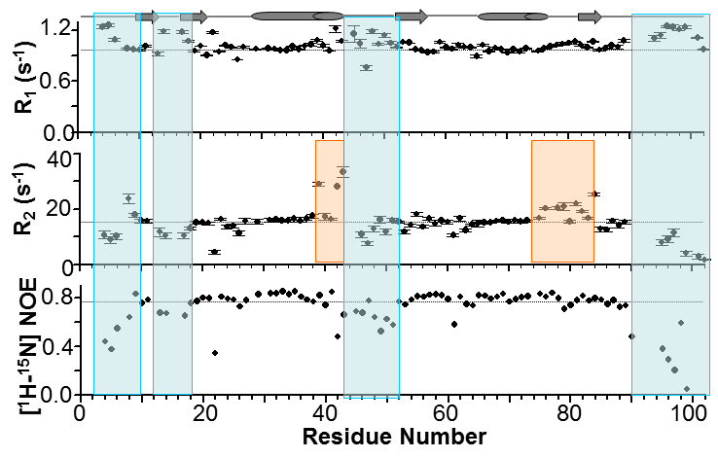
Supplemental Figure 1: ¹⁵N dynamics of MinC^{N}. ¹⁵N R₁ and R₂ relaxation rate and hetNOE (¹⁵N 80 MHz Larmor frequency). Annotated secondary structure is shown. The dynamic loops are highlighted in blue. Regions of potential conformational exchange are highlighted in orange.

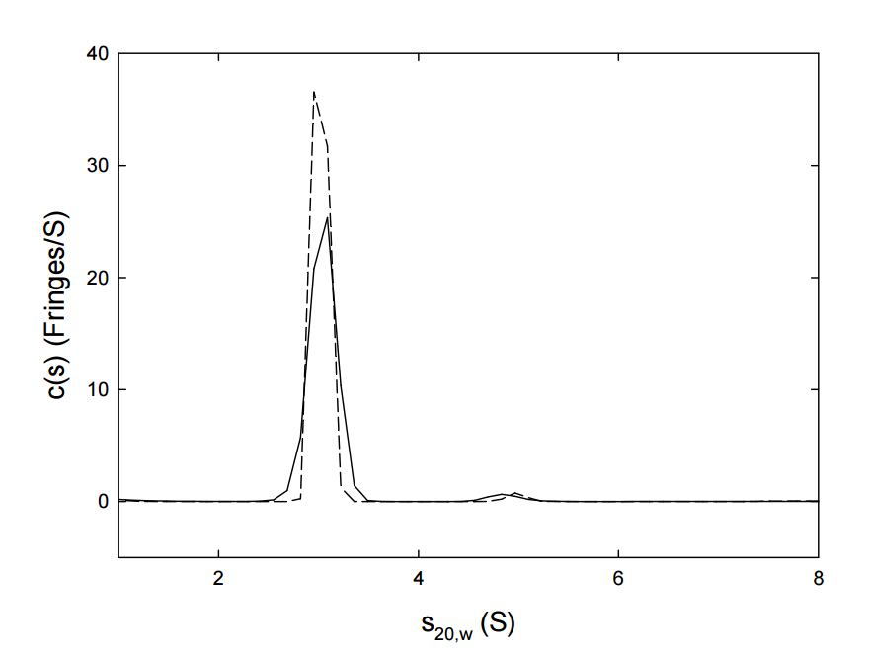

Supplemental Figure 2: Sedimentation coefficient distribution c(s) of 100 μM FtsZ^{1-315, A182E} in the presence of 1.5 mM GDP (dashed line) or 1.5 mM GTP (solid line). More than 97% of the protein sedimented as a single peak with a sedimentation coefficient s_{20,w} value 3.0 S, which is identical to that of the FtsZ¹⁻³¹⁵ monomer.

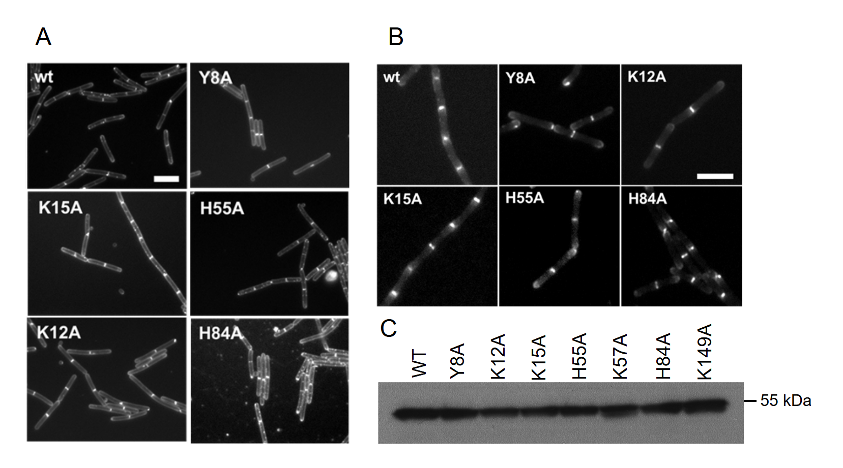
Supplemental Figure 3: (A) Cell division phenotype of GFP-MinC^{N} mutants. All strains contain IPTG inducible alleles (Pspac) of GFP-MinC and were grown on LB pads with 0.2 mM of IPTG at 37ºC for 3 hours. Cells were stained with FM 5-95. Scale bar 5 μm. (B) Subcellular localization of GFP-MinC^{N} mutants. Cells were induced with 0.2 mM IPTG, grown to exponential phase and immobilized on 1% agarose. Scale bar = 5 µm. (C) Western blot of whole cell extracts from each mutant revealed with anti-GFP antiserum. Predicted molecular weight of the GFP-MinC fusions is 52 kDa. Blot contains 2 mutants (K57A and K149A) that are not relevant for this work and will be described elsewhere.

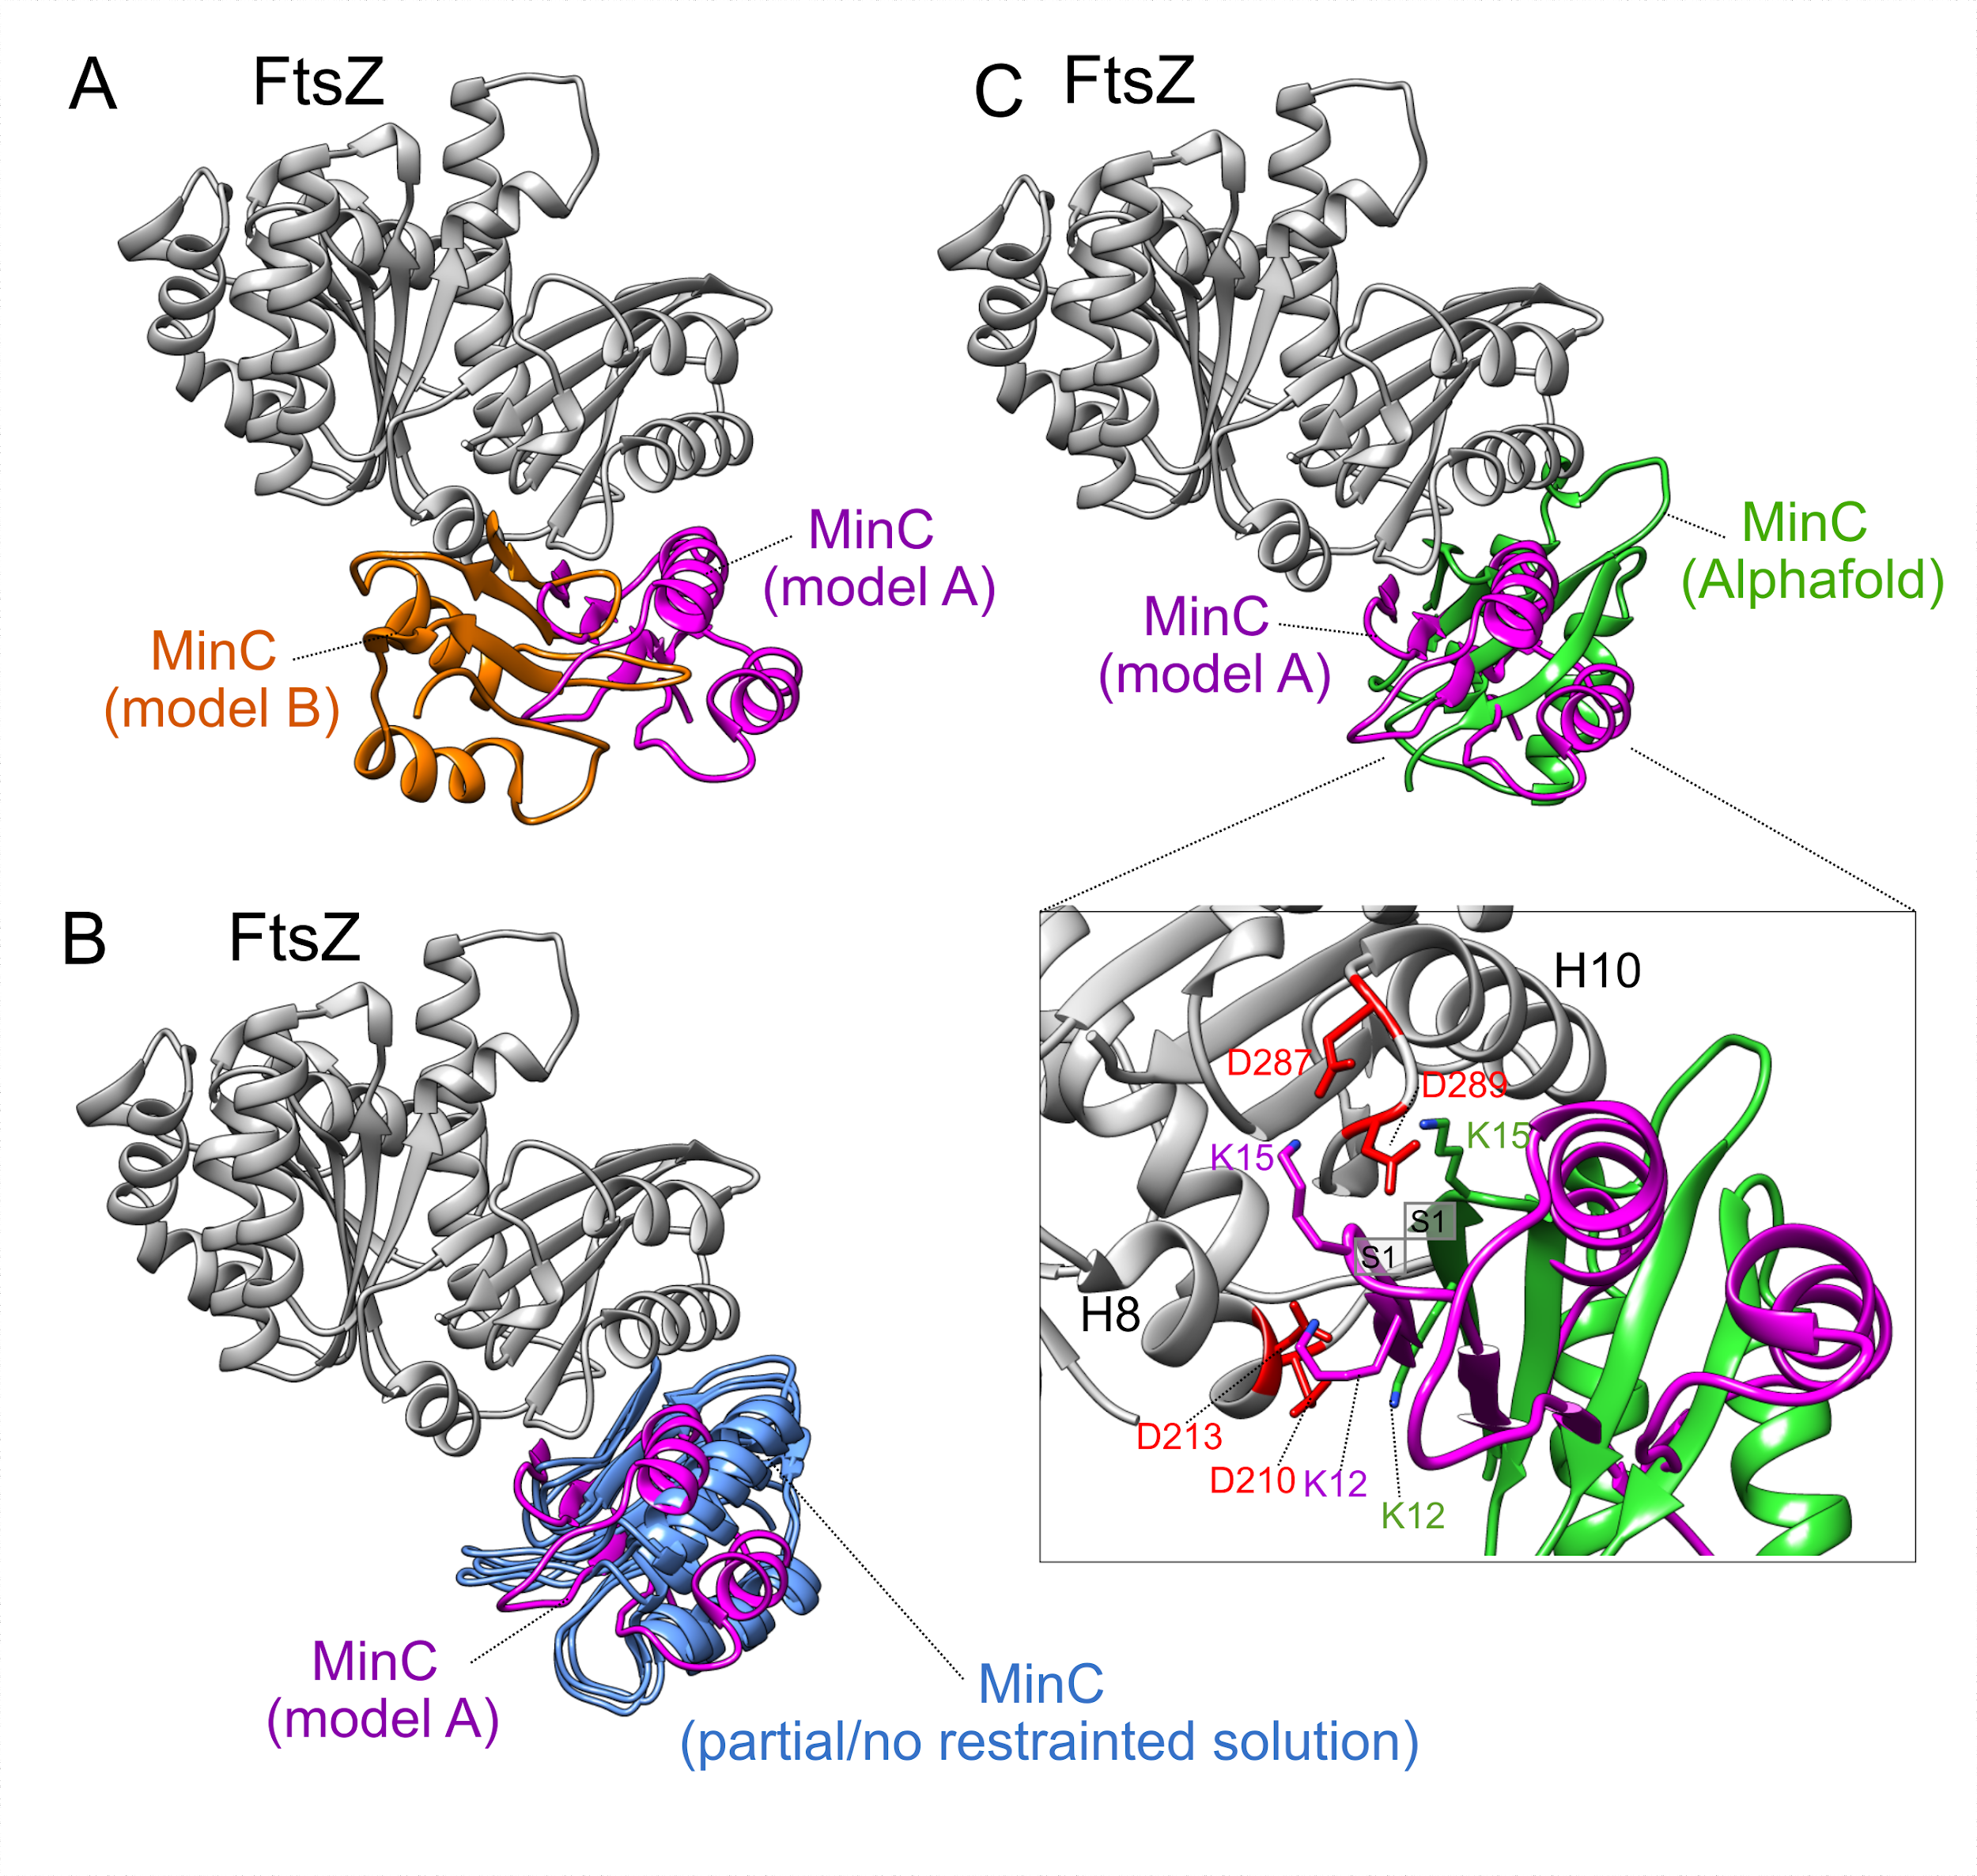
Supplemental Figure 4. Comparison among 3D structural models of FtsZ:MinC complex. (A) Structural comparison between FtsZ:MinC 3D models (model A, in magenta, and model B, in orange) modeled by protein-protein docking with ClusPro server, using constraints based on experimental data. Models are aligned by FtsZ structure. (B) Structural comparison between model A (in magenta), generated in ClusPro server with constraints, and three other best ranked models (in blue), generated in ClusPro server with no constraints (Model C), with only MinC constraints (Model D), or with only FtsZ constraints (Model E). Since all these alternative models C, D and E, adopts a similar interaction position, we did not name them in the structure, for clarity. (C) Structural comparison between model A (in magenta), generated in ClusPro server with constraints, and the structural model generated by AlphaFold-Multimer (in green). In inset, a zoomed view of contacts between positively charged residues of MinC S1 and negatively charged residues of FtsZ. Important residues in this contact adopt similar positions in both proposed models.
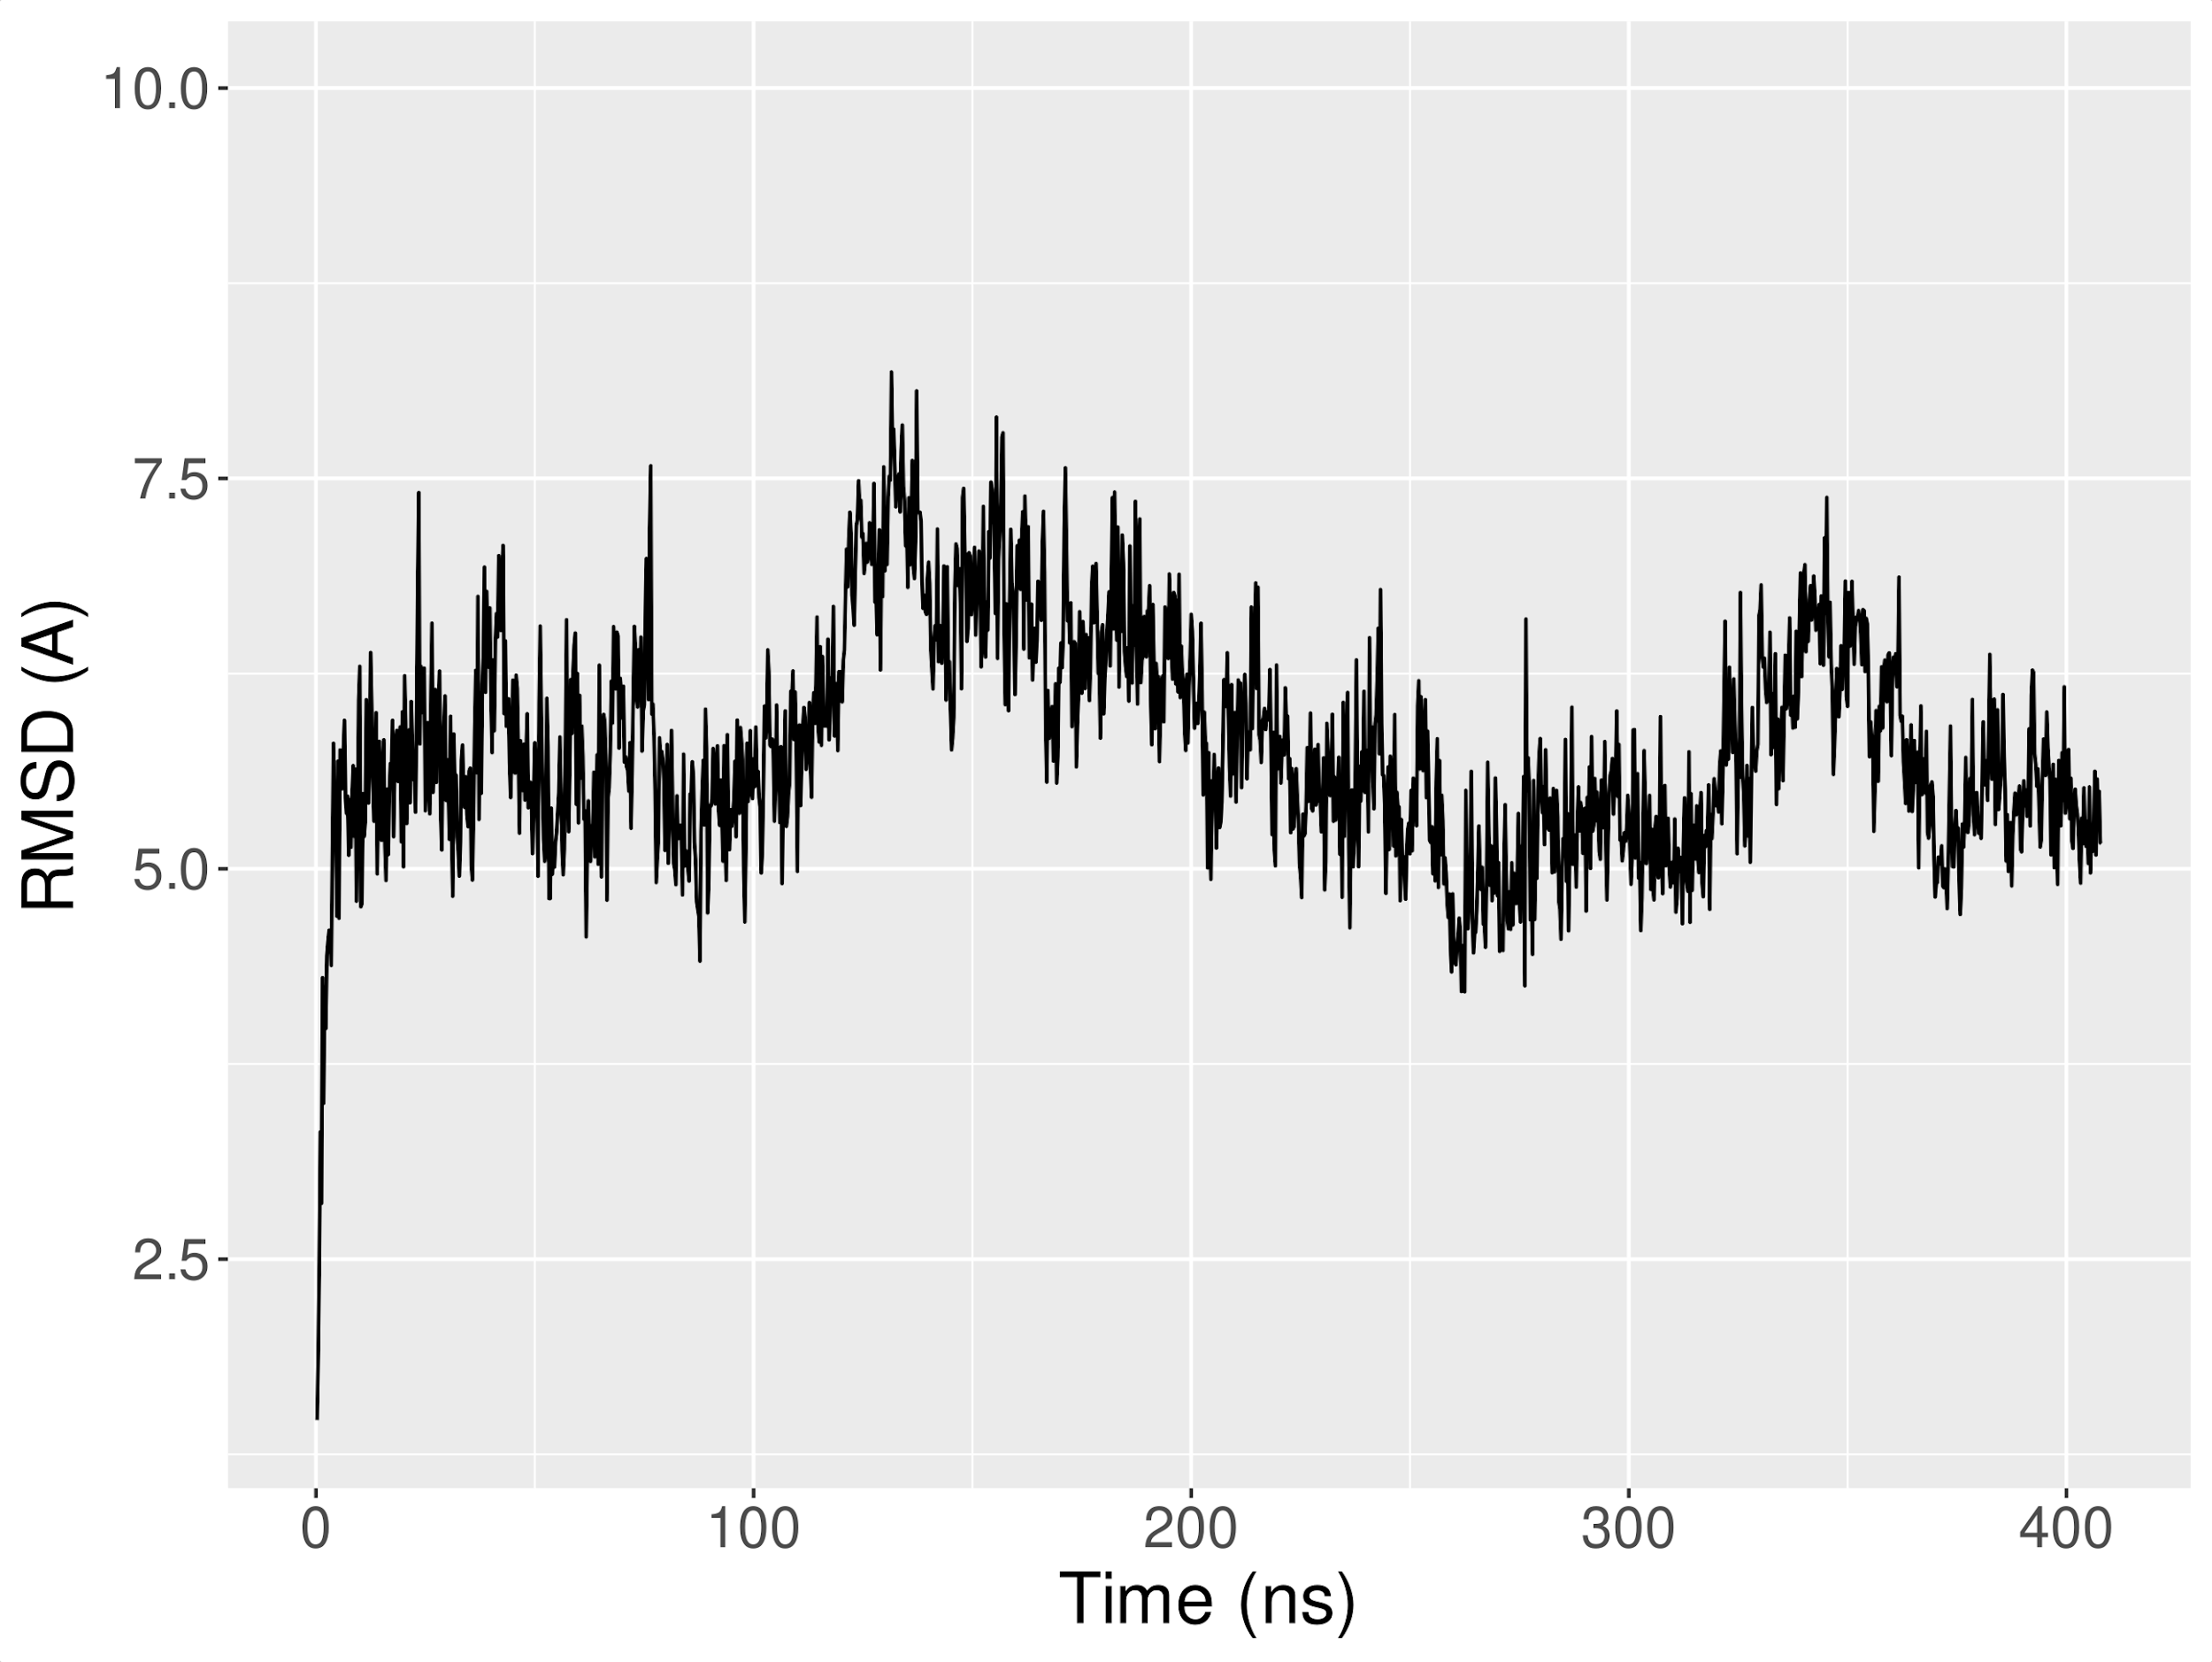
Supplemental Figure 5. Root-mean-squared deviation (RMSD) of MinC during the 400 ns molecular dynamics simulation. The backbone MinC RMSD was calculated in VMD software and the system was aligned by FtsZ proteins using the first frame as reference.

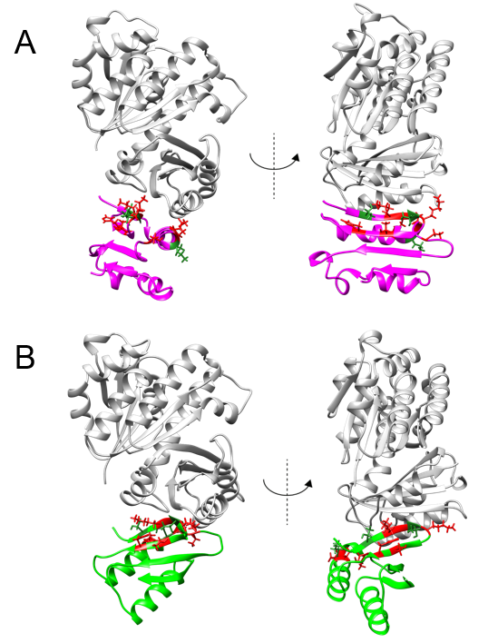

Supplemental Figure 6. Mapping of E. coli MinC^{N} mutations of Table S5 onto the structure of the NMR-docking complex (A) and Alpha Fold Multimer complex (B). Mutations are highlighted as sticks, with those that disrupt MinC^{N} function colored red and those without effect colored dark green.
Supplemental References
Blasios, V., Bisson-Filho, A.W., Castellen, P., Nogueira, M.L., Bettini, J., Portugal, R.V., Zeri, A.C., Gueiros-Filho, F.J., 2013. Genetic and biochemical characterization of the MinC-FtsZ interaction in Bacillus subtilis. PLoS One 8, e60690.
Castellen, P., Sforça, M.L., Gueiros-Filho, F.J., De Mattos Zeri, A.C., 2015. Backbone and side chain NMR assignments for the N-terminal domain of the cell division regulator MinC from Bacillus subtilis. Biomol. NMR Assign. 9, 1–5. https://doi.org/10.1007/s12104-013-9534-y
Park, K.-T., Dajkovic, A., Wissel, M., Du, S., Lutkenhaus, J., 2018. MinC and FtsZ mutant analysis provides insight into MinC/MinD-mediated Z ring disassembly. J. Biol. Chem. 293, 5834–5846. https://doi.org/10.1074/jbc.M117.815894
Youngman, P.J., Perkins, J.B., Losick, R., 1983. Genetic transposition and insertional mutagenesis in Bacillus subtilis with Streptococcus faecalis transposon Tn917. Proc Natl Acad Sci U A 80, 2305–9.

