APPENDIX

Illicit Stimulant Use and Ventricular Arrhythmias

Figure S1. Participant selection

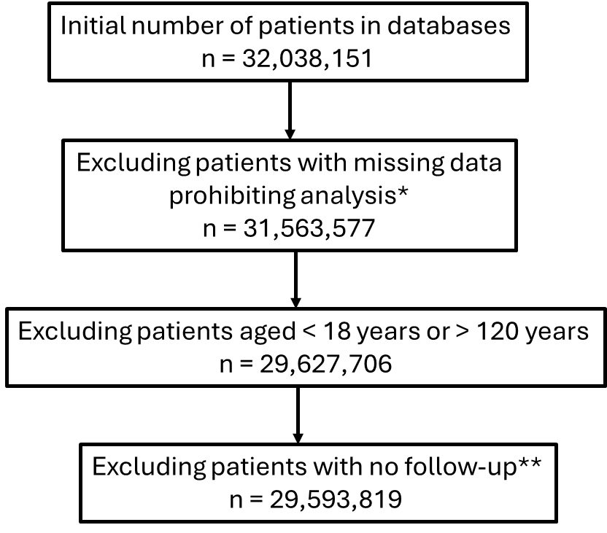
* Missing data on sex and race
** Patients who entered the cohort (first healthcare encounter) on the same day than their death or end of the study (December 31, 2019)

Table S1. CCS, ICD-9, and ICD-10 codes for diagnoses
Diagnoses | CCS | ICD-9 | ICD-10
Acromegaly |  | 253.0 | E22.0
ADHD |  | 314.0 | F90
Alcohol abuse |  | 291.x, 303.x, 303.00, 305.0, 790.3, 980.0 | F10.x, T51.x, R78.0
Amphetamine use |  | 304.40, 304.41, 304.42, 304.43, 305.70, 305.71, 305.72, 305.73, 969.72 | F15.1x, F15.2x, F15.9x
Cannabis |  |  | F12.1x, F12.2x, F12.9x
Cardiac arrest |  | 427.5 | I46
Chronic kidney disease |  | 585.x | N18.x
Chronic obstructive pulmonary disease |  | 491, 492, 496 | J41, J42, J43, J44
Cocaine use |  | 304.20, 304.21, 304.22, 304.23, 305.60, 305.61, 305.62, 305.63, 970.81 | F14.1x, F14.2x, F14.9x
Coronary heart disease |  | 410.x to 414.x | I20.x to I25.x, Z95.1, Z95.5, Z98.61
Diabetes mellitus | 49, 50 | 250.xx | E10.x to E13.x
Dyslipidemia | 53 | 272.0 to 272.5 | E78.x
Heart Failure | 108 | 428.x | I11.0, I13.0, I13.2, I50.x
HIV infection |  | 042 | B20
Hypertension | 98, 99 | 401.x | I10.x to I16.x, I67.4
Ischemic stroke |  | 433.x, 434.x, 436.x, 437.x, | I63.x, G46
Myasthenia gravis |  | 358.0 | G70.0
Narcolepsy |  | 347 | G47.4
Obesity-related disorders |  | 278.00, 278.01, 278.03 | E66.0, E66.1, E66.2, E66.8, E66.9
Opioid use |  | 304.00, 304.01, 304.02, 304.03, 304.70, 304.71, 304.72, 304.73, 305.50, 305.51, 305.52, 305.53, 965.00, 965.01, 965.02, 965.09, E850.0, E850.1, E850.2, E935.0, E935.1, E935.2 | F11.1x, F11.2x, F11.9x
Peripheral artery disease |  | 440.2x, 440.3x, 440.4x, 443.9 | I70.x, I71.x, I73.1, I73.9
Presbycusis |  | 388.01 | H91.1x
Smoking |  | V15.82, 305.1, 649.0, 989.84 | Z72.0, F17.21, F17.20, Z87.891
Ventricular tachycardia |  | 427.1 | I47.2
Ventricular fibrillation |  | 427.41 | I49.01
ADHD: Attention-deficit/hyperactivity disorder; CCS: Clinical Classification Software; ICD-9: International Classification of Diseases, Ninth Revision; ICD-10: International Classification of Diseases, Tenth Revision

Table S2. Consistency between diagnostic codes and documented substance use in medical records
 | Methamphetamine |  | Cocaine
 | Documented use | No documented use | Documented use | No documented use
ICD code present | 97 | 3 | 100 | 0
ICD code absent | 3 | 97 | 7 | 93
ICD code: International Classification of Diseases code
Documentation of substance use was determined by the review of patients’ electronic medical records.

Table S3. Crude incidence rates of ventricular tachycardia, ventricular fibrillation, cardiac arrest, ventricular arrhythmias and all-cause mortality stratified by methamphetamine and cocaine uses
Outcomes | Methamphetamine |  |  | Cocaine
 | Non-users | Users | P value | Non-users | Users | P value
Ventricular arrhythmias | 2.35 (2.34-2.35) | 4.56 (4.44-4.67) | <0.001 | 2.35 (2.34-2.36) | 5.02 (4.83-5.21) | <0.001
Ventricular tachycardia | 1.19 (1.18-1.19) | 2.35 (2.27-2.44) | <0.001 | 1.19 (1.19-1.19) | 2.58 (1.45-2.72) | <0.001
Ventricular fibrillation | 0.27 (0.27-0.27) | 0.54 (0.50-0.58) | <0.001 | 0.27 (0.27-0.28) | 0.66 (0.59-0.73) | <0.001
Cardiac arrest | 1.26 (1.25-1.26) | 2.54 (2.46-2.63) | <0.001 | 1.26 (1.26-1.26) | 2.80 (2.66-2.94) | <0.001
All-cause death | 10.84 (10.83-10.85) | 7.13 (6.99-7.28) | <0.001 | 10.82 (10.80-10.83) | 14.14 (13.81-14.47) | <0.001
Incidence rates are expressed in 1000 person-years (95% confidence interval)

Table S4. Sensitivity analyses for the risk of cardiac arrest coded in the emergency department and out-of-hospital mortality associated with methamphetamine and cocaine uses
 | Cardiac arrest coded in the emergency department |  | Out-of-hospital mortality
 | HR (95% CI) | P value | HR (95% CI) | P value
Substance use
Methamphetamine | 1.87 (1.76-1.97) | <0.001 | 1.52 (1.48-1.55) | <0.001
Cocaine | 0.95 (0.87-1.04) | 0.25 | 1.72 (1.68-1.77) | <0.001
Hazard ratio with 95% confidence interval, adjusted for demographics (age, sex, race and ethnicity), insurance status, level of income, substance use (methamphetamine, cocaine, cannabis, opioid), tobacco smoking, alcohol abuse, and co-morbidities (hypertension, diabetes, dyslipidemia, heart failure, chronic kidney disease, coronary artery disease, peripheral artery disease, ischemic stroke).

Table S5. Sensitivity analyses of the risk of ventricular arrhythmias associated with methamphetamine and cocaine uses after exclusion of patients with selected conditions
 | Ventricular arrhythmias
 | Patients with obesity-related disorders excluded |  | Patients with ADHD or narcolepsy excluded |  | Patients with HIV excluded
 | HR (95% CI) | P value | HR (95% CI) | P value | HR (95% CI) | P value
Substance use
Methamphetamine | 1.91 (1.86-1.97) | <0.001 | 1.90 (1.85-1.95) | <0.001 | 1.90 (1.85-1.95) | <0.001
Cocaine | 1.18 (1.13-1.23) | <0.001 | 1.15 (1.10-1.19) | <0.001 | 1.13 (1.09-1.18) | <0.001
ADHD: attention-deficit/hyperactivity disorder; CAD: coronary artery disease; CI: confidence interval; CKD: chronic kidney disease; HIV: human immunodeficiency virus; HR: hazard ratio; PAD: peripheral artery disease
Hazard ratio with 95% confidence interval, adjusted for demographics (age, sex, race and ethnicity), insurance status, level of income, substance use (methamphetamine, cocaine, cannabis, opioid), tobacco smoking, alcohol abuse, and co-morbidities (hypertension, diabetes, dyslipidemia, heart failure, chronic kidney disease, coronary artery disease, peripheral artery disease, ischemic stroke).

Table S6. Baseline participants characteristics according to cocaine use, before and after propensity score matching for the outcome of ventricular arrhythmia
 | Before propensity score matching |  | After propensity score matching
 | No cocaine use  (n = 29,228,316) | Cocaine use  (n=285,333) | No cocaine use  (n=123,743) | Cocaine use  (n=123,743)
Mean age (years) | 45.0 ± 19.4 | 40.5 ± 13.7 | 41.8 ± 14.4 | 41.4 ± 13.7
Male (%) | 13,420,861 (45.9) | 192,940 (67.6) | 68,800 (55.6) | 68,622 (55.5)
Race and ethnicity (%)
Asian | 2,914,265 (10.0) | 6,800 (2.38) | 6,334 (5.1) | 6,203 (5.0)
Black | 2,098,413 (7.2) | 85,963 (30.1) | 23,837 (19.3) | 23,496 (19.0)
Hispanic | 7,689,561 (26.3) | 68,677 (24.1) | 30,340 (24.5) | 30,363 (24.5)
Native American | 105,240 (0.4) | 964 (0.3) | 598 (0.5) | 637 (0.5)
White | 15,140,106 (51.8) | 114,955 (40.3) | 57,625 (46.6) | 58,055 (46.9)
Other | 1,280,731 (4.4) | 7,974 (2.8) | 5,009 (4.1) | 4,989 (4.0)
Co-morbidities
Diabetes (%) | 2,007,272 (6.9) | 41,816 (14.7) | 16,095 (13.0) | 15,588 (12.6)
Hypertension (%) | 4,356,815 (14.9) | 95,511 (33.5) | 29,600 (23.9) | 29,786 (24.1)
Heart failure (%) | 437,973 (1.5) | 20,941 (7.3) | 8,443 (6.8) | 7,803 (6.3)
Dyslipidemia (%) | 2,089,348 (7.2) | 39,070 (13.7) | 15,096 (12.2) | 15,153 (12.3)
CKD (%) | 320,230 (1.1) | 14,773 (5.2) | 6,196 (5.0) | 5,800 (4.7)
CAD (%) | 974,053 (3.3) | 17,171 (6.0) | 8,160 (6.6) | 7,879 (6.4)
PAD (%) | 145,139 (0.5) | 2,119 (0.7) | 1,718 (1.4) | 1,444 (1.2)
Ischemic stroke (%) | 204,992 (0.7) | 7,188 (2.5) | 3,734 (3.0) | 3,303 (2.7)
CAD: coronary artery disease; CKD: chronic kidney disease; PAD: peripheral artery disease
Baseline is the first healthcare encounter for non-users of cocaine and the first healthcare encounter with a diagnosis code for cocaine use for users
Cohorts matched based on age, sex, race, co-morbidities (hypertension, diabetes mellitus, heart failure, dyslipidemia, chronic kidney disease, coronary artery disease, peripheral artery disease, chronic obstructive pulmonary disease, and ischemic stroke)

Table S7. Baseline participants characteristics according to methamphetamine use, before and after propensity score matching for the outcome of ventricular arrhythmia
 | Before propensity score matching |  | After propensity score matching
 | No methamphetamine use  (n = 28,832,451) | Methamphetamine use  (n=681,198) | No methamphetamine use  (n=325,892) | Methamphetamine use  (n=325,892)
Mean age (years) | 45.2 ± 19.5 | 38.3 ± 12.9 | 41.3 ± 12.7 | 41.1 ± 12.5
Male (%) | 13,191,952 (45.8) | 423,947 (62.2) | 171,045 (52.5) | 170,306 (52.3)
Race and ethnicity (%)
Asian | 2,904,292 (10.1) | 17,148 (2.5) | 15,456 (4.7) | 15,553 (4.8)
Black | 2,116,846 (7.3) | 65,701 (9.6) | 29,039 (8.9) | 28,811 (8.8)
Hispanic | 7,560,952 (26.2) | 201,784 (29.6) | 91,771 (28.2) | 91,636 (28.1)
Native American | 101,192 (0.4) | 5,067 (0.7) | 1,927 (0.6) | 1,937 (0.6)
White | 14,881,823 (51.6) | 371,661 (54.6) | 174,032 (53.4) | 174,328 (53.5)
Other | 1,267,331 (4.4) | 19,837 (2.9) | 13,667 (4.2) | 13,627 (4.2)
Co-morbidities
Diabetes (%) | 1,994,722 (6.9) | 83,850 (12.3) | 31,327 (9.6) | 30,840 (9.5)
Hypertension (%) | 4,337,654 (15.0) | 186,776 (27.4) | 55,570 (17.1) | 55,998 (17.2)
Heart failure (%) | 434,730 (1.5) | 40,939 (6.0) | 13,568 (4.2) | 12,874 (4.0)
Dyslipidemia (%) | 2,084,584 (7.2) | 74,175 (10.9) | 28,680 (8.8) | 28,776 (8.8)
CKD (%) | 319,997 (1.1) | 22,753 (3.3) | 8,595 (2.6) | 7,926 (2.4)
CAD (%) | 971,898 (3.4) | 26,558 (3.9) | 13,129 (4.0) | 13,228 (4.1)
PAD (%) | 144,822 (0.5) | 3,888 (0.6) | 2,861 (0.9) | 2,522 (0.8)
Ischemic stroke (%) | 204,123 (0.7) | 13,391 (2.0) | 5,614 (1.7) | 5,256 (1.6)
CAD: coronary artery disease; CKD: chronic kidney disease; PAD: peripheral artery disease
Baseline is the first healthcare encounter for non-users of cocaine and the first healthcare encounter with a diagnosis code for cocaine use for users
Cohorts matched based on age, sex, race, co-morbidities (hypertension, diabetes mellitus, heart failure, dyslipidemia, chronic kidney disease, coronary artery disease, peripheral artery disease, chronic obstructive pulmonary disease, and ischemic stroke)

Table S8. Sensitivity analyses of the risk of ventricular arrhythmias associated with methamphetamine and cocaine based on propensity matched cohorts
 | Ventricular arrhythmias
 | HR (95% CI) | P value
Methamphetamine | 1.18 (1.14-1.21) | <0.001
Cocaine | 1.31 (1.26-1.37) | <0.001
Hazard ratio with 95% confidence interval

