Supplementary material

Adverse events caused by cannabinoids in middle aged and older adults for all indications: A meta-analysis of incidence rate difference

Contents
METHODS 4
Search strategy 4
Quality assessment 4
DISCUSSION: 5
FIGURES 7
Forest plots for THC and THC:CBD studies 7
Figure 1. Forest plot of all cause Adverse Events: THC studies 7
Figure 2. Forest plot of treatment-related adverse events: THC studies 7
Figure 3. Forest plot of all cause Serious Adverse Events: THC studies 8
Figure 4. Forest plot of Treatment-related Serious Adverse Events: THC studies 8
Figure 5. Forest plot of all cause Withdrawals: THC studies 9
Figure 6. Forest plot of treatment-related Withdrawals: THC studies 9
Forest 7. Forest plot of deaths: THC studies 10
Figure 8. Forest plot of All cause Adverse Events: THC:CBD studies 10
Figure 9. Forest plot of Treatment-related Adverse Events: THC:CBD studies 11
Figure 10. Forest plot of all cause serious adverse events: THC:CBD studies 11
Figure 11. Forest plot of Treatment-related Serious Adverse Events: THC:CBD studies 12
Figure 12. Forest plot of all cause withdrawals: THC:CBD studies 12
Figure 13. Forest plot of treatment-related withdrawals: THC:CBD studies 13
Figure 14. Forest plot of Deaths: THC:CBD studies 13
Quality rating – risk of bias plots 14
Figure 15a. Traffic lights plot showing quality ratings for THC studies 14
Figure 15b. Overall summary plot showing quality ratings per domain across studies for THC studies. 15
Figure 16a. Traffic lights plot showing quality ratings for THC:CBD studies 15
Figure 16b. Overall summary plot showing quality ratings per domain across studies for THC:CBD studies 16
Publication bias – funnel plots 16
Figure 17a. Funnel plots for all-cause adverse events (AEs) meta-analyses for THC studies 16
Figure 17b. Funnel plots for all-cause adverse events (AEs) meta-analyses for THC crossover studies 17
Figure 17c. Funnel plots for all-cause adverse events (AEs) meta-analyses for THC RCT studies 17
Figure 17d. Funnel plots for treatment-related adverse events (AEs) meta-analyses for THC studies 18
Figure 17e. Funnel plots for treatment-related adverse events (AEs) meta-analyses for THC crossover studies 18
Figure 17f. Funnel plots for treatment-related adverse events (AEs) meta-analyses for THC RCT studies 19
Figure 18a. Funnel plots for all-cause serious adverse events (SAEs) meta-analyses for THC studies. 19
Figure 18b. Funnel plots for all-cause serious adverse events (SAEs) meta-analyses for THC crossover studies 20
Figure 18c. Funnel plots for all-cause serious adverse events (SAEs) meta-analyses for THC RCT studies 20
Figure 18d. Funnel plots for treatment-related serious adverse events (SAEs) meta-analyses for THC studies 21
Figure 18e. Funnel plots for treatment-related serious adverse events (SAEs) meta-analyses for THC crossover studies 21
Figure 18f. Funnel plots for treatment-related serious adverse events (SAEs) meta-analyses for THC RCT studies 22
Figure 19a. Funnel plots for all-cause withdrawals meta-analyses for THC studies 22
Figure 19b. Funnel plots for all-cause withdrawals meta-analyses for THC RCT studies 23
Figure 19c. Funnel plots for treatment-related withdrawals meta-analyses for THC studies. 23
Figure 19d. Funnel plots for treatment-related withdrawals meta-analyses for THC crossover studies 24
Figure 19e. Funnel plots for treatment-related withdrawals meta-analyses for THC RCT studies 24
Figure 20a. Funnel plots for deaths meta-analyses for THC studies 25
Figure 20b. Funnel plots for deaths meta-analyses for THC crossover studies 25
Figure 20c. Funnel plots for deaths meta-analyses for THC RCT studies 26
Figure 21a. Funnel plots for all-cause adverse events (AEs) meta-analyses for THC:CBD studies 26
Figure 21b. Funnel plots for all-cause adverse events (AEs) meta-analyses for THC:CBD crossover studies 27
Figure 21c. Funnel plots for all-cause adverse events (AEs) meta-analyses for THC:CBD RCT studies 27
Figure 21d. Funnel plots for treatment-related adverse events (AEs) meta-analyses for THC:CBD RCT studies 28
Figure 22a. Funnel plots for all-cause serious adverse events (SAEs) meta-analyses for THC:CBD studies 28
Figure 22b. Funnel plots for all-cause serious adverse events (SAEs) meta-analyses for THC:CBD crossover studies 29
Figure 22c. Funnel plots for all-cause serious adverse events (SAEs) meta-analyses for THC:CBD RCT studies 29
Figure 22d. Funnel plots for treatment-related serious adverse events (SAEs) meta-analyses for THC:CBD studies 30
Figure 22e. Funnel plots for treatment-related serious adverse events (SAEs) meta-analyses for THC:CBD crossover studies 30
Figure 22f. Funnel plots for treatment-related serious adverse events (SAEs) meta-analyses for THC:CBD RCT studies 31
Figure 23a. Funnel plots for all-cause withdrawals meta-analyses for THC:CBD studies 31
Figure 23b. Funnel plots for all-cause withdrawals meta-analyses for THC:CBD RCT studies 32
Figure 23c. Funnel plots for treatment-related withdrawals meta-analyses for THC:CBD studies 32
Figure 23d. Funnel plots for treatment-related withdrawals meta-analyses for THC:CBD crossover studies 33
Figure 23e. Funnel plots for treatment-related withdrawals meta-analyses for THC:CBD RCT studies 33
Figure 24a. Funnel plots for deaths meta-analyses for THC:CBD studies 34
Figure 24b. Funnel plots for deaths meta-analyses for THC:CBD crossover studies 34
Figure 24c. Funnel plots for deaths meta-analyses for THC:CBD RCT studies 34
TABLES 36
Table 1a: Characteristics of included randomised controlled trials of THC in middle aged and older adults (N=31) 36
Table 1b: Characteristics of included randomised controlled trials of CBD:THC in middle aged and older adults (N=27). 39
Table 2a. Incidence rate difference for each system of classification (THC studies) 42
Table 2b. Incidence rate difference for each system of classification (THC:CBD studies) 42
REFERENCES 43

METHODS

Search strategy
Two categories of search terms were used. For subject groups we used: ‘Aged’ OR ‘frail’ OR ‘elderly’ OR ‘older’ OR ‘aging’ OR ‘ageing’ OR ‘geriatric’ OR ‘dementia’ OR ‘Parkinson’s’ OR Alzheimer’s’ OR ‘Huntington’s’ OR ‘demented’. For the intervention, we used: ‘Cannabinoids’ OR ‘cannabinoid’ OR ‘cannabinol’ OR ‘cannabidiol’ OR ‘tetrahydrocannabinol’ OR ‘THC’ OR ‘CBD’ OR ‘Sativex’ OR ‘nabilone’ OR ‘dronabinol’ OR ‘delta-9-tetrahydrocannabinol’ OR ‘delta-THC’ OR ‘medical cannabis’ OR ‘epidiolex’. The existing clinical query ‘Therapy/Broad’ was used in PubMed to select therapeutic studies. We identified additional studies from the reference lists of included studies and review articles. The search was complemented with information from ClinicalTrials.gov. We also contacted authors of the identified studies to clarify further appropriateness of inclusion if needed.

As described previously (1), the initial search strategy (KM and LV) identified 4132 citations (Pubmed n = 1305; OVID (Medline, EMBASE and Psychinfo) n = 2041; CINAHL n =786) on the initial inclusion/exclusion criteria between January 1990 to Oct 2020 leaving final 46 studies for final analysis after removal of duplicates, screening of titles and abstracts, and assessment of full text for inclusion. Further update of literature search until 11th Nov 2021 (SP and MD) provided 26 more citations. Following removal of duplicates (n=0), excluded based on screening of title and abstract (n= 15), and assessed based on the eligibility criteria of the full text (n= 10), we identified one more study (2), so we had a total of 47 studies that could be included with a focus for analysis of randomised trials only. A further search on 12th June 2023 yielded no further studies for inclusion in this review.

Quality assessment
For assessing the overall quality of evidence, we used the GRADE (Grading of Recommendations Assessment, Development and Evaluation) criteria to rate risk of bias, publication bias, imprecision, inconsistency, indirectness, and magnitude of effect (3). We have summarised the GRADE ratings of very low–, low-, moderate-, or high-quality evidence to reflect the extent to which we have confidence in the effect estimates are correct (4). This was done by one reviewer (KM) and checked by a second reviewer (LV), and disagreements were resolved via discussion with a third reviewer (SB) for articles for articles reviewed until Oct 2020. Following further updated literature search, grading was done by SP, MD and reviewed by LV.
In this approach, as previously described (1), evidence from randomised controlled trials (RCT) is initially rated as “high quality” but can be downgraded up to three levels to “moderate quality”, “low quality”, or “very low quality” based on five categories of limitations. A high-quality rating indicates that we are confident that the true effect is similar to the estimated effect; a very-low-quality rating indicates that the true effect is likely to be substantially different from the estimated effect. Limitations considered are the risk of bias (i.e., whether limitations in study design and execution would bias the effect estimate), indirectness of evidence (e.g., whether the adverse events (AEs) of cannabinoids had to be inferred from indirect evidence), imprecision (i.e., sample sizes, commonality of AE outcomes), and publication bias (i.e., selective publication of studies leading to a systematic bias in the effect estimate).

DISCUSSION:
As described in our earlier review, previous reviews of AEs with CBMs have either been qualitative, did not specifically focus on middle aged and older adults, or did not consider the effects of THC, CBD, or their combination separately (1). A Cochrane review of CBMs for dementia that included studies considering natural (Namisol) and synthetic THC analogues (dronabinol and nabilone) (5), found no clear differences between groups in numbers of AEs, except for sedation (including lethargy). Evidence for AE outcomes was low or very low with concerns regarding imprecision and indirectness as per the quality assessment of the studies included. Another meta-analysis of 17 RCTs using CBMs for Multiple Sclerosis which included 3161 patients, found a higher risk of AEs with active treatments versus placebo and reported a higher risk of dizziness or vertigo, dry mouth, fatigue, feeling drunk, impaired balance or ataxia, memory impairment, and somnolence with cannabinoids (6). A meta-analysis of published and unpublished 83 studies (40 RCTS, n=3067) with median age under 50 years found pharmaceutical THC-CBD led to significantly more adverse events (pooled AEs) (OR=1.99, 95%CI 1.20:3.29; k=10, n=1495; I 2=59%) in those with mental disorders (7). A recent meta-analysis of 32 RCTs (5174 adult patients) for medical cannabis and cannabinoids for chronic pain at ≥ 1 month follow up (median of the mean age 53 years; interquartile range 50-60 years), with moderate certainty of evidence showed oral medical cannabis small increase in risk of transient cognitive impairment, vomiting, drowsiness, impaired attention, and nausea. High certainty showed higher risk of dizziness at ≥3 months versus <3 months follow-up (8). Another recent meta-analysis of medical cannabis for impaired sleep (39 trials, n=5100) with median of average age 53 years (interquartile range 48-58 years), reported that moderate to high certainty evidence indicated that medical cannabis resulted in a substantial increase in the risk of dizziness for trials with ≥3 months follow-up), and a small increase in the risk of somnolence, dry mouth, fatigue, and nausea compared to placebo (9) .

FIGURES

Forest plots for THC and THC:CBD studies

Figure 1. Forest plot of all cause Adverse Events: THC studies
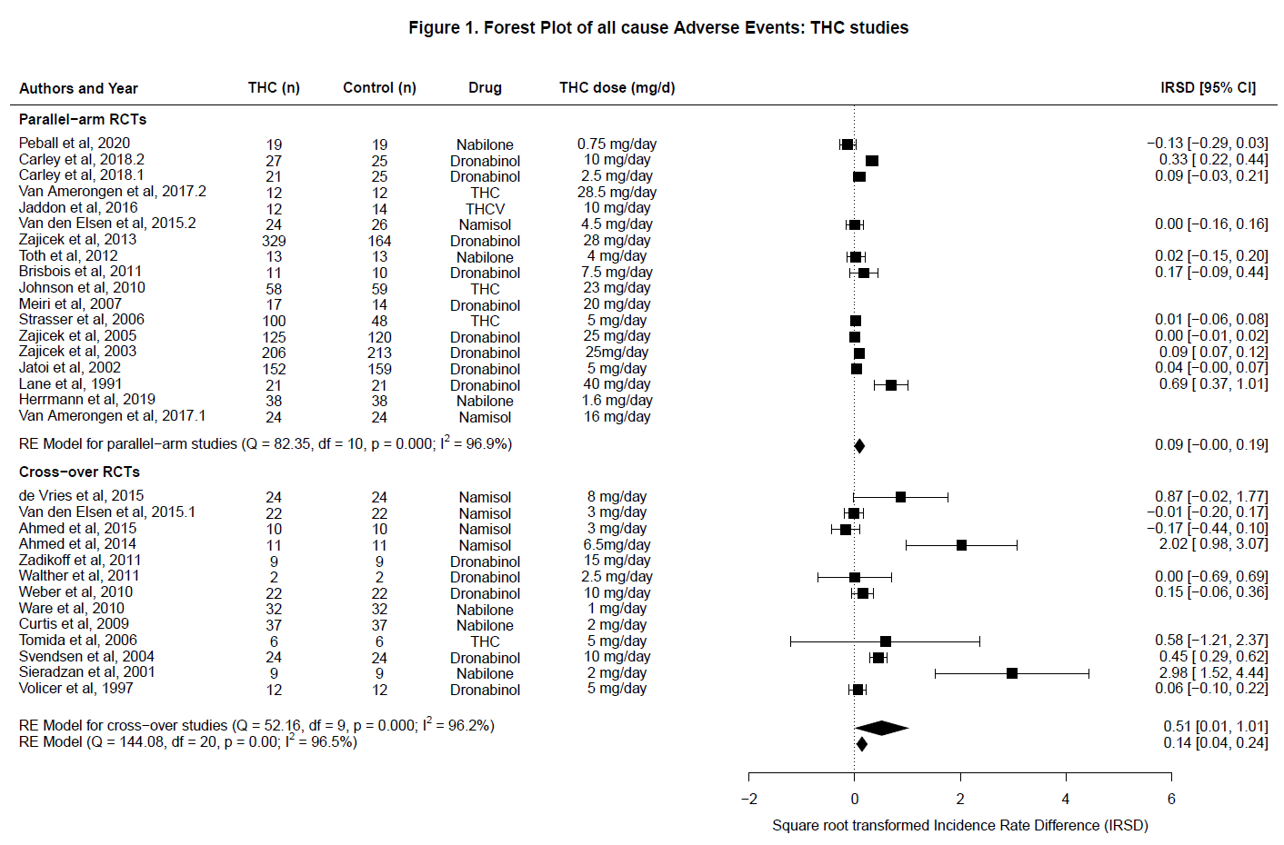

Figure 2. Forest plot of treatment-related adverse events: THC studies

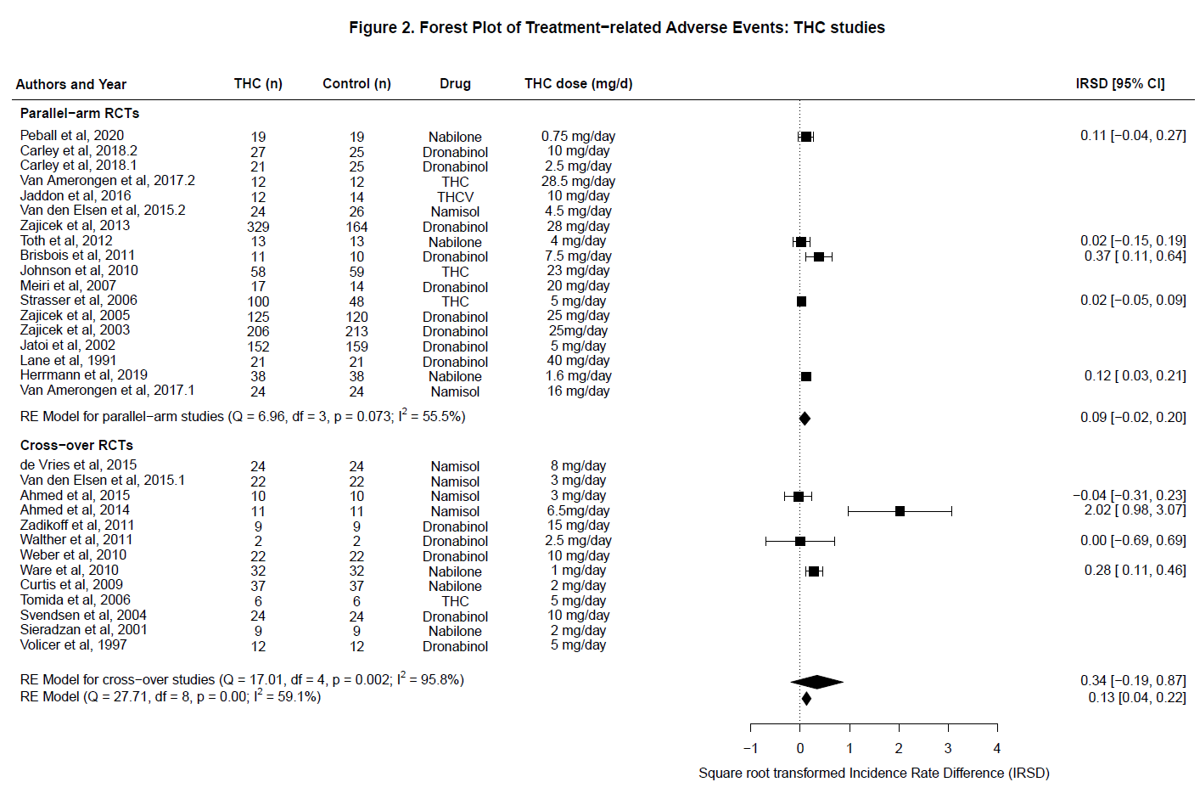

Figure 3. Forest plot of all cause Serious Adverse Events: THC studies
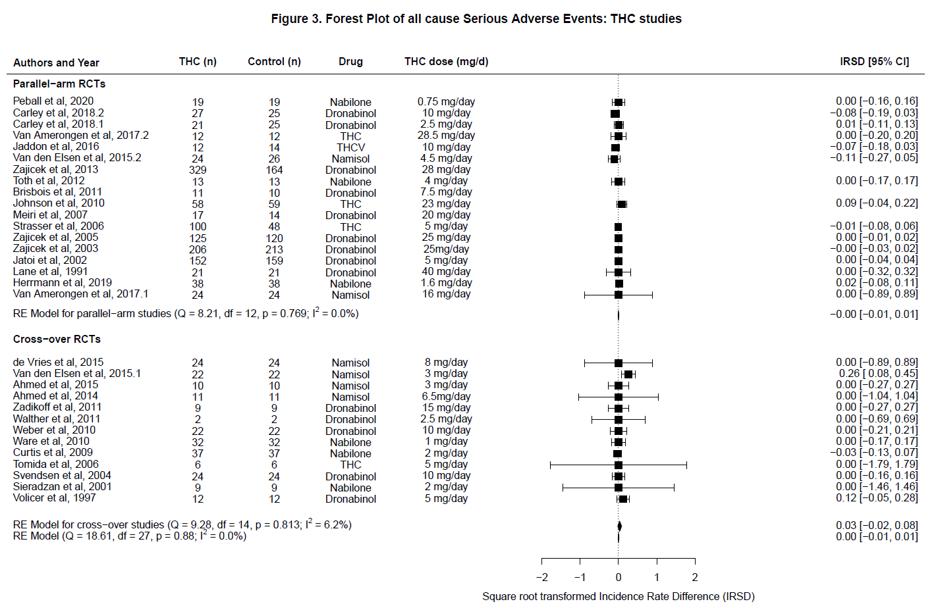

Figure 4. Forest plot of Treatment-related Serious Adverse Events: THC studies
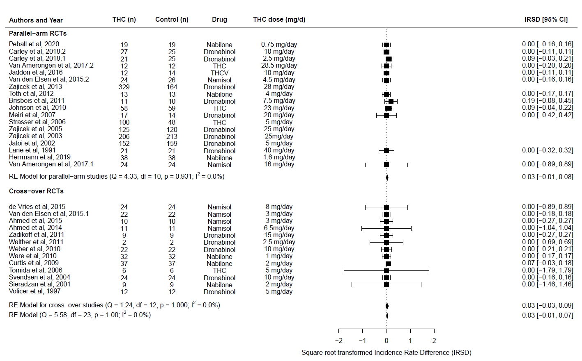

Figure 5. Forest plot of all cause Withdrawals: THC studies
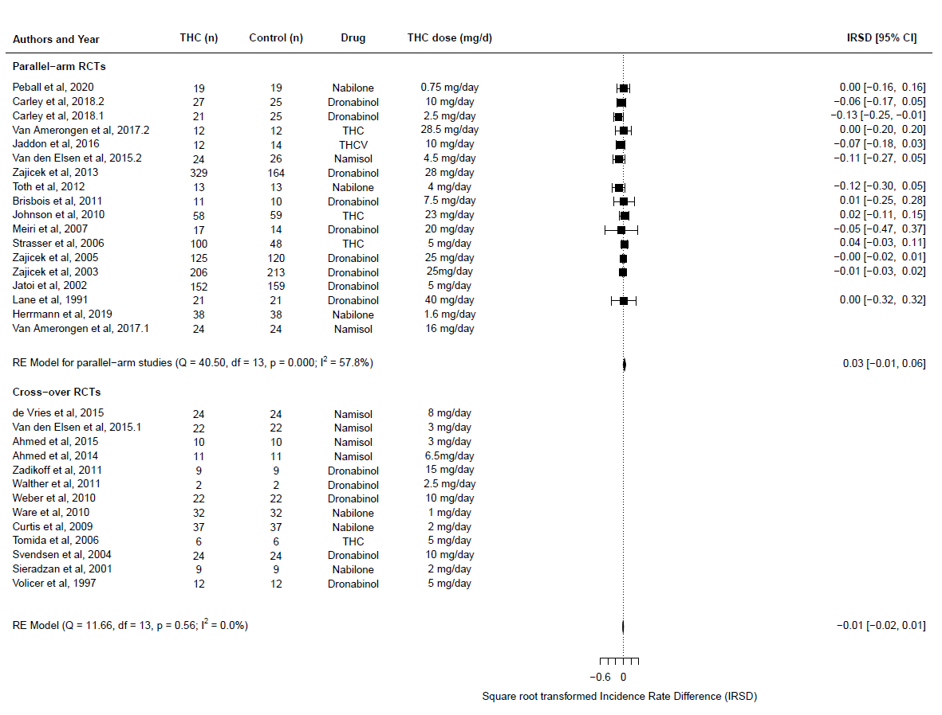

Figure 6. Forest plot of treatment-related Withdrawals: THC studies
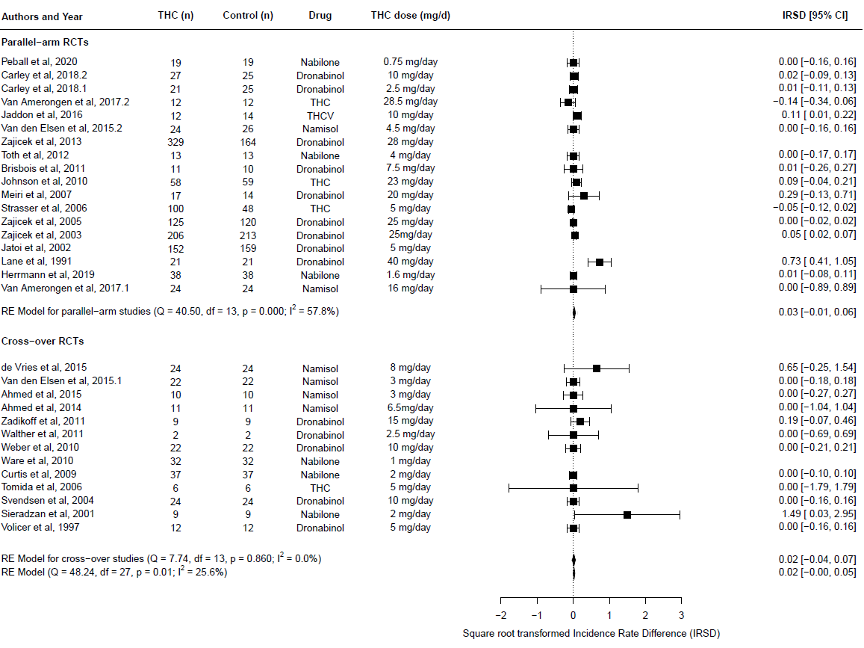

Forest 7. Forest plot of deaths: THC studies
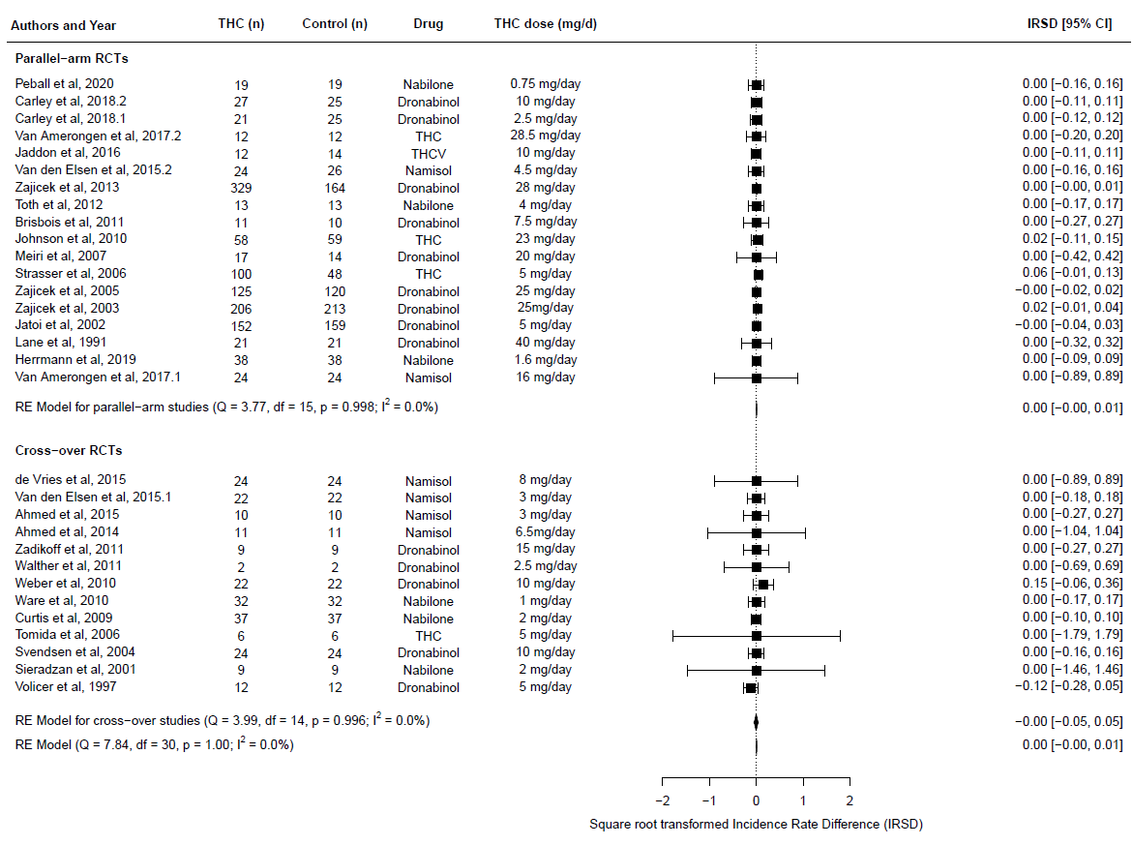

Figure 8. Forest plot of All cause Adverse Events: THC:CBD studies
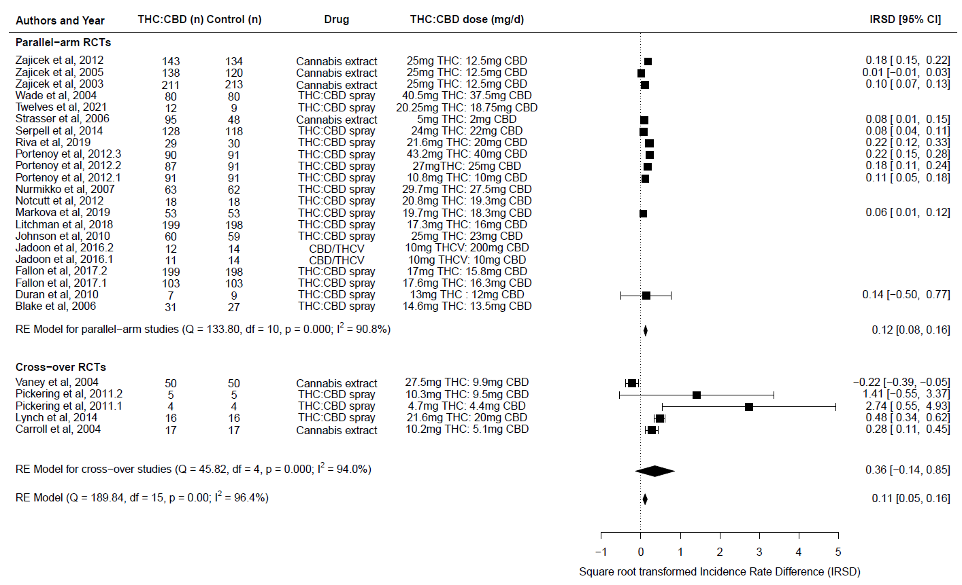

Figure 9. Forest plot of Treatment-related Adverse Events: THC:CBD studies
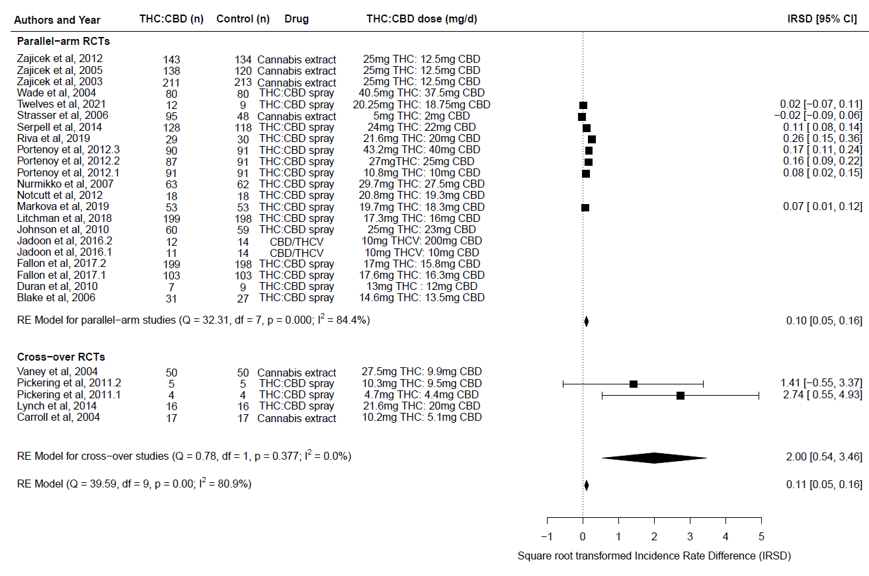

Figure 10. Forest plot of all cause serious adverse events: THC:CBD studies
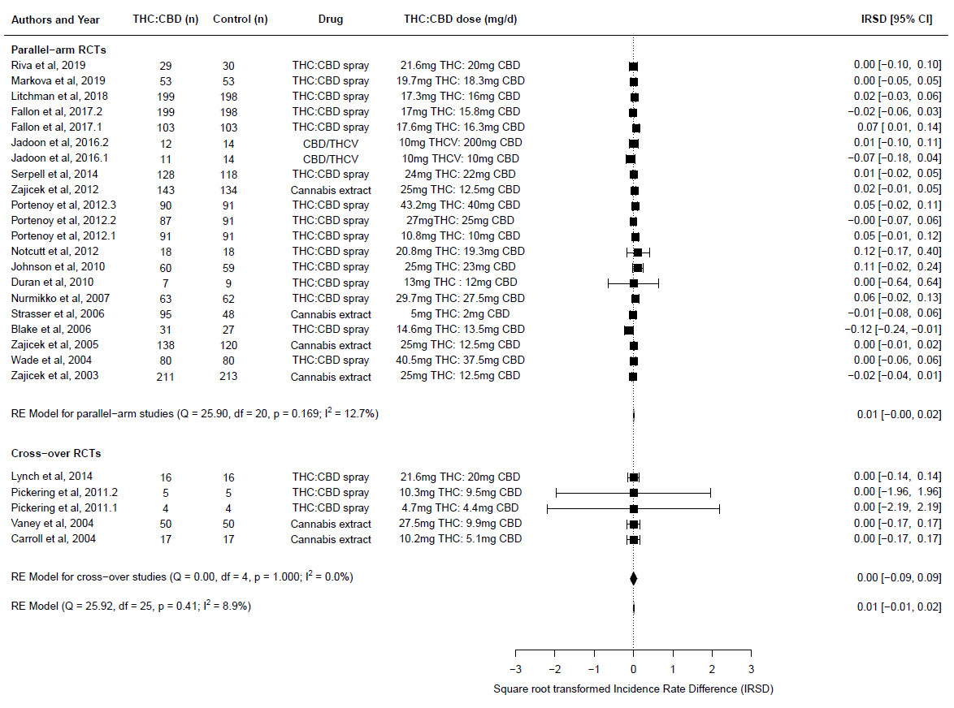

Figure 11. Forest plot of Treatment-related Serious Adverse Events: THC:CBD studies
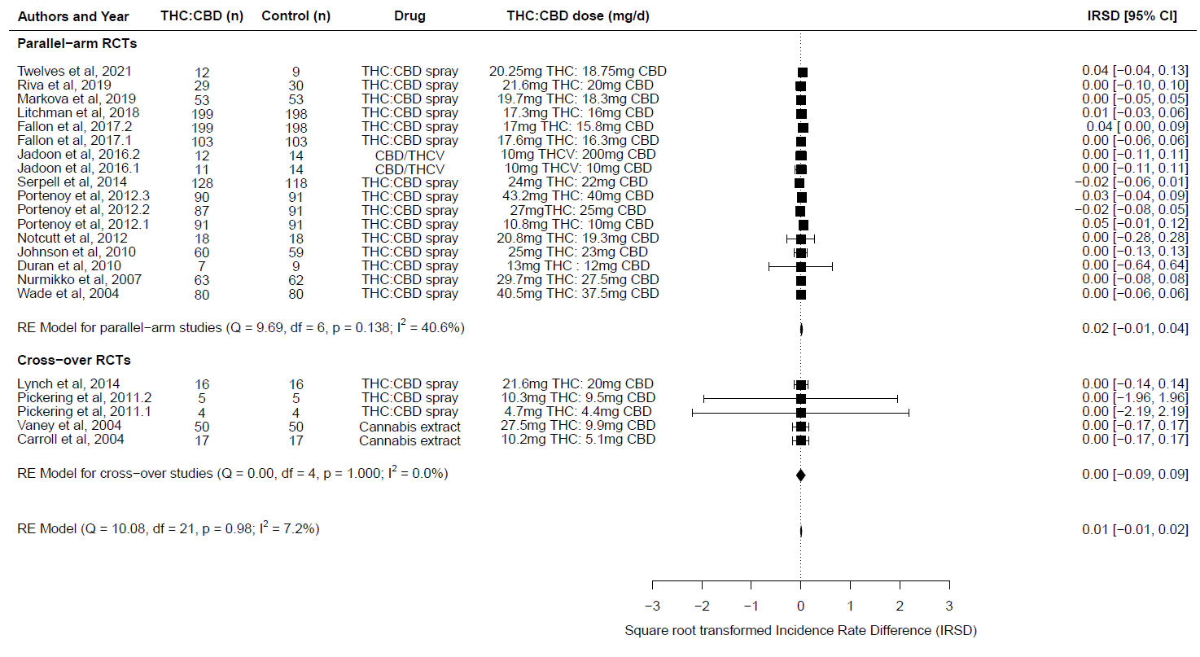

Figure 12. Forest plot of all cause withdrawals: THC:CBD studies
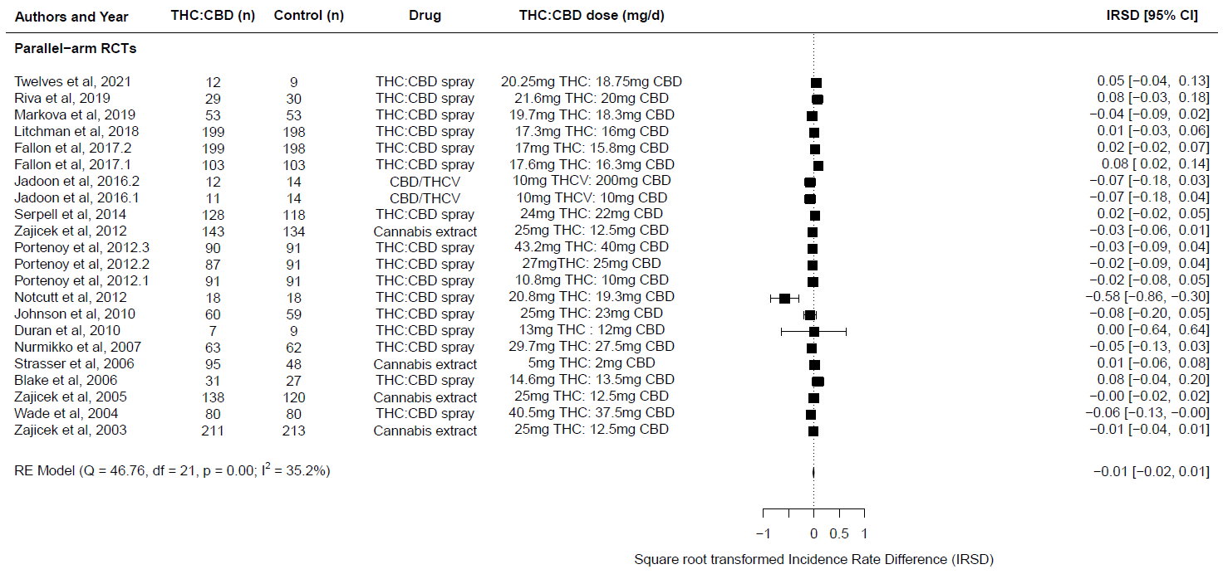

Figure 13. Forest plot of treatment-related withdrawals: THC:CBD studies
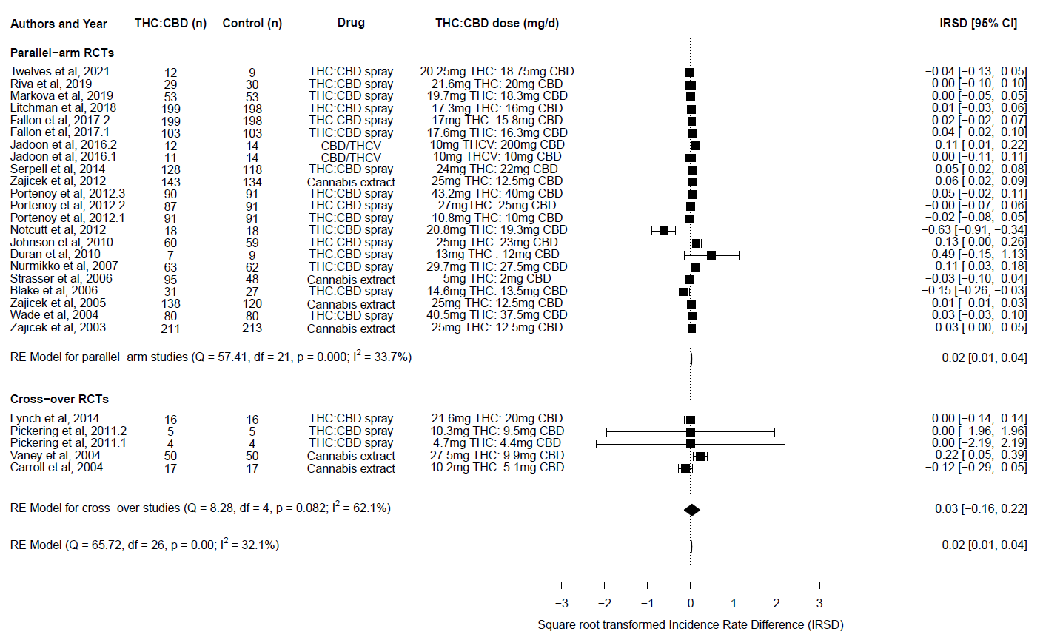

Figure 14. Forest plot of Deaths: THC:CBD studies
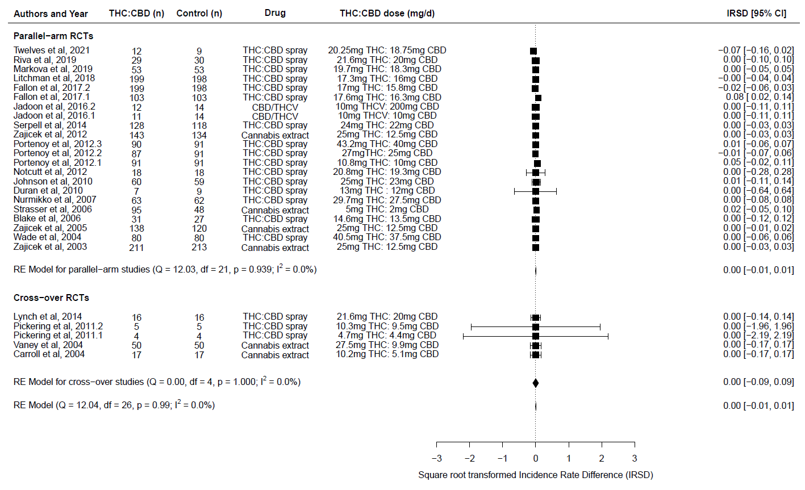

Quality rating – risk of bias plots
Quality rating plots reporting the rating for each domain based on the GRADE assessment tool. The overall column reports the global rating for each study.

Figure 15a. Traffic lights plot showing quality ratings for THC studies
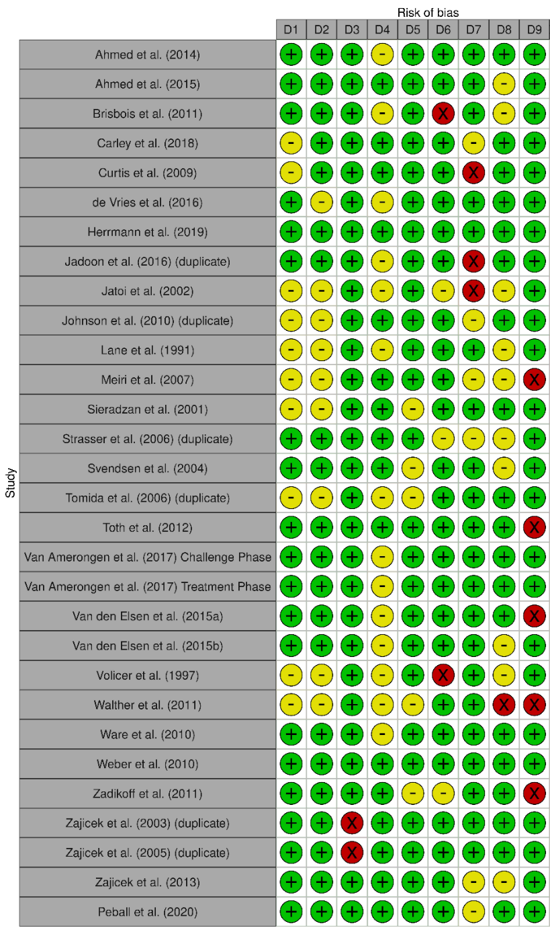

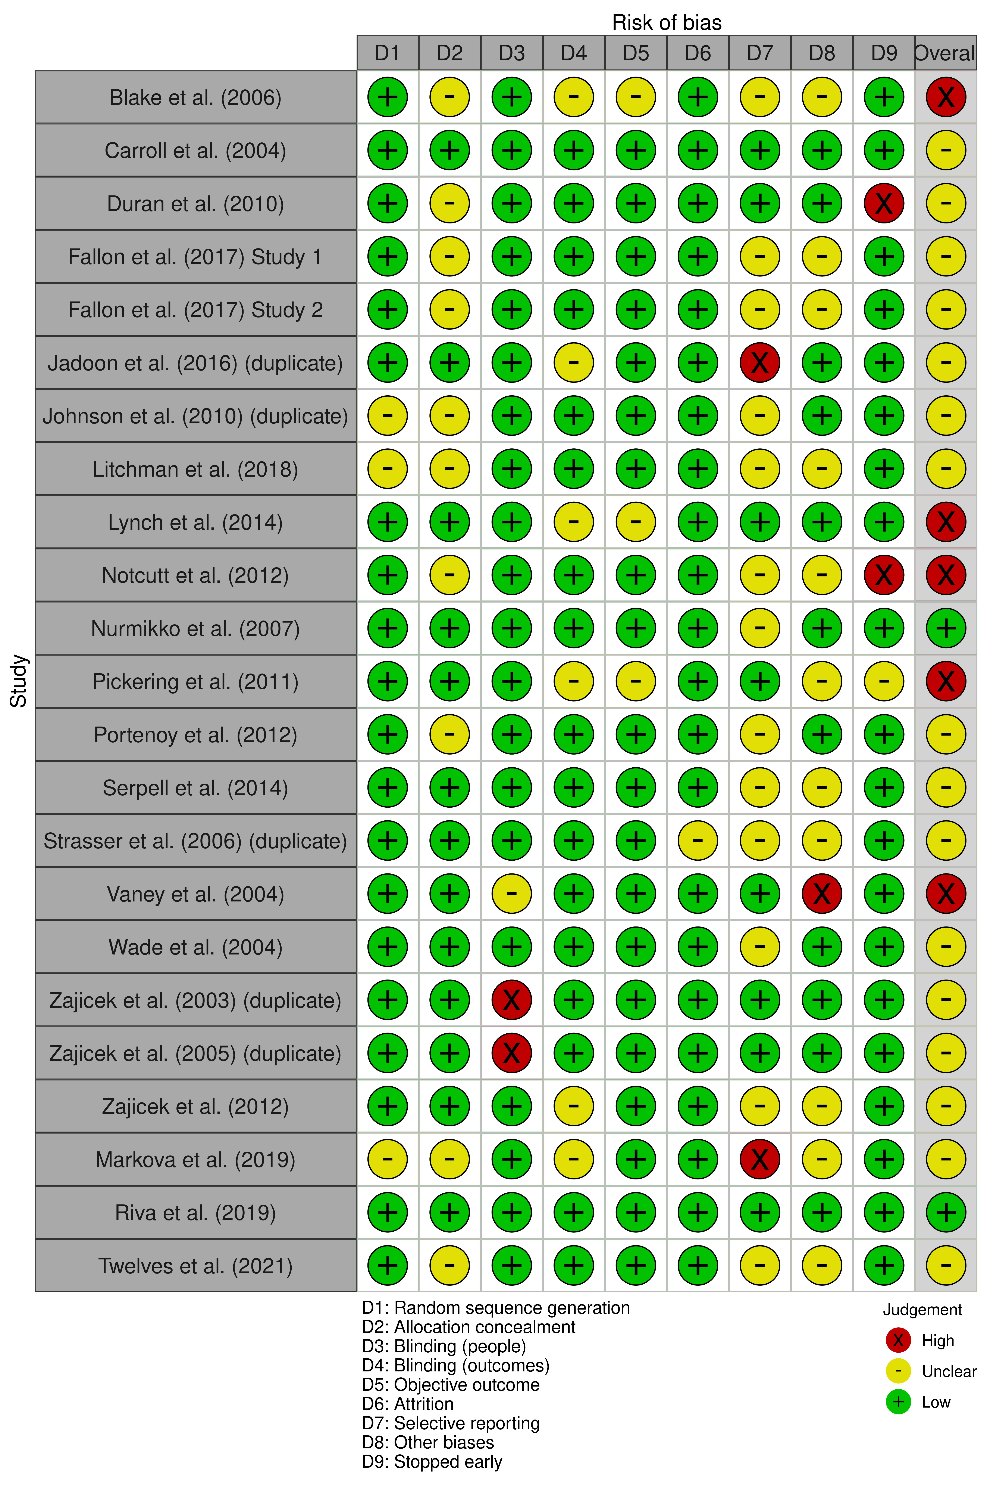

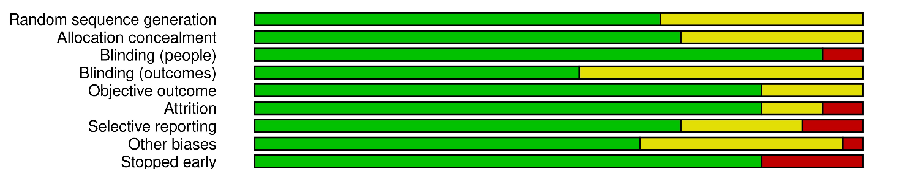
Figure 15b. Overall summary plot showing quality ratings per domain across studies for THC studies.

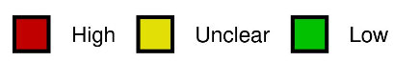

Figure 16a. Traffic lights plot showing quality ratings for THC:CBD studies

Figure 16b. Overall summary plot showing quality ratings per domain across studies for THC:CBD studies
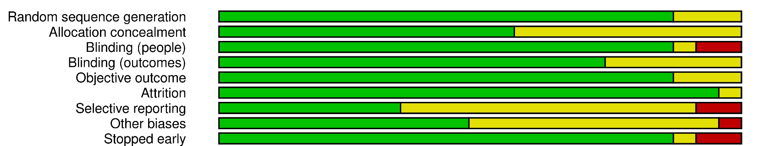
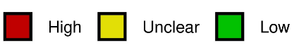

Publication bias – funnel plots
Funnel plots from the meta-analyses are reported for all-cause and treatment-related events (i.e., adverse events, serious adverse events, withdrawals, and deaths), and for the overall and subgroups analyses (i.e., overall, crossover, RCT studies).

THC studies

Figure 17a. Funnel plots for all-cause adverse events (AEs) meta-analyses for THC studies
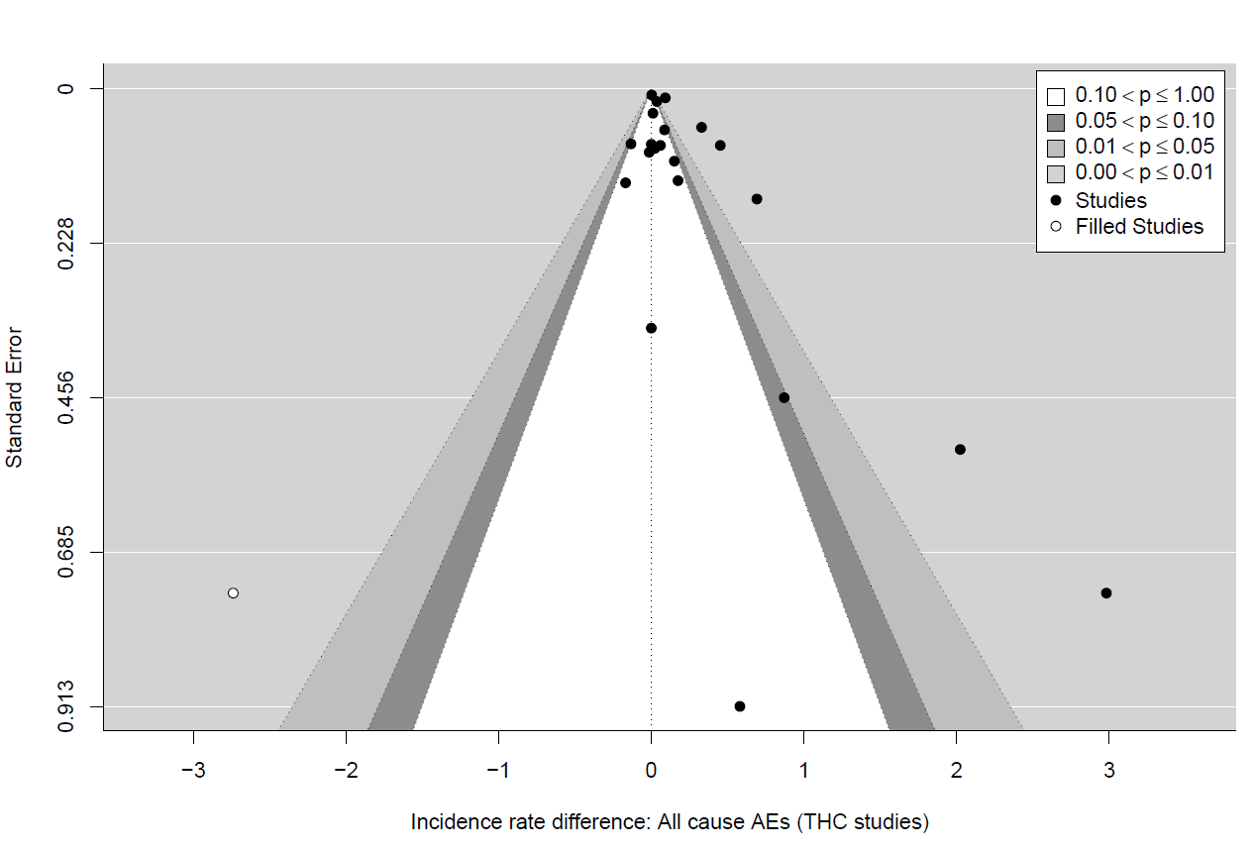

Figure 17b. Funnel plots for all-cause adverse events (AEs) meta-analyses for THC crossover studies
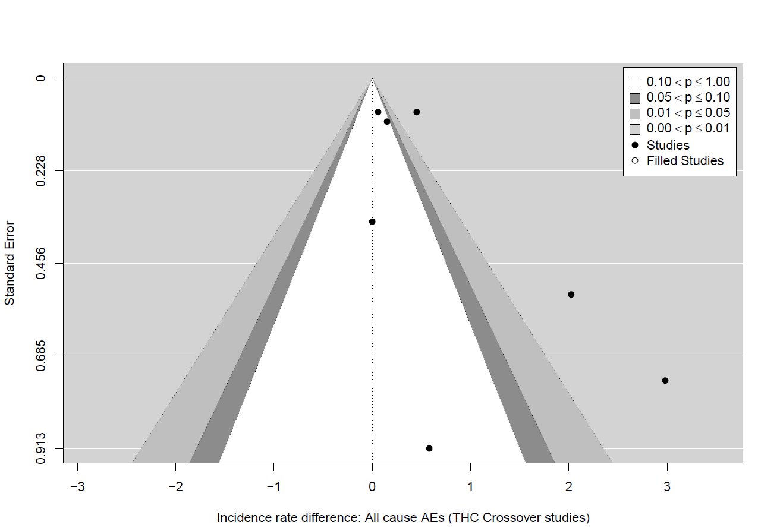

Figure 17c. Funnel plots for all-cause adverse events (AEs) meta-analyses for THC RCT studies
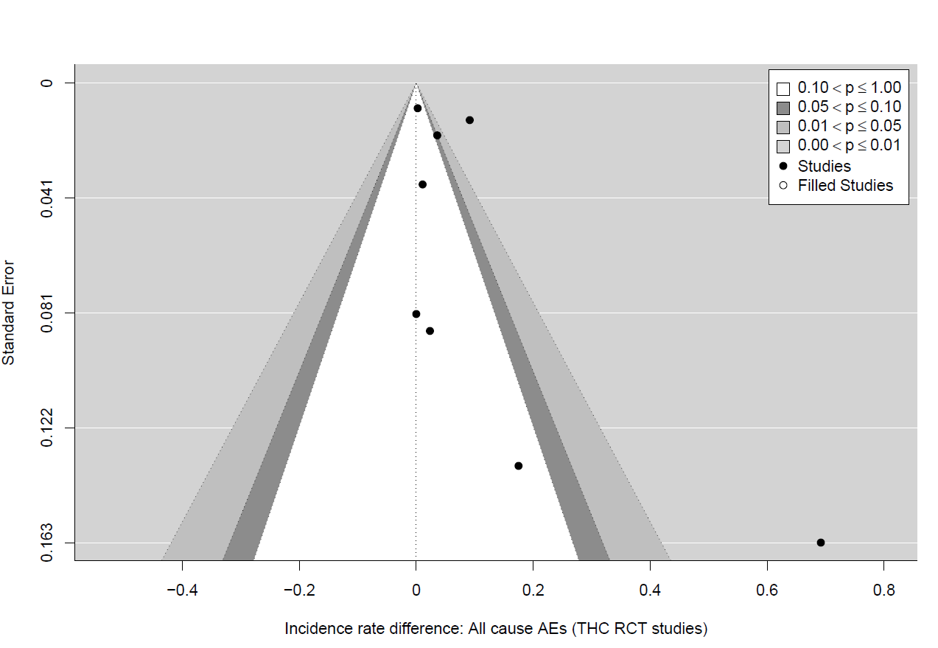

Figure 17d. Funnel plots for treatment-related adverse events (AEs) meta-analyses for THC studies
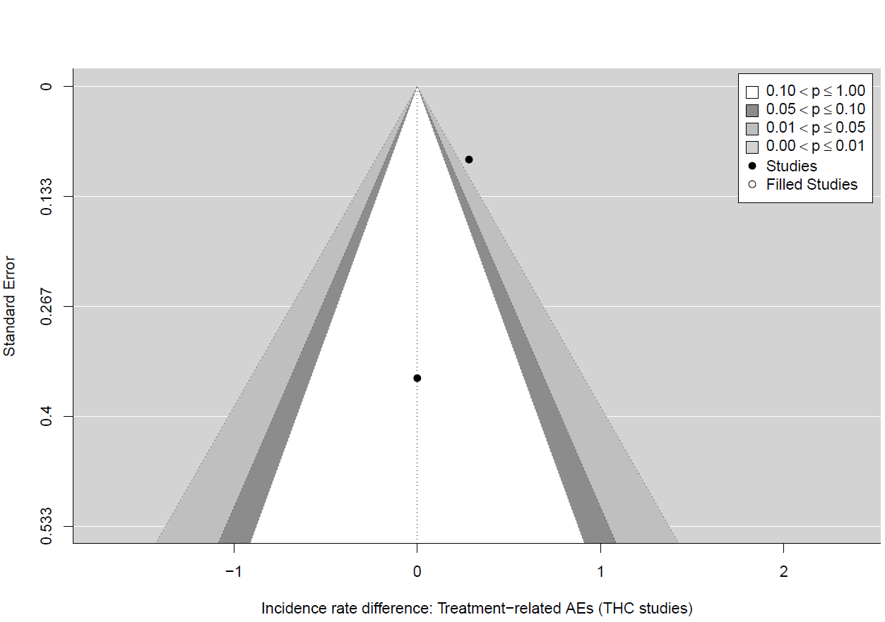

Figure 17e. Funnel plots for treatment-related adverse events (AEs) meta-analyses for THC crossover studies
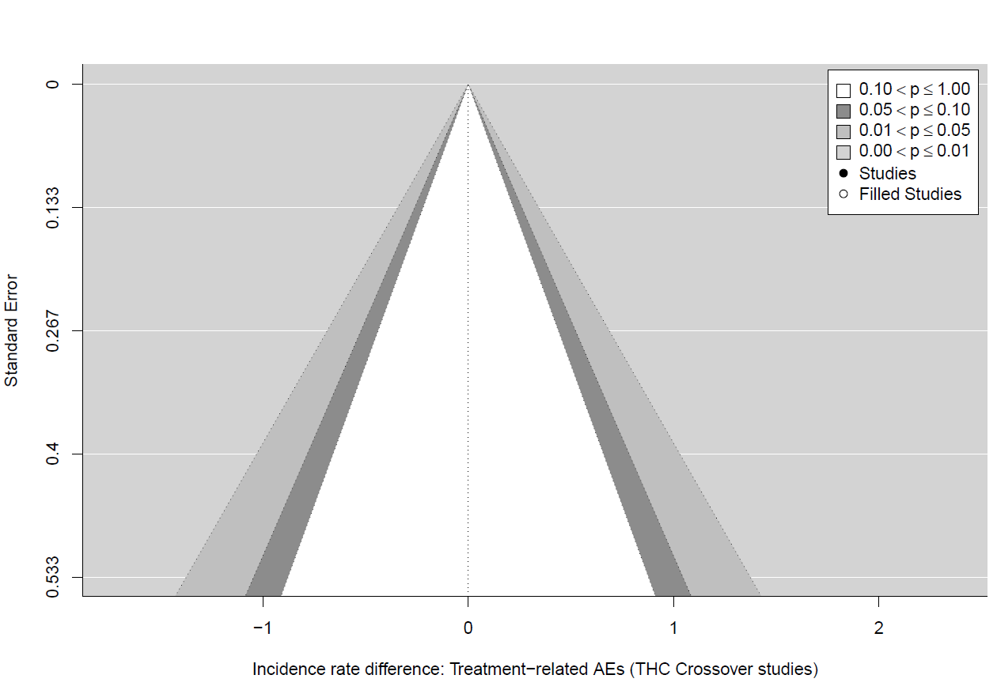

Figure 17f. Funnel plots for treatment-related adverse events (AEs) meta-analyses for THC RCT studies
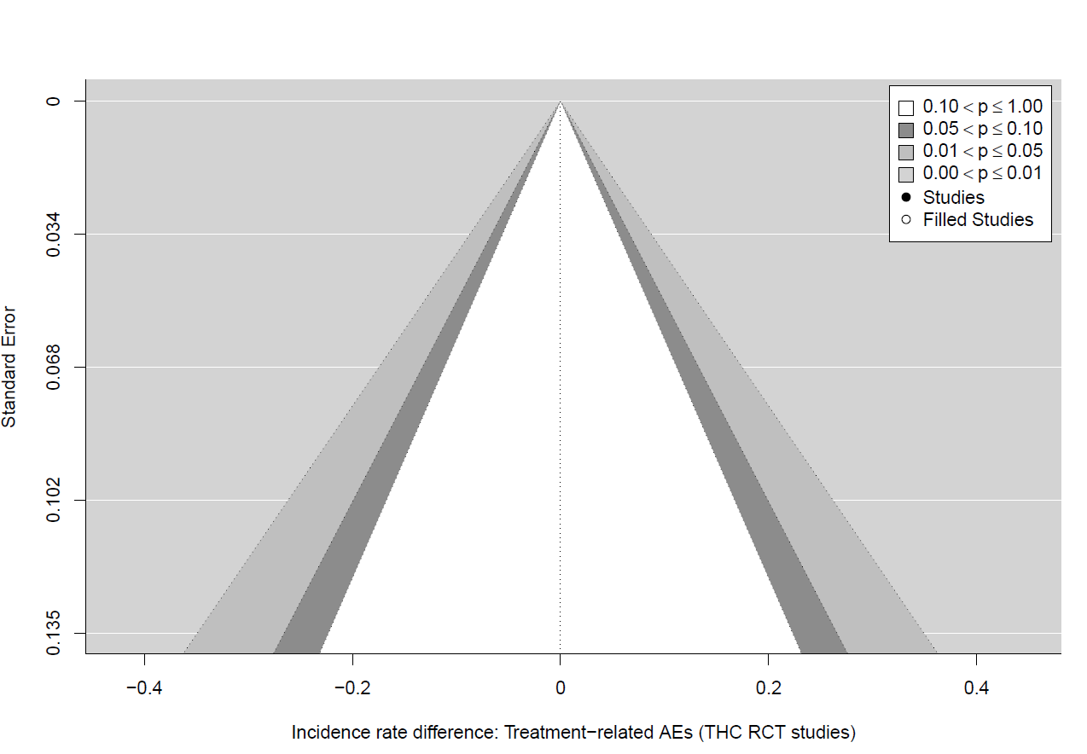

Figure 18a. Funnel plots for all-cause serious adverse events (SAEs) meta-analyses for THC studies.
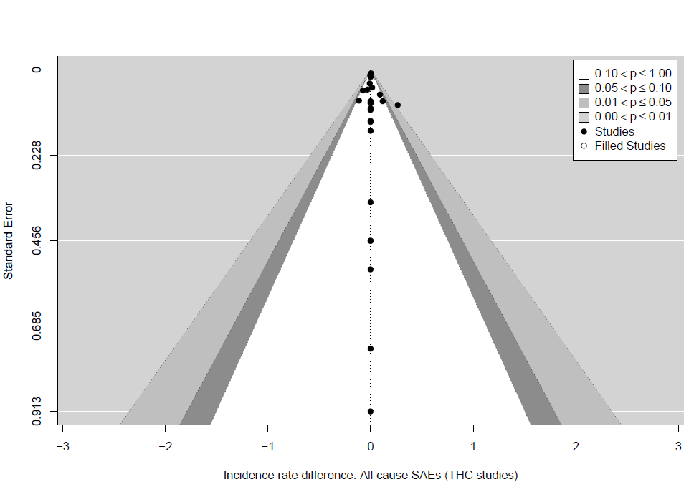

Figure 18b. Funnel plots for all-cause serious adverse events (SAEs) meta-analyses for THC crossover studies
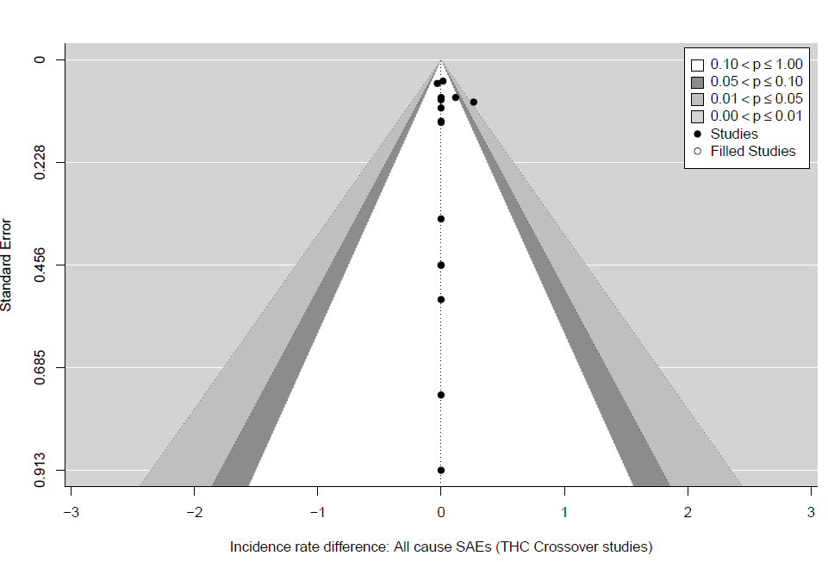

Figure 18c. Funnel plots for all-cause serious adverse events (SAEs) meta-analyses for THC RCT studies
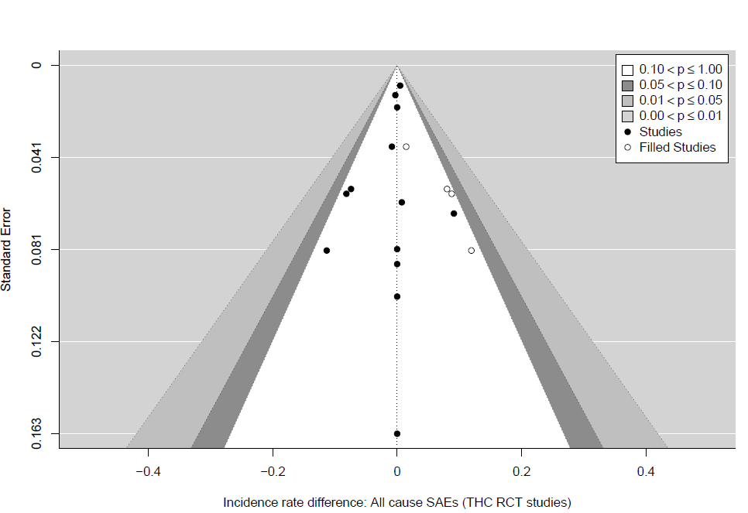

Figure 18d. Funnel plots for treatment-related serious adverse events (SAEs) meta-analyses for THC studies
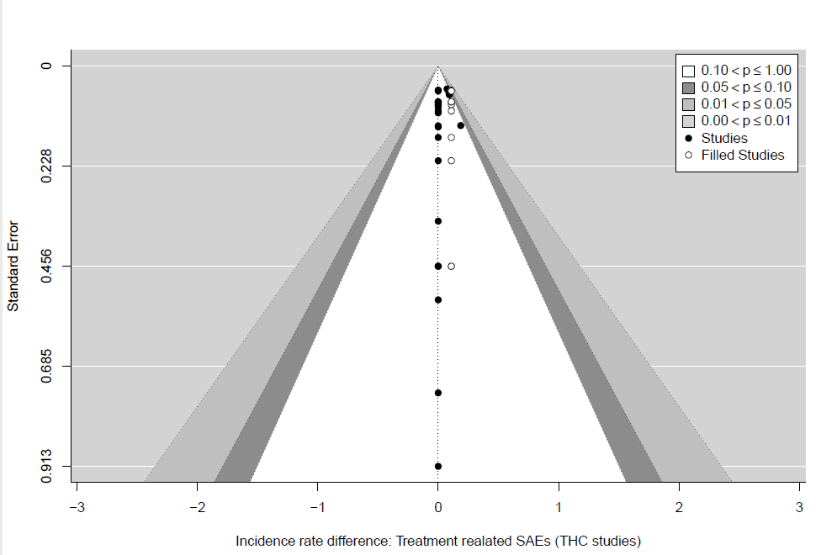

Figure 18e. Funnel plots for treatment-related serious adverse events (SAEs) meta-analyses for THC crossover studies
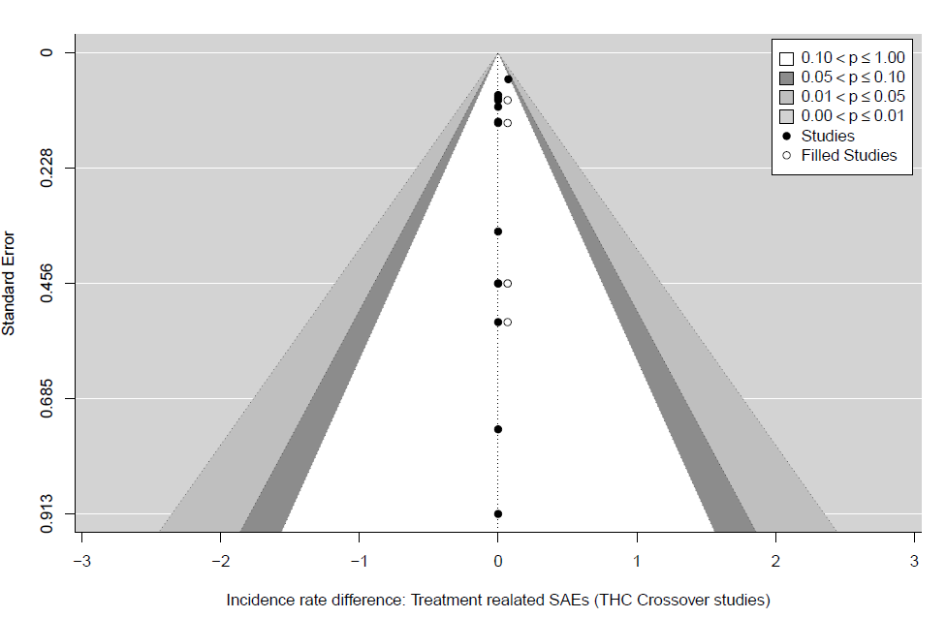

Figure 18f. Funnel plots for treatment-related serious adverse events (SAEs) meta-analyses for THC RCT studies
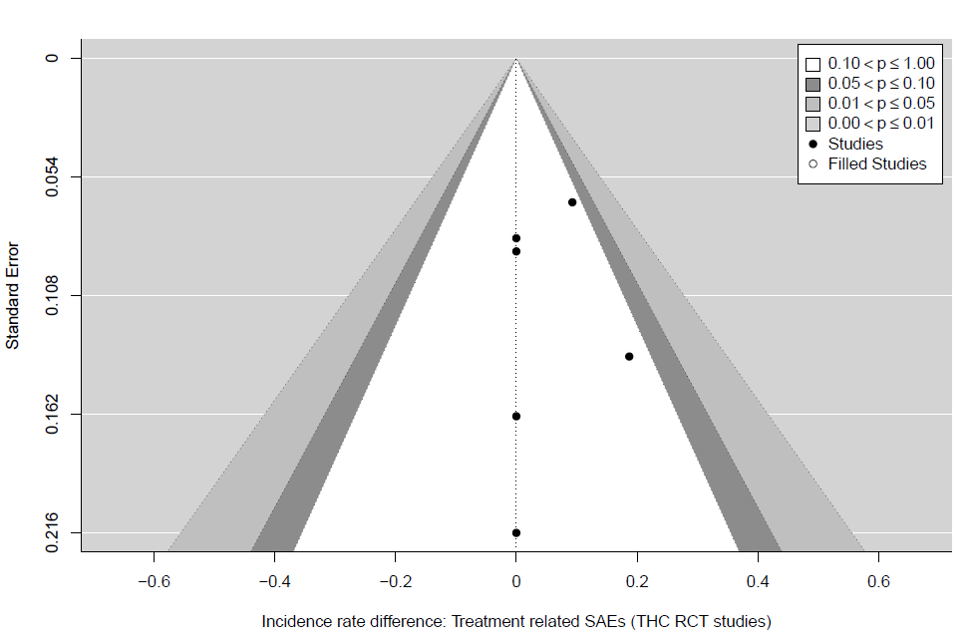

Figure 19a. Funnel plots for all-cause withdrawals meta-analyses for THC studies
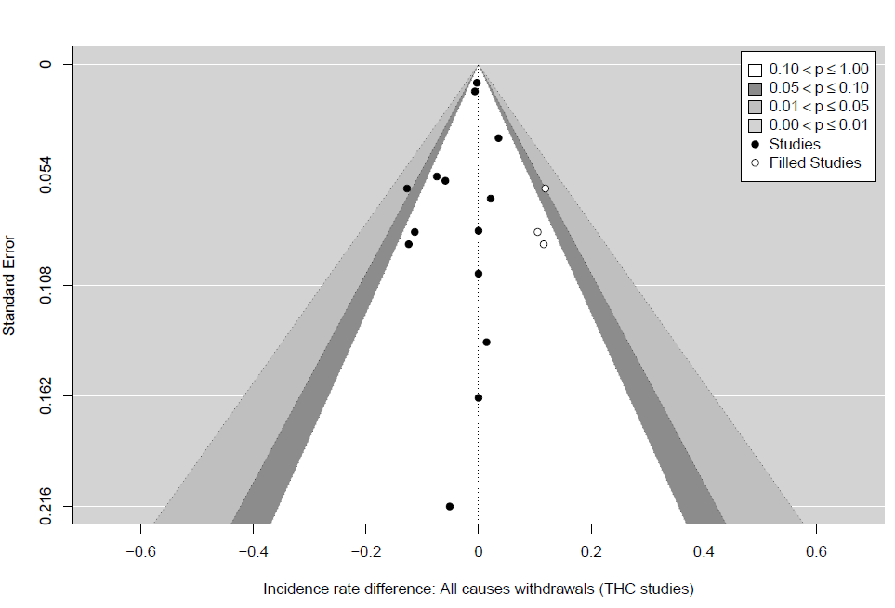

Figure 19b. Funnel plots for all-cause withdrawals meta-analyses for THC RCT studies
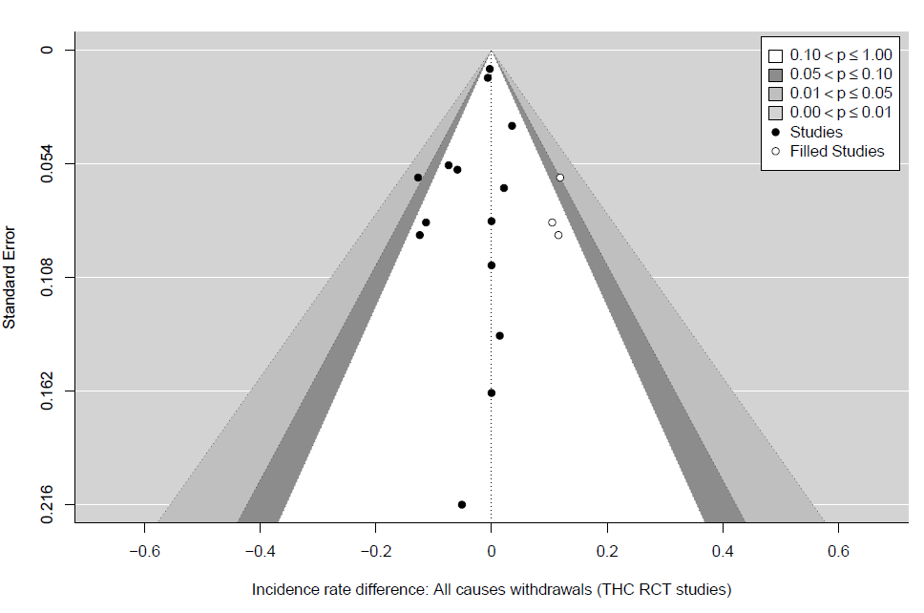

Figure 19c. Funnel plots for treatment-related withdrawals meta-analyses for THC studies.

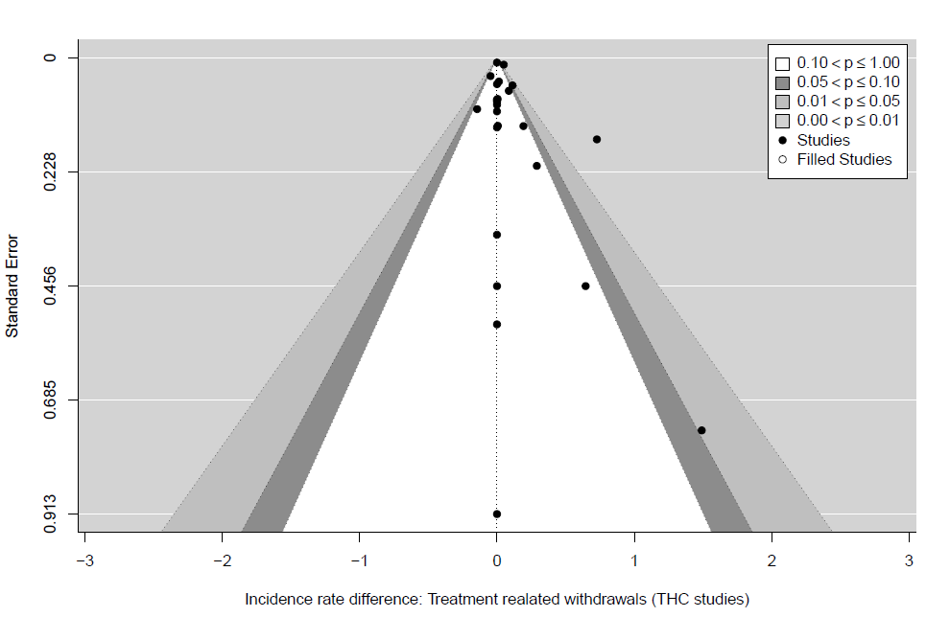

Figure 19d. Funnel plots for treatment-related withdrawals meta-analyses for THC crossover studies
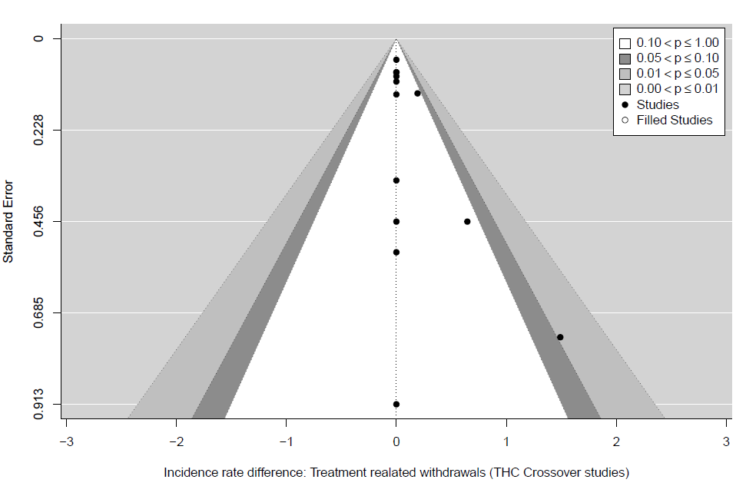

Figure 19e. Funnel plots for treatment-related withdrawals meta-analyses for THC RCT studies
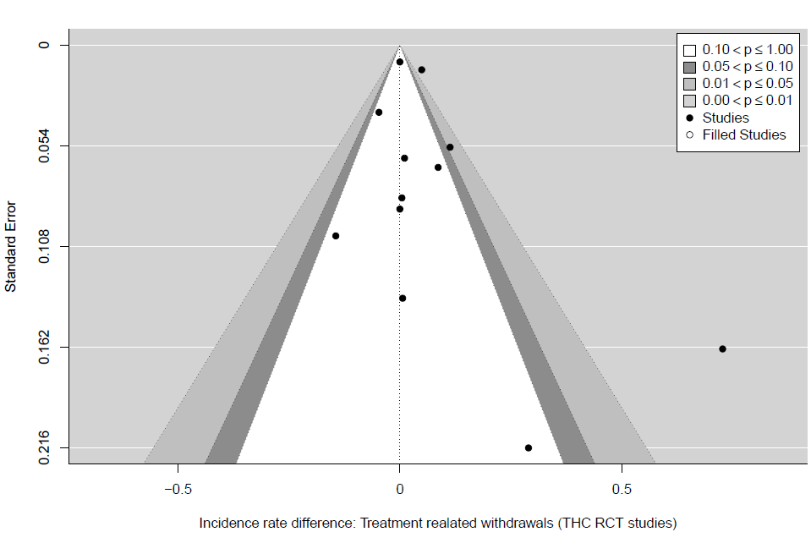

Figure 20a. Funnel plots for deaths meta-analyses for THC studies
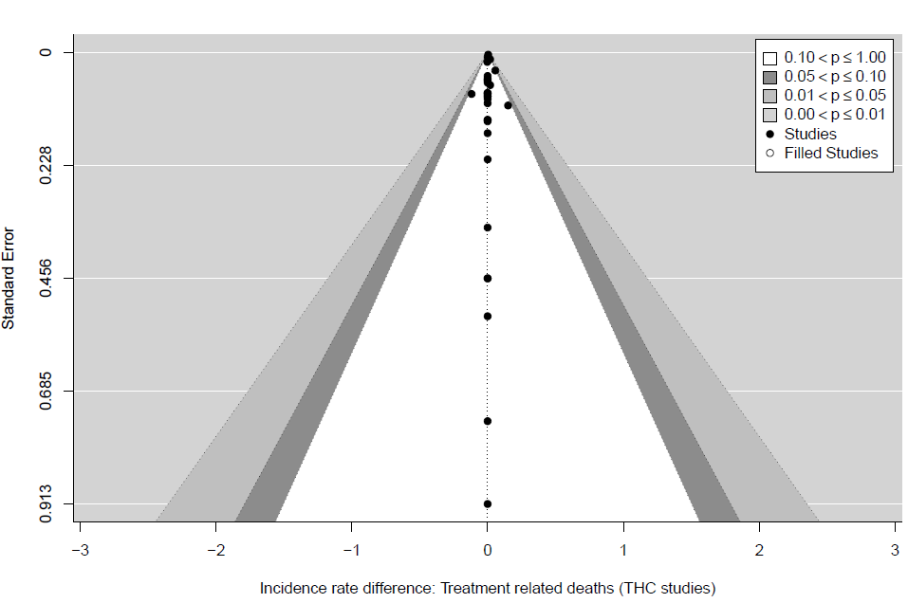

Figure 20b. Funnel plots for deaths meta-analyses for THC crossover studies
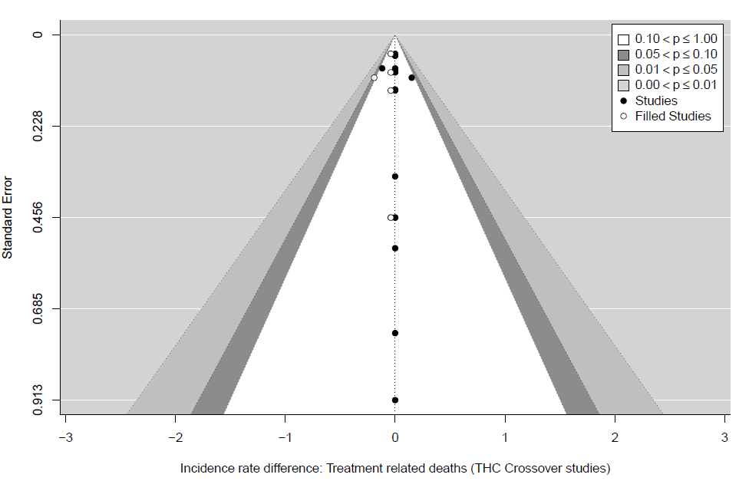

Figure 20c. Funnel plots for deaths meta-analyses for THC RCT studies
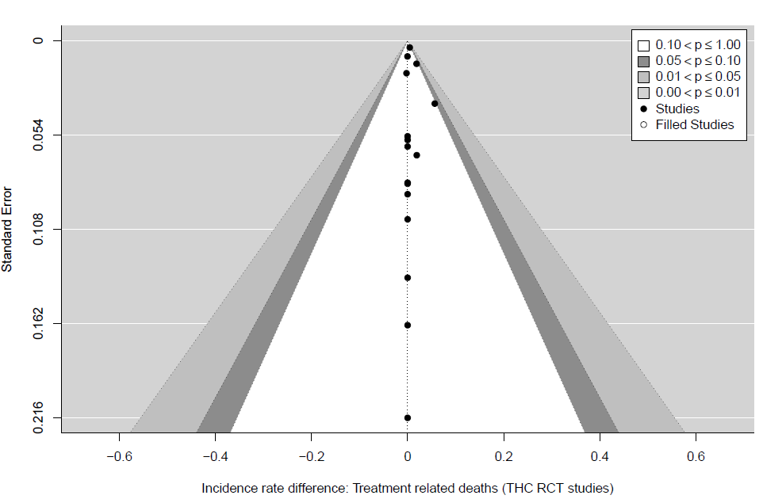

THC:CBD studies

Figure 21a. Funnel plots for all-cause adverse events (AEs) meta-analyses for THC:CBD studies

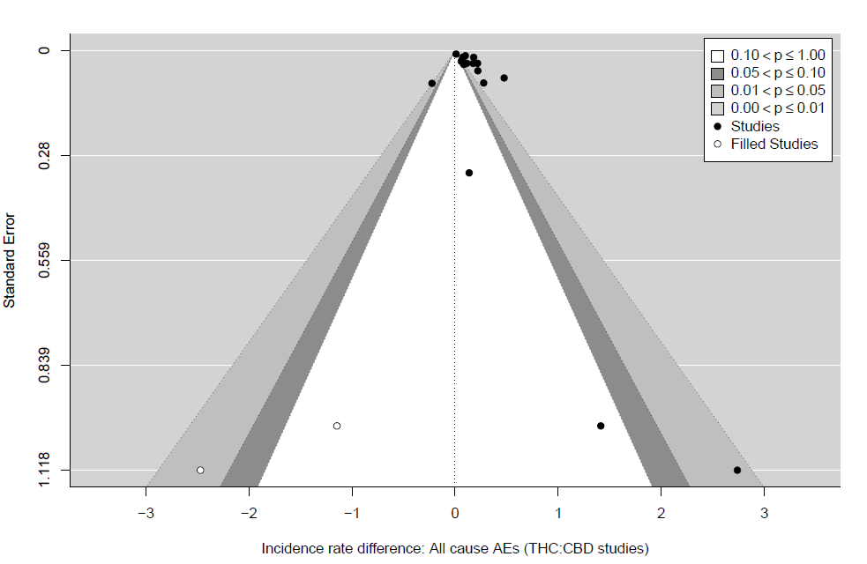

Figure 21b. Funnel plots for all-cause adverse events (AEs) meta-analyses for THC:CBD crossover studies
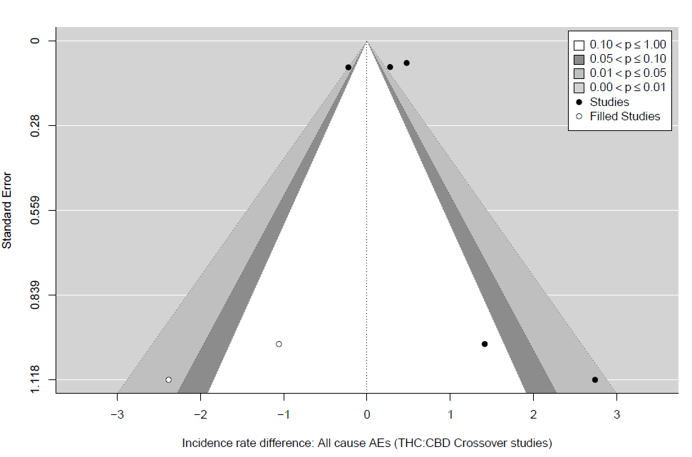

Figure 21c. Funnel plots for all-cause adverse events (AEs) meta-analyses for THC:CBD RCT studies

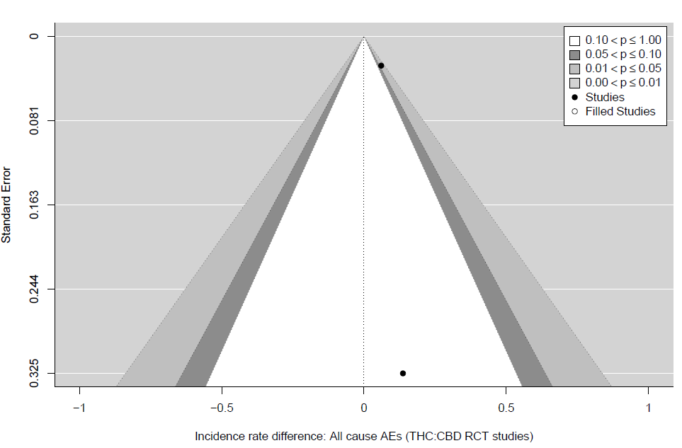

Figure 21d. Funnel plots for treatment-related adverse events (AEs) meta-analyses for THC:CBD RCT studies
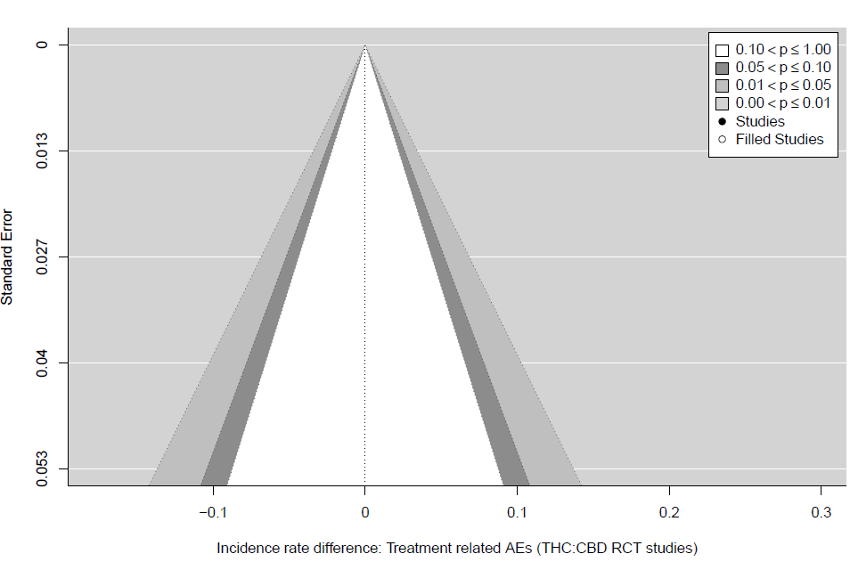

Figure 22a. Funnel plots for all-cause serious adverse events (SAEs) meta-analyses for THC:CBD studies
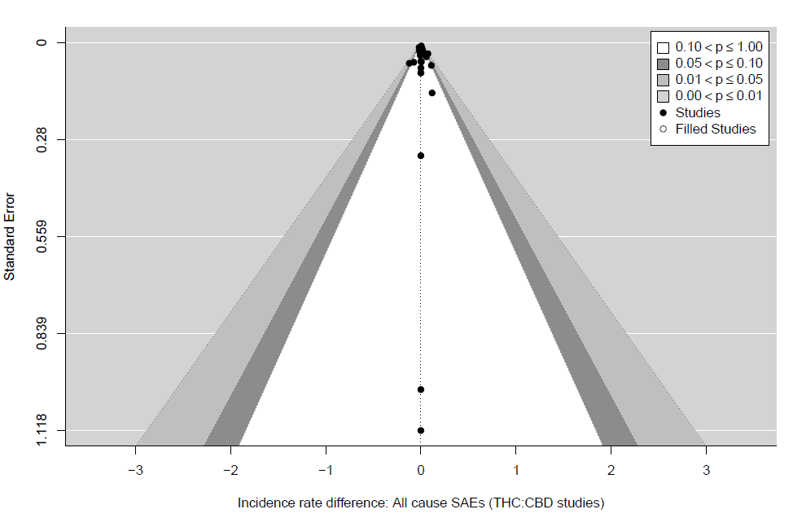

Figure 22b. Funnel plots for all-cause serious adverse events (SAEs) meta-analyses for THC:CBD crossover studies

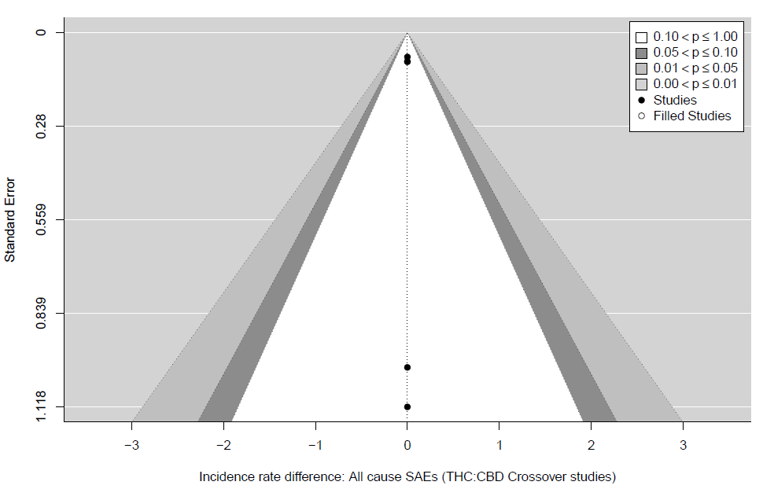

Figure 22c. Funnel plots for all-cause serious adverse events (SAEs) meta-analyses for THC:CBD RCT studies
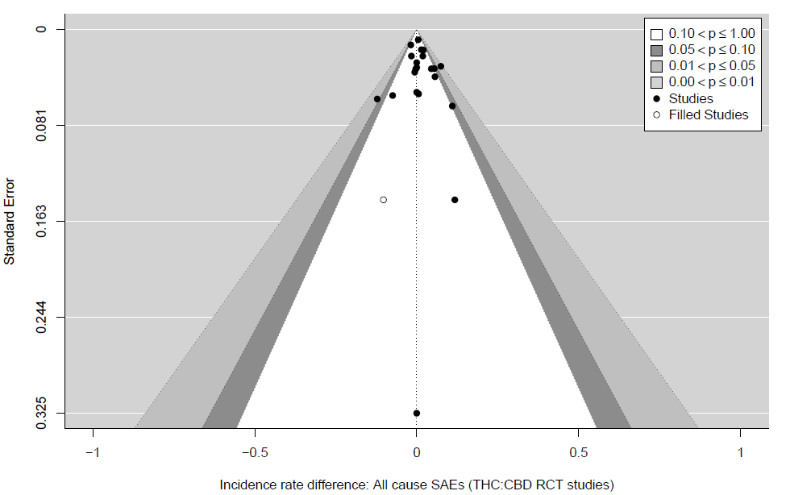

Figure 22d. Funnel plots for treatment-related serious adverse events (SAEs) meta-analyses for THC:CBD studies

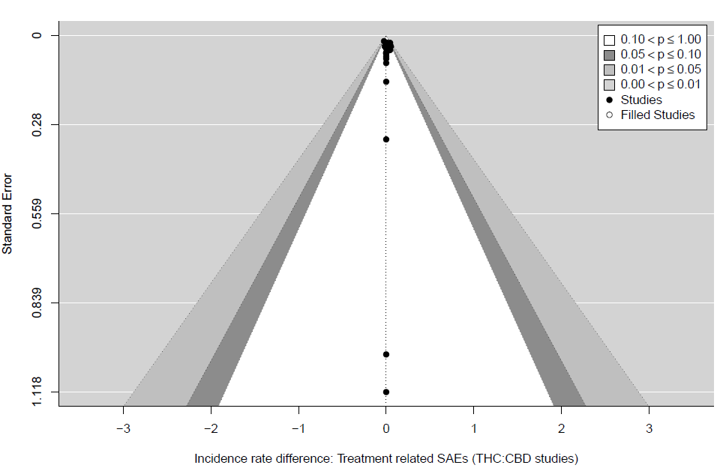

Figure 22e. Funnel plots for treatment-related serious adverse events (SAEs) meta-analyses for THC:CBD crossover studies
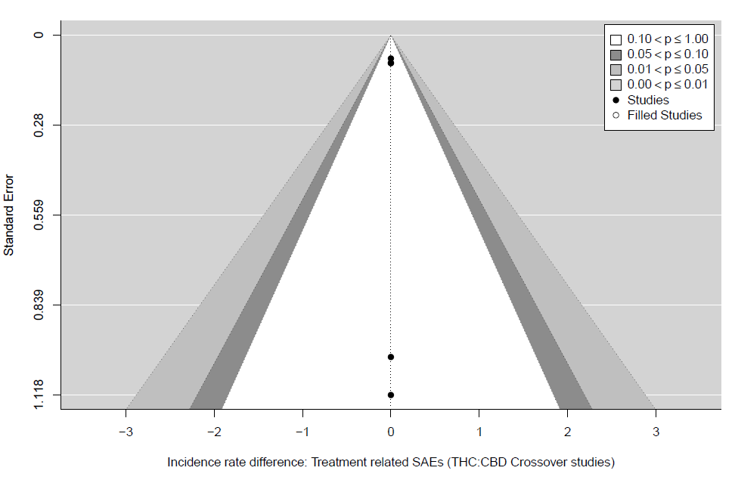

Figure 22f. Funnel plots for treatment-related serious adverse events (SAEs) meta-analyses for THC:CBD RCT studies

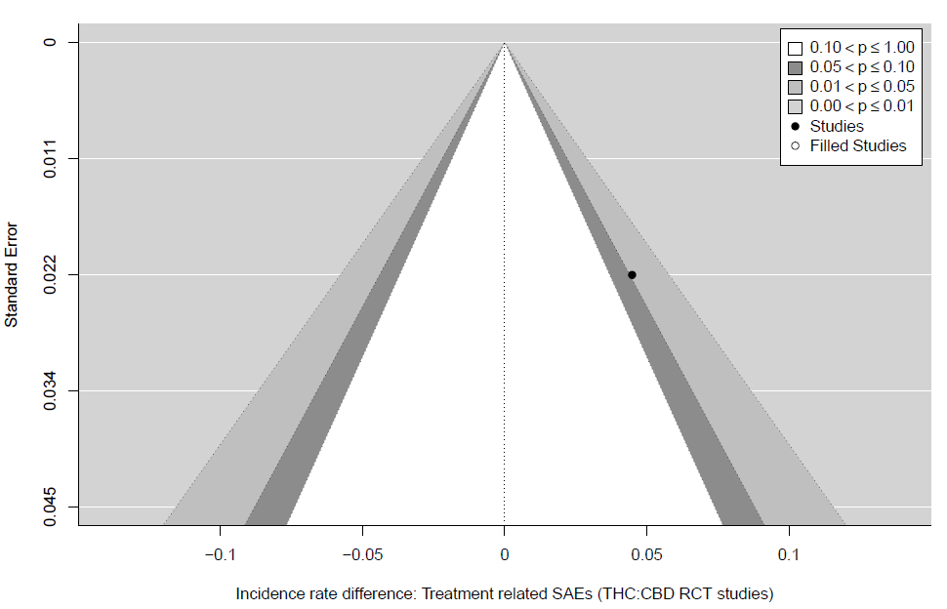

Figure 23a. Funnel plots for all-cause withdrawals meta-analyses for THC:CBD studies
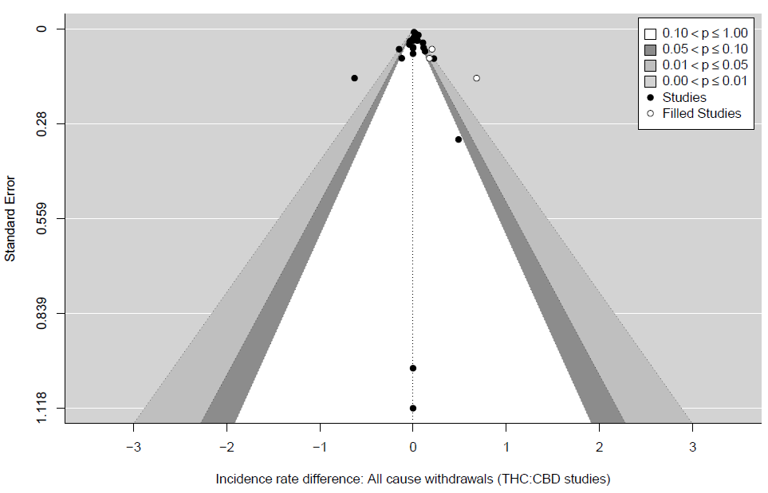

Figure 23b. Funnel plots for all-cause withdrawals meta-analyses for THC:CBD RCT studies
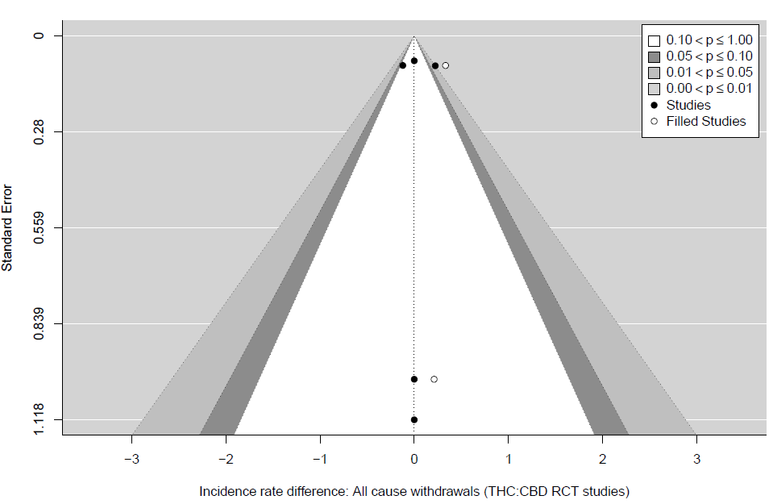

Figure 23c. Funnel plots for treatment-related withdrawals meta-analyses for THC:CBD studies
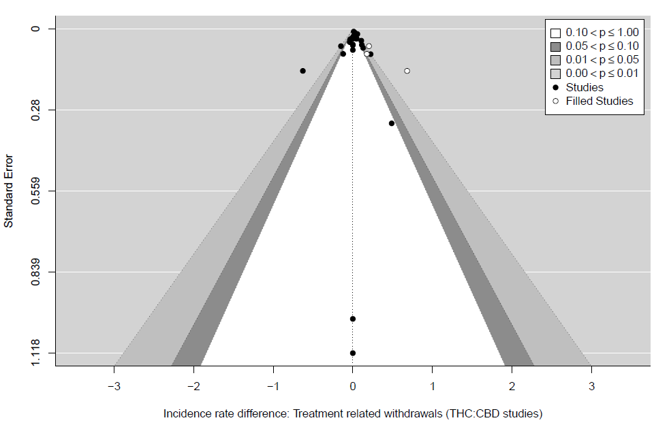

Figure 23d. Funnel plots for treatment-related withdrawals meta-analyses for THC:CBD crossover studies
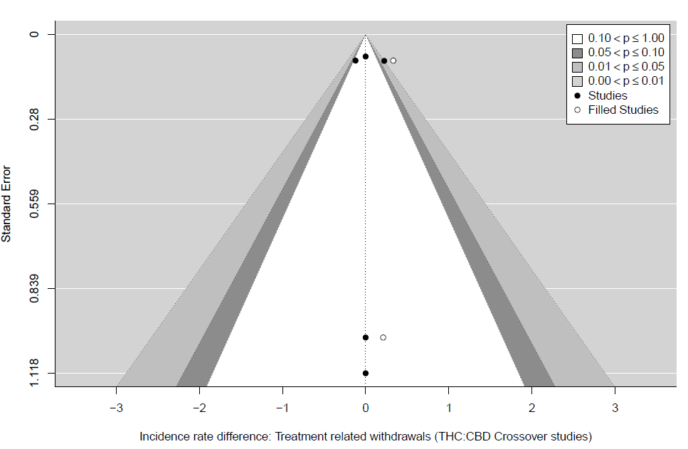

Figure 23e. Funnel plots for treatment-related withdrawals meta-analyses for THC:CBD RCT studies
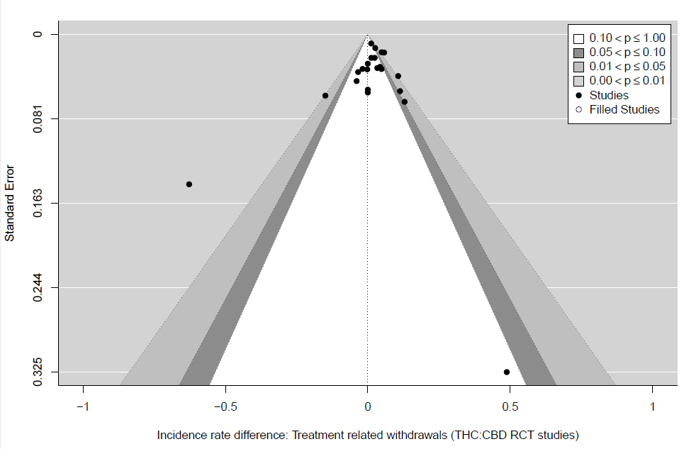

Figure 24a. Funnel plots for deaths meta-analyses for THC:CBD studies
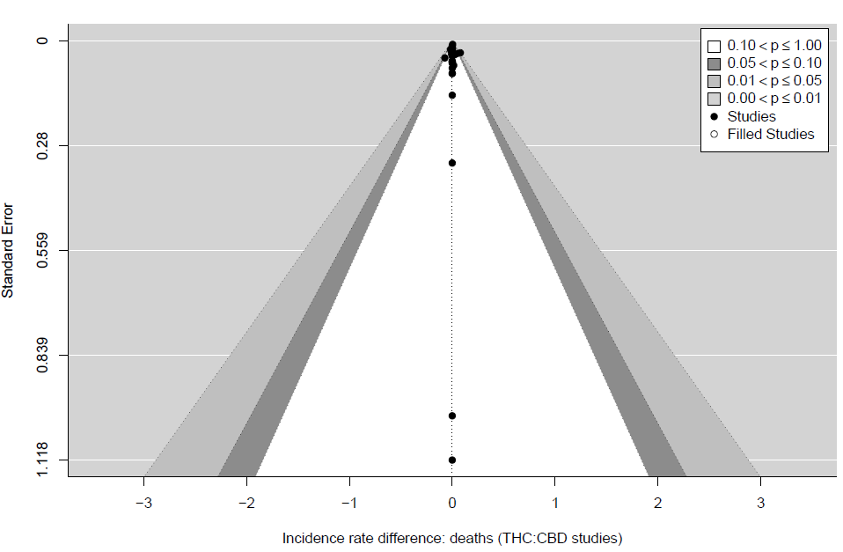

Figure 24b. Funnel plots for deaths meta-analyses for THC:CBD crossover studies
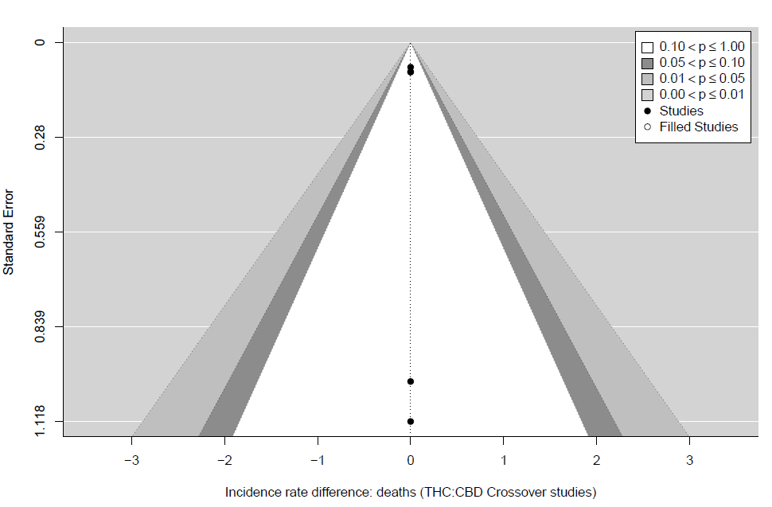

Figure 24c. Funnel plots for deaths meta-analyses for THC:CBD RCT studies

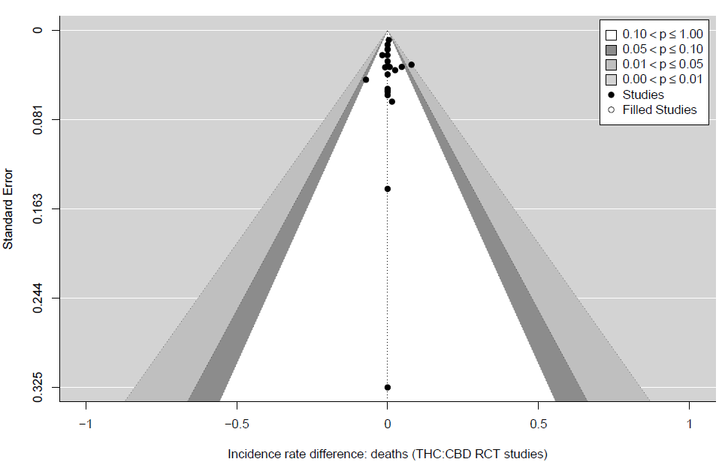

TABLES

Table 1a: Characteristics of included randomised controlled trials of THC in middle aged and older adults (N=31)

Study ID (country) | Study Design  (RCT) | THC:  Sample included/analysed N  Mean age (SD), Male % | Comparator:  Sample included/  analysed N  Mean age (SD), Male % | Indication | THC classification | Comparator | THC treatment duration, weeks | Calculated daily average THC dose | Overall GRADE rating for study
Ahmed et al. 2014, (Netherlands) | Crossover | 12/11  72.00 (5), 50 | 12/11  72.00 (5), 50 | Healthy older subjects | Namisol | Placebo | 0.4ʇ | 6.5mg | Moderate
Ahmed et al. 2015  (Netherlands) | Crossover | 10/10  77.30 (5.6), 70 | 10/10  77.30 (5.6), 70 | Dementia | Namisol | Placebo | 2.6 | 3 mg | Moderate
Brisbois et al. 2011  (Canada) | Parallel-arm | 24/11  67.00 (10.9), 64 | 22/10  65.50 (8), 50 | Cancer patients with chemosensory alterations | Dronabinol | Placebo | 2.6 | 7.5 mg | Low
Carley et al. 2018  (USA) ‡ | Parallel-arm | 21/21  52.70 (7.7), 76 | 25/25  58.80 (6.1), 72 | Obstructive Sleep Apnoea | Dronabinol | Placebo | 6.0 | 2.5 mg | Low
Carley et al. 2018  (USA) ‡ | Parallel-arm | 27/27  54.70 (7), 67 | 25/25  58.80 (6.1), 72 | Obstructive Sleep Apnoea | Dronabinol | Placebo | 6.0 | 10 mg | Low
Curtis et al. 2009  (UK) | Crossover | 44/37  52.00 (9.5), 50 | 44/37  52.00 (9.5), 50 | Huntington’s disease | Nabilone | Placebo | 5.0 | 2 mg | Low
De Vries et al. 2016  (Netherlands) | Crossover | 25/24  52.00 (NR), 62 | 25/24  52.00 (NR), 62 | Chronic pancreatitis | Namisol | Diazepam | 0.1 ʇ | 8 mg | Moderate
Herrmann et al. 2019, (Canada) | Crossover | 39/38  87.00 (10), 77 | 39/38  87.00 (10), 77 | Alzheimer’s disease | Nabilone | Placebo | 6.0 | 1.6 mg | Moderate
Jadoon et al. 2016, UK | Parallel-arm | 12/12  63.00 (12.6), 83 | 14/14  59.00 (7.7), 50 | Diabetes (type 2) | THCV | Placebo | 13.0 | 10 mg | Moderate
Jatoi et al. 2002  (USA) | Parallel-arm | 152/152  67.00 (10), 66 | 159/159  65.00 (11), 65 | Cancer-related anorexia | Dronabinol | Megestrol acetate | 8.1 | 5 mg | Low
Johnson et al. 2010  (UK) § | Parallel-arm | 58/58  61.30 (12.5), 52 | 59/59  60.10 (12.3), 54 | Patients with cancer-related pain | THC extract spray | Placebo | 2.0 | 23 mg | Moderate
Lane et al. 1991  (USA) | Parallel-arm | 21/21  52.0 (20-68) *,†  48 | 21/21  52.0 (22-64) *,†  48 | Chemotherapy-induced nausea and vomiting | Dronabinol | Prochlorperazine | 0.9 ʇ | 40 mg | Low
Meiri et al. 2007  (USA) | Parallel-arm | 17/17  61.60 (14.2), 53 | 14/14  57.20 (8.6), 38 | Chemotherapy-induced nausea and vomiting | Dronabinol | Placebo | 0.7 ʇ | 20 mg | Low
Peball et al. 2020  (Austria) | Parallel-arm | 19/19  65.4 (7.94), 53 | 19/19  64.0 (8.04), 74 | Parkinson’s disease | Nabilone | Placebo | 4.0 | 0.75 mg | Moderate
Sieradzan et al. 2001(UK) | Crossover | 9/9  59.00 (NR), 44 | 9/9  59.00 (NR), 44 | Parkinson’s disease | Nabilone | Placebo | 0.1 ʇ | 2 mg | Very low
Strasser et al. 2006  (Germany) § | Parallel-arm | 100/100  60.00 (12), 54 | 48/48  62.00 (10), 52 | Cancer-related anorexia | THC | Placebo | 6.0 | 5 mg | Low
Svendsen et al. 2004  (Denmark) | Crossover | 24/24  50.0 (NR), 42 | 24/24  50.0 (NR), 42 | Multiple sclerosis | Dronabinol | Placebo | 3.0 | 10 mg | Moderate
Tomida et al. 2006  (UK) § | Crossover | 6/6  55.30 (5), 100 | 6/6  55.30 (5), 100 | Intraocular pressure | THC extract spray | Placebo | 0.1 ʇ | 5 mg | Low
Toth et al. 2012  (Canada) | Parallel-arm | 13/13  60.80 (15.3), 38 | 13/13  61.60 (14.6), 69 | Diabetic peripheral neuropathic pain | Nabilone | Placebo | 5.0 | 4 mg | Low
Van Amerongen et al. 2017, 2  (Netherlands) || | Crossover | 24/24  54.30 (8.9), 33 | 24/24  54.30 (8.9), 33 | Multiple sclerosis | THC | Placebo | 0.1 ʇ | 16 mg | Moderate
Van Amerongen et al. 2017, 1  (Netherlands) || | Parallel-arm | 12/12  57.30 (9), 33 | 12/12  51.40 (8), 33 | Multiple sclerosis | THC | Placebo | 4.0 | 28.5 mg | Moderate
Van den Elsen et al. 2015, 1  (Netherlands) | Parallel-arm | 24/24  79.00 (8), 46 | 26/26  78.00 (7), 54 | Dementia | Namisol | Placebo | 3.0 | 4.5 mg | Moderate
Van den Elsen et al. 2015, 2  (Netherlands) | Crossover | 22/22  76.40 (5.3), 68 | 22/22  76.40 (5.3), 68 | Dementia | Namisol | Placebo | 2.6 | 3 mg | Moderate
Volicer et al. 1997  (USA) | Crossover | 15/12  72.70 (4.9), 92 | 15/12  72.70 (4.9), 92 | Alzheimer’s disease | Dronabinol | Placebo | 6.0 | 5 mg | Very low
Walther et al. 2011  (Switzerland) | Crossover | 2/2  78.00 (NR), 100 | 2/2  78.00 (NR), 100 | Alzheimer’s disease | Dronabinol | Placebo | 2.0 | 2.5 mg | Very low
Ware et al. 2010  (Canada) | Crossover | 32/32  50.00 (11.2), 16 | 32/32  50.00 (11.2), 16 | Fibromyalgia | Nabilone | Amitriptyline | 2.0 | 1 mg | Moderate
Weber et al. 2010  (Switzerland) | Crossover | 27/22  57.00 (12), 74 | 27/22  57.00 (12), 74 | Amyotrophic lateral sclerosis patients with cramps | Dronabinol | Placebo | 2.0 | 10 mg | Moderate
Zadikoff et al. 2011  (Canada) | Crossover | 9/9  60.00 (7), 0 | 9/9  60.00 (7), 0 | Cervical dystonia | Dronabinol | Placebo | 3.0 | 15 mg | Low
Zajicek et al. 2003  (UK) § | Parallel-arm | 216/206  50.00 (8.2), 31 | 222/213  51.00 (7.6), 37 | Multiple sclerosis | Dronabinol | Placebo | 14.0 | 25mg | Moderate
Zajicek et al. 2005  (UK) § | Parallel-arm | 125/125  50.00 (8.2), 31 | 120/120  51.00 (7.6), 37 | Multiple sclerosis | Dronabinol | Placebo | 52.0 | 25 mg | Moderate
Zajicek et al. 2013  (UK) | Parallel-arm | 332/329  52.30 (7.6), 40 | 166/164  52.00 (8.2), 41 | Multiple sclerosis | Dronabinol | Placebo | 160.0 | 28 mg | Moderate

*, Median age (range); †, Included as median age for whole study population was ≥50; ‡, Article included more than one dose level; ʇ Treatment duration less than a week; §, Article included more than one cannabinoid intervention; || , Article included the results of multiple trials; ¶, Article included multiple study groups/indications ; NR, Not recorded.

Table 1b: Characteristics of included randomised controlled trials of CBD:THC in middle aged and older adults (N=27).

Study ID (country) | Study Design | CBD/THC:  Sample included/  analysed N  Mean age (SD), Male % | Comparator:  Sample included/  analysed N  Mean age (SD), Male % | Indication | CBD/THC classification | Comparator | CBD/THC treatment duration, weeks | Calculated daily average CBD/THC dose | GRADE rating
Blake et al. 2006  (UK) | Parallel-arm | 31/31  60.9 (10.6), 26 | 27/27  64.9 (8.5), 15 | Rheumatoid arthritis | THC:CBD spray | Placebo | 5.0 | 14.6mg THC: 13.5mg CBD | Low
Carroll et al. 2004  (UK) | Crossover | 19/17  67.0 (NR)  63 | 19/17  67.0 (NR)  63 | Levodopa induced dyskinesia in Parkinson’s disease | Cannabis extract | Placebo | 4.0 | 10.2mg THC: 5.1mg CBD | Moderate
Duran et al. 2010  (Spain) | Parallel-arm | 7/7  50 (41-70) *  0 | 9/9  50 (34-76) *  11 | Chemotherapy induced nausea and vomiting | THC:CBD spray | Placebo | 0.6 ʇ | 13mg THC : 12mg CBD | Moderate
Fallon et al. 2017, 1  (Multicentre) || | Parallel-arm (withdrawal study) | 103/103  61.4 (10.9), 61 | 103103  61.6 (11.8), 53 | Advanced cancer patients with pain | THC:CBD spray | Placebo | 5.0 | 17.6mg THC: 16.3mg CBD | Moderate
Fallon et al. 2017, 2  (Multicentre) || | Parallel-arm | 200/199  60.0 (11), 53 | 199/198  59.6 (11), 49 | Advanced cancer patients with pain | THC:CBD spray | Placebo | 5.0 | 17mg THC: 15.8mg CBD | Moderate
Jadoon et al. 2016, 1  (UK) ‡,§ | Parallel-arm | 11/11  59.0 (8.8), 55 | 14/14  59.0 (7.7), 50 | Type 2 diabetes | CBD/THCV | Placebo | 13.0 | 10mg THC: 10mg CBD | Moderate
Jadoon et al. 2016, 2  (UK) ‡,§ | Parallel-arm | 12/12  58.0 (8.1), 75 | 14/14  59.0 (7.7), 50 | Type 2 diabetes | CBD/THCV | Placebo | 13.0 | 10mg THC: 200mg CBD | Moderate
Johnson et al. 2010, (UK) § | Parallel-arm | 60/60  59.4 (12.1), 55 | 59/59  60.1 (12.3), 54 | Patients with cancer-related pain | THC:CBD spray | Placebo | 2.0 | 25mg THC: 23mg CBD | Moderate
Litchman et al. 2018, (Multicentre) | Parallel-arm | 199/199  59.2 (12), 56 | 198/198  60.7 (11.1), 52 | Advanced cancer patients with pain | THC:CBD spray | Placebo | 5.0 | 17.3mg THC: 16mg CBD | Moderate
Lynch et al. 2014  (USA) | Crossover | 18/16  56.0 (10.8), 17 | 18/16  56.0 (10.8), 17 | Chemotherapy-induced neuropathic pain | THC:CBD spray | Placebo | 6.0 | 21.6mg THC: 20mg CBD | Low
Markova et al. 2019, (Czech Republic) | Parallel-arm | 53/53  51.3 (10.2)  30 | 53/53  51.3 (10.2)  30 | Multiple sclerosis | THC:CBD spray | Placebo | 12.0 | 19.7mg THC: 18.3mg CBD | Low
Notcutt et al. 2012  (UK) | Parallel-arm (withdrawal study) | 18/18  59.7 (9)  50 | 18/18  54.4 (10.4)  33 | Multiple sclerosis | THC:CBD spray | Placebo | 4.0 | 20.8mg THC: 19.3mg CBD | Very low
Nurmikko et al. 2007, (UK) | Parallel-arm | 63/63  52.4 (15.8), 44 | 62/62  54.3 (15.2), 37 | Neuropathic pain | THC:CBD spray | Placebo | 5.0 | THC 29.7mg: CBD 27.5mg | High
***Pickering et al. 2011, 1  (UK) ¶ | Crossover | 5/4  67.0 (NR), 50 | 5/4  67.0 (NR), 50 | COPD | THC:CBD spray | Placebo | 0.1 ʇ | 4.7mg THC: 4.4mg CBD | Low
Pickering et al. 2011, 2  (UK) ¶ | Crossover | 6/5  58.0 (NR), 80 | 6/5  58.0 (NR), 80 | Healthy controls | THC:CBD spray | Placebo | 0.1 ʇ | 10.3mg THC: 9.5mg CBD | Low
Portenoy et al. 2012, 1  (Multicentre) ‡ | Parallel-arm | 91/91  59.0 (12.3), 49 | 91/91  56.0 (12.2), 48 | Cancer patients with chronic pain | THC:CBD spray | Placebo | 5.0 | 10.8mg THC: 10mg CBD | Moderate
Portenoy et al. 2012, 2  (Multicentre) ‡ | Parallel-arm | 88/87  59.0 (13.1), 56 | 91/91  56.0 (12.2), 48 | Cancer patients with chronic pain | THC:CBD spray | Placebo | 5.0 | 27mgTHC: 25mg CBD | Moderate
Portenoy et al. 2012, 3  (Multicentre) ‡ | Parallel-arm | 90/90  58.0 (11.2), 53 | 91/91  56.0 (12.2), 48 | Cancer patients with chronic pain | THC:CBD spray | Placebo | 5.0 | 43.2mg THC: 40mg CBD | Moderate
Riva et al. 2019  (Italy) | Parallel-arm | 30/29  58.4 (10.6)  62 | 30/30  57.2 (13.8)  53 | Motor neurone disease | THC:CBD spray | Placebo | 6.0 | 21.6mg THC: 20.0mg CBD | High
Serpell et al. 2014, (UK) | Parallel-arm | 128/128  57.6 (14.4), 34 | 118/118  57.0 (14.1), 45 | Neuropathic pain | THC:CBD spray | Placebo | 14.0 | 24mg THC: 22mg CBD | Moderate
Strasser et al. 2006  (Germany) § | Parallel-arm | 95/95  61.0 (12), 56 | 48/48  62.0 (10), 52 | Cancer-related anorexia | Cannabis extract | Placebo | 6.0 | 5mg THC: 2mg CBD | Moderate
Vaney et al. 2004  (Switzerland) | Crossover | 57/50  55.0 (10), 49 | 57/50  55.0 (10), 49 | Multiple sclerosis | Cannabis extract | Placebo | 2.0 | 27.5mg THC: 9.9mg CBD | Low
Wade et al. 2004  (UK) | Parallel-arm | 80/80  51.0 (9.4), 41 | 80/80  50.0 (9.3), 35 | Multiple sclerosis | THC:CBD spray | Placebo | 6.0 | 40.5mg THC: 37.5mg CBD | Moderate
Zajicek et al. 2003, (UK) § | Parallel-arm | 219/211  51.0 (7.6), 36 | 222/213  51.0 (7.6), 37 | Multiple sclerosis | Cannabis extract | Placebo | 14.0 | 25mg THC: 12.5mg CBD | Moderate
Zajicek et al. 2005, (UK) § | Parallel-arm | 138/138  51.0 (7.6), 36 | 120/120  51.0 (7.6), 37 | Multiple sclerosis | Cannabis extract | Placebo | 52.0 | 25mg THC: 12.5mg CBD | Moderate
Zajicek et al. 2012, (UK) | Parallel-arm | 144/143  51.9 (7.7), 39 | 135/134  52.0 (7.9), 35 | Multiple sclerosis | Cannabis extract | Placebo | 12.0 | 25mg THC: 12.5mg CBD | Moderate
Twelves et al. 2021, (UK, Germany) | Parallel-arm | 12/12 57.8 (10.7), 42 | 9/9 57.8 (8.29), 89 | Cancer | THC:CBD spray | Placebo | 25.0 | 20.25mg THC: 18.75mg CB | Moderate

*, Median age (range); †, Included as median age for whole study population was ≥50; ‡, Article included more than one dose level; ʇ Treatment duration less than a week; §, Article included more than one cannabinoid intervention; || , Article included the results of multiple trials; ¶, Article included multiple study groups/indications ; NR, Not recorded.

Table 2a. Incidence rate difference for each system of classification (THC studies)
Effect of cumulative THC treatment across studies expressed as incidence rate difference (IRD, indicated by the summary estimate followed by 95% confidence intervals and associated p value) for each system of classification.

MedDRA high-level grouping | Summary estimate | 95% CI (lower, upper) | P value | k | QE | QEp | I2
Gastrointestinal | 1.2589 | 0.1370, 3.5114 | 0,003 | 60 | 93.625 | 0.003 | NA
General | 0.0004 | 0.0233, 0.0371 | 0.819 | 54 | 11.805 | 1.000 | NA
Cardiac | 0.0004 | 0.0573, 0.0778 | 0.881 | 39 | 7.754 | 1.000 | NA
Nervous System | 0.8588 | 0.3106, 4.7064 | <0.001 | 75 | 147.988 | <0.001 | NA
Psychiatric | 0.4402 | 0.0971, 4.3620 | 0.008 | 86 | 116.445 | 0.013 | NA
Skin/Subcutaneous | 0.0332 | 0.1956, 0.0060 | 0.170 | 45 | 8.147 | 1.000 | NA
Metabolism | 0.0001 | 0.0588, 0.0690 | 0.938 | 48 | 9.566 | 1.000 | NA
Infections | 0.0030 | 0.0377, 0.0072 | 0.443 | 48 | 17.480 | 1.000 | NA
Musculoskeletal | 0.0068 | 0.0409, 0.0014 | 0.178 | 51 | 17.780 | 1.000 | NA
* Medical Dictionary for Regulatory Activities (MedDRA).
I²= percent of total variability (heterogeneity plus sampling variability) attributed to heterogeneity among the true effects. N= number of studies included in analysis. QE= test statistic for the test of heterogeneity. QEp= p value for the test of heterogeneity. NA = not applicable

Table 2b. Incidence rate difference for each system of classification (THC:CBD studies)
Effect of cumulative THC:CBD combination treatment across THC:CBD studies expressed as incidence rate difference (IRD, indicated by the summary estimate, followed by 95% confidence intervals and associated p value) for each system of classification.

MedDRA high-level grouping | Summary estimate | 95% CI (lower, upper) | P value | k | QE | QEp | I2
Gastrointestinal | 0.6877 | 0.2314, 1.3864 | <0.001 | 57 | 101.314 | 0.000 | NA
General | 0.0966 | 0.0012, 0.3446 | 0.027 | 47 | 58.398 | 0.104 | NA
Cardiac | 0.0001 | 0.0540, 0.0647 | 0.929 | 30 | 14.345 | 0.989 | NA
Nervous System | 0.7046 | 0.2028, 1.5091 | <0.001 | 74 | 177.124 | <0.001 | NA
Psychiatric | 0.5610 | 0.1553, 1.2186 | <0.001 | 80 | 157.206 | <0.001 | NA
Skin/Subcutaneous | 0.0154 | 0.1365, 0.0147 | 0.322 | 28 | 7.245 | 1.000 | NA
Metabolism | 0.0168 | 0.0088, 0.1247 | 0.255 | 40 | 29.717 | 0.858 | NA
Infections | 0.0030 | 0.0377, 0.0072 | 0.443 | 30 | 3.440 | 1.000 | NA
Musculoskeletal | 0.0068 | 0.0409, 0.0014 | 0.177 | 29 | 6.771 | 1.000 | NA
* Medical Dictionary for Regulatory Activities (MedDRA).
I²= percent of total variability (heterogeneity plus sampling variability) attributed to heterogeneity among the true effects. N= number of studies included in analysis. QE= test statistic for the test of heterogeneity. QEp= p value for the test of heterogeneity. NA = not applicable

REFERENCES
1. Velayudhan L, McGoohan K, Bhattacharyya S. Safety and tolerability of natural and synthetic cannabinoids in adults aged over 50 years: A systematic review and meta-analysis. PLoS Med. 2021;18(3):e1003524. Epub 2021/03/30. doi: 10.1371/journal.pmed.1003524. PubMed PMID: 33780450; PubMed Central PMCID: PMCPMC8007034.
2. Twelves C, Sabel M, Checketts D, Miller S, Tayo B, Jove M, et al. A phase 1b randomised, placebo-controlled trial of nabiximols cannabinoid oromucosal spray with temozolomide in patients with recurrent glioblastoma. British journal of cancer. 2021;124(8):1379-87. Epub 2021/02/25. doi: 10.1038/s41416-021-01259-3. PubMed PMID: 33623076; PubMed Central PMCID: PMCPMC8039032 M.J., L.B. and S.S. have no conflicts of interest to declare.
3. Guyatt GH, Oxman AD, Vist GE, Kunz R, Falck-Ytter Y, Alonso-Coello P, et al. GRADE: an emerging consensus on rating quality of evidence and strength of recommendations. BMJ (Clinical research ed). 2008;336(7650):924-6. Epub 2008/04/26. doi: 10.1136/bmj.39489.470347.AD. PubMed PMID: 18436948; PubMed Central PMCID: PMCPMC2335261 GRADE’s success has a positive influence on their academic career. Authors listed in the byline have received travel reimbursement and honorariums for presentations that included a review of GRADE’s approach to rating quality of evidence and grading recommendations. GHG acts as a consultant to UpToDate; his work includes helping UpToDate in their use of GRADE. HJS is documents editor and methodologist for the American Thoracic Society; one of his roles in these positions is helping implement the use of GRADE. He is supported by “The human factor, mobility and Marie Curie actions scientist reintegration European Commission grant: IGR 42192—GRADE.”.
4. Balshem H, Helfand M, Schünemann HJ, Oxman AD, Kunz R, Brozek J, et al. GRADE guidelines: 3. Rating the quality of evidence. Journal of clinical epidemiology. 2011;64(4):401-6. Epub 2011/01/07. doi: 10.1016/j.jclinepi.2010.07.015. PubMed PMID: 21208779.
5. Bosnjak Kuharic D, Markovic D, Brkovic T, Jeric Kegalj M, Rubic Z, Vuica Vukasovic A, et al. Cannabinoids for the treatment of dementia. The Cochrane database of systematic reviews. 2021;9(9):Cd012820. Epub 2021/09/18. doi: 10.1002/14651858.CD012820.pub2. PubMed PMID: 34532852; PubMed Central PMCID: PMCPMC8446835.
6. Torres-Moreno MC, Papaseit E, Torrens M, Farré M. Assessment of Efficacy and Tolerability of Medicinal Cannabinoids in Patients With Multiple Sclerosis: A Systematic Review and Meta-analysis. JAMA network open. 2018;1(6):e183485. Epub 2019/01/16. doi: 10.1001/jamanetworkopen.2018.3485. PubMed PMID: 30646241; PubMed Central PMCID: PMCPMC6324456.
7. Black N, Stockings E, Campbell G, Tran LT, Zagic D, Hall WD, et al. Cannabinoids for the treatment of mental disorders and symptoms of mental disorders: a systematic review and meta-analysis. The lancet Psychiatry. 2019;6(12):995-1010. Epub 2019/11/02. doi: 10.1016/s2215-0366(19)30401-8. PubMed PMID: 31672337; PubMed Central PMCID: PMCPMC6949116.
8. Wang L, Hong PJ, May C, Rehman Y, Oparin Y, Hong CJ, et al. Medical cannabis or cannabinoids for chronic non-cancer and cancer related pain: a systematic review and meta-analysis of randomised clinical trials. BMJ (Clinical research ed). 2021;374:n1034. Epub 2021/09/10. doi: 10.1136/bmj.n1034. PubMed PMID: 34497047.
9. AminiLari M, Wang L, Neumark S, Adli T, Couban RJ, Giangregorio A, et al. Medical cannabis and cannabinoids for impaired sleep: a systematic review and meta-analysis of randomized clinical trials. Sleep. 2022;45(2). Epub 2021/09/22. doi: 10.1093/sleep/zsab234. PubMed PMID: 34546363.

