Supplementary Data
Solid-State Microwave Drying for Medical Cannabis Inflorescences - A Rapid and Controlled Alternative to Traditional Drying
Supplementary Methods
Figure S1. Comparison of phytocannabinoid profiles of Cannabis inflorescences by ESI-LC/MS
Table S1. List of full and abbreviated names of phytocannabinoids

Chemicals and reagents
Liquid chromatography-mass spectrometric (LC/MS) grade acetonitrile, methanol, and water for the mobile phase; ethanol, for standard solutions and sample preparation; and headspace gas chromatography (GC) grade dimethyl sulfoxide (DMSO) were purchased from Mercury Scientific and Industrial Products Ltd. (Rosh Haayin, Israel). LC/MS grade acetic acid was obtained from BioLab Ltd. (Jerusalem, Israel); LC/MS grade n-Hexane for terpenoid standard solution preparation was purchased from Merck (KGaA, Germany). Phytocannabinoid analytical standards (> 98%) cannabigerol (CBG), (-)-Δ⁹-trans-tetrahydrocannabinol ($∆$⁹ -THC), cannabidiol (CBD), cannabichromene (CBC), cannabinol (CBN), cannabigerolic acid (CBGA), (-)-Δ⁹-tetrahydrocannabinolic acid ($∆$⁹ -THCA), cannabidiolic acid (CBDA), cannabinolic acid (CBNA), cannabichromenic acid (CBCA), (-)-$∆$⁸ -trans-tetrahydrocannabinol ($∆$⁸-THC), (-)-$∆$⁹ -tetrahydrocannabivarin ($∆$⁹ -THCV), cannabidivarin (CBDV), cannabidivarinic acid (CBDVA), and cannabicyclol (CBL) were purchased from Sigma-Aldrich (Rehovot, Israel); cannabichromevarin (CBCV) and cannabicitran were purchased from Cayman Chemical (Ann Arbor, MI, United States). Terpenoid analytical standards (> 95%), α-terpinene, linalool, fenchol, fenchone, menthol, borneol, α-terpineol, d3-Carene, p-cymene, camphor, isopulegol, isoborneol, geraniol, nerol, pulegone, trans-b-farnesene, cedrol, cis-Nerolidol, and caryophyllene oxide were purchased from Sigma-Aldrich (Rehovot, Israel); valencene (> 80% pure), α- and β-pinene, camphene, β-myrcene, α-bisabolol, β-caryophyllene, α-humulene, limonene, trans-nerolidol, cis and trans ocimene, and terpinolene (>90% pure) were purchased from Restek (PA, United States); eucalyptol, guaiol, and sabinene (>90% pure) were purchased from Extrasynthese (Genay, France); and ledene (>90% pure) was purchased from Toronto Research Chemicals (Toronto, Canada).
Phytocannabinoid Identification and quantification
Ground Cannabis inflorescences (100 mg) were accurately weighed in triplicates and extracted with 1 mL ethanol. Samples were agitated in an orbital shaker at 25°C for 15 min, and then centrifuged at 20,000 x g for 5 min. Prior to analysis, all samples were filtered through a 0.22 µm PTFE syringe filter (Lumitron ltd, Petah Tikva, Israel).
CBDVA, CBDV, CBDA, CBGA, CBG, CBD, THCV, CBCV, CBN, $∆$⁹-THC, $∆$⁸-THC, CBNA, CBL, CBC, THCA, CBCA, and cannabicitran were analyzed by ultra-high performance liquid chromatography with an ultraviolet detector (UHPLC/UV, Thermo Scientific, Bremen, Germany). Chromatographic separation was achieved using a HALO C18 Fused-Core column (2.7 µm, 150 × 2.1 mm), with a HALO guard column (2.7 µm, 5 x 2.1 mm), and a ternary A/B/C multistep gradient (solvent A: 0.1% acetic acid in water, solvent B: 0.1% acetic acid in acetonitrile, and solvent C: methanol). The multistep gradient program was established as follows: initial conditions were 50% B, which was gradually raised to 67% B over 3 min, held at 67% B for 5 min, and then raised to 90% B over the next 4 min, held at 90% B for 3 min, decreased to 50% B over the next 1 min, and finally held at 50% B for 4 min to re-equilibrate the system prior to the next injection. Solvent C was initially 5%, and was then lowered to 3% over the next 3 min, held at 3% for 5 min, raised to 5% over the next 4 min, and then kept constant at 5% throughout the run. Flow rate was 0.25 mL/min, column temperature was 30°C, and injection volume was 1 µL. Data acquisition was performed in full UV-Vis scan mode.
All other phytocannabinoids were identified and quantified using a similar UHPLC system coupled to a Q ExactiveTM Focus Hybrid Quadrupole-Orbitrap MS (Thermo Scientific, Bremen, Germany) and a similar chromatographic method as described above. Identification and absolute quantification of phytocannabinoids were performed by external calibrations. For electro spray ionization (ESI)-LC/MS analysis, the extracted samples were further diluted at ratios of 1:9, 1:99, and 1:999 v/v Cannabis extract to ethanol.
Chemical analysis of terpenoids
Ground Cannabis inflorescences samples (35 mg) were accurately weighed in duplicates and mixed with 100 µL LC/MS grade ethanol in 20 mL amber rounded bottom headspace vials sealed with a magnetic 32 mm PTFE septa cap. Terpenoids were analyzed using a Trace 1310 GC (Thermo Scientific, Germany) coupled to a TSQ 8000 Evo triple-quadrupole MS (Thermo Scientific, Germany), equipped with a DB-35MS UI capillary column (30 m × 0.25 mm x 0.25 µm, Agilent, United States). A CTC autosampler (Pal RTC, CTC Analytics, Switzerland) was used in SHS injection mode, with a headspace static tool in splitless mode. Terpenoid analysis was performed with external calibrations. All the results were normalized to the weight of the dry sample according to the moisture content.
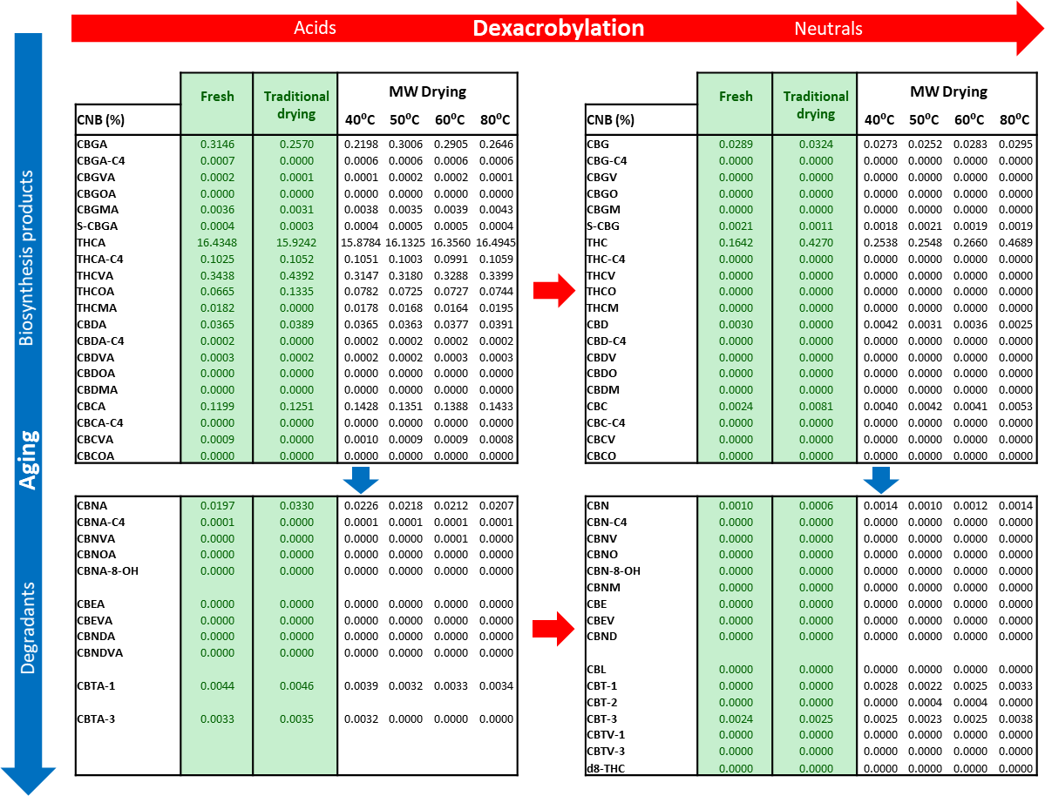
Figure S1. Comparison of phytocannabinoid profiles of Cannabis inflorescences by ESI-LC/MS. The concentrations of phytocannabinoids were assessed by ESI-LC/MS after harvesting (fresh), traditional drying, and MW drying at different temperatures (n=1). Phytocannabinoids are arranged according to biosynthesis and degradation products. Red and blue arrows indicate decarboxylation and aging pathways, respectively.

Table S1. List of full and abbreviated names of phytocannabinoids
1. Cannabigerol (CBG) type | Abbreviated name | Acid Form
Cannabigerol-C5 | CBG | CBGA
Cannabigerobutol-C4ª | CBG-C4 / CBGB | CBGA-C4
Cannabigerovarin-C3 | CBGV | CBGVA
Cannabigerorcol-C5 | CBGO | CBGOA
Sesquicannabigerol-C5 | S-CBG | S-CBGA
Cannabigerol monomethyl ether-C5 | CBGM | CBGMA
2. Δ⁹-trans-tetrahydrocannabinol (Δ⁹-THC) type
(-)-Δ⁹-trans-Tetrahydrocannabinol-C5 | THC | THCA
(-)-Δ⁹-trans-tetrahydrocannabutol-C4 | THC-C4 / THCB | THCA-C4
(-)-Δ⁹-trans-Tetrahydrocannabivarin-C3 | THCV | THCVA
(-)-Δ⁹-trans-Tetrahydrocannabiorcol-C1 | THCO | THCOA
(-)-Δ9-trans-Tetrahydrocannabinol monomethyl ether-C5 | THCM | THCMA
3. Cannabidiol (CBD) type
(-)-Cannabidiol-C5 | CBD | CBDA
(-)-Cannabidibutol-C4ª | CBD-C4 / CBDB | CBDA-C4
(-)-Cannabidivarin-C3 | CBDV | CBDVA
(-)-Cannabidiorcol-C1 | CBDO | CBDOA
Cannabidiol monomethyl ether-C5 | CBDM | CBDMA
4. Cannabichromene (CBC) type
(±)-Cannabichromene-C5 | CBC | CBCA
(±)-Cannabibutol-C4ª | CBC-C4 / CBCB | CBCA-C4
(±)-Cannabichromevarin-C3 | CBCV | CBCVA
(±)-Cannabiorchromorcol-C1 | CBCO | CBCOA
5. Cannabinol (CBN) type
Cannabinol-C5 | CBN | CBNA
Cannabibutol-C4ª | CBN-C4 / CBNB | CBNA-C4
Cannabivarin-C3 | CBNV | CBNVA
Cannabiorcol-C1 | CBNO | CBNOA
Cannabinodivarin-C3 | CBNDV | CBNDVA
8-hydroxycannabinol | CBN-8-OH | CBNA-8-OH
Cannabinol monomethyl ether-C5 | CBNM
6. Δ⁸-trans-tetrahydrocannabinol (Δ⁸-THC) type
(-)-Δ⁸-trans-(6aR,10aR)-Tetrahydrocannabinol-C5 | Δ⁸-THC
7. Cannabicyclol (CBL) type
(±)-(1aS,3aR,8bR,8cR)-Cannabicyclol-C5 | CBL
8. Cannabinodiol (CBND) type
Cannabinodiol-C5 | CBND | CBNDA
9. Cannabielsoin (CBE) type
(5aS,6S,9R,9aR)-Cannabielsoin-C5 | CBE | CBEA
Cannabielsoin-C3 | CBEV | CBEVA
10. Cannabitriol (CBT) type
(±)-cis/trans-Cannabitriol-C5-1 | CBT-1 | CBTA-1
(±)-cis/trans-Cannabitriol-C5-2 | CBT-2
(±)-cis/trans-Cannabitriol-C5-3 | CBT-3 | CBTA-3
Cannabitriol-C3-1 | CBTV-1
Cannabitriol-C3-3 | CBTV-3

