SUPPLEMENTARY DATA

Computational Identification of Potent Multi-Target Natural Ligands for Alzheimer's Disease Therapeutics
Nadia Sharif ¹, Ayesha Bibi ², Rakhshinda Sadiq ¹, Iffat Ullah ^{3,4}, Abdul Rauf ^{3,4}, Muhammad Tayyab Arshad ⁵, Hafsa Zamir ⁶, Sawaira gull ⁶, Taqwa Anwar ⁶, Emmanuel Laryea ⁷
- Department of Biotechnology, Women University Mardan, 23200, Pakistan (nadiasharif.s7@gmail.com) (rakhshinda_sadiq@yahoo.com)
- Department of Human Nutrition and Dietetics, Women University Mardan, 23200, Pakistan (ayeshabb2009@yahoo.com)
- Department of Pharmaceutical Chemistry, Faculty of Pharmaceutical Sciences, Prince of Songkla University, Hat Yai 90110, Songkhla, Thailand (rauf31015@gmail.com) (Iffatph126@gmail.com)
- Drug Delivery System Excellence Center, Faculty of Pharmaceutical Sciences, Prince of Songkla University, Hat Yai 90110, Songkhla, Thailand
- Functional Food and Nutrition Program, Center of Excellence in Functional Foods and Gastronomy, Faculty of Agro-Industry, Prince of Songkla University, Hat Yai, Songkhla, Thailand (tayyabarshad5512@gmail.com)
- Department of Zoology, Women University Mardan,23200, Pakistan (zhafsa555@gmail.com) (sawairagull9@gmail.com) (taqwaanwar2020@gmail.com)
- Department of Food Science and Technology, Kwame Nkrumah University of Science and Technology, Kumasi, Ghana (etettehlaryea@gmail.com)

*Corresponding author
Emmanuel Laryea (etettehlaryea@gmail.com)

This supplementary file contains information supporting the computational identification of potent multi-target natural ligands for Alzheimer disease therapeutics. Listed below tables and figures provide detailed insights into the receptor structures, molecular docking results, and interaction analyses. Specifically, this file includes: (1) receptor details (T1), (2) AutoDock Vina results for Sortilin, Clustrin, Amyloid peptide, and Tau protein (T2-T5), and (3) visualizations of receptor-ligand interactions (Figures S1-S72).

T1: Details of the receptor Sortilin, Clustrin, Tau and amyloid peptide including its PDB (IDs) three-dimensional structures.
Sr.No. | Protein name | Pdb IDs | Structures
1. | Sortilin related receptor(SORL1) | 7VTO | 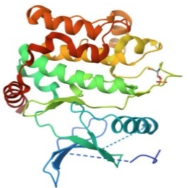
2. | Clusterin | 7ZET | 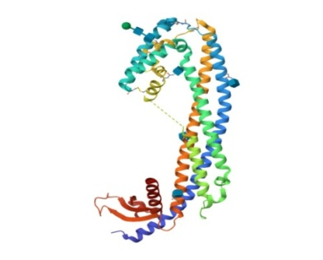
3. | Tau Peptide | 7mkh | 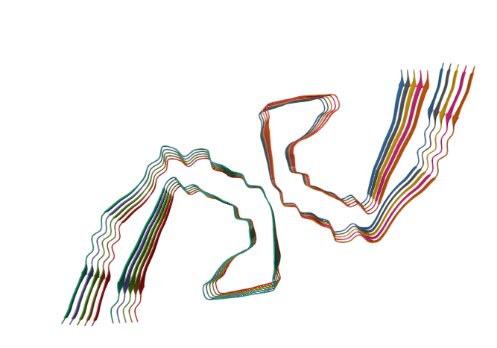
4. | Amyloid | 5txd | 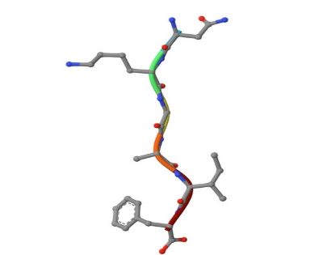

T2: Auto dock vina results of different ligands with Sortilin receptor and 3 drugs.
Sr.No. | Molecules | Binding energy  (kcal/mol) | Ligand efficiency | Inhibition constant (µM) | Electrostatic  Energy | Total Internal energy | Torsional energy  (kcal/mol) | Unbound energy  (kcal/mol) | Ref RMS | Amino acid  Residue
 | 4-tert-Amylphenol | -6.28 | -0.52 | 25.01 | -0.17 | -0.29 | 0.89 | -0.29 | 51.75 | ARG292: HH 21  TYR318: HN
 | Allicin | -4.75 | -0.53 | 330.59 | -0.25 | -0.2 | 1.49 | -0.2 | 52.2 | SER283: HG 1  ARG 292: HE 1
 | Apigenin | -7.33 | -0.37 | 4.27 | -0.37 | -0.86 | -0.86 | -0.86 | 38.01 | ILE494: HN  SER541:HN
 | Astragalosides | -5.14 | -0.23 | 169.72 | -0.14 | -1.28 | 2.98 | -1.28 | 43.07 | TRP83:HN 1  SER541:HN 1
 | Berberine | -7.24 | -0.29 | 4.95 | -0.09 | -0.35 | 0.6 | -0.35 | 49.49 | MET139: HN  TYR189: HN
 | Cannabidiol | -5.4 | -0.23 | 110.53 | -0.08 | -1.32 | 2.39 | -1.32 | 50.07 | TRP228: HN
 | Curcumin | -6.38 | -0.24 | 21.14 | -0.06 | -1.99 | 2.39 | -1.99 | 34.2 | SER432: HN  SER447:HN  GLY544:HN
 | Cyanidin | -5.94 | -0.28 | -44.07 | -0.3 | -0.37 | 1.79 | -0.37 | 50.33 | ILE141:HN
 | Dronabinol | -7.91 | -0.34 | 1.59 | -0.17 | -0.36 | 1.49 | -0.36 | 49.12 | ARG292:HH21 1
 | Galantamine | -6.98 | -0.33 | 7.58 | -1.81 | -0.74 | 0.6 | -0.74 | n/a | ARG403:HH21
 | Gingkolide | -16.29 | -0.54 | 1.14 | -0.28 | -0.74 | 0.89 | -0.74 | 54.03 | ARG292:HH21 1  TYR318:HN1
 | Ginsenosides | -8.07 | -0.25 | 1.22 | -0.14 | -1.69 | 1.79 | -1.69 | 48.14 | ILE141:HN1  MET139: O
 | Harman | -5.56 | -0.4 | 83.64 | 0.00 | 0.0 | 0.0 | 0.0 | 50.12 | ILE141:O
 | Hesperidin | -3.95 | -0.09 | 1.26 | -0.29 | -7.74 | 4.47 | -7.74 | 50.054 | TRP228:HN
 | Resveratrol | -5.61 | -0.33 | 77.12 | -0.25 | -0.27 | -0.27 | -0.27 | 37.95 | ILE494:HN 1
Drugs
 | Memantine | -6.9 | -0.53 | 8.83 | -0.0 | 0.69 | 0.6 | 0.69 | 31.7 | GLN400:O
 | Donepezil | -6.66 | -0.24 | 13.08 | -0.3 | -0.9 | 1.79 | -0.91 | n/a | TYR189:O
 | Rivastigmine | -5.61 | -0.33 | 77.12 | -0.25 | -0.27 | 1.49 | -0.27 | 37.95 | ILE494:HN

T3: Autodock via results of different 13 ligands with Clustirin receptor and 3 drugs.
Sr. No. | Molecules | Binding energy (kcl/mol) | Ligand efficiency | Inhabitation constant (Um) | Electrostatic energy | Total internal energy | Torsional energy(kcal/mol) | Unbounded energy(kcl/mol) | Ref RMS | Amino acid residue
 | 4-tert-Amylphenol | -3.99 | -0.33 | 1.19 | -0.08 | -0.27 | 0.89 | -0.27 | 26.38 | GLN349:HE22
 | Allicin | -3.93 | -0.44 | 1.32 | 0.02 | -0.2 | 1.49 | -0.2 | 36.19 | SER184:HG
 | Apigenin | -5.51 | -0.28 | 91.5 | -0.12 | -0.88 | 1.19 | -0.88 | 33.98 | LYS351:HZ2  GLN361:HE21
 | Astragalosides | -3.89 | -0.18 | 1.42 | -0.22 | -1.63 | 2.98 | -1.63 | 33.36 | LYS351:HZ2  NAG503:H2
 | Berbirine | -6.46 | -0.26 | 18.27 | -0.03 | -0.29 | 0.6 | -0.29 | 19.72 | ASN291:HD2
 | Cannabidiol | -3.56 | -0.15 | 2.45 | -0.08 | -1.5 | 2.39 | -1.5 | 32.77 | ARG 292: HE 1
 | Curcumin | -4.01 | -0.15 | 1.16 | -0.24 | -1.88 | 2.39 | -1.88 | 44.07 | GLU364:OE1
 | Cyanidin | -3.92 | -0.19 | 1.34 | -0.02 | -1.41 | 1.79 | -1.41 | 19.01 | No hydrogen bond
 | Dronabinol | -5.94 | -0.26 | 44.46 | -0.04 | -0.64 | 1.49 | -0.64 | 64.23 | ASN43:OD1
 | Galantamine | -5.53 | -0.26 | 88.04 | -0.75 | -0.76 | 0.6 | -0.76 | 38.67 | GLN255:HE22
 | Gingkolide | -13.98 | -0.47 | 56.33 | -0.09 | -0.74 | 0.89 | -0.74 | 56.75 | HIS205:HD1
 | Ginsenosides | -8.02 | -0.25 | 1.33 | -0.11 | -1.6 | 1.79 | -1.6 | 61.72 | PHE240:HN,
 | Harman | -5.52 | -0.39 | 90.4 | -0.17 | 0.0 | 0.0 | 0.0 | 21.05 | GLU287:OE2
 | Hesperidin | -5.42 | -0.13 | 106.76 | -0.39 | -6.12 | 4.47 | -6.12 | 19.54 | SER161:O, THR 283:O, GLU 287: OE1, THR293:HG1,
 | Resveratrol | -6.34 | -0.37 | 22.62 | -0.1 | -0.26 | 1.49 | -0.26 | 60.78 | NAG504:04, PRO212:0, ALA373:0
Drugs
1 | Donepezil | -5.65 | -0.2 | 72.53 | -0.86 | -0.86 | 1.79 | -0.86 | 38.88 | GLY378:0
2 | Memantine | -5.4 | -0.24 | 110.12 | -0.46 | 0.07 | 0.3 | 0.07 | 27.96 | No hydrogen bond
3 | Rivastigmine | -4.93 | -0.27 | 242.2 | -1.07 | -0.73 | 1.49 | -0.73 | 19.33 | THR293:HG1

T4. Autodock vina results of different ligands with Amyloid peptide.
Sr.No. | Molecule | Binding Energy (kcal/m0l) | Ligand Efficency | Inhibition constant | Electrostatic energy | Total internal energy | Torsional energy (kcal/mol) | Un bounded energy (kcal/mol) | ref RMS | Amino acid residue
 | 4 -tert-Amylphenol | -2.5 | -0.21 | 14.8 | -0.04 | 0.89 | 0.89 | -0.25 | 6.1 | ILE5::0, ILE5:HN
 | Allicin | -1.43 | -0.16 | 89.9 | -0.04 | -0.18 | 1.49 | -0.18 | 6.47 | GLY3:HN
 | Apigenin | -2.42 | -0.12 | 16.86 | -0.19 | -0.89 | 1.19 | -0.89 | 5.8 | LYS2:0, LYS2:HZ2
 | Astragalcociides | -1.37 | -0.06 | 98.21 | 0.07 | -1.55 | 2.98 | -1.55 | 5.77 | GLY3:HN
 | Berbirine | -3.57 | -0.14 | 2.43 | -0.06 | -0.33 | 0.6 | -0.33 | 5.89 | ILE5:0
 | Cannabidiol | -2.03 | -0.09 | 32.57 | -0.07 | -1.38 | 2.39 | -1.43 | 4.35 | GLY3:0
 | Curcumin | -2.17 | -0.08 | 25.65 | -0.12 | -2.0 | 2.39 | -2.0 | 5.63 | ASN1:HD22
 | Cyanidin | -3.94 | -0.19 | 1.3 | -0.19 | -1.26 | -1.79 | -1.26 | 4.58 | ILE5:0  ILE5:HN  ASN1:0
 | Dronabinol | -3.53 | -0.15 | 2.6 | -0.24 | -0.42 | 1.49 | -0.42 | 8.19 | LYS2:HZ2
 | Galantamine | -3.21 | -0.15 | 4.46 | -0.16 | -0.73 | 0.6 | -0.73 | 8.64 | No hydrogen bond
 | Ginkgolide | -8.4 | -0.28 | 700.13 | -0.02 | -0.73 | -0.89 | -0.73 | 7.0 | No hydrogen bond
 | Ginsenosides | -4.36 | -0.14 | 639.84 | -0.33 | -0.94 | 1.79 | -0.94 | 5.74 | ALA4:0, ALA4:HN, LYS2:HZ2
 | Harman | -3.7 | -0.26 | 1.93 | -0.06 | 0.0 | 0.0 | 0.0 | 4.66 | GLY3:0
 | Hesperidin | -2.37 | -0.06 | 18.35 | -0.31 | -5.18 | 4.47 | -5.18 | 5.8 | LYS2:HZ2, GLY3:HN, GLY3:0
 | Resveratrol | -2.2 | -0.13 | 24.41 | -0.24 | -0.26 | 1.49 | -0.26 | 4.39 | LYS2:HZ1, GLY3:HN, GLY3:0
 | Dopenzil | -3.35 | -0.12 | 3.48 | -0.04 | -1.27 | 1.79 | -1.27 | 5.4 | ILE5:HN
 | Memantine | -3.56 | -0.27 | 2.46 | 0.0 | 0.7 | 0.3 | 0.7 | 6.71 | ILE5:0
 | Rivastigmine | -2.16 | -0.12 | 26.21 | 0.07 | -0.84 | 1.49 | -0.84 | 7.22 | GLY3:HN

T5. Autodock vina results of different ligands with tau proteins.
Sr.  No | Molecules | Binding  Energy (kcal/m0l) | Ligand effiency |  | Inhibition constant |  | Electrostatic energy | Total internal energy | Torsional  energy  (kcal/mol) | Un bounded energy(kcal/mol) | ref RMS | Amino acid residue
 | 4 -tert-Amylphenol | -3.52 | -0.29 | 2.65 |  | -0.02 |  | -0.26 | 0.89 | -0.26 | 301.08 | VAL339:HN
 | Allicin | -2.5 | -0.28 | 14.75 |  | -0.05 |  | -0.12 | 1.49 | -0.12 | 292.96 | VAL339:HN
 | Apigenin | -5.01 | -0.25 | 211.53 |  | -0.13 |  | -0.9 | 1.19 | -0.9 | 293.09 | GLY326:0  VAL363:0  ILE328:HN
 | Astragalcociides | -3.8 | -0.17 | 1.64 |  | -0.03 |  | -1.44 | 2.98 | 1.44 | 295.34 | GLY326:0
 | Berberine | -5.33 | -0.21 | 124.0 |  | -0.02 |  | -0.34 | 0.6 | -0.34 | 315.74 | GLN351:HN
 | Cannabidiol | -3.46 | -0.15 | 2.89 |  | -0.03 |  | -1.46 | 2.39 | -1.46 | 269.48 | No hydrogen bond
 | Curcumin | -4.64 | -0.17 | 396.92 |  | -0.17 |  | -1.99 | 2.39 | -1.99 | 299.11 | VAL339:HN  LEU357:HN  SER341:HN  VAL337:0
 | Cyanidin | -4.45 | -0.21 | 551.53 |  | -0.03 |  | -1.28 | 1.79 | -1.28 | 304.57 | ILE360:0
 | Dronabinol | -4.78 | -0.21 | 310.89 |  | -0.02 |  | -0.25 | 1.49 | -0.25 | 288.21 | No hydrogen bond
 | Galantamine | -5.47 | -0.26 | 97.29 |  | 0.0 |  | -0.7 | 0.6 | -0.7 | 294.37 | VAL337:0  VAL339:HN
 | Ginkgolide | -10.63 | -0.35 | 16.16 |  | -0.14 |  | -0.73 | 0.89 | -0.73 | 295.52 | HIS329:HD1
 | Ginsenosides | -6.28 | -0.2 | 24.74 |  | -0.1 |  | -0.78 | 1.79 | -0.78 | 301.95 | HIS329:0  PRO364:0
 | Harman | -4.35 | -0.31 | 649.5 |  | 0.02 |  | 0.0 | 0.0 | 0.0 | 296.17 | ASN327:0D1
 | Hesperidin | -3.76 | -0.09 | 1.74 |  | -0.13 |  | -6.89 | 4.47 | -6.89 | 291.1 | ASN359:0
 | Resveratrol | -4.6 | -0.27 | 428.19 |  | -0.26 |  | -0.27 | 1.49 | -0.27 | 305.08 | ASP358:HN, ILE360:0, SER356:0G, LYS353:HZ3
1 | Dopenzil | -5.34 | -0.19 | 121.22 |  | 0.98 |  | -1.01 | 1.79 | -1.01 | 269.0 | No Hydrogen Bound
2 | Memantine | -4.81 | -0.37 | 295.65 |  | 0.0 |  | 0.69 | 0.3 | 0.69 | 300.92 | ILE360:0
 | Rivastigmine | -3.33 | -0.18 | 3.6 |  | 0.04 |  | -0.7 | 1.49 | -0.7 | 301.06 | VAL339:HN
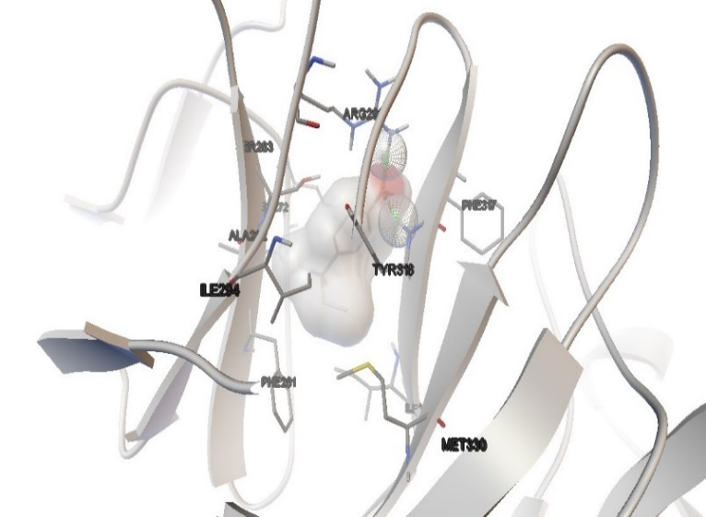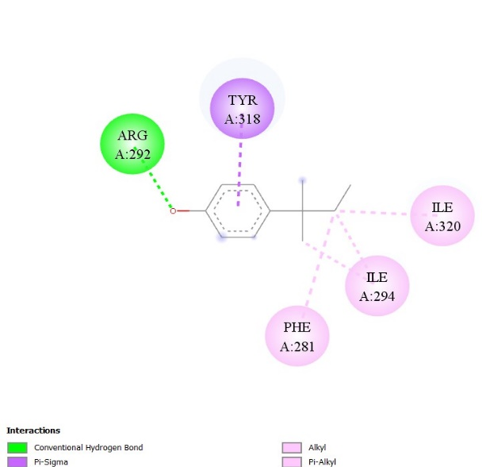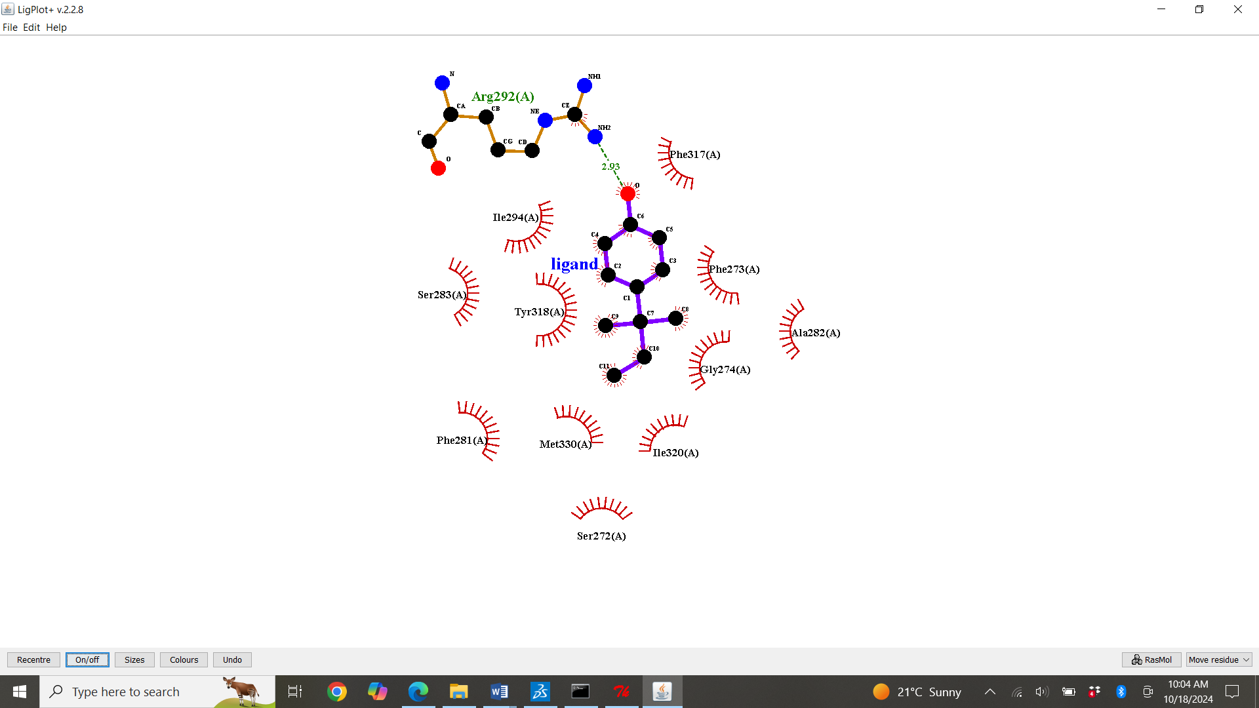

S1: Molecular Docking, secondary structure interaction and ligplus analysis of 4 -tert-Amylphenol interactions with Sortilin.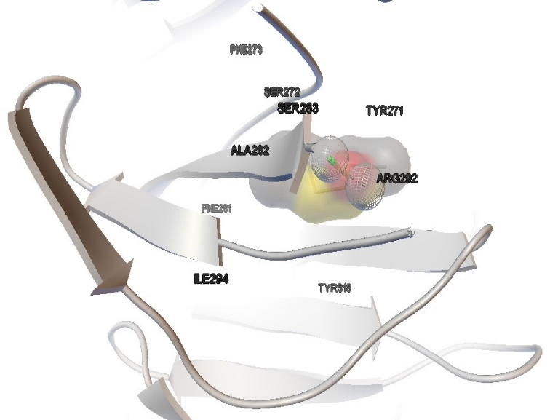 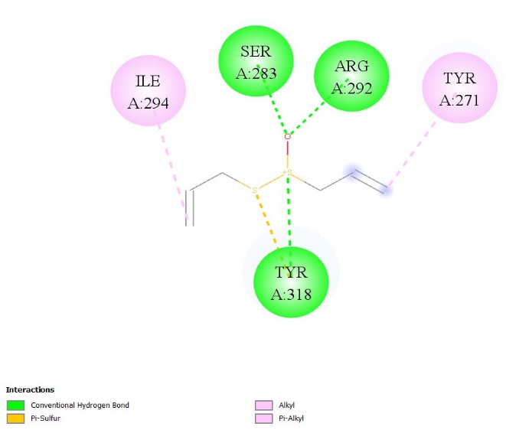 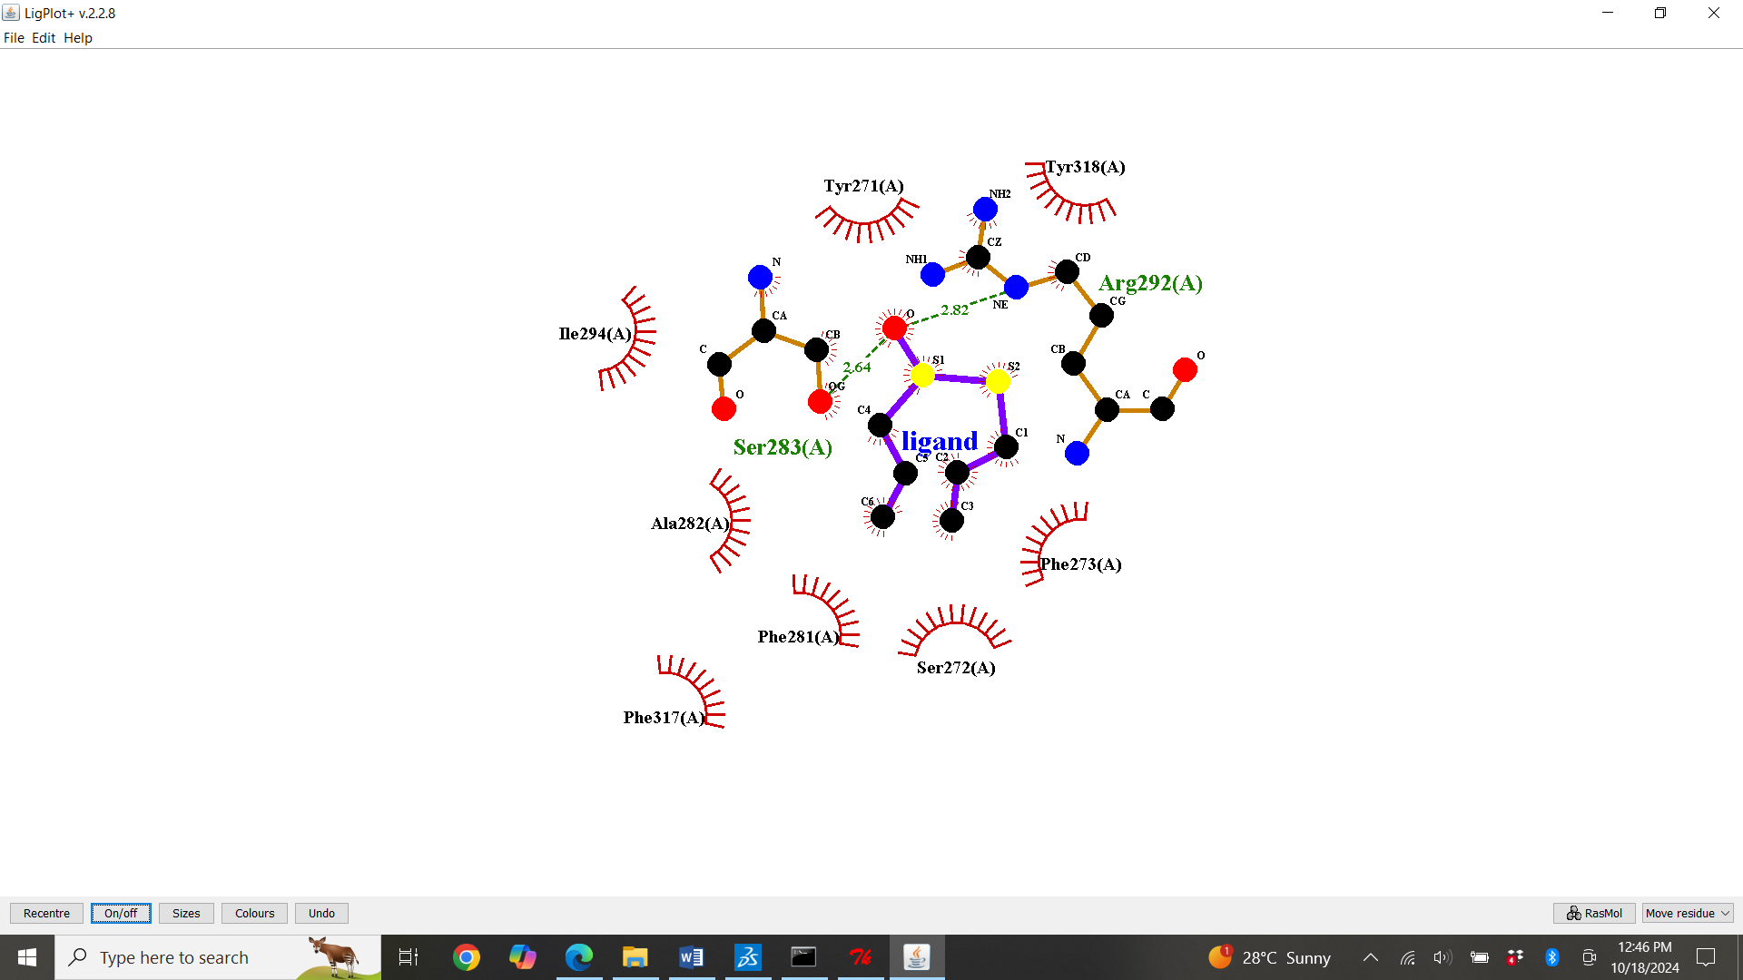
S2: Molecular Docking, secondary structure interaction and ligplus analysis of Allicin interactions with Sortilin.

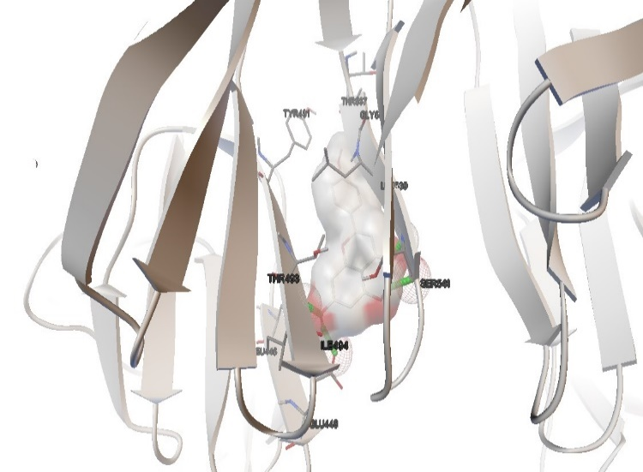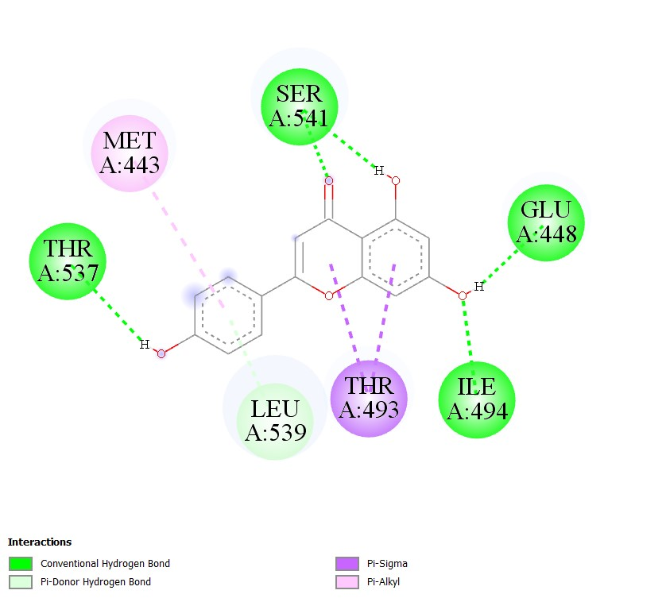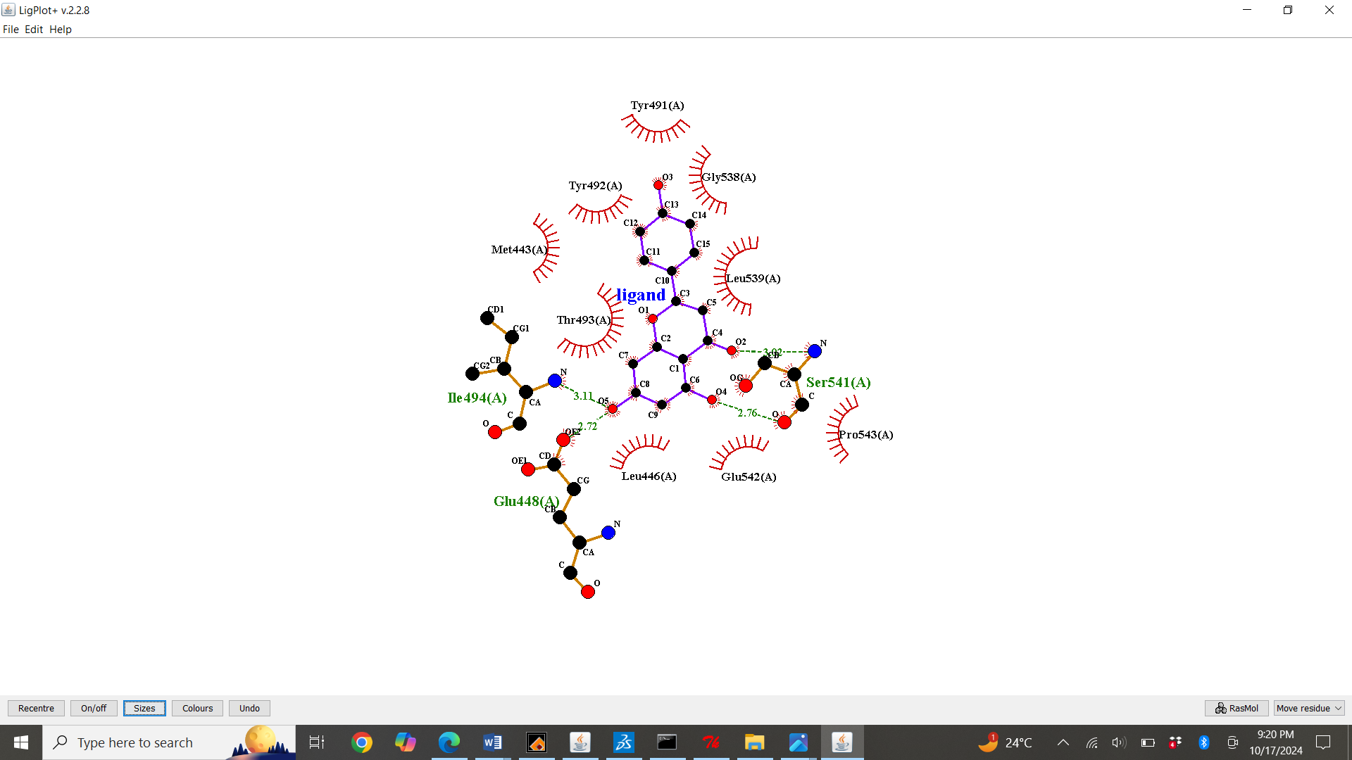
S3: Molecular Docking, secondary structure interaction and ligplus analysis of Apigenin interactions with Sortilin.
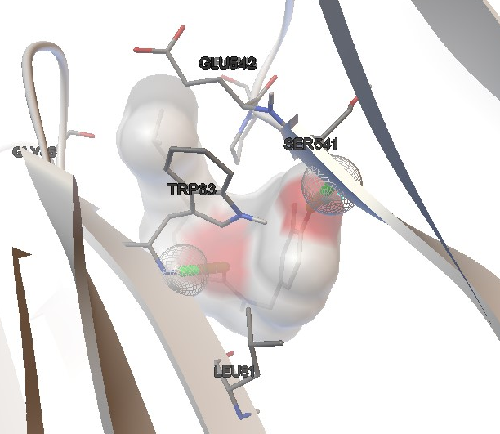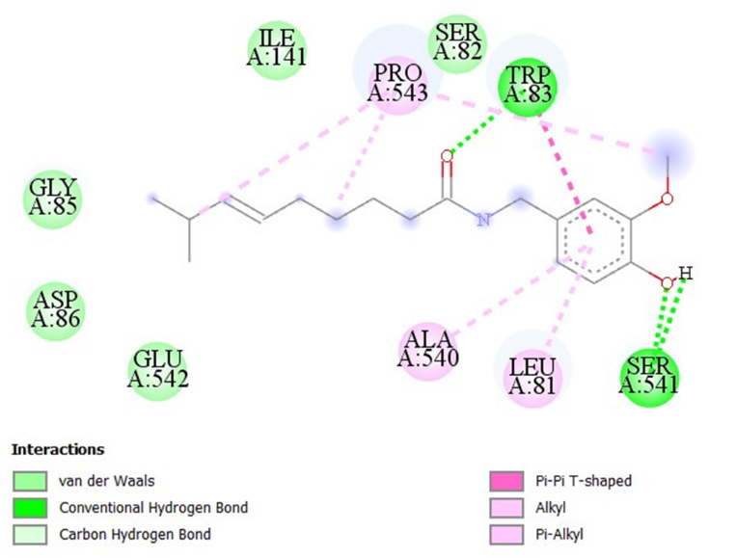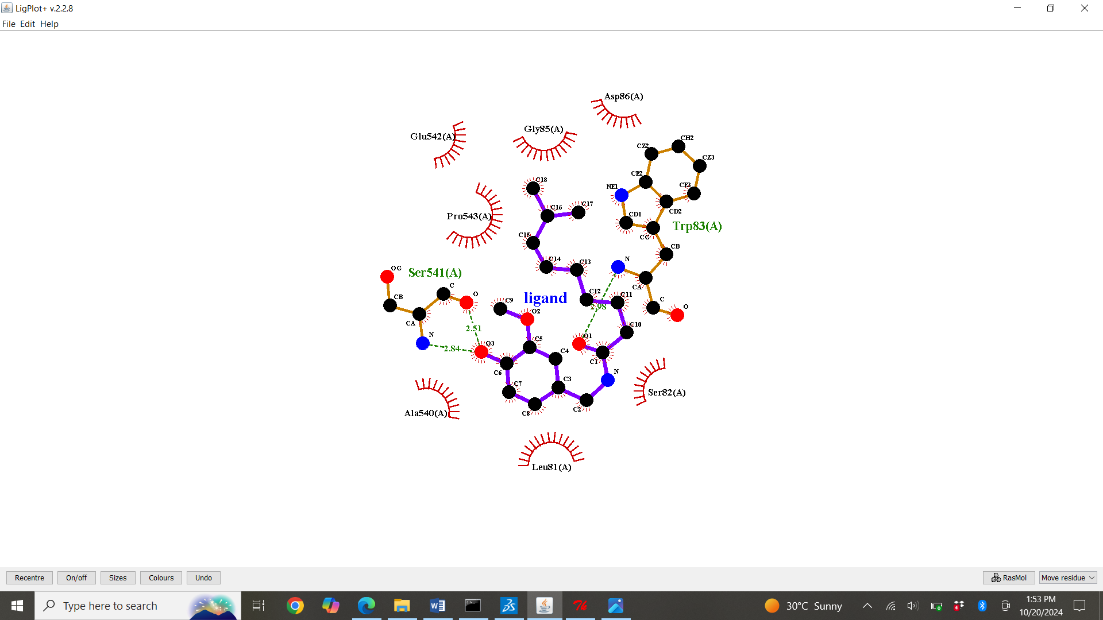
S4: Molecular Docking, secondary structure interaction and ligplus Analysis of Astragalosides Interactions with Sortilin.
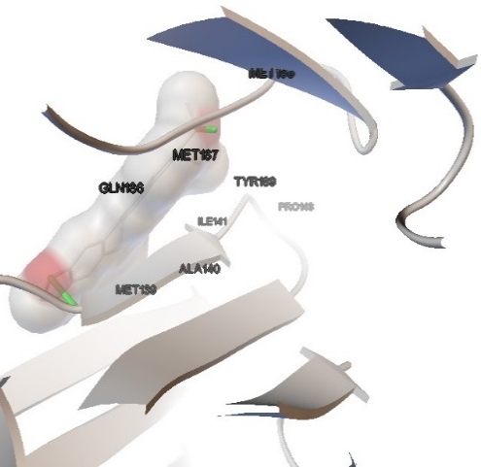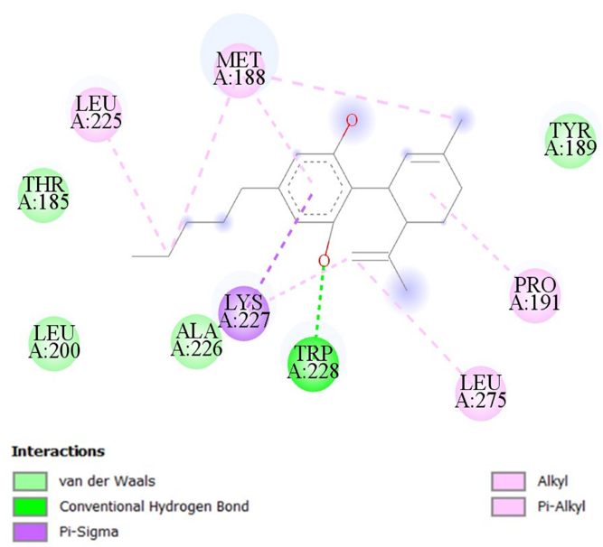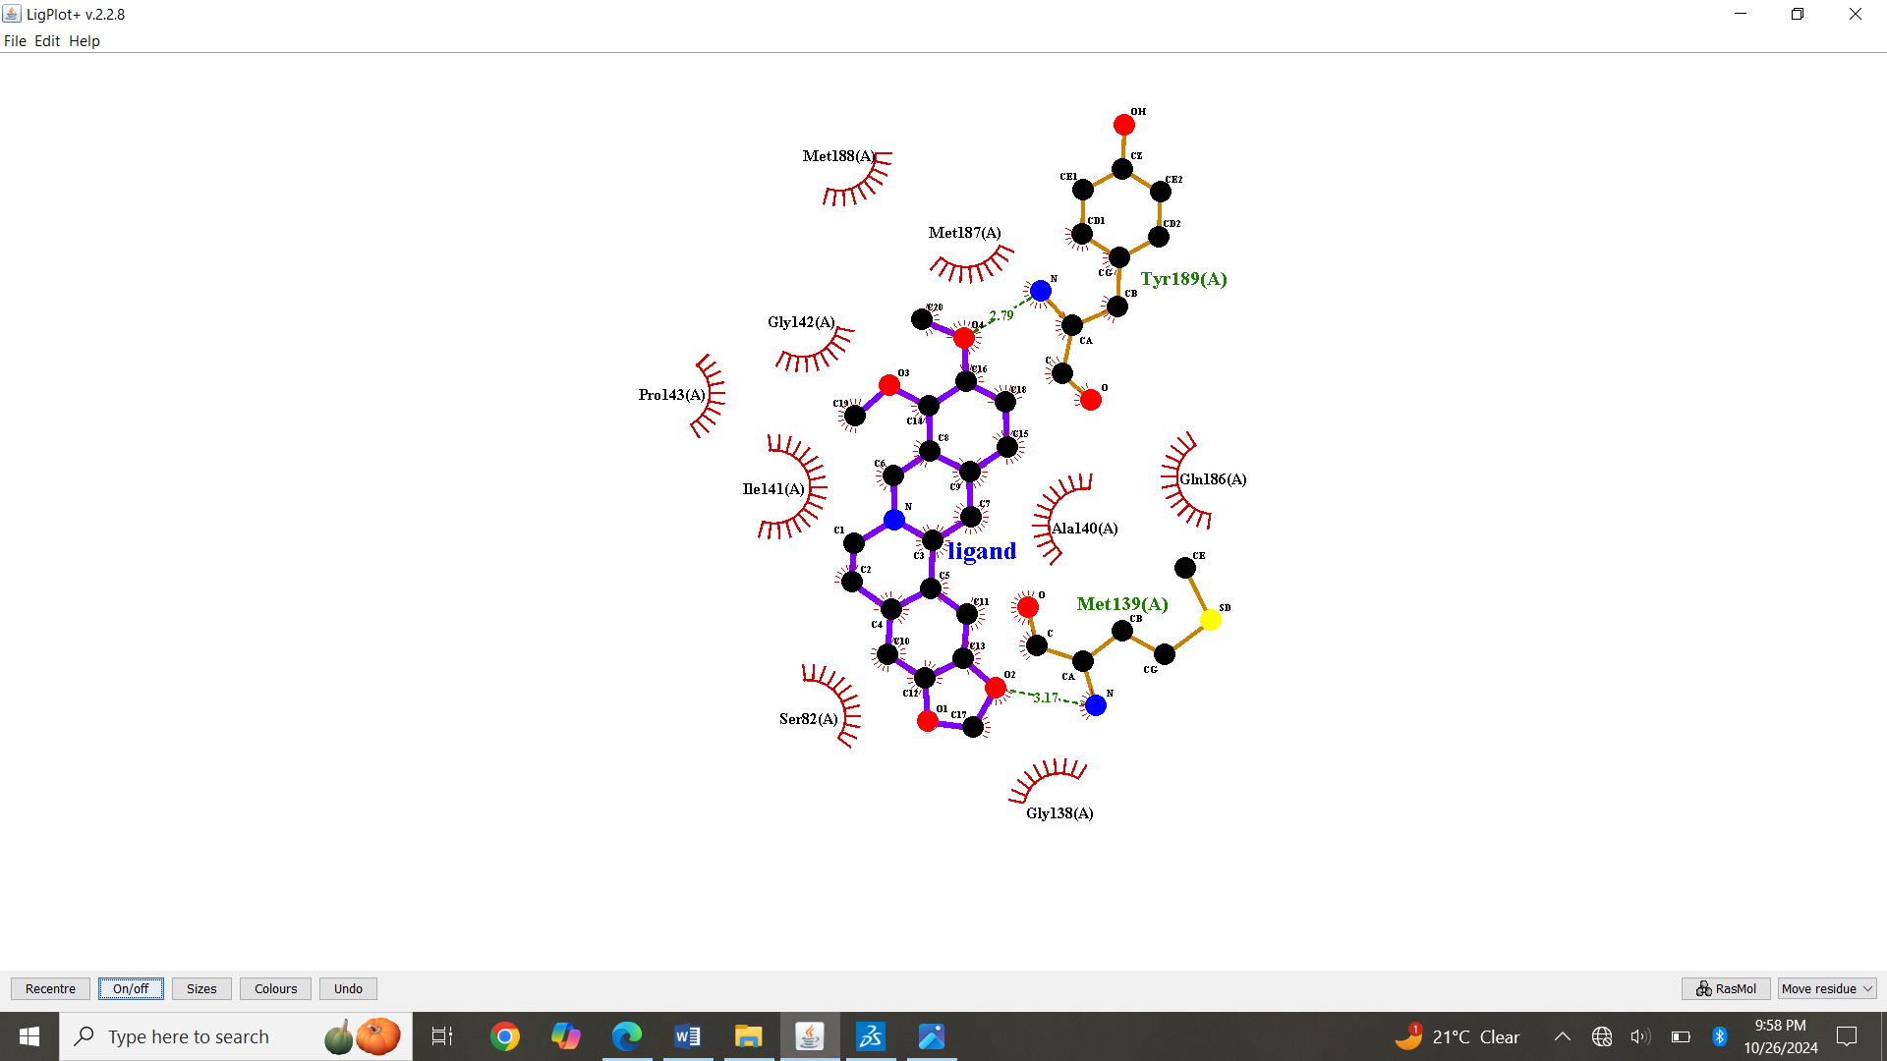
S5: Molecular Docking, secondary structure interaction and ligplus analysis of Berberine interactions with Sortilin.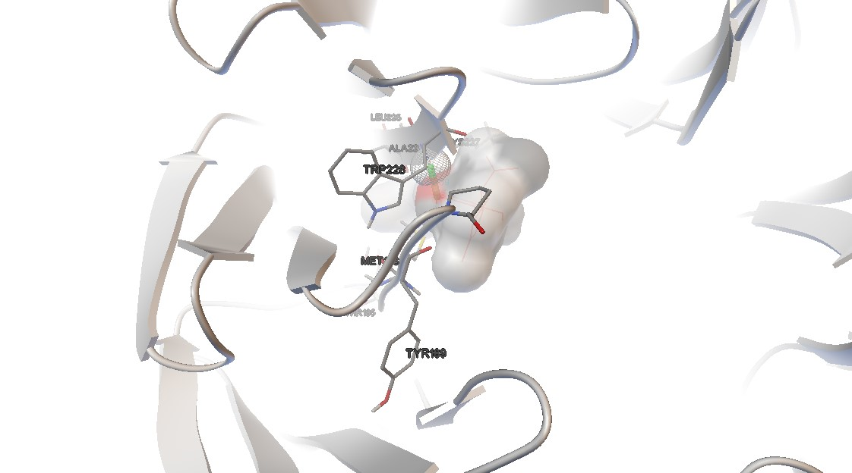 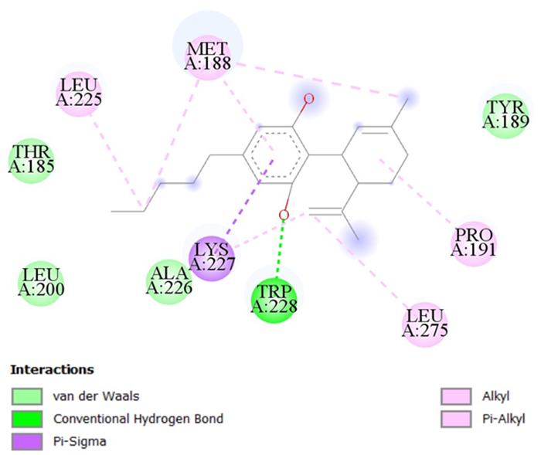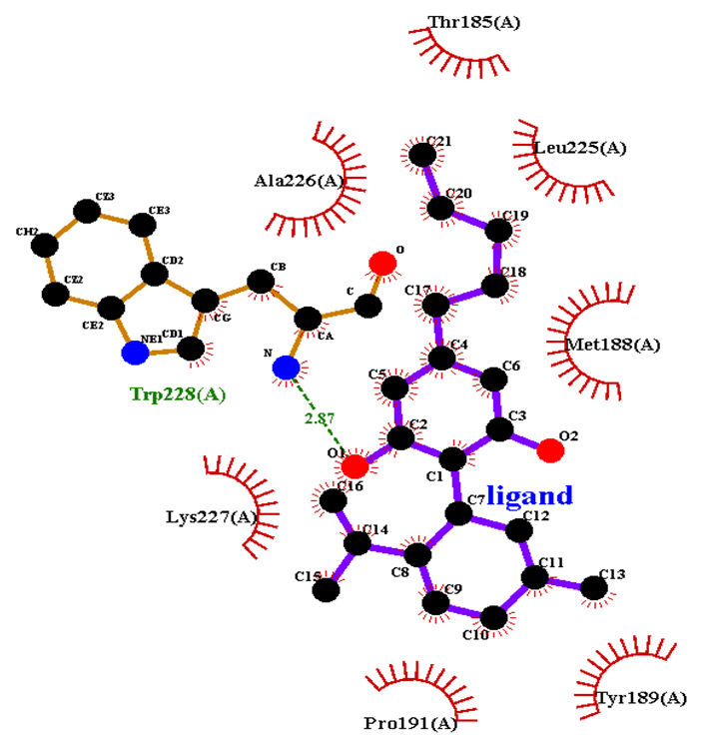
S6: Molecular Docking, secondary structure interaction and ligplus analysis of Cannabidiol interactions with Sortilin.
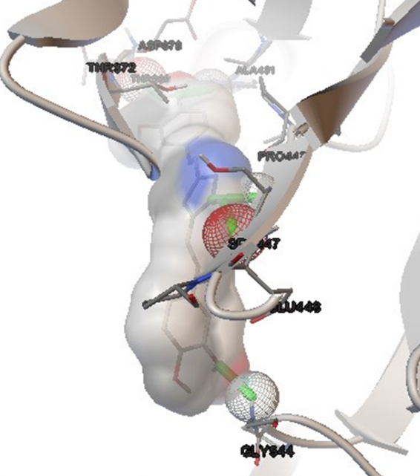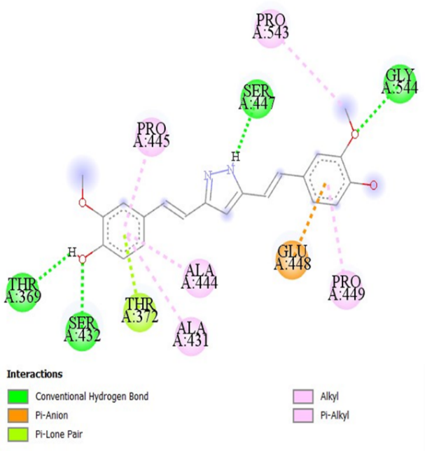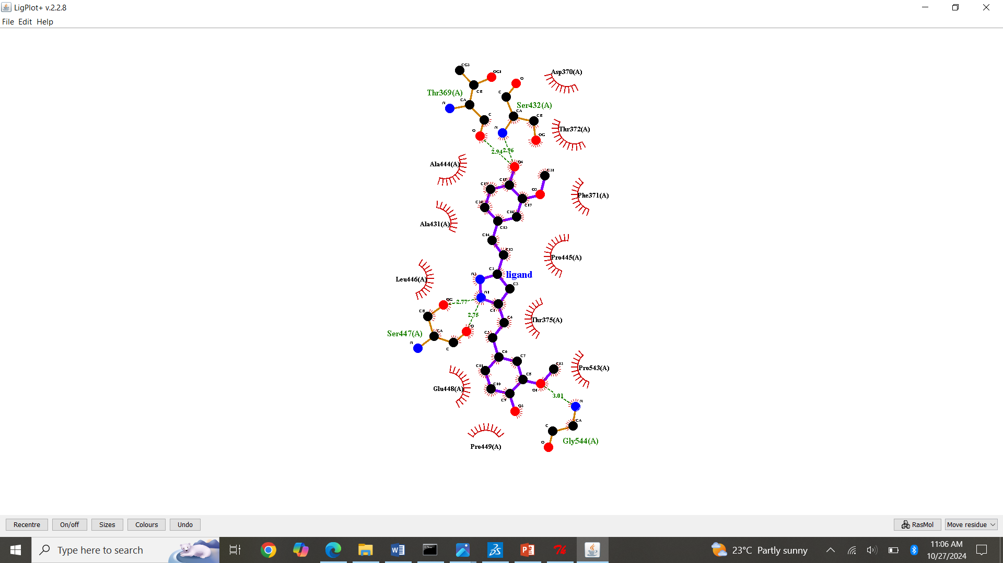
S7: Molecular Docking, secondary structure interaction and ligplus analysis of Curcumin interactions with Sortilin. 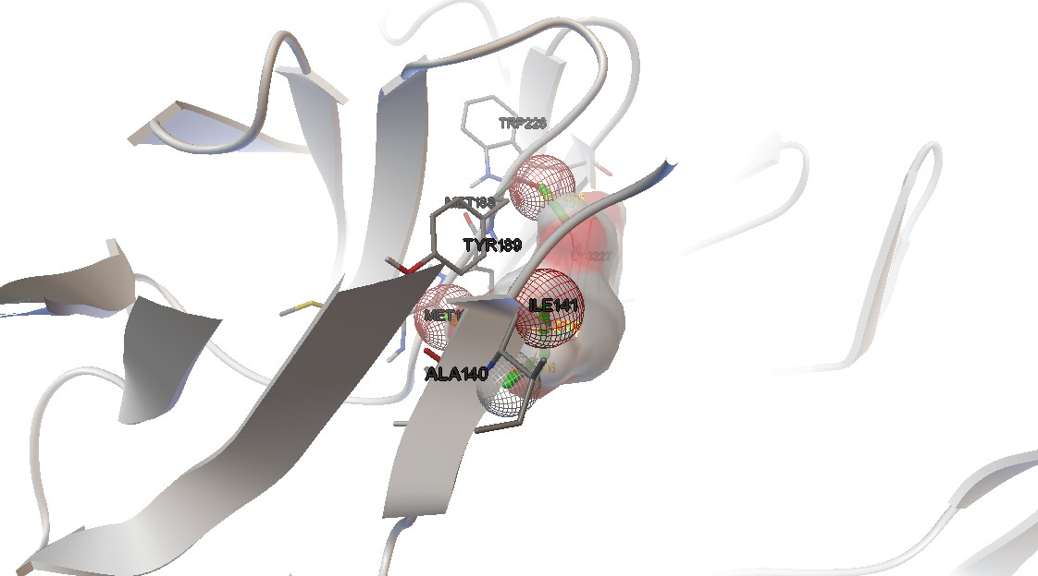 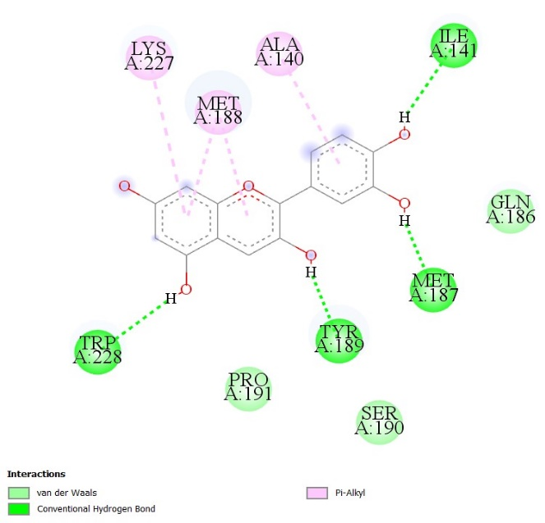 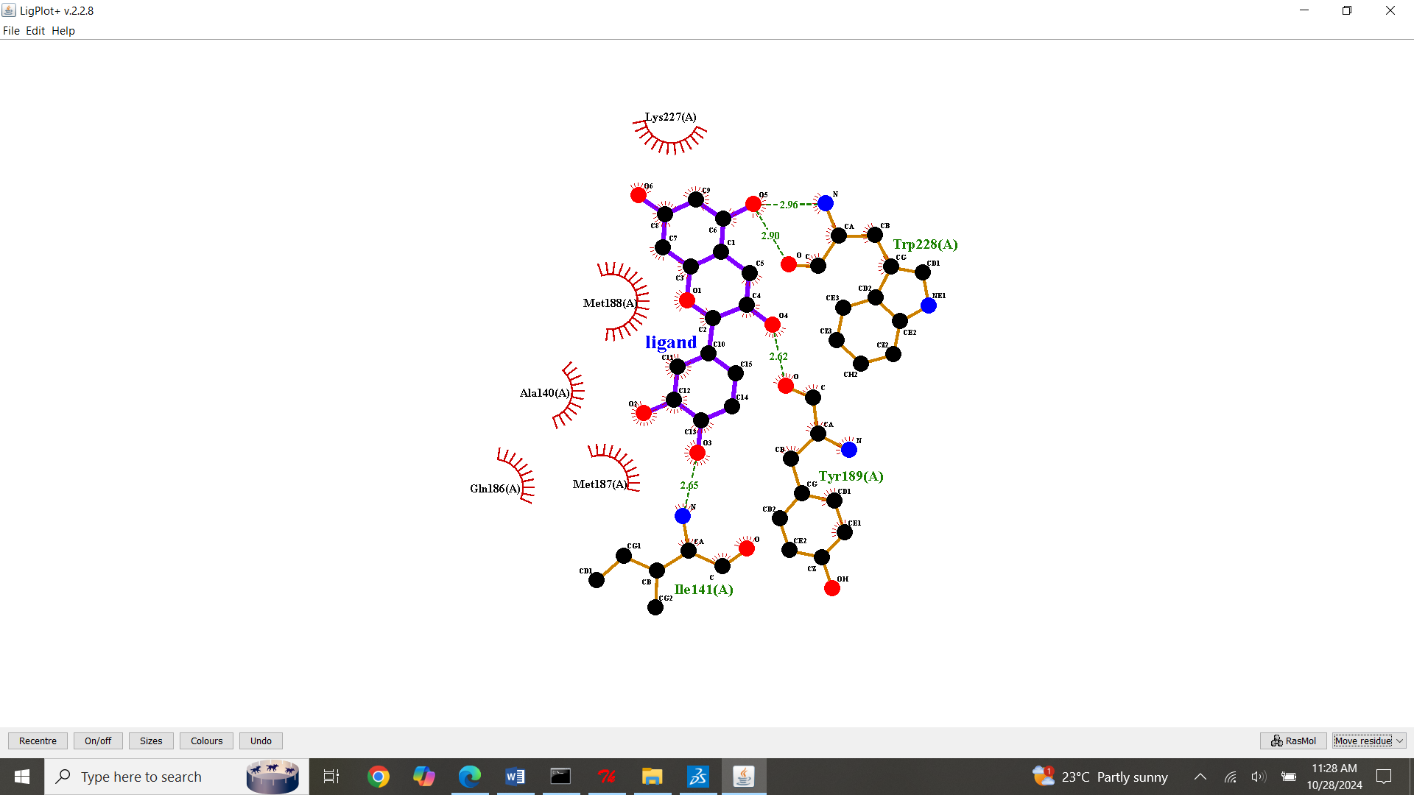
S8: Molecular Docking, secondary structure interaction and ligplus analysis of Cyanidin interactions with Sortilin.
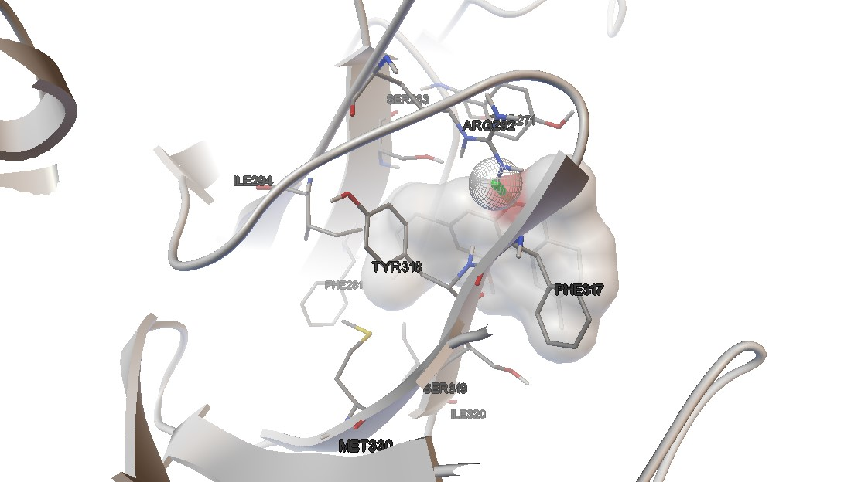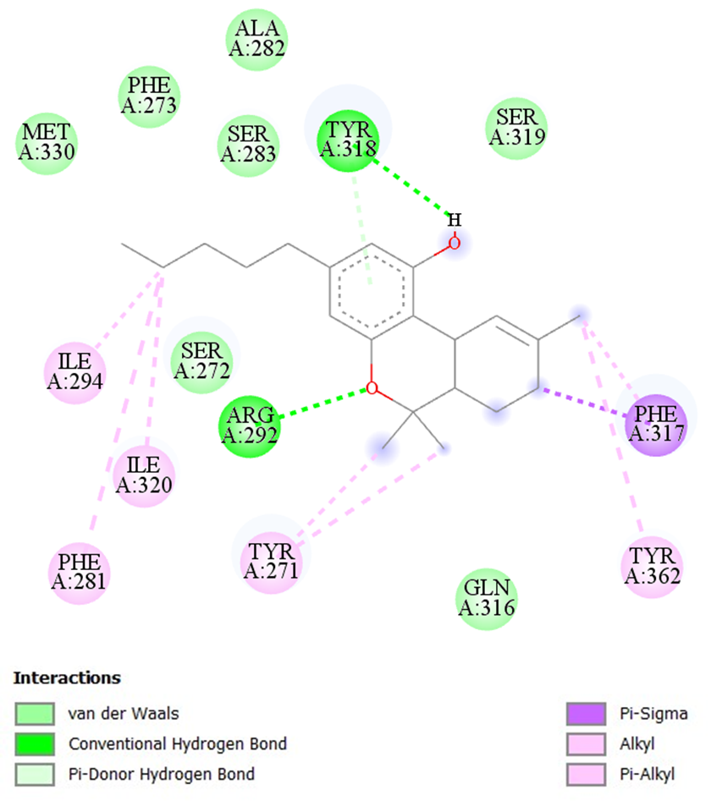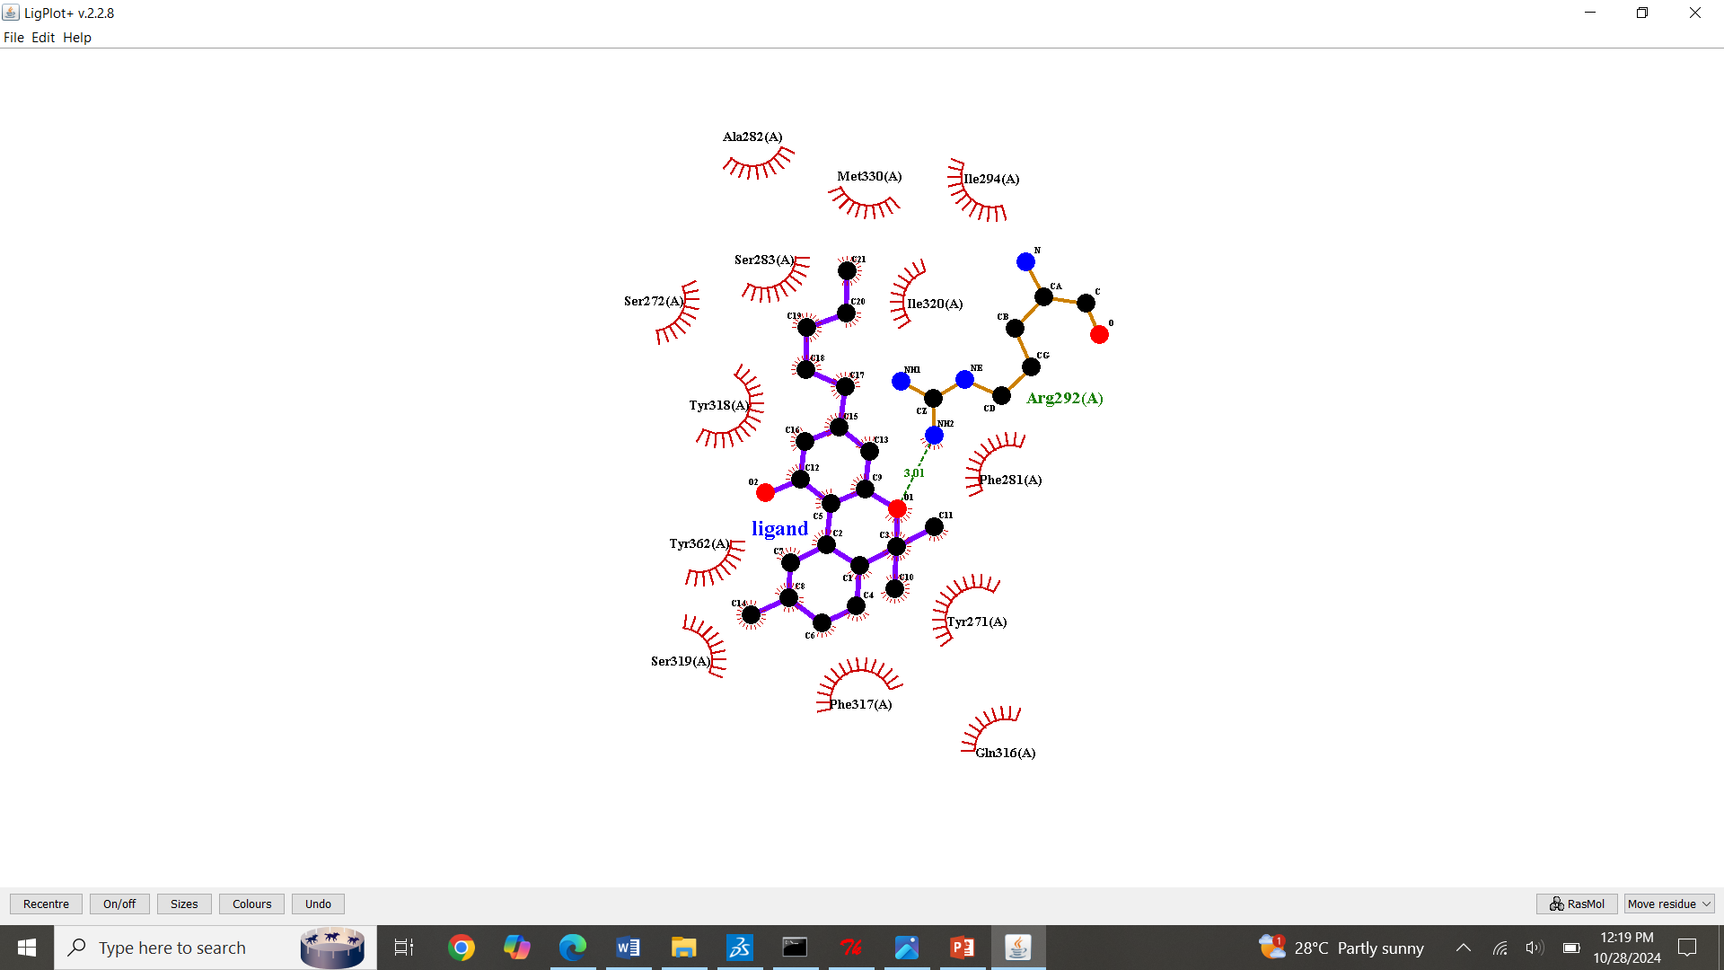
S9: Molecular Docking, secondary structure interaction and ligplus analysis of Dronabinol interactions with Sortilin.
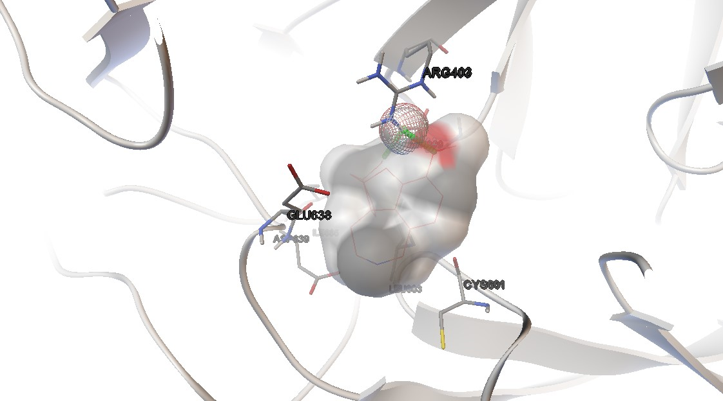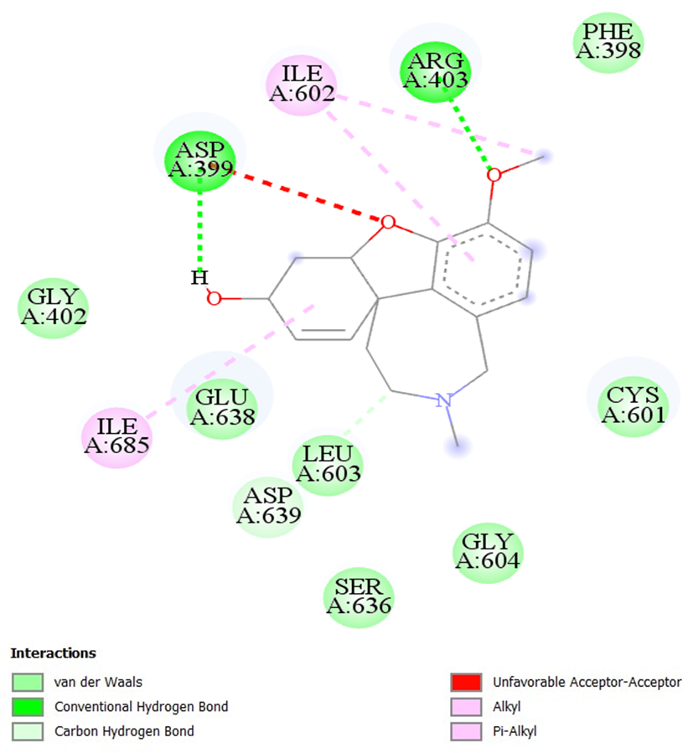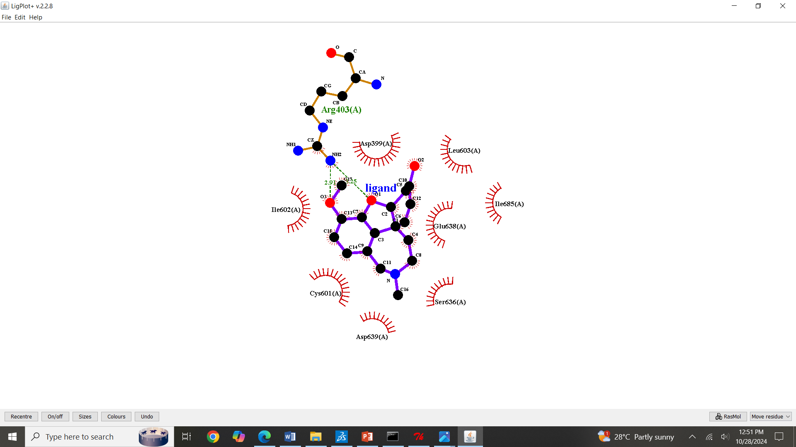
S10: Molecular Docking, secondary structure interaction and ligplus analysis of Galantamine interactions with Sortilin.
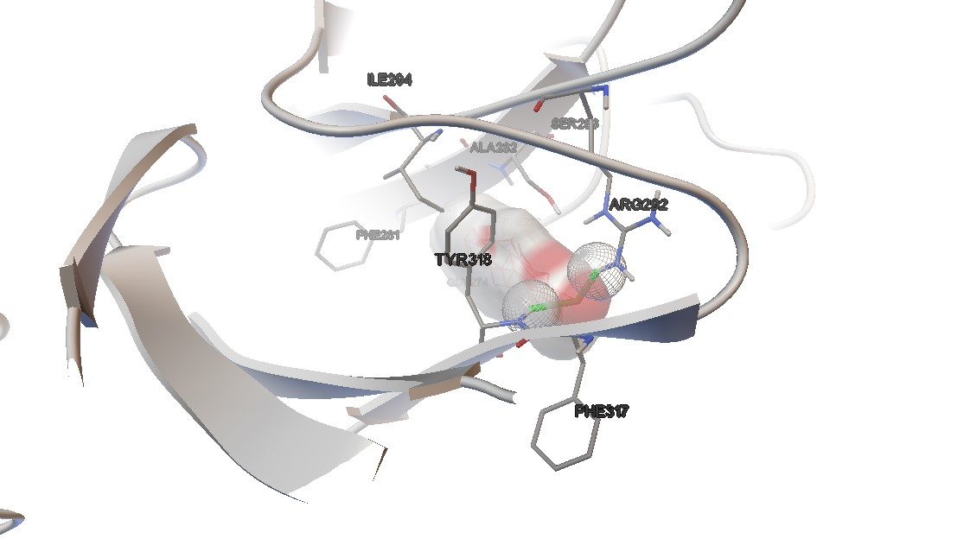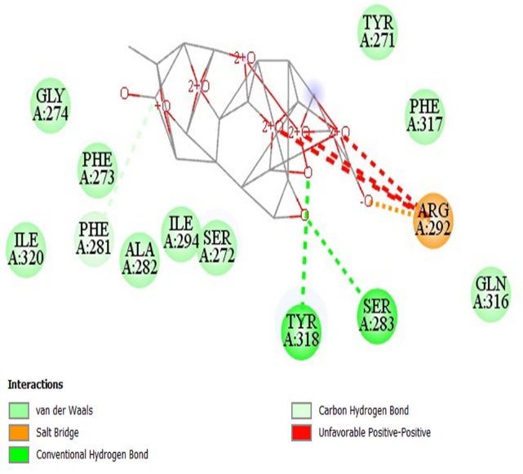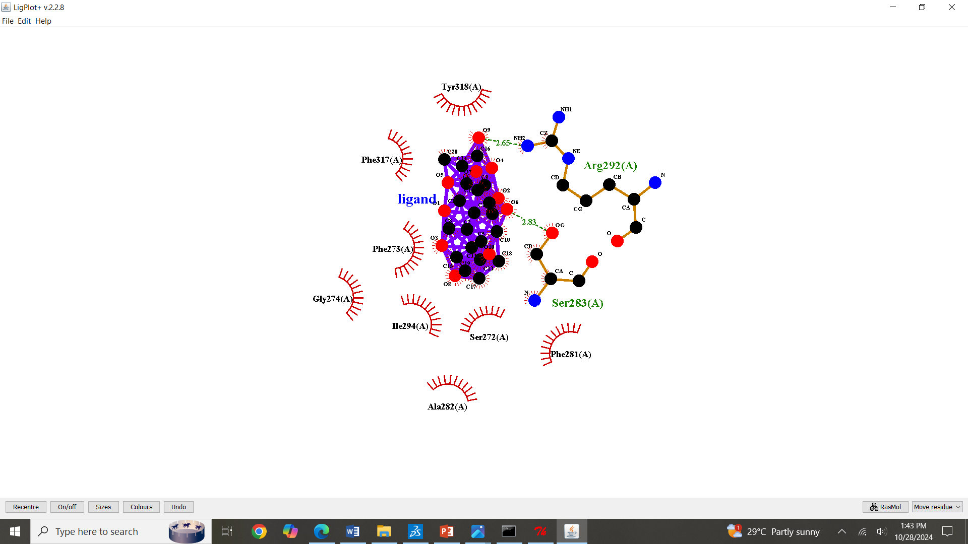
S11: Molecular Docking, secondary structure interaction and ligplus analysis of Ginkolide interactions with Sortilin.
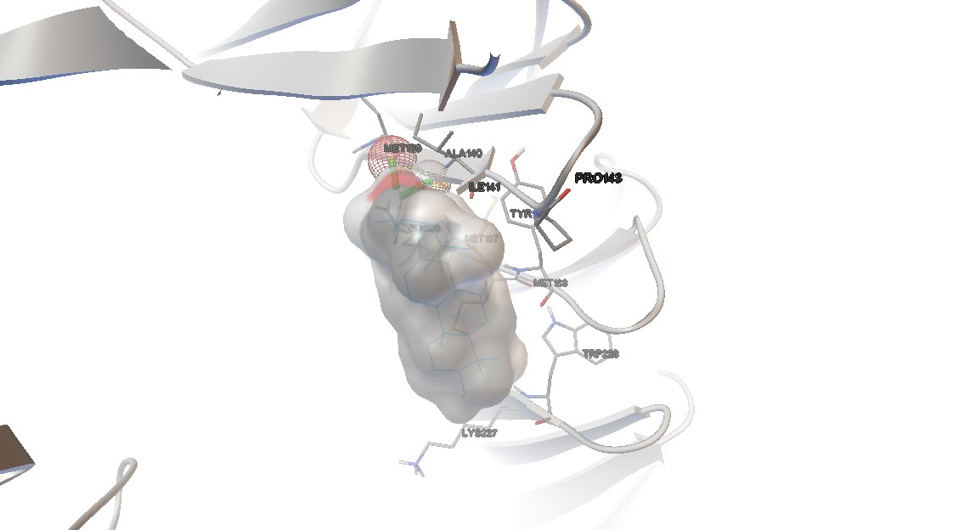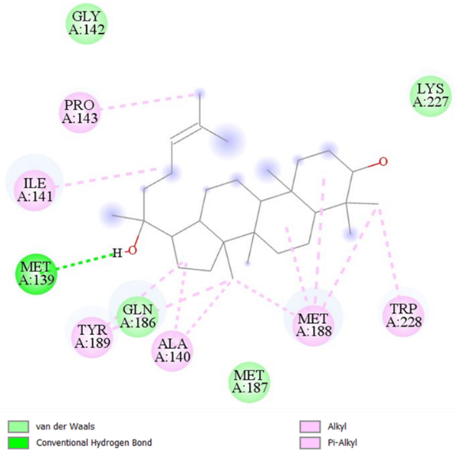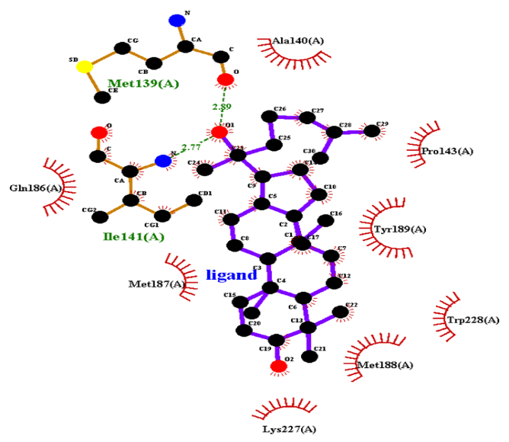
S12: Molecular Docking, secondary structure interaction and ligplus analysis of Ginsenosides interactions with Sortilin.
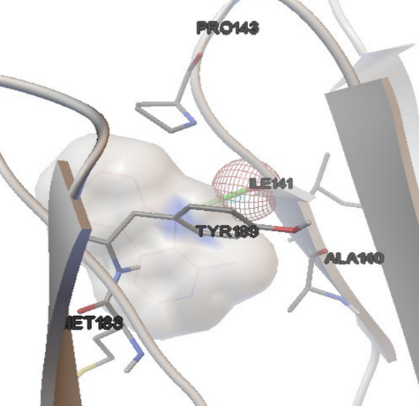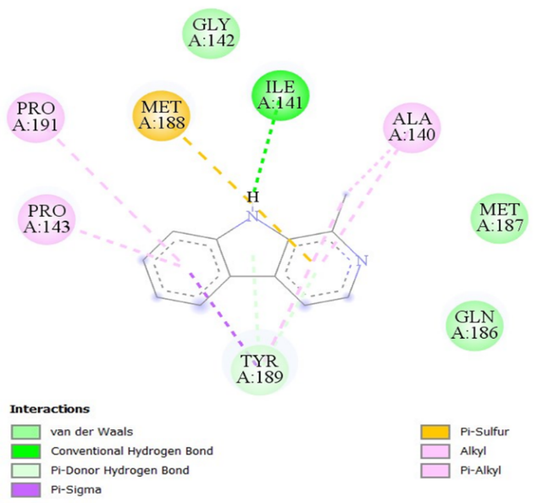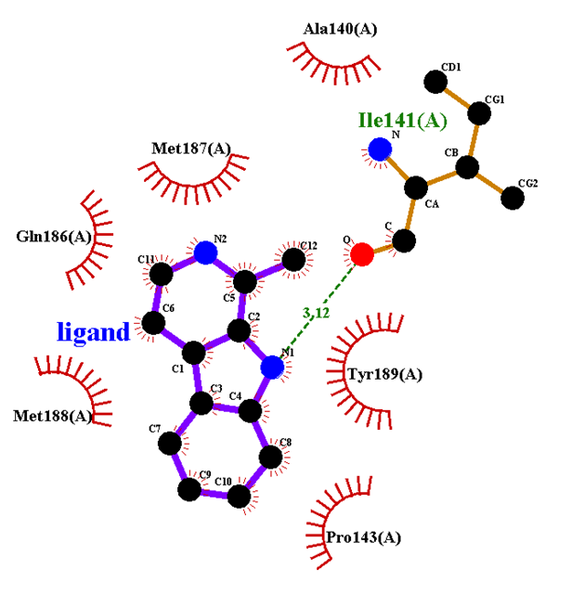
S13: Molecular Docking, secondary structure interaction and ligplus analysis of Harman interactions with Sortilin.
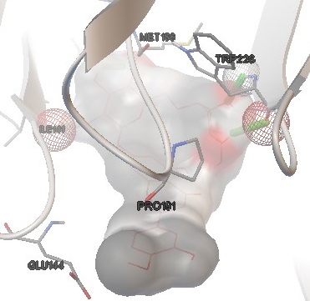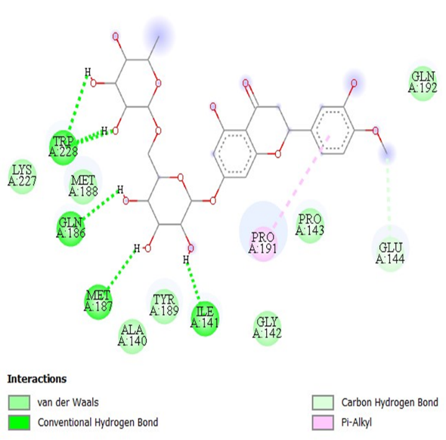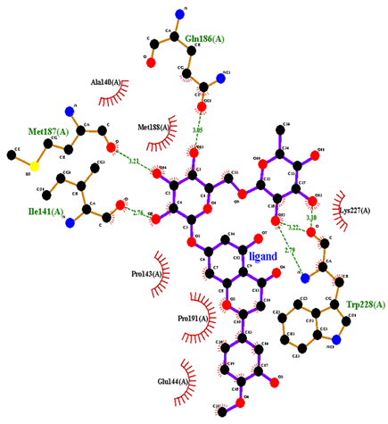
S14: Molecular Docking, secondary structure interaction and ligplus analysis of Hesperidin interactions with Sortilin.
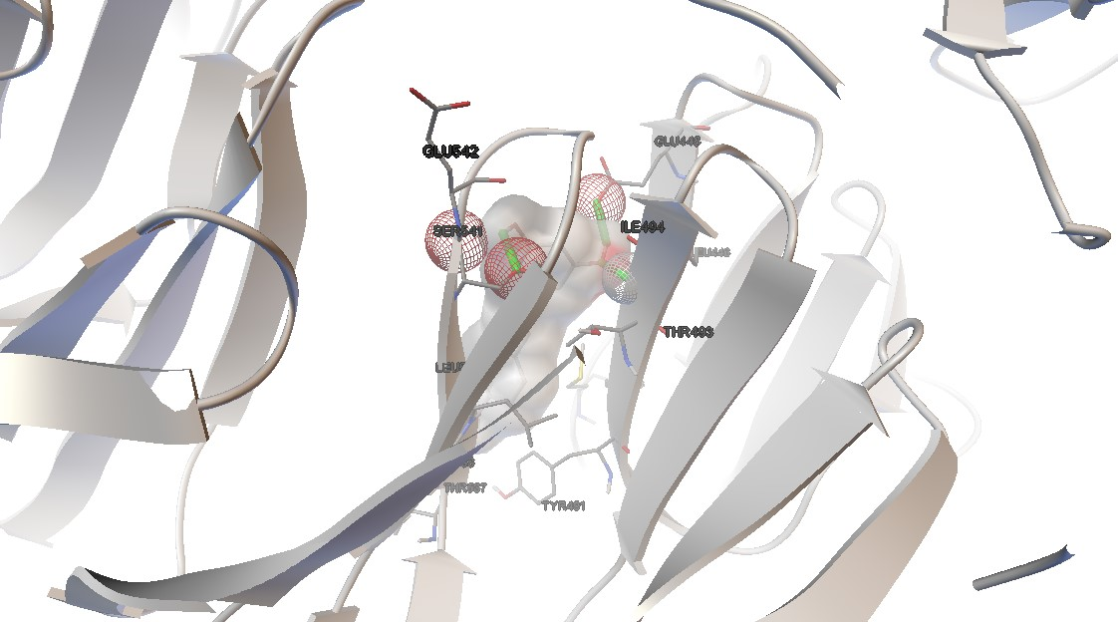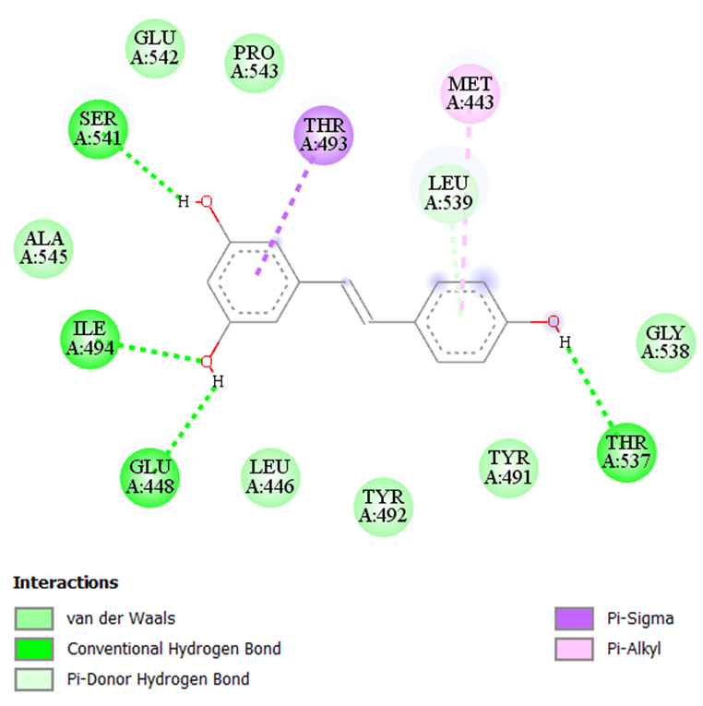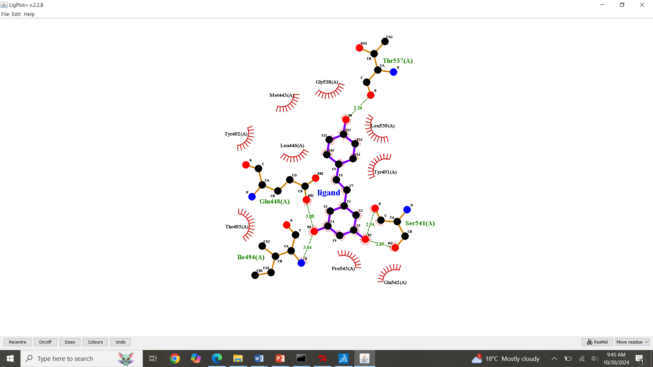
S15: Molecular Docking, secondary structure interaction and ligplus analysis of Resveratrol interactions with Sortilin.
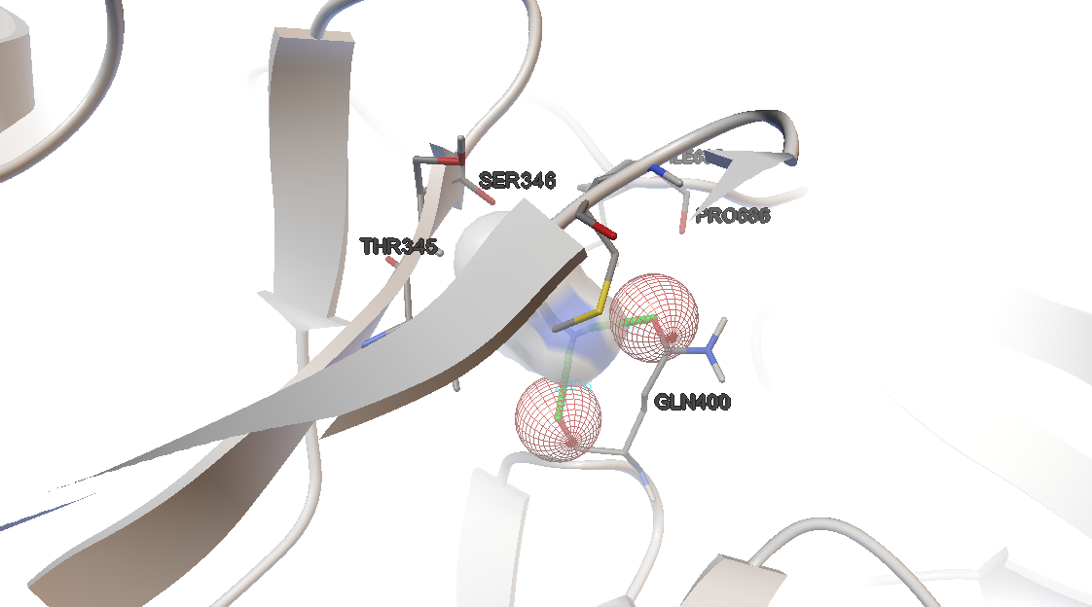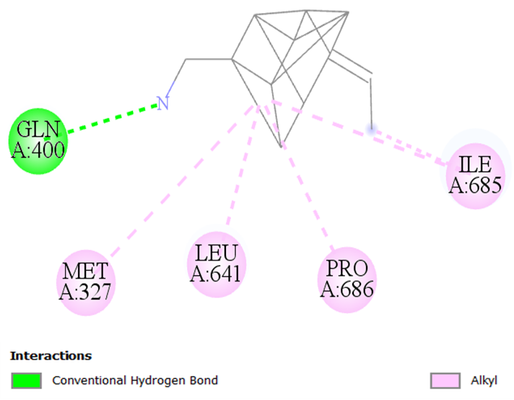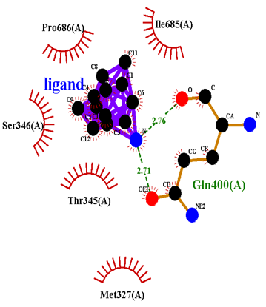
S16: Molecular Docking, secondary structure interaction and ligplus analysis of Memantine interactions with Sortilin.
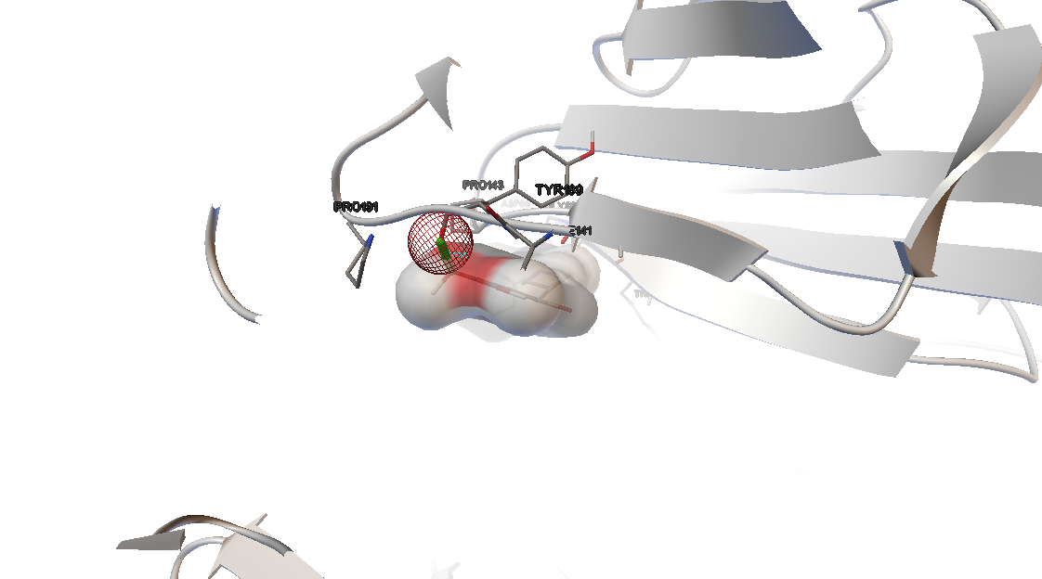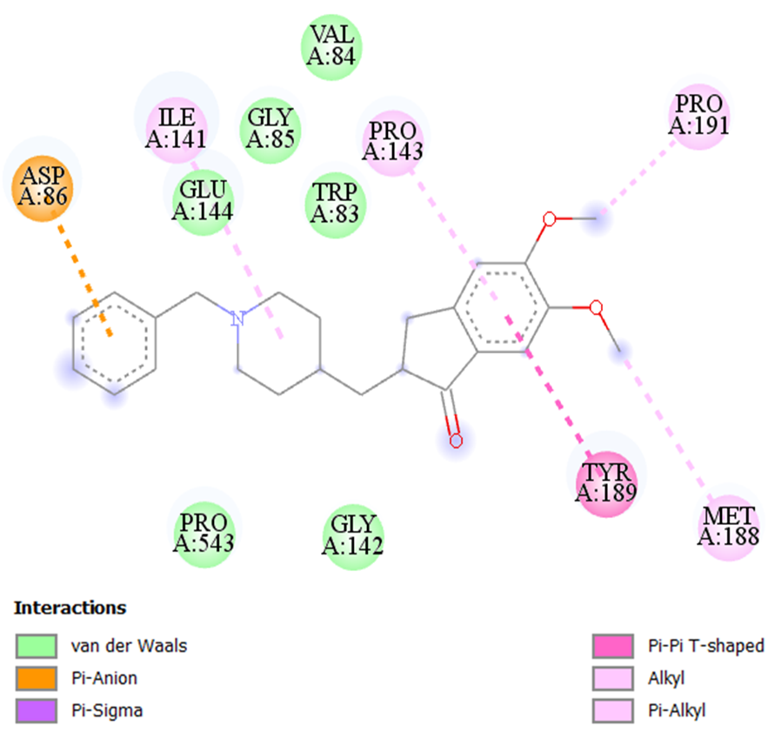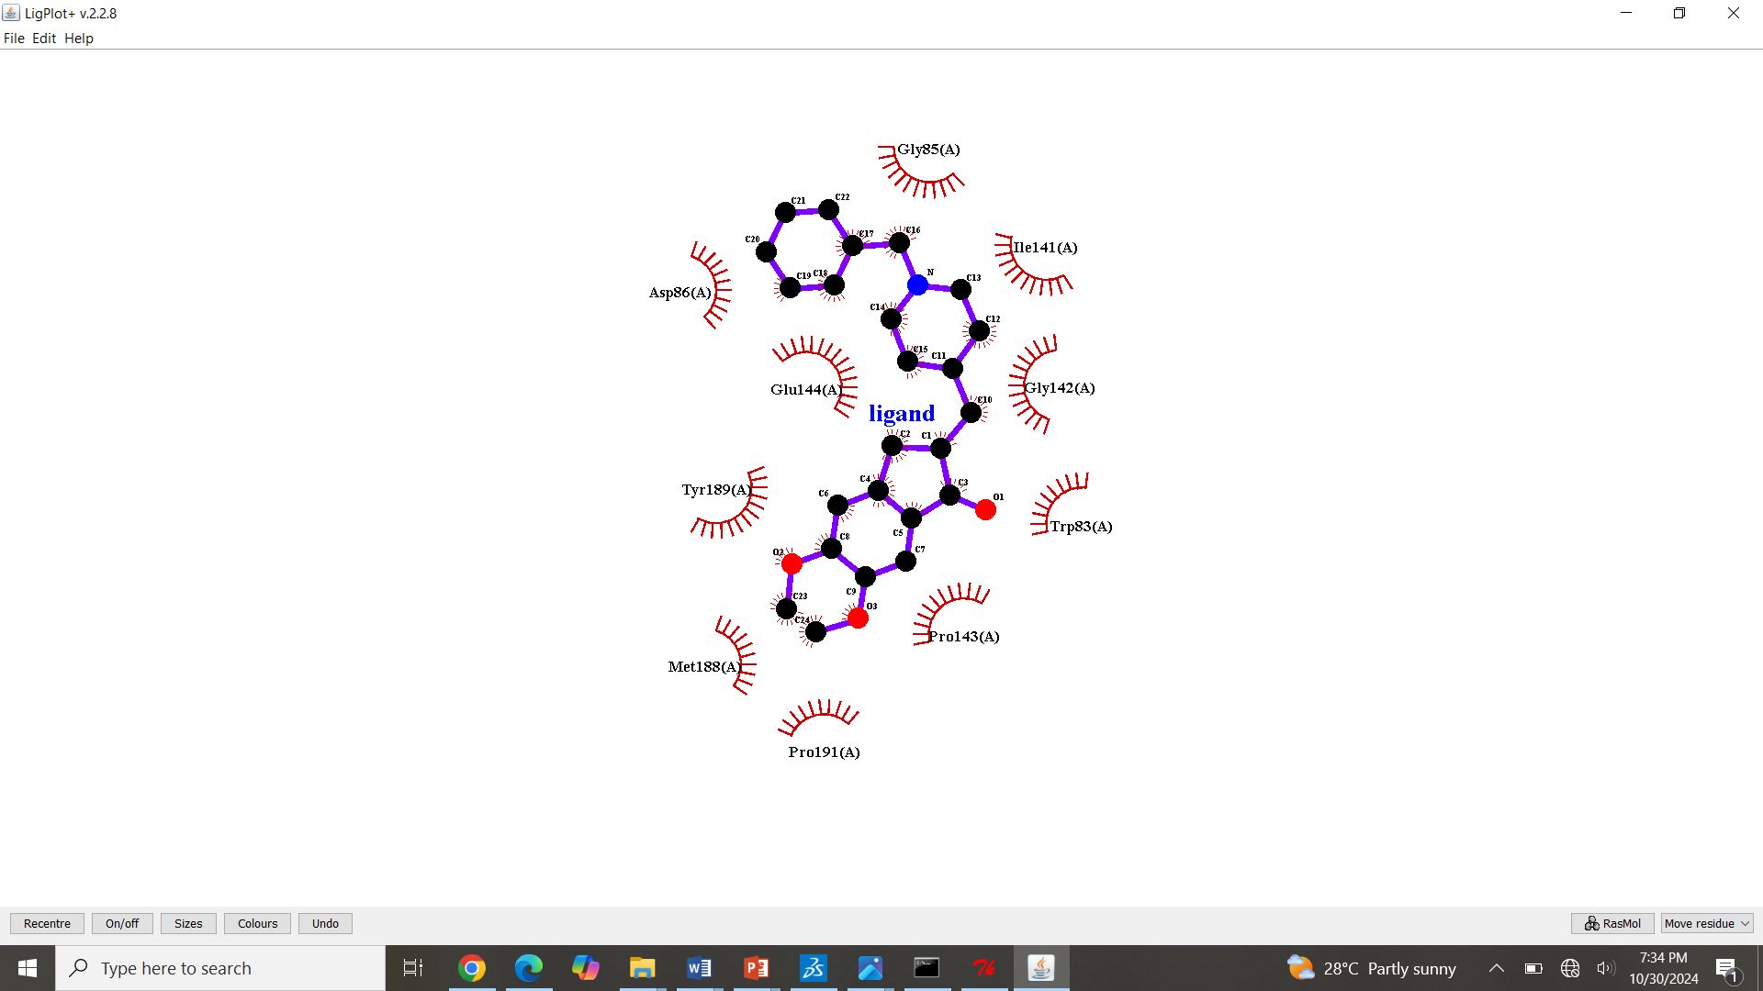
S17: Molecular Docking, secondary structure interaction and ligplus analysis of Donepezil interactions with Sortilin.
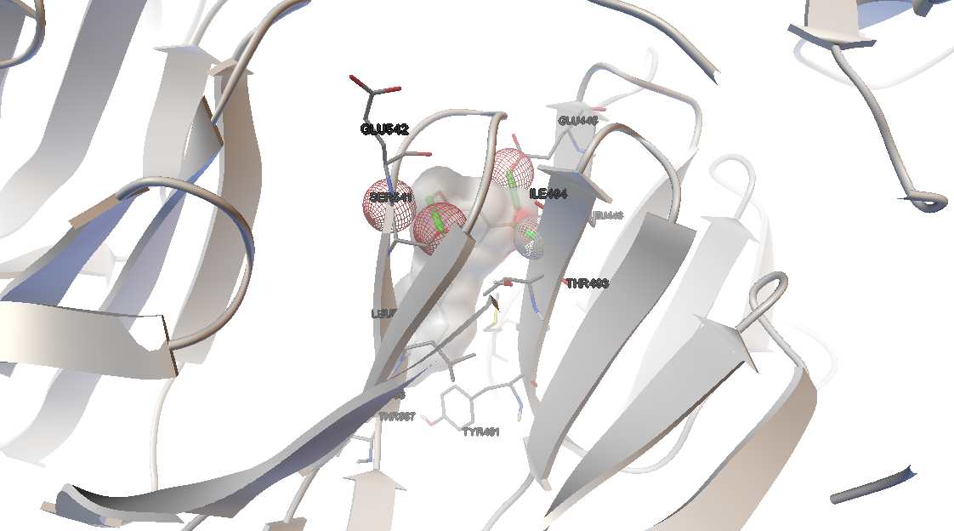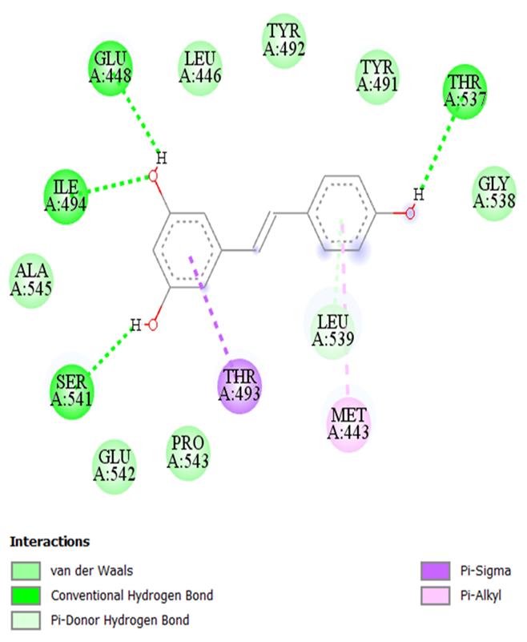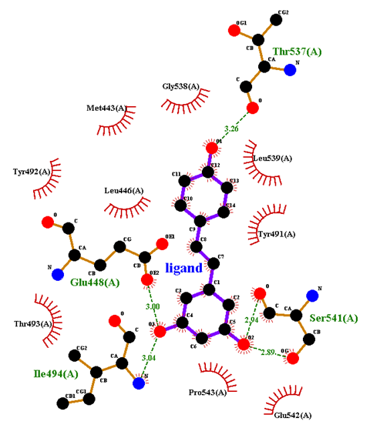
S18: Molecular Docking, secondary structure interaction and ligplus analysis of Rivastigmine interactions with Sortilin.
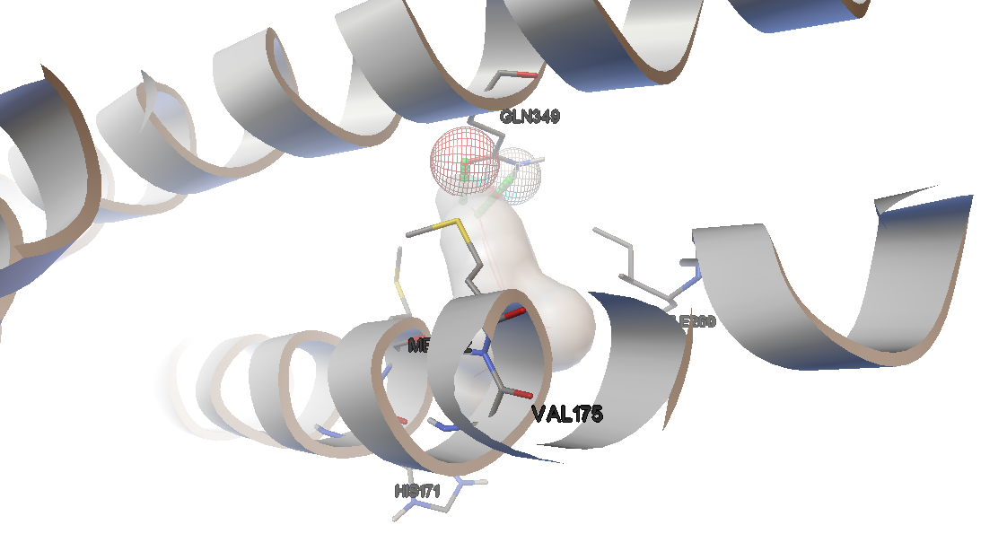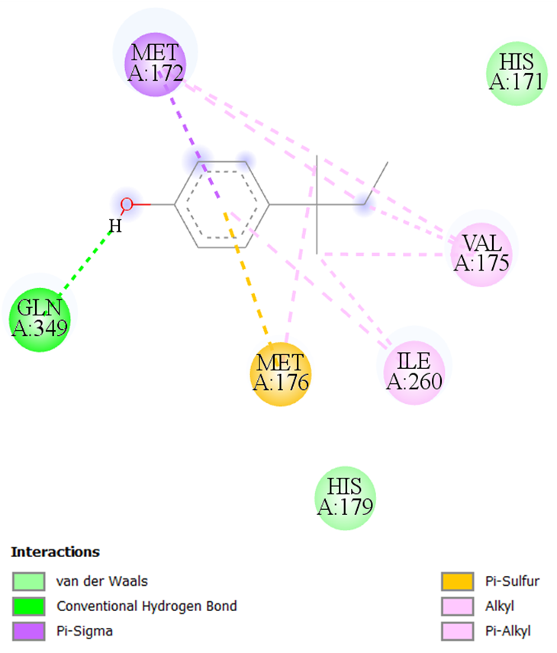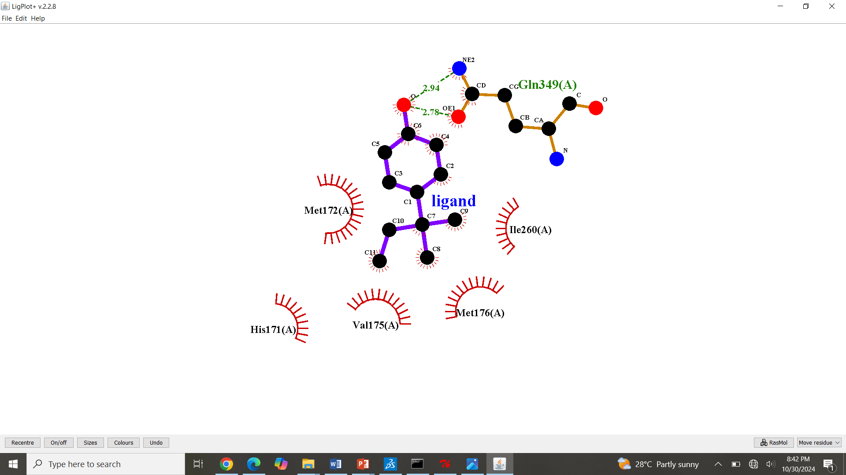
S19: Molecular Docking, secondary structure interaction and ligplus analysis of 4-tert-Amylphenol interactions with Clustrin.
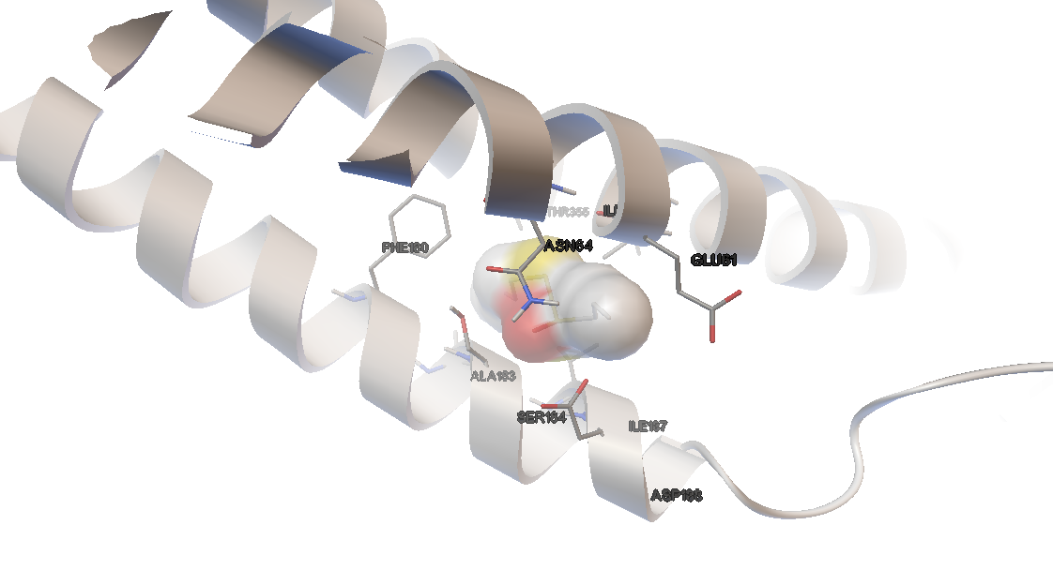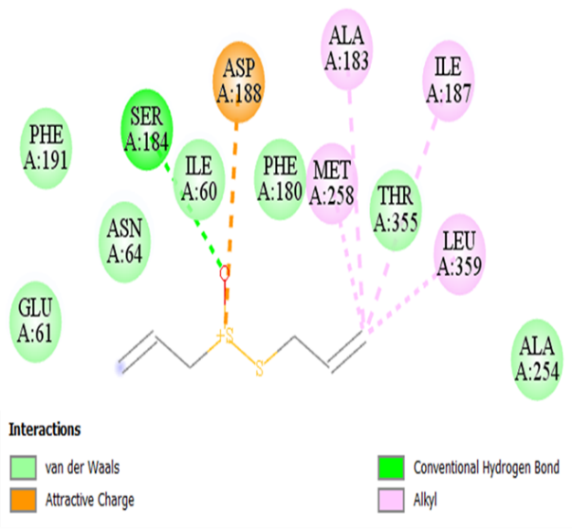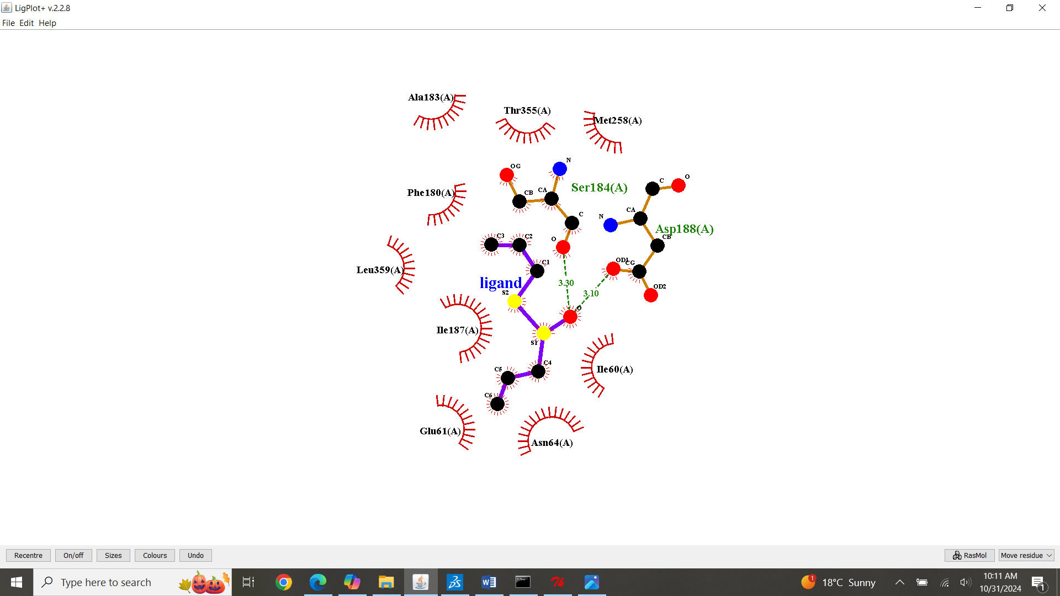
S20: Molecular Docking, secondary structure interaction and ligplus analysis of Allicin interactions with Clustrin.
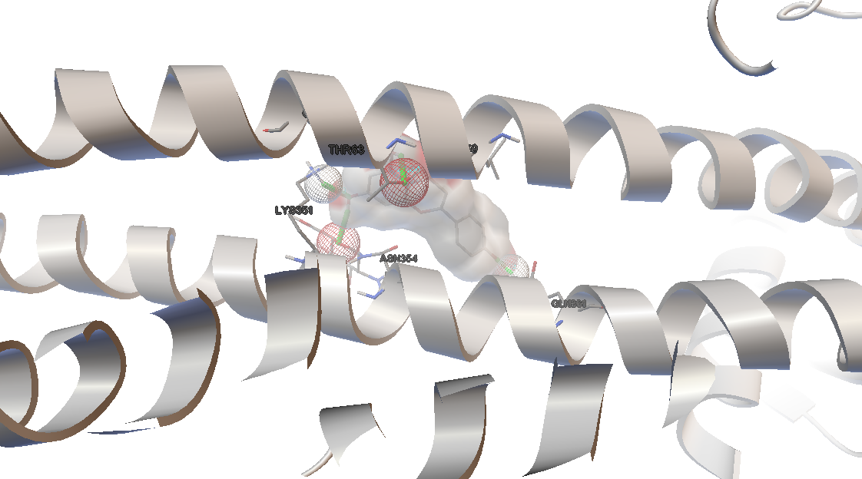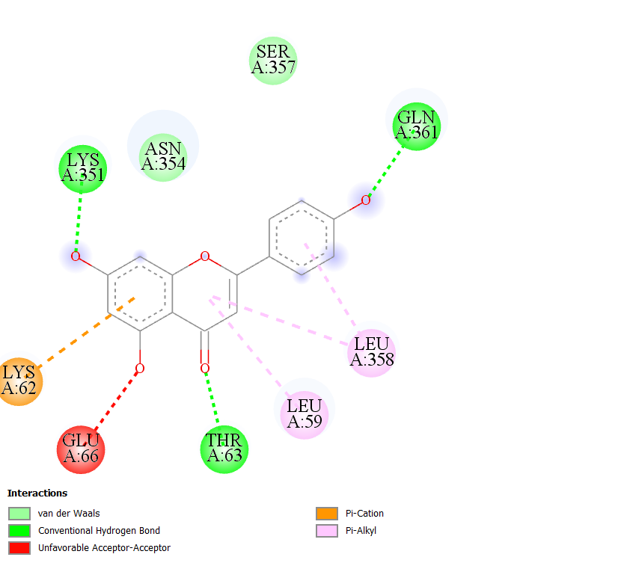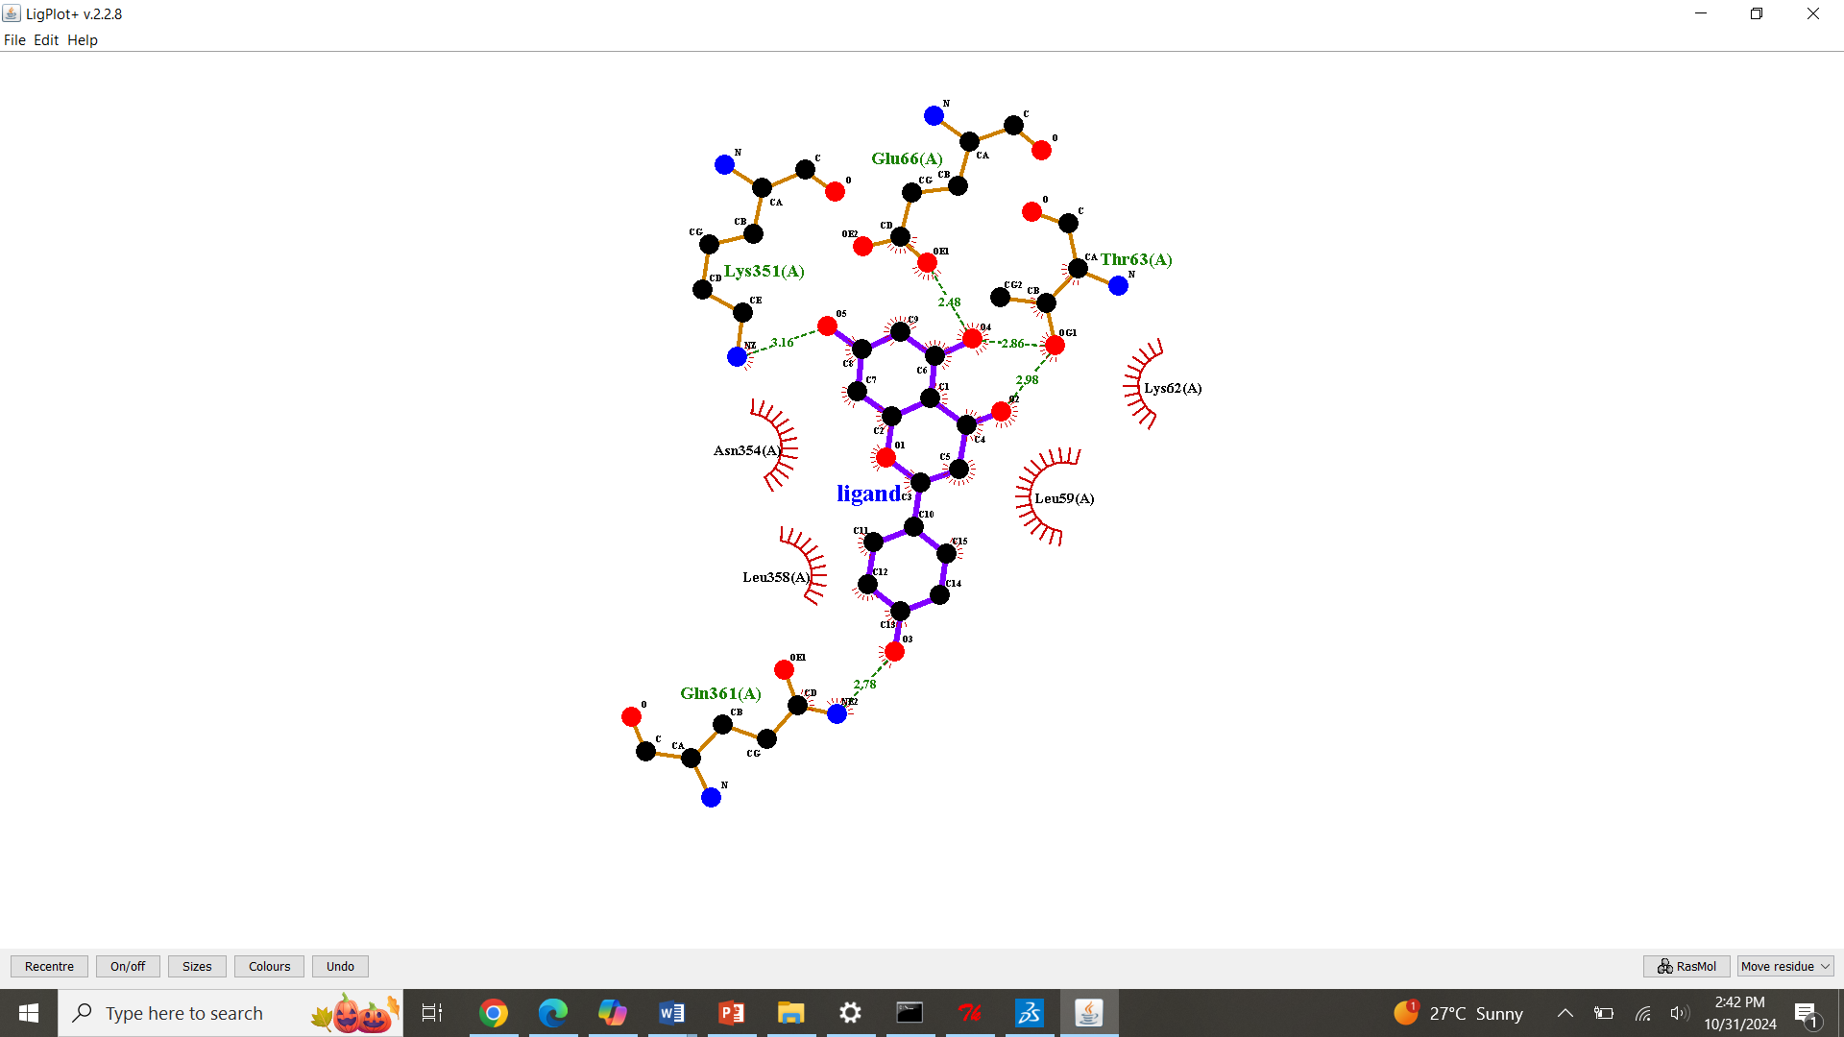
S21: Molecular Docking, secondary structure interaction and ligplus analysis of Apigenin interactions with Clustrin.

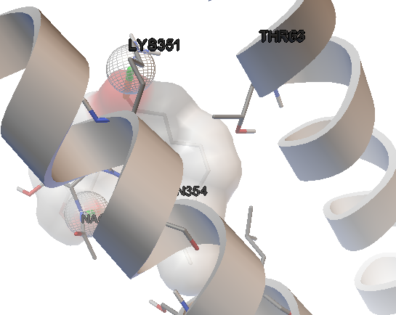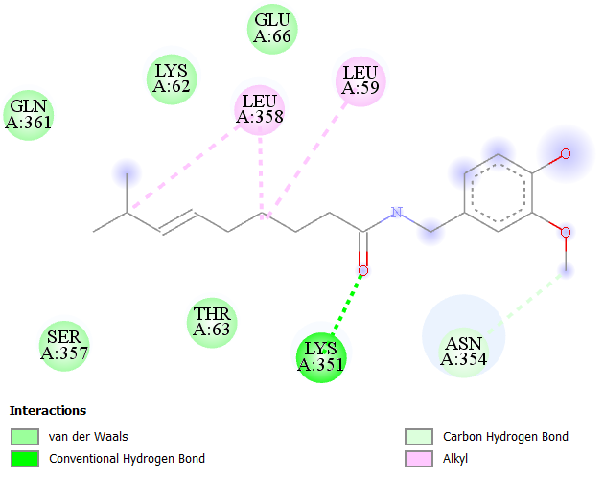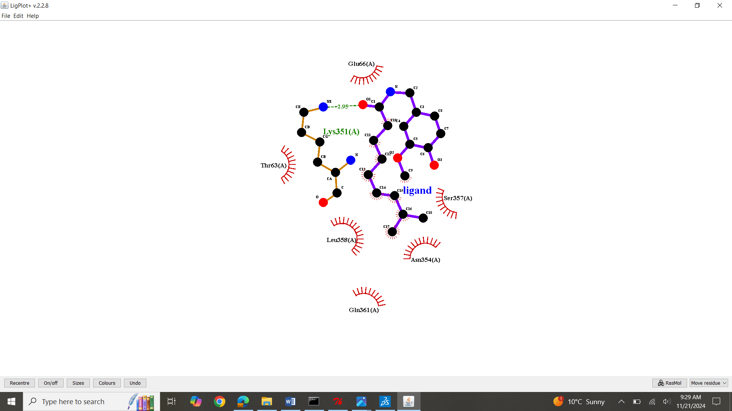
S22: Molecular Docking, secondary structure interaction and ligplus analysis of Astragalosides interactions with Clustrin.
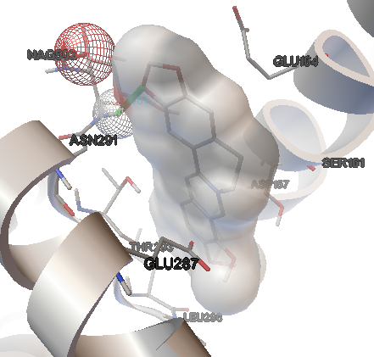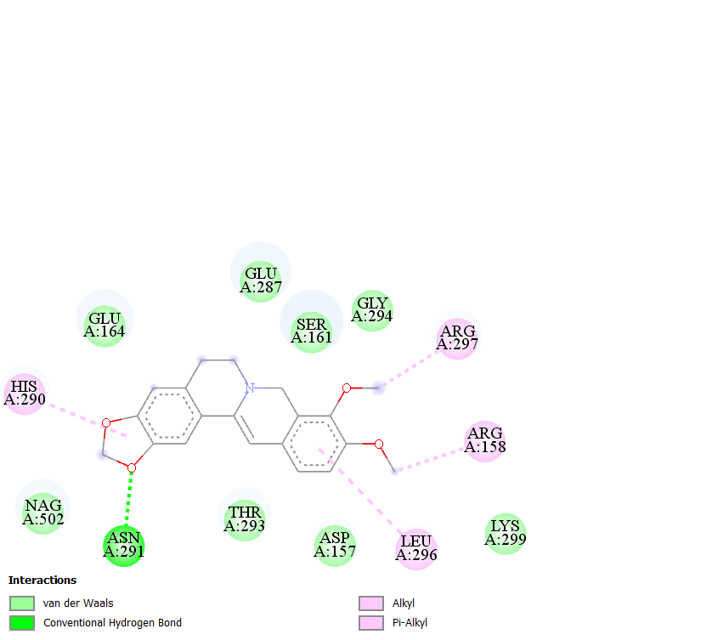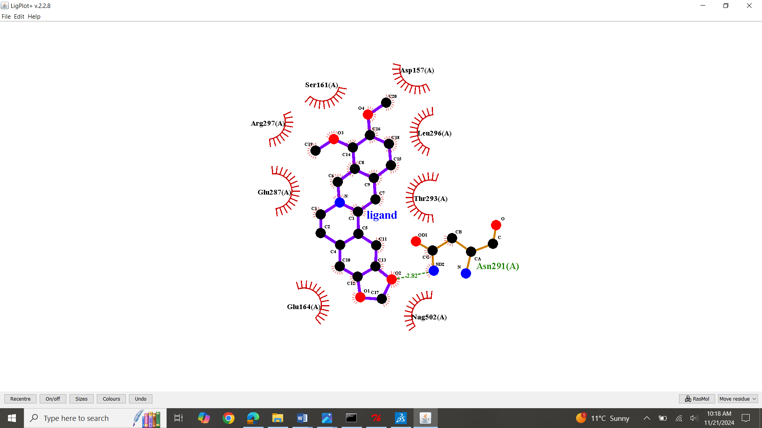
S23: Molecular Docking, secondary structure interaction and ligplus analysis of Berberine interactions with Clustrin.
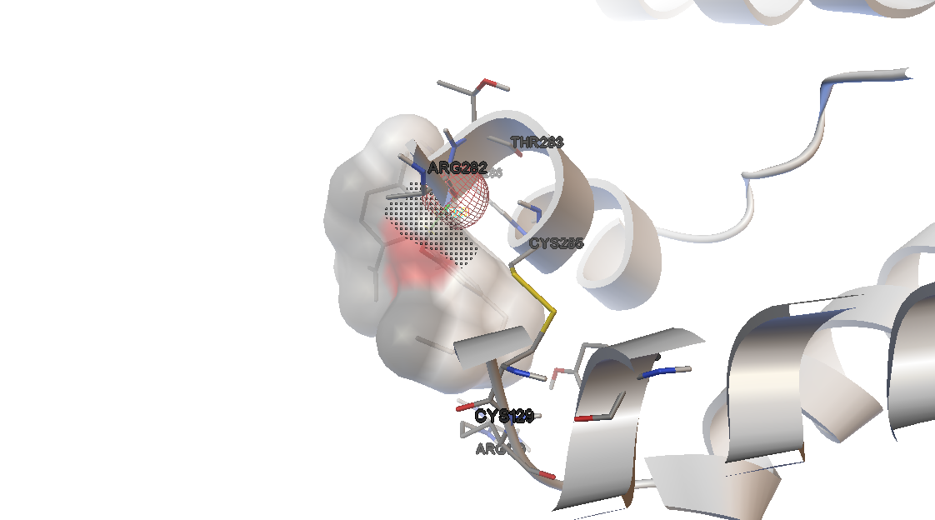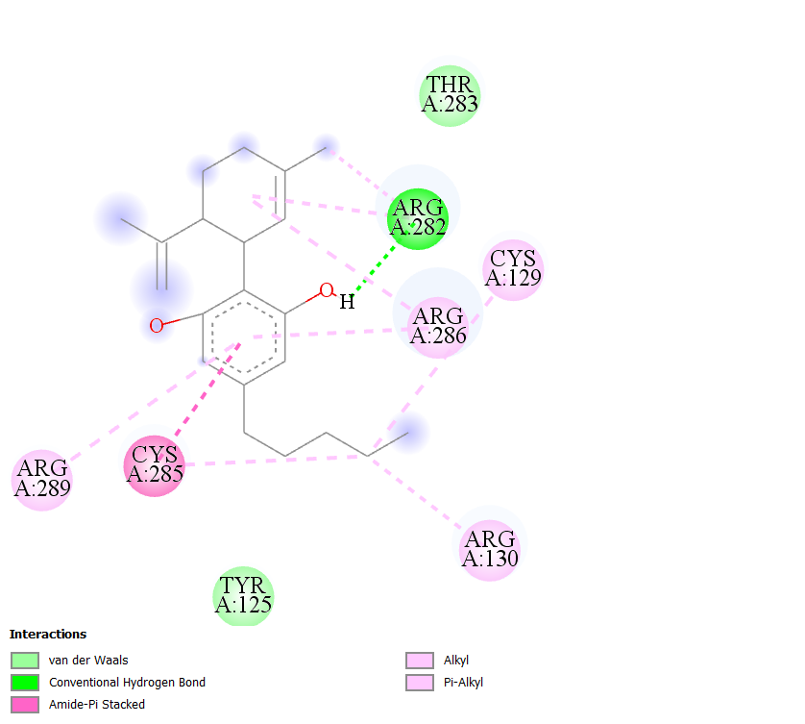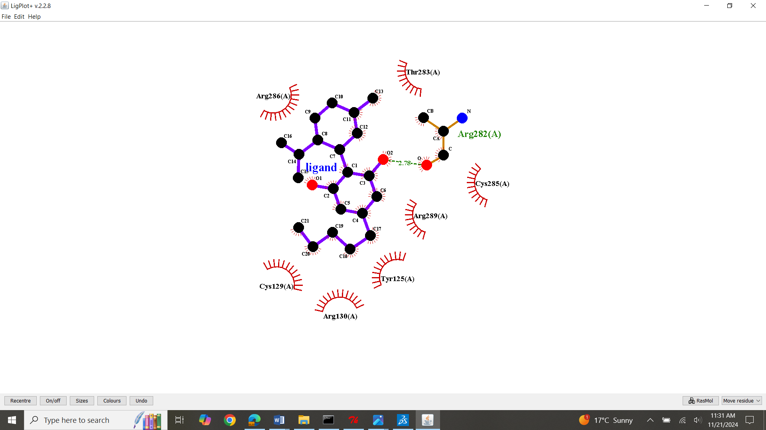
S24: Molecular Docking, secondary structure interaction and ligplus analysis of Cannabidiol interactions with Clustrin.
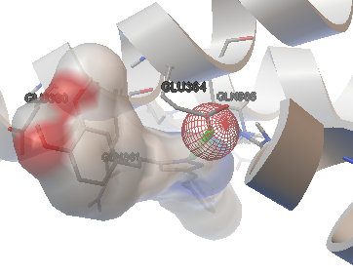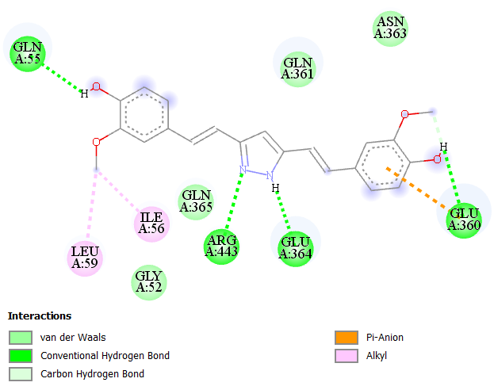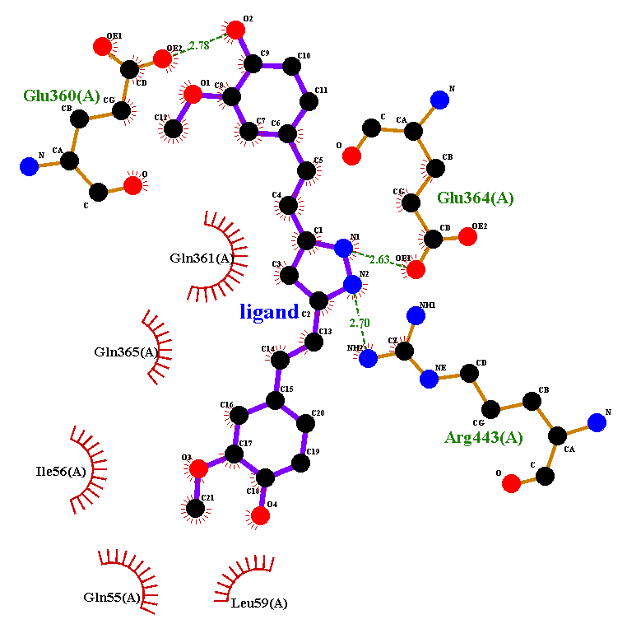
S25: Molecular Docking, secondary structure interaction and ligplus analysis of Curcumin interactions with Clustrin.
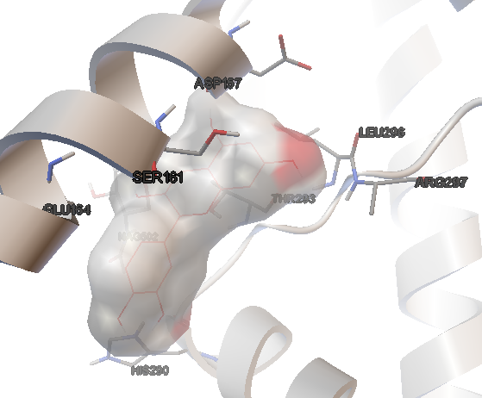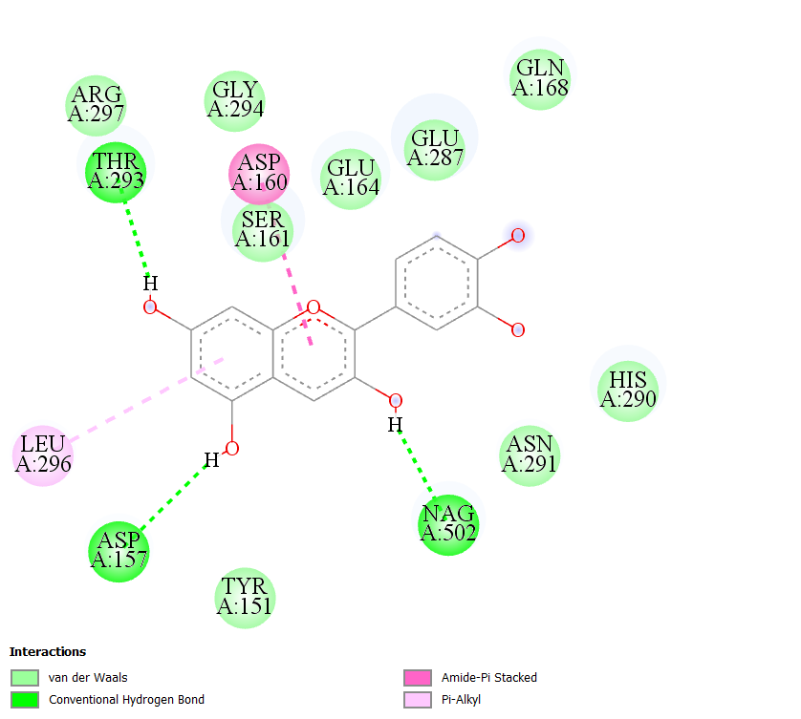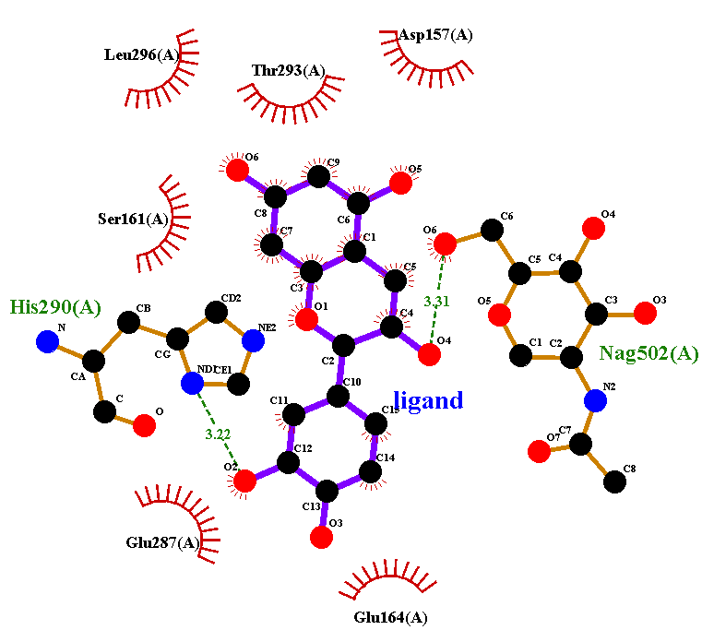
S26: Molecular Docking, secondary structure interaction and ligplus analysis of Cynidin interactions with Clustrin.
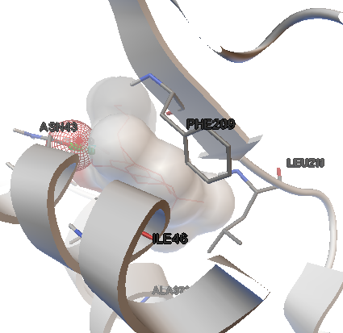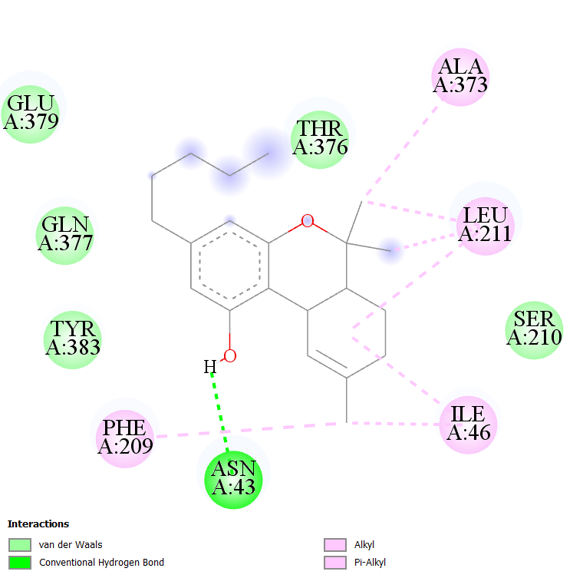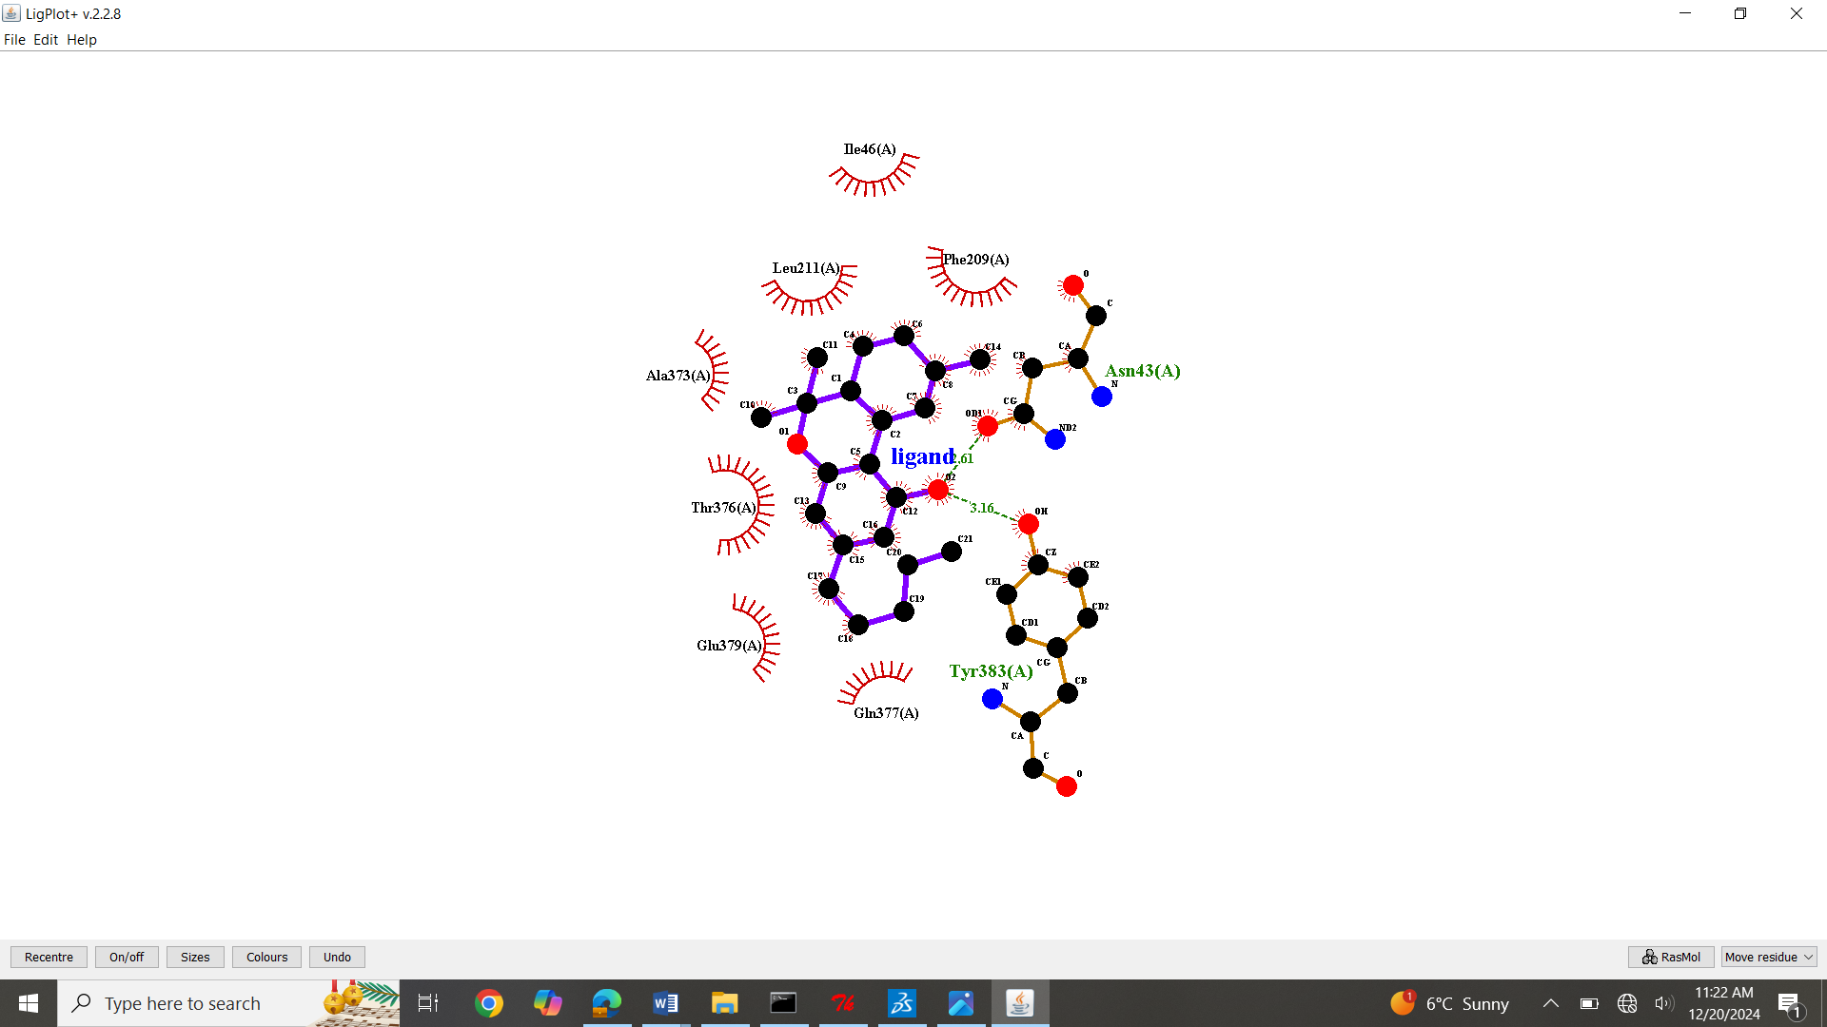
S27: Molecular Docking, secondary structure interaction and ligplus analysis of Dronabinol interactions with Clustrin.
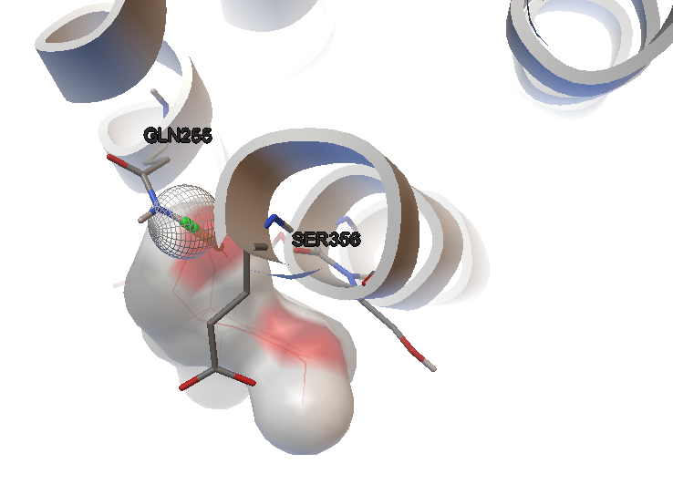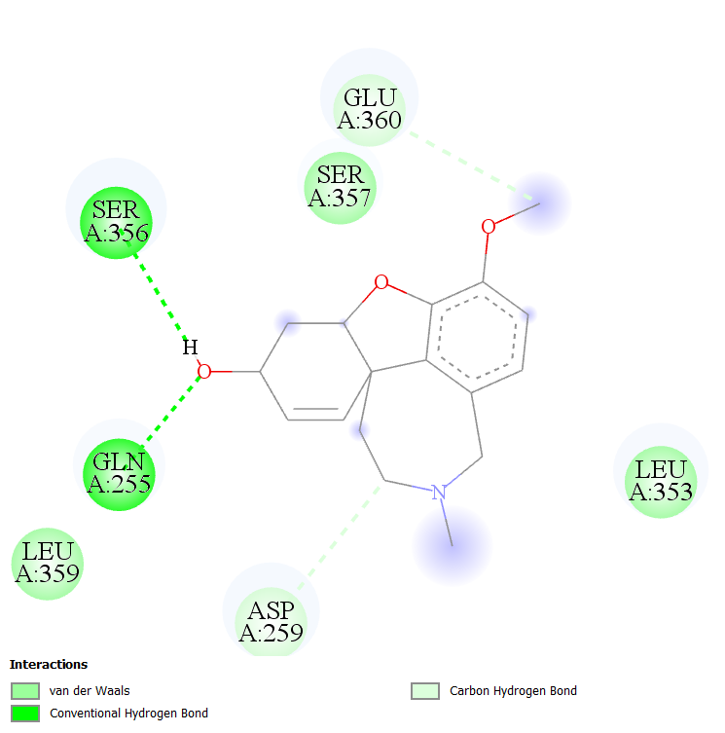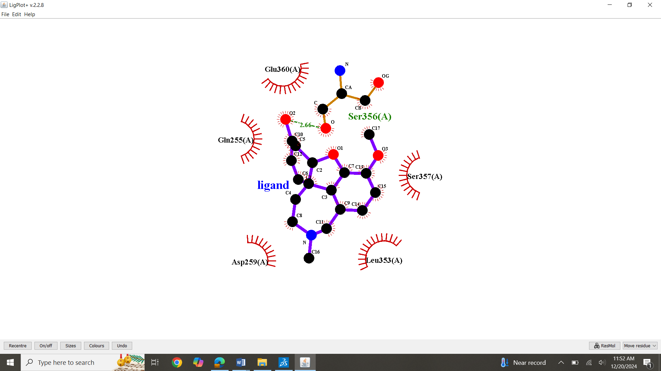

S28: Molecular Docking, secondary structure interaction and ligplus analysis of Galantamine interactions with Clustrin.
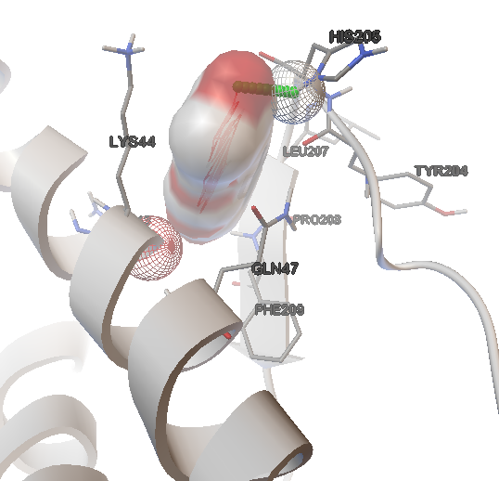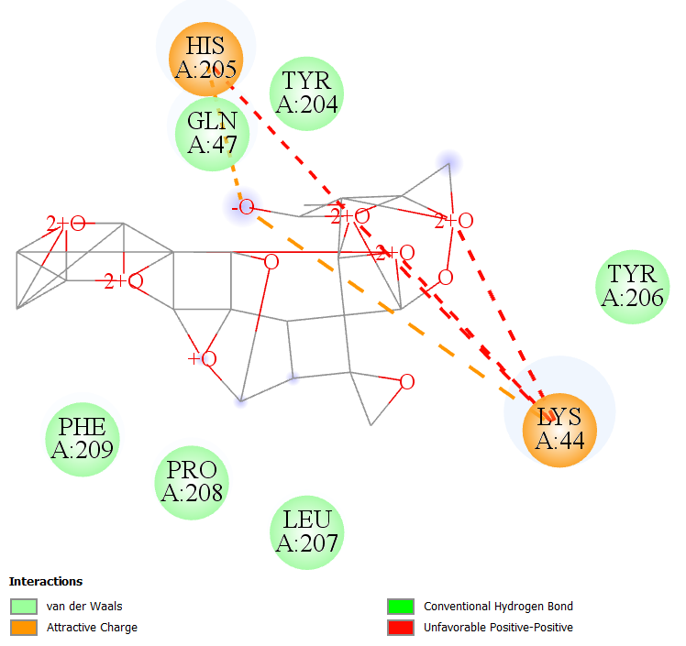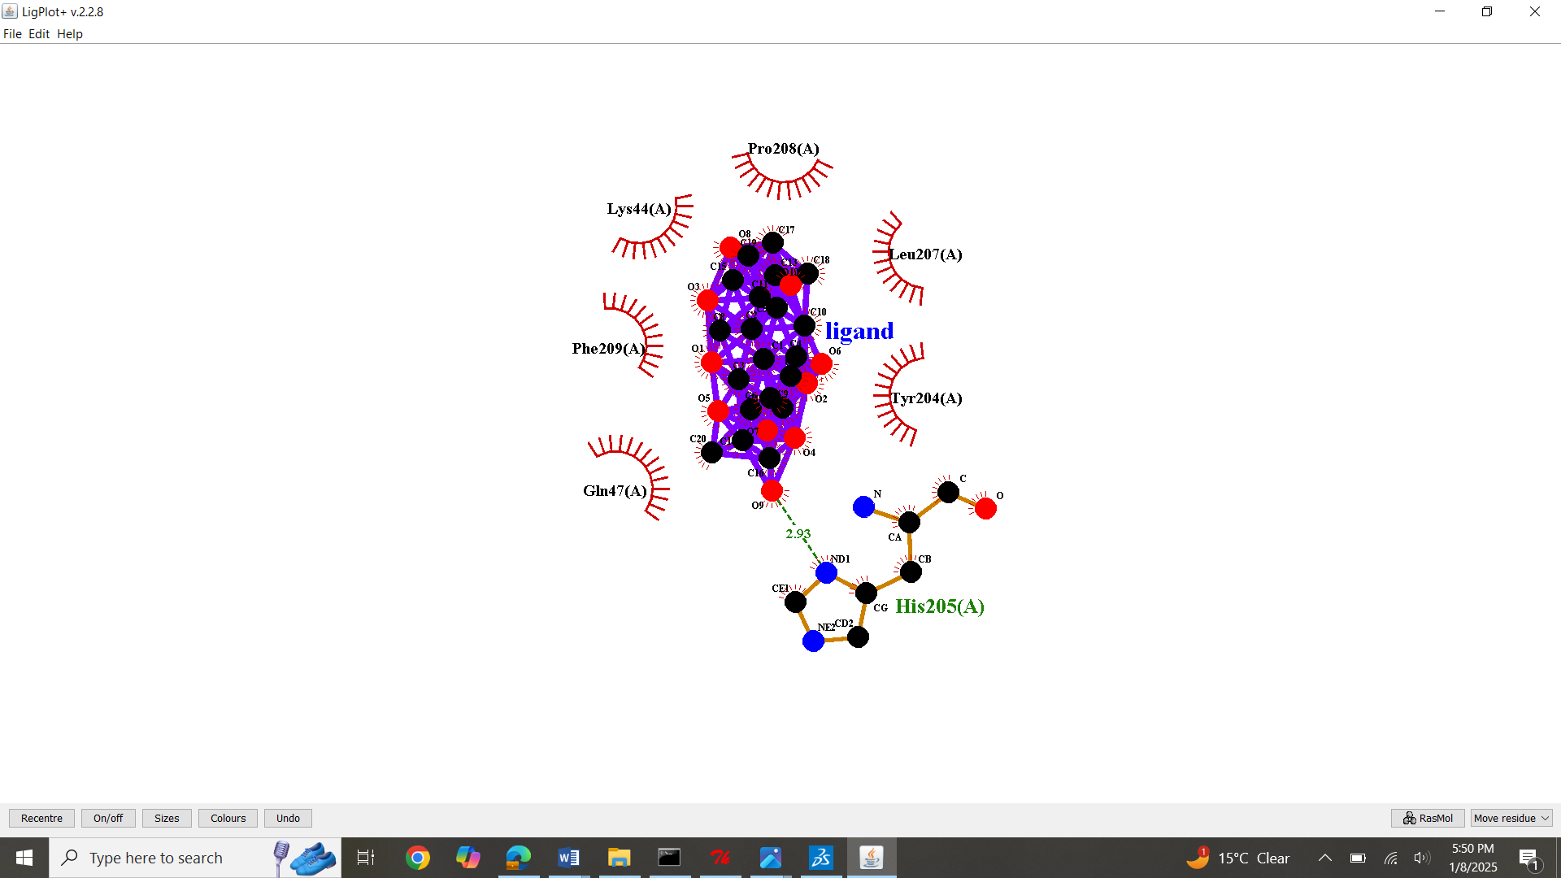
S29: Molecular Docking, secondary structure interaction and ligplus analysis of Ginkolide interactions with Clustrin.
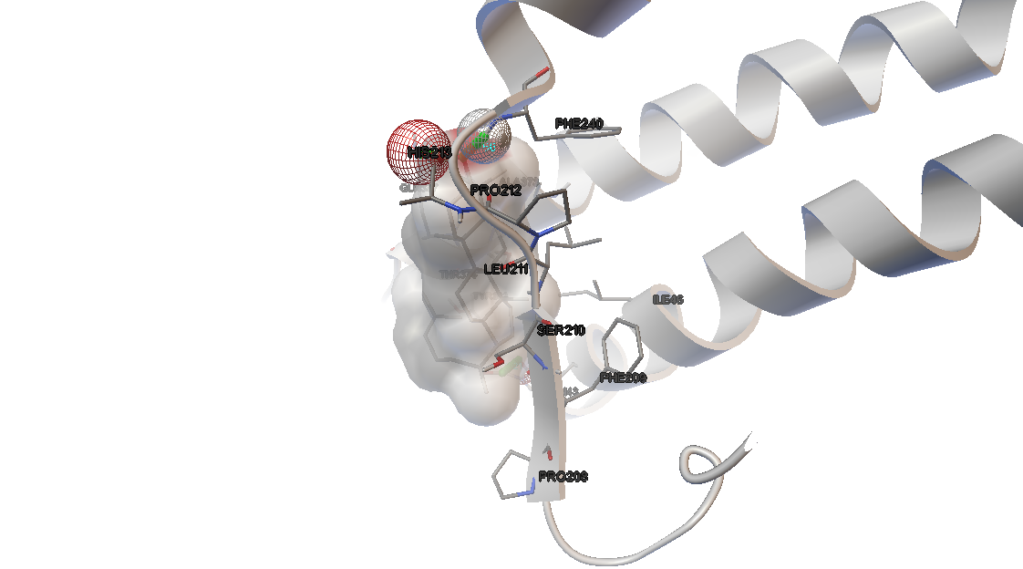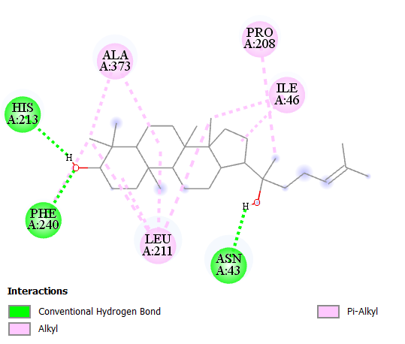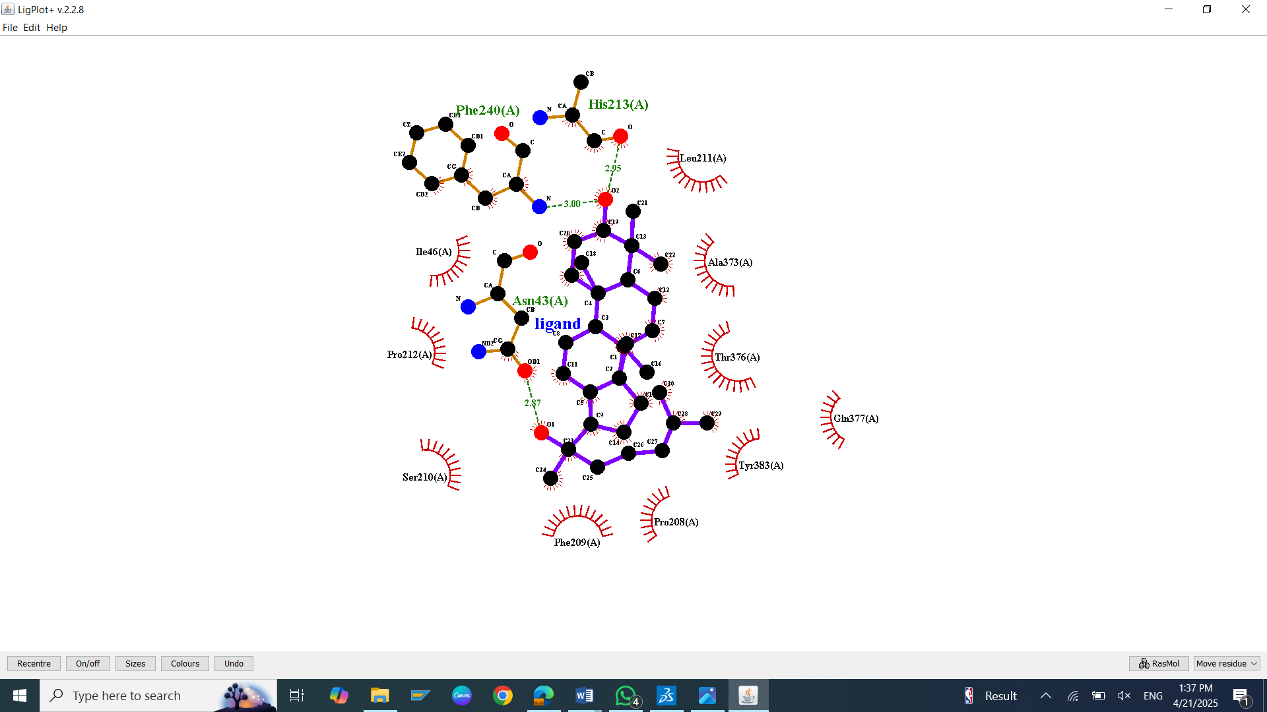
S30: Molecular Docking, secondary structure interaction and ligplus analysis of Ginsenosides interactions with Clustrin.
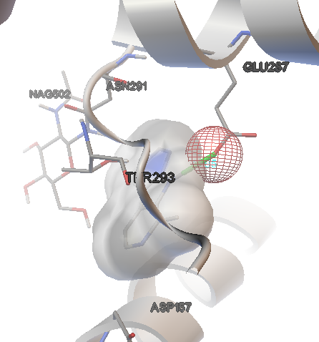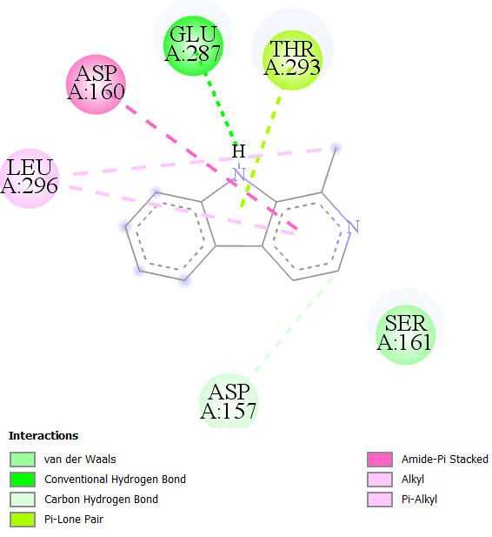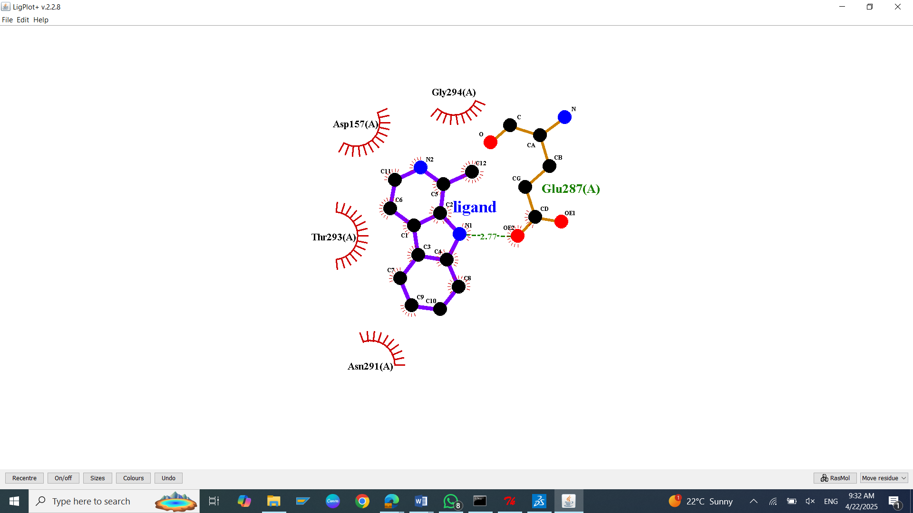
S31: Molecular Docking, secondary structure interaction and ligplus analysis of Harman interactions with Clustrin.
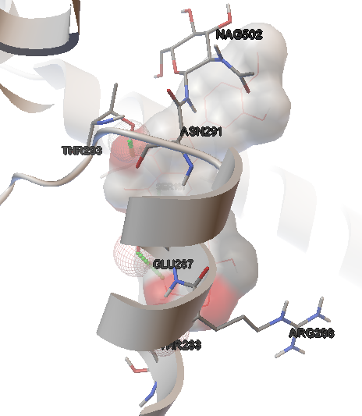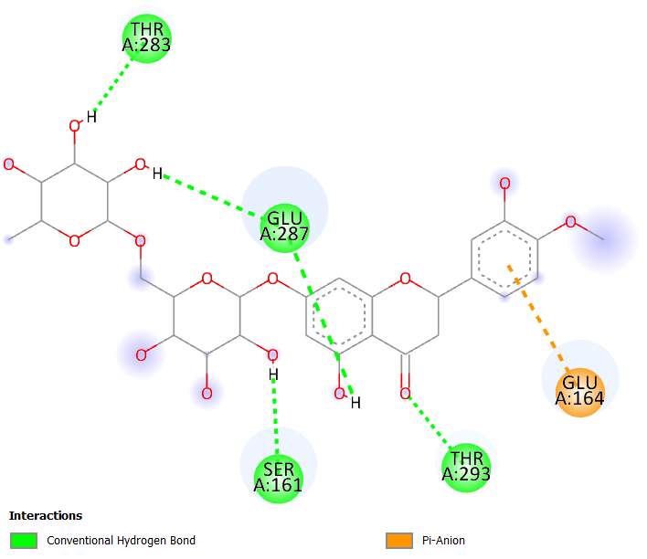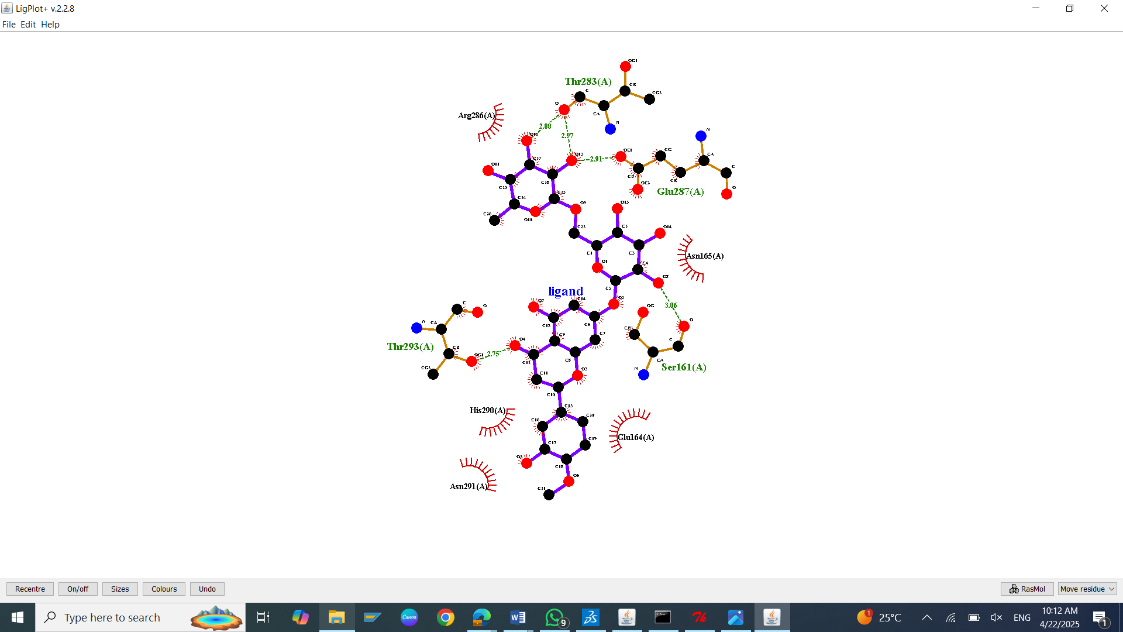
S32: Molecular Docking, secondary structure interaction and ligplus analysis of Hesperidin interactions with Clustrin.
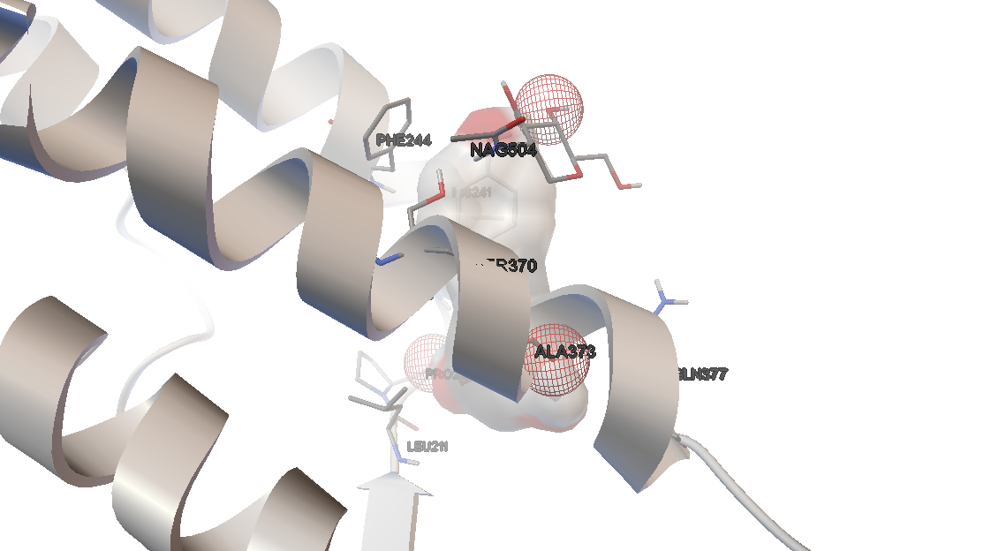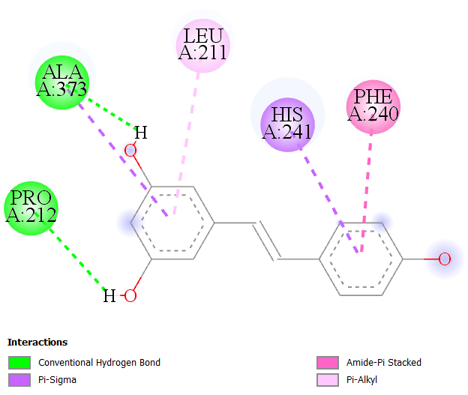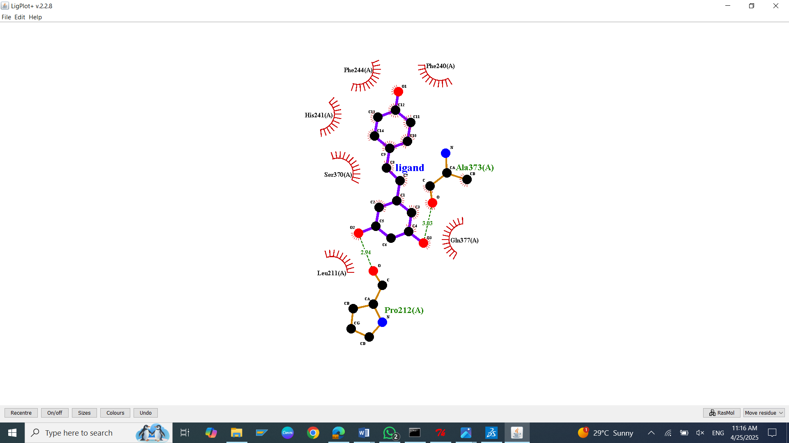
S33: Molecular Docking, secondary structure interaction and ligplus analysis of Resveratrol interactions with Clustrin.
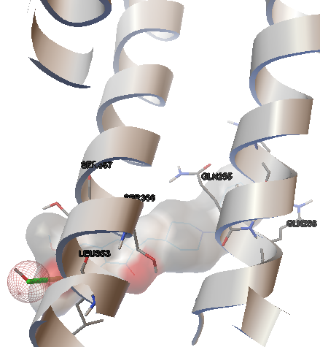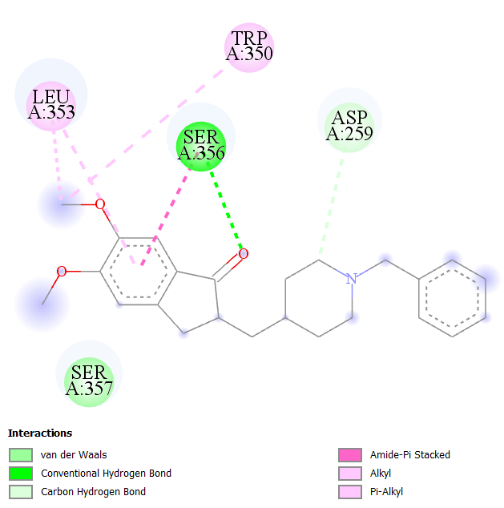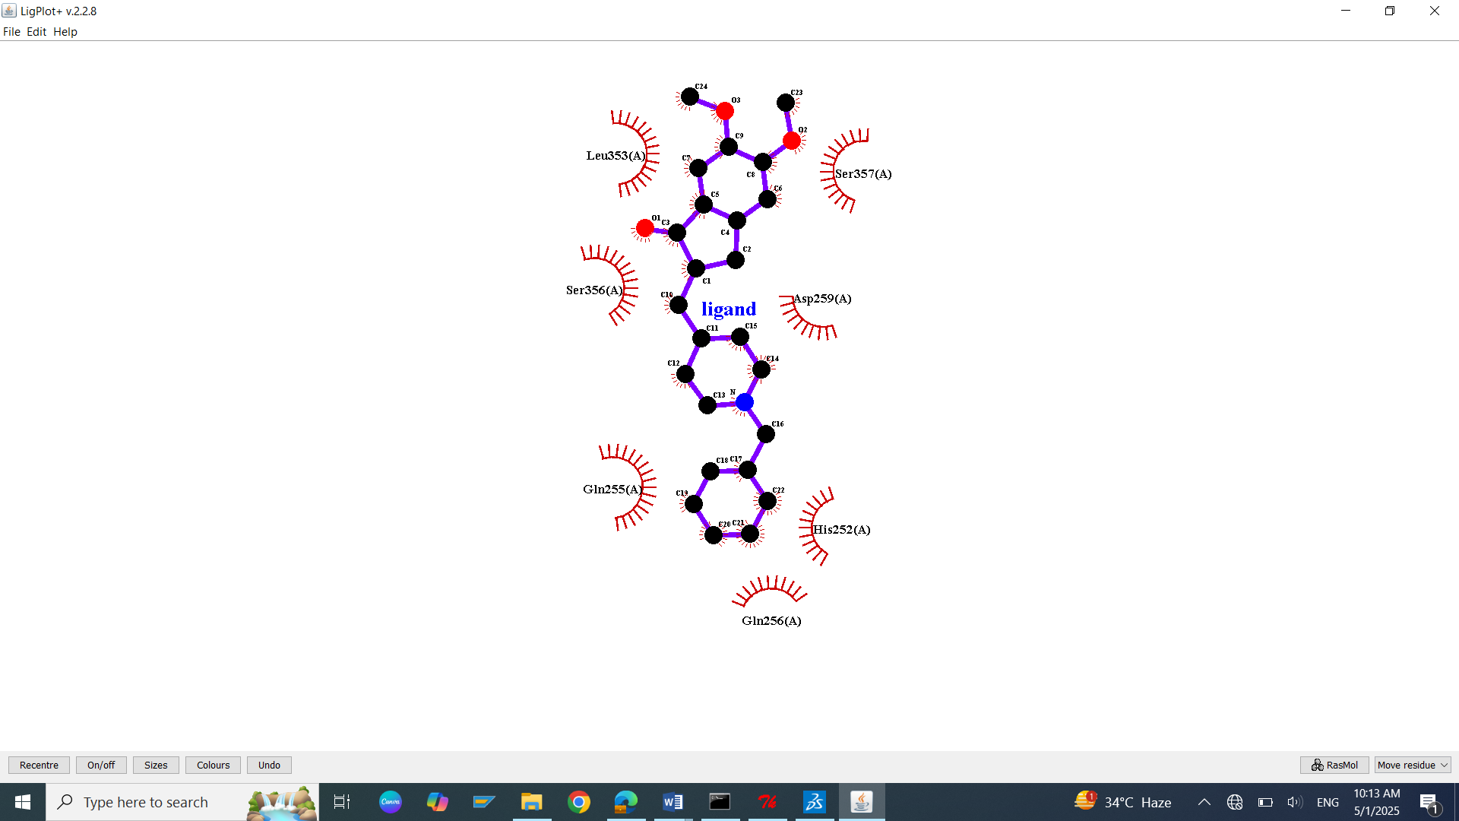
S34: Molecular Docking, secondary structure interaction and ligplus analysis of Donepezil interactions with Clustrin.
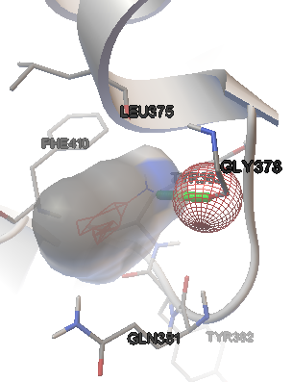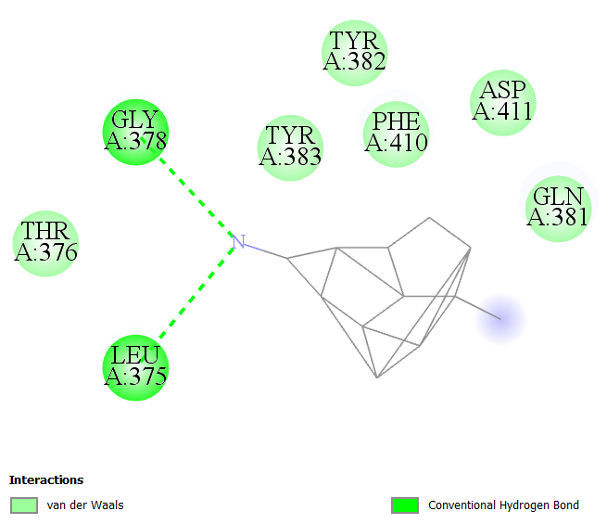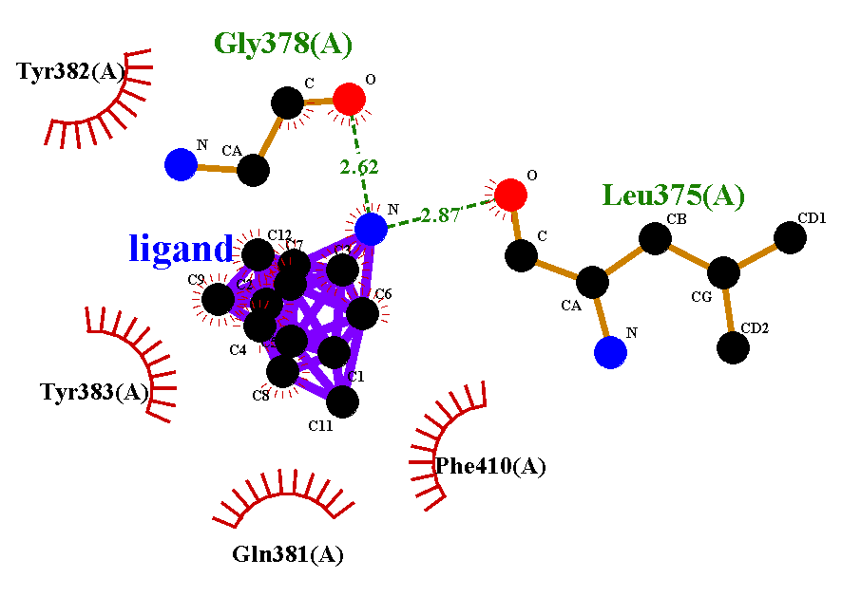
S35: Molecular Docking, secondary structure interaction and ligplus analysis of Memantine interactions with Clustrin.
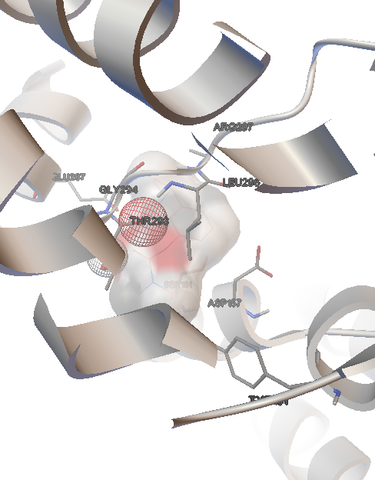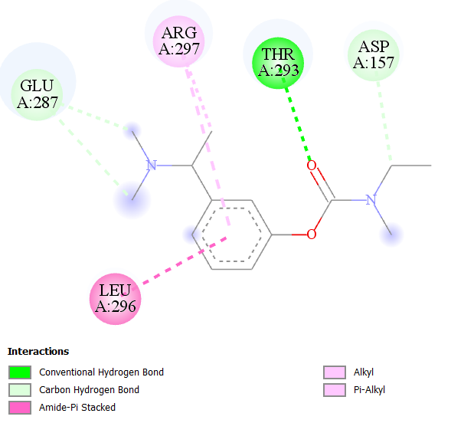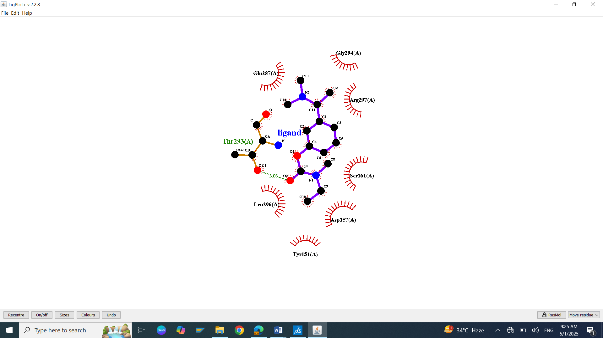
S36: Molecular Docking, secondary structure interaction and ligplus analysis of Rivastigmine interactions with Clustrin.

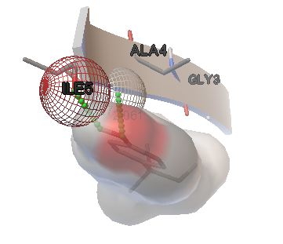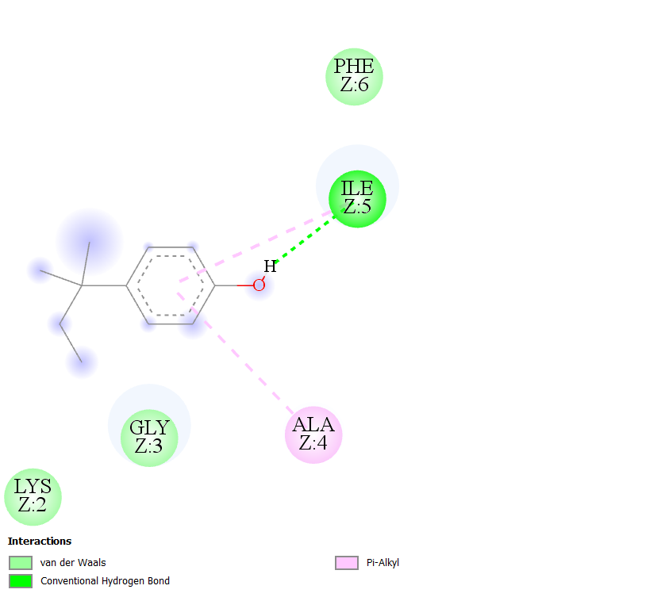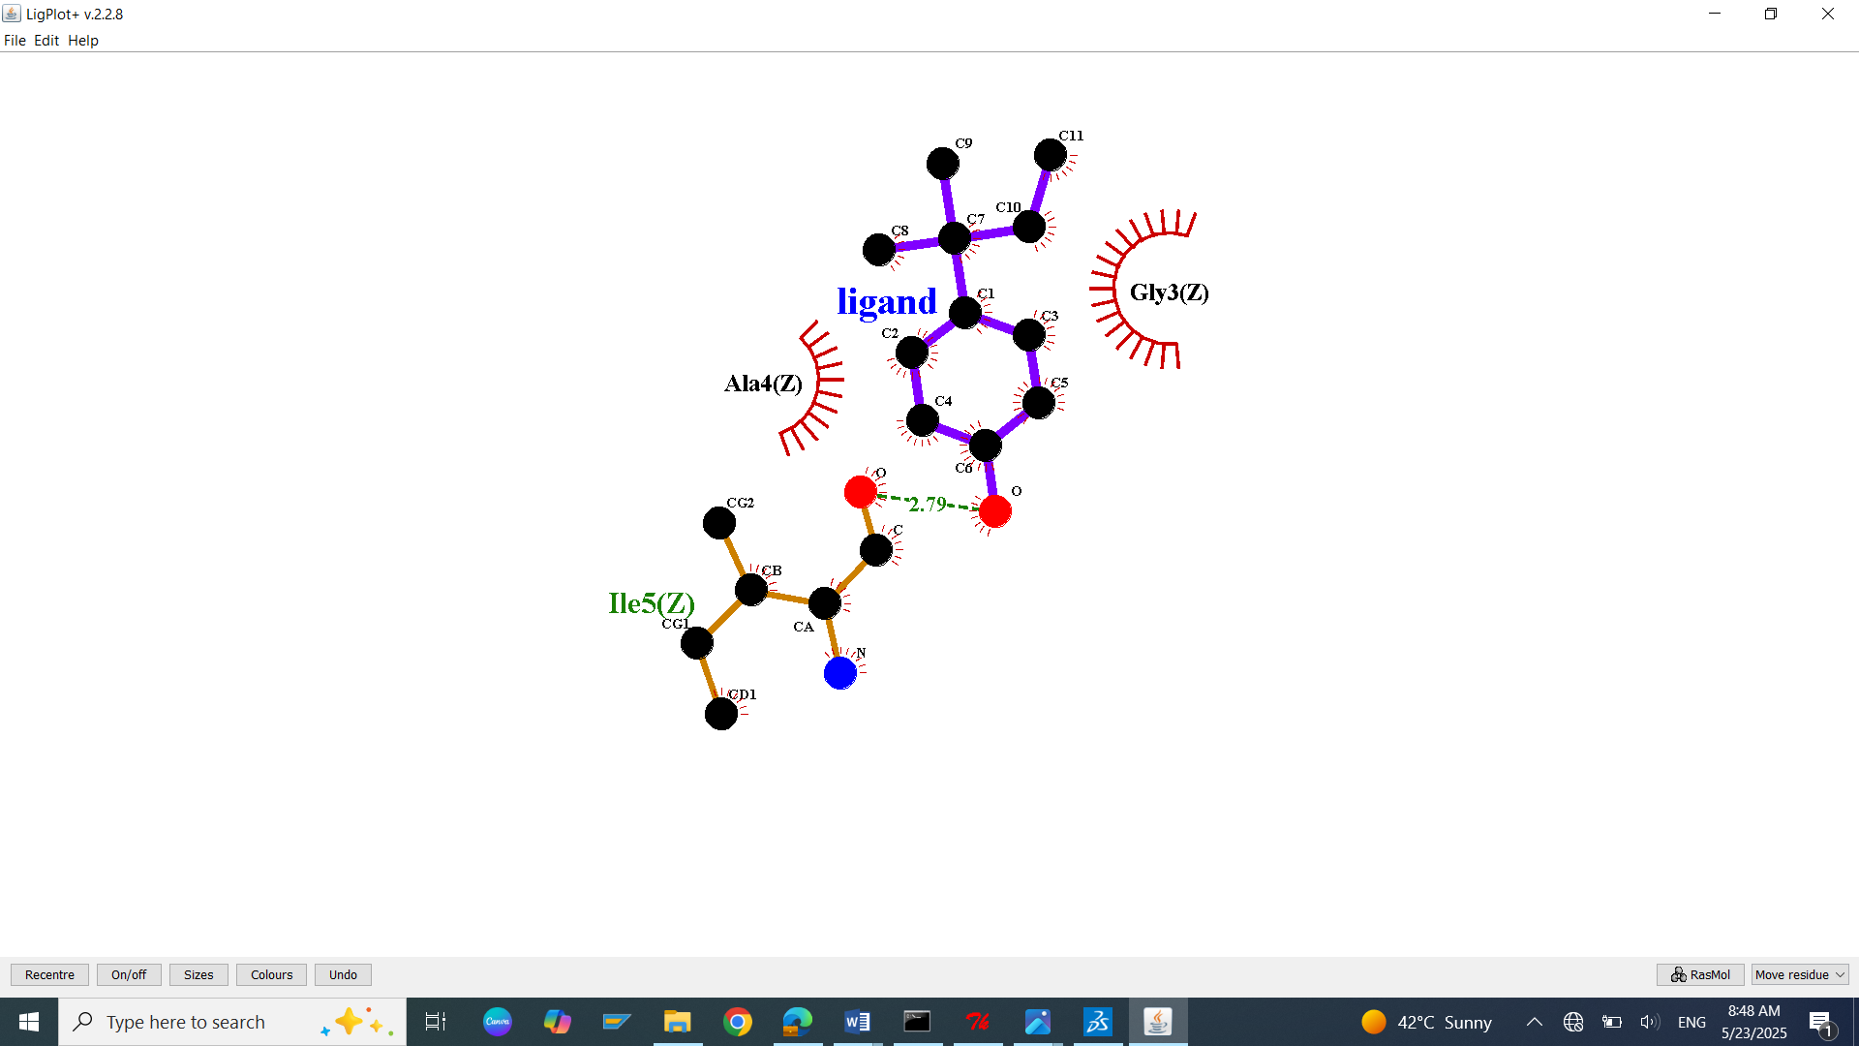
S37: Molecular Docking, secondary structure interaction and ligplus analysis of 4-tert-Amylphenol interactions with Amyloid peptide.
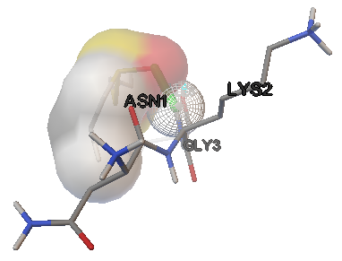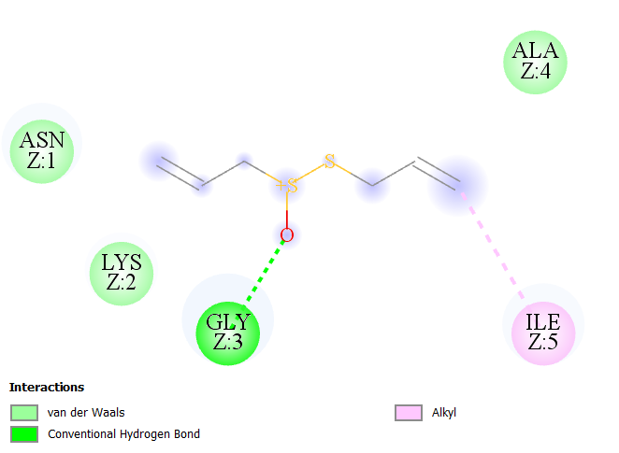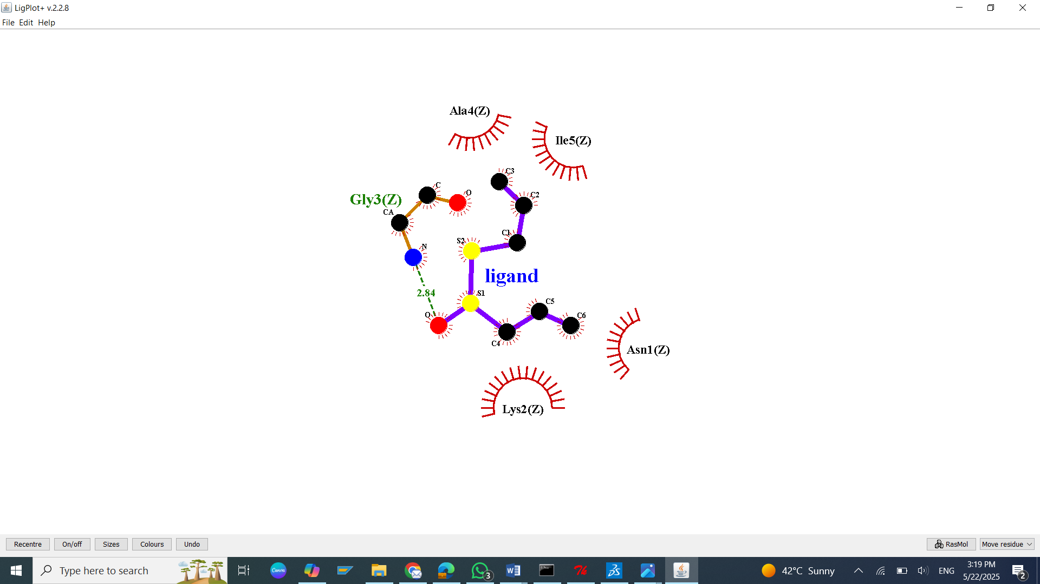
S38: Molecular Docking, secondary structure interaction and ligplus analysis of Allicin interactions with Amyloid peptide.

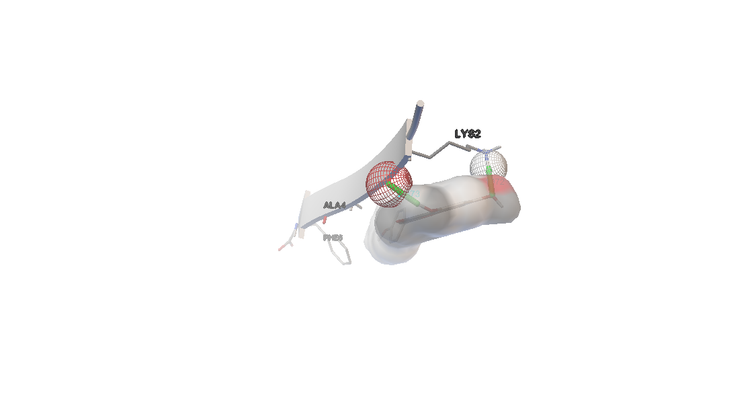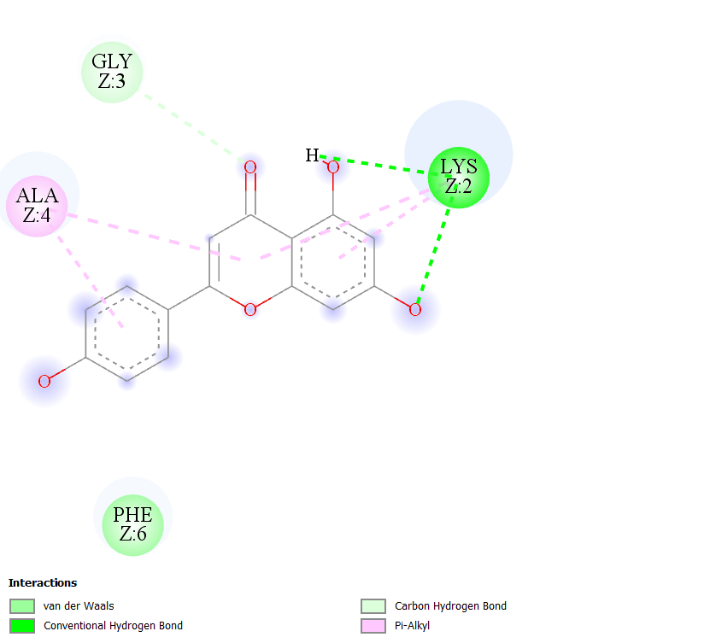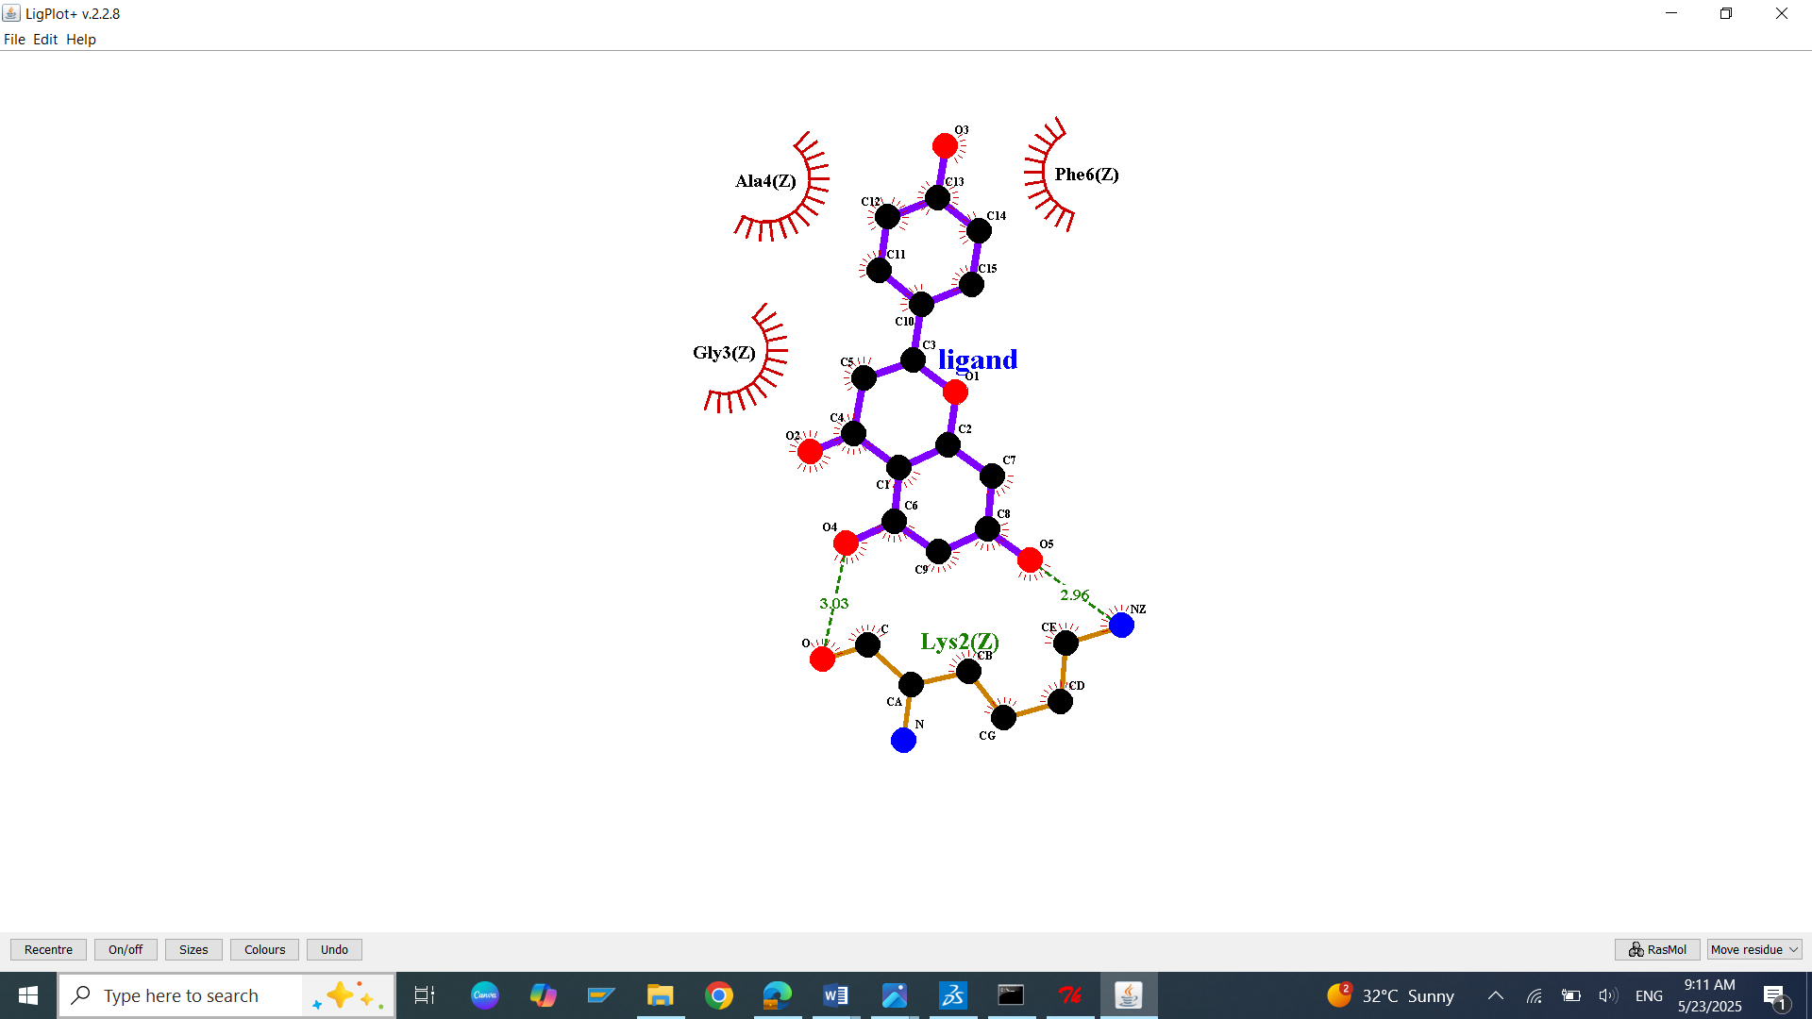
S39: Molecular Docking, secondary structure interaction and ligplus analysis of Apigenin interactions with Amyloid peptide.
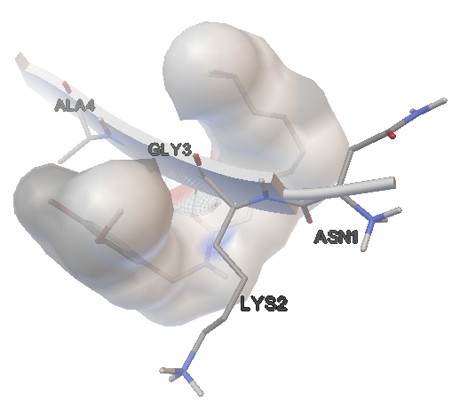 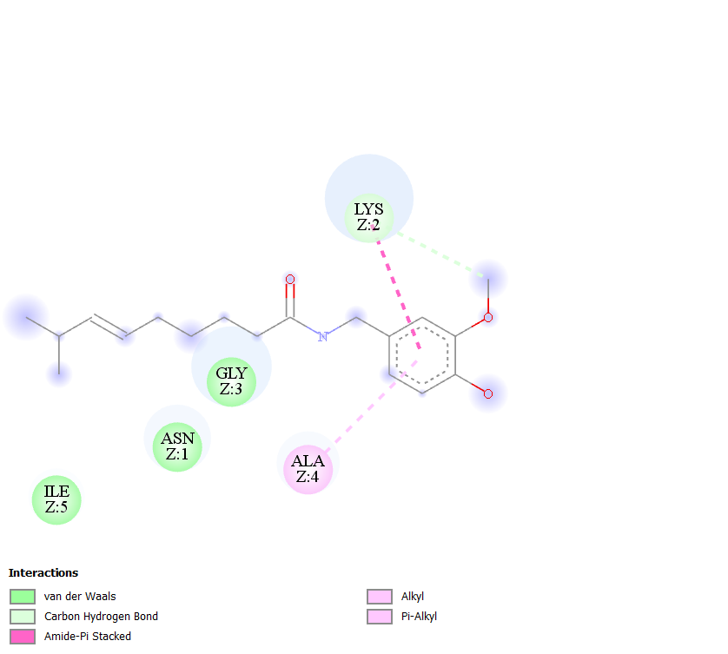 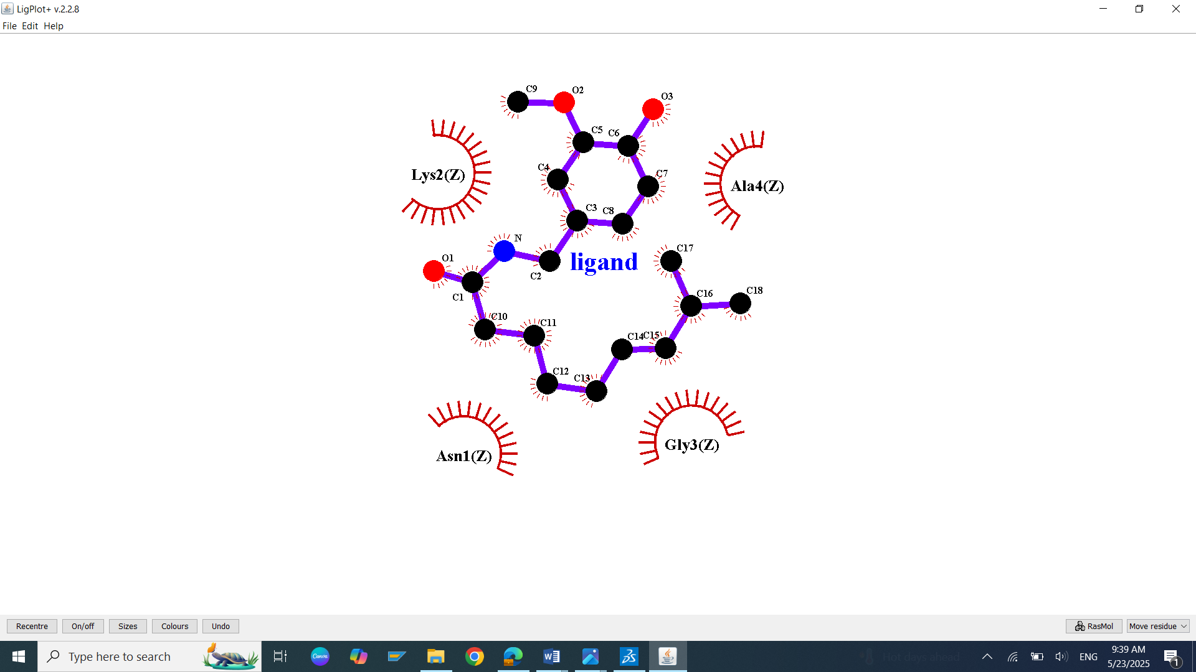 S40: Molecular Docking, secondary structure interaction and ligplus analysis of Astragalosides interactions with Amyloid peptide.
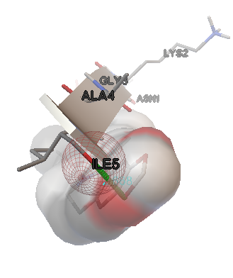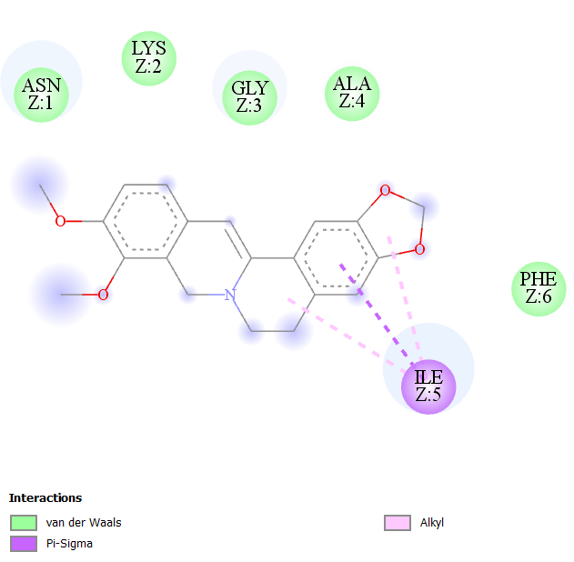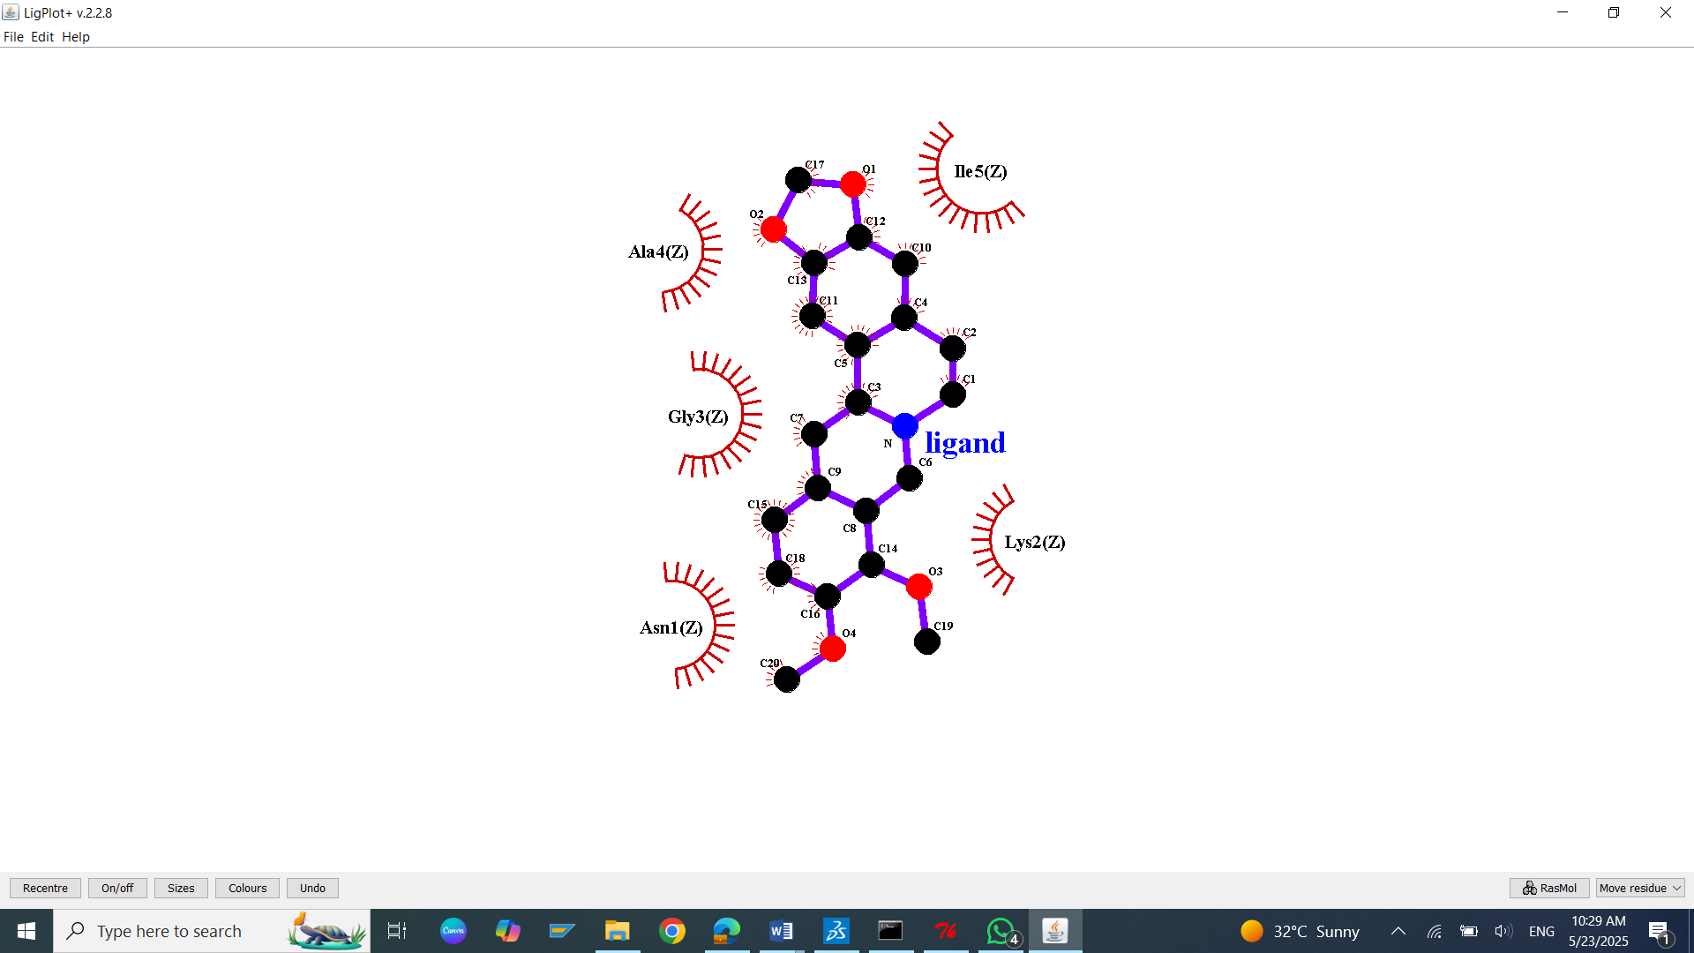
S41: Molecular Docking, secondary structure interaction and ligplus analysis of Berberine interactions with Amyloid peptide.
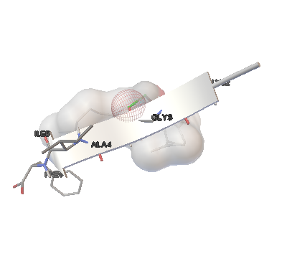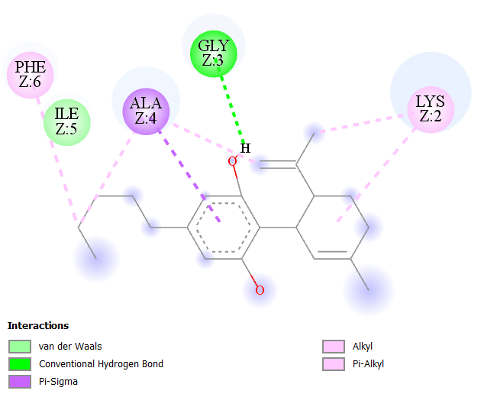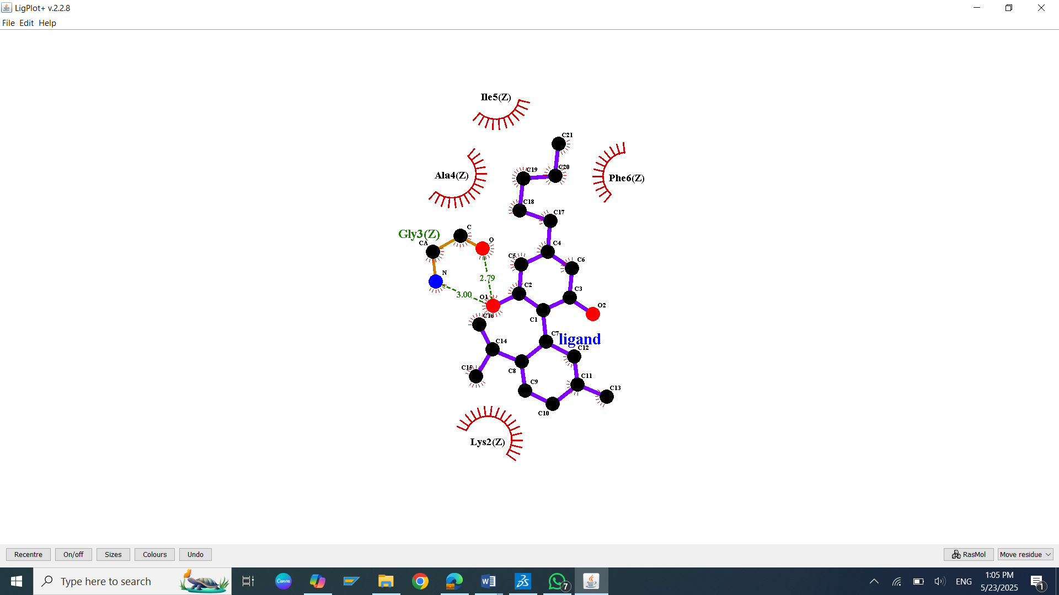
S42: Molecular Docking, secondary structure interaction and ligplus analysis of Cannabidiol interactions with Amyloid peptide.

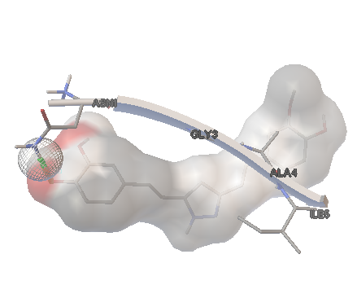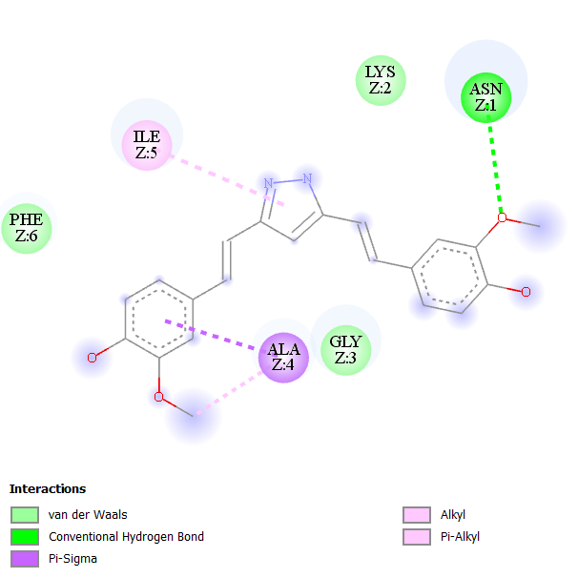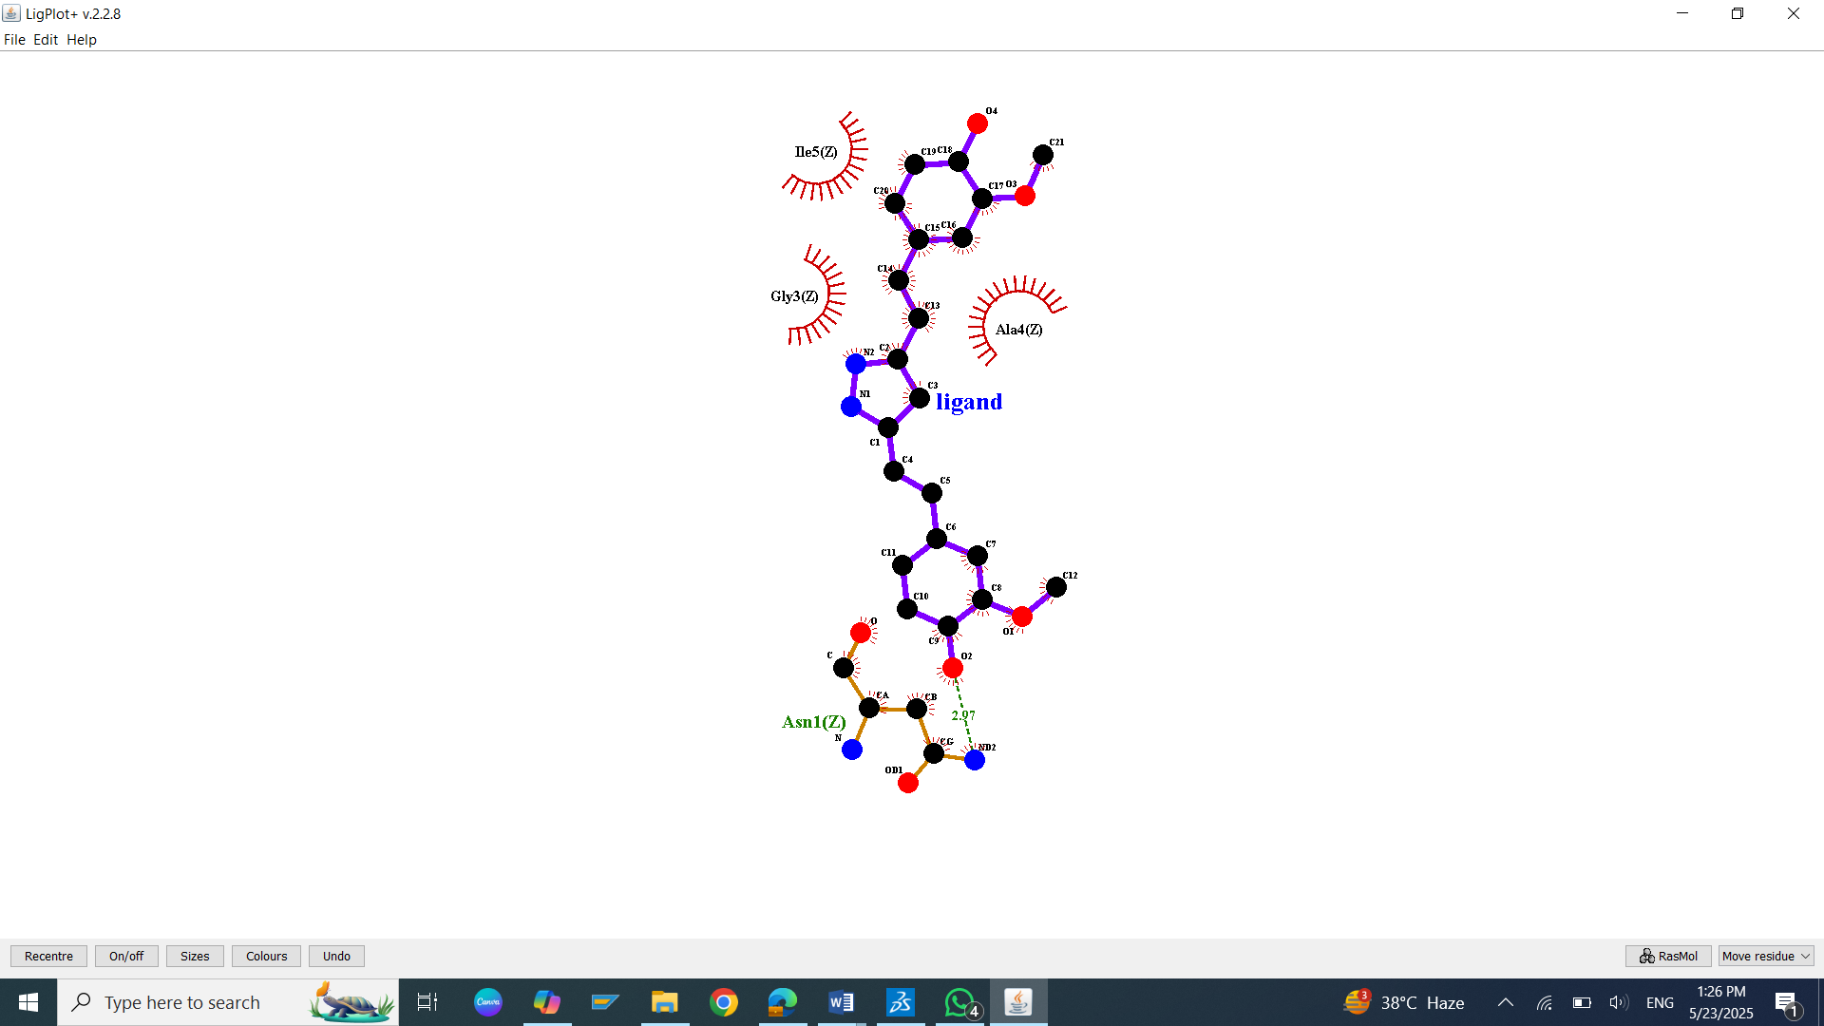
S43: Molecular Docking, secondary structure interaction and ligplus analysis of Curcumin interactions with Amyloid peptide.
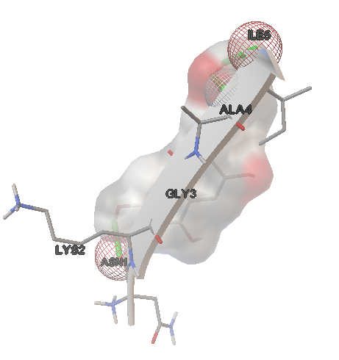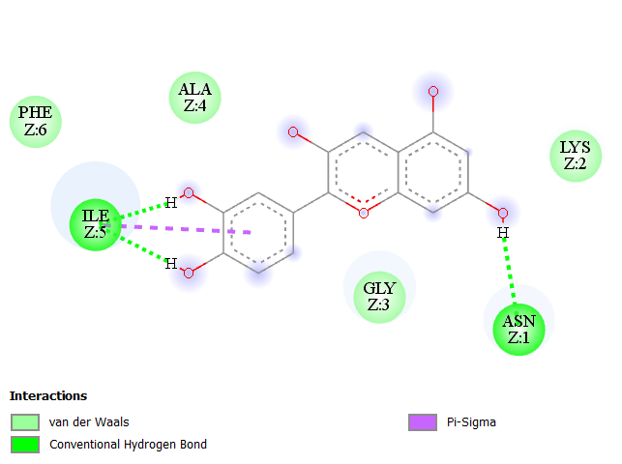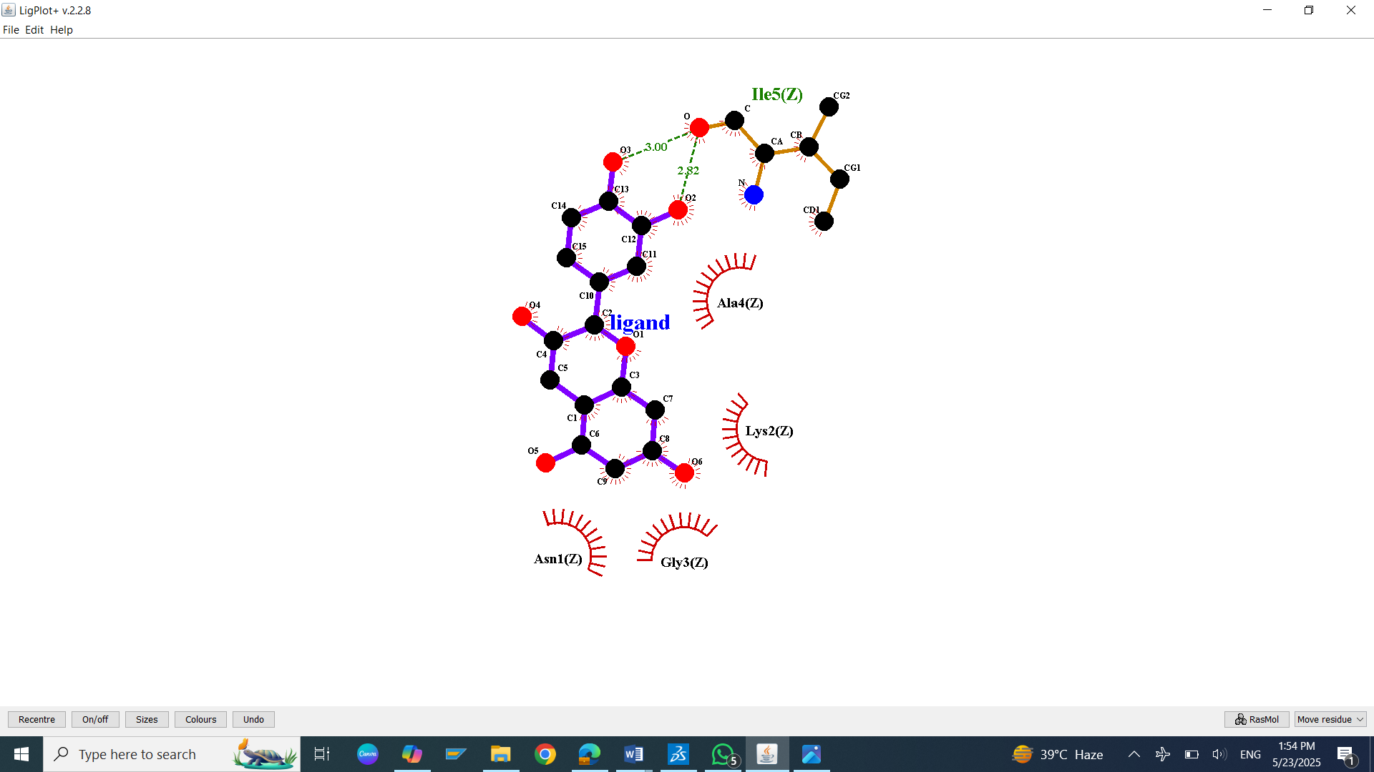
S44: Molecular Docking, secondary structure interaction and ligplus analysis of Cyanidin interactions with Amyloid peptide.
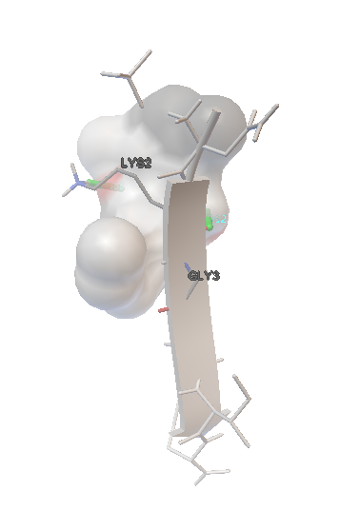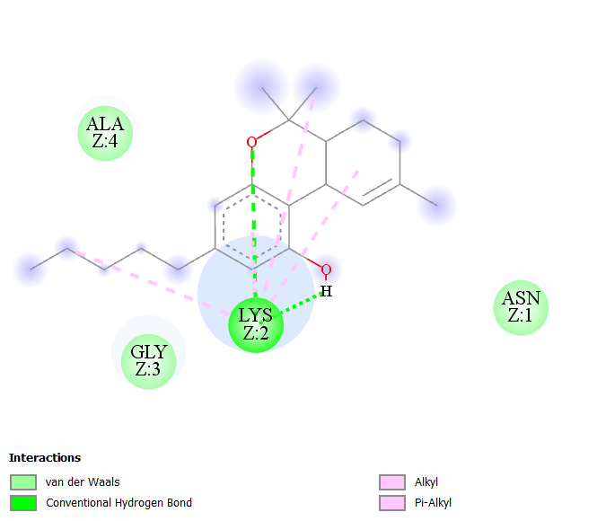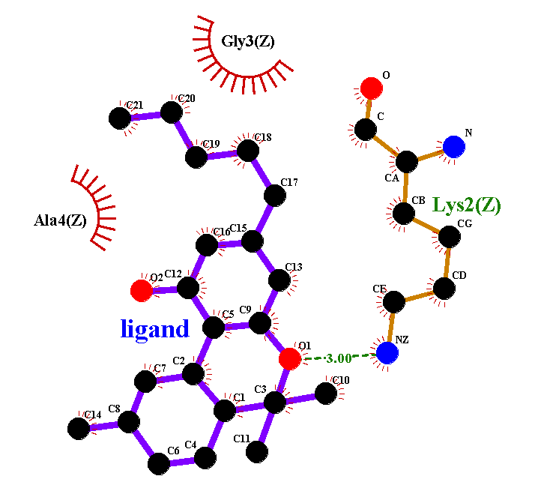
S45: Molecular Docking, secondary structure interaction and ligplus analysis of Dronabinol interactions with Amyloid peptide.
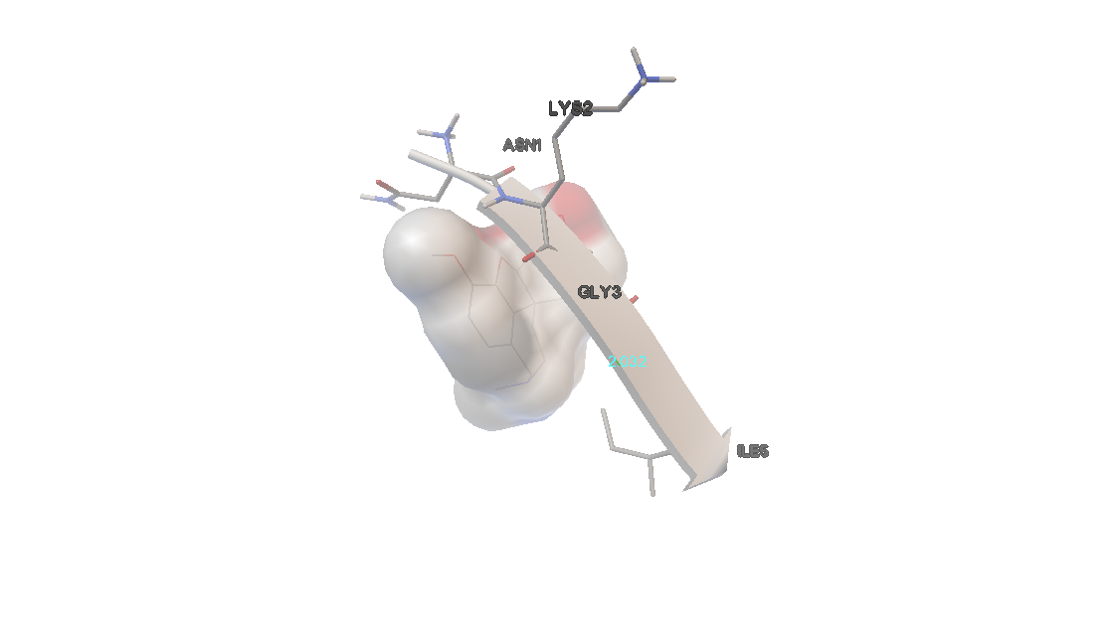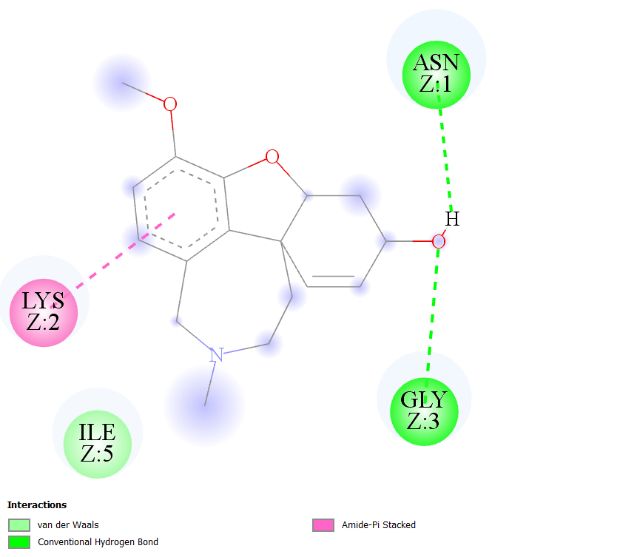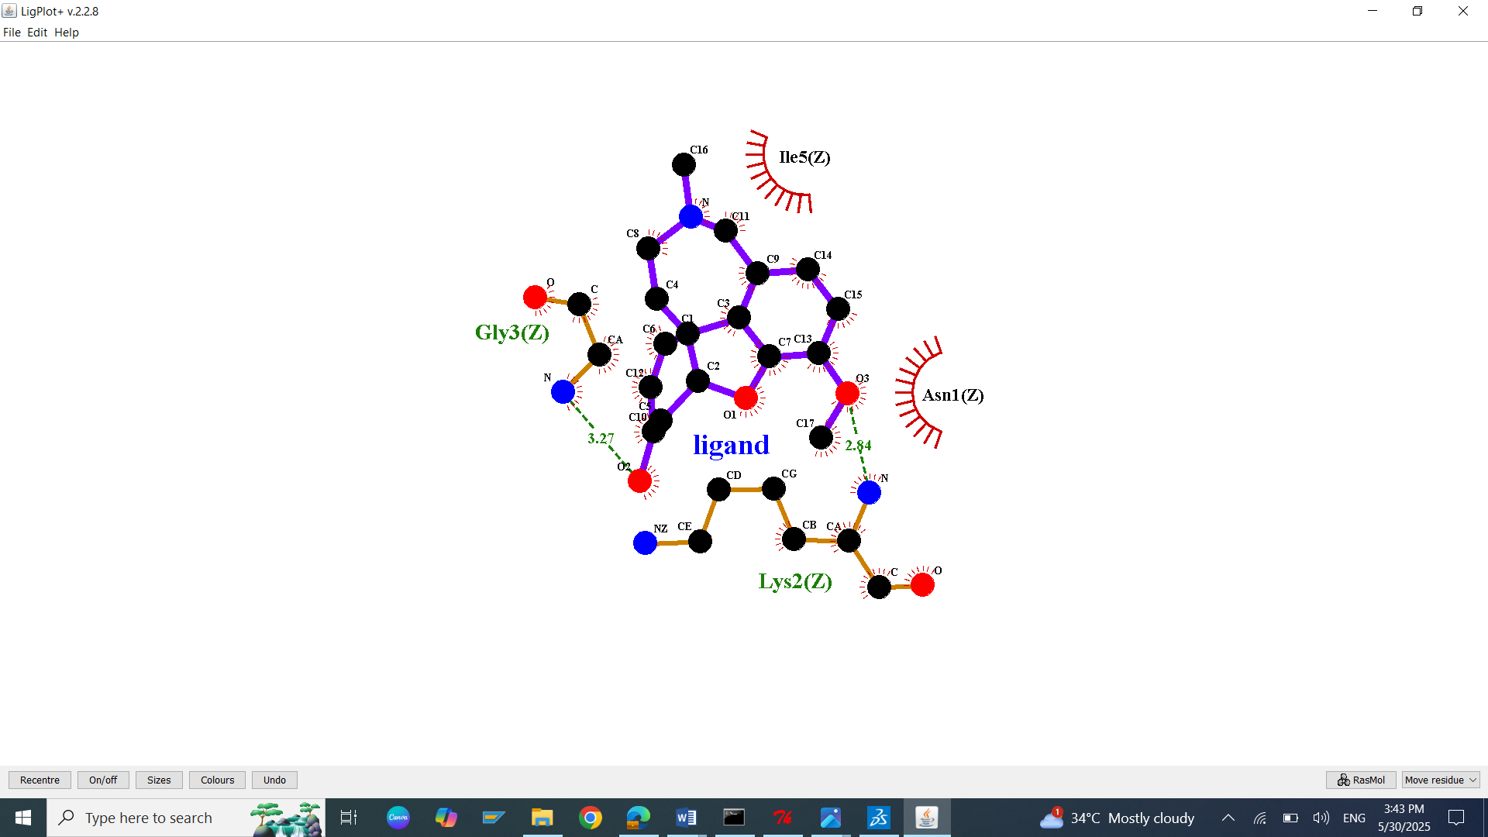
S46: Molecular Docking, secondary structure interaction and ligplus analysis of Galantamine interactions with Amyloid peptide.
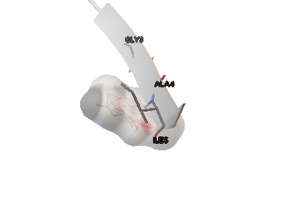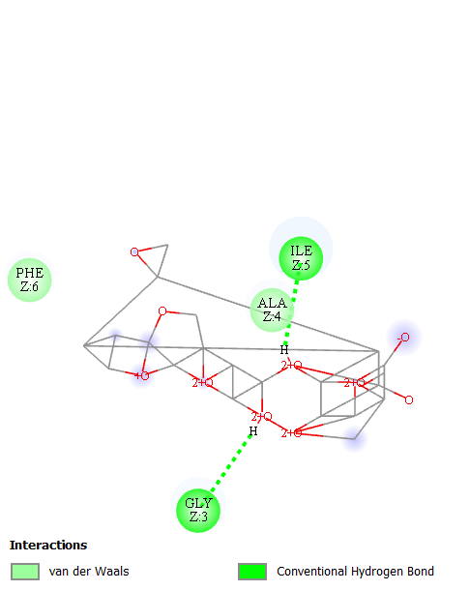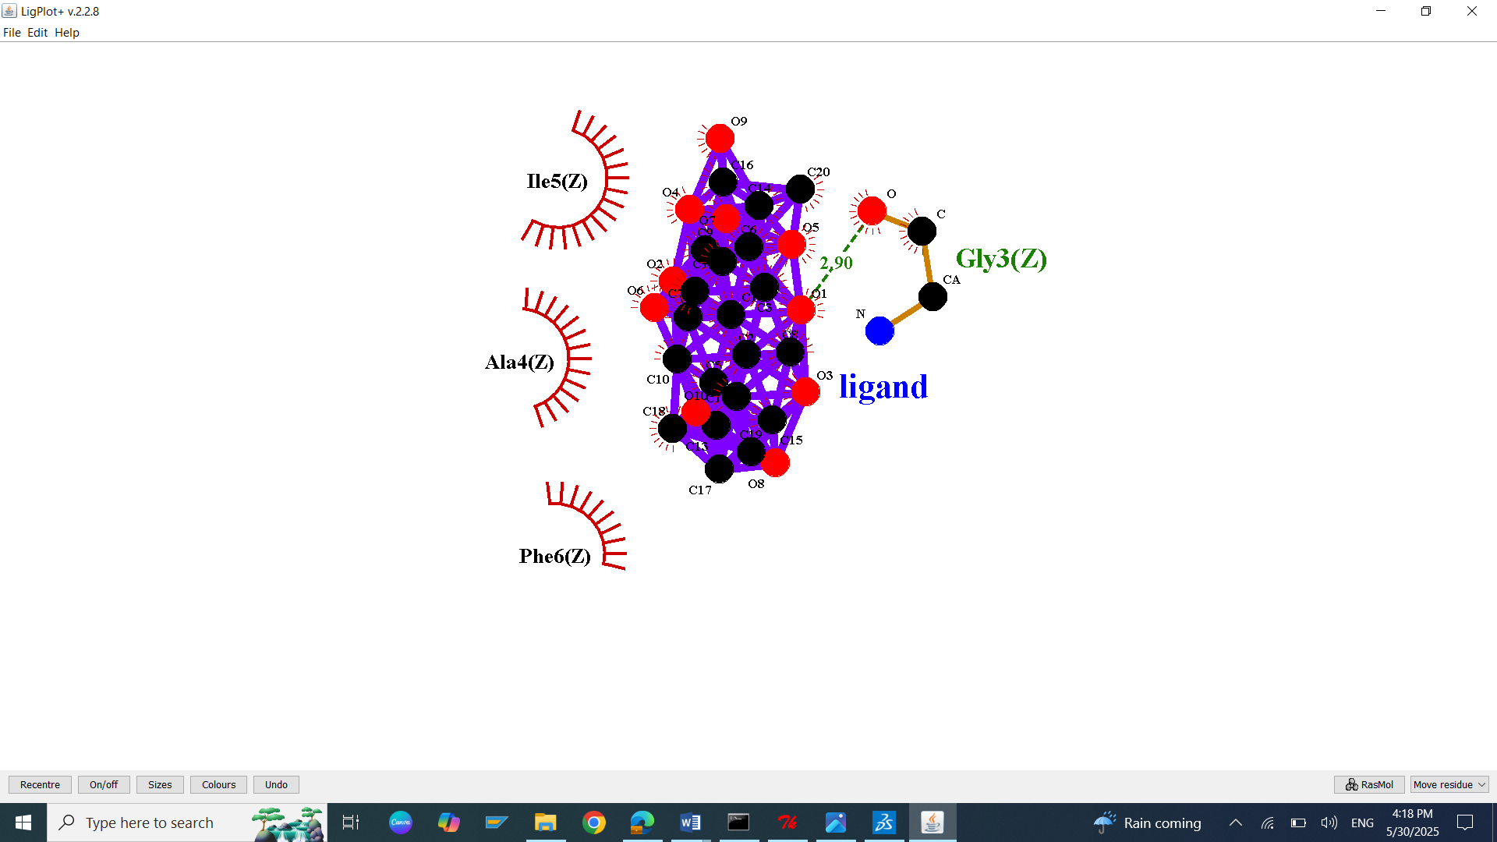
S47: Molecular Docking, secondary structure interaction and ligplus analysis of Gingkolide interactions with Amyloid peptide.
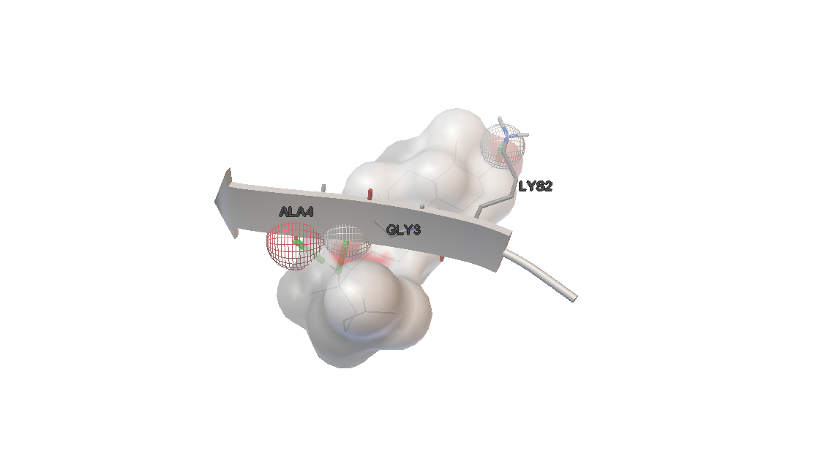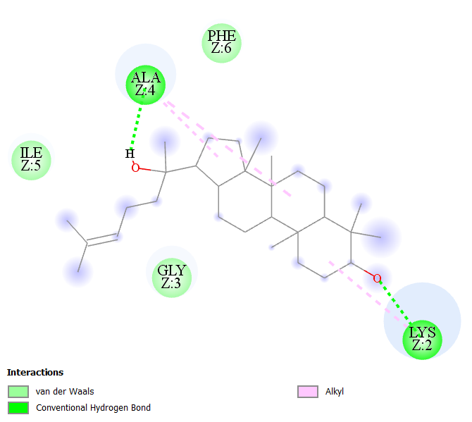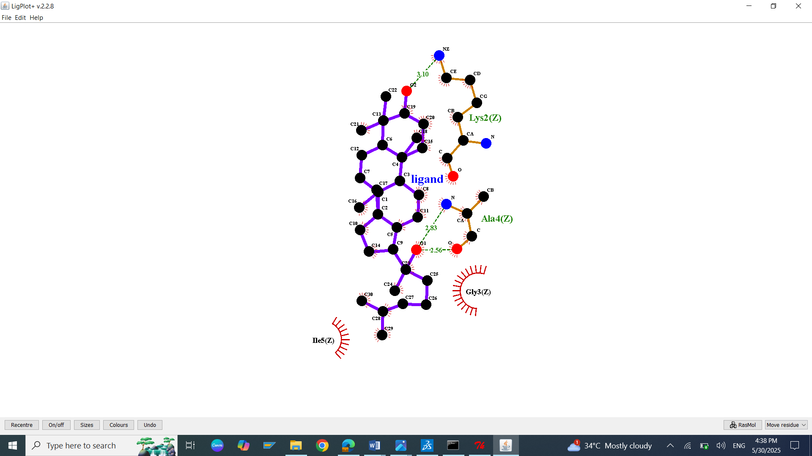
S48: Molecular Docking, secondary structure interaction and ligplus analysis of Ginsenosides interactions with Amyloid peptide.
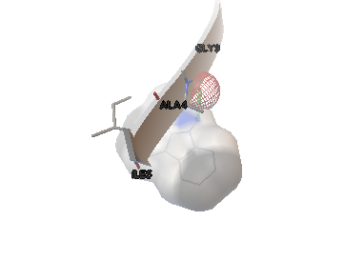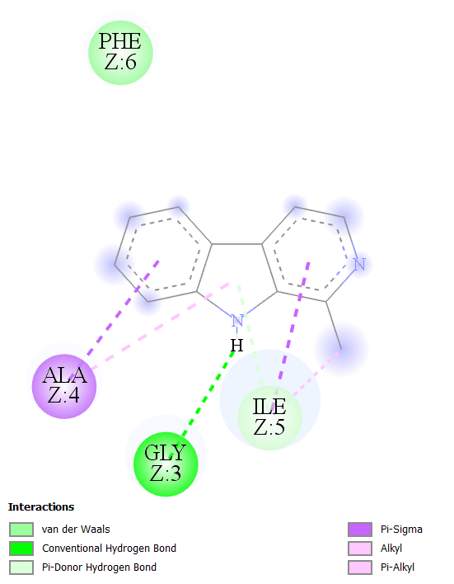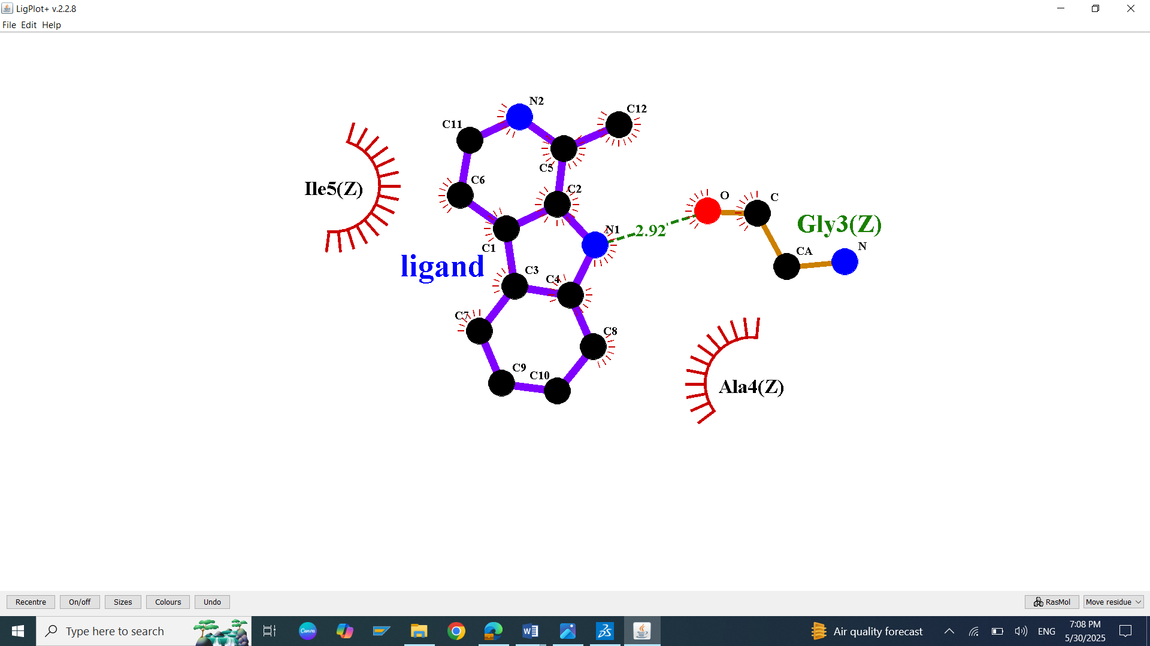
S49: Molecular Docking, secondary structure interaction and ligplus analysis of Harman interactions with Amyloid peptide.
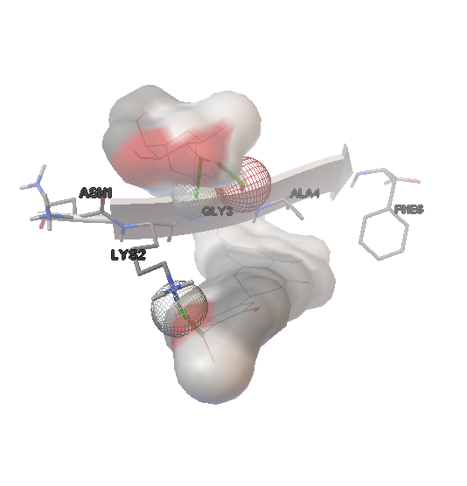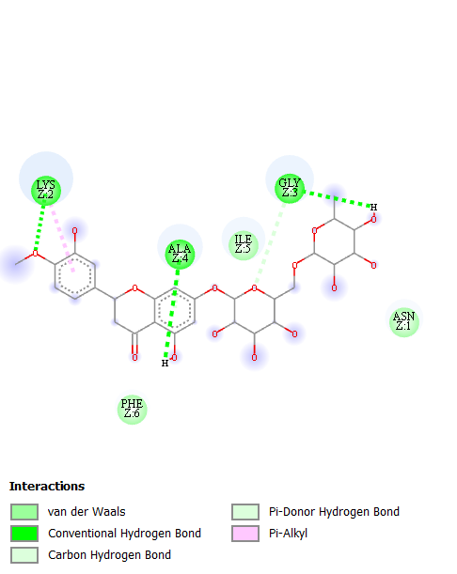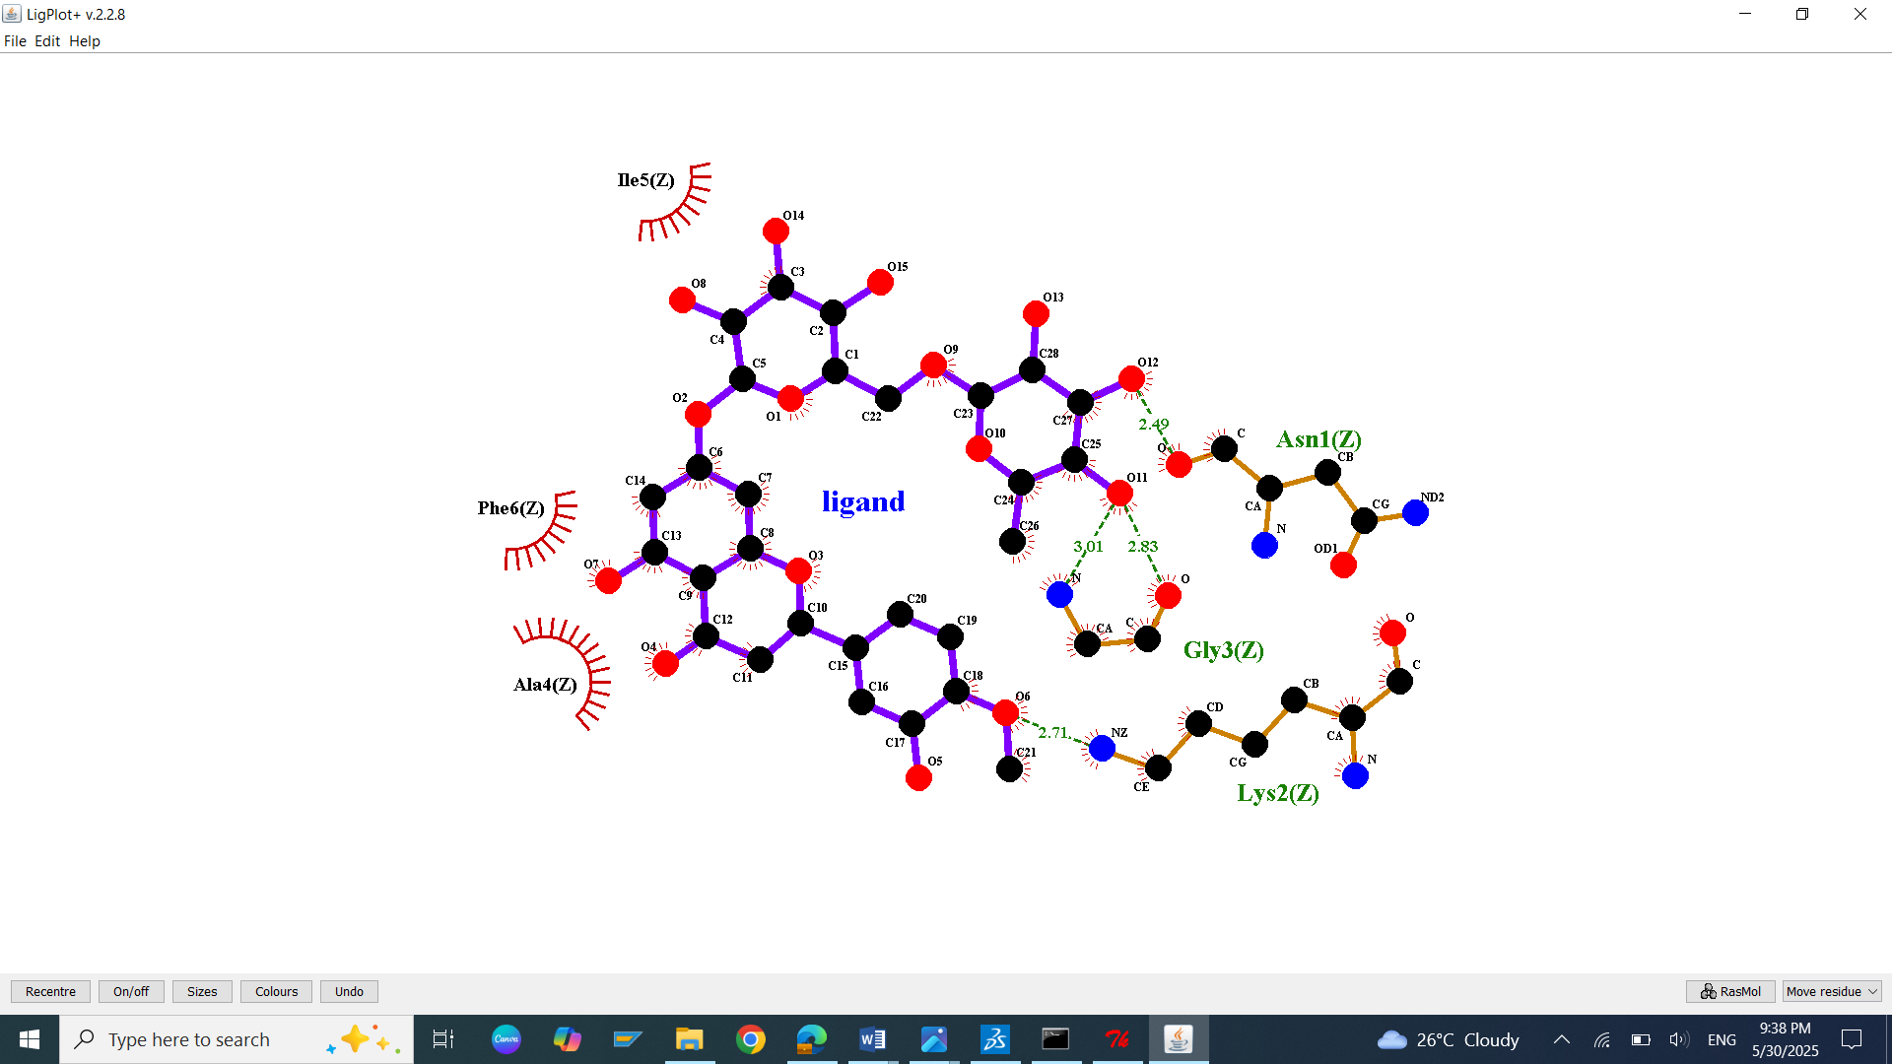
S50: Molecular Docking, secondary structure interaction and ligplus analysis of Hesperidin interactions with Amyloid peptide.
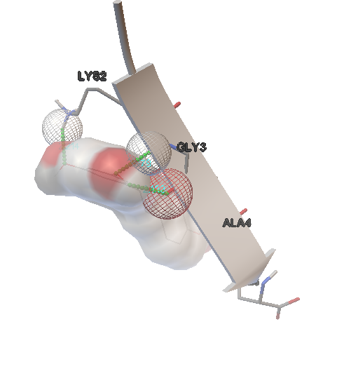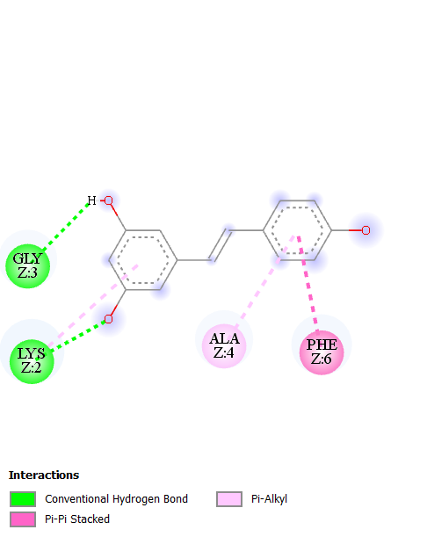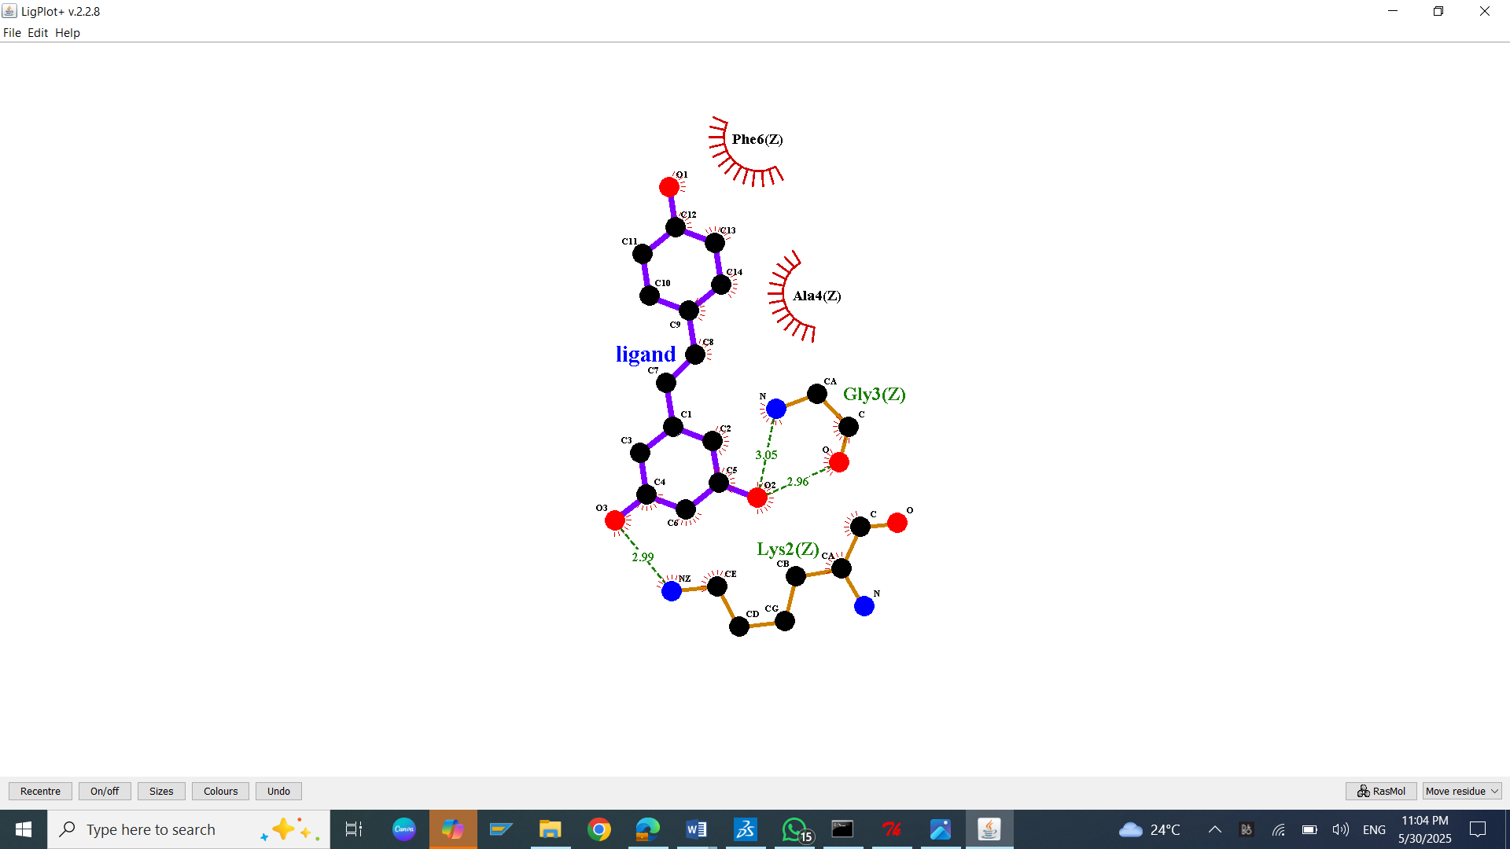
S51: Molecular Docking, secondary structure interaction and ligplus analysis of Reservetarol interactions with Amyloid peptide.
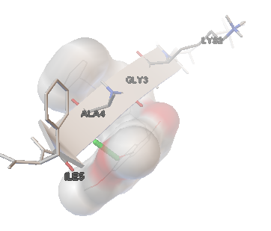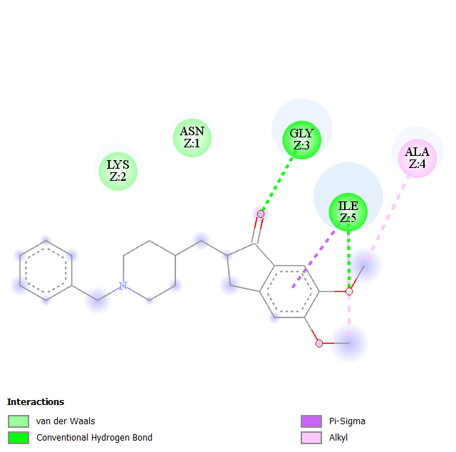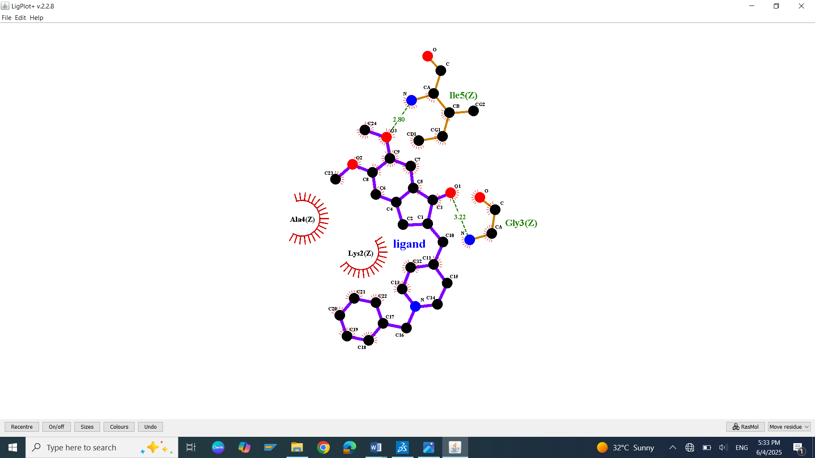
S52: Molecular Docking, secondary structure interaction and ligplus analysis of Donepezil interactions with Amyloid peptide.
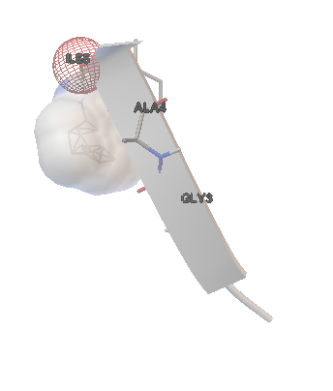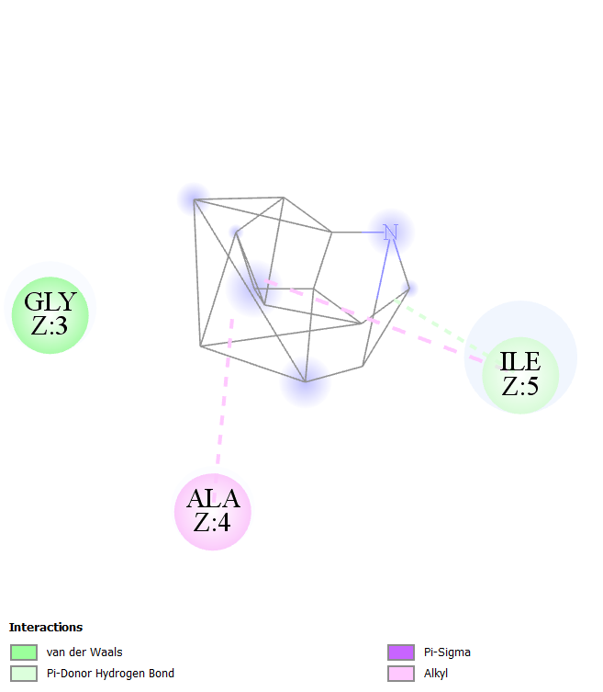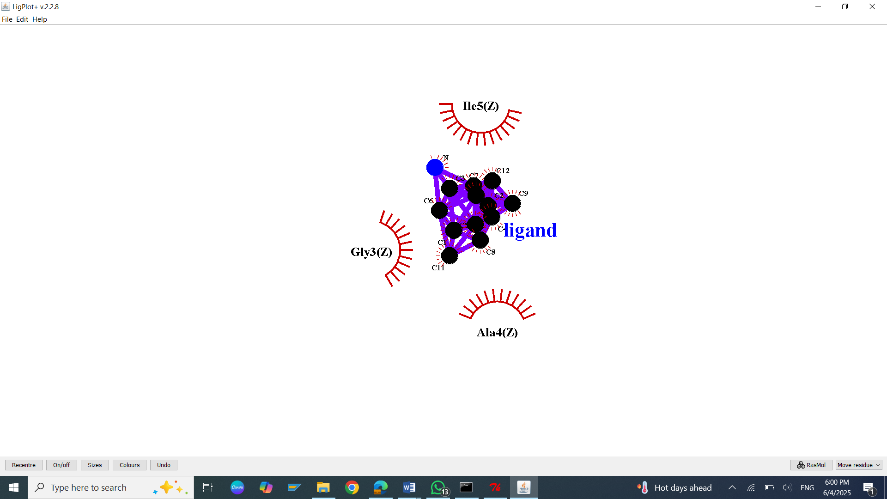
S53: Molecular Docking, secondary structure interaction and ligplus analysis of Memantine interactions with Amyloid peptide.
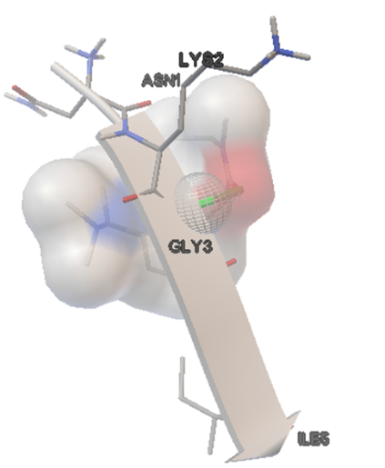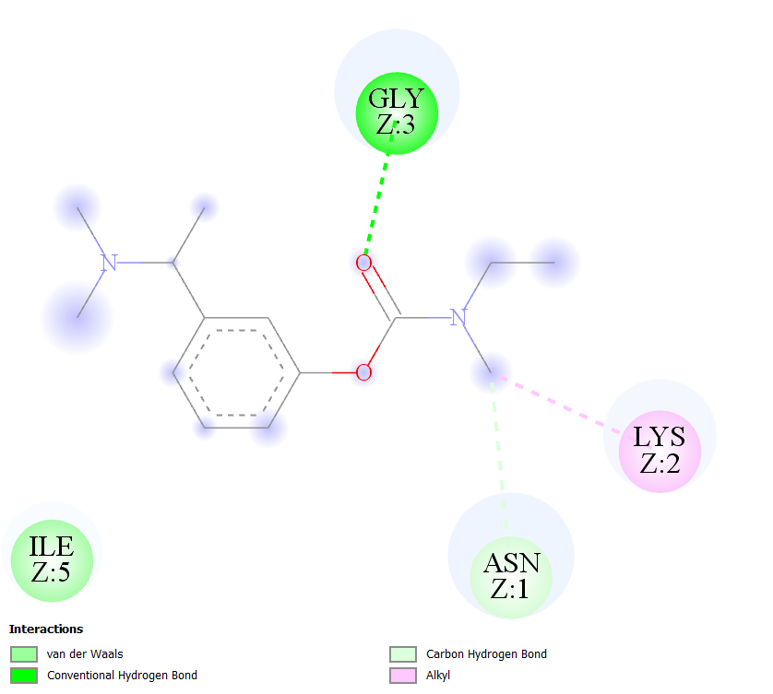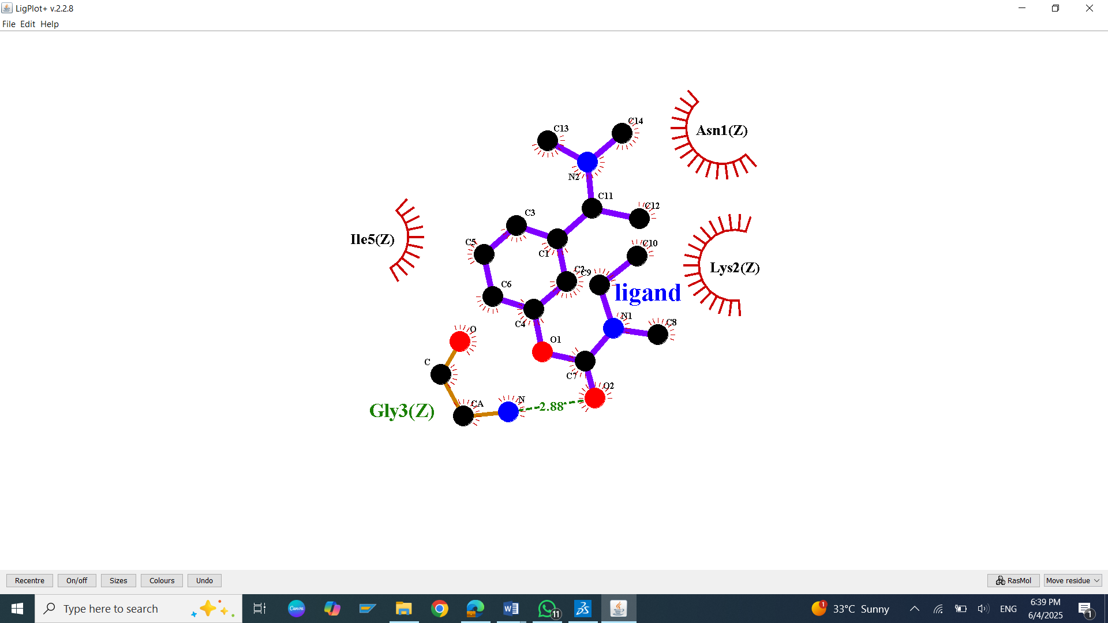
S54: Molecular Docking, secondary structure interaction and ligplus analysis of Rivastigmine interactions with Amyloid peptide.
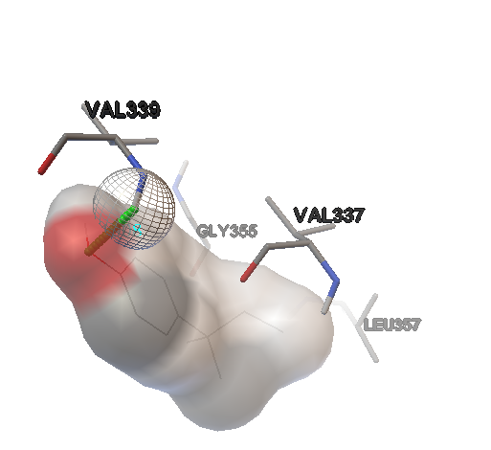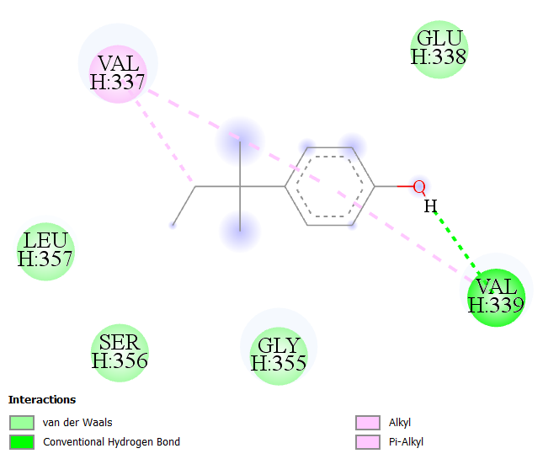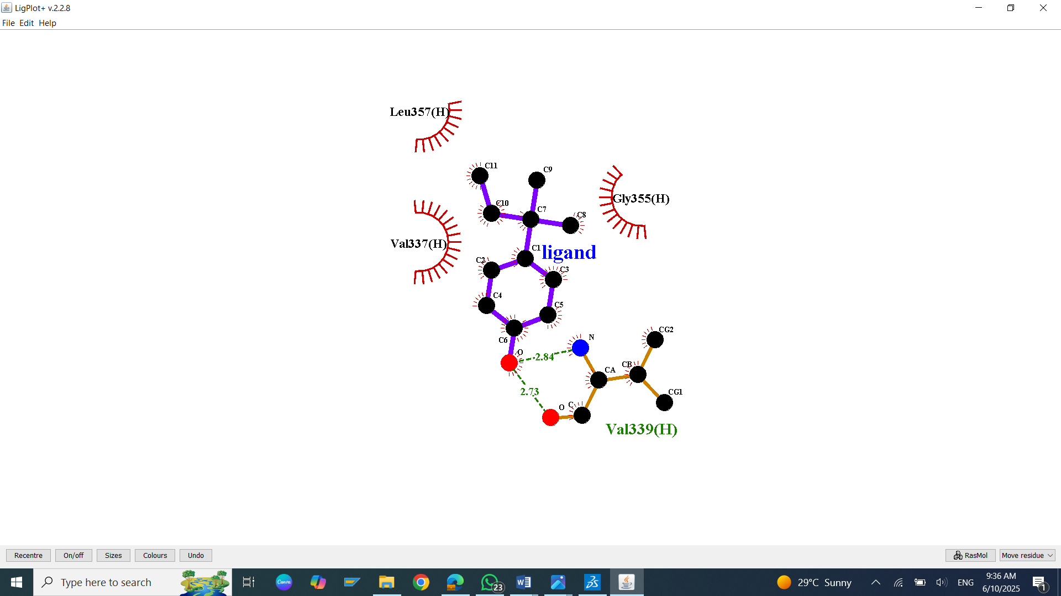
S55: Molecular Docking, secondary structure interaction and ligplus analysis of 4-tert-Amylphenol interactions with TAU.
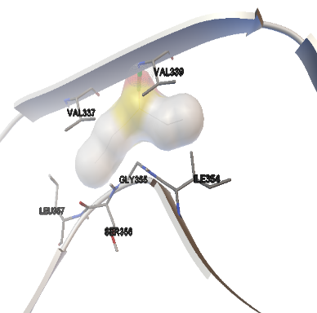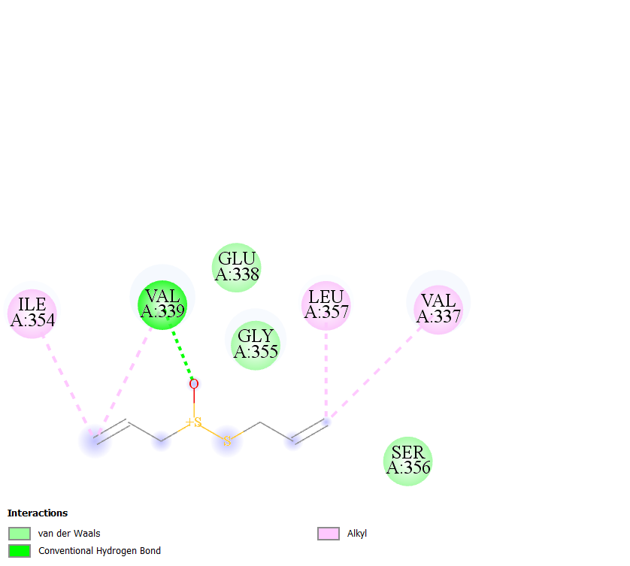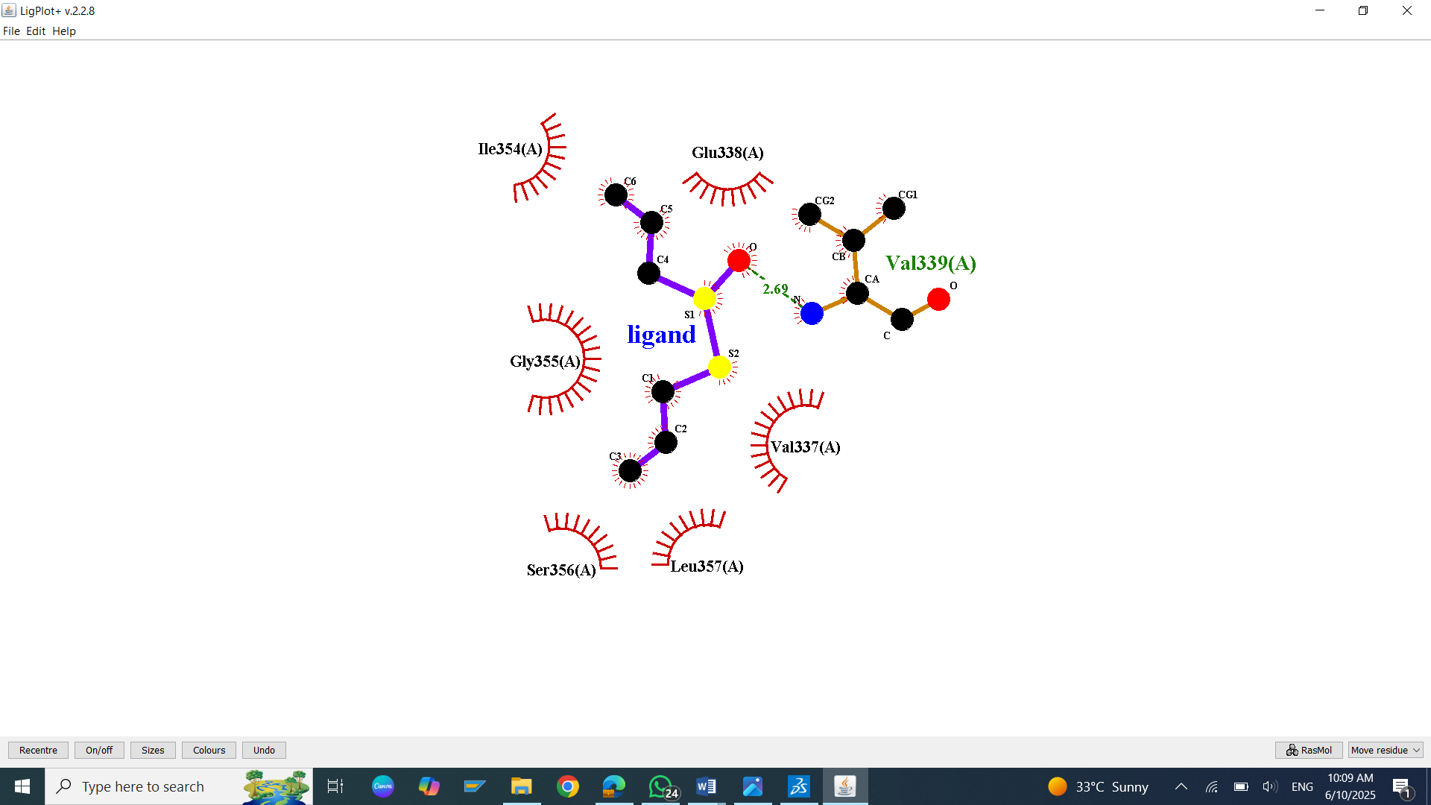

S56: Molecular Docking, secondary structure interaction and ligplus analysis of Allicin interactions with TAU.
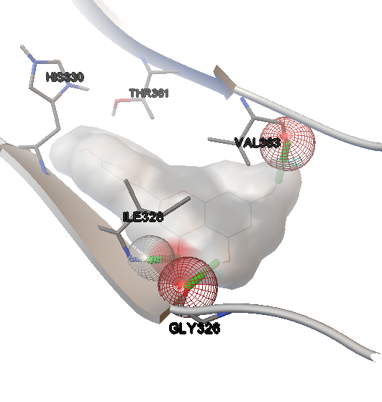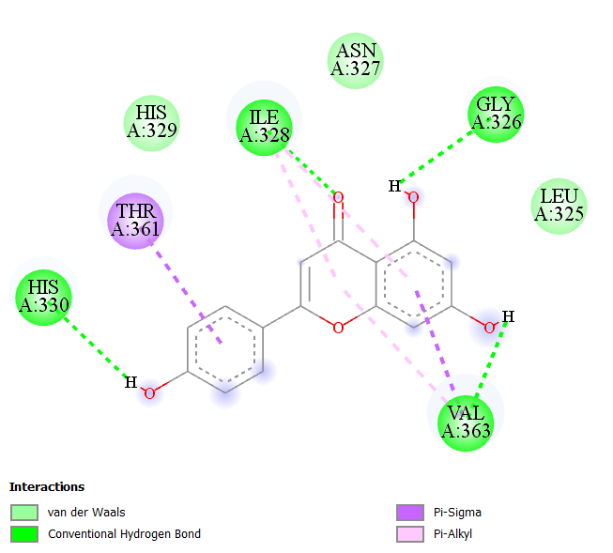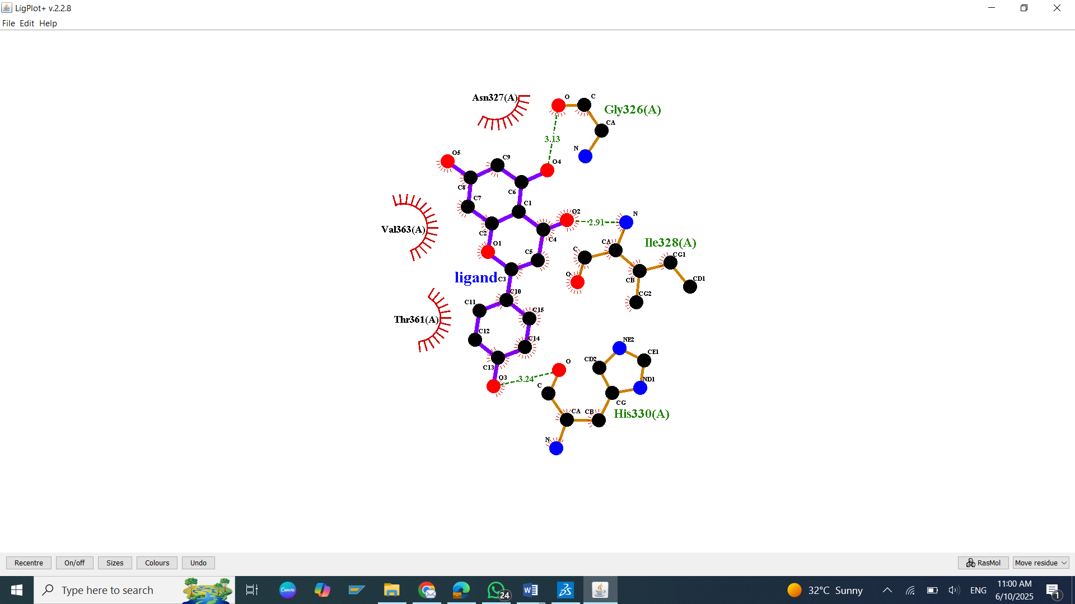
S57: Molecular Docking, secondary structure interaction and ligplus analysis of Apigenin interactions with TAU.
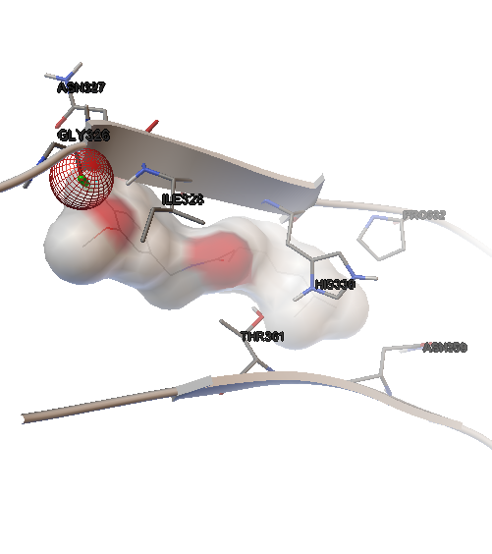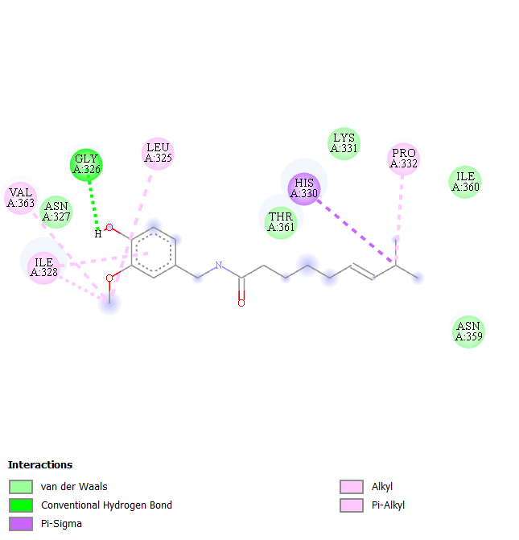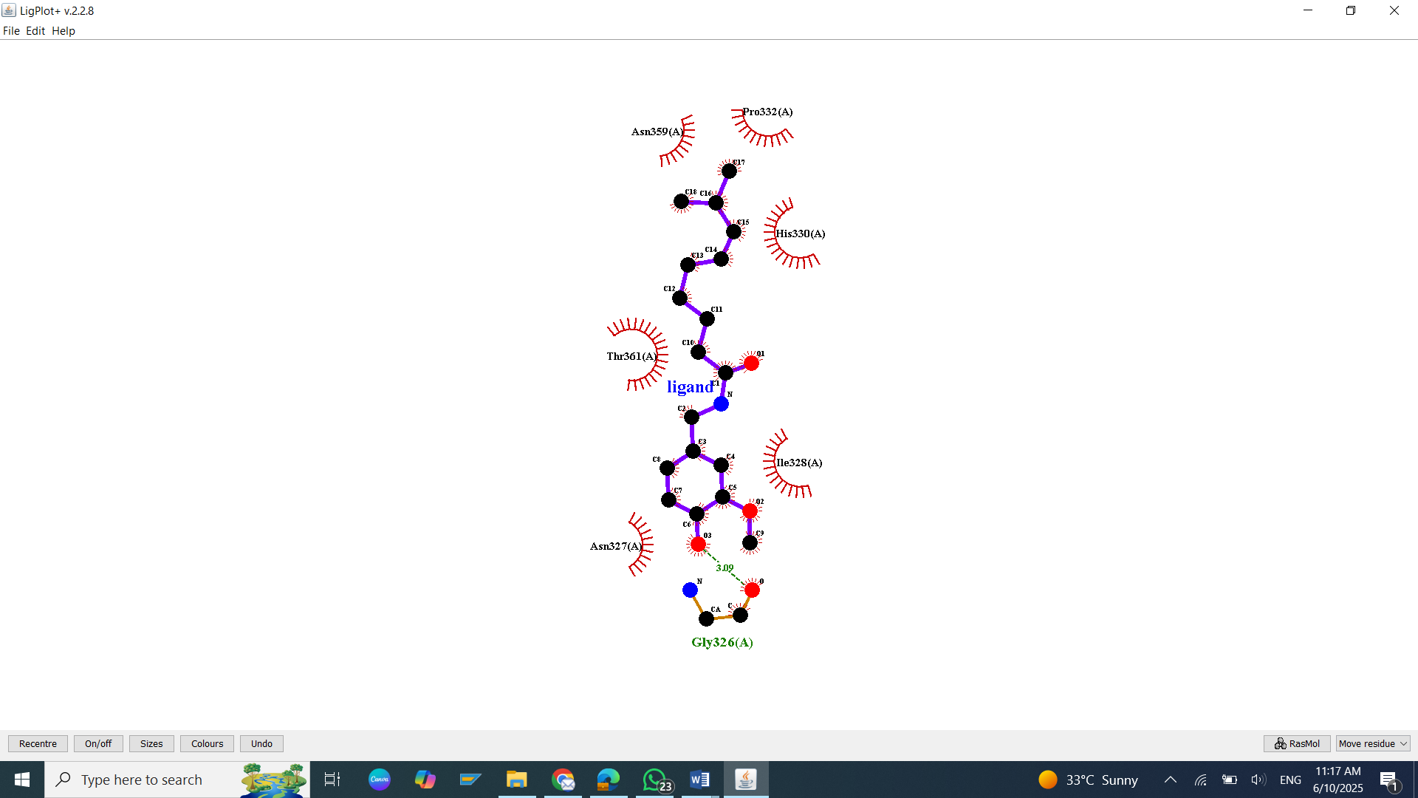
S58: Molecular Docking, secondary structure interaction and ligplus analysis of Astragalcocides interactions with TAU.
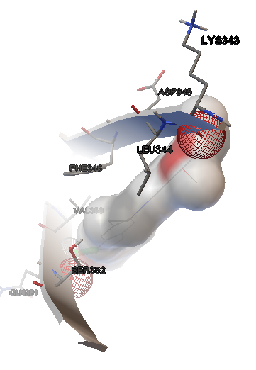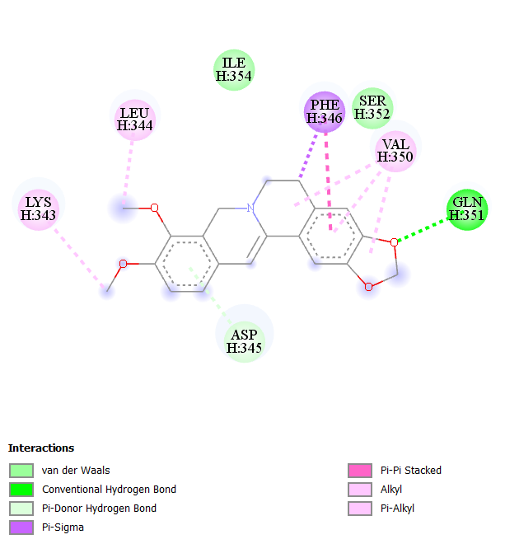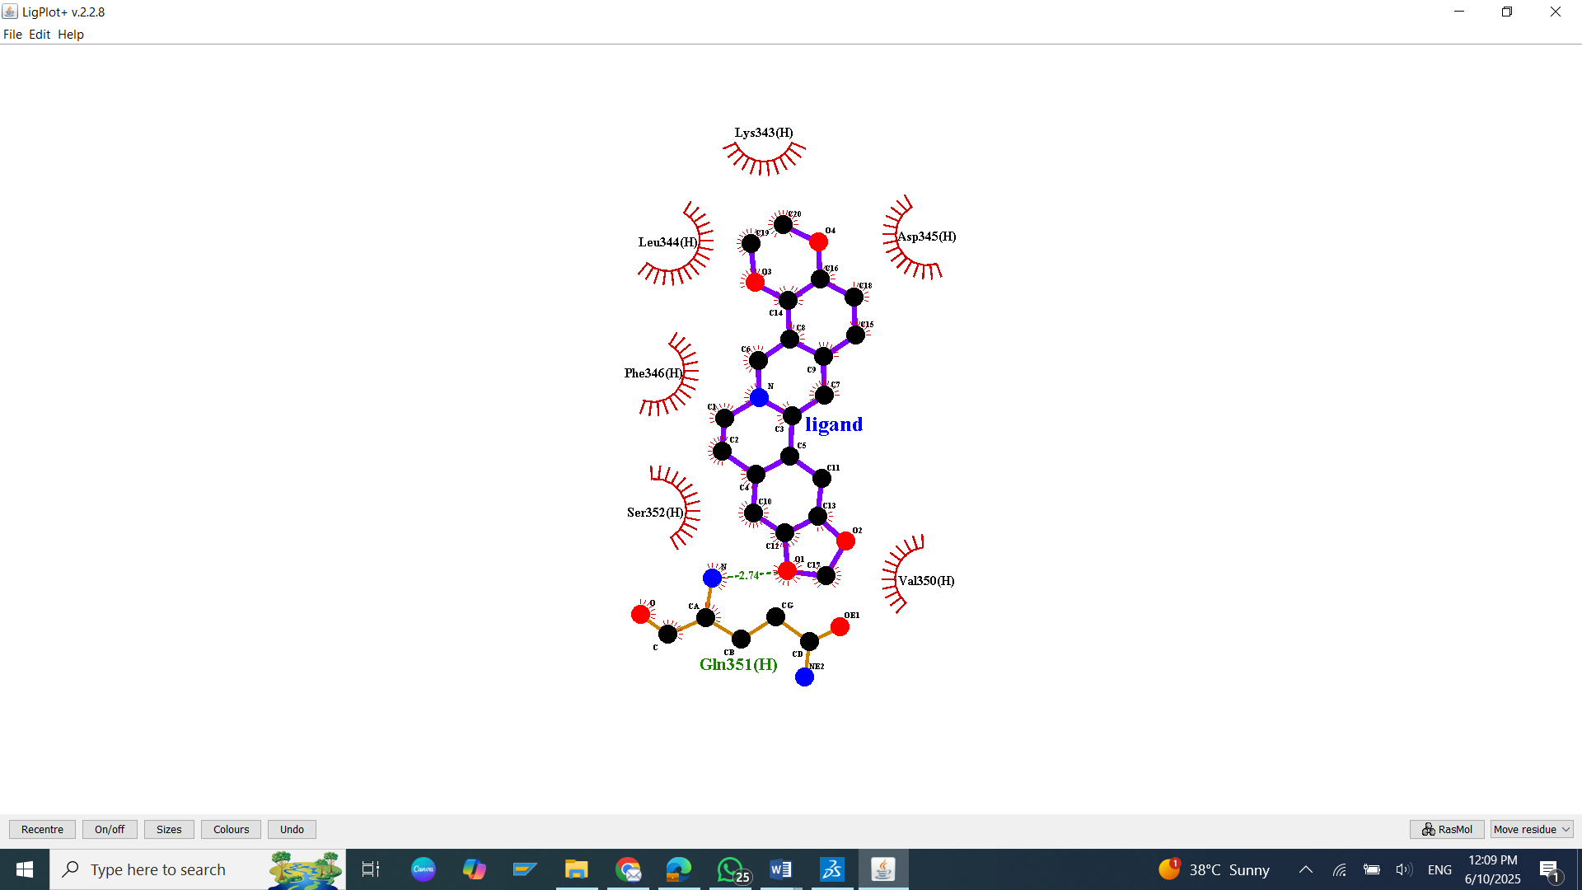
S59: Molecular Docking, secondary structure interaction and ligplus analysis of Berberine interactions with TAU.
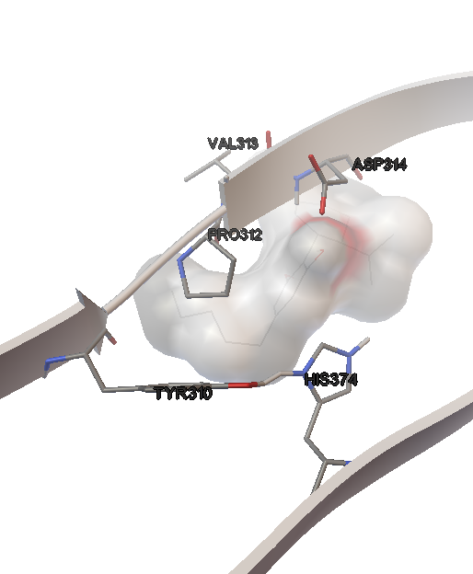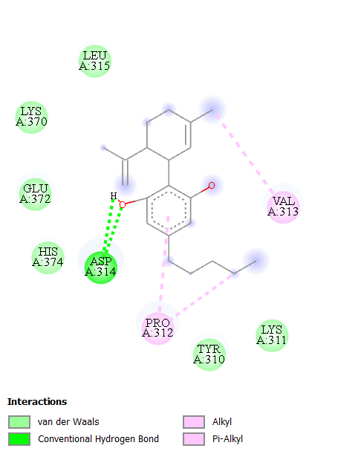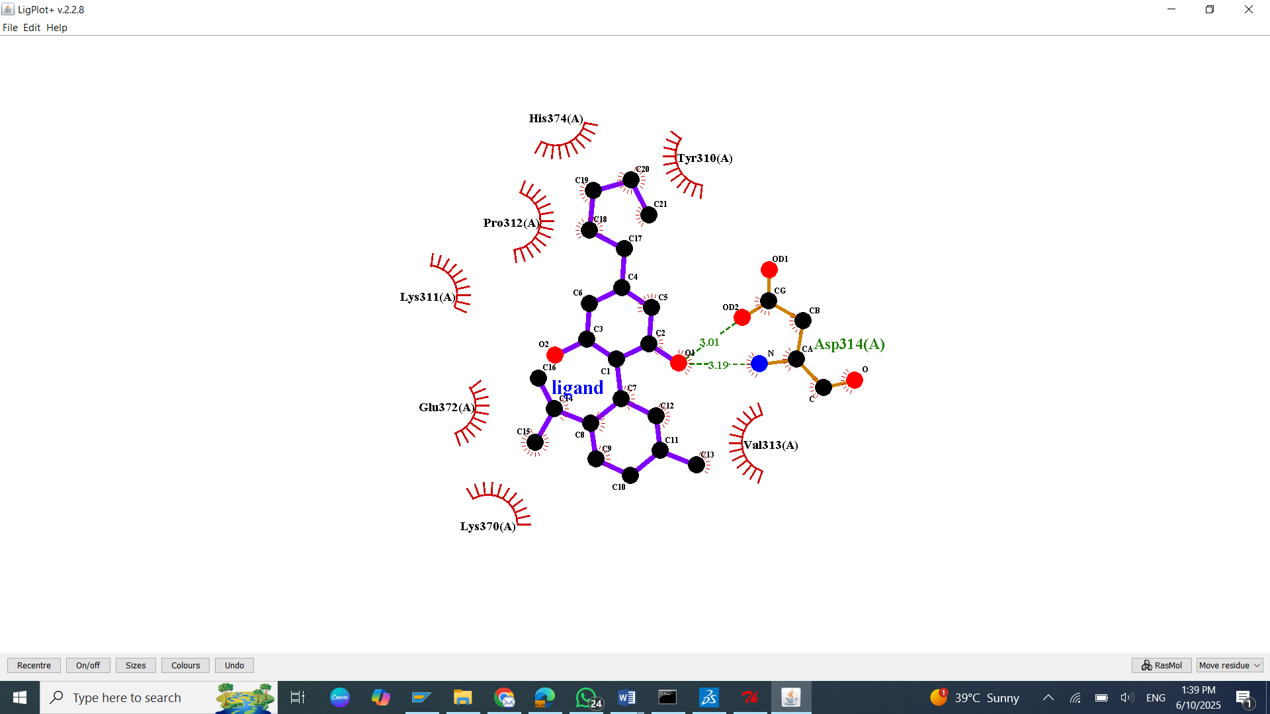
S60: Molecular Docking, secondary structure interaction and ligplus analysis of Cannabidiol interactions with TAU.
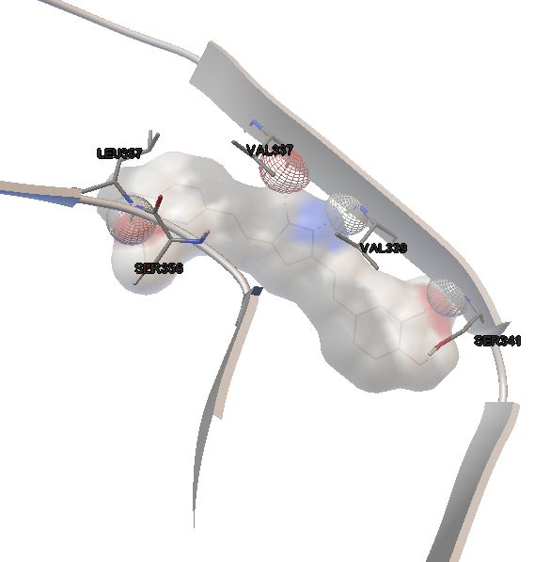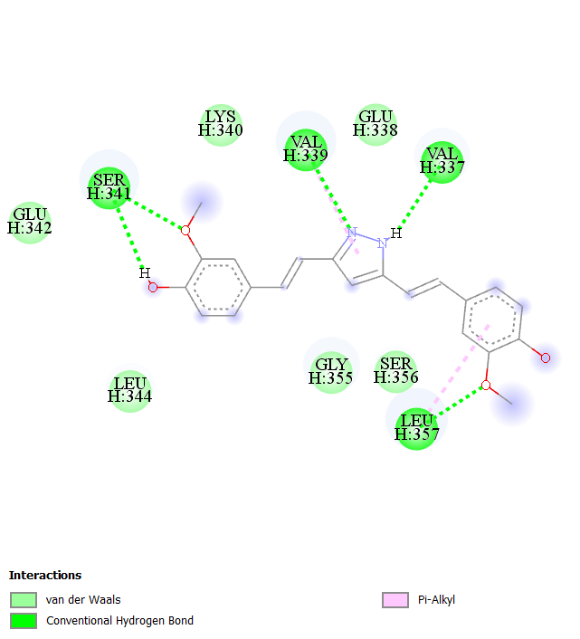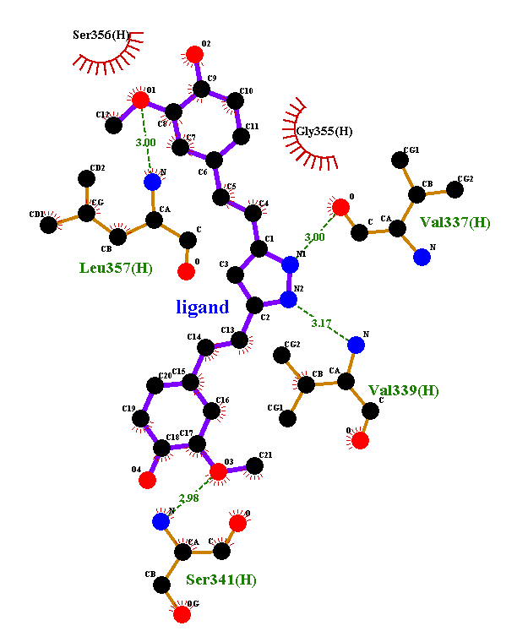
S61: Molecular Docking, secondary structure interaction and ligplus analysis of Curcumin interactions with TAU.
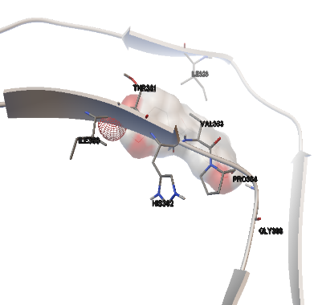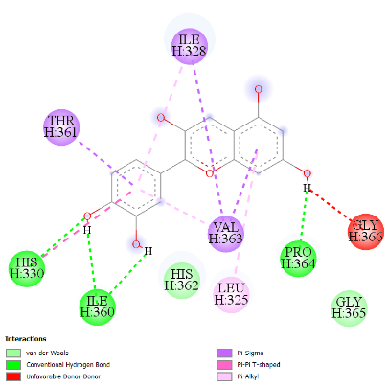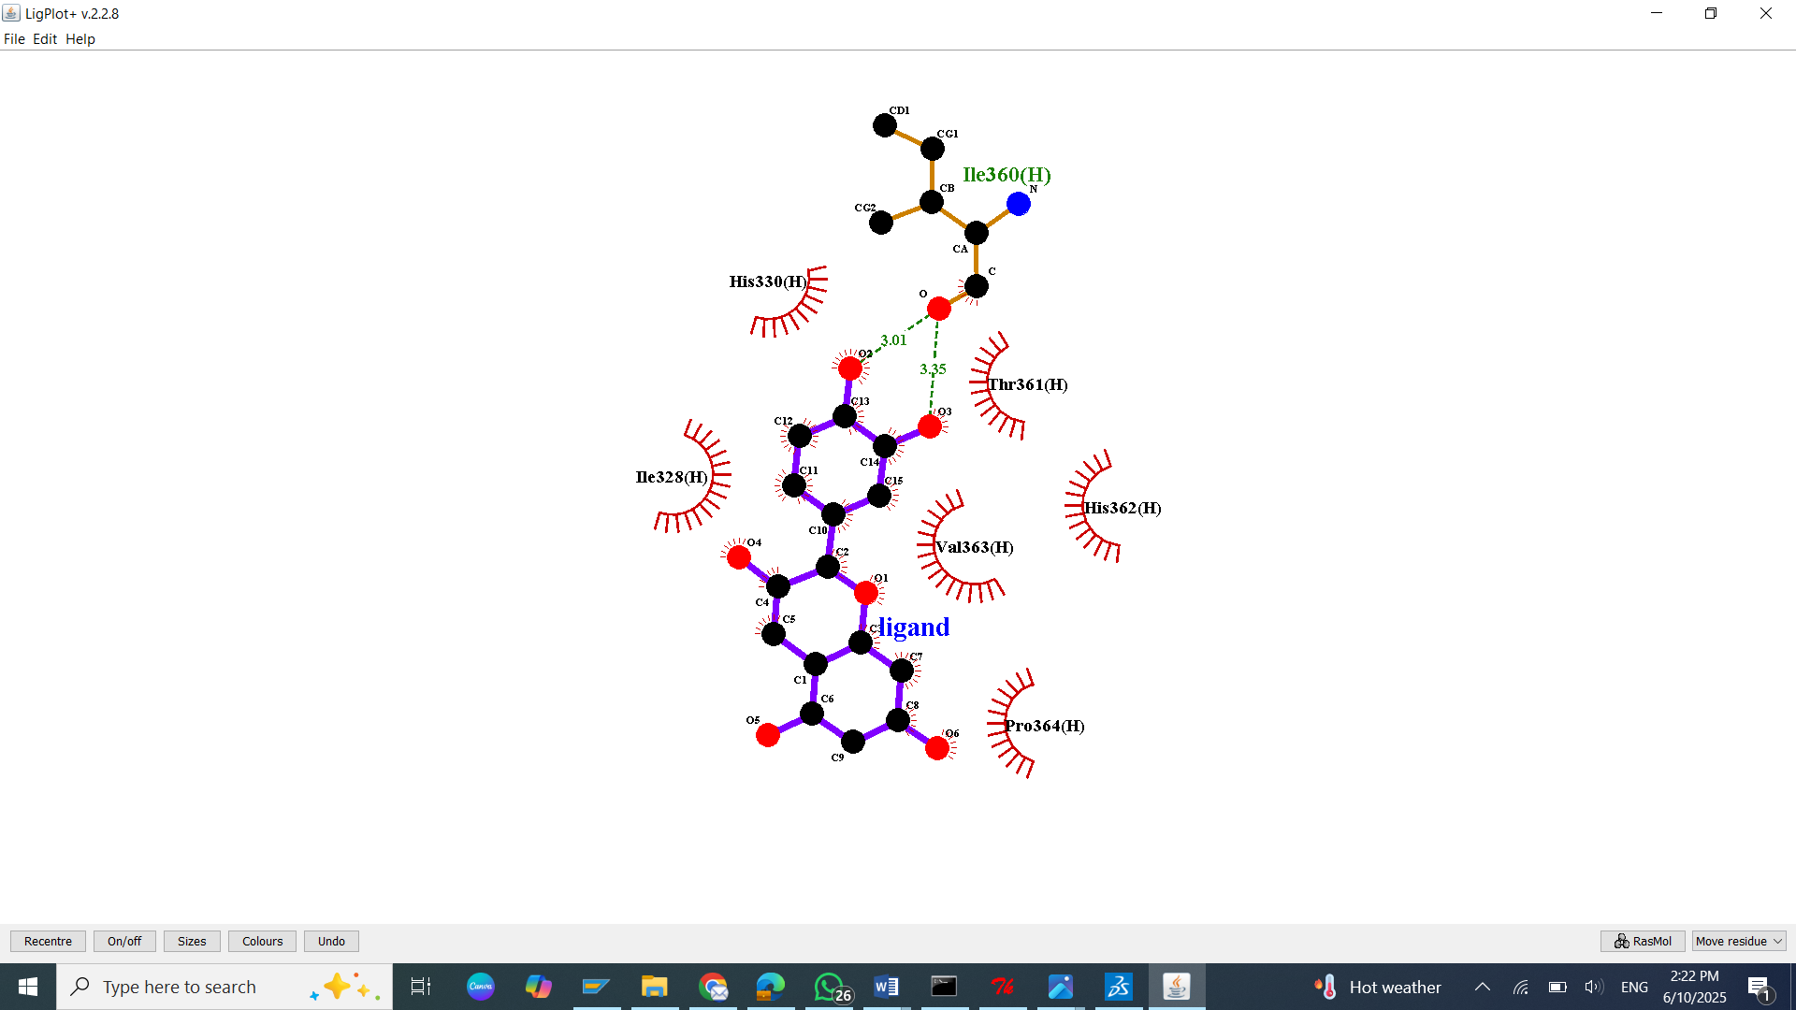
S62: Molecular Docking, secondary structure interaction and ligplus analysis of Cyanidin interactions with TAU.
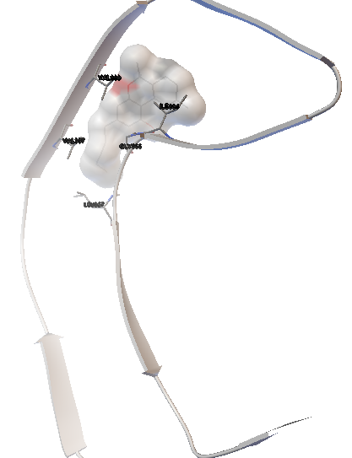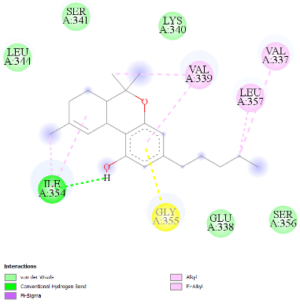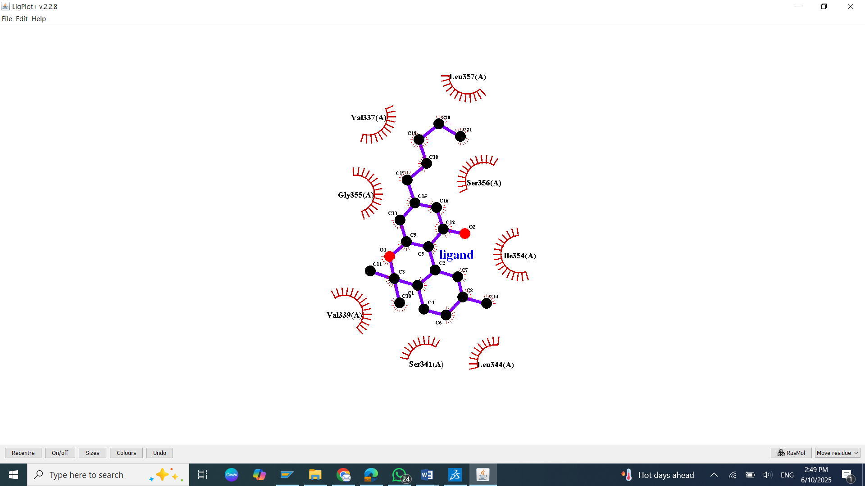
S63: Molecular Docking, secondary structure interaction and ligplus analysis of Dronabinol interactions with TAU.
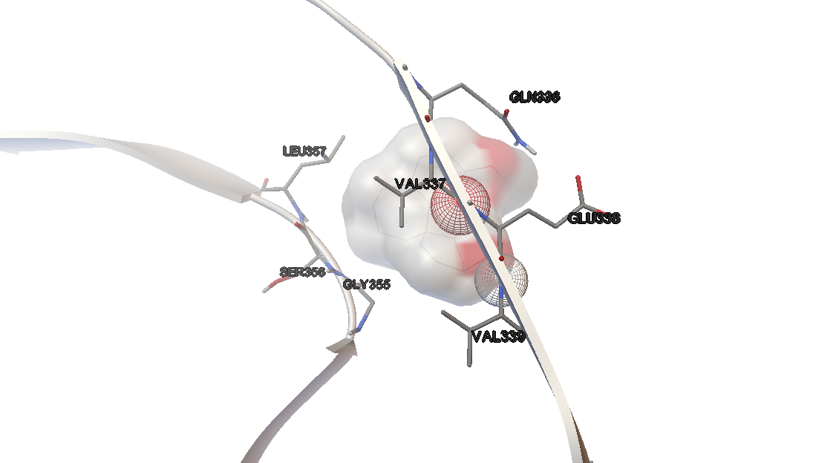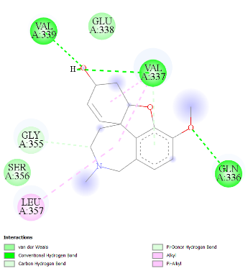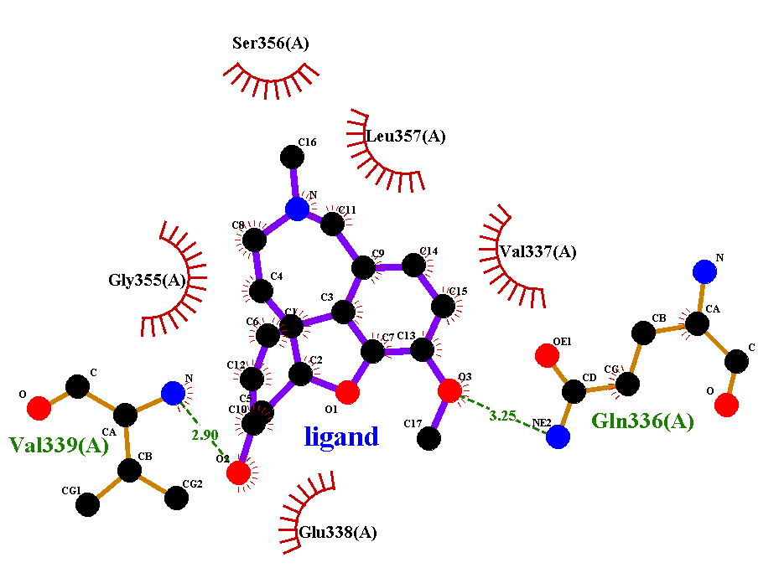

S64: Molecular Docking, secondary structure interaction and ligplus analysis of Galantamine interactions with TAU.
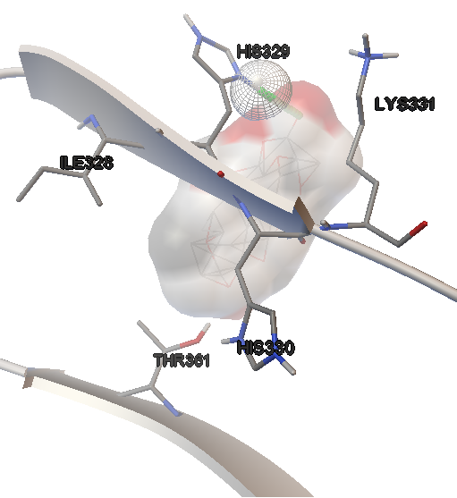
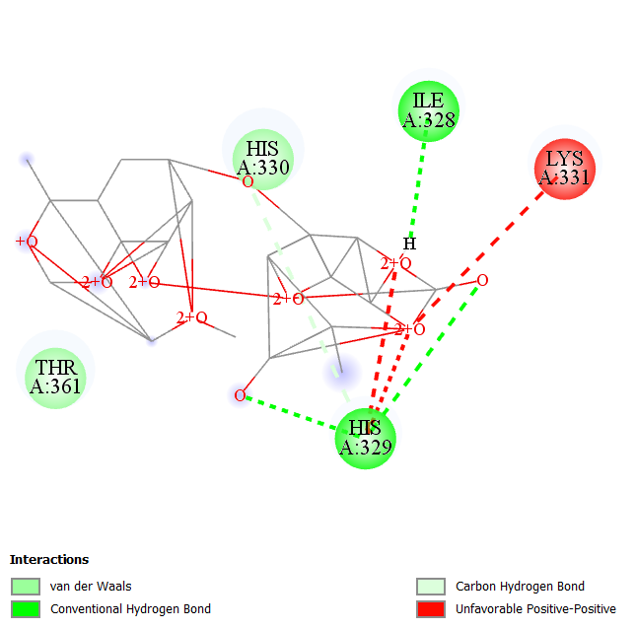
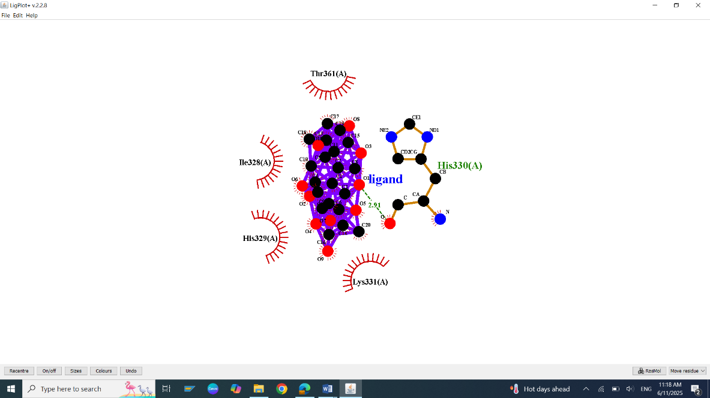
S65: Molecular Docking, secondary structure interaction and ligplus analysis of Gingkolide interactions with TAU.
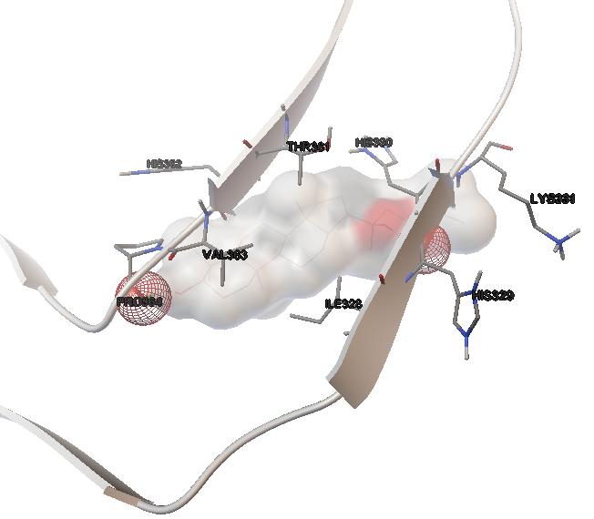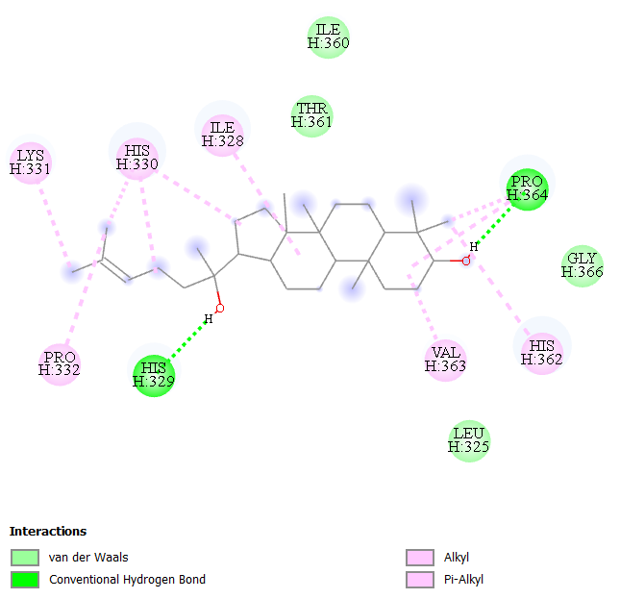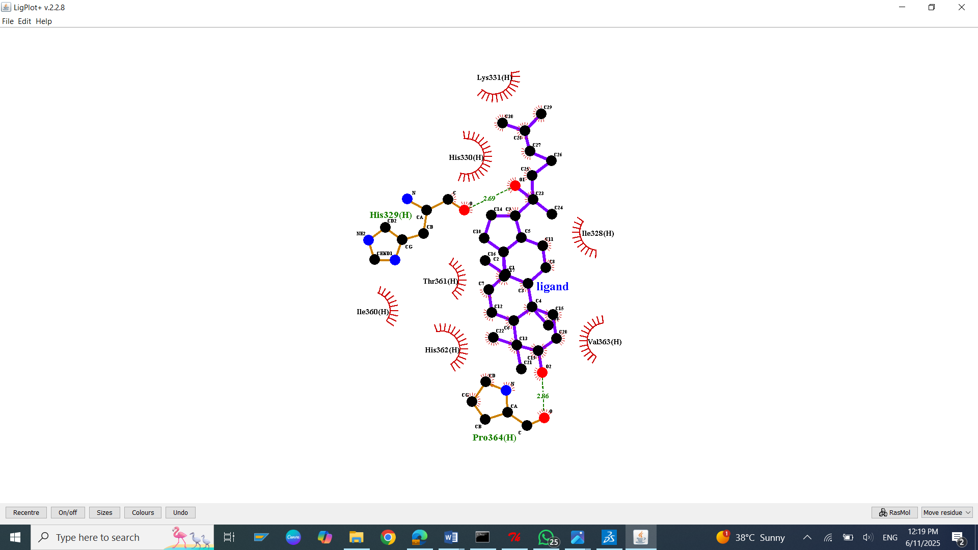
S66: Molecular Docking, secondary structure interaction and ligplus analysis of Ginsenosides interactions with TAU.
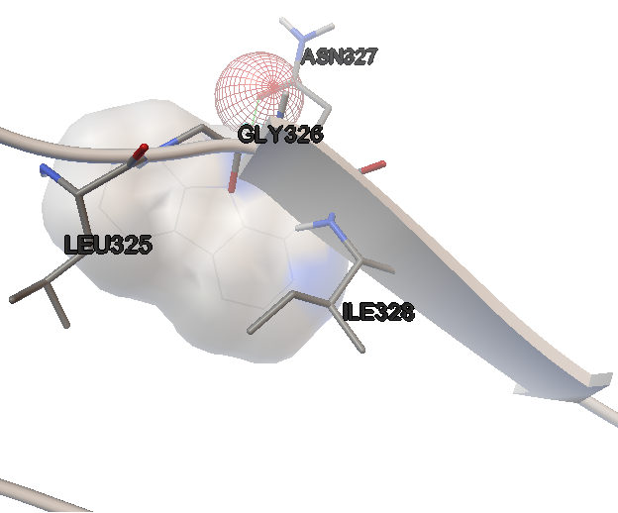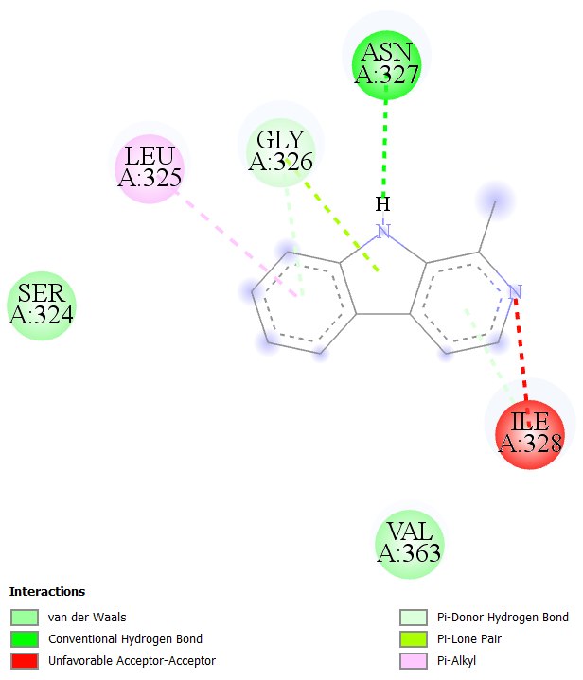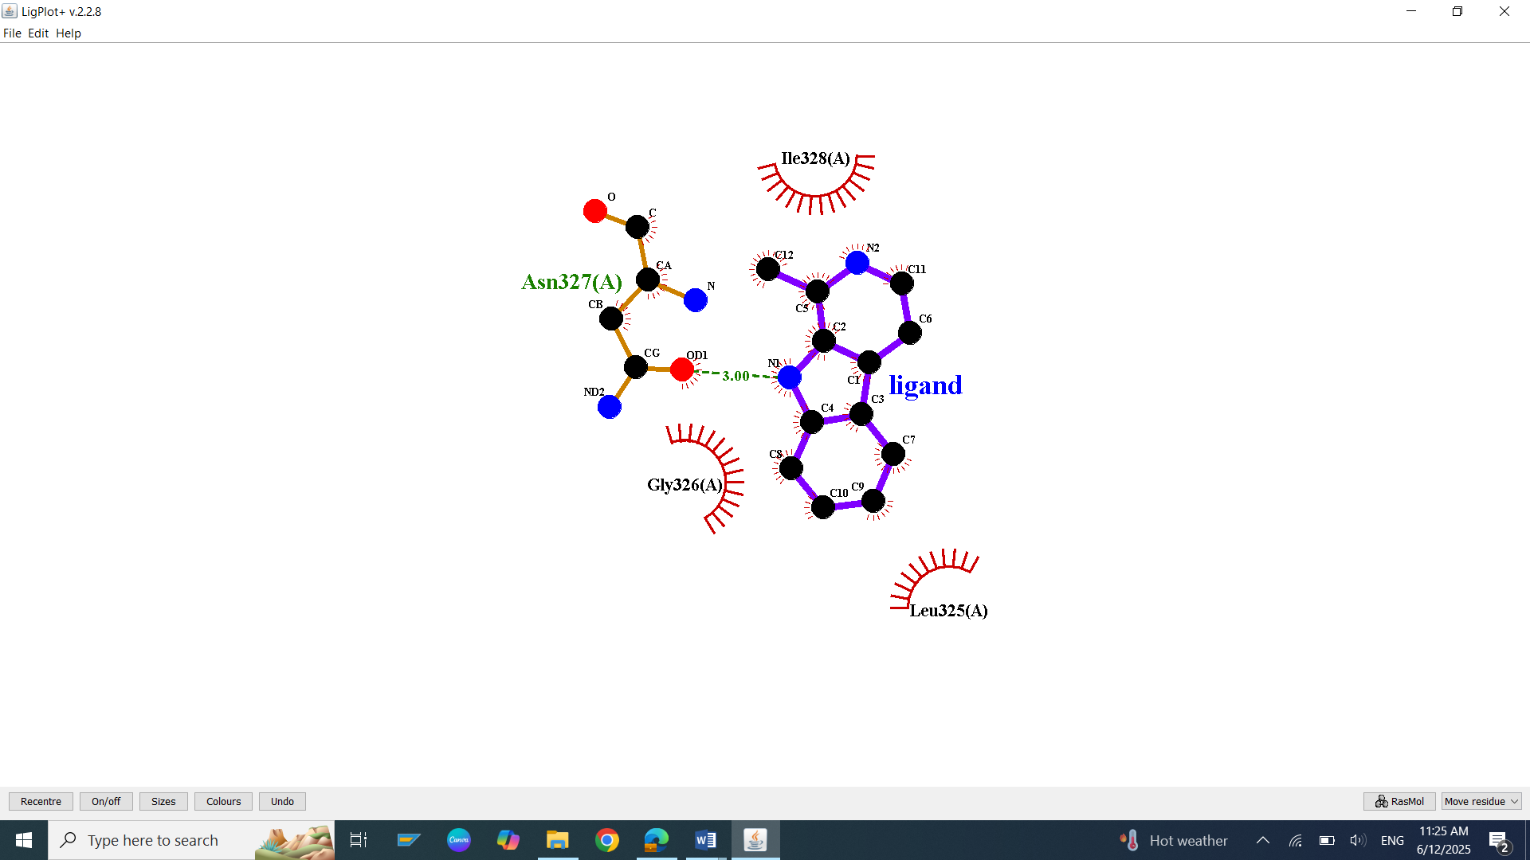
S67: Molecular Docking, secondary structure interaction and ligplus analysis of Harman interactions with TAU.
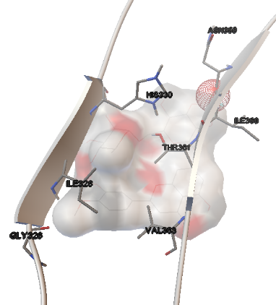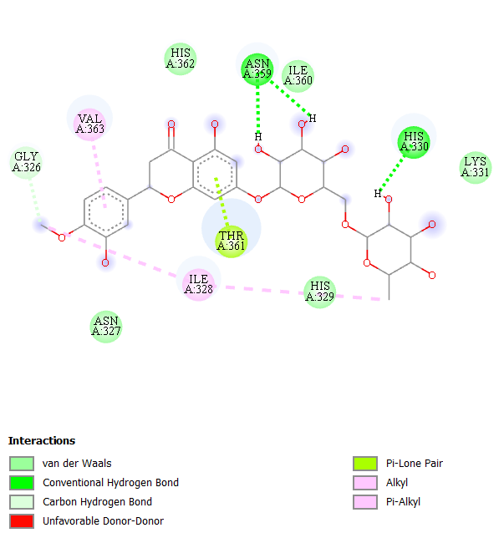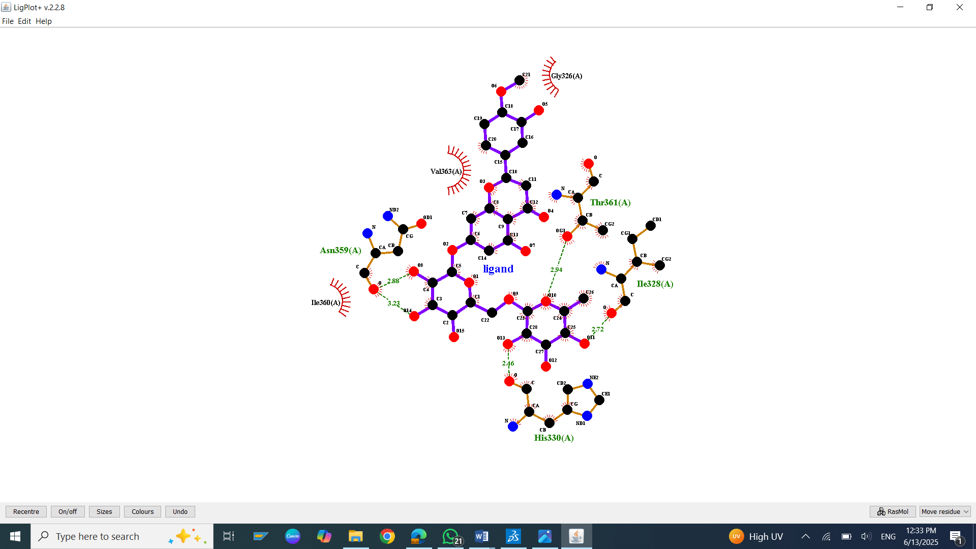

S68: Molecular Docking, secondary structure interaction and ligplus analysis of Hesperidin interactions with TAU.
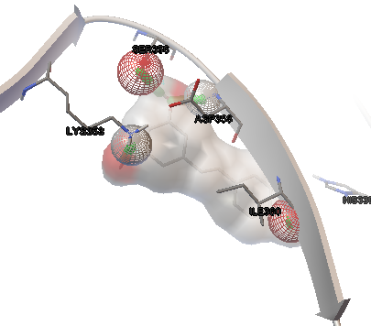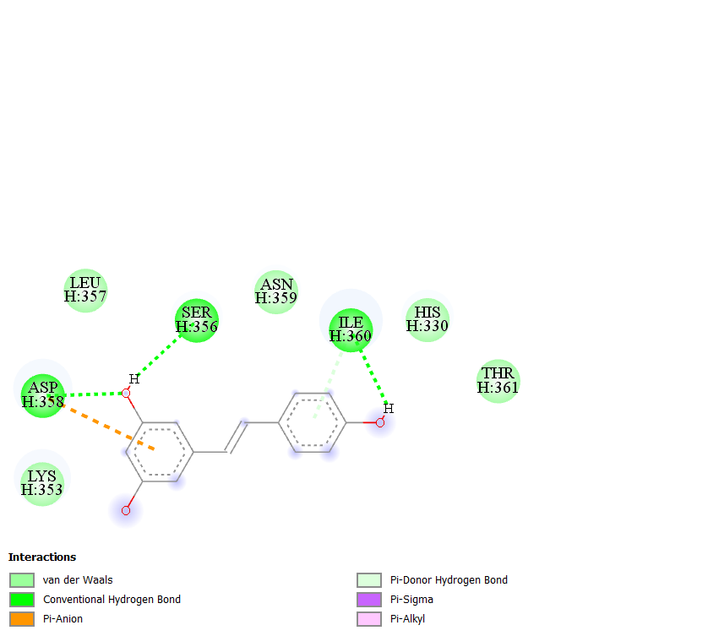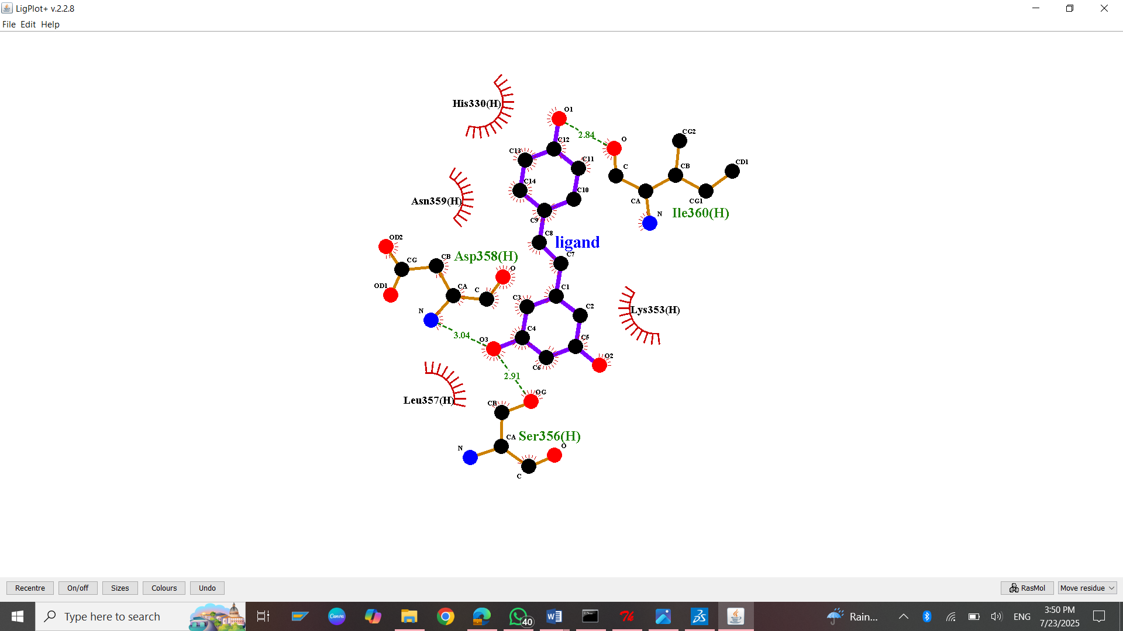
S69: Molecular Docking, secondary structure interaction and ligplus analysis of Resveratrol interactions with TAU.
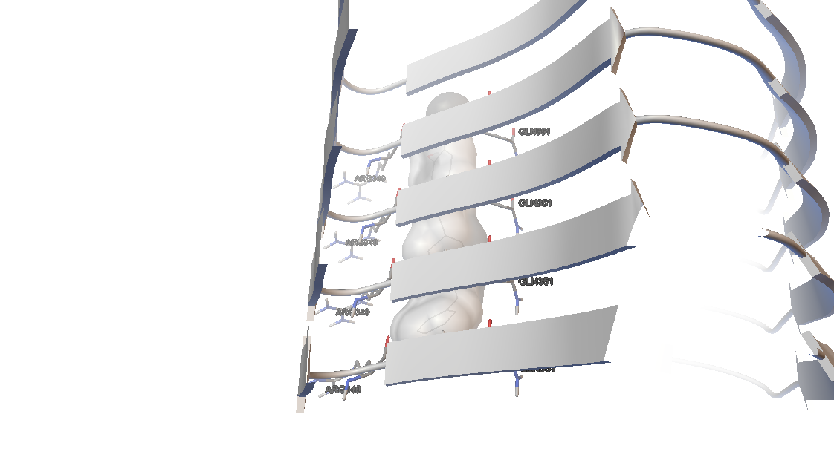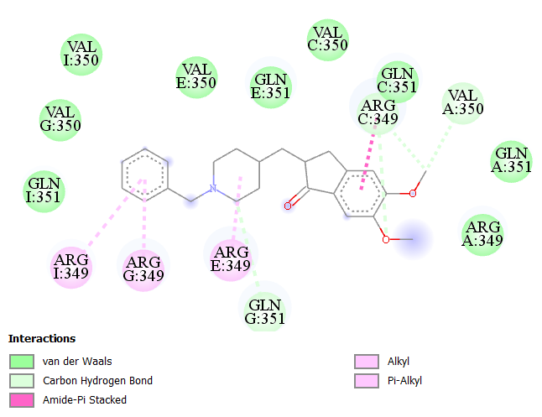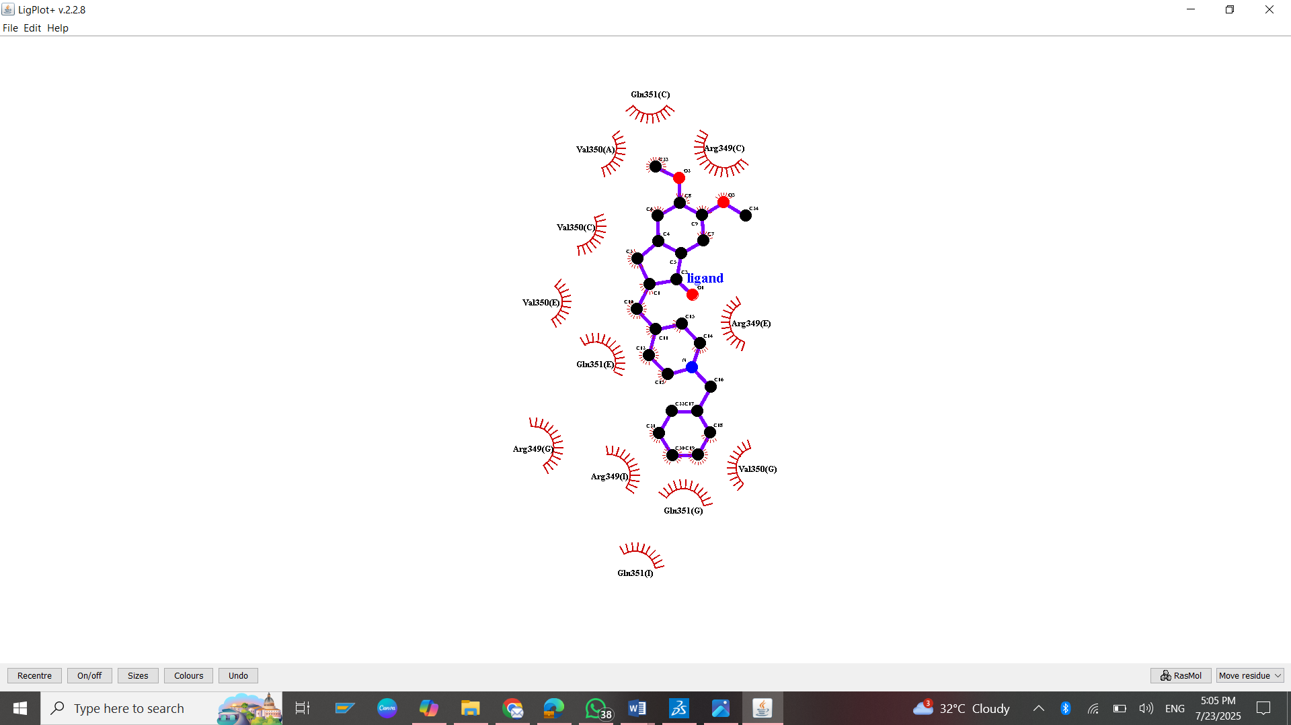
S70: Molecular Docking, secondary structure interaction and ligplus analysis of Donepezil interactions with TAU.
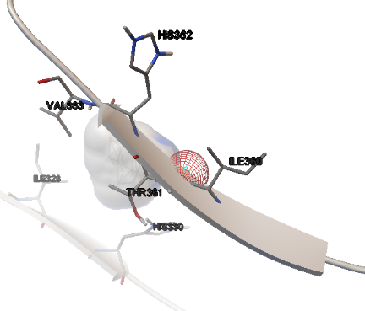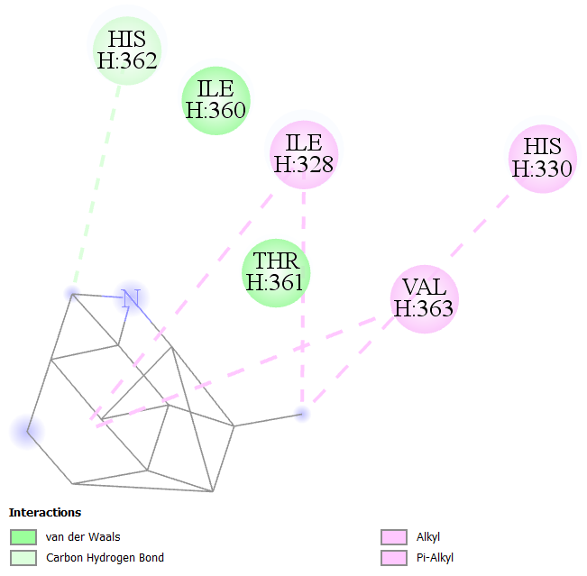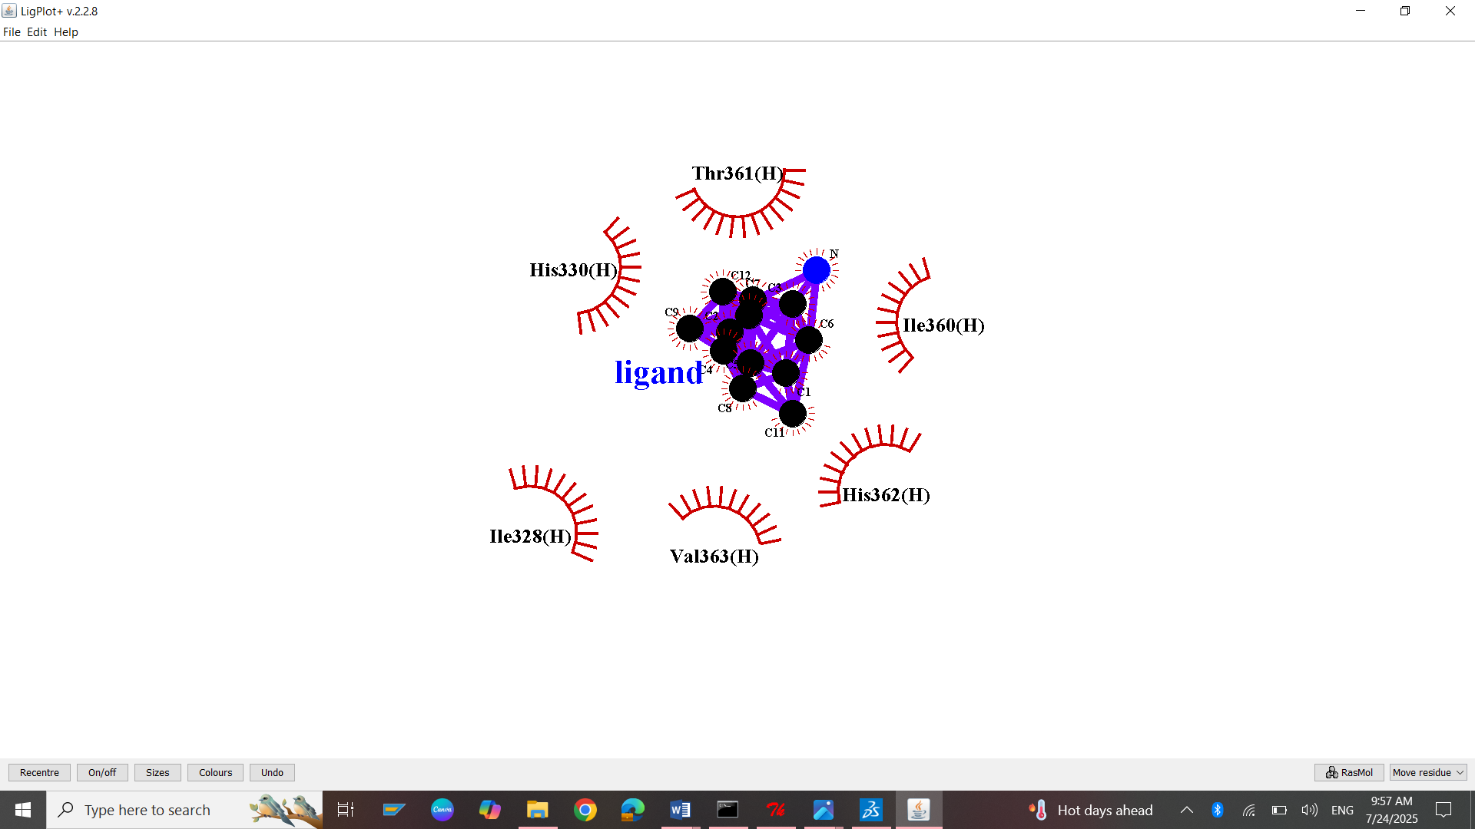
S71: Molecular Docking, secondary structure interaction and ligplus analysis of Memantine interactions with TAU.
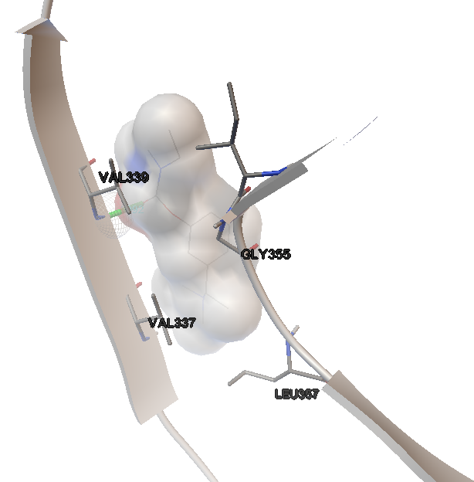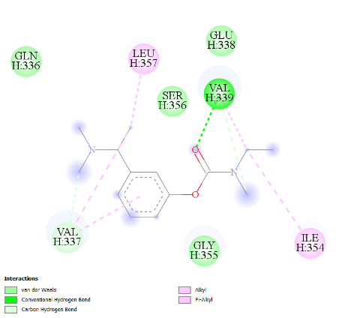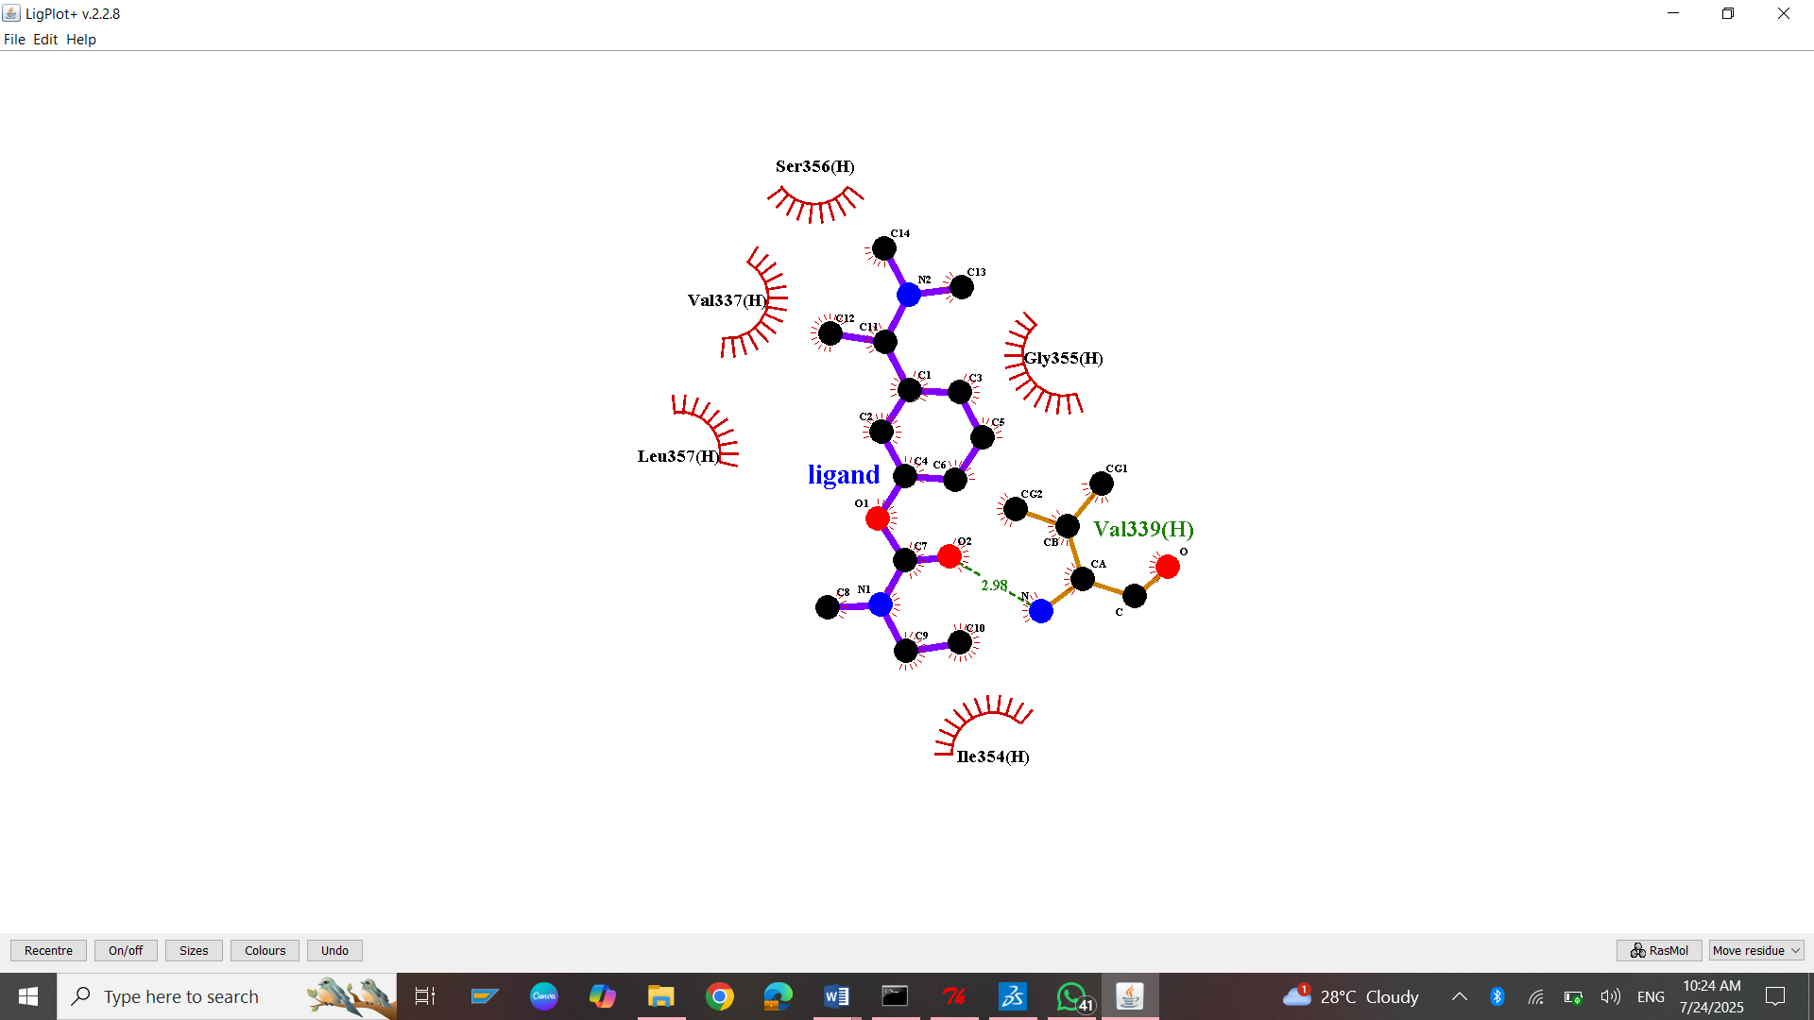
S72: Molecular Docking, secondary structure interaction and ligplus analysis of Rivastigmine interactions with TAU.

