Supplementary material

The non-psychoactive phytocannabinoids cannabidiolic and cannabigerolic acids as multitarget ligands against Alzheimer’s disease

Rosa Maria Vitale¹, Andrea Maria Morace², Antonio D’Errico³, Federica Ricciardi², Serena Boccella², Francesca Guida², Rosarita Nasso³, Sebastian Rading^{4,5}, Meliha Karsak^{4,5}, Diego Caprioglio⁶, Fabio Arturo Iannotti¹, Rosaria Arcone³, Livio Luongo², Mariorosario Masullo³, Sabatino Maione² and Pietro Amodeo¹
1 Institute of Biomolecular Chemistry (ICB)- National Research Council (CNR)- Via Campi Flegrei 34, 80078 Pozzuoli (NA)-Italy
2 Department of Experimental Medicine, Division of Pharmacology, University of Campania "Luigi Vanvitelli", Via S.M. di Costantinopoli, 16, 80138, Naples, Italy
3 Department of Medical, Health and Well-being Sciences, University of Naples “Parthenope”, Via Medina 40, 80133 Naples, Italy
4 Neuronal and Cellular Signal Transduction, Center for Molecular Neurobiology Hamburg (ZMNH), University Medical Center Hamburg-Eppendorf (UKE), 20251 Hamburg, Germany
5 Institute of Human Genetics, University Medical Center Hamburg-Eppendorf (UKE), 20251 Hamburg, Germany
6 Department of Pharmaceutical and Pharmacological Sciences, University of Eastern Piedmont "A. Avogadro", Via Bovio 6, 28100 Novara (Italy)

- H¹ NMR spectra

¹H 400 MHz NMR spectra were measured on Bruker 400 spectrometers (Bruker®, Billerica, MA, USA). Chemical shifts were referenced to the residual solvent signal (CDCl₃: δ_{H} = 7.26)
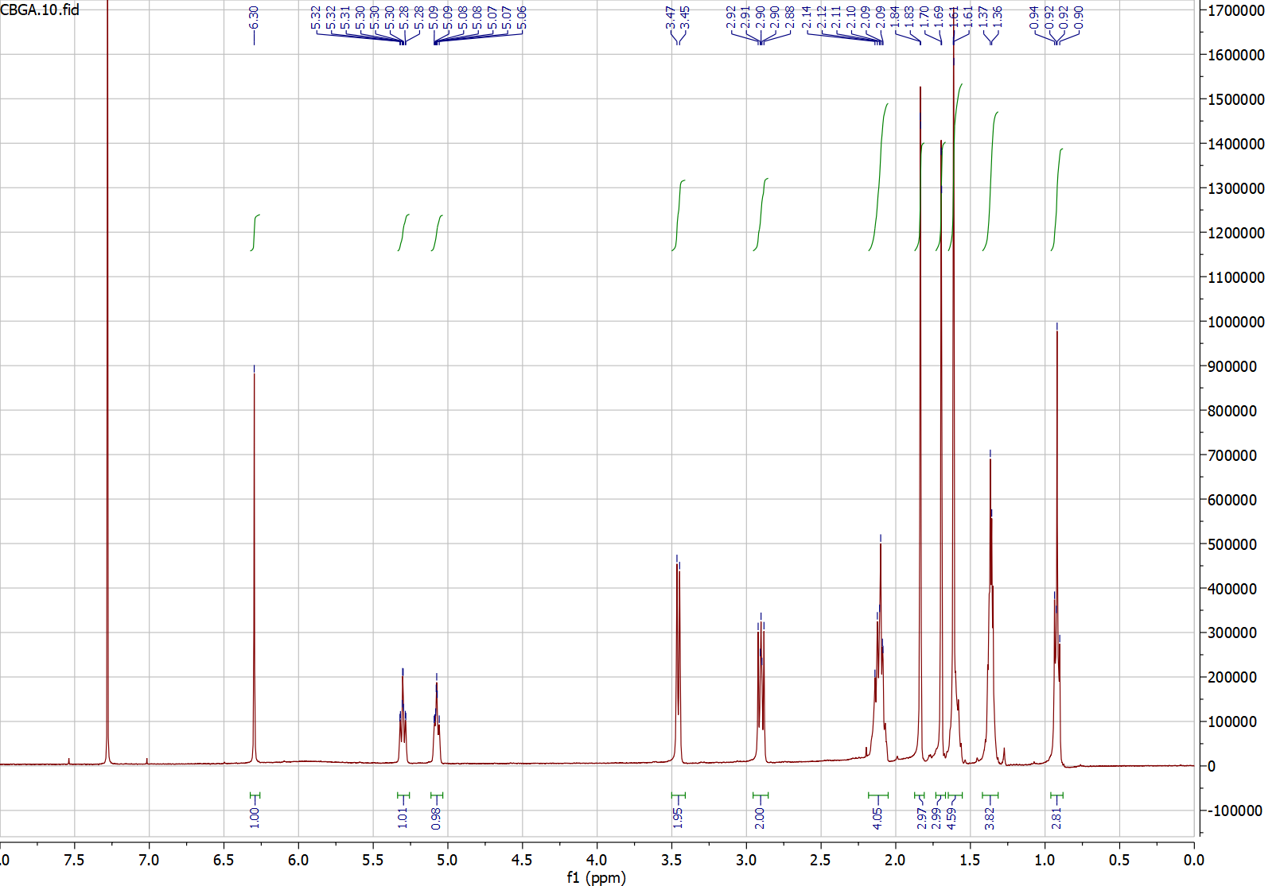
Figure S1. ¹H NMR of CBGA
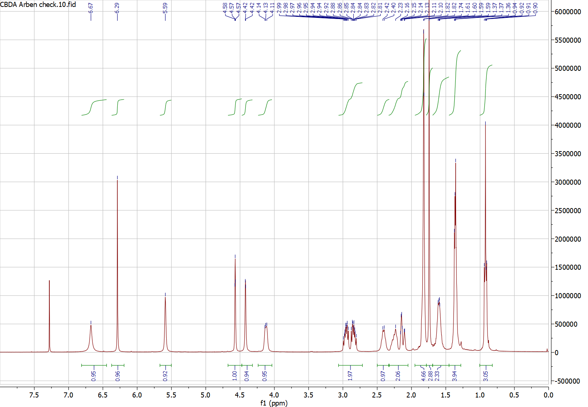
Figure S2 . ¹H NMR of CBDA

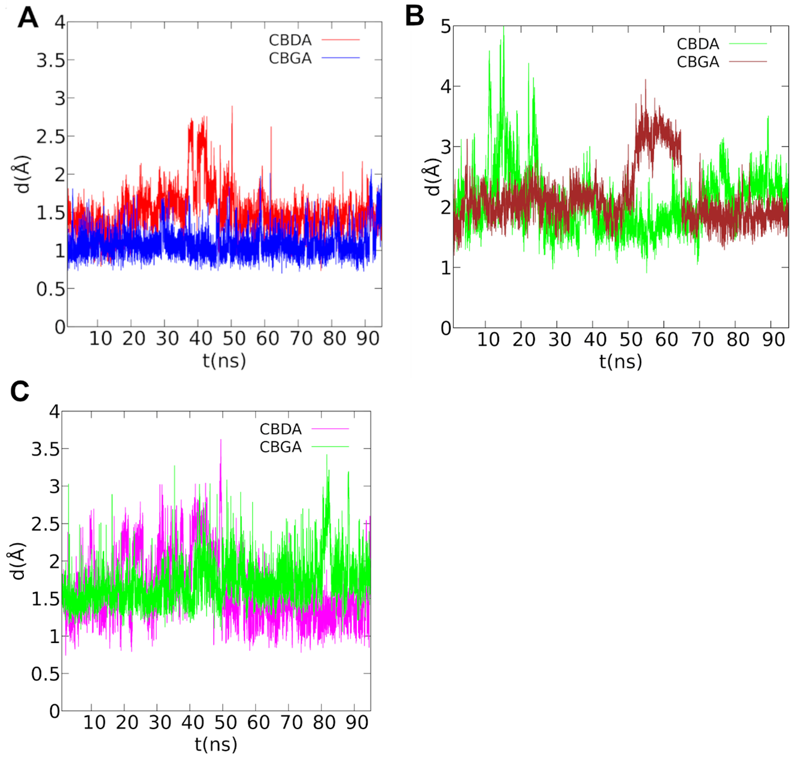
- Molecular dynamics rmsd plots for AChE, BuChE and BACE-1 in complex with CBGA and CBDA Figure S3. Root-mean-square deviation (RMSD) plots of CBDA and CBGA in complex with AChE (A), BuChE (B) and BACE-1 (C) over last 90ns of MD trajectories after best fitting of protein backbones. The ligand RMSD plot was smoothed with a five-point window running average.

- Determination of Cholinesterase activity kinetic parameters
Cholinesterase activity was assayed by the Elmann method using acetylthiocholine or butyrylthiocholine as substrate for AChE or BuChE, respectively. In particular, the reduction of DTNB was followed colorimetrically (412 nm) at room temperature (22-27°C). The reaction mixture (500 µL) contained 330 µM DTNB in 0.1 M sodium phosphate buffer, pH 7.1 and the reaction was started by the addition of 100 mU/ml AChE or BuChE, respectively, and the initial rate of the reaction was derived from the linear portion of the kinetics, determined at different substrate concentration. The kinetic parameters of the enzymatic reaction K_{m} and V_{max} were derived from the determination of the enzyme activity at different substrate concentration (50 – 500 µM). The data were either interpolated in the hyperbolic Michaelis-Menten equation or linearized with the Lineweaver-Burk equation, giving similar results.

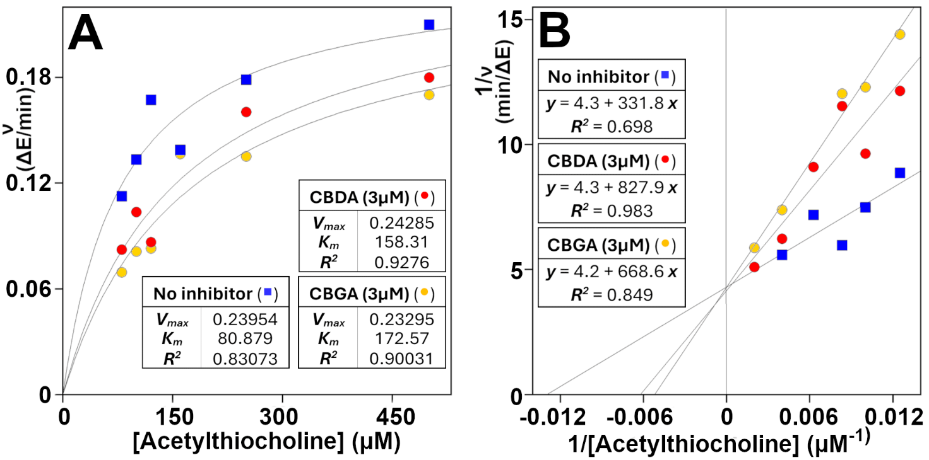
Figure S4. Representative experiment of the effect of CBDA and CBGA on the kinetics of AChE. Panel A. The initial rate of acethylthiocholine hydrolysis by AChE was measured at the indicated concentration and non-linear interpolated in hyperbolic Michaelis-Menten equation. Panel B. Lineveawer-Burk transformation of the data reported in Panel A. Insets: correlation data.

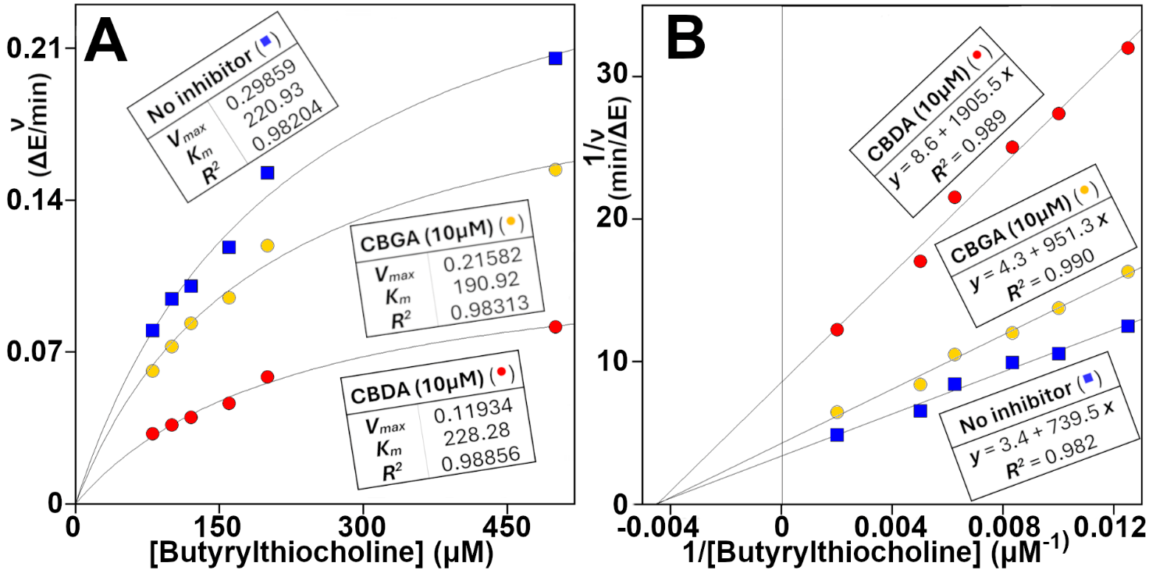
Figure S5. Representative experiment of the effect of CBDA and CBGA on the kinetics of BuChE. Panel A. The initial rate of butirrylthiocholine hydrolysis by BuChE was measured at the indicated concentration and non-linear interpolated in hyperbolic Michaelis-Menten equation. Panel B. Lineveawer-Burk transformation of the data reported in Panel A. Insets: correlation data.

- Inhibition constants determination
The values of K_{i} were derived from the equations, K_{m}' = K_{m} (1 + [I]/K_{i}) in the case of competitive inhibition, and V_{max}' = V_{max} (1 + [I]/K_{i}), in the case of non-competitive inhibition. V_{max}' and K_{m}' represent the value of V_{max} and K_{m} measured at the [I] concentration of inhibitor, respectively.
Table S1. Inhibition parameters of CBDA and CBGA on AChE
Values of K_{i} were derived only from the increase of K_{m} (competitive inhibition).
Compound | µM | V_{max} |  | K_{m} |  | K_{i}
Compound | µM | LB* | MM** | LB* | MM** | LB* | MM**
-- | 0 | 0.192±0.007 | 0.190±0.009 | 131.9±2.3 | 125.9±5.1 | - | -
CBDA | 1.25 | 0.211 | 0.208 | 134.9 | 130.8 | 55.0*** | 32.1***
“ | 1.75 | 0.242 | 0.212 | 187.3 | 141.8 | 4.2 | 13.9
“ | 2.50 | 0.233 | 0.255 | 163.3 | 190.8 | 10.5 | 4.8
“ | 3.00 | 0.248 | 0.301 | 169.2 | 237.5 | 10.6 | 3.4
CBGA | 1.25 | 0.196 | 0.196 | 144.1 | 143.1 | 13.5 | 9.1
“ | 2.50 | 0.201 | 0.190 | 166.1 | 151.8 | 9.6 | 12.2
“ | 3.00 | 0.232 | 0.233 | 192.4 | 172.6 | 6.5 | 8.1
“ | 3.75 | 0.209 | 0.196 | 166.3 | 143.6 | 14.4 | 26.7***
* Lineweaver-Burk equation
** Michaelis-Menten interpolation
*** Not included in the mean calculation of values reported in the manuscript.

Table S2. Inhibition parameters of CBDA and CBGA on BuChE
Values of K_{i} were derived only from the decrease of V_{max} (non-competitive inhibition).
Compound | Exp. | µM | V_{max} |  | K_{m} |  | K_{i}
Compound | Exp. | µM | LB* | MM** | LB* | MM** | LB* | MM**
-- | 1 | 0 | 0.295 | 0.299 | 218.5 | 220.9 | - | -
CBDA | 1 | 10 | 0.112 | 0.119 | 204.5 | 228.3 | 6.1 | 6.6
CBGA | 1 | 10 | 0.235 | 0.216 | 223.1 | 190.9 | 39.2 | 26.0
-- | 2 | 0 | 0.220 | 0.249 | 195.0 | 235.8 | - | -
CBDA | 2 | 2.66 | 0.162 | 0.0.176 | 182.0 | 209.9 | 7.5 | 6.4
GA | 2 | 2.66 | 0.185 | 0.209 | 158.3 | 196.9 | 14.1 | 14.0
* Lineweaver-Burk equation
** Michaelis-Menten interpolation

- Beta-arrestin assay on GPR109A

Figure S6. CBDA and CBGA do not activate GPR109A receptor by β-arrestin recruitment. Similar relative luminescence units (RLU) were determined in the β-arrestin recruitment assay for HCA2 receptor stimulation with (A) CBDA and (B) CBGA in comparison to vehicle treatment. In contrast, the cannabinoid CB2 receptor (CNR2-Tango) with its agonist JWH-133 (positive control) produced a strong β-arrestin recruitment in this reporter-gene based assay. Mean values +/- SD are given for nine replicate wells (for CB2 two replicates). Data were analyzed by a nonparametric one-way ANOVA (Kruskal-Wallis test) or t-test, with statistical significance set at P < 0.05. Data analysis and graphs were generated using GraphPad Prism Software.

