Supplementary information

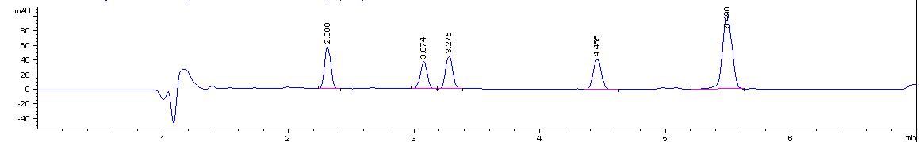
CBDV
CBG
CBD
CBN
THC
Time (minutes)

Figure a: Typical chromatogram depicting the elution time and peak separation of the different standard cannabinoids in methanol mixed together.

CBDV being the most polar relative to the other cannabinoids is eluted first followed by CBG, CBD, CBN and lastly THC (least polar) and they have retention times of 2.308, 3.074, 3.275, 4.455 and 5.490 minutes, respectively.
THC
CBN
CBD
CBG
CBDV
Time (minutes)

Figure b: Typical chromatogram of the organic cannabis extract (in methanol), depicting the presence of the different standard cannabinoids in the extract.

