Supporting information

A reliable quantitative method for determining CBD content and release from transdermal patches in Franz cells

Liyun Yu¹, Frederikke Bahrt Madsen^{1,2}, Sofie Helvig Eriksen¹, Aaron JC Andersen³, and Anne Ladegaard Skov^{1,2}

¹Danish Polymer Centre, Department of Chemical and Biochemical Engineering, Building 227, Technical University of Denmark, DK-2800 Kgs. Lyngby, Denmark
²Glysious, Kong Valdemarsvej 58, DK-2840 Holte, Denmark
³Department of Biotechnology and Biomedicine, Building 221, Technical University of Denmark, DK-2800 Kgs. Lyngby, Denmark

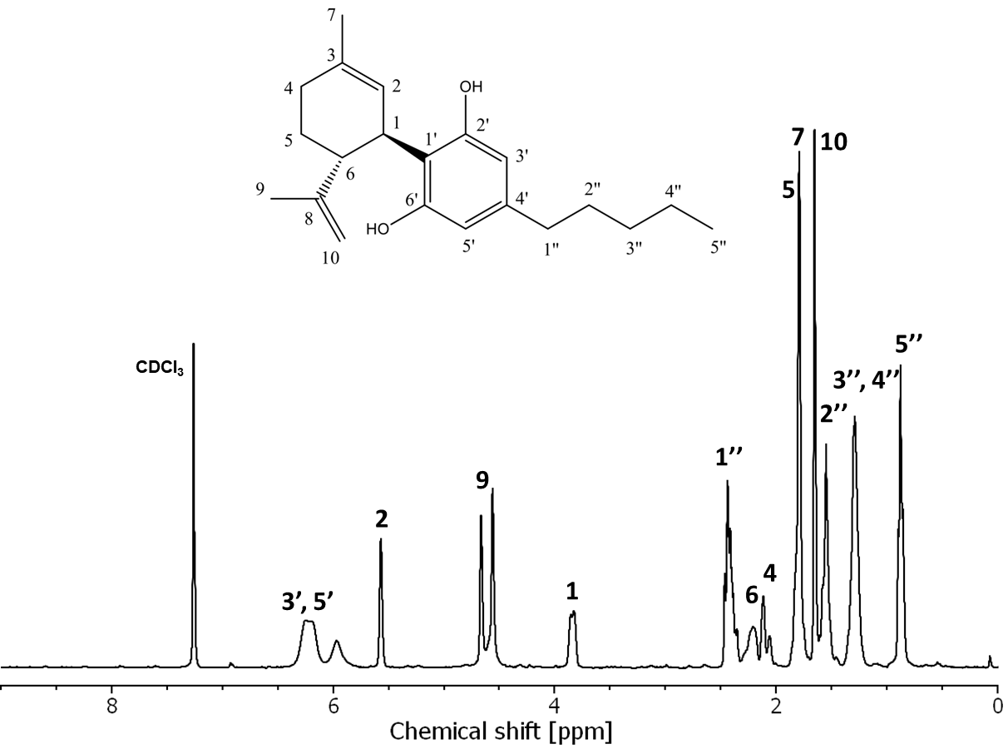
Figure S1: ¹H-NMR spectrum of pure CBD with the chemical structure of CBD shown along with the numbers used for peak identification.
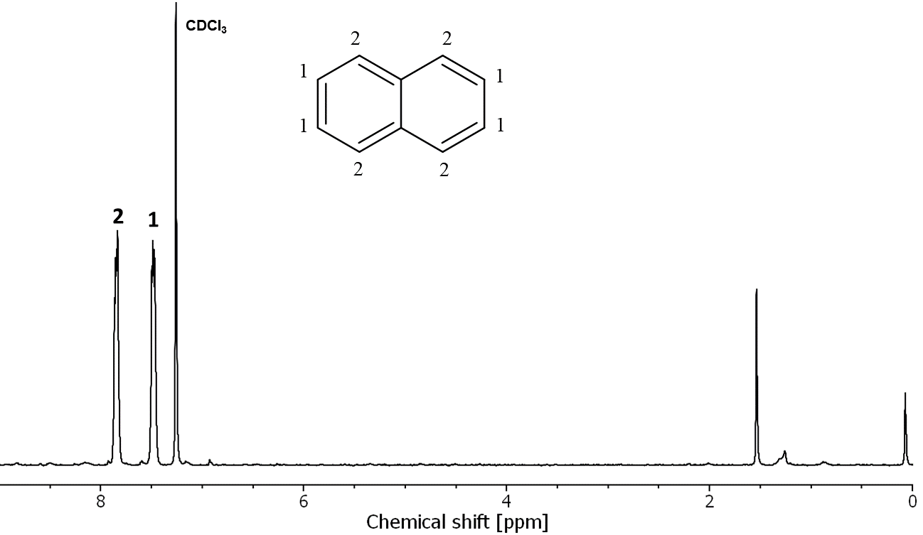
Figure S2: ¹H-NMR spectrum of pure naphthalene with the chemical structure shown along with the numbers used for peak identification.
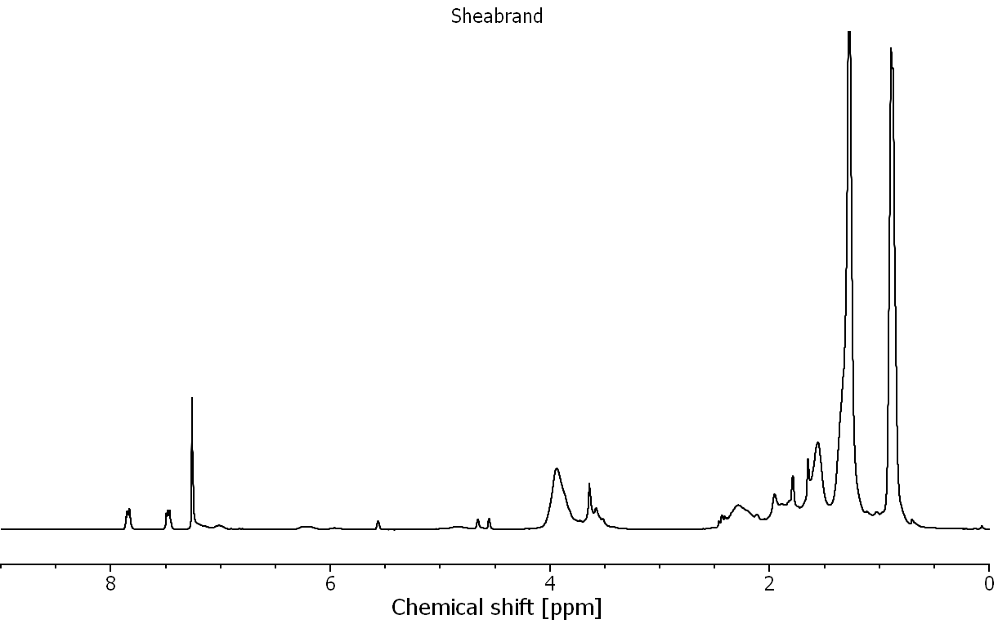
Figure S3: Representative ¹H-NMR spectrum of patch A in CDCl₃ with naphthalene as calibrant.
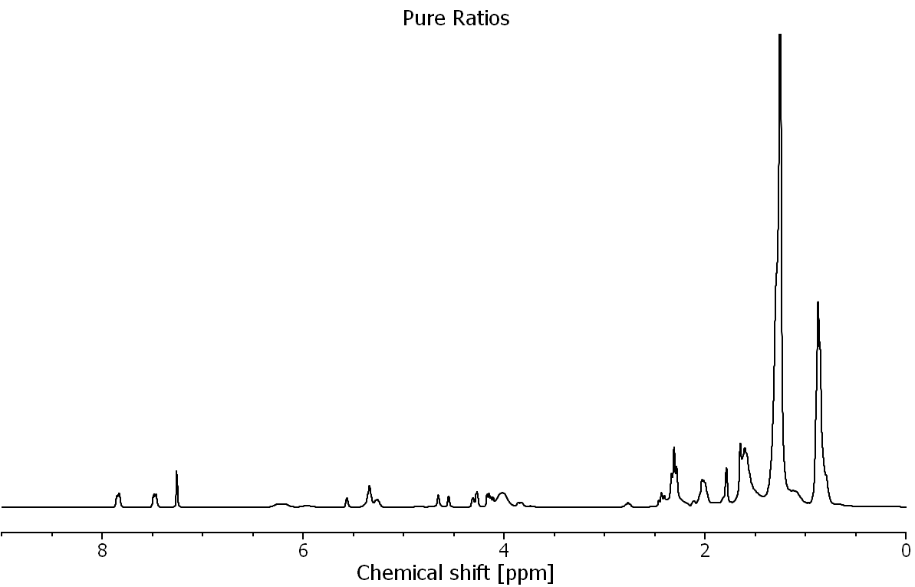
Figure S4: Representative ¹H-NMR spectrum of patch B in CDCl₃ with naphthalene as calibrant.
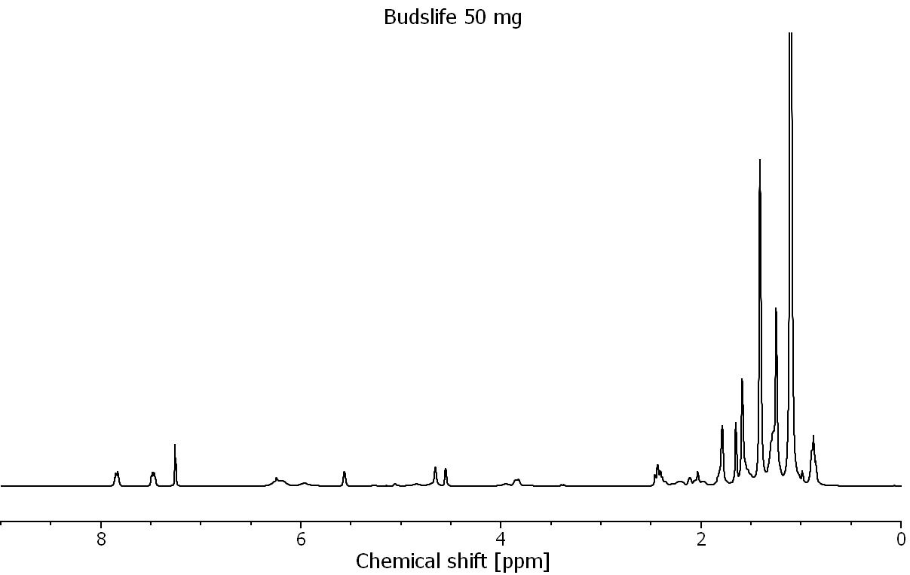
Figure S5: Representative ¹H-NMR spectrum of patch C 50 mg patch in CDCl₃ with naphthalene as calibrant.
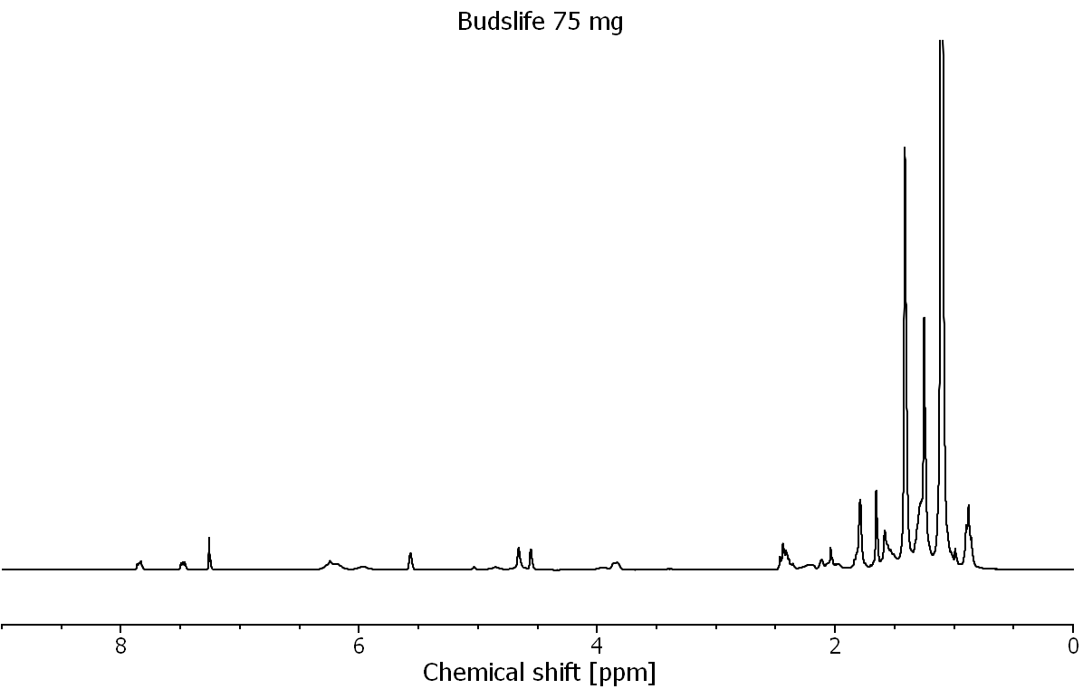
Figure S6: Representative ¹H-NMR spectrum of patch C 75 mg patch in CDCl₃ with naphthalene as calibrant.
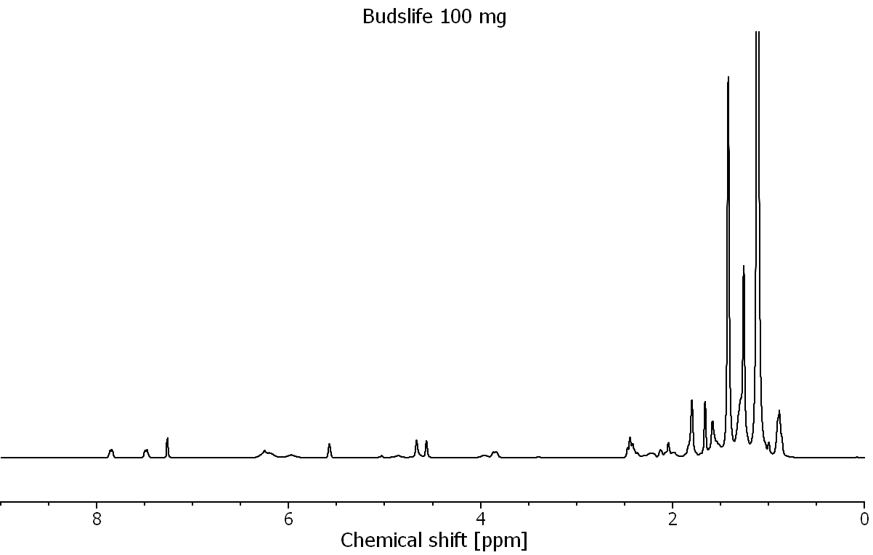
Figure S7: Representative ¹H-NMR spectrum of patch C 100 mg patch in CDCl₃ with naphthalene as calibrant.
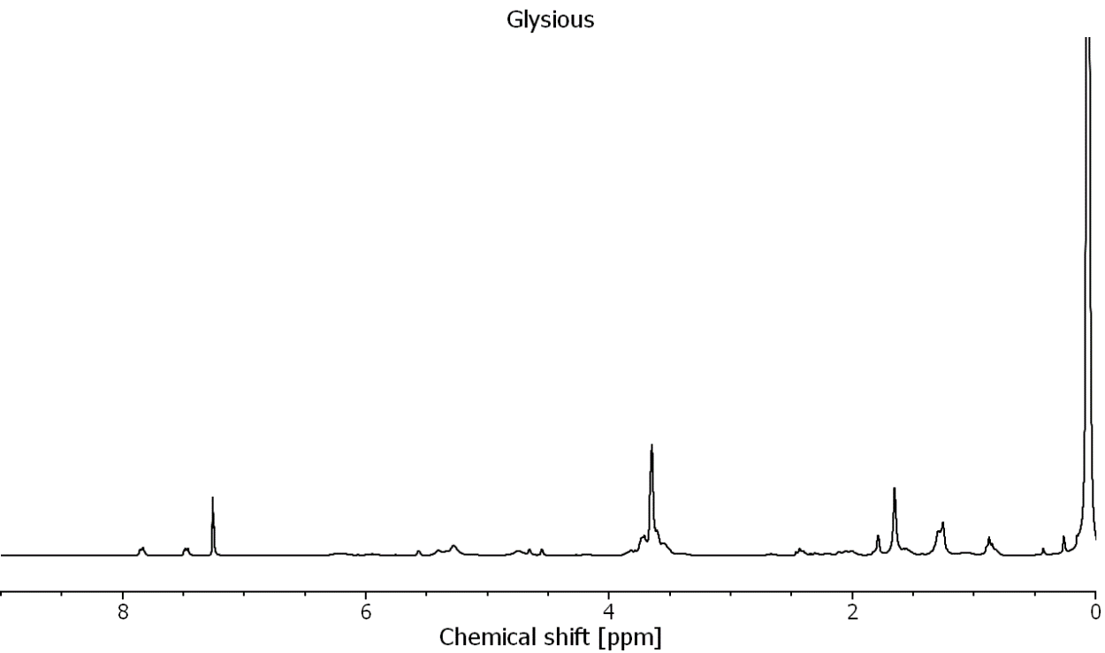
Figure S8: Representative ¹H-NMR spectrum of patch D in CDCl₃ with naphthalene as calibrant.

Table S1. Results of the qNMR and HPLC-MS testing, for six samples with known CBD content, in the form of the percentage of the recovery.
Sample no. | Recovery from qNMR [%] | Recovery from HPLC [%]
1 | 100.7 | 96.5
2 | 95.8 | 96.4
3 | 99.6 | 91.5
4 | 99.0 | 95.8
5 | 99.6 | 92.4
6 | 95.9 | 92.7
Total average | 98.4±2 | 94.2±2

Table S2. Results of the HPLC-MS testing in the form of the determined amount of CBD and the CBD stated by the manufacturer/company as well as the difference between the labeled and determined amount.
Brand | m_{CBD} determined HPLC-MS [mg] | m_{CBD} stated by manufacturer/company [mg] | Difference between labeled and determined value [%]
A | 29.3 | 40 | -31
B | 37.2 | 40 | -7
C 50 mg | 61.3 | 50 | 20
C 75 mg | 98.5 | 75 | 27
C 100 mg | 133.1 | 100 | 28

