Supplementary Materials

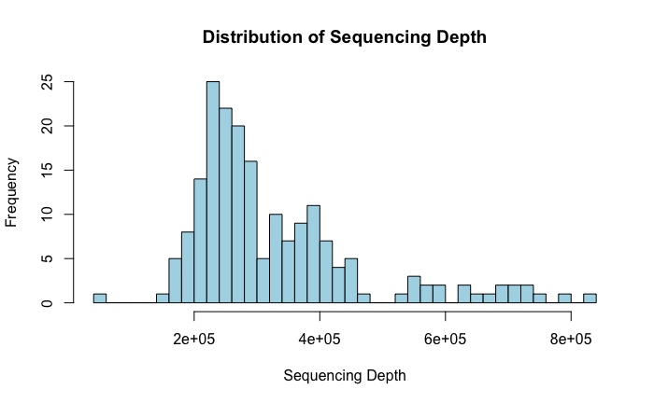
Figure S1. Distribution of Sequencing Depth.
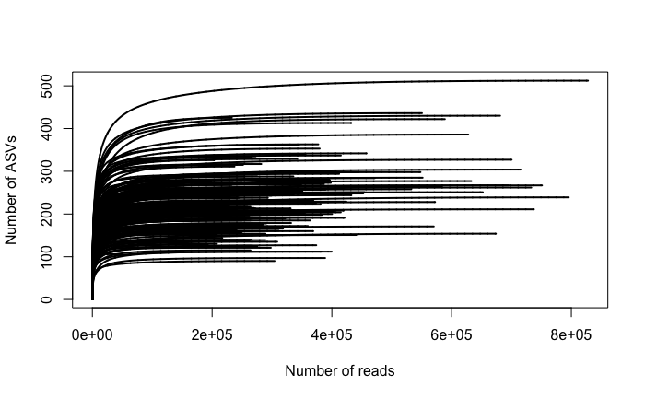
Figure S2. Rarefaction curve.

Saliva gDNA Isolation Protocol:

- Transfer 500 ul of saliva into Eppendorf tubes
- Add 250 ul of lysis (ASL) buffer to the saliva
- Incubate at 60 degrees Celsius for 30 minutes
- Move entire sample into tubes with .1 beads
- Homogenize for 2x 20 seconds cycles on fastprep bead beater system
- After bead beating, centrifuge the 2mL tubes for 5 minutes at 16,000x g
- Transfer the supernatant to the labeled Eppendorf tubes to pool the sample
- Total volume = 500 ul
- Add 500 ul of 100% ETOH
- Add 500 ul lysate to Epoch Biosciences gDNA spin columns
- Close the cap and centrifuge at 12,000 g for 1 minute
- Discard the flow through
- Add remaining 500 ul lysate to Epoch Biosciences gDNA spin columns
- Close the cap and centrifuge at 12,000 g for 1 minute
- Discard the flow through
- Add 500 ul AW1
- Close the cap and centrifuge at 12,000 g for 1 minute
- Discard the flow through
- Add 500 ul Buffer AW2
- Close the cap and centrifuge at 12,000 rpm for 1 minute
- Discard the flow through
- Transfer the spin columns into new labeled 1.5 mL microcentrifuge tube
- Carefully open the spin column and pipet 200 ul Buffer AE directly onto the spin column membrane
- Close the cap and incubate for 1 minute at room temperature
- Centrifuge at 12,000 g for 1 minute to elute DNA
- Store at -20 degrees Celsius

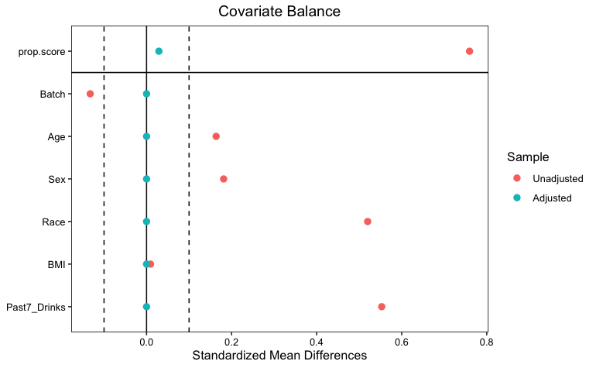
Figure S3. Love plot showing balancing covariates before and after propensity score matching at the genus level.

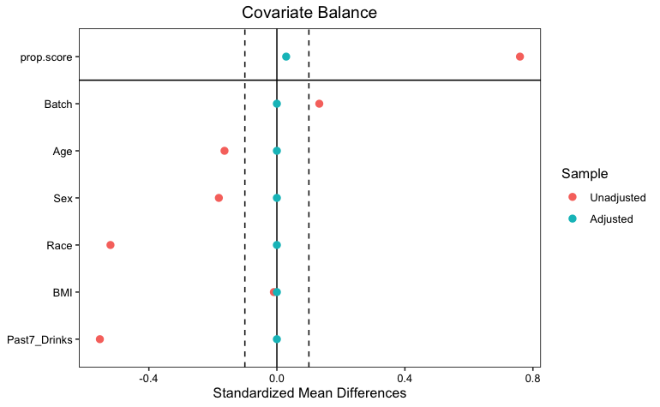
Figure S4. Love plot showing balancing covariates before and after propensity score matching at the species level.

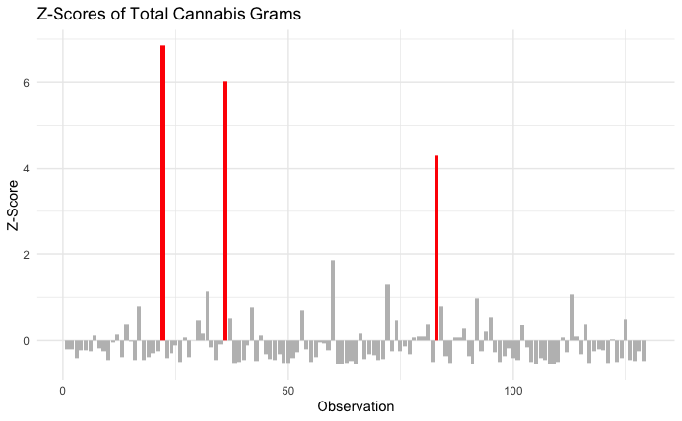
Figure S5. Z-scores of total cannabis grams.
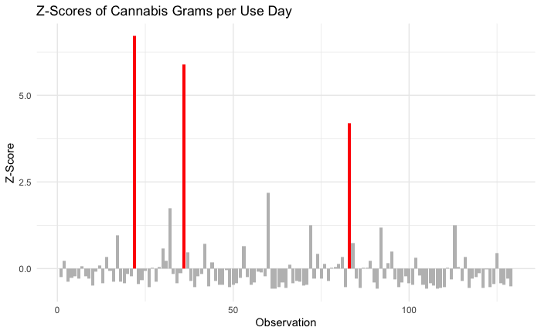

Figure S6. Z-Scores of cannabis grams per use day.

Table S1. Aim 1 Alpha Diversity Genus

Taxa level | Index | Estimate | Std. Error | Statistic | P value | 2.50% | 97.50%
Genus | Shannon | -0.198 | 0.043 | -4.621 | 0.000 | -0.282 | -0.114
Genus | Simpson | -0.014 | 0.005 | -2.913 | 0.004 | -0.023 | -0.005
Genus | Chao1 | -2.914 | 1.778 | -1.639 | 0.101 | -6.400 | 0.571
Genus | Pielou’s evenness | -0.042 | 0.009 | -4.639 | 0.000 | -0.060 | -0.024
Species | Shannon | -0.254 | 0.064 | -3.974 | 0.000 | -0.379 | -0.129
Species | Simpson | -0.009 | 0.003 | -2.579 | 0.010 | -0.016 | -0.002
Species | Chao1 | -9.996 | 6.212 | -1.609 | 0.108 | -22.171 | 2.179
Species | Pielou’s evenness | -0.043 | 0.010 | -4.250 | 0.000 | -0.063 | -0.023

Table S2. Aim 1 Beta Diversity

Taxa level | Metric | Sum of Sqs | R2 | F | P value
Genus | Bray-Curtis | 0.254 | 0.001 | 1.967 | 0.054
Genus | Jaccard | 0.383 | 0.006 | 1.252 | 0.167
Genus | Aitchison | 862 | 0.013 | 2.620 | 0.001
Species | Bray-Curtis | 0.303 | 0.001 | 1.746 | 0.058
Species | Jaccard | 0.421 | 0.001 | 1.203 | 0.109
Species | Aitchison | 3074 | 0.011 | 2.152 | 0.001

Table S3. Aim 2 Alpha Diversity

Variable | Taxa level | Index | Estimate | Std. Error | Statistic | P value | 2.50% | 97.50%
Days | Genus | Shannon | -0.015 | 0.017 | -0.851 | 0.397 | -0.049 | 0.020
Days | Genus | Simpson | 0.001 | 0.002 | 0.626 | 0.532 | -0.002 | 0.004
Days | Genus | Chao1 | -1.432 | 0.572 | -2.506 | 0.014 | -2.564 | -0.300
Days | Genus | Pielou’s evenness | -0.001 | 0.004 | -0.206 | 0.837 | -0.008 | 0.007
Days | Species | Shannon | -0.024 | 0.025 | -0.980 | 0.329 | -0.074 | 0.025
Days | Species | Simpson | 0.001 | 0.001 | 0.744 | 0.458 | -0.001 | 0.003
Days | Species | Chao1 | -4.848 | 1.948 | -2.489 | 0.014 | -8.706 | -0.991
Days | Species | Pielou’s evenness | -0.002 | 0.004 | -0.376 | 0.708 | -0.010 | 0.007
Grams per day | Genus | Shannon | -0.014 | 0.019 | -0.766 | 0.445 | -0.051 | 0.022
Grams per day | Genus | Simpson | -0.002 | 0.002 | -1.503 | 0.135 | -0.006 | 0.001
Grams per day | Genus | Chao1 | 0.538 | 0.623 | 0.863 | 0.390 | -0.696 | 1.771
Grams per day | Genus | Pielou’s evenness | -0.004 | 0.004 | -1.039 | 0.301 | -0.012 | 0.004
Grams per day | Species | Shannon | -0.005 | 0.027 | -0.178 | 0.859 | -0.057 | 0.048
Grams per day | Species | Simpson | -0.001 | 0.001 | -0.656 | 0.513 | -0.003 | 0.002
Grams per day | Species | Chao1 | 1.025 | 2.126 | 0.482 | 0.631 | -3.185 | 5.236
Grams per day | Species | Pielou’s evenness | -0.001 | 0.005 | -0.286 | 0.775 | -0.011 | 0.008
Total grams | Genus | Shannon | -0.002 | 0.003 | -0.854 | 0.395 | -0.008 | 0.003
Total grams | Genus | Simpson | 0.000 | 0.000 | -1.538 | 0.127 | -0.001 | 0.000
Total grams | Genus | Chao1 | 0.070 | 0.098 | 0.714 | 0.477 | -0.124 | 0.265
Total grams | Genus | Pielou’s evenness | -0.001 | 0.001 | -1.106 | 0.271 | -0.002 | 0.001
Total grams | Species | Shannon | -0.001 | 0.004 | -0.256 | 0.798 | -0.009 | 0.007
Total grams | Species | Simpson | 0.000 | 0.000 | -0.498 | 0.619 | 0.000 | 0.000
Total grams | Species | Chao1 | 0.084 | 0.335 | 0.250 | 0.803 | -0.580 | 0.747
Total grams | Species | Pielou’s evenness | 0.000 | 0.001 | -0.323 | 0.747 | -0.002 | 0.001

Table S4. Aim 2 Beta Diversity

Variable | Taxa level | Metric | Sum of Sqs | R2 | F | P value
Days | Genus | Bray-Curtis | 0.131 | 0.008 | 1.005 | 0.420
Days | Genus | Jaccard | 0.302 | 0.008 | 0.982 | 0.468
Days | Genus | Aitchison | 380.000 | 0.009 | 1.198 | 0.200
Days | Species | Bray-Curtis | 0.158 | 0.007 | 0.922 | 0.497
Days | Species | Jaccard | 0.346 | 0.008 | 0.994 | 0.461
Days | Species | Aitchison | 3315.000 | 0.012 | 2.323 | 0.001
Grams per day | Genus | Bray-Curtis | 0.063 | 0.004 | 0.458 | 0.858
Grams per day | Genus | Jaccard | 0.273 | 0.007 | 0.885 | 0.613
Grams per day | Genus | Aitchison | 324.000 | 0.008 | 1.022 | 0.277
Grams per day | Species | Bray-Curtis | 0.155 | 0.007 | 0.902 | 0.516
Grams per day | Species | Jaccard | 0.363 | 0.008 | 1.043 | 0.342
Grams per day | Species | Aitchison | 1711.000 | 0.006 | 1.192 | 0.166
Total grams | Genus | Bray-Curtis | 0.071 | 0.004 | 0.539 | 0.807
Total grams | Genus | Jaccard | 0.286 | 0.007 | 0.928 | 0.532
Total grams | Genus | Aitchison | 302.000 | 0.007 | 0.950 | 0.471
Total grams | Species | Bray-Curtis | 0.180 | 0.008 | 1.051 | 0.378
Total grams | Species | Jaccard | 0.389 | 0.009 | 1.116 | 0.219
Total grams | Species | Aitchison | 1677.000 | 0.006 | 1.168 | 0.179

