Longitudinal synaptic loss in primary tauopathies:
an in vivo [¹¹C]UCB-J PET study

***Supplementary material***

Longitudinal change in [¹¹C]UCB-J BP_{ND} (CSF corrected) over one year (%) in Hammersmith atlas regions of interest
Region | Mean | SD | Min | Max | p value
Pallidum L | -4.2 | 10.6 | -20.8 | 25.2 | 0.080
Caudate nucleus R | -3.9 | 9.9 | -23.7 | 13.1 | 0.046
Presubgenual frontal cortex L | -3.5 | 7.9 | -17.9 | 11.6 | 0.030
Presubgenual frontal cortex R | -3.2 | 11.3 | -23.2 | 31.3 | ns
Middle frontal gyrus R | -2.7 | 7.3 | -14.1 | 14.2 | ns
Caudate nucleus L | -2.6 | 10.4 | -20.1 | 22.4 | ns
Superior frontal gyrus R | -2.5 | 8.5 | -19.5 | 14.4 | ns
Middle frontal gyrus L | -2.5 | 9.4 | -19.8 | 17.5 | ns
Subcallosal area L | -2.3 | 13.2 | -21.0 | 25.2 | ns
Hippocampus R | -2.1 | 11.5 | -18.0 | 26.4 | ns
Thalamus R | -2.0 | 7.2 | -17.0 | 14.4 | ns
Superior frontal gyrus L | -1.9 | 7.8 | -15.6 | 15.8 | ns
Inferiolateral remainder of parietal lobe L | -1.8 | 7.9 | -22.5 | 11.7 | ns
Cuneus R | -1.8 | 7.3 | -14.2 | 15.7 | ns
Subgenual frontal cortex L | -1.7 | 8.4 | -15.2 | 20.2 | ns
Thalamus L | -1.7 | 7.2 | -15.7 | 15.3 | ns
Inferior frontal gyrus R | -1.7 | 6.6 | -11.8 | 10.6 | ns
Anterior orbital gyrus R | -1.7 | 8.5 | -17.5 | 17.8 | ns
Inferior frontal gyrus L | -1.7 | 8.3 | -15.3 | 14.1 | ns
Superior parietal gyrus R | -1.6 | 7.7 | -22.9 | 11.0 | ns
Cuneus L | -1.6 | 8.5 | -15.0 | 24.1 | ns
Cingulate gyrus anterior part L | -1.5 | 7.9 | -14.0 | 14.8 | ns
Precentral gyrus L | -1.4 | 8.1 | -18.1 | 13.2 | ns
Putamen R | -1.4 | 7.5 | -17.2 | 13.5 | ns
Subcallosal area R | -1.4 | 14.0 | -18.0 | 46.1 | ns
Hippocampus L | -1.3 | 8.2 | -13.6 | 15.6 | ns
Fusiform gyrus R | -1.2 | 9.3 | -15.4 | 21.3 | ns
Inferiolateral remainder of parietal lobe R | -1.1 | 6.9 | -11.5 | 12.1 | ns
Subgenual frontal cortex R | -1.1 | 13.7 | -27.2 | 28.2 | ns
Insula R | -1.1 | 8.3 | -18.3 | 11.9 | ns
Amygdala R | -1.0 | 9.4 | -16.0 | 22.5 | ns
Superior parietal gyrus L | -0.9 | 8.3 | -20.8 | 14.4 | ns
Parahippocampal and ambient gyri R | -0.8 | 6.6 | -18.2 | 11.4 | ns
Superior temporal gyrus posterior part R | -0.8 | 8.8 | -13.0 | 17.7 | ns
Cingulate gyrus anterior part R | -0.8 | 9.3 | -21.2 | 22.4 | ns
Cerebellum gm L | -0.8 | 8.5 | -12.8 | 25.9 | ns
Precentral gyrus R | -0.7 | 8.0 | -13.3 | 14.9 | ns
Lateral remainder of occipital lobe L | -0.7 | 8.1 | -13.7 | 18.9 | ns

Region | Mean | SD | Min | Max | p value
Amygdala L | -0.6 | 10.5 | -18.8 | 15.9 | ns
Anterior orbital gyrus L | -0.6 | 10.1 | -18.4 | 28.9 | ns
Putamen L | -0.6 | 8.0 | -14.6 | 16.6 | ns
Lateral remainder of occipital lobe R | -0.6 | 6.7 | -10.7 | 12.4 | ns
Cerebellum gm R | -0.6 | 7.5 | -12.4 | 18.3 | ns
Superior temporal gyrus posterior part L | -0.5 | 8.9 | -17.4 | 18.5 | ns
Straight gyrus L | -0.5 | 10.7 | -21.8 | 30.3 | ns
Middle and inferior temporal gyrus R | -0.4 | 8.9 | -14.6 | 26.3 | ns
Lingual gyrus L | -0.3 | 7.6 | -11.0 | 14.2 | ns
Posterior orbital gyrus R | -0.2 | 9.1 | -14.5 | 19.7 | ns
Anterior temporal lobe medial part L | -0.1 | 9.9 | -14.6 | 25.9 | ns
Postcentral gyrus L | -0.1 | 8.0 | -17.2 | 17.4 | ns
Superior temporal gyrus anterior part L | 0.0 | 9.8 | -14.1 | 20.3 | ns
Lingual gyrus R | 0.0 | 7.5 | -11.2 | 15.9 | ns
Pallidum R | 0.1 | 8.4 | -14.6 | 14.9 | ns
Posterior temporal lobe L | 0.2 | 10.3 | -16.1 | 33.6 | ns
Anterior temporal lobe medial part R | 0.3 | 10.0 | -14.0 | 29.1 | ns
Fusiform gyrus L | 0.3 | 11.1 | -18.9 | 34.4 | ns
Parahippocampal and ambient gyri L | 0.4 | 12.3 | -19.3 | 26.4 | ns
Posterior temporal lobe R | 0.4 | 8.4 | -11.2 | 19.7 | ns
Superior temporal gyrus anterior part R | 0.4 | 11.7 | -16.9 | 29.4 | ns
Gyrus cinguli posterior part L | 0.5 | 6.5 | -12.3 | 15.6 | ns
Gyrus cinguli posterior part R | 0.5 | 8.1 | -21.2 | 12.0 | ns
Posterior orbital gyrus L | 0.5 | 10.5 | -17.3 | 27.9 | ns
Cerebellum dentate L | 0.5 | 11.8 | -25.3 | 27.4 | ns
Insula L | 0.6 | 9.5 | -15.5 | 24.6 | ns
Straight gyrus R | 0.7 | 10.5 | -14.6 | 35.2 | ns
Middle and inferior temporal gyrus L | 0.7 | 11.9 | -13.9 | 45.1 | ns
Medial orbital gyrus R | 0.7 | 9.6 | -17.0 | 25.4 | ns
Anterior temporal lobe lateral part R | 0.9 | 13.9 | -23.9 | 50.9 | ns
Postcentral gyrus R | 0.9 | 8.6 | -12.0 | 17.2 | ns
Anterior temporal lobe lateral part L | 0.9 | 13.8 | -23.7 | 46.8 | ns
Lateral orbital gyrus R | 1.1 | 9.4 | -12.9 | 26.3 | ns
Lateral orbital gyrus L | 1.6 | 10.7 | -17.3 | 26.2 | ns
Medial orbital gyrus L | 1.8 | 9.9 | -13.0 | 32.5 | ns
Cerebellum dentate R | 2.8 | 14.1 | -23.1 | 44.7 | ns

Supplementary Table 1. Annual percentage change (Mean, standard deviation (SD), minimum (Min) and maximum (Max)), in [¹¹C]UCB-J BP_{ND} (CSF corrected). Unadjusted p values obtained from a two-way ANOVA of regional [¹¹C]UCB-J BP_{ND} at baseline and follow-up. L: left, R: right.

Longitudinal change in grey matter volume over one year (%) in Hammersmith atlas regions of interest

Region | Mean | SD | Min | Max | p value | adjusted p value
Thalamus_R | -11.8 | 10.6 | -36.9 | 1.8 | 0.000 | 0.002
Precentral_gyrus_L | -7.1 | 7.2 | -25.4 | 4.8 | 0.000 | 0.004
Caudate_nucleus_R | -7.5 | 7.5 | -24.4 | 5.7 | 0.000 | 0.009
Inferiolateral_remainder_of_parietal_lobe_R | -5.2 | 5.1 | -15.6 | 3.1 | 0.001 | 0.043
Cerebellum_gm_L | -2.8 | 4.0 | -13.5 | 5.6 | 0.001 | 0.044
Thalamus_L | -8.8 | 12.4 | -36.2 | 22.8 | 0.001 | ns
Inferior_frontal_gyrus_L | -6.3 | 8.9 | -29.5 | 8.9 | 0.001 | ns
Cuneus_L | -6.5 | 9.6 | -28.0 | 10.0 | 0.004 | ns
Superior_temporal_gyrus_anterior_part_R | -4.4 | 7.5 | -25.8 | 5.8 | 0.005 | ns
Superior_temporal_gyrus_posterior_part_R | -3.4 | 5.1 | -14.2 | 4.9 | 0.005 | ns
Cuneus_R | -5.8 | 9.1 | -26.4 | 11.9 | 0.006 | ns
Precentral_gyrus_R | -5.8 | 10.3 | -35.5 | 10.4 | 0.006 | ns
Lingual_gyrus_L | -5.3 | 7.4 | -25.8 | 4.6 | 0.006 | ns
Inferior_frontal_gyrus_R | -4.2 | 5.7 | -18.2 | 7.0 | 0.007 | ns
Inferiolateral_remainder_of_parietal_lobe_L | -3.8 | 6.1 | -13.7 | 5.9 | 0.009 | ns
Posterior_temporal_lobe_R | -2.6 | 4.6 | -12.2 | 7.4 | 0.011 | ns
Superior_temporal_gyrus_anterior_part_L | -4.5 | 10.7 | -27.2 | 25.4 | 0.012 | ns
Superior_parietal_gyrus_R | -2.6 | 5.0 | -12.2 | 9.6 | 0.012 | ns
Lingual_gyrus_R | -2.3 | 4.5 | -14.9 | 5.9 | 0.012 | ns
Postcentral_gyrus_R | -3.4 | 8.8 | -22.0 | 21.2 | 0.013 | ns
Anterior_temporal_lobe_lateral_part_R | -5.6 | 13.2 | -34.0 | 27.9 | 0.037 | ns
Anterior_temporal_lobe_medial_part_L | -5.0 | 10.9 | -29.7 | 14.0 | 0.016 | ns
Anterior_temporal_lobe_lateral_part_L | -4.1 | 13.0 | -34.0 | 19.3 | ns | ns
Middle_frontal_gyrus_L | -4.1 | 9.8 | -27.5 | 18.8 | 0.017 | ns
Middle_frontal_gyrus_R | -4.0 | 9.8 | -27.9 | 11.3 | ns | ns
Lateral_orbital_gyrus_L | -4.0 | 12.2 | -19.9 | 30.0 | 0.045 | ns
Caudate_nucleus_L | -3.8 | 9.4 | -19.4 | 27.8 | 0.020 | ns
Anterior_orbital_gyrus_L | -3.8 | 15.3 | -32.2 | 47.0 | 0.046 | ns
Superior_temporal_gyrus_posterior_part_L | -3.4 | 6.9 | -15.8 | 9.9 | 0.029 | ns
Posterior_orbital_gyrus_L | -3.3 | 7.9 | -18.2 | 12.5 | 0.041 | ns
Putamen_L | -3.3 | 9.4 | -17.0 | 22.9 | 0.021 | ns
Subcallosal_area_L | -3.3 | 14.5 | -47.3 | 22.1 | ns | ns
Superior_frontal_gyrus_L | -3.3 | 7.1 | -19.8 | 12.2 | 0.016 | ns
Middle_and_inferior_temporal_gyrus_R | -3.2 | 6.5 | -21.3 | 5.9 | 0.015 | ns
Fusiform_gyrus_L | -3.1 | 6.1 | -16.9 | 4.6 | 0.033 | ns
Lateral_remainder_of_occipital_lobe_R | -3.1 | 8.6 | -25.3 | 8.9 | ns | ns
Parahippocampal_and_ambient_gyri_L | -3.1 | 7.2 | -25.3 | 8.4 | 0.025 | ns
Posterior_orbital_gyrus_R | -2.9 | 5.8 | -18.5 | 5.3 | 0.022 | ns

Region | Mean | SD | Min | Max | p value | adjusted p value
Gyrus_cinguli_posterior_part_L | -2.9 | 5.7 | -18.8 | 2.4 | 0.016 | ns
Putamen_R | -2.9 | 11.2 | -21.1 | 24.7 | ns | ns
Postcentral_gyrus_L | -2.9 | 8.5 | -19.6 | 16.7 | 0.022 | ns
Middle_and_inferior_temporal_gyrus_L | -2.8 | 9.1 | -24.4 | 10.0 | ns | ns
Gyrus_cinguli_posterior_part_L | -2.9 | 5.7 | -18.8 | 2.4 | 0.016 | ns
Amygdala_L | -2.7 | 7.7 | -32.2 | 8.5 | ns | ns
Superior_frontal_gyrus_R | -2.6 | 8.3 | -18.9 | 17.4 | ns | ns
Anterior_temporal_lobe_medial_part_R | -2.3 | 8.5 | -16.8 | 21.3 | ns | ns
Lateral_remainder_of_occipital_lobe_L | -2.1 | 4.7 | -8.7 | 8.0 | ns | ns
Anterior_orbital_gyrus_R | -2.0 | 12.1 | -18.0 | 32.9 | ns | ns
Posterior_temporal_lobe_L | -1.8 | 3.6 | -10.2 | 3.2 | 0.027 | ns
Insula_R | -1.7 | 5.4 | -14.2 | 9.5 | ns | ns
Amygdala_R | -1.6 | 5.0 | -12.6 | 8.4 | ns | ns
Straight_gyrus_R | -1.4 | 6.9 | -10.0 | 21.7 | ns | ns
Superior_parietal_gyrus_L | -1.4 | 5.6 | -13.5 | 15.4 | ns | ns
Cerebellum_gm_R | -1.4 | 5.3 | -8.2 | 17.9 | 0.041 | ns
Hippocampus_L | -1.3 | 6.0 | -13.7 | 11.7 | ns | ns
Straight_gyrus_L | -1.2 | 6.8 | -9.1 | 16.5 | ns | ns
Fusiform_gyrus_R | -0.9 | 6.3 | -17.9 | 11.4 | ns | ns
Gyrus_cinguli_posterior_part_R | -0.7 | 5.2 | -13.5 | 9.4 | ns | ns
Insula_L | -0.6 | 5.8 | -14.4 | 16.8 | ns | ns
Parahippocampal_and_ambient_gyri_R | -0.1 | 7.1 | -12.5 | 18.2 | ns | ns
Lateral_orbital_gyrus_R | 0.0 | 9.1 | -16.8 | 19.5 | ns | ns
Medial_orbital_gyrus_R | 0.1 | 8.6 | -10.8 | 27.6 | ns | ns
Hippocampus_R | 0.2 | 3.9 | -6.5 | 9.3 | ns | ns
Subgenual_frontal_cortex_L | 0.5 | 9.6 | -17.0 | 32.4 | ns | ns
Subgenual_frontal_cortex_R | 0.8 | 15.0 | -36.1 | 33.6 | ns | ns
Cingulate_gyrus_anterior_part_L | 1.9 | 17.3 | -30.2 | 66.8 | ns | ns
Subcallosal_area_R | 2.6 | 24.2 | -72.2 | 67.7 | ns | ns
Medial_orbital_gyrus_L | 3.0 | 12.8 | -15.1 | 35.2 | ns | ns
Presubgenual_frontal_cortex_L | 3.9 | 21.2 | -52.1 | 59.0 | ns | ns
Cingulate_gyrus_anterior_part_R | 7.9 | 22.0 | -12.5 | 88.2 | ns | ns
Presubgenual_frontal_cortex_R | 8.0 | 34.4 | -73.7 | 120.5 | ns | ns
Supplementary Table 2. Annual percentage change in grey matter volume (Mean, standard deviation (SD), minimum (Min) and maximum (Max). The significant grey matter volumetric changes are highlighted in bold. L: left, R: right.

Widespread severe reductions in [¹¹C]UCB-J BP_{ND} without partial volume correction, beyond grey matter atrophy in the cross-sectional cohort
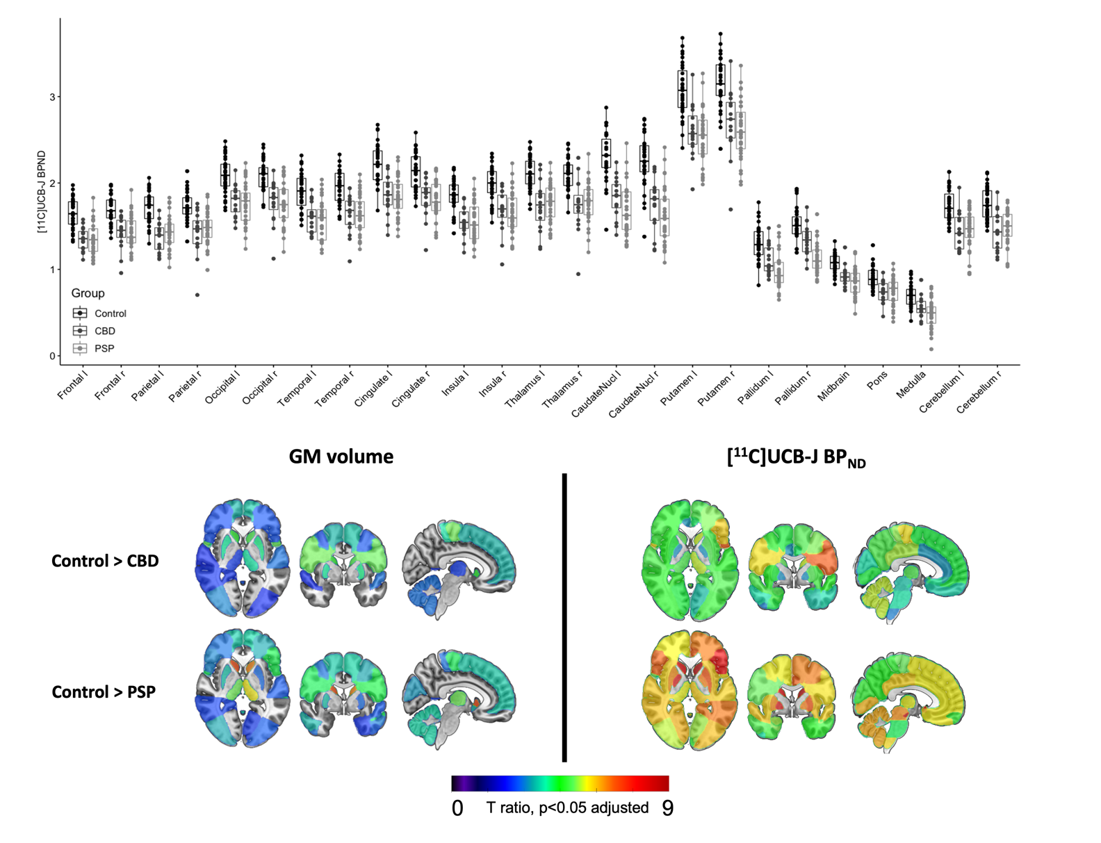
A
B
Supplementary Figure 1. A) Regional [¹¹C]UCB-J BP_{ND} without partial volume correction in healthy volunteers (n=31) and patients (PSP, n=32; CBD, n=16), in major regions of interest. B) t-statistic maps comparing grey matter (GM) volume and [¹¹C]UCB-J BP_{ND} in patients versus controls. Only t values significant at p<0.05 adjusted for multiple comparisons, are shown here; higher t values illustrate greater reduction in GM volume and synaptic density; orange/red=more severe atrophy/synaptic loss).

Longitudinal change in [¹¹C]UCB-J BP_{ND} (CSF uncorrected) over one year (%)

A one-sample t-test, applied to the mean proportional change in [¹¹C]UCB-J BP_{ND} without partial volume correction over one year, suggested a significant overall reduction in [¹¹C]UCB-J BP_{ND} over time (p=0.002). A paired-sample, two-way ANOVA, testing for a difference in [¹¹C]UCB-J BP_{ND} between baseline and follow-up visits, showed a significant region-by-visit interaction (p=0.002). A post-hoc, paired-sample ANOVA in each region between visits, illustrated significant reductions in [¹¹C]UCB-J BP_{ND} within the right caudate (-5.6%, p=0.01), left presubgenual frontal cortex (-3.7%, p=0.05), unadjusted. A summary of annual percentage change in [¹¹C]UCB-J BP_{ND} in all relevant Hammersmith atlas regions of interest are given in Supplementary Table 3.

Region | Mean | SD | Min | Max
Caudate_nucleus_R | -5.6 | 9.8 | -22.5 | 13.5
Hippocampus_R | -3.9 | 11.2 | -20.9 | 22.7
Hippocampus_L | -3.9 | 8.6 | -16.8 | 12.8
Pallidum_L | -3.9 | 10.8 | -21.4 | 25.2
Subcallosal_area_R | -3.8 | 10.1 | -20.4 | 10.9
Presubgenual_frontal_cortex_L | -3.7 | 8.9 | -17.6 | 13.9
Caudate_nucleus_L | -3.4 | 11.4 | -23.8 | 24.1
Subcallosal_area_L | -3.1 | 15.2 | -23.8 | 35.5
Fusiform_gyrus_R | -3.0 | 9.5 | -20.9 | 12.9
Middle_frontal_gyrus_L | -2.7 | 9.9 | -19.7 | 20.6
Cuneus_R | -2.6 | 7.8 | -15.0 | 15.1
Fusiform_gyrus_L | -2.6 | 9.4 | -19.4 | 17.8
Thalamus_R | -2.4 | 7.5 | -18.3 | 14.0
Anterior_temporal_lobe_lateral_part_L | -2.2 | 9.3 | -18.9 | 15.7
Superior_frontal_gyrus_R | -2.1 | 9.3 | -19.7 | 18.8
Middle_frontal_gyrus_R | -2.1 | 8.3 | -16.2 | 18.5
Lateral_remainder_of_occipital_lobe_L | -2.1 | 8.2 | -15.2 | 17.5
Presubgenual_frontal_cortex_R | -2.1 | 12.6 | -20.2 | 44.7
Thalamus_L | -2.1 | 7.3 | -16.8 | 15.6
Inferiolateral_remainder_of_parietal_lobe_L | -2.1 | 9.2 | -25.6 | 15.9
Parahippocampal_and_ambient_gyri_R | -2.1 | 7.1 | -21.8 | 8.7
Cuneus_L | -2.1 | 7.9 | -14.4 | 15.2
Cerebellum_gm_L | -2.1 | 7.9 | -15.9 | 20.7
Anterior_temporal_lobe_medial_part_L | -2.0 | 8.8 | -17.0 | 13.9
Middle_and_inferior_temporal_gyrus_L | -1.9 | 9.0 | -16.8 | 25.0
Inferior_frontal_gyrus_L | -1.9 | 8.1 | -14.2 | 16.2
Anterior_orbital_gyrus_L | -1.9 | 8.5 | -20.4 | 15.6
Anterior_orbital_gyrus_R | -1.9 | 8.0 | -15.7 | 16.3
Insula_R | -1.9 | 8.6 | -20.1 | 13.8
Amygdala_R | -1.8 | 9.8 | -19.0 | 22.3
Superior_frontal_gyrus_L | -1.7 | 8.4 | -14.8 | 16.6
Posterior_temporal_lobe_L | -1.7 | 10.1 | -21.5 | 27.2
Lingual_gyrus_L | -1.7 | 7.4 | -13.4 | 11.7
Parahippocampal_and_ambient_gyri_L | -1.6 | 12.5 | -23.3 | 19.0
Subgenual_frontal_cortex_L | -1.6 | 8.8 | -14.5 | 21.8
Superior_parietal_gyrus_R | -1.6 | 9.6 | -28.3 | 15.4
Inferior_frontal_gyrus_R | -1.5 | 7.3 | -15.1 | 14.6
Superior_temporal_gyrus_posterior_part_L | -1.5 | 9.3 | -19.4 | 18.8
Posterior_orbital_gyrus_R | -1.5 | 8.3 | -15.4 | 16.9
Superior_temporal_gyrus_anterior_part_L | -1.5 | 8.4 | -17.8 | 18.8

Region | Mean | SD | Min | Max
Amygdala_L | -1.5 | 10.2 | -19.7 | 12.8
Cerebellum_gm_R | -1.4 | 7.4 | -15.0 | 14.7
Middle_and_inferior_temporal_gyrus_R | -1.4 | 8.1 | -17.1 | 14.5
Precentral_gyrus_L | -1.3 | 8.8 | -19.8 | 16.8
Inferiolateral_remainder_of_parietal_lobe_R | -1.3 | 7.7 | -14.1 | 11.1
Lingual_gyrus_R | -1.2 | 7.6 | -13.9 | 12.3
Lateral_remainder_of_occipital_lobe_R | -1.2 | 7.6 | -11.9 | 12.5
Superior_temporal_gyrus_posterior_part_R | -1.2 | 9.2 | -14.4 | 20.4
Anterior_temporal_lobe_lateral_part_R | -1.2 | 9.7 | -25.9 | 22.8
Cingulate_gyrus_anterior_part_L | -1.1 | 9.8 | -17.6 | 15.9
Anterior_temporal_lobe_medial_part_R | -1.1 | 9.0 | -15.3 | 19.7
Putamen_R | -1.1 | 7.0 | -12.5 | 13.7
Subgenual_frontal_cortex_R | -1.0 | 13.8 | -20.9 | 32.3
Straight_gyrus_L | -0.9 | 10.1 | -20.1 | 24.4
Posterior_orbital_gyrus_L | -0.9 | 9.2 | -17.0 | 18.2
Lateral_orbital_gyrus_L | -0.9 | 9.0 | -17.9 | 15.9
Medial_orbital_gyrus_R | -0.9 | 9.6 | -18.7 | 20.3
Superior_parietal_gyrus_L | -0.8 | 9.9 | -25.3 | 18.5
Posterior_temporal_lobe_R | -0.7 | 8.7 | -11.7 | 16.2
Precentral_gyrus_R | -0.7 | 9.0 | -16.4 | 17.9
Superior_temporal_gyrus_anterior_part_R | -0.7 | 11.1 | -25.4 | 22.6
Straight_gyrus_R | -0.6 | 9.9 | -15.2 | 27.8
Insula_L | -0.6 | 9.4 | -16.5 | 20.7
Cingulate_gyrus_anterior_part_R | -0.5 | 10.0 | -19.9 | 20.3
Lateral_orbital_gyrus_R | -0.4 | 8.3 | -15.3 | 16.3
Putamen_L | -0.4 | 7.7 | -10.6 | 16.5
Brainstem_mid_B | -0.4 | 8.7 | -14.3 | 23.3
Medial_orbital_gyrus_L | -0.1 | 8.4 | -16.4 | 18.5
Pallidum_R | 0.0 | 7.8 | -14.5 | 14.2
Cerebellum_dentate_L | 0.1 | 11.7 | -23.8 | 25.8
Postcentral_gyrus_L | 0.2 | 9.2 | -20.2 | 22.4
Brainstem_pon_B | 0.3 | 11.9 | -17.4 | 36.1
Gyrus_cinguli_posterior_part_R | 0.3 | 9.2 | -22.2 | 16.8
Gyrus_cinguli_posterior_part_L | 0.6 | 8.0 | -14.0 | 18.1
Postcentral_gyrus_R | 1.2 | 9.4 | -13.3 | 21.0
Cerebellum_dentate_R | 2.4 | 14.1 | -22.5 | 44.2
Brainstem_med_B | 4.7 | 22.5 | -31.3 | 76.2
Supplementary Table 3. Annual percentage change (Mean, standard deviation (SD), minimum (Min) and maximum (Max)), in [¹¹C]UCB-J BP_{ND} (without partial volume correction). The annual percentage change in the right caudate is significantly reduced (p<0.05, unadjusted). B: bilateral, L: left, R: right.

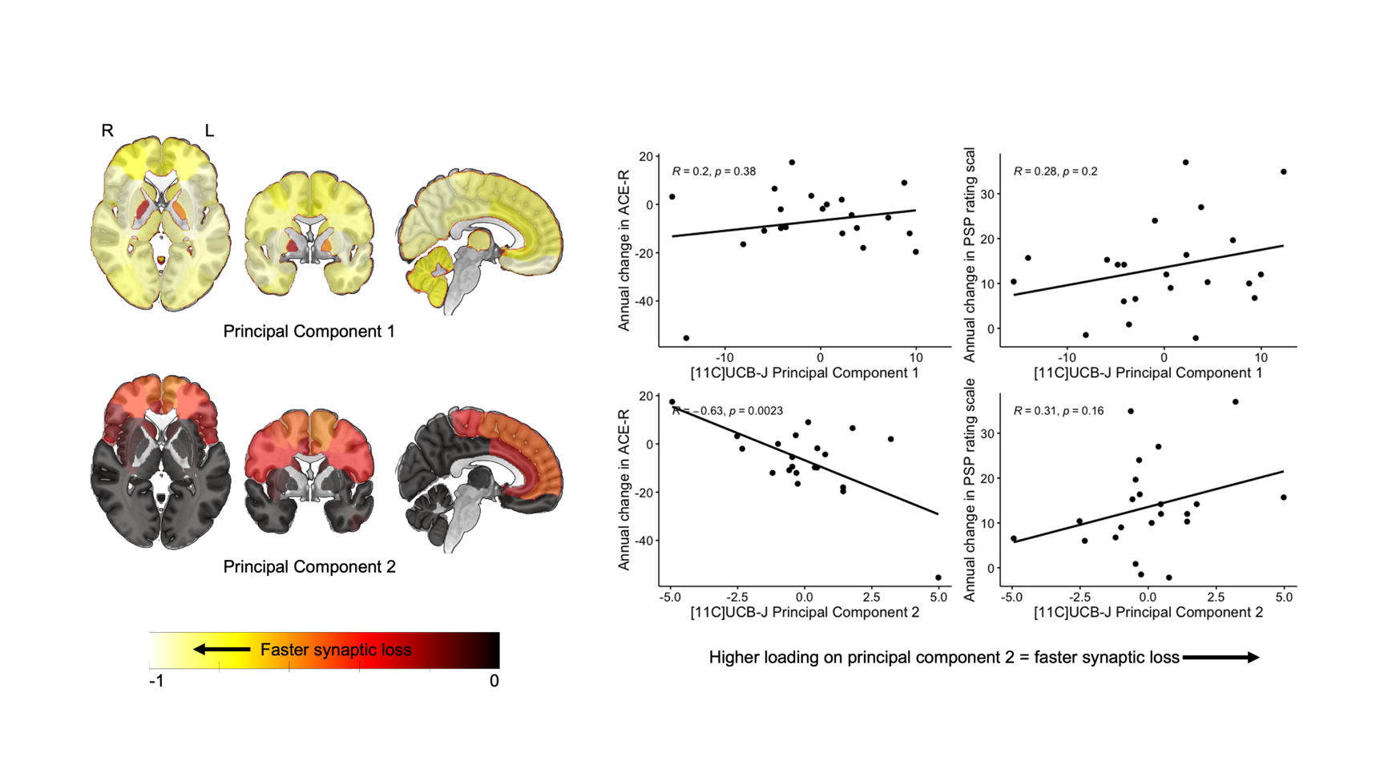
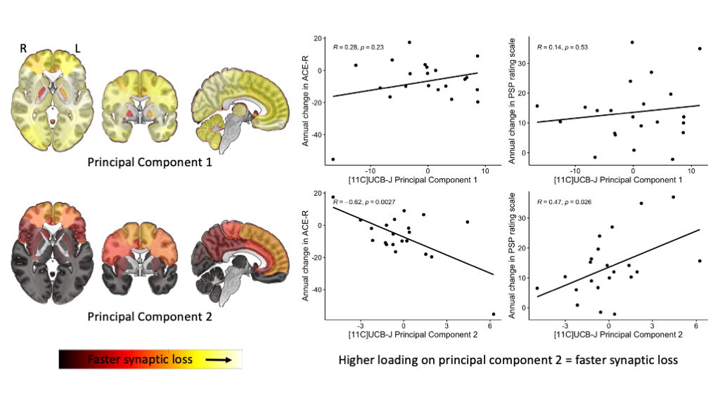
Faster reductions in frontal and cingulate [¹¹C]UCB-J BP_{ND} is associated with worsening symptoms over time; principal component analysis (without partial volume correction).
A
B
Supplementary Figure 2. (A) Brain maps illustrating principle component 1 and 2 weighting (yellow = faster synaptic loss) obtained from a principal component analysis of the annualised proportional change in [¹¹C]UCB-J BP_{ND} (without partial volume correction). (B) The relationship between disease severity (PSP rating scale)/Addenbrooke’s Cognitive Examination-Revised (ACE-R), and individual loadings on principal components 1 (top row) and 2 (bottom row). L: left, R: right.

