KDM4B Regulates Shared and Tissue-specific Pathways in Three Different Cancers Dependent or Independent of HIF signaling
Lei Qiu^{1,2,3*}, Yang Meng^{1*}, Lingli Wang¹, Yan Hong², Sumedha Gunewardena⁴, Sicheng Liu¹, Junhong Han^{1#}, Adam J. Krieg^{2,3,5#}
¹Research Laboratory of Cancer Epigenetics and Genomics, Department of General Surgery, Frontiers Science Center for Disease-related Molecular Network, and Cancer Center, West China Hospital, Sichuan University, Chengdu, China; ²Department of Obstetrics and Gynecology, University of Kansas Medical Center, Kansas City, KS, USA; ³Department of Pathology and Laboratory Medicine, University of Kansas Medical Center, Kansas City, KS, USA; ⁴Department of Molecular and Integrative Physiology, University of Kansas Medical Center, Kansas City, KS, USA; ⁵Department of Obstetrics and Gynecology, Oregon Health and Science University, Division of Reproductive and Developmental Sciences, Oregon National Primate Research Center, Beaverton, OR, USA.
Correspondence:
#Adam J. Krieg, Department of Obstetrics and Gynecology, Oregon Health and Science University, Division of Reproductive and Developmental Sciences, Oregon National Primate Research Center, 505 NW 185th Avenue, Mail Stop L584, Beaverton, OR 97006, USA; E-mail: kriega@ohsu.edu.
#Junhong Han, Research Laboratory of Cancer Epigenetics and Genomics, Department of General Surgery, Frontiers Science Center for Disease-related Molecular Network, and Cancer Center, West China Hospital, Sichuan University, Chengdu 610041, China; Telephone (86) 28-61528677; E-mail: hjunhong@scu.edu.cn.
*These authors contributed equally to this work.
Supplemental Figure Legends
Figure S1. GO biological process analysis. GO analysis of biological process using the 133+315 genes from Figure 1B overlapped in SKOV3ip.1 and RCC4 cells, excluding the 26 genes common in all three cell lines.
Figure S2. Expression level of the KDM4B gene in different tumors and pathological stages. A, The expression statuses of the KDM4B gene in ESCA (Esophageal carcinoma), DLBC (Lymphoid Neoplasm Diffuse Large B-cell Lymphoma), COAD (Colon adenocarcinoma), CHOL (Cholangio carcinoma), BLCA (Bladder Urothelial Carcinoma), ACC (Adrenocortical carcinoma), THYM (Thymoma), SARC (Sarcoma), LAML (Acute Myeloid Leukemiav), KIRP (Kidney renal papillary cell carcinoma), KIRC (Kidney renal clear cell carcinoma), KICH (Kidney Chromophobe), HNSC (Head and Neck squamous cell carcinoma), GBM (Glioblastoma multiforme) in TCGA project were compared with the corresponding normal tissues of the GTEx databases. B, Expression levels of the KDM4B gene by different pathological stages of BLCA, CHOL, DLBC, ESCA; KIRC, KIRP, LIHC (Liver hepatocellular carcinoma), STAD (Stomach adenocarcinoma), HNSC, READ (Rectum adenocarcinoma), LUAD (Lung adenocarcinoma), TGCT (Testicular Germ Cell Tumors), UCS (Uterine Carcinosarcoma).
Figure S3. Correlation between KDM4B expression and patient overall survival (OS). The correlation was analyzed within the pan-cancer RNA-seq project; cancer types shown here displayed no biological significance.
Figure S4. correlation between KDM4B expression and patient relapse-free survival (RFS). The correlation between KDM4B expression and patient relapse-free survival (RFS) were analyzed with cases from TCGA database; cases shown here displayed no biological significance.

Figure S1
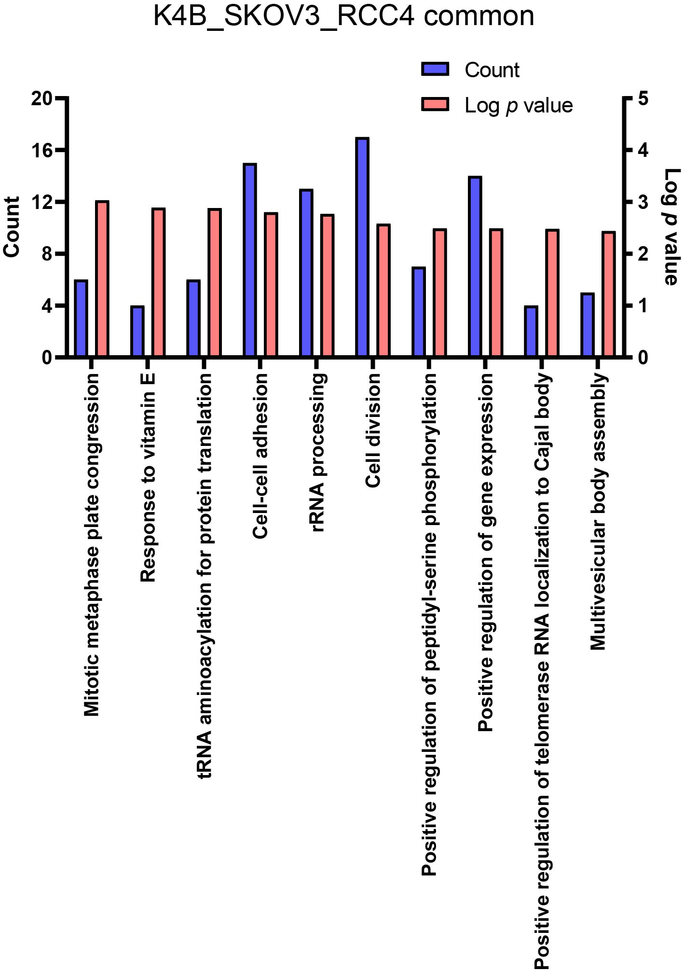

Figure S2
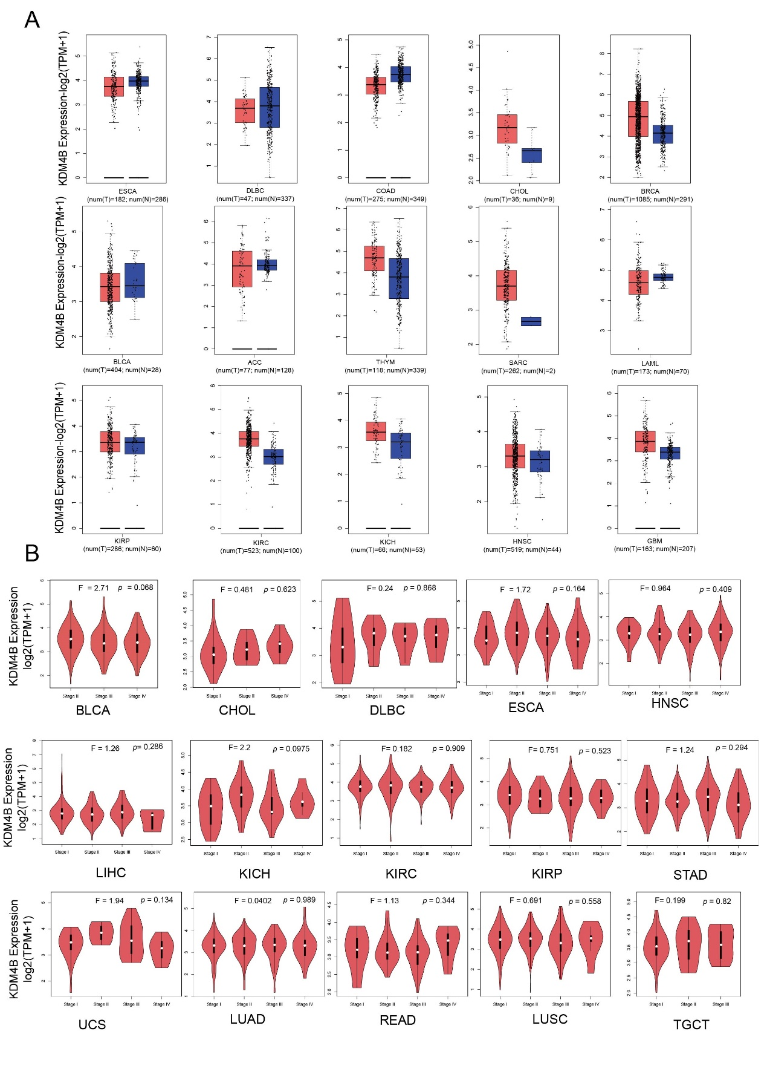

Figure S3
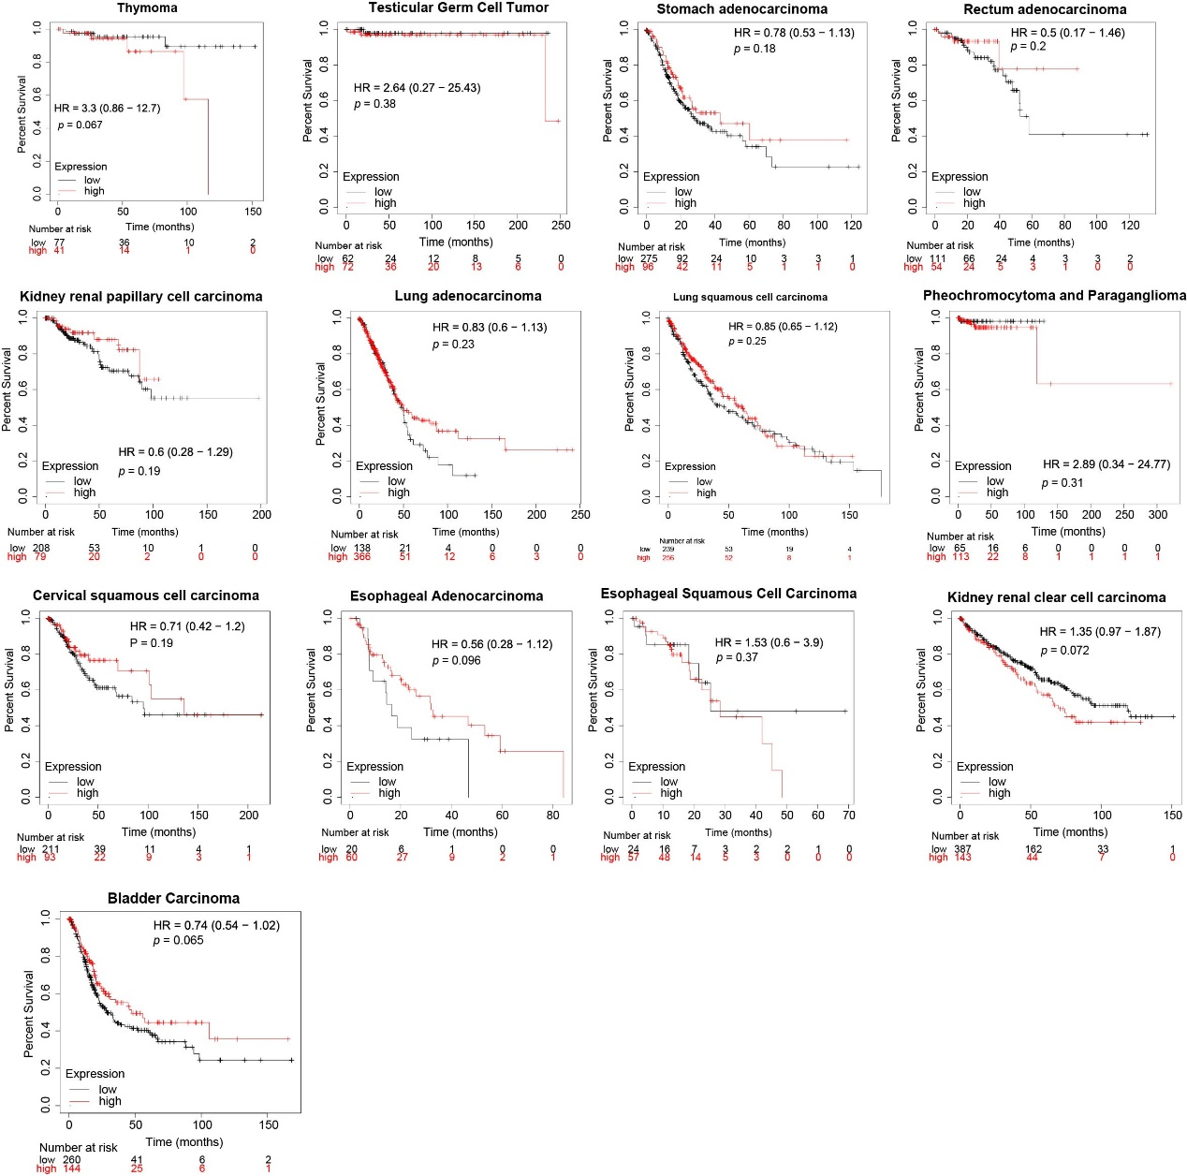

Figure S4
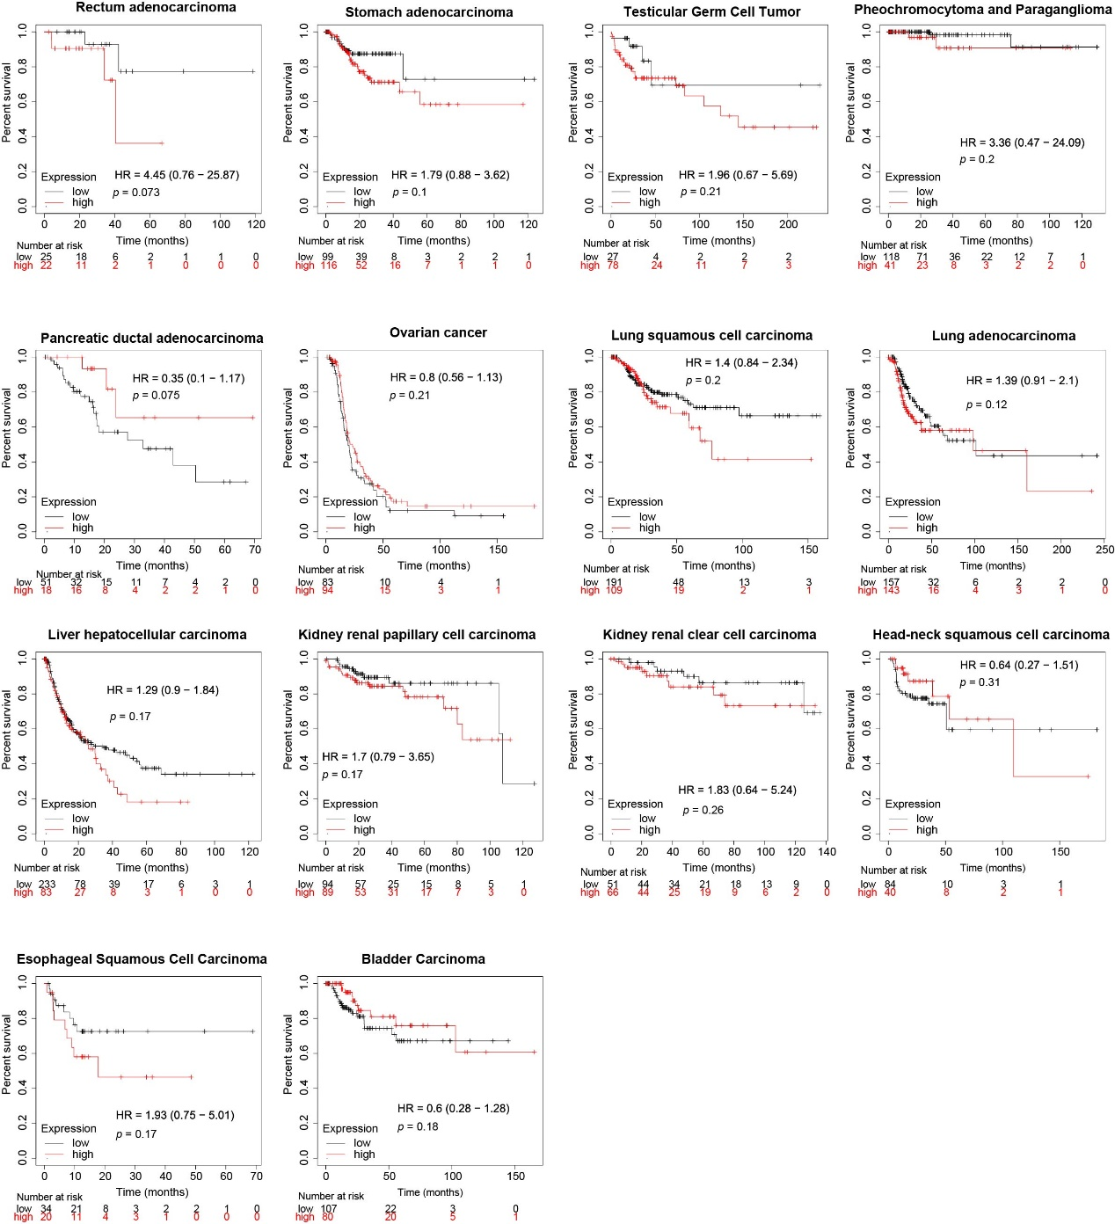

Table S1. Description of the 26 common genes regulated by KDM4B in SKOV3ip.1, HCT116 and RCC4 cell lines.
Gene Symbol | Fold Change |  |  | Gene Description | Cellular Process | Related Disease
Gene Symbol | SKOV3ip.1 | HCT116 | RCC4 | Gene Description | Cellular Process | Related Disease
CLDN12 | -2.24 | -1.52 | -1.7 | Claudin 12 | Tumorigenesis¹, chemoresistance², metastasis³ | Colorectal cancer¹, breast cancer², lung squamous cell crcinoma³, osteosarcoma⁴
LUZP6 | -1.44 | -1.53 | -1.49 | Myotrophin; leucine zipper protein 6 | Myeloproliferative disease-associated antigen⁵
SEPT2 | -1.97 | -1.46 | -2.24 | Septin 2 | Cell proliferation⁶, carcinogenesis⁷, migration⁸ | Colorectal cancer⁹, breast cancer ⁸, prostate cancer¹⁰, hepatocellular carcinoma⁶, biliary tract cancer¹¹, leukemia¹², glioblastoma¹³
MMD | -4.4 | -1.63 | -5.49 | Monocyte to macrophage differentiation-associated | Tumor growth¹⁴, metastasis/EMT¹⁵, mediate Ras signaling in the Golgi apparatus¹⁶, monocyte-to-macrophage differentiation and phatogenesis¹⁷ | Lung and breast cancer ¹⁵, non-small cell lung cancer¹⁴, rheumatoid arthritis¹⁷
LOXL2 | -3.18 | -1.62 | -3.28 | Lysyl oxidase-like 2 | Metastasis/EMT¹⁸, tumor microenvironment¹⁹, radiosensitivity²⁰ | Cervical carcinoma¹⁸, prostate cancer^{19, 20}, breast cancer²¹, pancreatic cancer²², colorectal cancer²³, Hepatocellular carcinoma²⁴, osteosarcoma²⁵, gastric cancer²⁶, cervical cancer²⁷, alveolar rhabdomyosarcoma²⁸, head and neck squamous cell carcinoma²⁹, intrahepatic cholangiocarcinoma³⁰
OSMR | -1.61 | -1.52 | -1.73 | Oncostatin M receptor | Angiogenesis and invasion³¹, radiosensitivity³², growth and metastasis³³, cancer local immune response³⁴, chemoresistance³⁵ | Glioblastoma³², colorectal cancer³⁶, bladder cancer³⁷, gastric cancer³³, pancreatic ductal adenocarcinoma³⁸, squamous cell carcinoma³⁹, medullary thyroid carcinoma⁴⁰, non-small cell lung cancer³⁵, breast cancer⁴¹, leukemia⁴², Ewing sarcoma⁴³, osterosarcoma³¹, ovarian carcinoma ⁴⁴
PALLD | -1.47 | -1.58 | -1.78 | Palladin, cytoskeletal associated protein | Invasion/metastasis⁴⁵, anti-migration⁴⁶, phagocytosis⁴⁷ | Pancreatic cancer⁴⁵, breast cancer⁴⁶, colorectal cancer⁴⁸, renal cell carcinoma⁴⁹
ERO1L | -3.38 | -1.43 | -2.85 | ERO1-like (S. cerevisiae) | Disulphide bond formation in ER⁵⁰, cancer progression⁵¹, metastasis⁵², cell cycle⁵³, tumorigenesis⁵⁴ | Gastric cancer ⁵⁵, pancreatic cancer⁵¹, lung cancer^{52, 53}, oral squamous cell carcinoma⁵⁴, multiple myeloma⁵⁶
USP6NL | -1.48 | -1.49 | -1.82 | USP6 N-terminal like | cell proliferation⁵⁷, cancer development⁵⁸ | Colorectal cancer⁵⁷, breast cancer⁵⁸, Alzheimer's disease⁵⁹
ELAV1 | -1.6 | -1.45 | -1.63 | Embryonic lethal, abnormal vision, Drosophila-like 1 (Hu antigen R) | Regulation of RNA stability⁶⁰, apoptosis⁶¹, DNA damage response⁶² | Urinary tumors⁶³, breast cancer ⁶⁰
BACE2 | -1.81 | -1.4 | -1.8 | Beta-site APP-cleaving enzyme 2 | Cleaves Amyloid-beta-precursor protein⁶⁴ | Alzhermer's disease⁶⁵, diabetes ⁶⁶
TWSG1 | -1.94 | -1.45 | -2.39 | Twisted gastrulation homolog 1 (Drosophila) | Tumor suppressor⁶⁷, cell motility and proliferation⁶⁸ | Gastric cancer⁶⁷, papillary thyroid cancer⁶⁸
ZAK | -1.65 | -1.54 | -1.64 | Sterile alpha motif and leucine zipper containing kinase AZK | Cardiac compensation⁶⁹, cellular hypertrophy⁷⁰, ECM remodeling⁷¹, TGF-β signaling⁷², tumor cell invasion⁷³, radiosensitivity⁷⁴, pro-apoptotic signaling p38/JNK⁷⁵ | Lung and breast cancer⁷²
ZDHHC2 | -1.53 | -1.49 | -2.06 | Zinc finger, DHHC-type containing 2 | Metastasis⁷⁶⁻⁷⁸ | Hepatocellular carcinoma⁷⁷, gastric adenocarcinoma⁷⁸, nasopharyngeal carcinoma⁷⁶, renal clear cell carcinoma⁷⁹
DENND5A | -1.62 | -1.4 | -2.6 | DENN/MADD domain containing 5A | MDCK cystogenesis⁸⁰, tumor suppressor⁸¹ | Colorectal cancer⁸¹
DAZAP2 | -2.5 | -1.52 | -3.73 | DAZ associated protein 2 | TCF4 binding factor and coactivator⁸², Posterior neural patterning⁸³, ectoderml differentiation⁸⁴ | Multiple myeloma⁸⁵
STARD7 | 2.04 | 2.13 | 1.52 | StAR Related Lipid Transfer Domain Containing 7 | Wnt/β-catenin signaling pathway⁸⁶, cell migration, proliferation, and differentiation⁸⁷ | Gestational trophoblast tumor⁸⁸, choriocarcinoma⁸⁷
GEMIN5 | 1.97 | 1.71 | 2.08 | Gem Nuclear Organelle Associated Protein 5 | Alternative mRNA splicing patterns and tumor cell motility⁸⁹ | Breast cancer⁸⁹
CPA4 | 1.75 | 1.47 | 2.15 | Carboxypeptidase A4 | Proliferation^{90, 91}, stem cell characteristics⁹¹, EMT⁹² | Hepatocellular carcinoma⁹¹, colorectal cancer⁹⁰, non-small-cell lung cancer⁹³, Breast Cancer⁹⁴, pancreatic cancer⁹²
FKBP14 | 2.20 | 1.57 | 2.58 | FKBP Prolyl Isomerase 14 | Carcinogenesis⁹⁵, proliferation, adhesion and invasion⁹⁶ | Osteosarcoma⁹⁵, gastric cancer⁹⁶, Ovarian Cancer⁹⁷
CARNMT1 | 2.47 | 1.49 | 3.07 | Carnosine N-Methyltransferase 1
MPZL3 | 2.65 | 1.51 | 1.65 | Myelin Protein Zero Like 3 | Metabolism⁹⁸, adhesive and immune functions⁹⁹, Epidermal Differentiation¹⁰⁰, hair cycle clock¹⁰¹ | Obesity⁹⁸, immune-related hereditary hair loss⁹⁹
DYRK2 | 2.10 | 1.47 | 2.03 | Dual Specificity Tyrosine Phosphorylation Regulated Kinase 2 | Apoptotic induction¹⁰², suppresses carcinogenesis¹⁰³, suppresses cell proliferation¹⁰⁴, controls EMT¹⁰⁵, suppresses migration and invasion¹⁰⁶ | liver cancer¹⁰², colorectal cancer¹⁰³, Non-Hodgkin's Lymphoma¹⁰⁴, breast cancer¹⁰⁵, colorectal cancer¹⁰⁶
KCTD10 | 1.81 | 1.66 | 1.77 | Potassium Channel Tetramerization Domain Containing 10 | K27-polyubiquitination of EIF3D¹⁰⁷, Rac1 activation through RhoB degradation¹⁰⁸ | Gastrointestinal stromal tumor¹⁰⁹, hepatocellular carcinoma¹⁰⁷, breast cancer¹⁰⁸
RNF6 | 1.63 | 1.49 | 1.44 | Ring Finger Protein 6 | Cell growth^{110, 111}, Activating the Wnt/β-Catenin Pathway via Ubiquitination of TLE3¹¹² | Gastric cancer¹¹⁰, breast cancer¹¹¹, colorectal cancer¹¹²
HCCS | 2.08 | 1.57 | 1.95 | Holocytochrome C Synthase

References
1. Grone J, Weber B, Staub E, et al. Differential expression of genes encoding tight junction proteins in colorectal cancer: frequent dysregulation of claudin-1, -8 and -12. Int J Colorectal Dis. 2007;22(6):651-9.
2. Du Y, Zhou L, Lin Y, Yin K, Yin W, Lu J. Polymorphisms in microRNA let-7 binding sites of the HIF1AN and CLDN12 genes can predict pathologic complete response to taxane- and platinum-based neoadjuvant chemotherapy in breast cancer. Ann Transl Med. 2019;7(7):138.
3. Sun L, Feng L, Cui J. Increased expression of claudin-12 promotes the metastatic phenotype of human bronchial epithelial cells and is associated with poor prognosis in lung squamous cell carcinoma. Exp Ther Med. 2019;17(1):165-174.
4. Tian X, He Y, Han Z, Su H, Chu C. The Cytoplasmic Expression Of CLDN12 Predicts An Unfavorable Prognosis And Promotes Proliferation And Migration Of Osteosarcoma. Cancer Manag Res. 2019;11:9339-9351.
5. Xiong Z, Liu E, Yan Y, et al. An unconventional antigen translated by a novel internal ribosome entry site elicits antitumor humoral immune reactions. J Immunol. 2006;177(7):4907-16.
6. Yu W, Ding X, Chen F, et al. The phosphorylation of SEPT2 on Ser218 by casein kinase 2 is important to hepatoma carcinoma cell proliferation. Mol Cell Biochem. 2009;325(1-2):61-7.
7. Liu M, Shen S, Chen F, Yu W, Yu L. Linking the septin expression with carcinogenesis. Mol Biol Rep. 2010;37(7):3601-8.
8. Cai B, Wang X, Bu Q, et al. LncRNA AFAP1-AS1 Knockdown Represses Cell Proliferation, Migration, and Induced Apoptosis in Breast Cancer by Downregulating SEPT2 Via Sponging miR-497-5p. Cancer Biother Radiopharm. 2020;
9. Zhang W, Liao K, Liu D. MicroRNA7445p is downregulated in colorectal cancer and targets SEPT2 to suppress the malignant phenotype. Mol Med Rep. 2021;23(1)
10. Xing Z, Li S, Liu Z, Zhang C, Meng M, Bai Z. The long non-coding RNA LINC00473 contributes to cell proliferation via JAK-STAT3 signaling pathway by regulating miR-195-5p/SEPT2 axis in prostate cancer. Biosci Rep. 2020;40(9)
11. Yu J, Zhang W, Tang H, et al. Septin 2 accelerates the progression of biliary tract cancer and is negatively regulated by mir-140-5p. Gene. 2016;589(1):20-26.
12. Cerveira N, Correia C, Bizarro S, et al. SEPT2 is a new fusion partner of MLL in acute myeloid leukemia with t(2;11)(q37;q23). Oncogene. 2006;25(45):6147-52.
13. Xu D, Liu A, Wang X, et al. Repression of Septin9 and Septin2 suppresses tumor growth of human glioblastoma cells. Cell Death Dis. 2018;9(5):514.
14. Li W, He F. Monocyte to macrophage differentiation-associated (MMD) targeted by miR-140-5p regulates tumor growth in non-small cell lung cancer. Biochem Biophys Res Commun. 2014;450(1):844-50.
15. Tan X, Banerjee P, Guo HF, et al. Epithelial-to-mesenchymal transition drives a pro-metastatic Golgi compaction process through scaffolding protein PAQR11. J Clin Invest. 2017;127(1):117-131.
16. Jin T, Ding Q, Huang H, et al. PAQR10 and PAQR11 mediate Ras signaling in the Golgi apparatus. Cell Res. 2012;22(4):661-76.
17. Lin Y, Huang M, Wang S, You X, Zhang L, Chen Y. PAQR11 modulates monocyte-to-macrophage differentiation and pathogenesis of rheumatoid arthritis. Immunology. 2021;
18. Cao C, Lin S, Zhi W, et al. LOXL2 Expression Status Is Correlated With Molecular Characterizations of Cervical Carcinoma and Associated With Poor Cancer Survival via Epithelial-Mesenchymal Transition (EMT) Phenotype. Front Oncol. 2020;10:284.
19. Nguyen EV, Pereira BA, Lawrence MG, et al. Proteomic Profiling of Human Prostate Cancer-associated Fibroblasts (CAF) Reveals LOXL2-dependent Regulation of the Tumor Microenvironment. Mol Cell Proteomics. 2019;18(7):1410-1427.
20. Xie P, Yu H, Wang F, Yan F, He X. Inhibition of LOXL2 Enhances the Radiosensitivity of Castration-Resistant Prostate Cancer Cells Associated with the Reversal of the EMT Process. Biomed Res Int. 2019;2019:4012590.
21. Cebria-Costa JP, Pascual-Reguant L, Gonzalez-Perez A, et al. LOXL2-mediated H3K4 oxidation reduces chromatin accessibility in triple-negative breast cancer cells. Oncogene. 2020;39(1):79-121.
22. Park JS, Lee JH, Lee YS, Kim JK, Dong SM, Yoon DS. Emerging role of LOXL2 in the promotion of pancreas cancer metastasis. Oncotarget. 2016;7(27):42539-42552.
23. Park PG, Jo SJ, Kim MJ, et al. Role of LOXL2 in the epithelial-mesenchymal transition and colorectal cancer metastasis. Oncotarget. 2017;8(46):80325-80335.
24. Wang M, Zhao X, Zhu D, et al. HIF-1alpha promoted vasculogenic mimicry formation in hepatocellular carcinoma through LOXL2 up-regulation in hypoxic tumor microenvironment. J Exp Clin Cancer Res. 2017;36(1):60.
25. Matsuoka K, Bakiri L, Wolff LI, et al. Wnt signaling and Loxl2 promote aggressive osteosarcoma. Cell Res. 2020;30(10):885-901.
26. Xiang Z, Li J, Song S, et al. A positive feedback between IDO1 metabolite and COL12A1 via MAPK pathway to promote gastric cancer metastasis. J Exp Clin Cancer Res. 2019;38(1):314.
27. Tian J, Sun HX, Li YC, Jiang L, Zhang SL, Hao Q. LOXL 2 Promotes The Epithelial-Mesenchymal Transition And Malignant Progression Of Cervical Cancer. Onco Targets Ther. 2019;12:8947-8954.
28. Almacellas-Rabaiget O, Monaco P, Huertas-Martinez J, et al. LOXL2 promotes oncogenic progression in alveolar rhabdomyosarcoma independently of its catalytic activity. Cancer Lett. 2020;474:1-14.
29. Liu C, Guo T, Sakai A, et al. A novel splice variant of LOXL2 promotes progression of human papillomavirus-negative head and neck squamous cell carcinoma. Cancer. 2020;126(4):737-748.
30. Bergeat D, Fautrel A, Turlin B, et al. Impact of stroma LOXL2 overexpression on the prognosis of intrahepatic cholangiocarcinoma. J Surg Res. 2016;203(2):441-50.
31. Fossey SL, Bear MD, Kisseberth WC, Pennell M, London CA. Oncostatin M promotes STAT3 activation, VEGF production, and invasion in osteosarcoma cell lines. BMC Cancer. 2011;11:125.
32. Sharanek A, Burban A, Laaper M, et al. OSMR controls glioma stem cell respiration and confers resistance of glioblastoma to ionizing radiation. Nat Commun. 2020;11(1):4116.
33. Yu Z, Li Z, Wang C, et al. Oncostatin M receptor, positively regulated by SP1, promotes gastric cancer growth and metastasis upon treatment with Oncostatin M. Gastric Cancer. 2019;22(5):955-966.
34. Guo Q, Guan GF, Cao JY, et al. Overexpression of oncostatin M receptor regulates local immune response in glioblastoma. J Cell Physiol. 2019;
35. Shien K, Papadimitrakopoulou VA, Ruder D, et al. JAK1/STAT3 Activation through a Proinflammatory Cytokine Pathway Leads to Resistance to Molecularly Targeted Therapy in Non-Small Cell Lung Cancer. Mol Cancer Ther. 2017;16(10):2234-2245.
36. Hibi K, Goto T, Sakuraba K, et al. Methylation of OSMR gene is frequently observed in non-invasive colorectal cancer. Anticancer Res. 2011;31(4):1293-5.
37. Deng S, He SY, Zhao P, Zhang P. The role of oncostatin M receptor gene polymorphisms in bladder cancer. World J Surg Oncol. 2019;17(1):30.
38. Zhu YX, Li CH, Li G, et al. LLGL1 Regulates Gemcitabine Resistance by Modulating the ERK-SP1-OSMR Pathway in Pancreatic Ductal Adenocarcinoma. Cell Mol Gastroenterol Hepatol. 2020;10(4):811-828.
39. Kucia-Tran JA, Tulkki V, Scarpini CG, et al. Anti-oncostatin M antibody inhibits the pro-malignant effects of oncostatin M receptor overexpression in squamous cell carcinoma. J Pathol. 2018;244(3):283-295.
40. Qi XP, Zhao JQ, Chen ZG, et al. RET mutation p.S891A in a Chinese family with familial medullary thyroid carcinoma and associated cutaneous amyloidosis binding OSMR variant p.G513D. Oncotarget. 2015;6(32):33993-4003.
41. West NR, Murray JI, Watson PH. Oncostatin-M promotes phenotypic changes associated with mesenchymal and stem cell-like differentiation in breast cancer. Oncogene. 2014;33(12):1485-94.
42. Walker EC, McGregor NE, Poulton IJ, et al. Oncostatin M promotes bone formation independently of resorption when signaling through leukemia inhibitory factor receptor in mice. J Clin Invest. 2010;120(2):582-92.
43. David E, Tirode F, Baud'huin M, et al. Oncostatin M is a growth factor for Ewing sarcoma. Am J Pathol. 2012;181(5):1782-95.
44. Savarese TM, Campbell CL, McQuain C, et al. Coexpression of oncostatin M and its receptors and evidence for STAT3 activation in human ovarian carcinomas. Cytokine. 2002;17(6):324-34.
45. Goicoechea SM, Garcia-Mata R, Staub J, et al. Palladin promotes invasion of pancreatic cancer cells by enhancing invadopodia formation in cancer-associated fibroblasts. Oncogene. 2014;33(10):1265-73.
46. Chin YR, Toker A. Akt isoform-specific signaling in breast cancer: uncovering an anti-migratory role for palladin. Cell Adh Migr. 2011;5(3):211-4.
47. Sun HM, Chen XL, Chen XJ, et al. PALLD Regulates Phagocytosis by Enabling Timely Actin Polymerization and Depolymerization. J Immunol. 2017;199(5):1817-1826.
48. Tay PN, Tan P, Lan Y, et al. Palladin, an actin-associated protein, is required for adherens junction formation and intercellular adhesion in HCT116 colorectal cancer cells. Int J Oncol. 2010;37(4):909-26.
49. Gupta V, Bassi DE, Simons JD, et al. Elevated expression of stromal palladin predicts poor clinical outcome in renal cell carcinoma. PLoS One. 2011;6(6):e21494.
50. Cabibbo A, Pagani M, Fabbri M, et al. ERO1-L, a human protein that favors disulfide bond formation in the endoplasmic reticulum. J Biol Chem. 2000;275(7):4827-33.
51. Han F, Xu Q, Zhao J, Xiong P, Liu J. ERO1L promotes pancreatic cancer cell progression through activating the Wnt/catenin pathway. J Cell Biochem. 2018;119(11):8996-9005.
52. Lei Y, Zang R, Lu Z, et al. ERO1L promotes IL6/sIL6R signaling and regulates MUC16 expression to promote CA125 secretion and the metastasis of lung cancer cells. Cell Death Dis. 2020;11(10):853.
53. Shi X, Wu J, Liu Y, Jiang Y, Zhi C, Li J. ERO1L promotes NSCLC development by modulating cell cycle-related molecules. Cell Biol Int. 2020;44(12):2473-2484.
54. Li X, Li Y, Jiang C, Chen L, Gan N. MicroRNA-144-3p Inhibits Tumorigenesis of Oral Squamous Cell Carcinoma by downregulating ERO1L. J Cancer. 2020;11(3):759-768.
55. Zhou B, Wang G, Gao S, et al. Expression of ERO1L in gastric cancer and its association with patient prognosis. Exp Ther Med. 2017;14(3):2298-2302.
56. Hayes KE, Batsomboon P, Chen WC, et al. Inhibition of the FAD containing ER oxidoreductin 1 (Ero1) protein by EN-460 as a strategy for treatment of multiple myeloma. Bioorg Med Chem. 2019;27(8):1479-1488.
57. Sun K, He SB, Yao YZ, et al. Tre2 (USP6NL) promotes colorectal cancer cell proliferation via Wnt/beta-catenin pathway. Cancer Cell Int. 2019;19:102.
58. Ma T, Liu H, Liu Y, et al. USP6NL mediated by LINC00689/miR-142-3p promotes the development of triple-negative breast cancer. BMC Cancer. 2020;20(1):998.
59. Jun GR, Chung J, Mez J, et al. Transethnic genome-wide scan identifies novel Alzheimer's disease loci. Alzheimers Dement. 2017;13(7):727-738.
60. Licata LA, Hostetter CL, Crismale J, Sheth A, Keen JC. The RNA-binding protein HuR regulates GATA3 mRNA stability in human breast cancer cell lines. Breast Cancer Res Treat. 2010;122(1):55-63.
61. Winkler C, Doller A, Imre G, et al. Attenuation of the ELAV1-like protein HuR sensitizes adenocarcinoma cells to the intrinsic apoptotic pathway by increasing the translation of caspase-2L. Cell Death Dis. 2014;5:e1321.
62. Lal S, Burkhart RA, Beeharry N, et al. HuR posttranscriptionally regulates WEE1: implications for the DNA damage response in pancreatic cancer cells. Cancer Res. 2014;74(4):1128-40.
63. Zhang F, Cai Z, Lv H, et al. Multiple functions of HuR in urinary tumors. J Cancer Res Clin Oncol. 2019;145(1):11-18.
64. Farzan M, Schnitzler CE, Vasilieva N, Leung D, Choe H. BACE2, a beta -secretase homolog, cleaves at the beta site and within the amyloid-beta region of the amyloid-beta precursor protein. Proc Natl Acad Sci U S A. 2000;97(17):9712-7.
65. Stockley JH, O'Neill C. The proteins BACE1 and BACE2 and beta-secretase activity in normal and Alzheimer's disease brain. Biochem Soc Trans. 2007;35(Pt 3):574-6.
66. Southan C. BACE2 as a new diabetes target: a patent review (2010 - 2012). Expert Opin Ther Pat. 2013;23(5):649-63.
67. Yuan J, Zeng J, Shuai C, Liu Y. TWSG1 Is a Novel Tumor Suppressor in Gastric Cancer. DNA Cell Biol. 2018;37(6):574-583.
68. Xia S, Ji R, Xu Y, Ni X, Dong Y, Zhan W. Twisted Gastrulation BMP Signaling Modulator 1 Regulates Papillary Thyroid Cancer Cell Motility and Proliferation. J Cancer. 2017;8(14):2816-2827.
69. Christe M, Jin N, Wang X, et al. Transgenic mice with cardiac-specific over-expression of MLK7 have increased mortality when exposed to chronic beta-adrenergic stimulation. J Mol Cell Cardiol. 2004;37(3):705-15.
70. Hsieh YL, Tsai YL, Shibu MA, et al. ZAK induces cardiomyocyte hypertrophy and brain natriuretic peptide expression via p38/JNK signaling and GATA4/c-Jun transcriptional factor activation. Mol Cell Biochem. 2015;405(1-2):1-9.
71. Cheng YC, Kuo WW, Wu HC, et al. ZAK induces MMP-2 activity via JNK/p38 signals and reduces MMP-9 activity by increasing TIMP-1/2 expression in H9c2 cardiomyoblast cells. Mol Cell Biochem. 2009;325(1-2):69-77.
72. Nyati S, Chator A, Schinske K, Gregg BS, Ross BD, Rehemtulla A. A Requirement for ZAK Kinase Activity in Canonical TGF-beta Signaling. Transl Oncol. 2016;9(6):473-481.
73. Korkina O, Dong Z, Marullo A, Warshaw G, Symons M, Ruggieri R. The MLK-related kinase (MRK) is a novel RhoC effector that mediates lysophosphatidic acid (LPA)-stimulated tumor cell invasion. J Biol Chem. 2013;288(8):5364-73.
74. Markowitz D, Powell C, Tran NL, et al. Pharmacological Inhibition of the Protein Kinase MRK/ZAK Radiosensitizes Medulloblastoma. Mol Cancer Ther. 2016;15(8):1799-808.
75. Wang X, Mader MM, Toth JE, et al. Complete inhibition of anisomycin and UV radiation but not cytokine induced JNK and p38 activation by an aryl-substituted dihydropyrrolopyrazole quinoline and mixed lineage kinase 7 small interfering RNA. J Biol Chem. 2005;280(19):19298-305.
76. Jiang YX, Du ZM, Jiao L, et al. Inhibition of MiR-155 suppresses cell migration in nasopharyngeal carcinoma through targeting ZDHHC2. Int J Clin Exp Med. 2015;8(6):8472-84.
77. Peng C, Zhang Z, Wu J, et al. A critical role for ZDHHC2 in metastasis and recurrence in human hepatocellular carcinoma. Biomed Res Int. 2014;2014:832712.
78. Yan SM, Tang JJ, Huang CY, et al. Reduced expression of ZDHHC2 is associated with lymph node metastasis and poor prognosis in gastric adenocarcinoma. PLoS One. 2013;8(2):e56366.
79. Liu Z, Liu C, Xiao M, Han Y, Zhang S, Xu B. Bioinformatics Analysis of the Prognostic and Biological Significance of ZDHHC-Protein Acyltransferases in Kidney Renal Clear Cell Carcinoma. Front Oncol. 2020;10:565414.
80. Li Y, Xu J, Xiong H, et al. Cancer driver candidate genes AVL9, DENND5A and NUPL1 contribute to MDCK cystogenesis. Oncoscience. 2014;1(12):854-865.
81. Tang J, Li Y, Lyon K, et al. Cancer driver-passenger distinction via sporadic human and dog cancer comparison: a proof-of-principle study with colorectal cancer. Oncogene. 2014;33(7):814-22.
82. Lukas J, Mazna P, Valenta T, et al. Dazap2 modulates transcription driven by the Wnt effector TCF-4. Nucleic Acids Res. 2009;37(9):3007-20.
83. Roche DD, Liu KJ, Harland RM, Monsoro-Burq AH. Dazap2 is required for FGF-mediated posterior neural patterning, independent of Wnt and Cdx function. Dev Biol. 2009;333(1):26-36.
84. Sugawara T, Miura T, Kawasaki T, Umezawa A, Akutsu H. The hsa-miR-302 cluster controls ectodermal differentiation of human pluripotent stem cell via repression of DAZAP2. Regen Ther. 2020;15:1-9.
85. Li J, Hu WX, Luo SQ, et al. Promoter methylation induced epigenetic silencing of DAZAP2, a downstream effector of p38/MAPK pathway, in multiple myeloma cells. Cell Signal. 2019;60:136-145.
86. Zhang T, Zheng T, Wang C, et al. EFFECTS OF Wnt / beta-CATENIN SIGNALING PATHWAY AND STAR D7 ON TESTOSTERONE SYNTHESIS. Acta Endocrinol (Buchar). 2018;14(2):155-162.
87. Flores-Martin J, Rena V, Marquez S, Panzetta-Dutari GM, Genti-Raimondi S. StarD7 knockdown modulates ABCG2 expression, cell migration, proliferation, and differentiation of human choriocarcinoma JEG-3 cells. PLoS One. 2012;7(8):e44152.
88. Durand S, Angeletti S, Genti-Raimondi S. GTT1/StarD7, a novel phosphatidylcholine transfer protein-like highly expressed in gestational trophoblastic tumour: cloning and characterization. Placenta. 2004;25(1):37-44.
89. Lee JH, Horak CE, Khanna C, et al. Alterations in Gemin5 expression contribute to alternative mRNA splicing patterns and tumor cell motility. Cancer Res. 2008;68(3):639-44.
90. Pan H, Pan J, Ji L, et al. Carboxypeptidase A4 promotes cell growth via activating STAT3 and ERK signaling pathways and predicts a poor prognosis in colorectal cancer. Int J Biol Macromol. 2019;138:125-134.
91. Zhang H, Hao C, Wang H, Shang H, Li Z. Carboxypeptidase A4 promotes proliferation and stem cell characteristics of hepatocellular carcinoma. Int J Exp Pathol. 2019;100(2):133-138.
92. Shao Q, Zhang Z, Cao R, Zang H, Pei W, Sun T. CPA4 Promotes EMT in Pancreatic Cancer via Stimulating PI3K-AKT-mTOR Signaling. Onco Targets Ther. 2020;13:8567-8580.
93. Sun L, Wang Y, Yuan H, et al. CPA4 is a Novel Diagnostic and Prognostic Marker for Human Non-Small-Cell Lung Cancer. J Cancer. 2016;7(10):1197-204.
94. Bademler S, Ucuncu MZ, Tilgen Vatansever C, Serilmez M, Ertin H, Karanlik H. Diagnostic and Prognostic Significance of Carboxypeptidase A4 (CPA4) in Breast Cancer. Biomolecules. 2019;9(3)
95. Huang Z, Li J, Du S, et al. FKBP14 overexpression contributes to osteosarcoma carcinogenesis and indicates poor survival outcome. Oncotarget. 2016;7(26):39872-39884.
96. Wang R, Fang H, Fang Q. Downregulation of FKBP14 by RNA interference inhibits the proliferation, adhesion and invasion of gastric cancer cells. Oncol Lett. 2017;13(4):2811-2816.
97. Lu M, Miao Y, Qi L, Bai M, Zhang J, Feng Y. RNAi-Mediated Downregulation of FKBP14 Suppresses the Growth of Human Ovarian Cancer Cells. Oncol Res. 2016;23(6):267-274.
98. Worley BL, Auen T, Arnold AC, Monia BP, Hempel N, Czyzyk TA. Antisense oligonucleotide-mediated knockdown of Mpzl3 attenuates the negative metabolic effects of diet-induced obesity in mice. Physiol Rep. 2021;9(9):e14853.
99. Racz P, Mink M, Ordas A, et al. The human orthologue of murine Mpzl3 with predicted adhesive and immune functions is a potential candidate gene for immune-related hereditary hair loss. Exp Dermatol. 2009;18(3):261-3.
100. Bhaduri A, Ungewickell A, Boxer LD, Lopez-Pajares V, Zarnegar BJ, Khavari PA. Network Analysis Identifies Mitochondrial Regulation of Epidermal Differentiation by MPZL3 and FDXR. Dev Cell. 2015;35(4):444-57.
101. Nicu C, Wikramanayake TC, Paus R. Clues that mitochondria are involved in the hair cycle clock: MPZL3 regulates entry into and progression of murine hair follicle cycling. Exp Dermatol. 2020;29(12):1243-1249.
102. Yokoyama-Mashima S, Yogosawa S, Kanegae Y, et al. Forced expression of DYRK2 exerts anti-tumor effects via apoptotic induction in liver cancer. Cancer Lett. 2019;451:100-109.
103. Kumamoto T, Yamada K, Yoshida S, et al. Impairment of DYRK2 by DNMT1mediated transcription augments carcinogenesis in human colorectal cancer. Int J Oncol. 2020;56(6):1529-1539.
104. Wang Y, Wu Y, Miao X, et al. Silencing of DYRK2 increases cell proliferation but reverses CAM-DR in Non-Hodgkin's Lymphoma. Int J Biol Macromol. 2015;81:809-17.
105. Mimoto R, Taira N, Takahashi H, et al. DYRK2 controls the epithelial-mesenchymal transition in breast cancer by degrading Snail. Cancer Lett. 2013;339(2):214-25.
106. Wang Y, Sun J, Wei X, et al. Decrease of miR-622 expression suppresses migration and invasion by targeting regulation of DYRK2 in colorectal cancer cells. Onco Targets Ther. 2017;10:1091-1100.
107. Maekawa M, Hiyoshi H, Nakayama J, et al. Cullin-3/KCTD10 complex is essential for K27-polyubiquitination of EIF3D in human hepatocellular carcinoma HepG2 cells. Biochem Biophys Res Commun. 2019;516(4):1116-1122.
108. Murakami A, Maekawa M, Kawai K, et al. Cullin-3/KCTD10 E3 complex is essential for Rac1 activation through RhoB degradation in human epidermal growth factor receptor 2-positive breast cancer cells. Cancer Sci. 2019;110(2):650-661.
109. Kubota D, Yoshida A, Tsuda H, et al. Gene expression network analysis of ETV1 reveals KCTD10 as a novel prognostic biomarker in gastrointestinal stromal tumor. PLoS One. 2013;8(8):e73896.
110. Huang Z, Cai Y, Yang C, et al. Knockdown of RNF6 inhibits gastric cancer cell growth by suppressing STAT3 signaling. Onco Targets Ther. 2018;11:6579-6587.
111. Huang ZM, Ge HF, Yang CC, et al. MicroRNA-26a-5p inhibits breast cancer cell growth by suppressing RNF6 expression. Kaohsiung J Med Sci. 2019;35(8):467-473.
112. Liu L, Zhang Y, Wong CC, et al. RNF6 Promotes Colorectal Cancer by Activating the Wnt/beta-Catenin Pathway via Ubiquitination of TLE3. Cancer Res. 2018;78(8):1958-1971.

Table S2. Hypoxic regulation of the 16 common KDM4B targets in the three cell lines.
Gene | Protein name | Oxygen condition | Regulation | Log2 ratio |  | P value | FDR | Sample type |  | Evidence level | Method
MMD | monocyte to macrophage differentiation associated | hypoxia/24h vs normoxia | ↑ | 1.049 |  | <0.001 | 0.014 | HCT116 cells |  | transcript | high throughput sequencing
OSMR | oncostatin M receptor | hypoxia/24h vs normoxia | ↑ | 1.003 |  | <0.001 | 0.01 | HCT116 cells |  | transcript | high throughput sequencing
OSMR | oncostatin M receptor | hypoxia/24h vs normoxia | ↑ | 1.451 |  | <0.001 | 0.001 | HCT116 cells |  | transcript | high throughput sequencing
OSMR | oncostatin M receptor | hypoxia/24h vs normoxia | ↑ | 1.857 |  | <0.001 | 0.007 | HCT116 cells |  | transcript | high throughput sequencing
OSMR | oncostatin M receptor | 0%/48h vs normoxia | ↑ | 2.357 |  | <0.001 | 0.05 | HCCT116 cells |  | transcript | array
PALLD | palladin, cytoskeletal associated protein | 1%/48h vs normoxia | ↓ | -0.273 |  | N/A | N/A | 786-O/VHL cells |  | protein | SILAC
PALLD | palladin, cytoskeletal associated protein | 1%/24h vs normoxia | ↑ | 0.172 |  | N/A | N/A | HCT116 cells |  | protein | SILAC
USP6NL | USP6 N-terminal like | 1%/24h vs normoxia | ↓ | -0.086 |  | N/A | N/A | HCT116 cells |  | protein | SILAC
USP6NL | USP6 N-terminal like | 0%/48h vs normoxia | ↓ | -2.211 |  | <0.001 | 0.004 | HCCT116 cell |  | transcript | array
DAZAP2 | DAZ associated protein 2 | hypoxia vs normoxia | ↑ | 1.02 |  | <0.001 | 0.004 | HT29 cells |  | transcript | microarray analysis
ERO1L | ERO1-Like (S. Cerevisiae) | 1%/24h vs normoxia* |  | N/A |  |  |  | HCT116 cells* |  | Protein* | Immunoblot*
ERO1L | ERO1-Like (S. Cerevisiae) | 1%/24h vs normoxia | ↑ | 1.09 |  | N/A | N/A | HCT116 cells |  | protein | SILAC
Gene | Protein name | Condition | Regulaion | Log2 ratio |  | P value | FDR | Sample type |  | Evidence level | Method
SEPT2 | septin 2 | 1%/24h vs normoxia | ↑ | 0.179 |  | N/A | N/A | HCT116 cells |  | protein | SILAC
SEPT2 | septin 2 | hypoxia/24h vs normoxia | ↑ | 1.378 |  | 0.002 | 0.043 | HCT116 cells |  | transcript | high throughput sequencing
SEPT2 | septin 2 | 1%/24h vs normoxia | ↓ | -1.105 |  | N/A | N/A | HCT116 cells (secretome) |  | protein | SILAC
SEPT2 | septin 2 | hypoxia/24h vs normoxia | ↓ | -1.185 |  | 0.001 | 0.033 | HCT116 cells |  | transcript | high throughput sequencing
SEPT2 | septin 2 | 1%/48h vs normoxia | ↑ | 0.043 |  | N/A | N/A | 786-O/VHL cells |  | protein | SILAC
LOXL2 | lysyl oxidase like 2 | hypoxia/24h vs normoxia | ↑ | 1.053 |  | <0.001 | 0.009 | HCT116 cells |  | transcript | high throughput sequencing
LOXL2 | lysyl oxidase like 2 | 1%/24h vs normoxia | ↑ | 1.104 |  | N/A | N/A | renal proximal tubule epithelial cells |  | transcriptomics | N/A
LOXL2 | lysyl oxidase like 2 | hypoxia/24h vs normoxia | ↑ | 1.262 |  | <0.001 | <0.001 | HCT116 cells |  | transcript | high throughput sequencing
LOXL2 | lysyl oxidase like 2 | 1%/24h vs normoxia | ↑ | 1.411 |  | N/A | N/A | renal proximal tubule epithelial cells |  | transcriptomics | N/A
Gene | Protein name | Condition | Regulaion | Log2 ratio |  | P value | FDR | Sample type |  | Evidence level | Method
LOXL2 | lysyl oxidase like 2 | 1%/24h vs normoxia | ↑ | 1.428 |  | N/A | N/A | HCT116 cells (secretome) |  | protein | SILAC
LOXL2 | lysyl oxidase like 2 | 0%/48h vs normoxia | ↑ | 1.531 |  | <0.001 | 0.003 | HCCT116 cell |  | transcript | array
LOXL2 | lysyl oxidase like 2 | 1%/48h vs normoxia | ↑ | 1.548 |  | <0.001 | <0.001 | ovarian cancer cell line A2780 |  | transcript | high throughput sequencing
LOXL2 | lysyl oxidase like 2 | 1%/6d vs normoxia | ↑ | 2.405 |  | <0.001 | <0.001 | ovarian cancer cell line A2780 |  | transcript | high throughput sequencing
LOXL2 | lysyl oxidase like 2 | 1%/72h vs normoxia | ↑ | 3.819 |  | <0.001 | <0.001 | SK-OV-3 ovarian cancer cells |  | transcript | array
LOXL2 | lysyl oxidase like 2 | hypoxia/24h vs normoxia | ↑ | 4.283 |  | <0.001 | <0.001 | HCT116 cells |  | transcript | high throughput sequencing
ELAV1 | ELAV like RNA binding protein 1 | 1%/24h vs normoxia | ↑ | 0.011 | N/A |  | N/A | HCT116 cells | protein |  | SILAC
ELAV1 | ELAV like RNA binding protein 1 | 1%/48h vs normoxia | ↓ | -0.029 | N/A |  | N/A | 786-O/VHL cells | protein |  | SILAC
ELAV1 | ELAV like RNA binding protein 1 | 1%/24h vs normoxia | ↓ | -0.467 | N/A |  | N/A | HCT116 cells (secretome) | protein |  | SILAC

Gene | Protein name | Condition | Regulaion | Log2 ratio | P value | FDR | Sample type | Evidence level | Method
ZAK | mitogen-activated protein kinase kinase kinase 20 | 1%/24h vs normoxia | ↑ | 0.196 | N/A | N/A | HCT116 cells | protein | SILAC
DENND5A | DENN domain containing 5A | hypoxia/24h vs normoxia | ↓ | -1.165 | <0.001 | 0.001 | HCT116 cells | transcript | high throughput sequencing
DAZAP2 | DAZ associated protein 2 | hypoxia vs normoxia | ↑ | 1.02 | <0.001 | 0.004 | HT29 cells | transcript | microarray analysis
LUZP6 | Leucine Zipper Protein 6 | 1%/24h vs normoxia | ↑ | 0.094 | N/A | N/A | HCT116 cells | protein | SILAC
*The asterisk mark shows the evidence from low-throughput experiment
This table shows the information from the database of iHypoxia (integrative database for Hypoxia associated proteins in mammals, http://ihypoxia.omicsbio.info/), which host the results of hypoxia regulatory proteins based on low-throughput and high-throughput identification.

