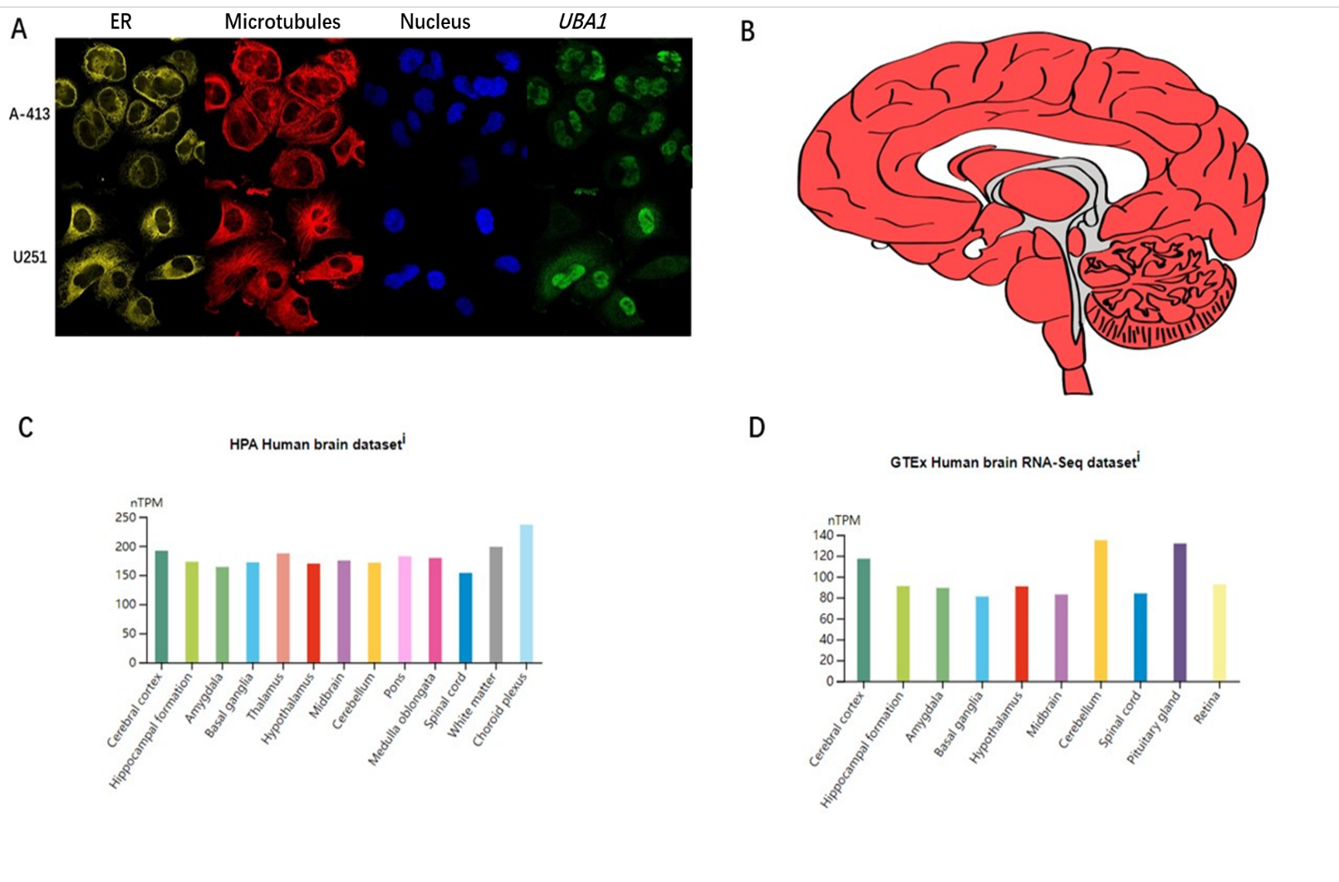
Figure S1 Subcellular localization of UBA1 and its expression distribution in the brain
(A) Based on the HPA database, the subcellular localization of UBA1 was obtained through immunofluorescence localization of nuclei, microtubules and ER in A-431 and U-251 MG cells. UBA1 is mainly located in Nucleopasm;
(B-D) Demonstrated the expression level and distribution of UBA1 in the brain.
Figure S2 Pan-cancer analysis of the correlation between UBA1 expression and clinical stages
(A) The results from the TCGA database showed that there was a significant expression difference of UBA1 between stages in TGCT.
(B) The results from the TCGA database showed that there was a significant expression difference of UBA1 between stages in READ.
(C) The results from the TCGA database showed that there was a significant expression difference of UBA1 between stages in UVM.
(D) The expression level of UBA1 gradually increased in DLBC.
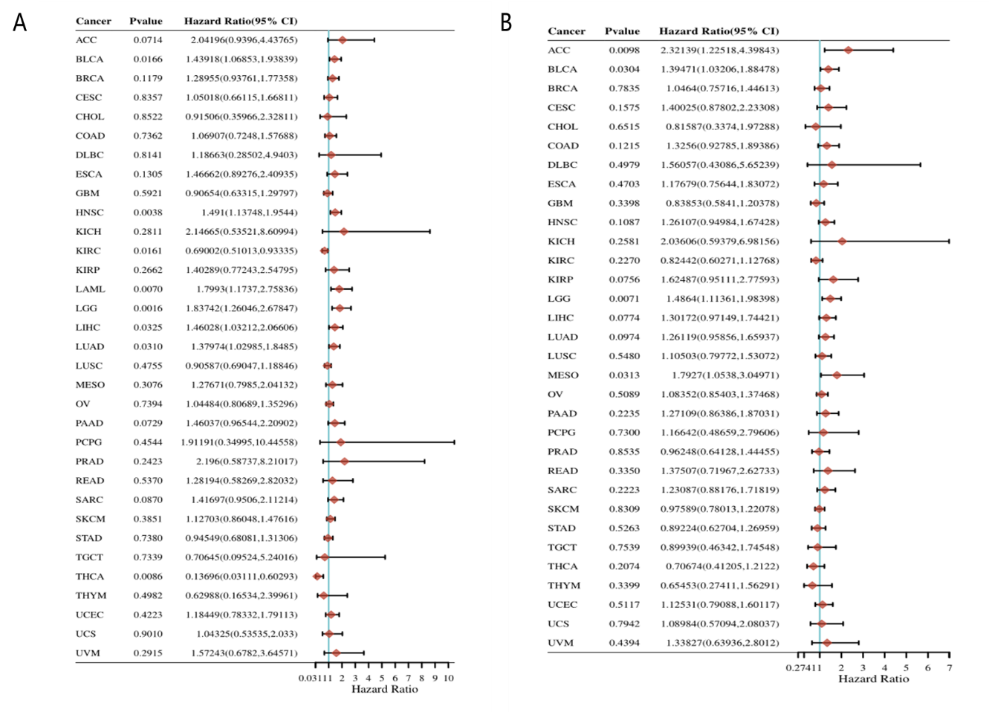
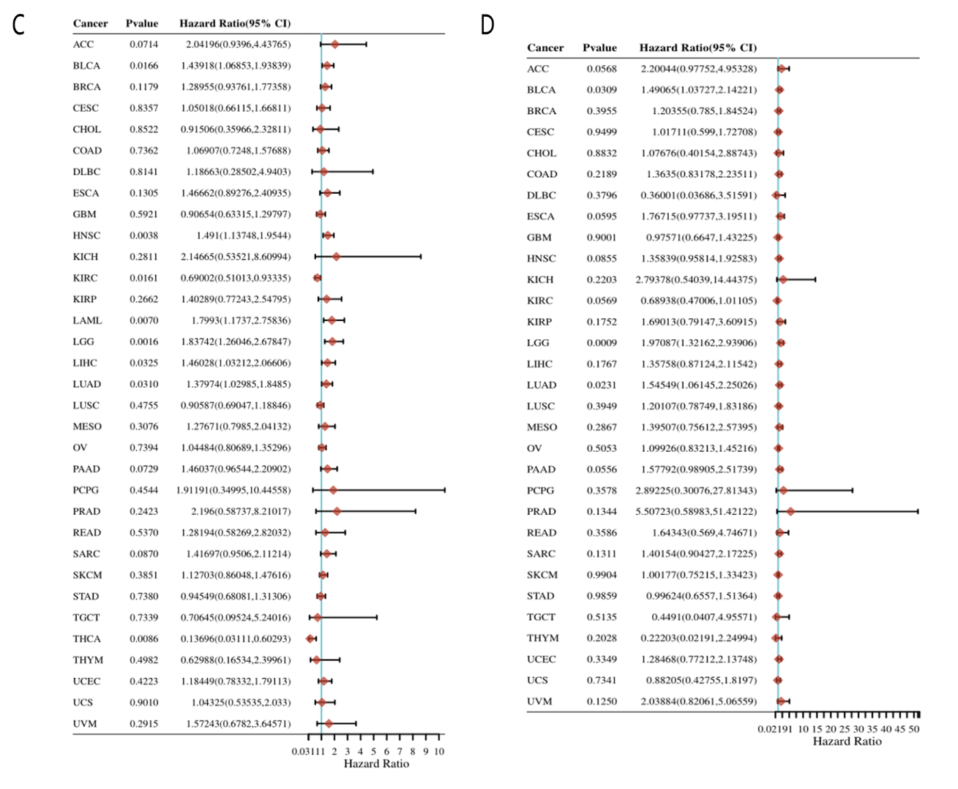
Figure S3 Cox regression analysis was conducted on the prognostic characteristics of 33 types of cancer based on the TCGA database
(A) Cox regression analysis–OS;
(B) Cox regression analysis–PFS;
(C) Cox regression analysis–DFS;
(D) Cox regression analysis–DSS.
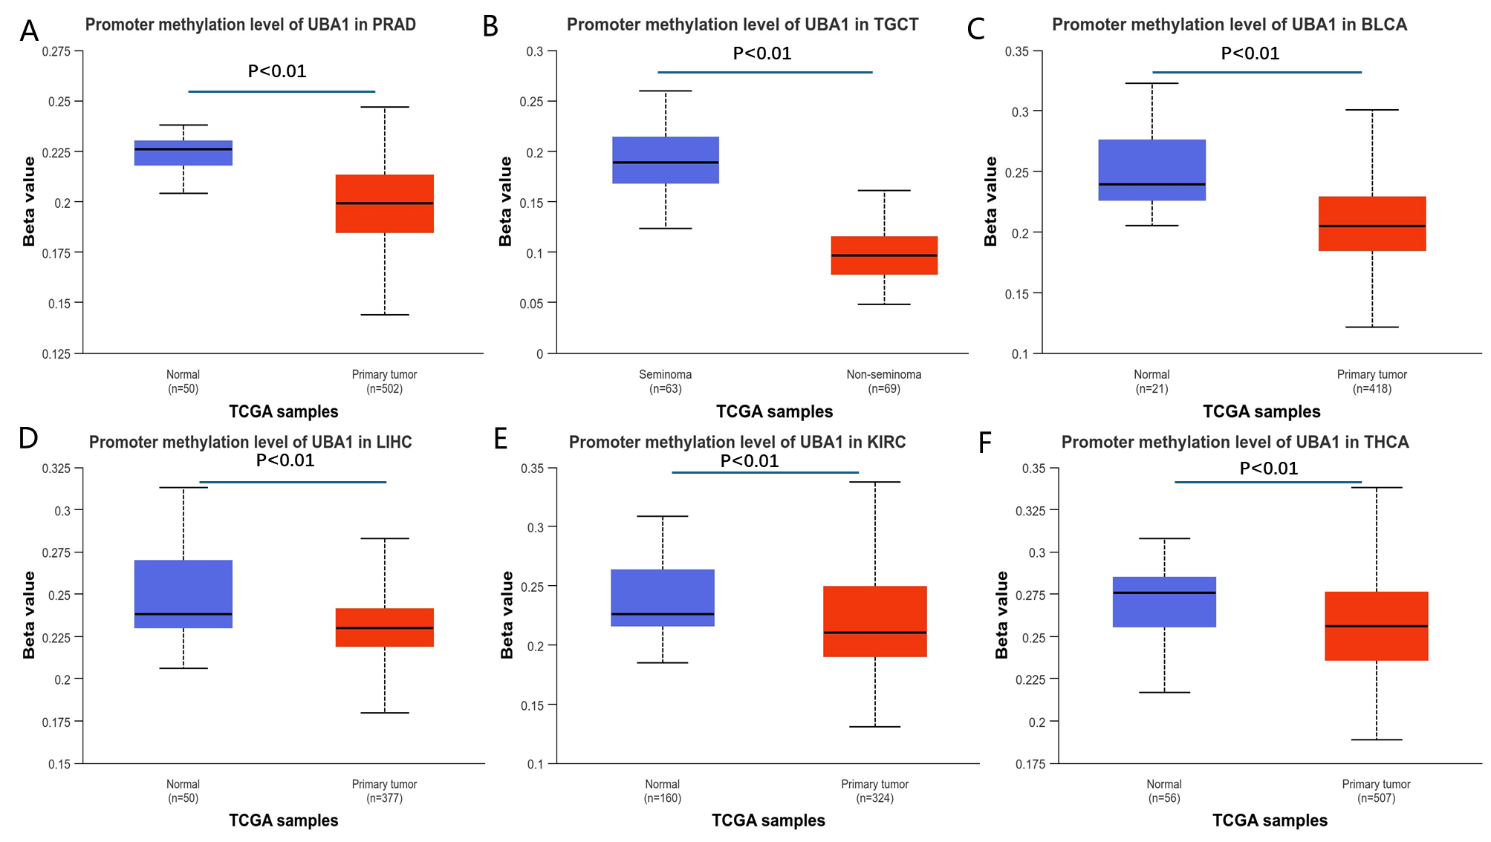

Figure S4 Pan-cancer analysis of methylation levels and UBA1 mutations
(A) According to the UALCAN database, the levels of UBA1 methylation in PRAD tissues significantly decreased compared to normal tissues.
(B) According to the UALCAN database, the levels of UBA1 methylation in TGCT tissues significantly decreased compared to normal tissues.
(C) According to the UALCAN database, the levels of UBA1 methylation in BLCA tissues significantly decreased compared to normal tissues.
(D) According to the UALCAN database, the levels of UBA1 methylation in LIHC tissues significantly decreased compared to normal tissues.
(E) According to the UALCAN database, the levels of UBA1 methylation in KIRC tissues significantly decreased compared to normal tissues.
(F) According to the UALCAN database, the levels of UBA1 methylation in THCA tissues significantly decreased compared to normal tissues.
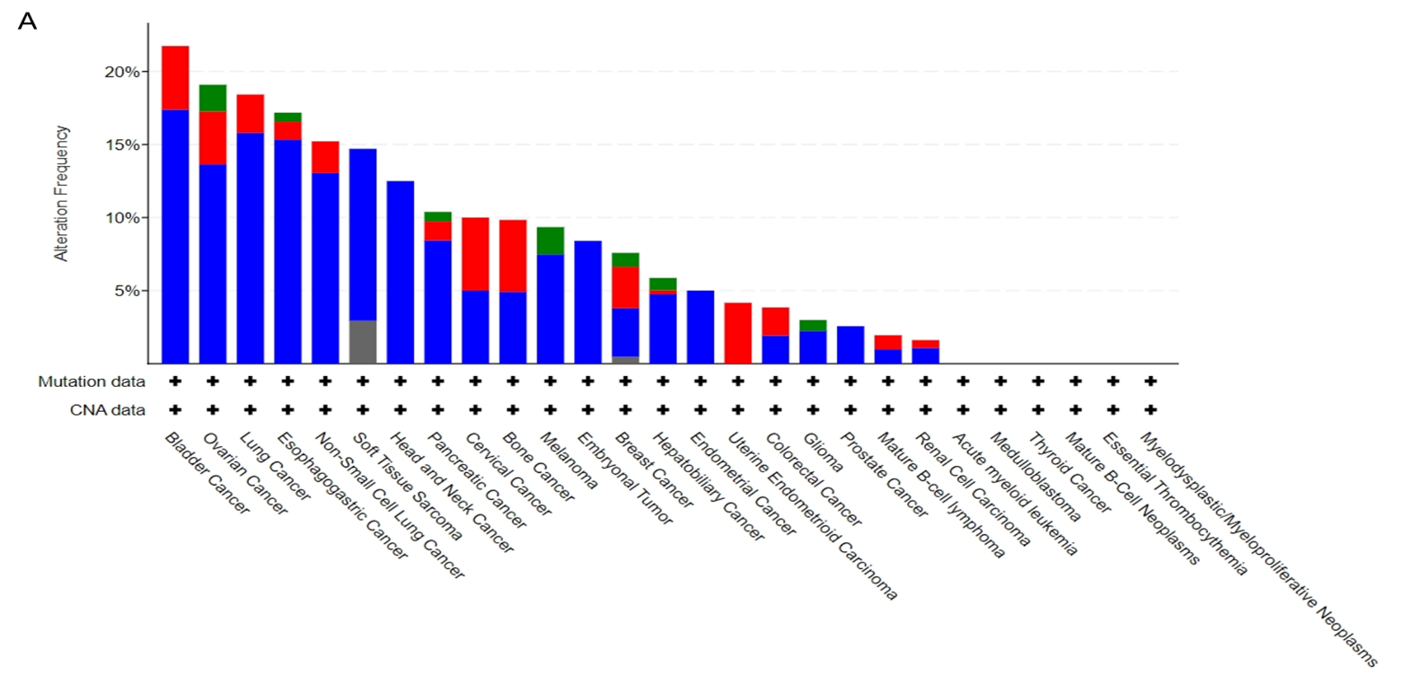
Figure S5 Pan-cancer analysis of UBA1 mutations
(A) The results show that the highest mutation frequency of UBA1 in bladder cancer patients is about 27%.
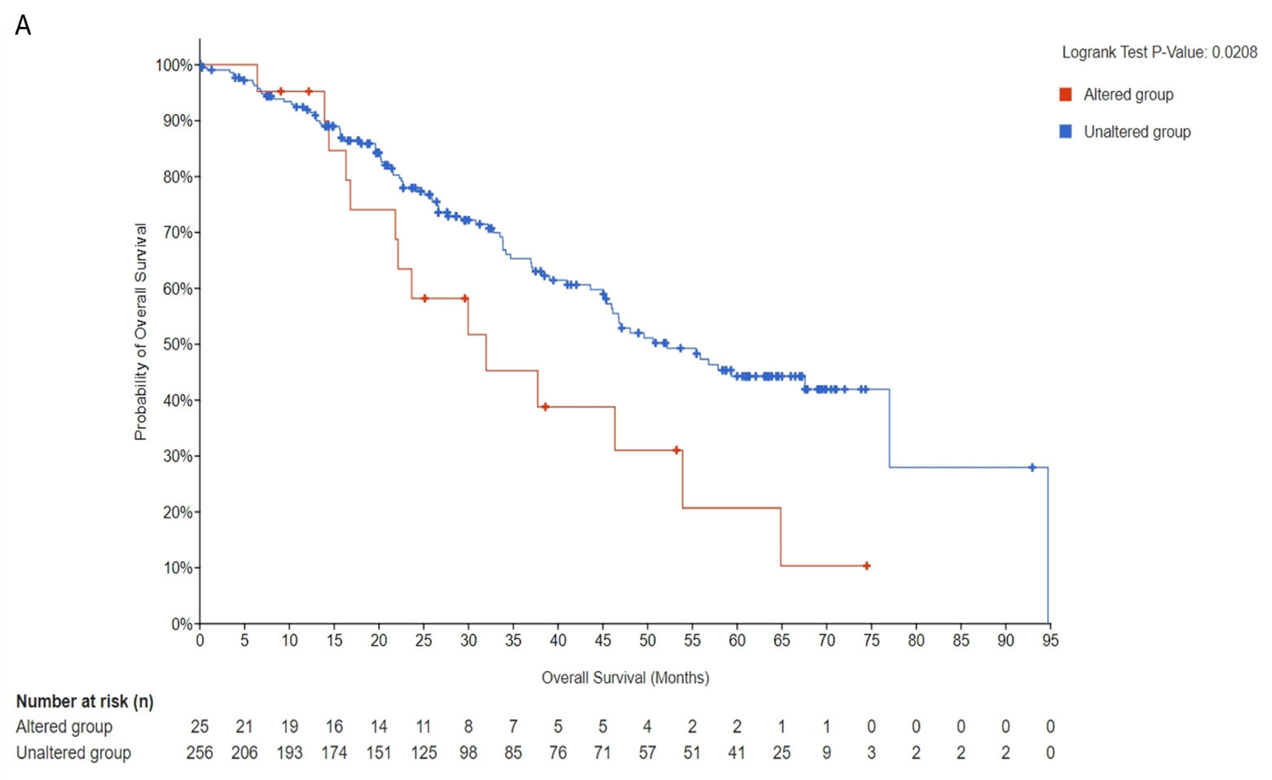
Figure S6 Analysis of prognostic differences between tumor patients with UBA1 gene mutations and those without mutations
(A) Tumor patients with UBA1 gene mutations have significantly poorer prognosis in OS compared to those without mutations.
Figure S7 Pan-cancer analysis of UBA1 phosphorylation
(A) The CPTAC database analysis found that, compared with normal samples, the S46 phosphorylation of UBA1 in lung adenocarcinoma increased significantly.
(B) The CPTAC database analysis found that, compared with normal samples, the S46 phosphorylation of UBA1 in lung squamous cell carcinoma increased significantly.
(C) The CPTAC database analysis found that, compared with normal samples, the S46 phosphorylation of UBA1 in pancreatic cancer increased significantly.
(D) The CPTAC database analysis found that, compared with normal samples, the S46 phosphorylation of UBA1 in liver cancer increased significantly.
(E) The CPTAC database analysis found that, compared with normal samples, the S46 phosphorylation of UBA1 in Clear cell RCC decreased significantly.

Figure S8 Pan-cancer analysis of the correlation between UBA1 expression and immune regulatory factors TMB, MSI and MMR related genes
(A) UBA1 expression was significantly correlated with TMB in 10 types of cancer (P<0.05). UBA1 was positively correlated with TMB in 9 types of tumors including STAD, UCEC, SARC, SKCM, PAAD, GBM, LUSC and LGG, while negatively correlated with TMB in THCA and KIRP.
(B) UBA1 expression was significantly correlated with MSI in 11 types of cancer (P<0.05). UBA1 is positively correlated with MSI in 8 types of tumors, including LUSC, KIRC, STAD, UCEC, UVM, TGCT, LUAD and LIHC, while negatively correlated with MSI in DLBC, PCPG and READ.
(C) The correlation between UBA1 expression and MMR genes was evaluated, including MLH1, MSH2, MSH6, PMS2 and EPCAM. Except for READ, SKCM, uterine carcinosarcoma (UCS)UCS, and UVM, the expression of UBA1 in most tumors is associated with the expression of the MMR gene.

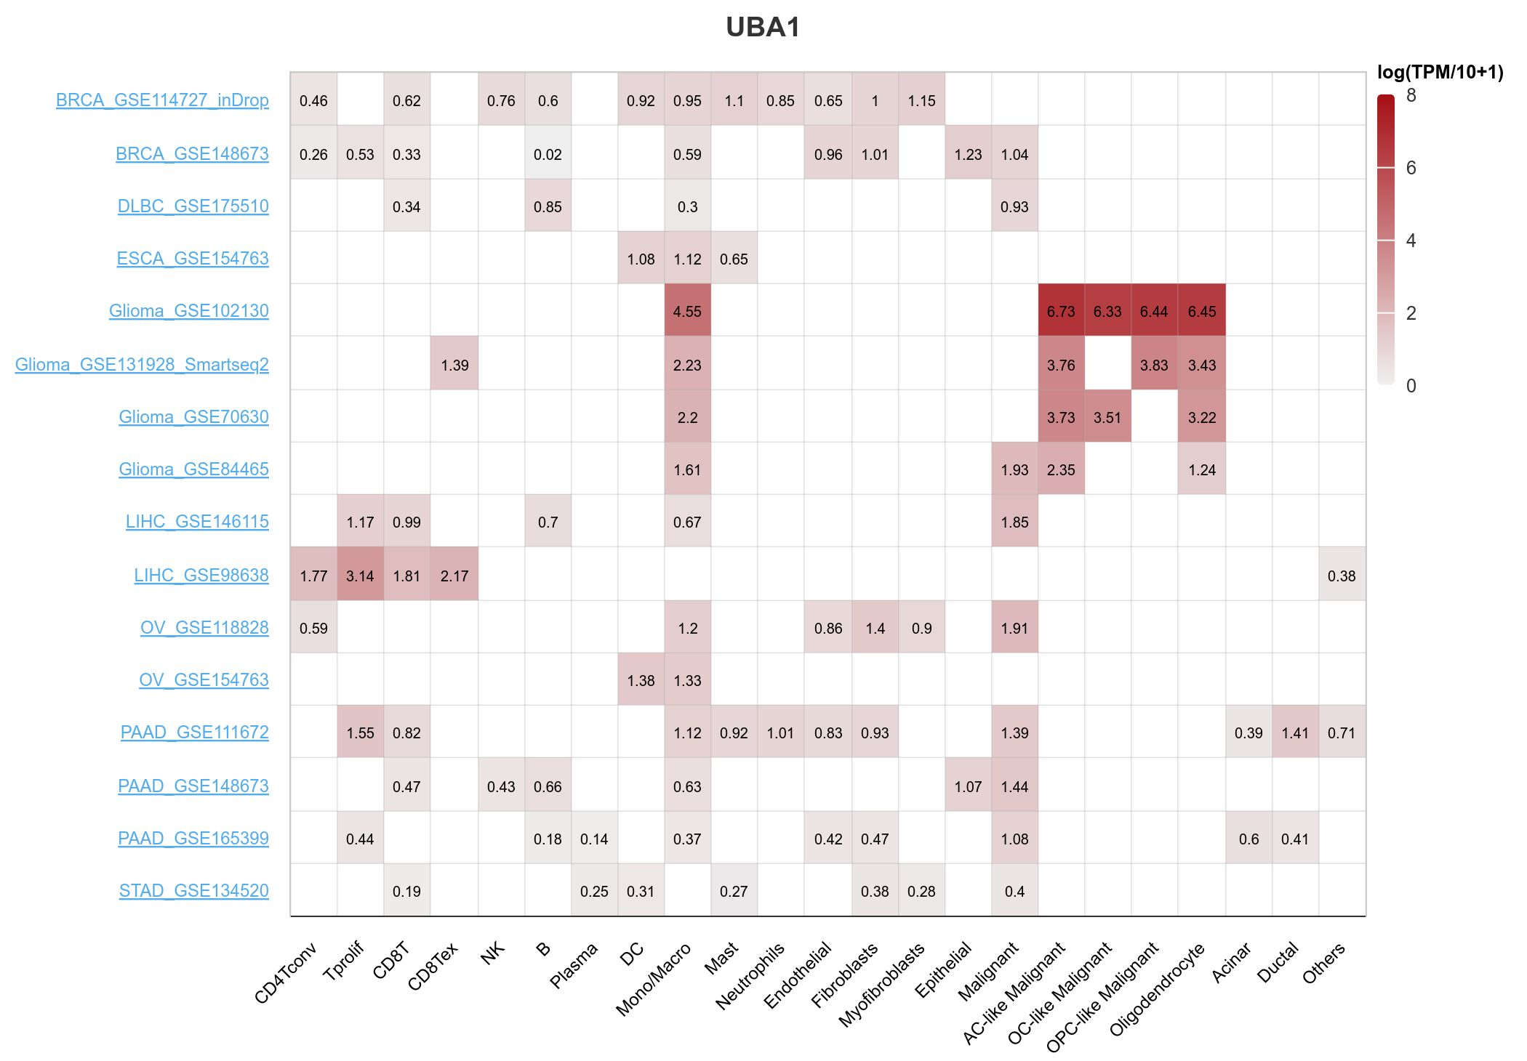
Figure S9 The expression of UBA1 on immune cells
UBA1 is expressed by macrophages and malignant cells in BRCA, DLBC, glioma, LIHC, OV and PAAD.
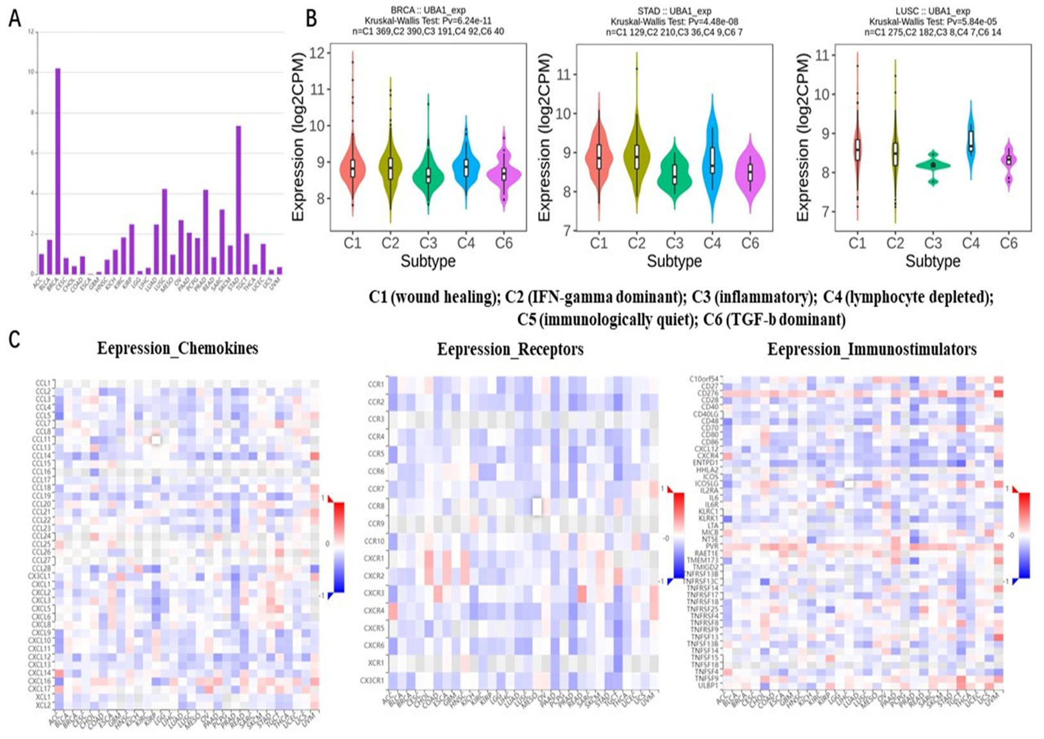
Figure S10 Analysis of differential expression of UBA1 in different immune subtypes of cancer based on TISIDB database
(A) Correlation map between UBA1 and cancer immune subtypes;
(B) Association diagram between UBA1 and various subtypes of cancer immunity;
(C) Heat map of the correlation between UBA1 and chemokines (left), receptors (center) and immune stimulatory molecules (right).
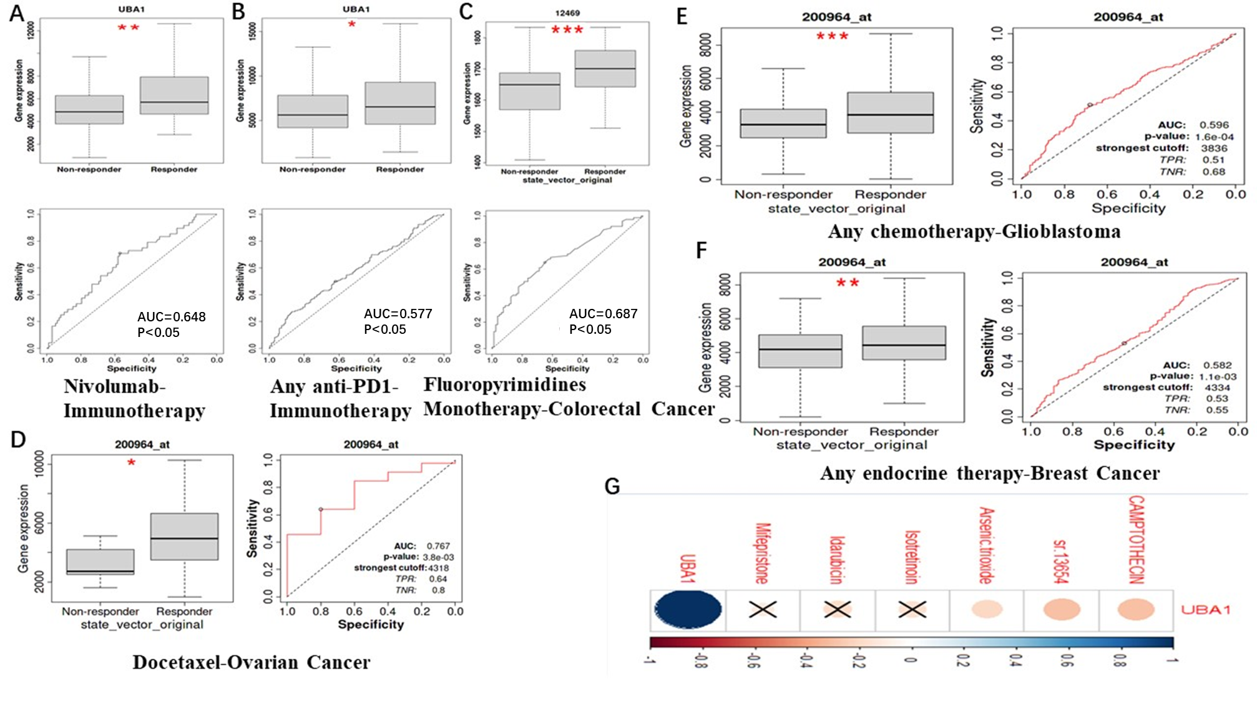
Figure S11 UBA1 predicts treatment response to Pan-cancer
(A) Respondents treated with nivolumab immunotherapy showed higher expression of UBA1, with an area under curve (AUC) value of 0.65.
(B) Respondents treated with PD1 immunotherapy showed higher expression of UBA1, with an AUC value of 0.58.
(C) In CRC, responders treated with fluoropyrimidine monotherapy showed higher UBA1 expression, with an AUC value of 0.69.
(D) In OV, responders treated with docetaxel exhibited higher UBA1 expression, with an AUC value of 0.77.
(E) In GBM, UBA1 is highly expressed in post chemotherapy responders, with an area under the curve (AUC) value of 0.60.
(F) In BRCA, responders after endocrine therapy had higher UBA1 expression, with an AUC value of 0.58.
(G) The drug sensitivity of UBA1 expression in tumors was studied using GSCALite. The expression of UBA1 is positively correlated with the 50% inhibitory concentration (IC50) values of CAMPTOTHECIN, sr.13654 and Arsenal.

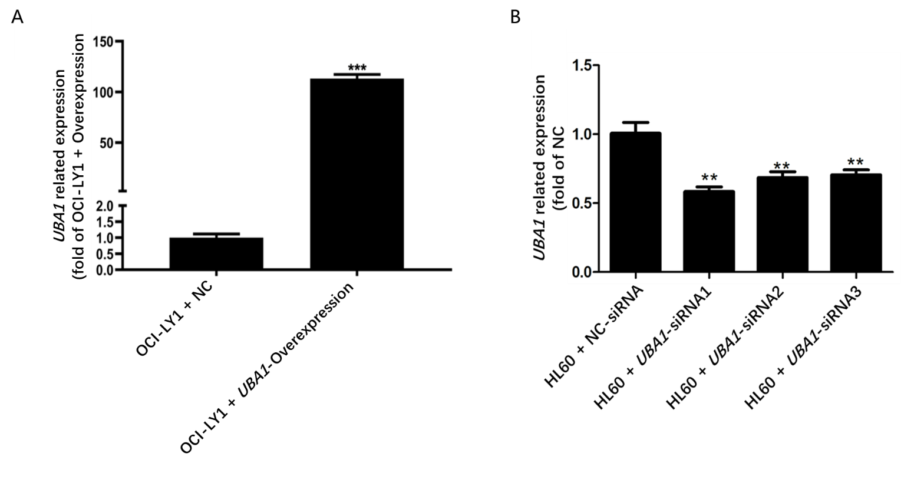
Figure S12 Construction of UBA1 overexpression DLBCL cell model and UBA1 interference AML cell model
(A) The qPCR results showed that compared with the control group, the cells transfected with OCI-LY1+UBA1-Overexpression had the significant overexpression effect on UBA1 and named OCI-LY1+UBA1-Overexpression.
(B) The qPCR results showed that compared with the control group, the cells transfected with HL-60+UBA1-siRNA1 had the most significant interference effect on UBA1.

