A Pan-Cancer Analysis of the Oncogenic Role of ZNRF2 in Human Tumors
Fujie Shi^{#1,2}, Yunfei Wu^{#1}, Kai Wang^{#3}, Jiafan Wang¹, Minghui Liu^{*1}, Xinlei Sun^{*1}
1 State Key Laboratory of Natural Medicines, School of Life Science and Technology, China Pharmaceutical University, 639 Longmian Avenue, Nanjing, Jiangsu, 211198, China;
2 School of Life Sciences, Nanjing University, 163 Xianlin Avenue, Nanjing, Jiangsu, 210023, China;
3 Division of Trauma and Surgical Intensive Care Unit, Research Institute of General Surgery, Jinling Hospital, Medical School of Nanjing University, Nanjing, Jiangsu, 210002, China.

#These authors contributed equally to this work
∗Corresponding author
Minghui Liu, State Key Laboratory of Natural Medicines, School of Life Science and Technology, China Pharmaceutical University, Nanjing 211198, China.minghuiliu@cpu.edu.cn
Xinlei Sun, State Key Laboratory of Natural Medicines, School of Life Science and Technology, China Pharmaceutical University, Nanjing 211198, China. xsun@cpu.edu.cn

Running title: Role of ZNRF2 in Tumor

Supplementary Figure 1
Supplementary Figure 2
Supplementary Figure 3
Supplementary Figure 4
Supplementary Figure 5
Supplementary Figure 6
Supplementary Figure 7
Supplementary Figure 8
Table S1.

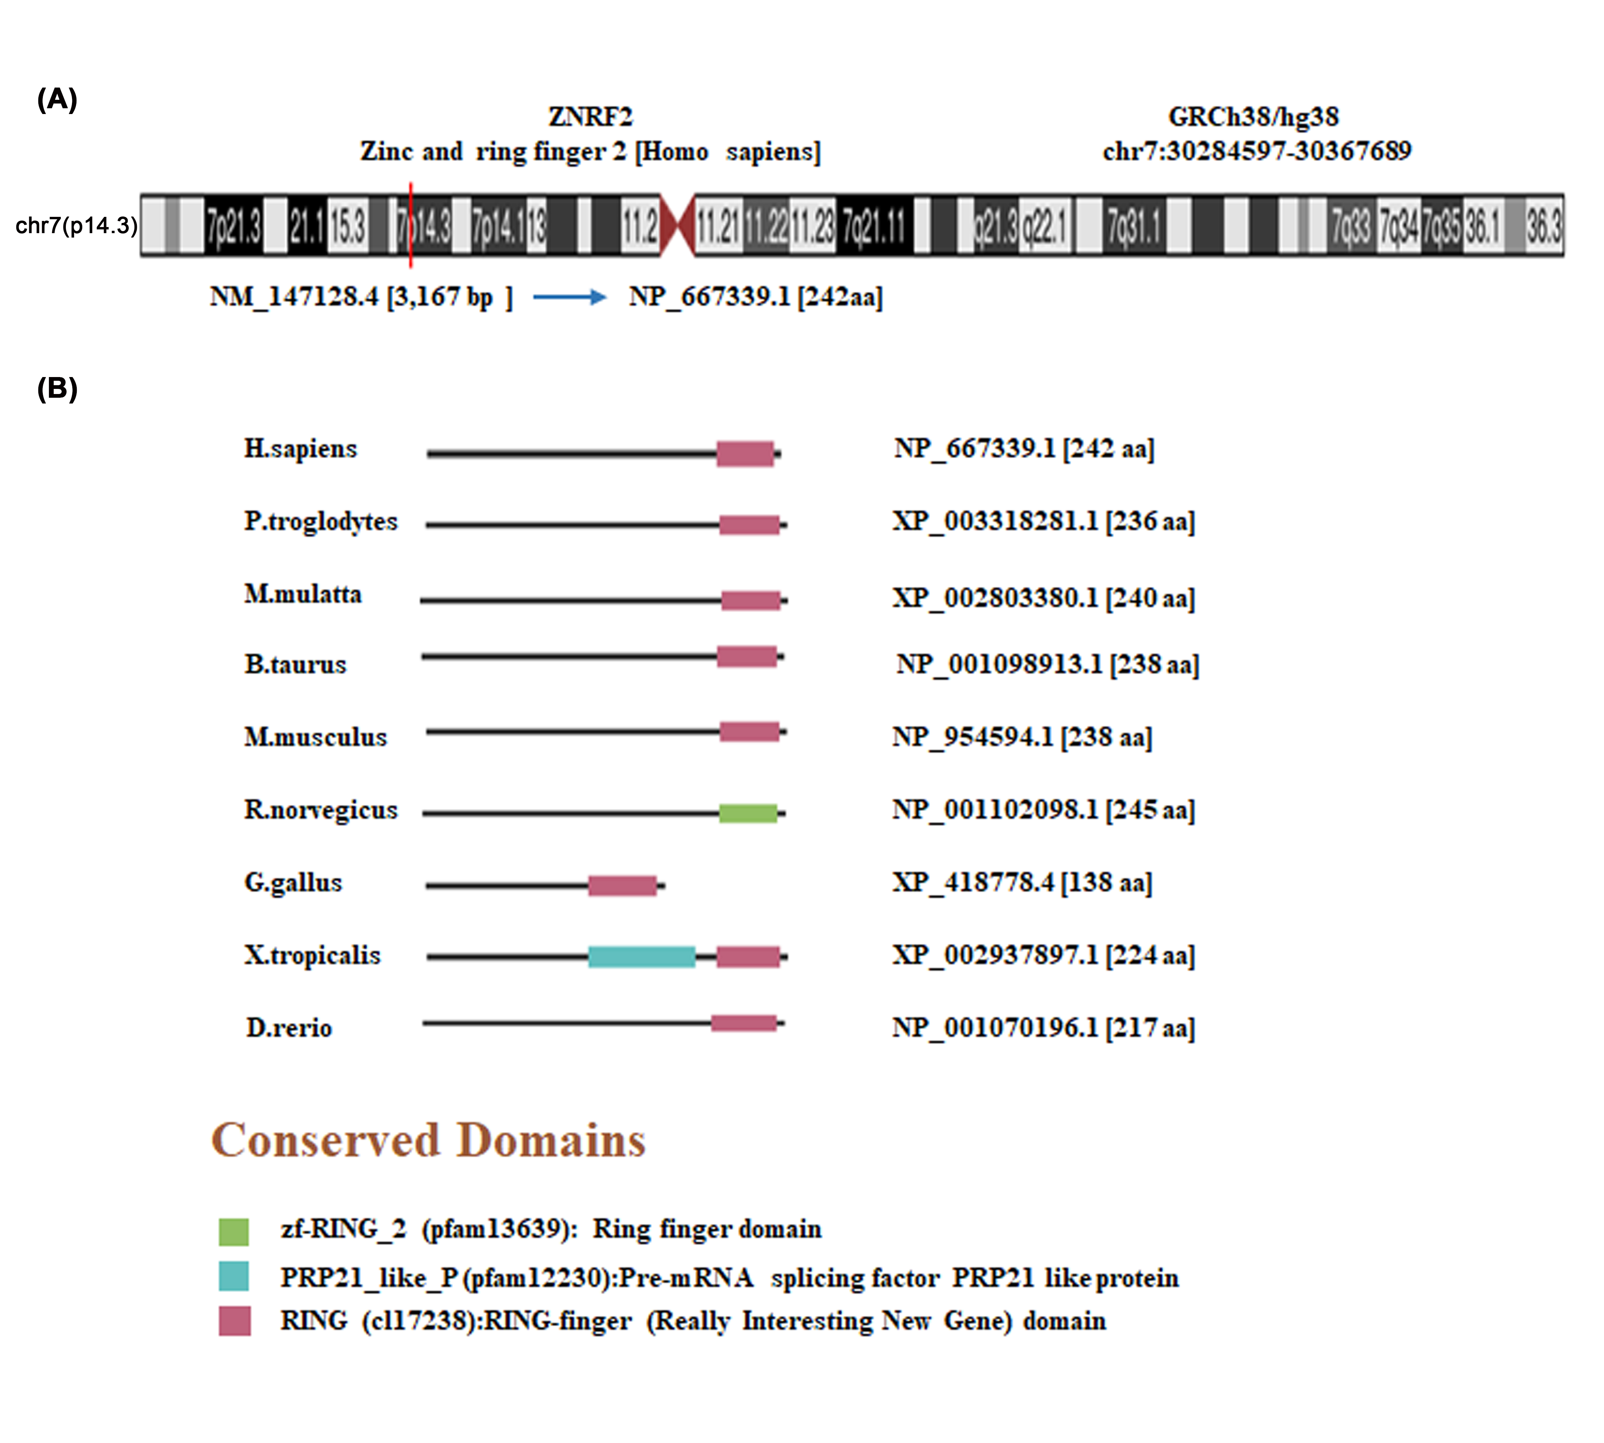
Supplementary Figure 1 Structural characteristics of ZNRF2 in different species. (A) Genomic location of human ZNRF2, (B) Conserved domains of ZNRF2 protein among different species.

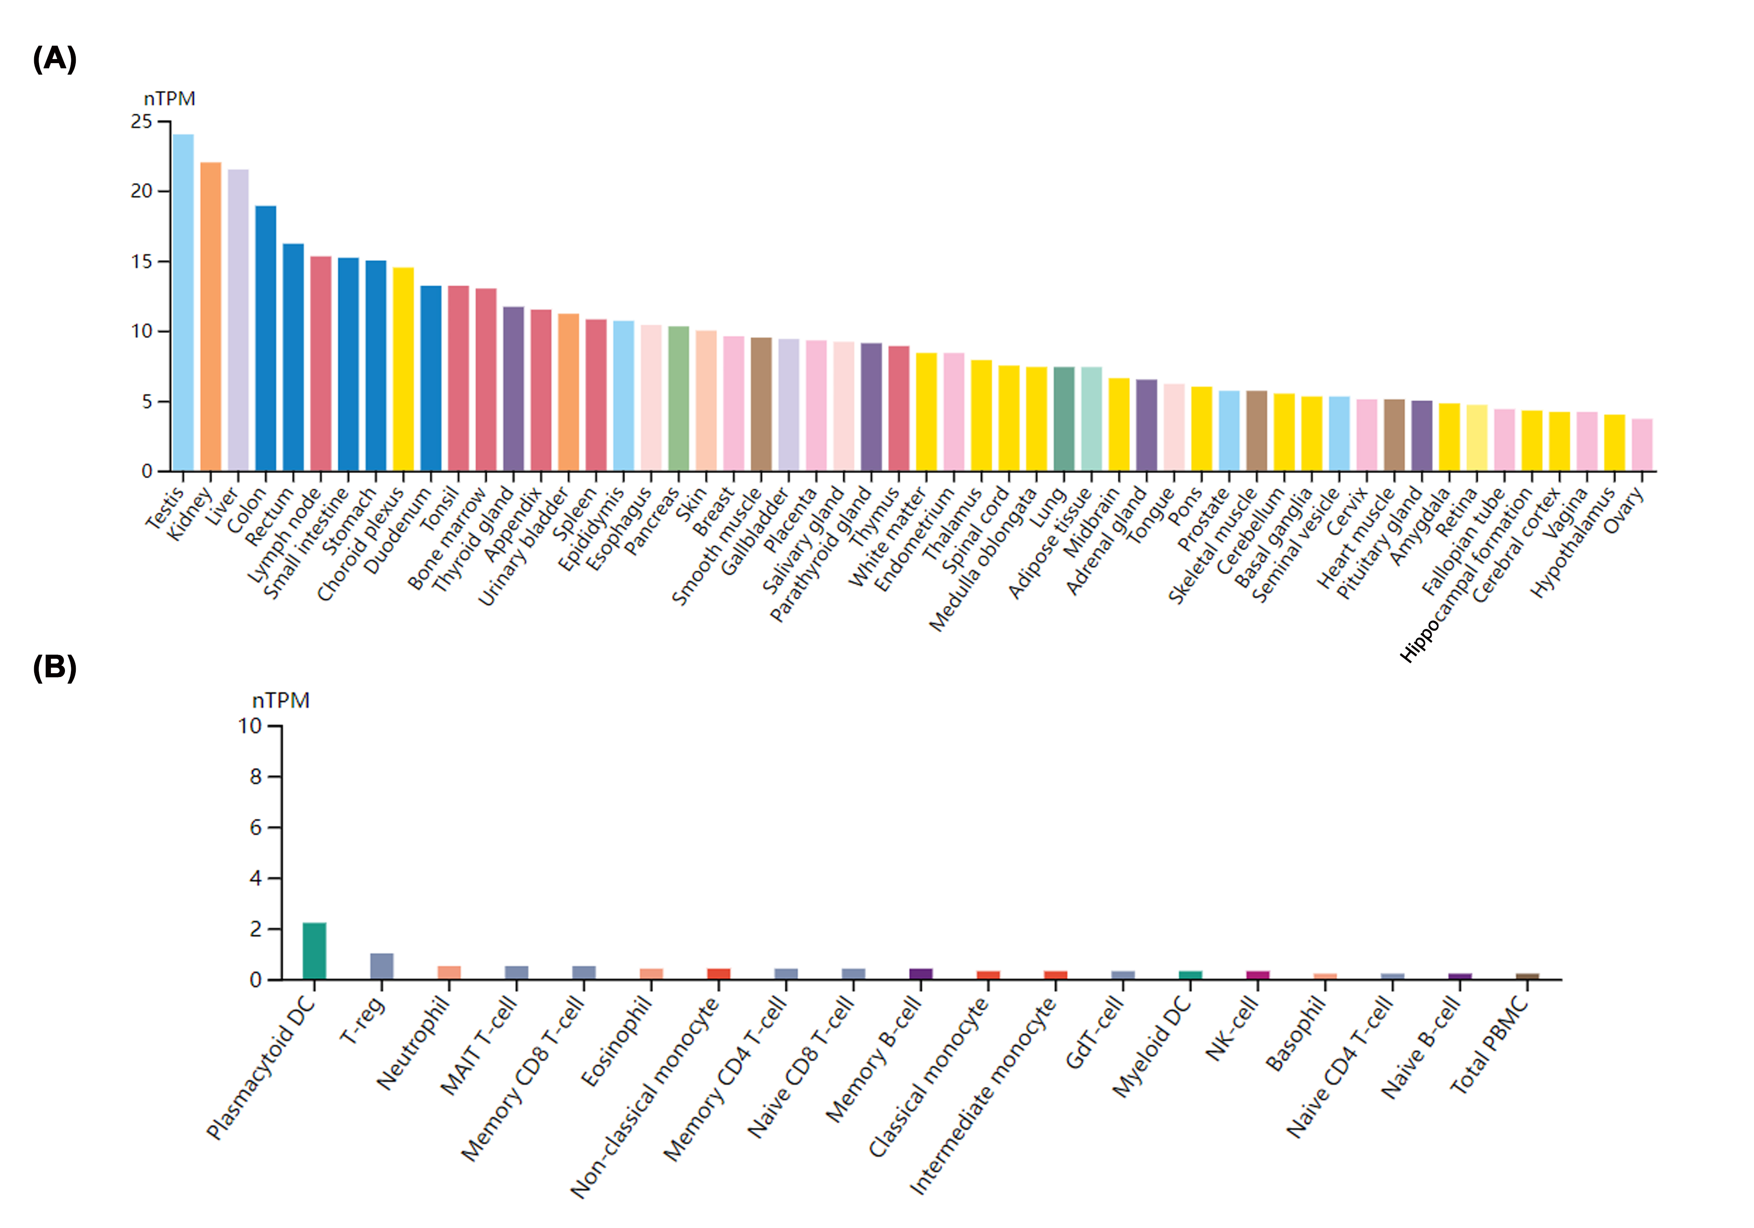
Supplementary Figure 2 Expression level of ZNRF2 in different tissues and blood cells in the normal physiological state. (A) the expression of the ZNRF2 gene in different tissues in the consensus dataset of HPA and GTEx dataset, (B) in different blood cells in the HPA dataset.

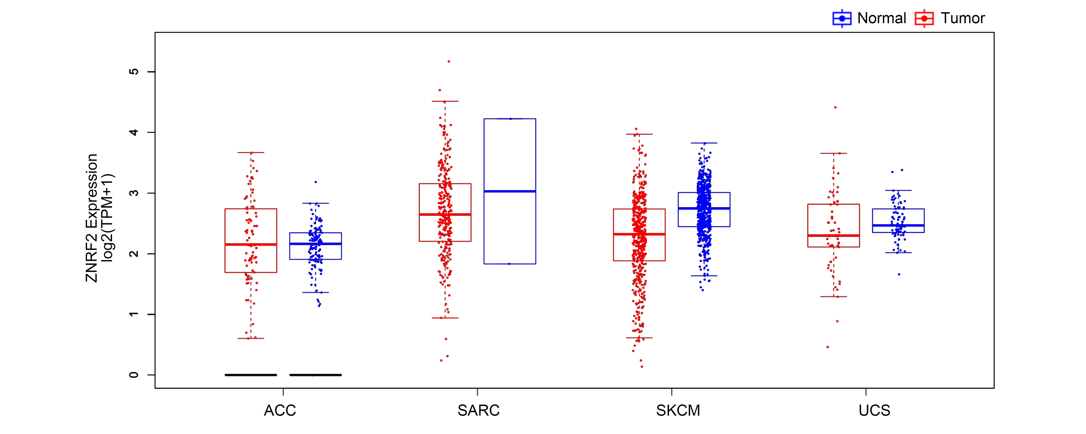
Supplementary Figure 3 Expression level of the ZNRF2 gene in different tumors. The expression statuses of the ZNRF2 gene in ACC, SARC, SKCM, and UCS in TCGA (P>0.05) project were compared with the corresponding normal tissues of the GTEx databases.

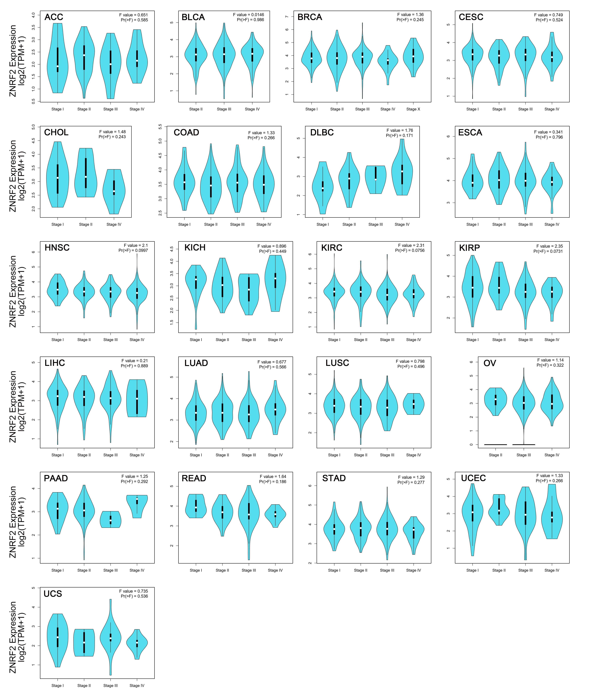
Supplementary Figure 4 Expression level of the ZNRF2 gene in different TCGA tumors pathological stages. Including ACC, BLCA, BRCA, CESC, CHOL, COAD, DLBC, ESCA, HNSC, KICH, KIRC, KIRP, LIHC, LUAD, LUSC, OV, PAAD, READ, STAD, UCEC, UCS (P>0.05).

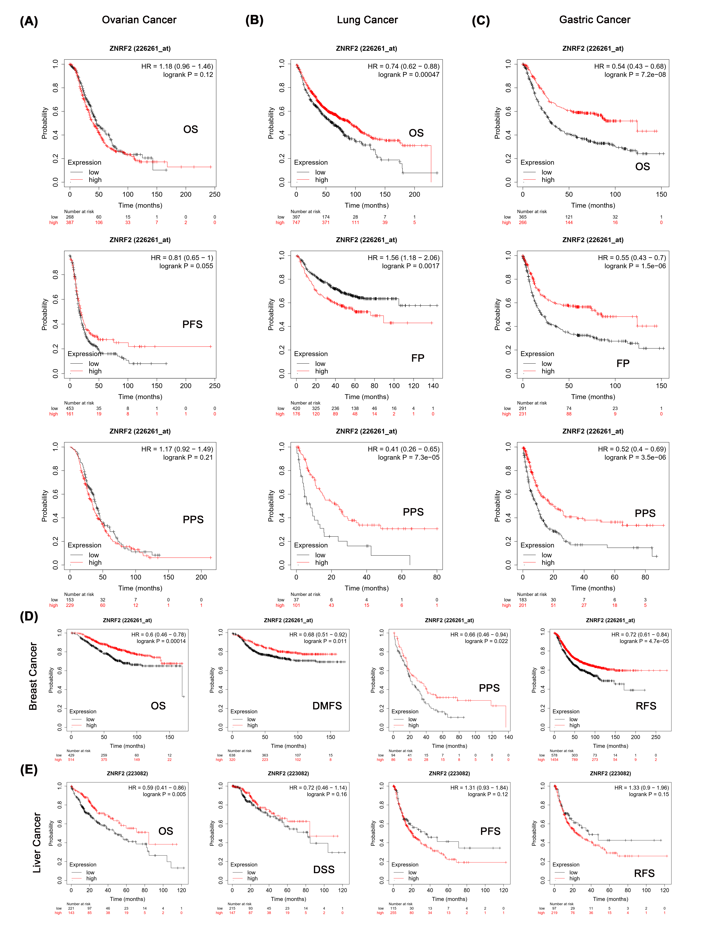
Supplementary Figure 5 ZNRF2 expression level and tumor prognosis. We analyzed the relationship between ZNRF2 expression levels and survival curves (OS, DMFS, RFS, PFS, PPS, FP, and DSS) using the Kaplan-Meier plotter. (A) Ovarian cancer, (B) Lung cancer, (C) Gastric cancer, (D) Breast cancer, (E) Liver cancer.

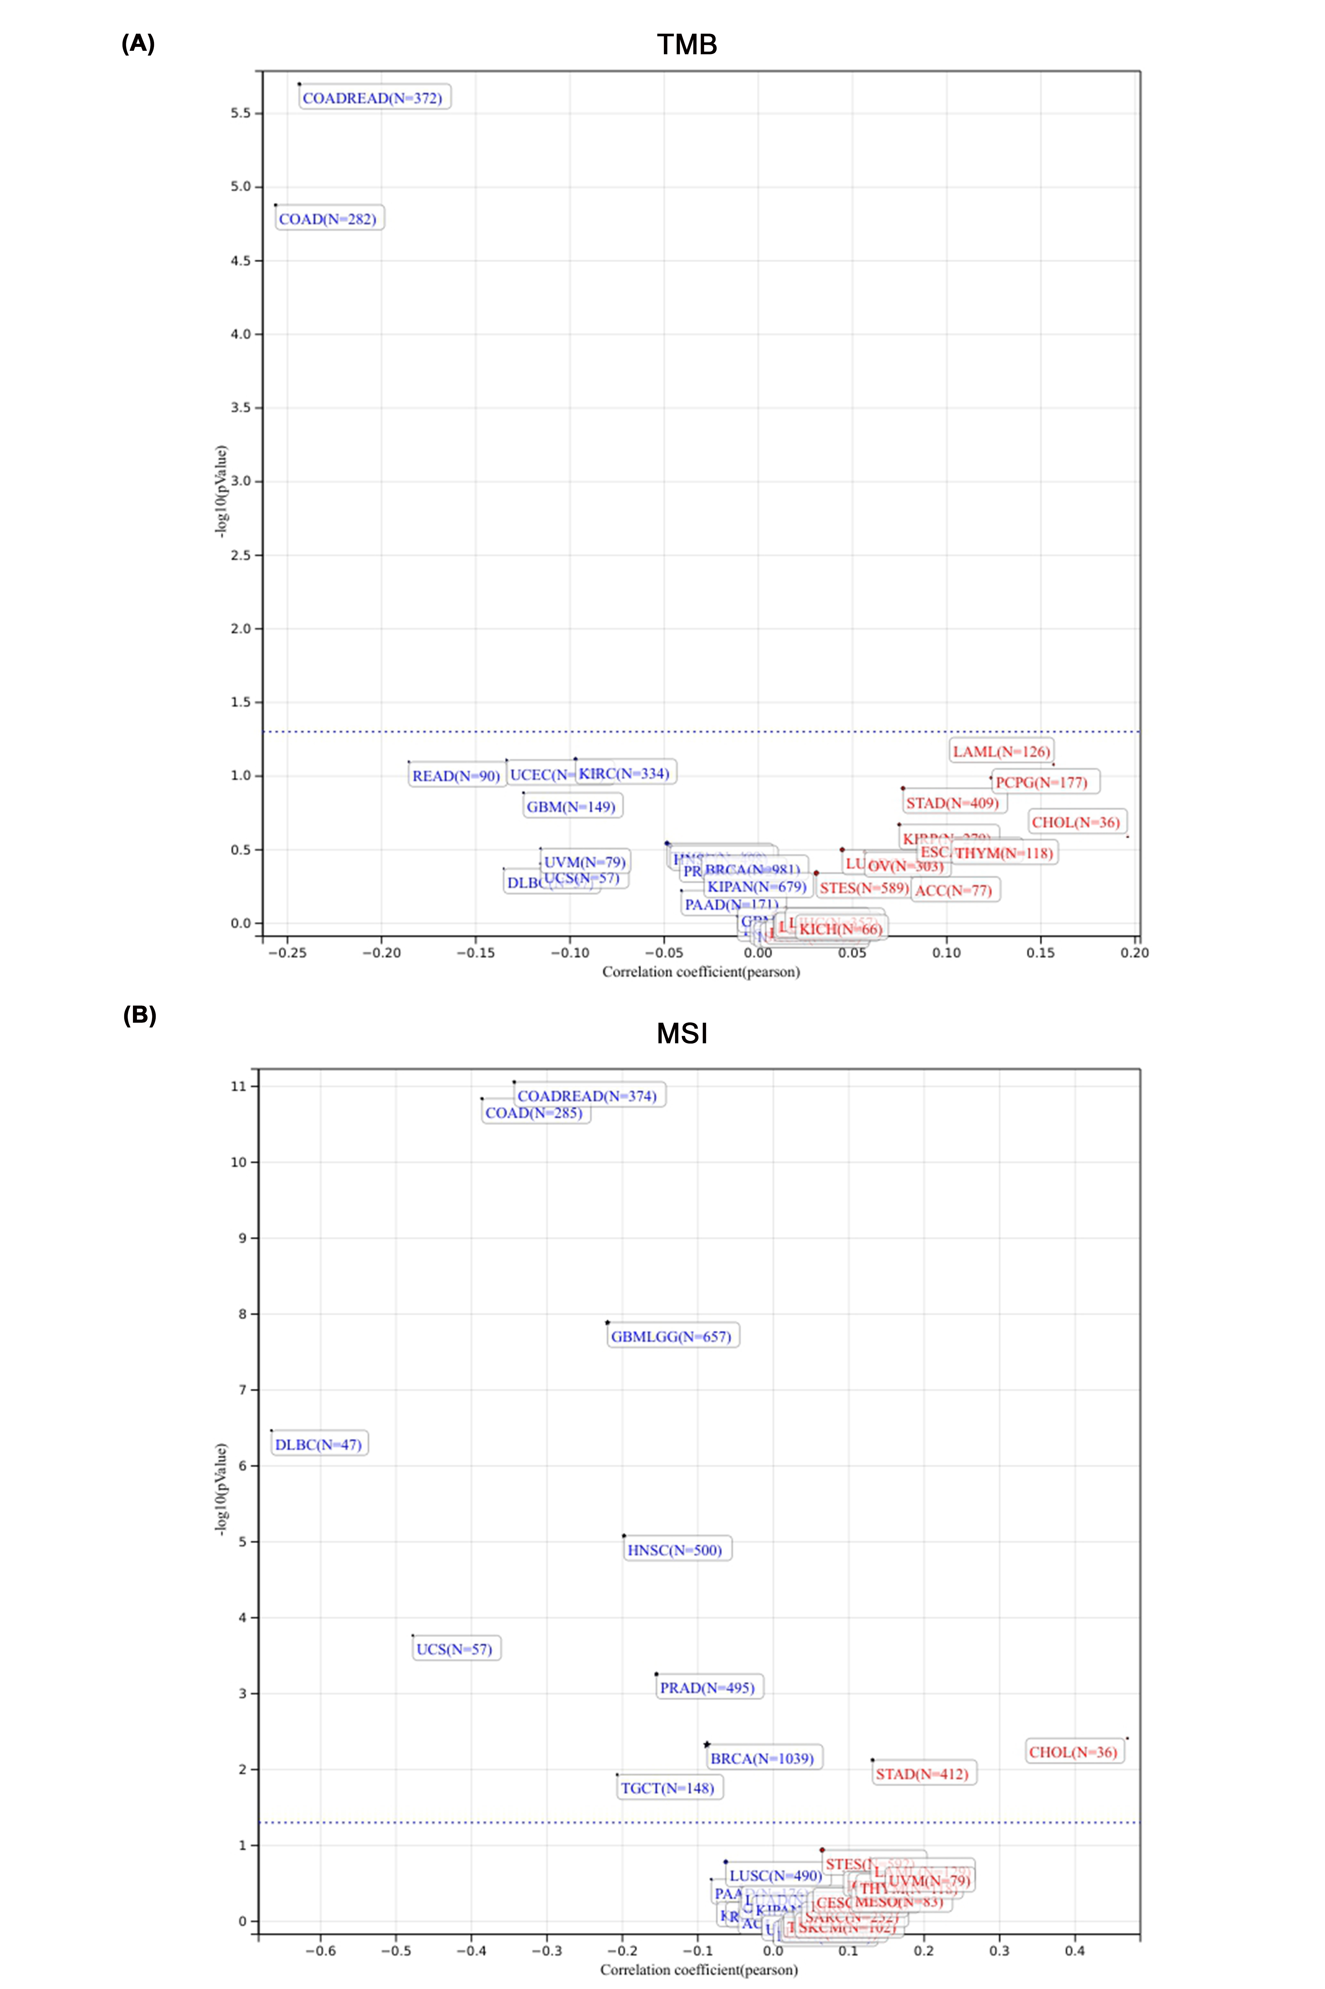
Supplementary Figure 6 The relationship between the expression level of ZNRF2 and (A) TMB and (B) MSI.

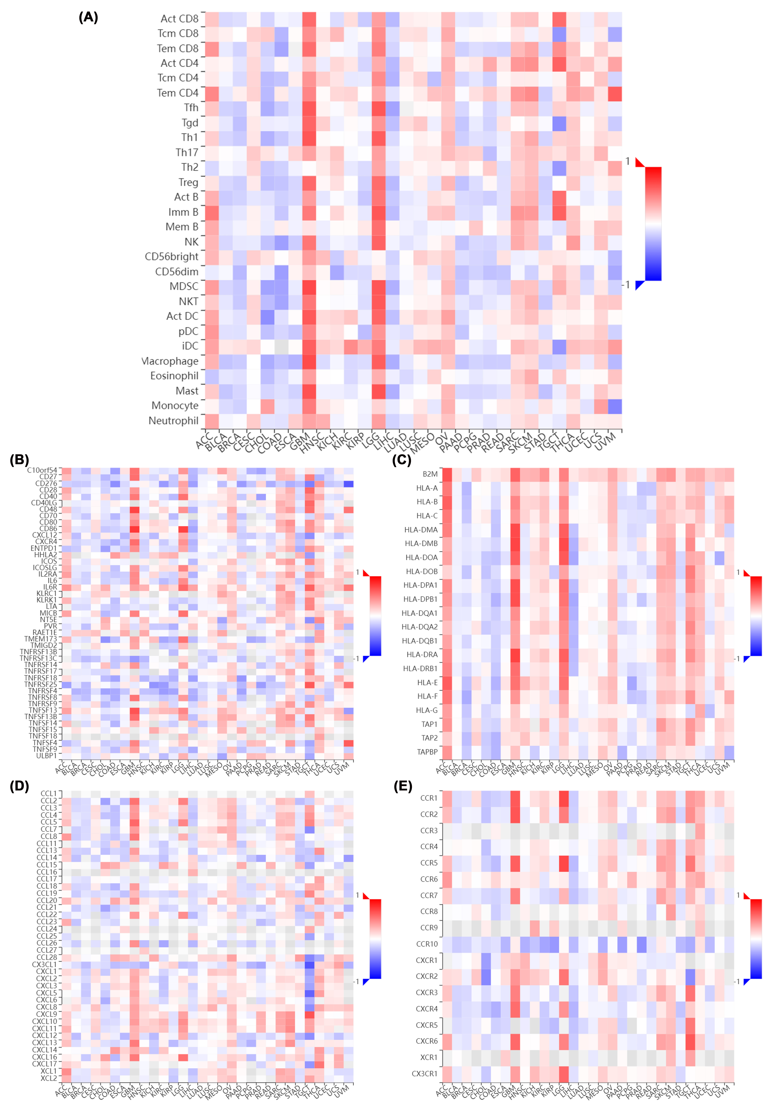
Supplementary Figure 7. Relationship between ZNRF2 expression levels and tumor-infiltrating lymphocytes, immune-stimulators, MHC molecules, chemokines, and chemokine receptors. (A) Tumor-infiltrating lymphocytes, (B) Immune-stimulators, (C) MHC molecules, (D) Chemokines, and (E) Chemokine receptors.

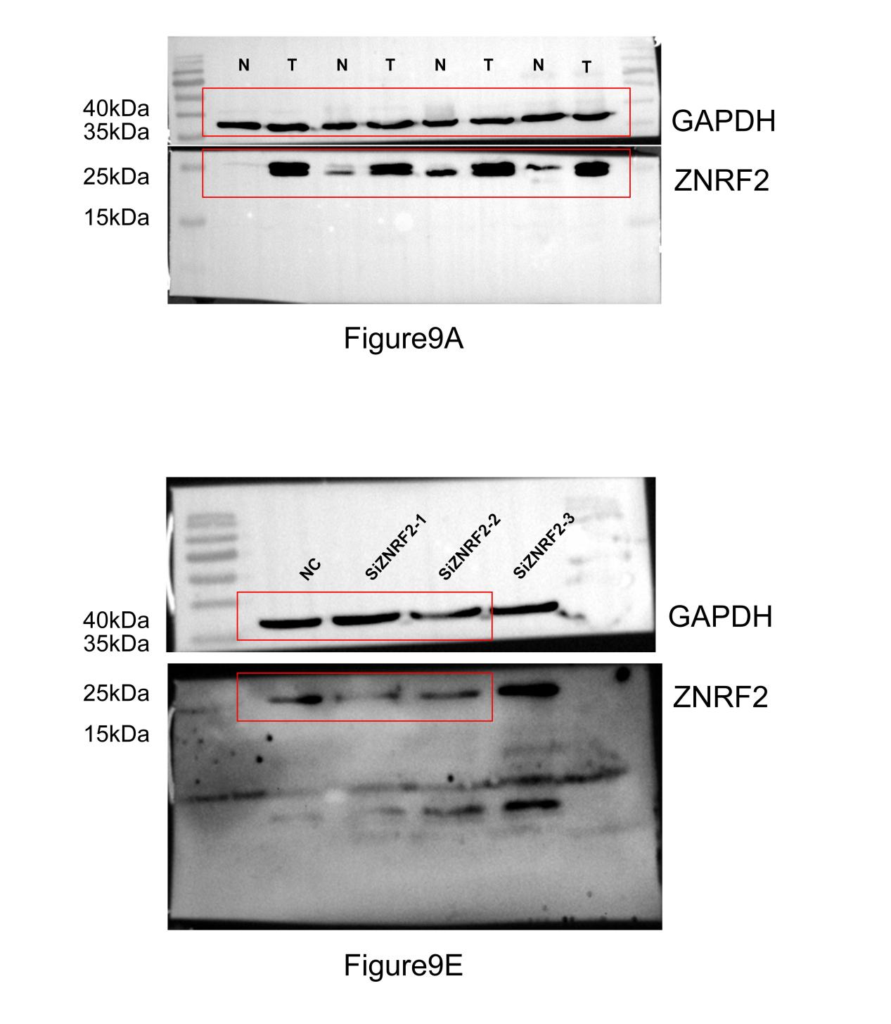

Supplementary Figure 8. All the uncropped data of Western Blotting.

Table S1. Analysis of CPTAC-identified phosphorylation sites of ZNRF2 via the PhosphoNET database.
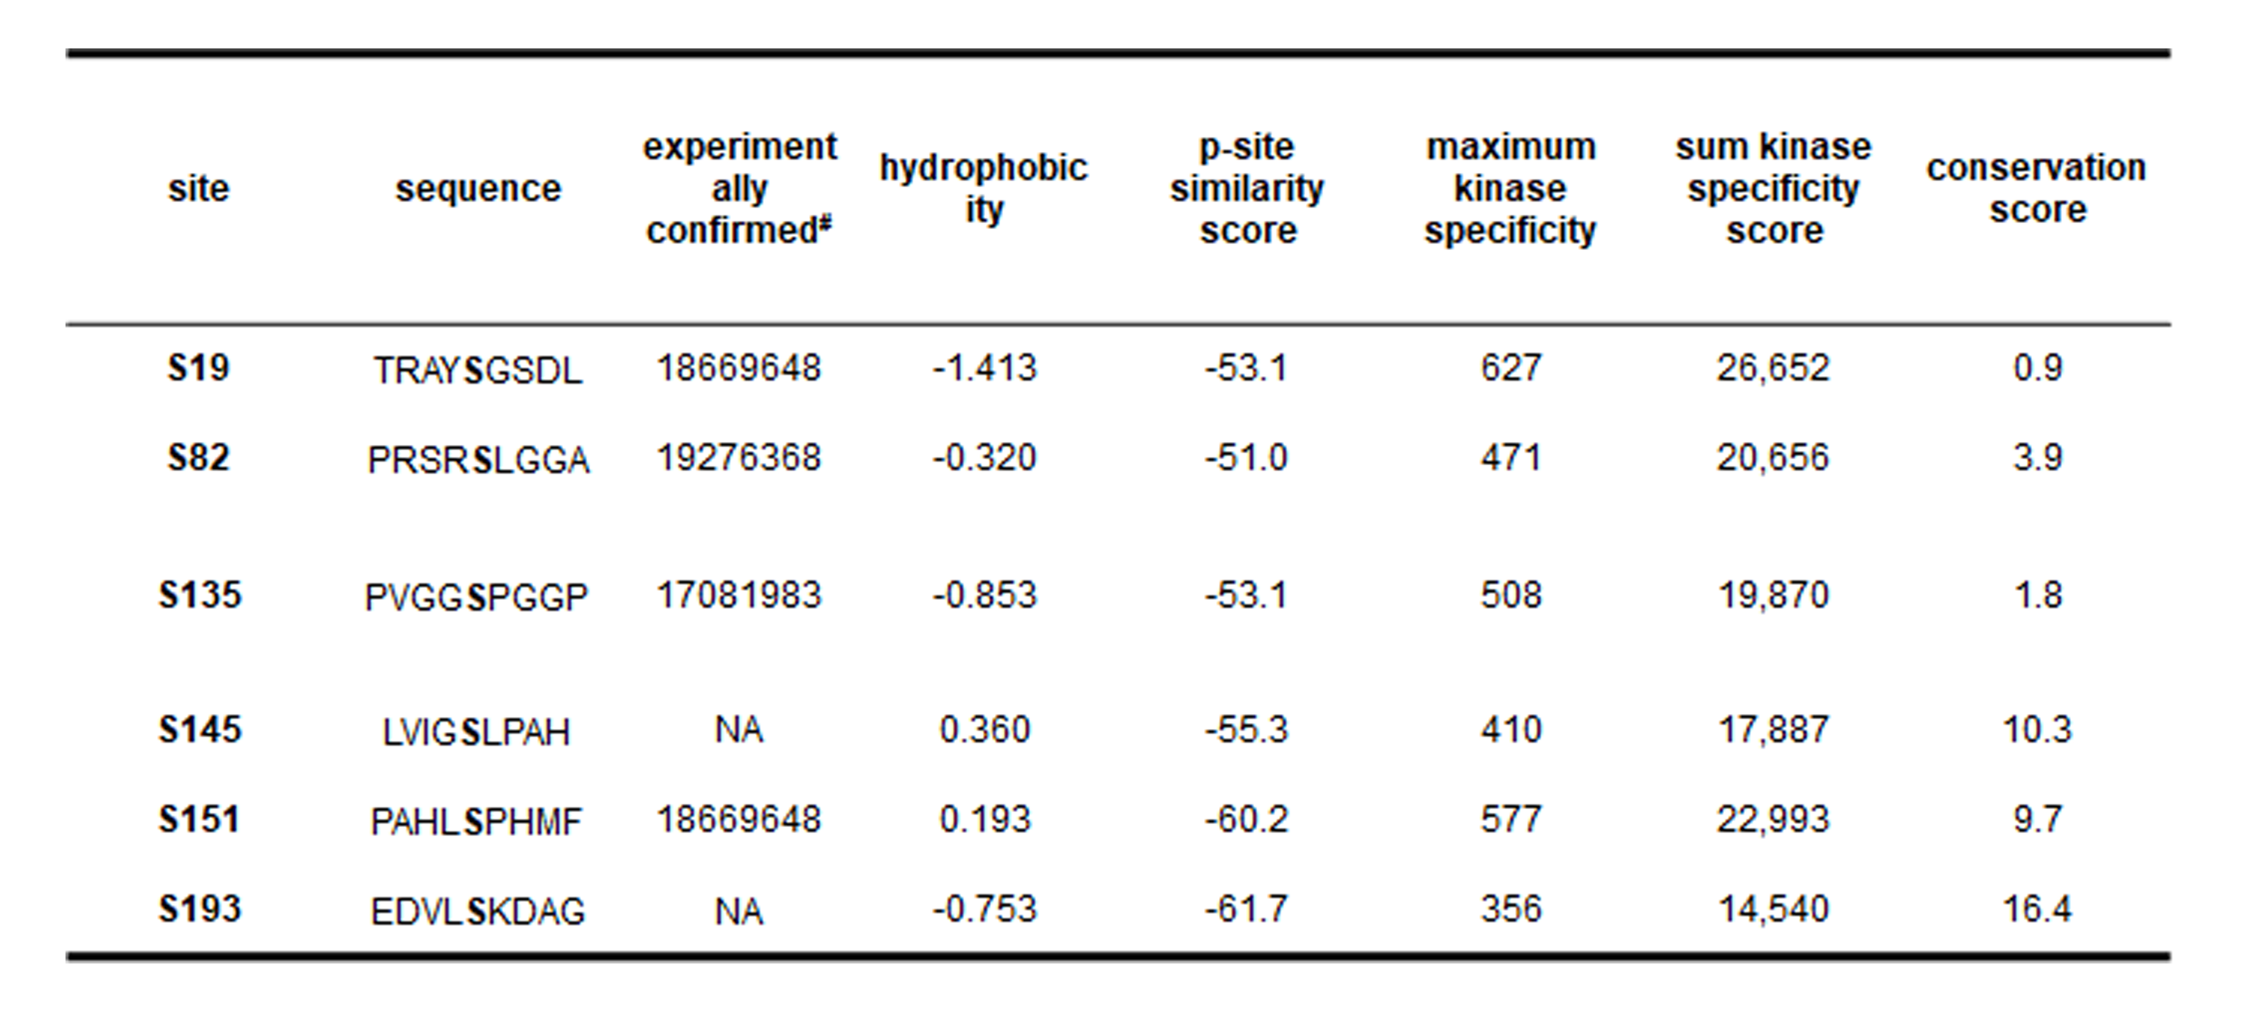
#The PMID (PubMed Unique Identifier) information of the publication was provided; NA, not available.

