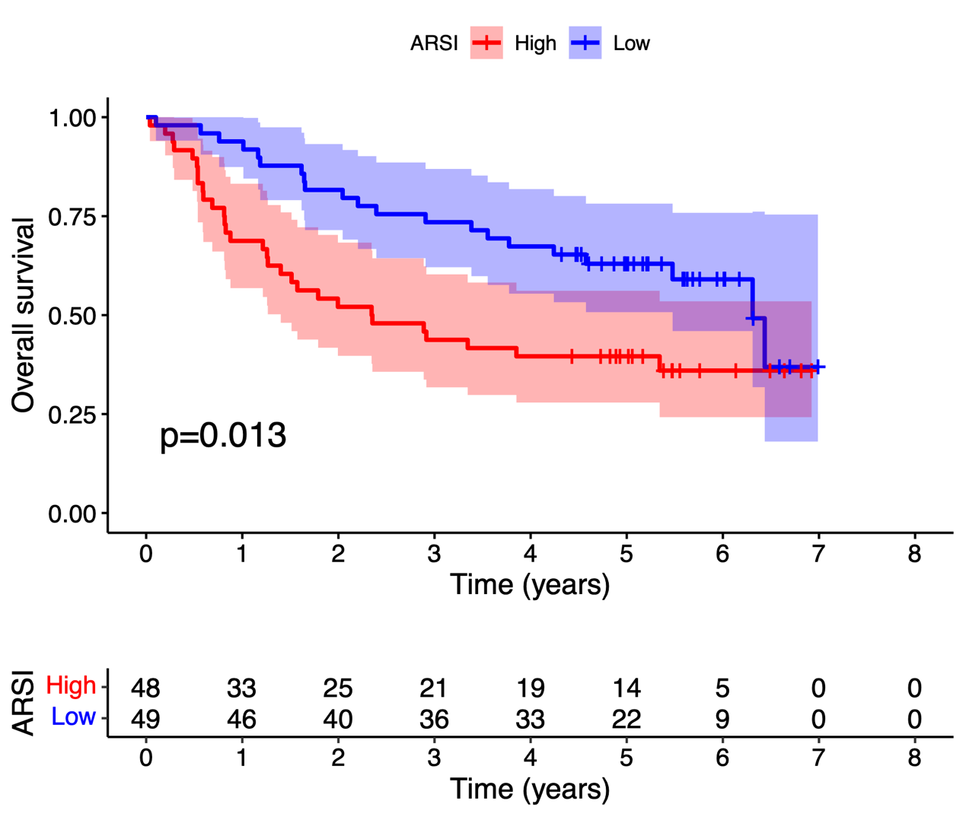
Figure S1: The survival value of ARSI in GSE41613.

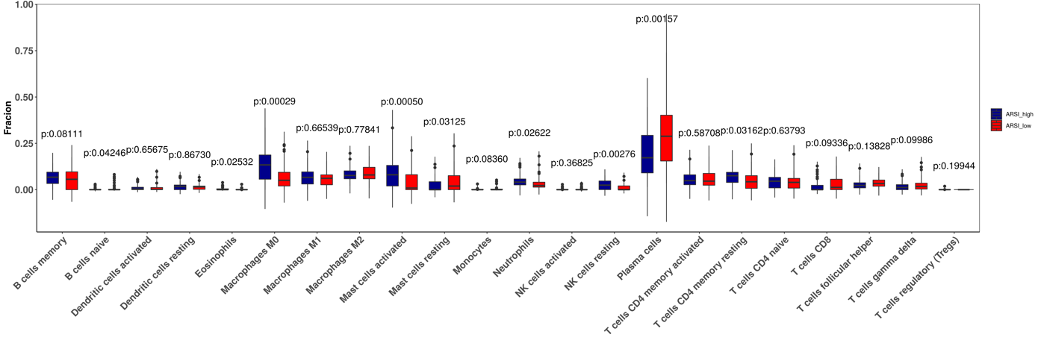
Figure S2: The relationship between ARSI expression and the infiltrating immune cells in GSE41613.

